EFFECTIVE TEAM WORKING & COMMUNICATION

BMSW4002

ANDREW STONE
1912735

LECTURER: TOYIN ADISA

TABLE OF CONTENTS
PAGE

ABSTRACT……………..……………………………………….… 3
INTRODUCTION…………………………...………………………3
COMMUNICATION CYCLE…….……………………………….. 3
SHANNON WEAVER MODEL……………………………………4
DAVID BERLO’S MODEL…………………………………………4
SHRAMM’S MODEL……………………………………………….5
ORGANISATIONAL STRUCTURE……………………………….6
CHIEF EXECUTIVE AND DIRECTORS…………………………6
HEAD OF SERVICE AND DIRECTORS………………………...6
WORKERS AND LINE MANAGERS………………………….….7
WORKERS AND MEMBERS OF THE PUBLIC………….……..7
COMMUNICATION BARRIERS……………………………….….7
RECOMMENDATIONS TO IMPROVE COMMUICATION…..…8
CONCLUSION………………………………………………...…....8
REFERENCES ………………………………………………….…9

ABSTRACT
This report investigates the communication process at the London Borough of Hammersmith and Fulham (LBHF). The report identifies problems with the communication process withing the organisation and makes recommendations how the communication can be improved. The report then concludes with an overview of the report.

INTRODUCTION
This report examines the communication process at the London Borough of Hammersmith and Fulham. Communication was once perceived as the sending of information only, however, feedback, which is the most neglected, is the most critical element in the cycle. Shannon Weaver’s theory on communication, also known as the information theory, is broken down into six main parts. They are, sender, encoder, channel, noise, decoder and receiver. Berlo’s SMCR model on the other hand, incorporates only four of the main elements to explain communication i.e. sender, message, channel and receiver. Each element can be influenced by many factors.

The LBHF is one of London's leading councils, who had previously merged from two Local boroughs and were renamed in 1980. With three major football clubs, this borough is quite unique. They are located on Hammersmith Town Hall, Kings Street. (LBHF,2020).

COMMUNICATION CYCLE
According to Ruck and Welch, (2012) at a time when there is a rise in challenging financial pressures, organisations will succeed when there is an effective internal communication process. This is usually a precondition to whether businesses succeed or not. Effective communication is invaluable to both the business and the employees.
The communication cycle demonstrates how the system of transmitting and comprehending messages works. Organisations are made up of people and it is critical that people are able to convey messages and understand one another. Various styles of the communication cycle may include different descriptions, steps and elements. However, most of the communication cycles have similar basic components. These are: sender, encoding, message, channel, receiver, decoding and feedback. The sender is the individual who initiates communication, who then encodes his/her thoughts into a suitable form for sending a message. The message is the information which is sent via a channel. The information is received by the receiver who then decodes in order to understand the content of the message. Finally, the receiver gives a feedback in response.

SHANNON WEAVER MODEL
Weaver developed this theory as a method to develop effective communication between individuals (See Fig.1). The model includes the concepts: information source, message, channel, receiver, encode and decode and noise.
There are some shortcomings with this model, in that, human communication is not mathematical as this theory denotes. Some critics consider this inaccurate and not a true reflection of communication between individuals. This model is better suited for interpersonal communication than mass communication. The feedback is not regarded as valuable when comparing to that of the source information. The sender plays the principal role, while the receiver performs the passive part in the communication cycle (Lecture notes, 2020)

DAVID BERLO’S MODEL
Berlo developed the Sender-Message-Channel-Receiver (SMCR) model of communication which had its origins from Weaver. This model however only has these four elements and emphasises encoding and decoding (See Fig.2). Berlo outlines elements that hinder the process of communication such as attitudes, culture, social system and knowledge.
There are some shortcomings with this model. The key one is that it overlooks the use of insight as a channel such as analysing, thinking and understanding. Additionally, there is no feedback so there is no knowledge of the effectiveness of the message. Communication barriers are not mentioned. Lastly, this model asserts that in order for communication to take place, both sender and receiver must be on the same level (Lecture notes, 2020). This however, is not true to real life situations.
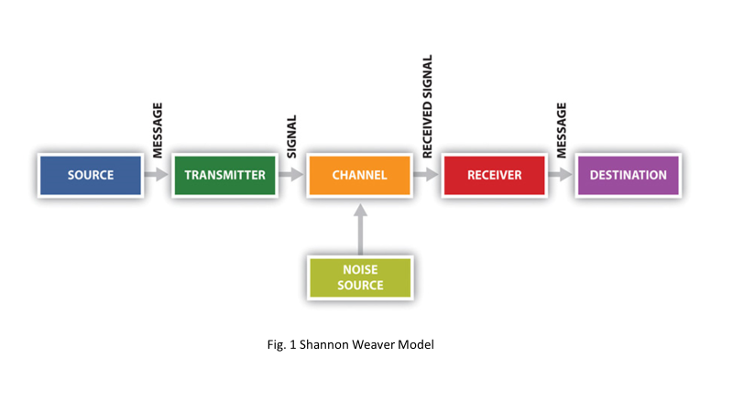

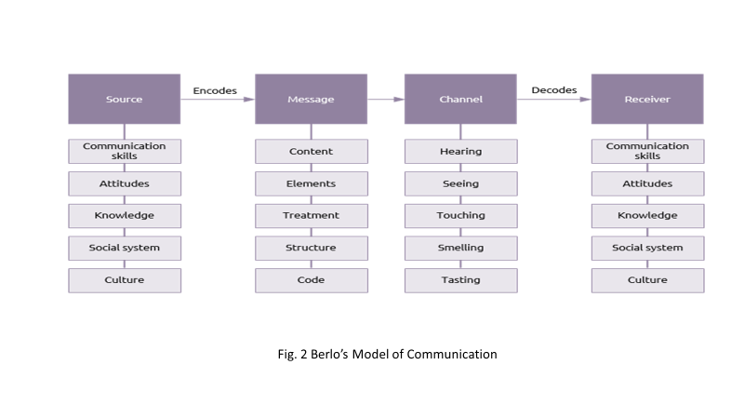
SCHRAMM’S MODEL
According to Schramm communication is not complete until and unless there is feedback (See Fig.3). He further states that until others received transmitted information that are carefully put into words, the information is of no use. This theory describes information being passed from the source to the receiver who deciphers it correctly and then provide a feedback. In this model encoding and decoding are important for successful communication to take place.
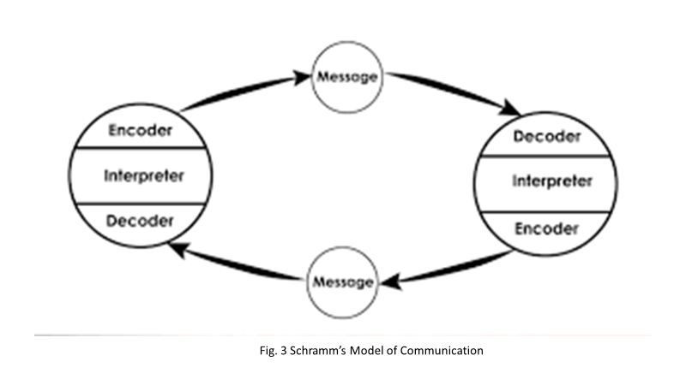

ORGANISATIONAL STRUCTURE
London borough of Hammersmith and Fulham has a decentralised communication structure. Communication is organised in a distributed fashion among directors in different departments within the council. This allows room for manoeuvre and more contented and stimulated staff. In addition, the service provided by the council is speedy and more responsive. Heads of services are familiar with local and individual needs and leaving managers free to manage.
The organisational structure comprises of: Chief Executive, Strategic Director, Directors, Heads of Service, Line Managers, and Staff.
The strategic director reports to the chief executive, the directors report to the strategic director, the head of service reports to the directors, the managers’ report to the head of service and the staff report to the managers. The four directors are responsible for the following four departments:
- Housing
- Finance
- Environment
- Human resources
The communication strategy employed by the LBHF council, ensures that decision making is divided amongst the directors and Head of Service for their respective departments regarding the strategic decisions. The Heads of Service along with the managers are responsible for making operational decisions. And finally, the workers communicate with their line managers.

CHIEF EXECUTIVE AND DIRECTORS
The chief executive of the council along with the directors are responsible for the strategic development, co-ordination and implementation of public services in accordance with the organisation’s Code of Practice. Directors communicate with the Chief Executive using various channels of communication. Some of which are emails, telephone conversations, Teams, Skype and face to face. The Directors formulate the message and sends it using of the above channels and the Chief Executive and Strategic Director decodes the message. The cycle of communication used is reflects that of the Shannon Weaver Model.

HEAD OF SERVICE AND MANAGERS
The Heads of Service are responsible for the management and efficient running of the operation. They guarantee that the visions communicated to them from the Directors are passed down. In addition, they update managers on new and existing legislations that affect the organisation, via various channels. The Heads of Service consult widely with all managers in order to secure their support and involvement in the vision of the Chief Executive. They also provide advice and information to all sections. The model of communication used by the Head of Service and managers are like that of Berlo’s. To ensure effective communication within the organisation between the Head of Services and managers’, all parties must take into account factors such as, attitudes, social systems, culture and knowledge

WORKERS AND LINE MANAGERS
Line managers’ report to the Head of Service whilst managing the workers by providing clear objective and supportive guidance and advice. In addition, the line manager oversees a large budget and ensures financial procedures are adhered to. The communication process between line managers and staff take place daily. This is to ensure the smoothing running of the operation. Communication between manager and staff occurs in complete cycle in that staff can feedback to managers and vice versa. Operational decisions are made at the managerial level. This includes, staffing, recruitment, budgetary and Human Resources issues. Managers within the organisation are expected to carry out regular one to ones and appraisal review meetings. In addition, all staffing and operational issues are expected to be fed back to the Head of Service, until it gets back to the CEO.

WORKERS AND MEMBERS OF THE PUBLIC
The frontline staff communicates with the members of the public using different channels to get the messages across. The council moved to smart working, which is a roll out of laptop and mobile phones for all staff. As a result, communication is more effective as both managers and staff are readily available to answer the phones and emails received from the members of the public.

COMMUNICATION BARRIERS
Communication barriers identified within the London Borough of Hammersmith are a lack of direct and indirect contact with staff and the leaders. When information is cascaded down to employees the communication cycle stops without the opportunity for direct feedback. Research has shown that in order to maintain a company’s profitability leader’s must engage with their employees. Lack of interpersonal communication has been identified as a cause for poor productivity and lower employee engagement (Osbourne and Hammoud, 2017).
Although there are minimal external communication barriers within the organisation e.g. noise, there still exists barriers in relation to the information and how it is received. Low staff morale and a negative attitude can impact the way the message is intended and therefore prevents correct decoding.

RECOMMENDATIONS TO IMPROVE COMMUNICATION
Communication can be improved at the London Borough of Hammersmith. Leaders have an important role to play in improving and developing employee relations. It has been shown that leaders foster positive influence and motivation of their employees when there’s an agreeable approach (Kouzes et al, 2012 cited in Osborne and Hammound, 2017). Therefore, by incorporating elements of feedback as described by Shramm or Berlo, the organisation will facilitate enthusiasm in their staff and as a result greatly improve the communication cycle.
Studies have also suggested that workplace health promotion programs are effective in developing clear communications strategy (Lally, 2016). By default, if this strategy were employed within this organisation, staff members would have a positive attitude thus enabling them to receive and decode information correctly. Attitude, according to Berlo’s is a key element for an effective communication between sender and receiver.

CONCLUSION
Success and performance of an organisation is dependent upon a complete cycle of effective communication between individuals in that organisation. Many corporate organisations on the forefront appear to have good communication based on the organisational structure. However, large decentralised organisations such as The London Borough of Hammersmith and Fulham show that the gap in communication from the top down to the bottom has a significant impact on employees’ attitude and work productivity. It is essential to close the gap in the communication cycle in large government organisations such as LBHF, in order to prevent low productivity, which in turn results in financial loss, as well as reducing the number of aggrieved staff. This can be achieved through facilitating wellness programs, separate to one-to-ones and appraisals.
This report undoubtedly reveals that feedback is critical in any communication. Therefore, it can be concluded that both Shramm and Berlo are correct in their emphasis of the importance of feedback in completing the cycle of communication. Berlo also highlighted elements such as attitude in his theory as factors that impact communication, and this can clearly be seen in this analysis.

REFERENCES

Adisa, T. (2020) Effective Team Working & Communication, In-Class Lecture Notes.
Lally, S. (2016) ‘Culture, Communication key to effective workplace wellness programs’, Professional Safety; Des Plaines, 61 (5) pp.18 [Online] Available from: https://search-proquest-com.ezproxy.uwtsd.ac.uk/docview/1789356886?accountid=130472&rfr_id=info%3Axri%2Fsid%3Aprimo (Accessed: 3 May 2020).
LBHF, (2020) London Borough of Hammersmith and Fulham [Online] Available from: https://www.lbhf.gov.uk/ (Accessed: 30 April 2020).
Osbourne, S. and Hammoud, M. (2017) ‘Effective Employee Engagement in the Workplace’, International Journal of Applied Management and Technology, 16 (1) [Online] Available from: https://search-proquest-com.ezproxy.uwtsd.ac.uk/docview/2103083931?rfr_id=info%3Axri%2Fsid%3Aprimo (Accessed: 3 May 2020).
Ruck and Welch, (2012) ‘Valuing internal communication; management and employee perspectives’, [Online] Available from: https://www.sciencedirect.com/science/article/abs/pii/S0363811111002116 (Accessed: 3 May 2020).

