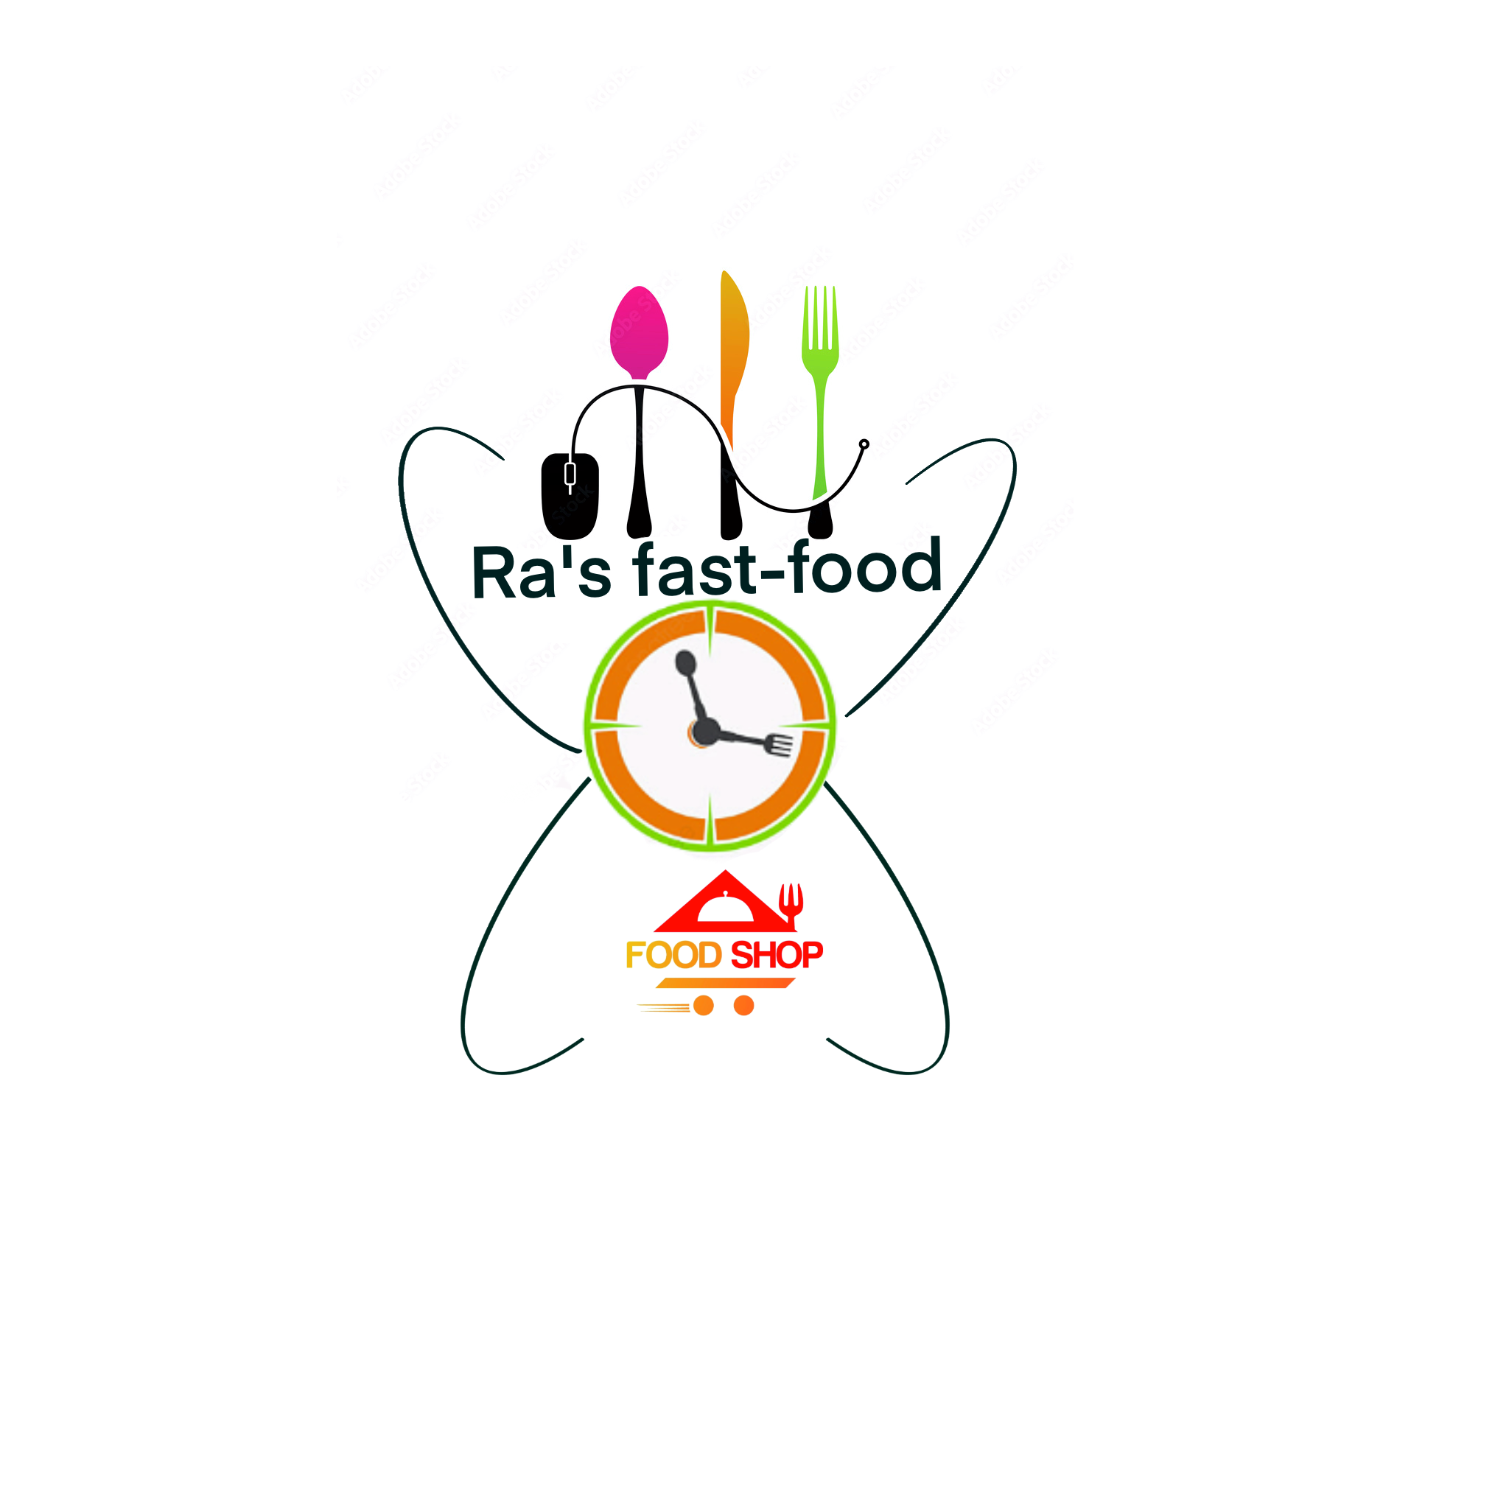  Strategic Management for SMEs  Ra’s Fast-Food Business | Abstract  In the following pages you will find the Ra's Fast-food project, a project that I thought about more than 10 years ago. What I learned at university is that good businesses are based on customer dissatisfaction, and this is exactly what happens with this project, basically it is a project in which I present my vision about food and about fast-food, being dissatisfied with today's fast-food restaurants.  Rares Albei 1913799  BMSW6104_BIRM

Table of Contents
Strategic Management for SMEs 2
Introduction: 3
The basic principles and philosophy of the company 6
To succeed in this business, we must: 6
PEST analysis 7
Political 8
Economic 8
Social – 8
Technologically 9
Conclusions about: 9
External Factors 9
Porter’s 5 Forces 10
Competitive Rivalry: 11
Threat of substitute – high 11
Barging power of customers 12
Barging power of suppliers 12
Threat of new entrants 12
SWOT analysis 13
SWOT analysis conclusions: 15
VRIO Analysis 15
Marketing objectives and defining strategies 16
The marketing mixes 16
Products Prices 17
Promotion policy 17
Distribution policy 18
Market analysis: 18
Customer needs: 19
Market trends 20
Implementation strategy 20
Price strategy 20
Sales strategy 20
Human resources (HR) 20
Conclusion: 22
References: 23

Introduction:

Our top objective is to open a fast-food restaurant in a packed mall, preferably one of the larger malls in Coventry or the West Midlands. We want to establish a solid business, even if we have more than enough finances to develop more restaurants.
• We sell high-quality items and strive to keep consumers pleased with all categories of products, from food to merchandise sold in the restaurant.
• We deliver 100 percent satisfaction to our clients and maintain a better level of service in contrast to other rivals.
• We support the two most significant values in the fast-food industry: brand and image, because these two elements are crucial in marketing communication.
• We gain access to high-traffic malls near the target market.
• We advocate for corporate culture and business philosophy Marketing objectives and defining strategies The business wants to go into the fast-food industry, which has obvious potential to grow even in the current economic climate. The excellent Pizza establishment will be viewed as a kind, inviting place where the staff makes friends with the clients and forges a bond of trust. Additionally, customers will be given the option to design their own menu by picking the components for the sandwiches, salads, and desserts they want to order. Distribution policy the restaurant will launch its operations on the grounds of a mall, giving it access to a sizable client base.
In the previous three years, we have all seen large rises in the costs of oil, gas, electricity, and food goods, as well as severe drops in incomes and countless layoffs in both private firms and public organisations.
However, one industry appears to have been unaffected by the huge financial changes: the "fast food" business.

Fast food is by far the most popular restaurant chain in the United Kingdom. As of 2022, there are 46,248 Takeaway & Fast-Food Restaurants enterprises in the UK, a 2.9 percent growth from 2021, with about 2.9 5 more units open than the previous year.

The balance sheet is respectable, given the significant financial strength behind foreign fast-food chains that have been steadily increasing on the global map over the previous two decades, and the growing demand for similar items in the UK. It should also be noted that the restaurant sector in the UK is heterogeneous and fragmented, with very few restaurant owners considering the construction of a profile brand. Most owners started one or two restaurants or wanted to launch many brands concurrently.
According to the data supplied by the firms, McDonald's serves more than 3.8 million people every day in the United Kingdom. According to a 2022 poll of restaurant brands in the United Kingdom, Greggs had the top rating from the British population, with 74% favouring the brand. Pizza Express, KFC, Pizza Hut, McDonalds, and Costa Coffee were also ranked in the top five.

Ra's Fast-Food is a fast-food restaurant that will be successful as a result of our innovative approach to the company's image and detailed presentation. Ra's Fast-Food will provide good cuisine in a pleasant environment with stylish packaging. Ra's Fast-Food is a response to the increased demand for quick food consumed while shopping in a mall.
In today's highly competitive world, differentiating one fast food from another is getting increasingly challenging. Our top objective is to open a fast-food restaurant in a packed mall, preferably one of the larger malls in Coventry or the West Midlands. In the future, we intend to expand by opening retail shops in the neighbouring districts.

Our major objective is to be one of the most successful fast-food restaurants in Coventry, beginning with an outlet within a mall to test the market.
Ra's Fast-Food will seek to be a market leader in the fast-food industry. We want our clients to have a whole experience when they visit our restaurant and website, and we want them to become acquainted with the intriguing "pop culture."
We will offer anything from pre-packaged sauces and t-shirts to potato-cutter equipment, all emblazoned with our official trademark.
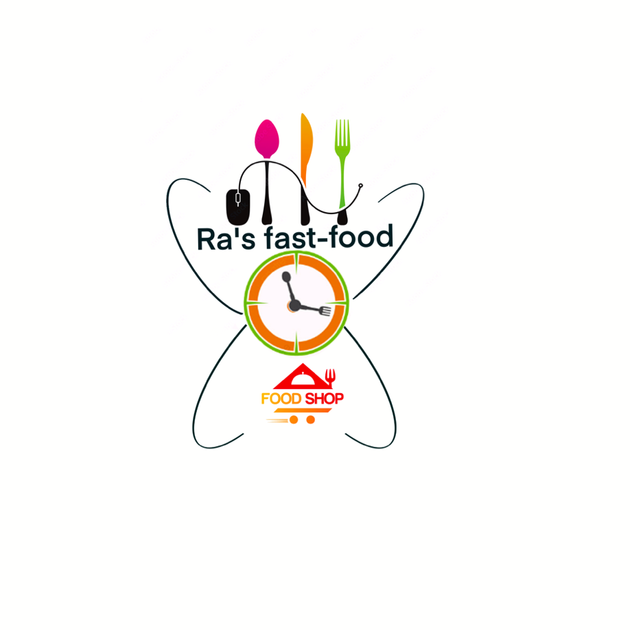
In terms of goods, our firm seeks to bring intelligent food, utilising only high-quality ingredients, food that entails determining the optimal balance of benefit and flavour of the food created. One of the basic goals is to assist growers in the growth of their crops for eco-bio food production, which will be marketed by fast food restaurants. A positive connection with them requires the development of a high-quality product, one that meets the requirements imposed by fast food clients.

From the perspective of the consumers, we propose to approach them by attempting to adapt the products and services to the liking of each client, by the excellent mood that they will find in our units, by the desire to engage with them, and by satisfying all of their gastronomic needs. A quick solution is to employ surveys within the units, questionnaires that will help us to choose the course of action we will take based on the perspective of the customers.

From a technological standpoint, our firm presents a high standard, one that allows for the high level of cleanliness and hygiene that is needed of all organisations in the food sector. It is preferred to employ a modern gadget in order to enjoy a shortened time of supplying the items, which will allow for a rise in the number of consumers who pass the unit on a daily basis, implying an increase in profit.

The basic principles and philosophy of the company

The ideals represented by the following principles form the foundation of our company's corporate culture.
- Trust in people: We believe in individuals and their good intentions, and we support the expression of ideas and the development of a diverse team in terms of style and composition.
- Recognition: We find reasons to honour our colleagues' accomplishments and have fun while doing so.
Training and assistance: We provide training and assistance to all team members in carrying out activities.
- Accountability: we do what we say and are accountable for what we do.
- Perfection: we are proud of our work and strive for it.
- Positive energy: we work with joy and enthusiasm; we despise bureaucracy and all it produces.
- Teamwork: We operate as a group yet value uniqueness.

Our values, in which we believe and respect, are as follows:
customer focus,
teamwork,
integrity,
responsibility,
commitment,
innovation,
punctuality,
correctness,

To succeed in this business, we must:

• We were developing a distinct, inventive cuisine that would set us apart from the competitors.
• We limit expenses at all times and in all areas, and we follow a cautious growth strategy. We want to establish a solid business, even if we have more than enough finances to develop more restaurants.
• We sell high-quality items and strive to keep consumers pleased with all categories of products, from food to merchandise sold in the restaurant. • We deliver 100 percent satisfaction to our clients and maintain a better level of service in contrast to other rivals.
• We support the two most significant values in the fast-food industry: brand and image, because these two elements are crucial in marketing communication.
• We gain access to high-traffic malls near the target market.
• We advocate for corporate culture and business philosophy.

PEST analysis
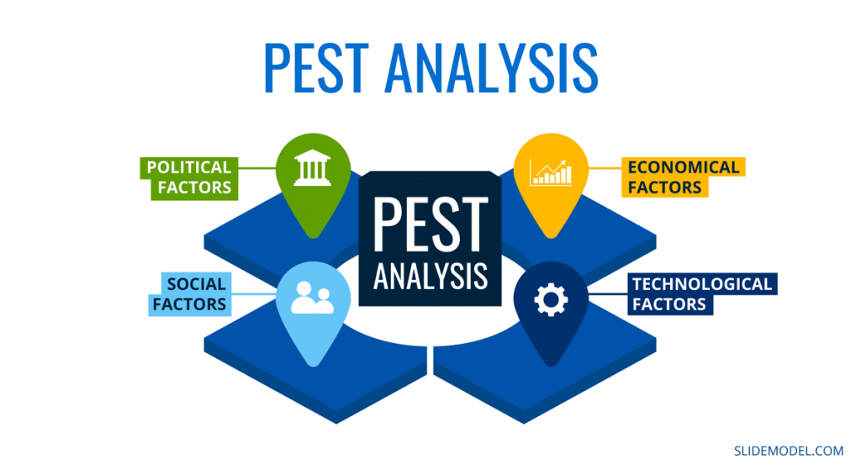
Any companies must keep track of and identify all external environmental elements that may have an influence on their operations. Many of these are beyond the control of organisations, but their ramifications must be acknowledged.
The PESTLE Analysis is a prominent approach for identifying these external influences. This application enables you to identify and analyse the primary drivers of change in the business environment.
Any companies must keep track of and identify all external environmental elements that may have an influence on their operations. Many of these are beyond the control of organisations, but their ramifications must be acknowledged.
The PESTLE Analysis is a prominent approach for identifying these external influences. This application enables you to identify and analyse the primary drivers of change in the business environment.
Currently, PEST analysis gives a broad overview of a company's or project's macroenvironmental circumstances and position. In this study, a new model for PEST analysis based on fuzzy decision maps is provided for the food business.

Political -
* - UK government taxes
* - Brexit treaties effect commerce between Europe and the UK
* - Staff shortage due to Brexit - only persons with settled status may work in the UK, with many ordinary employees having to leave * Political and economic insecurity

Economic -
* - Brexit engaged in a mandate to increase inflation by 2.9 percent
* - War between Russia and Ukraine Under the circumstances, Ukraine was one of the European engines for cereal delivery. - The increase in the price of gasoline, the price has quadrupled, making import and export difficult owing to the very high prices of fuel
* - Strong investors from the foreign market are retreating from the UK market
Brexit split the country's people into two groups: pro-Brexit citizens and anti-Brexit citizens. - Cultural diversity, distinctions between cuisines, each fas meal is unique
* - Political-economic instability * - Due to lower lifestyle standards, people prefer cheaper items over more costly but higher quality ones.

Social –
* - Fast-food companies are also influenced by health and lifestyle trends. The food industry has been impacted by health awareness. All foods and beverages are included, not just fast food. The average person now thinks twice before eating. It was the
changing attitude of consumers that compelled restaurant brands to include low-calorie options on their menus.
* - Health has a vastly different social perception today. This perception was shaped by media in its own way. The fast-food unyoung children have been targeted by the fast-food industry.
People have also adopted low-calorie foods because of the attack on junk food. Sales of the entire industry are impacted by such changing social trends. Obesity among children has been blamed on the industry.
* - Consequently, it needed to make nutritional information more visible on labels and reduce calories.
* - Fast food consumption is also influenced by cultural factors since some cultures discourage it.
Nevertheless, it has been adapted by most nations with modifications to suit regional tastes.
* - The global Coronavirus pandemic is currently responsible for yet another significant upheaval in civilization. Globally, the epidemic has significantly altered people's way of life.
Technologically –

* - the UK is relatively steady,
* - The use of gadgets that work on eco-green energy
* - The use of ovens and devices required in the newest generation Ovens, kitchens, fans, air conditioning, and alarm systems
* Adapting to online orders owing to the epidemic, creating a website, and advertising the internet company across all platforms

Conclusions about:

The Business is experiencing economic insecurity as a result of the present financial crisis.
Attracting new clients is more challenging, necessitating campaigns, discounts, and incentives that lower prices for consumers while increasing the company's costs. As a result, the employees' salaries are reduced, and they are less motivated to grow sales.
The number of clients, as well as the number of competent individuals, is diminishing as the senior population grows and young people migrate.
- Pandemic Covid 19 - For the past two years, 80 percent of small enterprises in properties have gone bankrupt.

External Factors:
Consequences of a bad economy-low consumer spending Following the plague and, more recently, the war in Ukraine, the people feel unsettled and strives to save money; one simple method to save money is to cease eating out. People no longer want to spend money, or they spend as little as possible in the city to save money.
The Ukrainian war has compounded the challenges of restaurant regulation and food safety. Ukraine supplies 40% of the World Food Program's wheat supply. Because of the crisis, some merchants have begun to utilise wheat substitutes, and market clients are not used to switching from wheat flour to tapioca. The difference in flavour, digestion, and amino acids is substantial.
Most Europeans have been accustomed to wheat flour for hundreds of years; a sudden shift in the main ingredient from wheat flour to other similar alternatives may result in pain, allergies, and potentially financial difficulties until we can grow accustomed to this substitute.
Another external factor is meat substitutes; at Ra's Fast-Food, we utilise fresh meat, but our rivals use a meat substitute, such as soya, which experts believe "produces some serious hormonal abnormalities."
Because they are vegetarian, these vegetable proteins are inferior. They lack all of the essential amino acids found in full animal proteins. 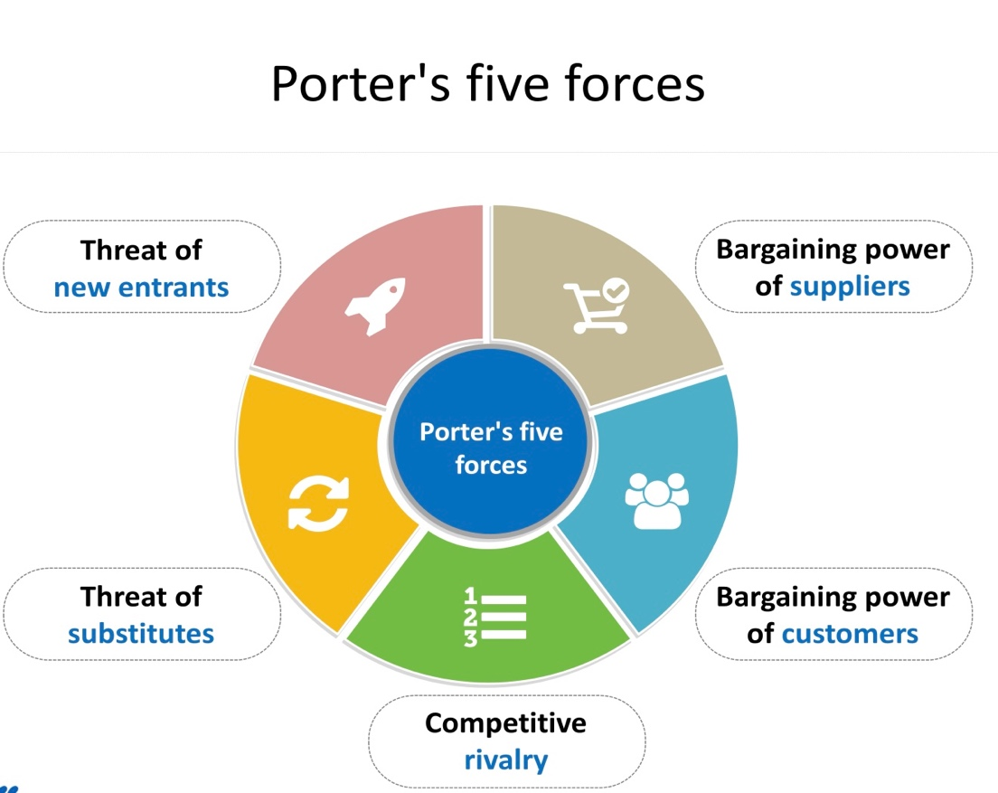

Porter’s 5 Forces

“In 1979, Michael E. Porter published a seminal framework about competitive forces, the five forces framework, which quickly became the definitive tool to identify forces driving industry competition (Porter, 1979). The five forces - threat of new entrants, bargaining power of buyers, bargaining power of suppliers, threat of substitute products or services, and rivalry among existing competitors - were considered applicable to every industry, regardless of level of technology or economic development (Porter, 2008). The business world has become increasingly more global and complex since then, which is prompting a reappraisal of this highly popular managerial tool.”

Competitive Rivalry:

Ra's Fast-Food seeks to be as visible as its competitors in a fast-food restaurant industry dominated by Pizza Express, KFC, Pizza Hut, and McDonalds.

In 1986, McDonalds and its innovative Mc Drive drive-thru restaurant debuted in Fallowfield.
Menu selections include burgers, pies, pastries, salads, ice cream, and shakes. Of course, the burgers are the most popular. Along with them, the shake became popular with customers.
Without a doubt, one of the strongest features is the service. Some sites are open 24 hours a day, which is especially convenient on weekends. Despite the advertising that displays the nutritional composition of each piece of food, the restaurant continues to lose significantly in terms of healthy meals.

Pizza Hut: At the time, Pizza Hut developed a novel idea for a restaurant: a combination of a fast-food establishment and a system restaurant. Hence the costs, which are horrendously high for a fast-food restaurant (7£ for an average pizza), the amenities, which include table service, and the slightly more upscale environment compared to other fast-food restaurants. With 11 different varieties of pizza, 110 pasta dishes, 11 entrees, 9 salads, and unusually for a restaurant, more than 10 different types of wine, the menu is diverse. Pizza is delicious, but you can get a nicer pizza in a restaurant for less money.

KFC – With five different varieties, KFC chicken seems to be more popular for its spiciness than for Colonel Sanders' original recipe. Even though mashed potatoes are on the menu, the restaurant's success on the Coventry market is the combo of hot wings, garlic sauce, coleslaw salad, and a side of mashed potatoes.
Given that fried chicken is healthier than grilled steak, the kitchen is seen as being somewhat healthier than at McDonald's. However, the food is subpar and lacks variation. In the eco zone, however, maize is valued when boiled with butter, and the natural juices are pure nectars, unlike at Mc, where the ecological menus with salads are jokes that no one has ever been curious to try.the price (£1.99).

Threat of substitute – high

Frozen dinners, home cooked meals, and food trucks are among the alternatives for food service. They provide comparable product qualities due to the low switching costs associated with these replacements and their appealing price.

Barging power of customers

A few reasons contribute to fast food consumers having strong negotiating power (customers). Customers may readily transfer restaurants and enforce demands such as lower pricing, increased services, or higher quality since switching costs are minimal. The cost of a product impacts purchasing decisions. Aside from the financial status of UK consumers, buyer price sensitivity is also an issue. Due to pricing concerns, the majority of UK consumers reduced their use of fast food in 2019. As a result, fast food establishments might cut their pricing in order to attract consumers.

Barging power of suppliers

The supplier's bargaining strength in the market may have an impact on the purchaser's business climate and profit potential. A number of essential elements should be addressed when evaluating suppliers' negotiating strength, including the proportion of suppliers to buyers, the dependency of suppliers' sales on individual customers, supply switching costs, and the possibility of forward integration by suppliers.

Fast food restaurants must have suppliers that supply dough, meat, and veggies. Supplier power is minimal since there are currently other providers that can supply these items. In terms of raw materials, fast food outlets have a big variety of suppliers. This allows fast food outlets to readily swap suppliers at a low cost.

Threat of new entrants

Regardless of existing obstacles, the fast-food business faces a moderate threat from new entrants. It may require a reasonable amount of capital to become an established fast-food business, but as a new entry, achieving economies of scale may be challenging because new enterprises tend to join the industry with tiny market shares and high fixed expenses. Most new entrants may be deterred from entering the global fast-food sector due to the dominance of Quick Service Restaurant Chains such as McDonald's, KFC, and Pizza Hut.
New entrants might invest extensively in advertising and marketing because of their cash.
There is a requirement for marketing to develop brand recognition as fast food goods are marketed to create brand awareness.

SWOT analysis
Opportunities

Entering new markets.
Finding sources of supply with cheaper raw materials.
Increasing demand for fast-food products.
Products at affordable prices.

Weaknesses

It is a new company in the field, unstable relationship with suppliers.
Company standards are not yet well established.
Low credibility on the part of clients.
Lack of a reputation on the fast-food market

Threats

Strong competition.
Devaluation of the national currency.
Rent increase for commercial spaces.
Tougher credit conditions
Strengths

It offers a diverse range of products.
good location.
The company benefits from a modern management.
Through the technologies and modern equipment with which it is equipped, the busyness has the possibility effective tracking of product quality.

SWOT analysis conclusions:

Ra's Fast-Food is a newcomer to the industry, thus there is a significant danger of instability, so the business must take advantage of the chances that are presented. Building a reputation in the fast-food industry is crucial, as is developing trustworthy relationships with clients and vendors. For a new business, the competition and the economic crisis pose serious challenges, but Ra's Fast-Food will endeavour to achieve its objectives and get through this challenging time with the aid of effective teamwork, promotion, and existing advantages.

VRIO Analysis

Resources | Valuable | Rare | Imitable | Organized
Resources of the highest quality | Yes | No | Yes | Competitive advantage – Temporarily
Environment atmosphere | yes | Yes | Yes | Competitive advantage – Temporarily
Human Resources HR | yes | Yes | No | Sustainable competitive advantage
Placement Location; Selling point | yes | No | yes | Competitive Parity
First concept to be implemented | yes | Yes | No | Sustainable competitive  Advantage

Our value-added strategy will be generated through these classes:

Since Ra's Foods has established the ideal setting to produce high-quality goods and atmosphere, the value of high-quality products and atmosphere cannot be understated. We stand out from the competition by producing all the ingredients with a made-in-style. It's possible that a rival won't be able to immediately collect these resources at the same moment. These tactics have the drawback of being easily imitated by potential rivals, which would eliminate the momentary competitive advantage edge they would otherwise provide.

Because it is challenging to find suitable personnel, for instance, to build the Ra's Fast-Food specialisation in the service industry as they must be adequately trained, we are searching for difference via human resources. We can develop a "sustainable competitive advantage" in this area since these resources are expensive and difficult to duplicate because they depend on how our firm is organised.

Location is important since it can result in distinctiveness. It is not unusual for a rival retail location to start up close to us at the same time. Therefore, it is crucial to talk about "competitive parity" in this section.
Our concept of first mover takes into account that it is an intangible asset. Because distinctiveness is uncommon and rarely replicable, our company is structured to capitalise on the market we are developing and create "sustainable competitive advantage."

Marketing objectives and defining strategies

The business wants to go into the fast-food industry, which has obvious potential to grow even in the current economic climate. The management's goal is to draw in customers, particularly the elect, and to maintain their loyalty by providing high-quality goods at competitive prices and with excellent customer service.
The excellent Pizza establishment will be viewed as a kind, inviting place where the staff makes friends with the clients and forges a bond of trust.

The marketing mixes

Product regulation Products available for purchase at Ra's Food Place include:
sandwiches: Hamburger, Big-burger, Chickenburger, Fish burger, and Cheeseburger potatoes mashed
desserts: Apple, strawberry, apricot, and cherry pie with various toppings for ice cream
refreshments
coffee-based beverages
salads

Depending on the needs of the customers, the product selection will change over time. Additionally, customers will be given the option to design their own menu by picking the components for the sandwiches, salads, and desserts they want to order. The restaurant will show pictures of potatoes being prepared in various ways, from chopping to frying. Brochures with internal recipes and suggested sauces will be available for customers to read.
The layout of the restaurant will be fast-food-inspired, with a cheerful bar and menu shown on the wall and on the room's digital displays.
Because they sell goods aimed at various customer types, everyone can afford them, and they occasionally give specials and discounts to students.

Products Prices

Products | Prices
Chickenburger | 4 £
Fish-burger | 4.5 £
Big burger | 6 £
Hamburgers | 5.5 £
Cheeseburger | 5 £
Salads | 3 £
Pies | 3.5 £
Pancakes | 2 £
Ice cream | 2.5 £
Small/Medium/Large Coolers/Juices | 1.5 £ / 2 £/ 3.25 £
Fries small/medium/large | 1.5 £ / 2.25 £ / 3.5 £
Coffee | 2.5 £
Frappe | 3 £
Milk Shake (banana, strawberries) | 3 £
Alcoholic drinks (beer, cocktails) | 4 £ / 7£
Non-Alcoholic drinks | 6.5 £

Promotion policy

In addition to advertising through leaflets, specials, campaigns, and internet marketing, it is preferred that the foundation of the restaurant's promotion be the recommendations of happy customers. Because brand and image are two key components in marketing communication, we support the two most significant values in the fast-food industry.

Distribution policy
The restaurant will launch its operations on the grounds of a mall, giving it access to a sizable client base. The business will be open from 10:00 until 23:00.
Customers will have the option of purchasing the goods directly from the restaurant, with on-site service or takeout, or they may place an order from home via the phone, the internet, or both, and the distributors will deliver the goods as soon as feasible.

Society

Market analysis:

At the end of 2021, consumer expenditure on fast food climbed in the UK. This industry has experienced tremendous development as a result of the expansion of new businesses including fast food restaurants, bakeries, and restaurants in the area of United Kingdom.

Young adults who are presently enrolled in high school and college.

Families: We'll also try to reach out to young families with kids.

We will concentrate on both sexes, with a small slant toward men because they have fewer nutritional issues.

Income - People with medium and low incomes will be taken into account.
Our objective is to become the go-to place for fans of fast food.
80 percent of those polled who were between the ages of 15 and 45 reported eating fast food, according to a recent survey. Ninety percent of them usually eat fast food, and ten percent of them said they "love" or "enjoy" it. Additionally, the study offered the following unique explanations for the rise in popularity of fast food:

Every year, there are three extended vacations and 52 weekends for workers. Because Coventry is a multicultural city with a diverse range of cultural mythologies, people there like shopping and require a fast snack while they do so.

Instead, then bringing takeaway, corporate employees now choose to consume hamburgers, pizza, or other fast-food snacks nearby.

Most people do not view fast food as a luxury and frequent fast-food locations with their families, especially if they have young children.

Customer needs:

We recognised the demands of the clients after researching the industry, and we aim to provide them with the finest and quickest meal service possible.

• Delicious and diverse cuisine, particularly fried

• Quick response

• A fun encounter

• A welcoming, tidy, and beautiful setting

• Global way of life

• He likes the stuff he consumes.

• Leads a healthy lifestyle

• They have a range of racial and ethnic origins.

Market trends
Coventry locals formerly favoured western restaurant brands. KFC, McDonald's, and Pizza Hut ruled the market at this time. However, the pattern appears to have shifted in the last ten years as local companies experience increasing success.

Implementation strategy

We'll start by setting up shop within the West Orchards Shopping Center.
This will serve as our market test location, and Ra's Fast-Food has future intentions to set a shop in a neighbouring shopping complex, possibly Gallagher Retail Park. We will provide them with information and brochures about how our products are made in an effort to entice them to try them.

Price strategy
Insofar as our pricing strategy is concerned, 4 £ stands in for what the typical customer spends on a snack or lunch.

Sales strategy

Building and opening more sites is the sales approach used to boost sales. However, this strategy won't be put into action until the "market tester" demonstrates that there is room for expansion. The aim of each store is to make £100,000 Pounds yearly, and the "market tester" store is anticipated to generate around £150,000 Pounds annually because each site will develop a local client base in the first three years of operation.

Human resources (HR)

We will start out with three cashiers, two chefs, two drivers each site, and one cleaner. For a restaurant of our size, this is regarded as the appropriate staffing ratio. Each worker will put in 38–40 hours each week.
Long term, we will add more middle management staff as we broaden our product categories and retail marketplaces.

The business will be managed by a hired manager who will oversee operations, submit activity reports on a regular basis, and be specifically chosen in light of the company's characteristics:
- the pleasure of working in the field.
- organizational skill.
- sincerity and loyalty.
- assuming responsibility
- Originality in thought
- Innovative spirit

The required staff will be located and hired using recruitment-placement firms, job postings on specialist websites like Indeed.co.Uk, or even on social networking sites like Facebook, Instagram, and Twitter.

The company's salary strategy will be based on a review of the variables that affect income levels, including employment demand and supply, legal requirements (such as the UK minimum wage), and the business's payment options.

The Business will implement a policy of high compensation, above the average salary level, in order to maintain its status and foster a favourable image. A baseline pay will always be guaranteed, adjusted for inflation and living expenses, and modified independently of the company's profits. The salary fund won't change based on the profit made. Additional premiums, bonuses, and payments will be allowed under the salary plan.

Staff retention will be improved in addition to compensation levels by offering job security (5-year contracts), as well as by advancing personnel within the business. In order to bring employees together and foster a nice work environment, the organisation will provide staff with specialised training and hold competitions and recreational events.

Conclusion:

Fast food is by far the most popular restaurant chain in the United Kingdom. Ra's Fast-Food will provide good cuisine in a pleasant environment with stylish packaging. The company seeks to bring intelligent food, utilising only high-quality ingredients and determining the optimal balance of benefit and flavour. From a technological standpoint, our firm presents a high standard that allows for the high level of cleanliness and hygiene that is needed of all organisations. It is preferred to employ a modern gadget to enjoy a shortened time of supplying the items, which will allow for a rise in the number of consumers.

• In this study, a new model for PEST analysis based on fuzzy decision maps is provided for the food business.
• Any companies must keep track of and identify all external environmental elements that may have an influence on their operations.
• Building a reputation in the fast-food industry is crucial, as is developing trustworthy relationships with clients and vendors.
• VRIO Analysis Although the resource-based view and the value-rarity-imitability-organization (VRIO) technique are extensively utilised in management practise courses, it is still unknown from research to what extent they aid managers in understanding a firm's resources.
• This paper's goal is to concentrate on what happens when VRIO informs strategy action in light of the recent interest in the usage of strategy tools.

References:

1. The Rise and Fall of Strategic Planning (1994). Henry Mintzberg.
2.
3. LOPEZDOMÍNGUEZ Rivas, Sol David, and Maikel LEVYA. "PEST analysis based on fuzzy decision maps for food industry." (2019).
4. Shatskaya, E., M. Samarina, and K. Nekhorosheva. "PESTEL Analysis as a tool of strategic analysis in international markets." SCOPE ACADEMIC HOUSE B&M PUBLISHING (2016): 47.
5. Caddy, T., 2019. Eating Out Review -UK‬- December 2019, ‬London: Mintel.‬‬

6. ﻿Isabelle, Diane, et al. "Is Porter's Five Forces Framework Still Relevant? A study of the capital/labour intensity continuum via mining and IT industries." Technology Innovation Management Review 10.6 (2020)
7. Cardeal, N., & Antonio, N. S. (2012). Valuable, rare, inimitable resources and organization (VRIO) resources or valuable, rare, inimitable resources (VRI) capabilities: What leads to competitive advantage. Cardeal, N., António, (2012), 10159-10170.

