The Relevance of Professional Skills in a Work Environment

Prepared for:
Rhodri

Created by:
Lloyd wilson
2211509

Date completed:
January 2023

Word count: 1050

Contents
Induction 2
Findings 2
Defining academic skills 2
Emails 2
EXCEL Spreadsheets 3
Property management systems 4
Communication Letters, satisfaction surveys 5
Conclusion 6
References 7

Induction

In this report I will be discussing why computer skills is an important academic skill to have in the construction industry. I will provide personal experiences and how having a good level of I.T. is vital for the roles I have done and the importance to deliver the day-to-day activities. I will show why I chosen computer skills and its relevance to me and future progression.

Findings

Defining academic skills

Academic skills in relation to construction would include:
- Time management
- Research skills
- Computer Skills
- Self-discipline
- Critical thinking
- Group work
These examples, though there are many more lay the frame to academic skills in the workplace. They can be broken down into more detail and more importantly can be improved upon through learning and experiences. Developing on these skills in a professional workplace improves the overall performance output of the company, so it’s vital that training is provided so all the roles can be continually improved for personal and company growth. In my workplace we have annual training and individual training if identified for certain roles. In my previous position as a team leader/foreman I was assigned to do an ILM 3 in management to improve upon my management skills. Within the course it covered things like: personal Performance, team performance with detailed theories and methods of achieving this.

Emails

Sending and receiving emails is vital in the construction industry and can make a paper trail of communication between different persons, groups etc…. they must be clear and used correctly as under GDPR information must be protected and not shared to nonrelative persons. I use emails daily, and we must be careful with what type of written language we use as our tenants/customers can demand information relating to them under (Data Protection Act 2018). Its best practise to write professionally with no personal discrimination tones to be used as the customers has the right to view every bit of information Ateb has about them. Emails are a great way to communicate clear and precise information, it is paramount in my role to do this as what I put in them can be used for and against me. E.g., if I task a contractor some extra work via email, I will be hold accountable for that instruction.

EXCEL Spreadsheets

Site address | Pre Inspection | Forms | Site inspection | forms | Post inspection | forms
Kitchens
24 Croft court |  |  | 06/01/2023 | Y
34 Croft court |  |  | 13/01/2023 | Y
20 Croft Court |  |  | 16/01/2023 | Y
17 Hounsell AVE |  |  | 06/01/2023 9/1/2023 | Y | 13/01/2023 | Y
12 Gordon Parry RD |  |  | 09/01/2023 16/01/2023 | Y
13 Gordon Parry RD |  |  | 09/01/2023 16/01/2023 | Y
11 Gordon Parry RD |  |  | 16/01/2023 | Y
3 Gordon Parry RD |  |  | 16/01/2023 | Y
In my current role as planned maintenance surveyor all my work is on spreadsheets, its broken down into addresses, job numbers, description of works and other details. It can be manipulated by having data pulled from the spreadsheet or adding/attaching information which equates to the overall job lists and accurate expenditure of the works programs. The budgets and amount of work gets set before each financial year, its then up to my team to deliver these works on time and in budget. Understanding the importance of correct data input equals correct information, I must ensure that I do this correctly as I must achieve the planned works program. I’m analysed on achieving these results and receive personal work-related bonuses as an additional incentive, so having this academic skill is important to continually improve and maintain throughout my professional career.

Illustration: Microsoft Excel
Source: Lloyd wilson 16/1/2023

Property management systems

In ateb we use Microsoft dynamics which is tailored to a property management system which stores information such as property, tenant, and job history information. It’s important to be able to navigate this software to use it correctly and gather the information that is needed. Without this management system my company (Ateb) would not be able to operate, it’s just as important to have IT support so bugs, updates and user support can all be maintained. This academic skill is improved upon with annual training to always upskill the user and show alterations in the software. I have recently had training on raising a job so it can digitally give to my contractor. I was put through the training with a member of staff who gave me guidance of the process, once raised I then sent it over to the contractor, I then had to update my spreadsheet with the job details etc…. it’s extremely important that all the information is correct as financial budgets are in place and it would be scrutinised at the end of the financial year by the accounts department. Adding to that it also releases the correct money for payments of the work, so it must be all correct and it is an important task to complete.

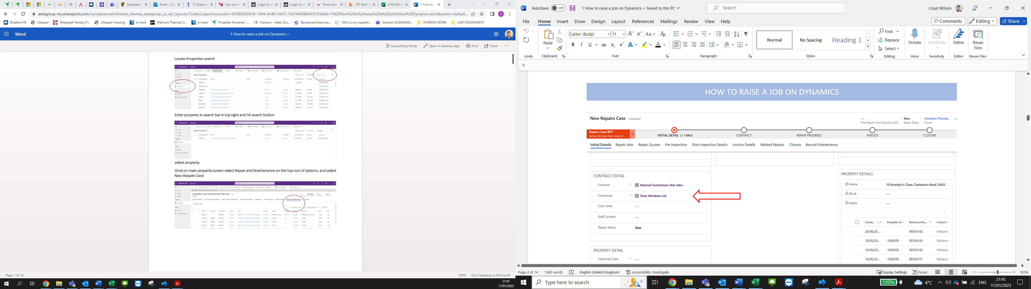

Illustration: Microsoft Dynamics
Source: Lloyd wilson 16/1/2023

Communication Letters, satisfaction surveys

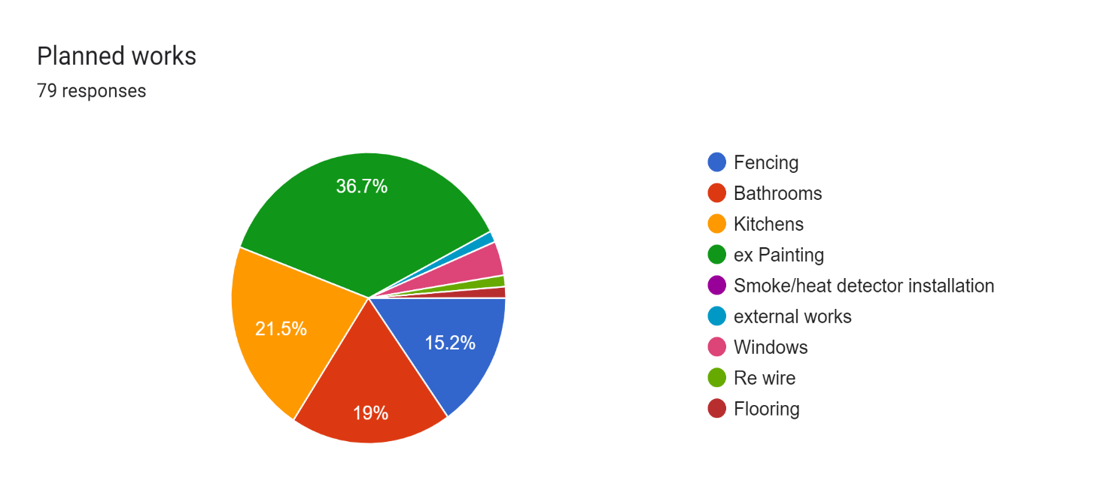
Understanding software and its uses has become more the norm in construction, whereas before information was handwritten or posted out to our customers. Using IT software like (Canva, 2023) we can make letters using our branded logos and templates. Again, when doing this, its best practise to get a team member to check over before you send it out to the customer. As part of my role, I do post inspections of work that is carried out on the planned maintenance contracts, I use my tablet to fill out the questionnaire survey with the customer. I then upload my results using (Google Docs, 2023), the results can be pulled into a spreadsheet or results analysed as shown in my pie chart below.
Illustration: Google Doc result
Source: Lloyd Wilson 17/1/2023

I then present the results to my line manger every financial quarter, it’s crucial that I meet Ateb’s criteria of achieving twenty five percent of all works carried out under planned works program as these results are presented to the board. Data analysis of these results can be used to improve the delivery of works and if red flags may appear that have to be addressed I can then performance manage the contractors to increase workflow.

Conclusion

I’ve produced evidence of my own use of IT skills, reinterpreting daily use with my own examples in the report. Being professional doesn’t always mean just looking and talking in a professional manner, you must have academic skills with always trying to strive to improve on them if you want to achieve targets and progress throughout your professional working career. I.T. skills are important for all the construction industry sectors, with new software and hardware always being implemented. Your company must adapt, train employees, and invest in an ever-changing working environment to maintain relevance. Having employees up to date and foreseeing potential future working practises is key to prosper in the sector.

References

Canva. (2023, 1 16). Canva. Retrieved from https://www.canva.com/en_gb/

Data Protection Act 2018. (n.d.). Retrieved 01 17, 2023, from https://www.legislation.gov.uk/ukpga/2018/12/contents

Google Docs. (2023, 01 18). Google Docs. Retrieved from https://www.google.co.uk/docs/about/

