Daniel Leone (2317483)
2317483@student.uwtsd.ac.uk
The Effects of cryptowall, and how to protect yourself
Academic Skills – COMPUTING, Module code: ACHA4005

Table of Contents
1. Introduction 2
2. Evaluating Cryptowall 2
2.1 What is Cryptowall? 2
2.1.1 Ransomware 2
2.1.2 How does it infect your computer? 2
2.2 What files could be at risk? 3
2.3 Consequences of infection 4
2.3.1 Productivity Loss 4
2.3.2 Damage to Reputation 4
2.3.3 Financial Impact 4
2.4 How to recover your data 4
2.4.1 Should you pay the ransom? 4
2.4.2 Alternative Recovery Methods 5
2.4.3 Prevention, and Backup Strategies 5
3. Conclusion 6
4. References 6

Introduction
The aim of this report is to provide readers with an insight into the ransomware known as Cryptowall, covering the key objectives of explaining what it is, what it does, and how it can infect a user’s computer. This report will also highlight the types of files that could be at risk, and the real-world consequences of becoming a victim of Cryptowall. Finally, the author will explore and detail some of the potential ways in which a victim could recover their data, and how to minimize the risks and subsequent fallout of becoming a victim to such attacks in the future.

2. Evaluating Cryptowall

2.1 What is Cryptowall?

2.1.1 Ransomware
Before exploring the nuances of Cryptowall, it is important to first understand what is ransomware, or, ransom malware. This is the terminology given to a specific type of malware which maliciously gains access to an unsuspecting victims computer system, in order for the attacker to then leverage their control over the victim, and to extort them for monetary gain. As stated on ‘Malwarebytes’ website [1], Ransomware “is a type of malware that prevents users from accessing their system or personal files and demands a ransom payment in order to regain access”. Cybercriminals can use ransomware to target a wide array of different computer users, such as organisations, businesses, and even individual users at home. It has been found through research by the ‘Cyber Threat Alliance’ [2] that more affluent geographical locations are at greater risk of being targeted. Their research showed that the North American region has been affected more-so than others.


2.1.2 How does it infect your computer?
Infection is often, but not exclusively, achieved through a Trojan Horse. What this means is that the malware will be disguised and distributed as something that appears to be normal, and legitimate. As described in a blog post on ‘swift tech solutions’ website [3] Its’ name is in direct reference to Greek mythology. An artistic visual interpretation of a digital trojan horse can be seen in Figure 1.
A theoretical scenario of infection portrayed in an article on Malwarebytes website [1] is as follows; an attacker sends what appears to be company email, with an important new policy attached for all employees to read. The email itself is a phishing attempt, and opening the so-called policy document, in this case: the Trojan Horse, will execute the malware and begin the hidden process of infecting the unsuspecting victims’ computer. In this example, the victim did not recognise that the email was not legitimately sent from within the organisation, and was easily mislead into believing that the email and the attachment therein were exactly what it was claimed to be.
Figure 1: Trojan Horse
Source: [3]

As written in a blogpost, Michael Buckbee [4] claims that, Once the Cryptowall ransomware has been executed on a computer, it will quickly begin the process of hiding itself in the main operating systems’ start-up files. It will then automatically locate and encrypt the users’ data, thus locking them out of their personal files. Cryptowall will also delete shadow copies of the now highly encrypted files, thus making it extremely difficult, and in many cases, impossible for the user to regain proper control over their system and restore access to their own personal files. Since Cryptowall roots itself into the operating systems’ start-up files, rebooting the computer will make no difference.

2.2 What files could be at risk?
Cryptowall will target and encrypt all of the victims personal data, These are files which are generally user created, often irreplaceable, and will be unique to each specific user.
An extensive list provided by Michael Buckbee in his blogpost [4] shows the filetypes that would typically be targeted by Cryptowall, see figure 2 below.

Figure 2: Vulnerable filetypes
Source: [4]

2.3 Consequences of infection

2.3.1 Productivity Loss
To most modern businesses and organisations, their data is absolutely vital to their day-to-day operations. In an article [5], Thorsten Kurpjuhn describes an organisations data as “The lifeblood”. The downtime alone, will significantly impact a business through the sudden halt in normal operations and the loss of productivity. In a journal article by Megan Wade [6], Wade claims that the value of an organisations’ data can be equivalent to the number of hours that would be required to rebuild or recoup the data loss. The aphorism ‘Time is money’ becomes prevalent in this type of downtime scenario.

2.3.2 Damage to Reputation
Compromised organisation databases, can indirectly create further victims of crime. In an article written by Ms. Smith [7], a particular group of cybercriminals with the alias ‘The Dark Overlord’, or ‘TDO’ are noted to have attempted to sell 655,000 stolen digital healthcare records, containing patients’ personal information, on a dark web marketplace. Data breaches such as this, understandably, raise huge security concerns and can severely reduce the trust and confidence of an organisations’ clients. Malwarebytes [1] claims that during the 2020 coronavirus pandemic, hospitals were increasingly targeted, as cybercriminals were able to doubly extort their victim, not only with the leverage of crippling data encryption, but also with the threat of leaking sensitive data.

2.3.3 Financial Impact
In the same article by Ms. Smith [7], Another example of an attack by the cybercriminal group ‘TDO’ is highlighted. This separate attack details their breach of Larson Studios which allowed them to acquire ten brand new episodes of a popular television series which were due to be aired on Netflix in the near future. Although Larson Studios initially co-operated, Neither Netflix, nor Larson Studios paid off the ransom and therefore TDO released the episodes publicly, for free. Although the group did not successfully secure the fifty bitcoin ransom, they exercised this leak as an example, to aid their credibility and to reinforce their scare tactics toward other organisations. As for Larson studios and Netflix, there would still have been an estimated loss in the way of potential revenue from those who chose to watch the episodes for free rather than streaming them legitimately.

Referring to data recorded by the Cyber Threat Alliance [2], it is said that “CryptoWall is one of the most lucrative and broad-reaching ransomware campaigns being witnessed by Internet users today”. During the investigation detailed in the report, it was found that Cryptowall alone had caused an estimated US$325 million worth of damages globally at the time.

2.4 How to recover your data

2.4.1 Should you pay the ransom?
The first obvious solution to decrypting and recovering your data, is the attacker’s proposed solution, and that is to follow instruction, and pay the demanded ransom. The problem is, as noted by Lee Matthews on Forbes [8], who refers to information published in a report by Cyber Edge Group, it has been found that statistically only 19% of the victims who pay these ransoms result in having their files decrypted as promised. This statistic proves that the cybercriminals, most of the time, cannot be trusted to uphold their end of the deal. It has also been advised by the American FBI [9], not to pay a ransom, as it could actually encourage further attacks and even fund other illegal activities.
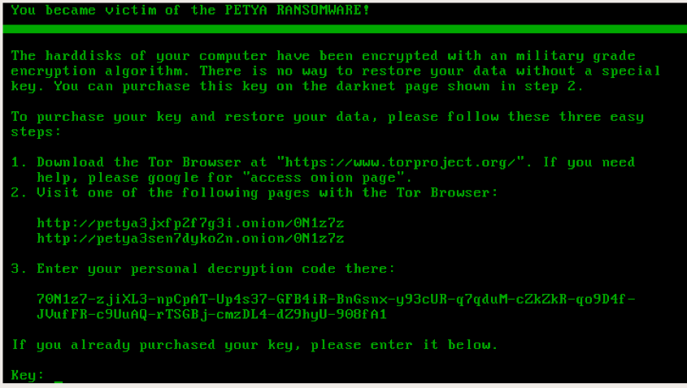

Figure 3 Ransomware instructions
Source: [10]

2.4.2 Alternative Recovery Methods
Contrary to what the attackers will lead their victims to believe, there are ways in which a victim can decrypt their files without ever having to engage with the attackers. As described by Adam Kujawa [10], There are free decryption tools available online, created by trusted security organisations to decrypt and combat the effects of many different ransomwares. This route is not fool proof though, and will usually require some investigation, and diligence by the user to ensure that the correct tool is used as to not further encrypt or damage their files. With that being said, it is also important to understand that not all ransomware is created equal. Some ransomwares are newer, more advanced, and use highly sophisticated encryption methods. Therefore, it is possible that a required decryption tool has yet to be created.

2.4.3 Prevention, and Backup Strategies
The American FBI [9] suggest that firstly, organisations should focus on prevention. Employees should be trained in awareness and use due diligence to identify and avoid potential breaches. Secondly, organisations should have a solid and regularly tested remediation plan in place to allow “…recovery and continuity”.
The tried and tested strategy for backups is the “3-2-1 rule”. This rule is described in an article written by W Curtis Preston [11]. Preston breaks down this strategy into the following elements:

- Three copies or versions
- 2 different media
- 1 backup off-site

Malwarebytes [1] recommends that one of your backup locations is a cloud based solution, that uses “high-level encryption and multiple-factor authentication”. Physical detachable media can be used, but it is important to remember to disconnect the media once the backup is complete. Keeping the media connected can result in the external media also becoming infected in the event of an attack.

Conclusion
Cryptowall and other Ransomwares are ever evolving, refining their techniques and increasing the complexity of their encryption methods with each new iteration. Although substantial efforts have been made to provide legitimate decryption solutions to victims, tackling ransomware in this way could be viewed as continuing a ‘cat and mouse’ game. The best solution is to understand your vulnerabilities and to always focus on prevention. It is of utmost importance for all individuals, and organisations to be diligent and pro-active rather than reactive on the matter of ransomware.

References

[1] | “All about ransomware attacks,” [Online]. Available: https://www.malwarebytes.com/ransomware. [Accessed November 2023].
[2] | Cyber Threat Alliance, “Lucrative Ransomware Attacks: Analysis of the CryptoWall Version 3 Threat,” 2018.
[3] | “Trojan Horses: Malware in Disguise,” 9 August 2017. [Online]. Available: https://swifttechsolutions.com/swifttech-blog/cybersecurity/trojan-horses-malware-disguise/. [Accessed 4 November 2023].
[4] | M. Buckbee, “The State of CryptoWall in 2018,” 9 May 2022. [Online]. Available: https://www.varonis.com/blog/cryptowall. [Accessed 4 November 2023].
[5] | T. Kurpjuhn, “Computer Fraud & Security,” The guide to ransomware: how businesses can manage the evolving threat, p. 14, 21 November 2019.
[6] | M. Wade, “Digital hostages: Leveraging ransomware attacks in cyberspace,” Business Horizons, vol. 64, no. 6, pp. 787-797, November-December 2021.
[7] | M. Smith, “Hackers leak 10 new Orange Is the New Black episodes after Netflix failed to pay ransom,” Trade Journal, 30 April 2017.
[8] | L. Mathews, “Forbes,” Forbes, 9 March 2018. [Online]. Available: https://www.forbes.com/sites/leemathews/2018/03/09/why-you-should-never-pay-a-ransomware-ransom/. [Accessed 5 November 2023].
[9] | FBI, “Incidents of Ransomware on the Rise Protect Yourself and Your Organization,” 29 April 2016. [Online]. Available: https://www.fbi.gov/news/stories/incidents-of-ransomware-on-the-rise/incidents-of-ransomware-on-the-rise. [Accessed 5 November 2023].
[10] | A. Kujawa, “Ransomware doesn’t mean game over,” MalwareBytes, 10 November 2016. [Online]. Available: https://www.malwarebytes.com/blog/news/2016/11/ransomware-doesnt-mean-game-over. [Accessed 5 November 2023].
[11] | W. C. Preston, “For secure data backup, here’s how to do the 3-2-1 rule right: The venerable 3-2-1 rule for backing up data remains a tried-and-true method for insuring the integrity of copied data that is essential to disaster recovery efforts, but it has to be done pro,” Network World (Online), 25 February 2020.

