From Viewing to Co-Creation:A Study on the Aesthetic Reception of Chinese Painting in the Contemporary Context

Introduction

The development of contemporary art is gradually showing a trend of moving from quiet observation to interaction and from appreciation to participation. For the art form of Chinese painting, which is deeply rich in traditional connotations, its aesthetic acceptance has also undergone a transformation from one-way viewing to audience co-creation in the contemporary context. This transformation is not only reflected in the synchronous development of creative thinking and practice but also involves the profound changes in the audience's identity recognition and participation roles (Berger, 1972). As Duchamp put it, "The act of creating an artwork is not accomplished by the artist alone; The audience contributes to the creative act by connecting the work with the outside world through interpretation and interpretation (Duchamp, 1957) [1]. This indicates that the audience's viewing itself has become a part of the creative process. The audience is no longer passive recipients but constructors and co-creators of artistic meaning (Zheng, 2009). In recent years, artists across the country have been constantly exploring in practice how to enable audiences to come into contact with Chinese painting in new ways and to breathe new life into traditional art in the contemporary context. This article takes my (Meixin Tian) visiting experience in the British Museum project as a clue, and combines creative practice and theoretical reflection to conduct a systematic study on the "from viewing to co-creation" accepted by Chinese painting aesthetics in the contemporary context.
The Co-development of Creation and Practice
As an art practitioner, I firmly believe that the development of creative thinking should be closely integrated with the practice process. During my visits to art exhibitions in the UK, each visit has become an important opportunity to inspire creativity and reflection. For instance, when viewing the "To Shift a Stone" exhibition at the Cardiff National Museum, I appreciated the "collaborative tools" developed by artist Sophie Mak-Schram in collaboration with the community. These tools challenged and reimagined the power structure within the museum [2], including modified amplifiers and ceramic installations, creating opportunities for shared learning and more equitable collaboration [3]. The exhibition invited visitors to "come into contact with and try out" these project elements [4], breaking the one-way viewing pattern typical of traditional museums. This curatorial practice of placing visitors in an interactive position made me realise that in my own creative work, I could also incorporate audience interaction to enrich the content of the works.
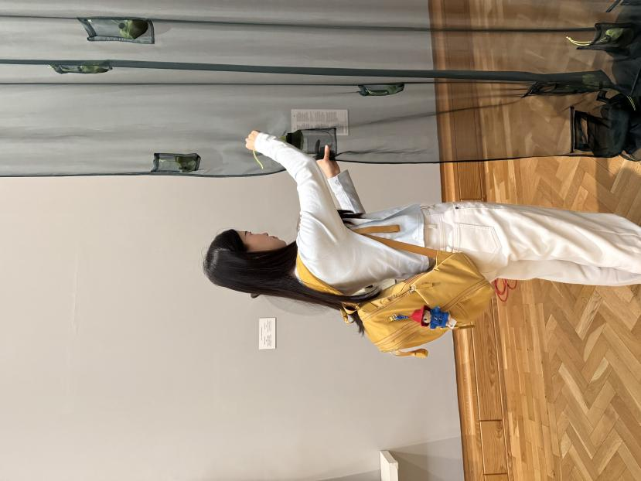
Figure 1, visiting the Bristol Museum, picture from the author
Meanwhile, during my visit to the exhibition "Bristol Art School (1810-1840)" held at the Bristol Museum, I noticed that the museum had planned a special project where contemporary art groups from the Bristol community were asked to create modern responses to the original works and display them side by side [5]. The original painters of the "Bristol School" focused on issues such as the natural environment and social inequality in the 19th century [5]; the museum invited the contemporary groups to respond to these themes in any style [5], thus creating a dialogue across time and space in the exhibition hall. Next to a Francis Danby landscape painting, modern community artists responded to it using collage, graffiti, etc., and this scene not only allows one to experience the collision of tradition and modernity but also increases the possibility for the audience (me) to directly participate in the interpretation of the classic. This curatorial concept inspired me to try to introduce modular creative methods in my own practice, encouraging participants to re-create the works, to achieve the synchronous evolution of creative thinking and practice. And when observing the oil paintings of the Bristol Art School from 1810 to 1840 in the Bristol Museum, I noticed that the brushstrokes were very similar to those of Chinese landscape paintings. I noticed that these British painters' expressions of nature had a deep visual commonality with Chinese landscape paintings in terms of brushstroke rhythm, composition logic and spatial atmosphere. This unintended "Oriental temperament" made me reflect: landscape images are not inherent national identifiers, but a visual language that can be recognised and freely constructed by different cultures. This directly inspired me to modularise and collage the landscape images in the screen installation, and guide the audience to think about "what is the attribution of the image" and "whether cultural identity can be jointly defined" during the participation behaviour.
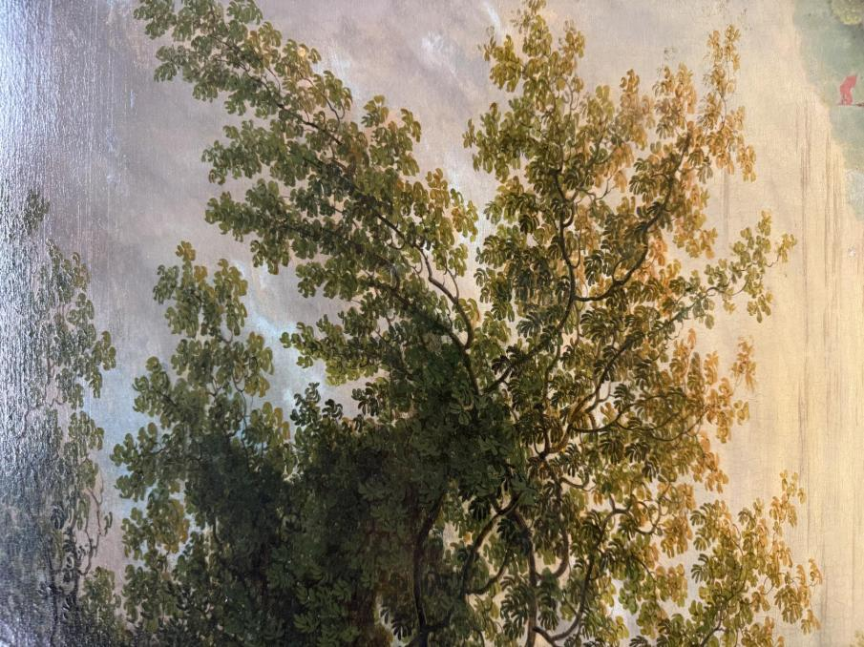
Figure2, a painting from the Bristol Art School (1810-1840), photographed by the author
During the creative process, I continuously incorporated my experience of visiting art exhibitions into my theoretical thinking. In the participatory experience of the public art project "The World Reimagined", we can see that 103 art globes covering cities across the UK present the history of the Atlantic slave trade through visual art [6][7]. Visitors stroll along the city streets, obtain the stories behind each globe by scanning QR codes, and deeply participate in this public narrative process of "reimagining the world" [8]. As one of the project's initiators, Yinka Shonibare, pointed out, art is the best way to communicate complex emotional themes - "Through art, you can explore multiple dimensions, including culture, history and discussion... It provides an excellent platform for public participation" [9]. This experience prompted me to reflect: Can traditional Chinese painting convey richer meaning levels in the contemporary era through the active participation of the audience? The creative practice thus gradually shifted to focusing on audience interaction, regarding their feedback and behaviors as part of the extension of creative thinking. Through continuous exhibition visits, literature research and practical attempts, my creative concept achieved dynamic development, that is, the creative thinking was tested and deepened in practice, and the practice process in turn stimulated new ideas, and both improved simultaneously.
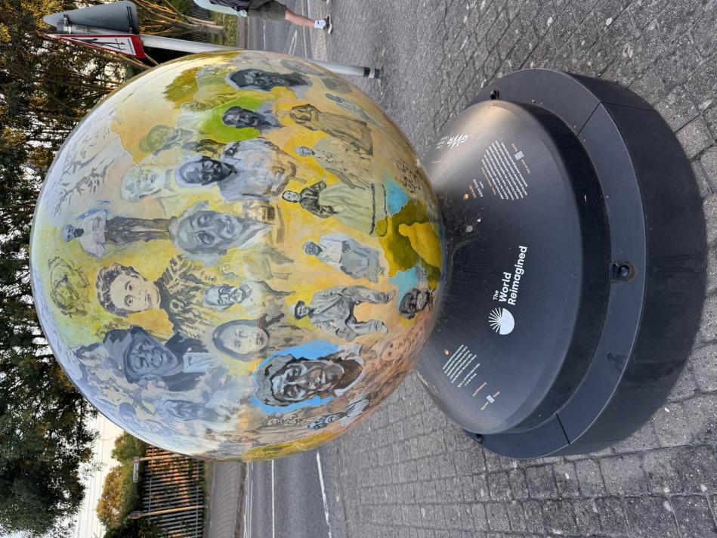

Figure3, the public art project "The World Reimagined", photographed by the author
The Connection between Theory and Reflection: Viewing, Participating and Identity Formation
At the theoretical level, the concepts of "viewing" and "participating" are crucial for understanding the transformation of aesthetic reception. John Berger pointed out in "The Viewing of Things" that seemingly neutral viewing behaviour is actually constrained by the cultural context and the viewer's identity (Berger, 1972). Traditionally, the appreciation of Chinese paintings emphasised the viewer's quiet contemplation, "lying in the mountains and rivers," and entering the aesthetic realm of the work through viewing. However, contemporary art emphasises the viewer's participation and co-creation of meaning. As Duchamp discussed in "The Act of Creation", artists are no longer regarded as the sole genius creators; the viewer's construction of the meaning of the work is equally indispensable (Duchamp, 1957).
As viewers transition from being "viewers" to "participants", their identity also transforms. When viewers participate in the artistic creation, they change from passive observers to active participants in the artistic process. This point is fully discussed in the theory of participatory art. The theorist Lori Waxman emphasises that when viewers directly participate in the work, they should no longer be simply called viewers but rather collaborators of the artist [10]. Zhou Na (2023) also found in her empirical study on the participation level of art museums that enhancing the participation of viewers can significantly enhance the richness and depth of the artistic experience [11]. The high participation of viewers can enable them to deeply understand and perceive the artwork, thereby personalising the experience [11]. This indicates that the identity of the viewers has transcended the traditional aesthetic object and has become one of the entities that create meaning.
When I visited the reconstructed work of Marcel Duchamp's "Large Glass" (i.e., "The Bride Even Was Pulled Naked by Bachelors") at Tate Britain, I had an intuitive understanding of the concept of "viewing as creating". This translucent glass installation allows viewers to "see through" the work and even see the space on the opposite side, suggesting the significant role of the viewer's perspective in the completion of the work. This work and its theoretical proposition by Duchamp illustrate how viewers "come into contact with the external world with the work... and add contributions to the creative act" (Duchamp, 1957) [1]. Therefore, in contemporary discussions on the aesthetic reception of Chinese painting, we must consider viewers as active meaning constructors. Their cultural background, identity, and depth of participation jointly influence the interpretation of the work.
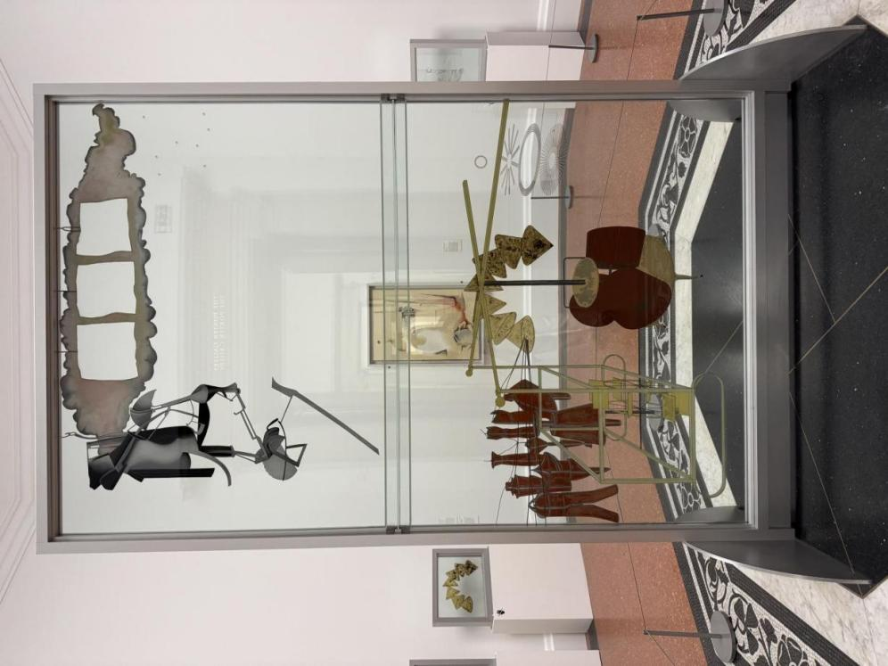

Figure 4, the Large Glass, photographed by the author
Identity recognition is also an important aspect in the interaction between viewers and art. In the contemporary multicultural environment, viewers often participate in the works with their own identities and memories and give new interpretations to traditional images. For instance, British artist Adam Farah-Saad's installation work "Two traumatised young men connect while wandering through the city of London, helping each other to survive..." (THE INNER CHILDREN MIX) (2023) incorporates the artist's personal identity and urban subcultural experience. This work is composed of wall-mounted bars, wind chimes, and medicine bottles, symbolising images such as urban wandering, gay nightlife, and trauma healing. According to the Tate Gallery, this wind chime sculpture utilises fitness equipment and club culture objects to visualise the artist's inner childhood emotions [12]. When viewers watch, it is difficult for them to merely appreciate the work based on traditional "formal beauty", but they are instead drawn into empathy and association with the identities of urban youth and traumatic memories. For viewers with similar identity backgrounds, this viewing is the confirmation and healing of their own identities; while for viewers from different backgrounds, it is an experience of understanding others' identities through art. It can be seen that contemporary art, through the participation of viewers, integrates identity recognition into the aesthetic acceptance process, expanding the traditional Chinese painting mode of expressing personality through poetic landscapes. Viewers no longer merely appreciate the situation of the other person in the painting, but have a dialogue with the work based on their own identities, achieving a dual resonance of aesthetics and identity.生对话，实现审美与认同的双重共鸣。
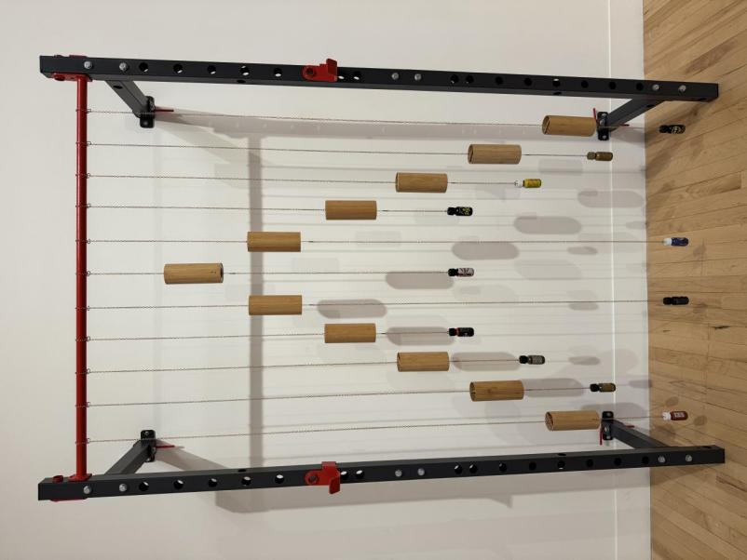
Figure 5, THE INNER CHILDREN MIX, photographed by the author

Work Form and Interactive Structure: Mirror Surface, Landscape Painting and Collage Blocks
In the contemporary context, the innovation in the acceptance of Chinese painting aesthetics is largely reflected in the changes of the form and interaction structure of the works. My practical research is carried out through the form of "screen installation", combining mirror surfaces, traditional landscape paintings with reconfigurable collage modules, aiming to create an interactive aesthetic space where the audience can participate and co-create.
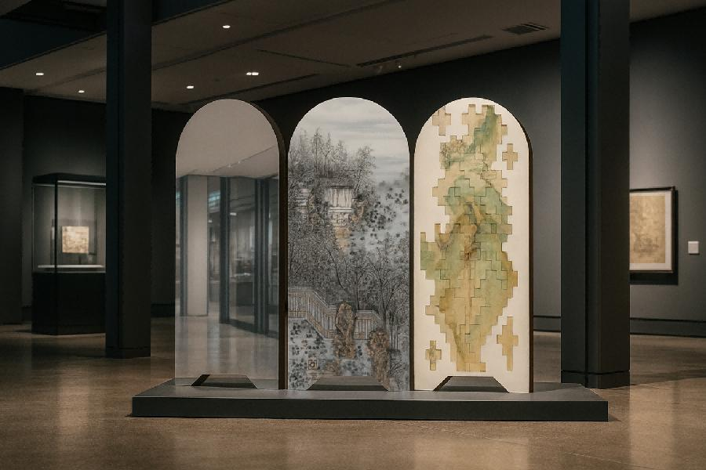
Figure 6, the display effect design, created by the author
My three-panel screen installation. The left panel is made of black mirror-like stainless steel, which can reflect the viewer's figure and directly lead the viewer into the work space; the central panel presents a traditional landscape painting scene of personal paintings; the right panel is composed of several detachable and reconfigurable landscape image modules, allowing the viewer to freely move and assemble the modules to create a landscape. This installation combines mirror reflection and image reconstruction, inviting the viewer to interact during the viewing process.
The screen installation depicted in the figure integrates traditional and contemporary elements. Firstly, the use of mirror materials enables viewers to see their own figures superimposed with the picture while appreciating the work, creating a "participatory viewing" experience. The reflective effect of the mirror screen breaks the boundary between the viewer and the work: the viewer not only views the scene on the screen but also sees their own existence in the mirror. In traditional aesthetics, paintings are often regarded as a window or mirror for viewing, allowing viewers to understand the other's world through the picture. Here, the mirror truly becomes a mirror, incorporating the viewer's real image into the artistic space. This design, on the one hand, echoes the concept of "observing the heart" in Chinese painting, and on the other hand, physically prompts the viewer to realise their own subjectivity. Every movement and angle change of the viewer will generate new visual effects on the mirror surface, so they participate in the dynamic presentation of the installation while viewing. Secondly, the landscape painting scene in the middle screen reflects an answer to Chinese traditional aesthetics. Choosing landscape paintings aims to evoke the artistic conception of traditional literati paintings: the beauty of mountains and waters provides a spiritual refuge. However, instead of appearing in the form of scrolls or vertical paintings, they are incorporated into the screen installation. This medium transformation is itself an innovative response to tradition. Wu Hong pointed out that screens have a "trinity" identity in the history of Chinese art: they are both a painting medium, an independent object, and a quasi-architectural component for constructing space [13]. In my own creation, the screen carrier enables landscape paintings to transcend the limitations of flat hanging scrolls and become a spatial existence that viewers can walk around and appreciate closely. The 2019 "Screen: Tradition and Future" special exhibition at the Suzhou Museum emphasised that screens integrate objects, images, and space, rejuvenating new life in the connection between the past and the present [14][15]. Drawing on this concept, I present landscape paintings in the form of a screen, not only preserving the poetic images of traditional landscapes but also giving them a spatial dimension, allowing viewers to "step into" the landscape scenario and achieve a dual immersion of the body and vision.
Finally, the right screen is composed of collage modules, embodying an interactive, participatory structure. The modular landscape image fragments can be manually moved and recombined by the audience on-site, similar to an open jigsaw puzzle or scroll painting. Each audience member can arrange the modules according to their own understanding, thereby "co-creating" their own landscape image. This design implies the deconstruction and reconstruction of traditional images: landscape paintings are no longer a static work finalised by the artist in a one-way manner, but a dynamic process that the audience can participate in and recreate. This interaction is not only game-like but also guides the viewers to think: the generation of the landscape can have multiple paths, and how can tradition and personal experience merge to create new images? Just as someone commented on contemporary landscape installation art, viewers engage in physical interaction with the work, and traditional landscape art has gained a new lease of life in the contemporary era through this interaction [16]. Each viewer's collage action transforms them from an appreciator to a creator, and the "atmosphere" of traditional landscape paintings is constantly redefined in this process.
Through the combination of mirror reflection, landscape imagery, and collage interaction, my screen installation explores new possibilities for the acceptance of Chinese painting aesthetics. Viewers in front of the work can not only gaze at the beauty of traditional landscape paintings but also establish a connection with the work through the mirror image, and can actually physically change the parts of the work. These design elements in the form of the work fully embody the concept of "from viewing to co-creation": the viewing behaviour of the audience is integrated into the creative mechanism, and the aesthetic experience is jointly completed by the artist and the viewer.

On-site Feedback and Audience Experience Survey
In the practical research, I attached great importance to collecting on-site feedback and audience experiences in order to evaluate the impact of audience participation on the aesthetic acceptance effect. Through on-site observation, simple conversations, and designing questionnaires, I obtained audience feedback. Due to the exhibition taking place during the summer vacation, there were fewer on-site audiences, and the number of recoverable questionnaire responses was insufficient. Therefore, I adopted on-site observation and conversation as the main survey methods, with a qualitative approach. The on-site feedback revealed some notable phenomena. On one hand, not all audiences were accustomed to "touching" the works in the artistic context. A few older audiences, during the interviews, expressed that at first they didn't believe they could physically alter the artworks. The audience also expressed that they felt for the first time their presence in the artworks. They also believed that in traditional concepts, "touching artworks" was taboo. With my encouragement, they attempted to participate and found that this experience was very unique. On the other hand, some young audiences naturally engaged in the interaction, even inviting friends to watch together, and then taking photos in front of the mirror. This suggests that when promoting interactive art, we need to consider the psychological barriers and motivation mechanisms of different audience groups. By guiding to lower the threshold, setting prompts in prominent locations at the exhibition site, clearly inviting audiences to touch and interact, and arranging guide personnel to demonstrate, we can create an atmosphere that encourages participation.
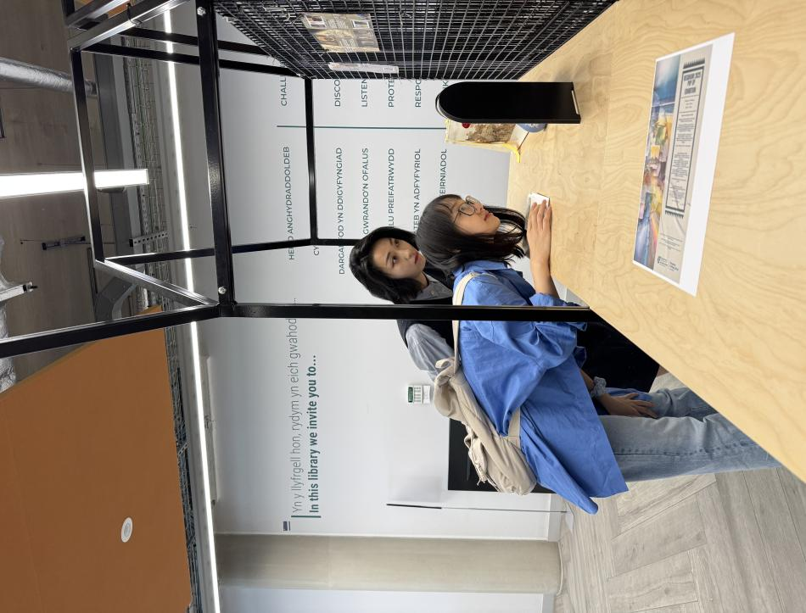
Figure 7, the on-site display, photographed by the author

It is worth noting that intense immersive interaction can also lead to strong sensory and emotional reactions. When observing Mona Hatoum's "Current Disturbance" (1996) installation at the Tate Britain Museum, I learned that this work, with its constantly flashing lights and humming current sounds, had caused discomfort among some audience members and staff [17][18]. This room installation composed of overlapping metal mesh cages and bulbs creates a "dreadful yet fascinating spectacle", creating a highly tense sensory experience through the combination of sound and light [19][20]. Some exhibition guards reported experiencing physiological reactions such as anxiety and tinnitus when looking after this work for a long time [21]. This indicates that interaction and immersion are not purely positive experiences. Excessive intense sensory stimulation may lead to negative feedback. Therefore, when designing interactive art, especially installations involving sound and light effects, it is necessary to balance the stimulation with comfort and provide appropriate buffering measures (such as providing earplugs, as Hatoum did during her exhibition [18]). Although my screen installation does not involve strong light or sound, this case still provokes deep reflection: If multiple sensory elements are introduced into the works in the future, they should be carefully tested for their impact on the audience's physical and mental health, ensuring that the interactive experience generates aesthetic pleasure and thought within a controllable range, rather than causing discomfort.
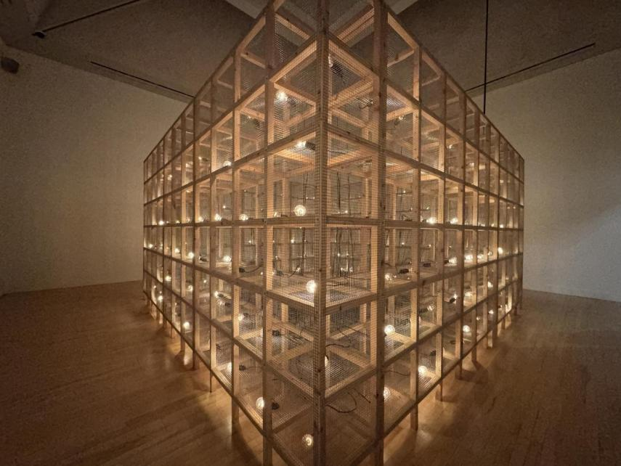
Figure 8, Current Disturbance, photographed by the author

Overall, the on-site feedback and audience surveys supported the view that an increase in audience participation significantly enhanced the depth of aesthetic acceptance. Interactive displays of Chinese paintings can stimulate the creativity and self-awareness of the audience, enabling them to invest their emotions and intellect in the aesthetic process, thereby achieving a richer experience. However, successful participatory art must fully consider the needs and reactions of different audience groups and carefully design interactive methods to achieve a "subtle and imperceptible" effect. In terms of the research methods, the audience feedback itself has also become a part of the research results: the expressions and behaviors of the audience are not only a re-creation of the work but also provide valuable materials for us to understand "co-creation".

Response and Challenge to Tradition: Landscape and Screens
The contemporary art's response to tradition often manifests as a posture that both inherits the essence and boldly innovates. Regarding traditional landscape paintings in Chinese painting and the "screen" art of Yuan Dynasty paintings, my practice and reflection have all suggested various new possibilities and challenges in the contemporary context.
The screen, as a special carrier of Chinese painting, has been re-examined and utilized in the contemporary era. The traditional screen not only has practical functions but also carries paintings. It was widely used in court and literati spaces throughout history. Its multi-faceted expansion and spatial partitioning characteristics make it a medium for interaction between people and paintings, different from scrolls. When viewing the exhibition of the ancient Chinese painting "The Lady Shizhen Scroll" at the British Museum, I deeply realized the significant impact of the display medium on the acceptance of the work. The original "Lady Shizhen Scroll" was a handscroll by the Eastern Jin Dynasty's Gu Kaizhi, but in the British Museum, due to protection needs, this Tang Dynasty copy was divided and mounted on several vertical panels for display [24]. A handscroll that needs to be held and read while unfolding has been transformed into a form similar to a screen or a flat display of a long scroll in a showcase. This structural change greatly affects the viewing method of the viewer. As Wu Hong said, "Handscrolls have temporality and require the viewer to manipulate with their hands to gradually unfold." While screens are spatial, the pictures are presented simultaneously, allowing multiple people to appreciate from different perspectives. The British Museum's approach was an inevitable protective measure, but it also hinted that contemporary displays could try screen-like or digital means to compensate for the limitations of traditional scrolls in museum contexts. In fact, museums have also provided electronic screens in the exhibition halls for year-round browsing of the entire scroll [26]. Thus, the challenges for contemporary art towards traditional carriers often arise from practicality and dissemination considerations, while also bringing about new forms of acceptance. My choice of the screen as a creative medium is inspired by such cases: This ancient form of screen, in the modern exhibition environment, actually has certain advantages - it retains the Eastern charm and conforms to contemporary spatial aesthetics, and can be displayed for a long time in public places without damaging the cultural relics. More importantly, screens inherently have the meaning of an interactive space. Viewers can walk around, view from multiple angles, which coincides with the concept of contemporary interactive art: The screen transcends time and is both traditional and future-oriented. Its media characteristics continue to play a role in contemporary art [14][15].
Of course, the response and challenge to tradition are not without contradictions. Innovation and inheritance require a balance. When artists draw on traditional elements, they must avoid superficial symbolization and prevent excessive embellishment from losing the traditional charm. For instance, some contemporary landscape installations overly focus on technological spectacle, which may cause viewers to overlook the spiritual essence of the landscape. This is something that needs to be guarded against; another example is that converting handscrolls into screens for exhibition is convenient, but it sacrifices the intimate experience of reading the scroll alone with the work (Wu, 2011). Therefore, every innovative response to tradition should be accompanied by reflection and refinement of the traditional aesthetic spirit, rather than merely a form transplant. In my practice, I have realized that the best way to respond to tradition is not simply to复古 or abandon it， but to transform it using contemporary language based on a profound understanding of the traditional aesthetic value. This transformation may be reflected in changes in medium and structure， or the reconfiguration of the relationship with the audience， but the ultimate goal should be to enable traditional art to regain its meaning in a new context and truly resonate with contemporary audiences.

Reflection on the Methods of Practical Research
Through the above practices and research, I have deeply reflected on the methods of artistic practice research. During the process of simultaneously advancing creation and research, how to effectively connect the practical output with theoretical discoveries is a topic that practical researchers must confront. This study adopted the methodological path of "reflective practice", on the one hand, taking one's own creative practice as the research object, and on the other hand, using the observations seen during visits and theoretical literature to examine the practice, extracting valuable artistic concepts from it.
Firstly, in the practical actions of designing screen installations and organising audience interactions, I continually evaluated my artistic intentions and their effects. For example, after the initial exhibition of the screen installation, I immediately recorded field observation notes, including the time the audience spent gazing at different modules, the frequency of interaction, and facial reactions. These first-hand data became the basis for reflecting on the effectiveness of the interactive mechanism of the work. Subsequently, by referring to participatory art theory, I gained a deeper understanding of why certain parts of the work successfully mobilised the audience, while others were relatively indifferent. Comparing theory with observation helps to discover the hidden factors in practice. For example, theoretically emphasising "creating context" (context creation) is reflected in practice as the need to provide the audience with clear hints and motivations. This was verified through this study. Following my guidance and explanation, the audience participation rate increased significantly. This cycle of identifying problems in action, immediately adjusting, and then re-practising is the core of the reflective practice method.
Secondly, practical research should emphasise the integration of a multi-disciplinary perspective and various methods. This project involves issues in the fields of art, aesthetics, museology, and even sociology. Therefore, during the research process, multiple sources of data and analytical methods were adopted. For instance, when grasping the psychology of the audience, references were made to studies in psychology regarding curiosity and participation behaviour; to analyse the effect of interactive design, the assessment framework of museum education was drawn upon; and at the level of aesthetic theory, viewpoints from Western reception aesthetics and traditional Chinese perception theory were combined. This cross-disciplinary perspective makes the research conclusions more comprehensive and robust. Additionally, in terms of methodology, both qualitative and quantitative approaches are employed, involving both qualitative analysis of audience interviews and quantitative results from questionnaire statistics. This mixed method ensures that the description of practical phenomena is both vivid and well-grounded.
Furthermore, the positioning of the researcher's subjectivity is also worth discussing. Practical researchers simultaneously assume the dual identities of artist and researcher. Their subjective experience is both creative motivation and research material. This study fully utilised the advantage of my being a "first-hand witness": my experience of observing art exhibitions in the UK not only recorded the information about the exhibits but also recorded my emotions and thoughts at that time. These contents later became one of the materials for analysing the practice.
Finally, through this research, I have come to realise the openness of practice and the continuity of research. The practice of art research does not come to an end once the works are exhibited or the papers are completed. Every new piece of feedback from the audience, every re-exhibition in a different venue, may give new meanings to the works and thereby trigger new research questions. For instance, if the screen installation is brought back to China for exhibition, will the conclusions of this research still hold? Or what changes will occur in the audience’s experience after introducing digital interactive technology? These questions will be left for future exploration.

Future Research Direction
This study initially explored the transformation of the aesthetic reception of Chinese painting from viewing to co-creation in the contemporary context and verified through practice the positive effect of audience participation on deepening the aesthetic experience. In future work, I plan to further expand and deepen this topic. Firstly, I will broaden the research subjects and scenarios. This study primarily focuses on landscape painting themes and screen forms; however, Chinese painting encompasses a rich array of themes and media that have yet to be explored. For example, how will figure paintings and flower-and-bird paintings be presented in interactive displays? Can calligraphy and seal engraving, etc., be introduced for audience co-creation? Future experiments can select different types of traditional Chinese art as experimental subjects, design corresponding interactive forms, and observe audience reactions. Scenarios will not be limited to art galleries and museums, but can bring interactive art into public spaces and even natural environments. For instance, setting interactive digital landscape projections in outdoor landscapes and allowing pedestrians to participate in creation spontaneously will push the research into the field of public art, testing the aesthetic reception of a wider public.
Secondly, it needs to be analysed further the impact of audience participation on aesthetic value. This study focuses on the depth and interest of audience experience, but has not fully discussed the impact of audience co-creation on the aesthetic value of the work itself. When the audience becomes co-creators, how is the artistic quality of the work evaluated? The changes made by the audience may enhance or weaken the aesthetic appeal of the work, which involves the issue of the subjective and objective boundaries of aesthetic evaluation. Future research will attempt to introduce aesthetic evaluation indicators, compare the differences in presentation when there is or is not audience participation, and invite art critics to view the original works and the audience-modified works separately, to provide evaluations and thereby explore the impact of co-creation on artistic quality. This is crucial for balancing the control of artists' creation and the freedom of the audience. At the same time, as technology and traditional experiences are balanced, the development of AR/VR (augmented reality/virtual reality), AI, and other innovations will enable art interaction to take on more diverse forms. Future work can attempt to apply AR technology to traditional painting exhibitions, allowing viewers to see the three-dimensional landscapes extended from the paintings through mobile phones or AR glasses, and even interact with virtual characters. However, technology is not better, and attention should be paid to its impact on traditional aesthetic conceptions. For example, landscape paintings emphasise "feasibility and possibility"; overly realistic three-dimensional modelling may instead destroy the space for imagination. Therefore, future research will strive to find the best balance point between the integration of technology and traditional artistic conception. Perhaps a "adaptive" system can be developed, adjusting the intensity of interactive feedback according to the audience's engagement level, ensuring that deep participants have sufficient fresh experiences while still allowing casual viewers to appreciate the beauty of traditional art. This direction integrates engineering, human-computer interaction, and aesthetics, presenting high challenges and innovative significance.
Finally, a cross-cultural comparative study is conducted. The aesthetic reception of Chinese painting may present different emphases in different cultural contexts. In the future, the findings of this study in the Western context can be compared with those in the Eastern (especially Chinese native) context. For instance, in the UK, the audience's exposure to Chinese landscapes is more of a cross-cultural experience, and their co-creation may focus more on the novelty and interaction itself. In contrast, in the Chinese native context, the audience is more familiar with the spiritual connotations of landscapes, and the interaction may have a stronger cultural emotional projection. Through a comparative study of similar interactive installations exhibited in both China and the UK, the influence of cultural background on the "viewing and co-creation" process can be revealed. This is of practical significance for promoting China's excellent traditional culture and enhancing cultural exchanges between China and the West.
Due to space limitations in this exhibition, only a scaled-down screen model can be presented offline. It is difficult to fully verify the spatial narrative and group co-creation mechanism that the works rely on, which are based on "walkable, panoramic, and interactive" spaces. The key to the screen is the rhythm and relationship generated by the audience's transformation at different angles and distances, while the scale compression of the model and the limited number of visitors make it difficult for the gaze and interaction facing the entire mirror to occur. Due to the limited space, the magnetic attraction modules cannot be deployed in sufficient quantities, and there are significant differences in material texture and pre-designed design, resulting in the compression of the "strategic space" for collage, thereby weakening the empirical verification of this study. The online video concept explanation has improved the information density, but its conceptual explanation, to some extent, pre-establishes the understanding framework, making the audience return to a passive acceptance, and weakening the open-ended interactive experience. At this stage, the data mainly consist of on-site observations and a small number of questionnaires. The sample size is small and lacks a control group, making it difficult to support robust causal inference. Overall, this exhibition has verified the usability of the core concepts and interface design; however, in terms of spatial scale, concurrent participation, and social interaction density, it still falls short of supporting a strong causal argument. In the future, a full-size tri-screen wall, sufficient magnetic attraction modules, and layered guidance should be set up, as well as additional basic conditions and a sufficient sample size, to systematically test the research topic of this art installation on the aesthetic reception, identity recognition, and meaning co-creation of contemporary Chinese painting under real audience density.

Conclusion
From observation to co-creation, this represents the transformation of the role of the audience in contemporary art aesthetics. For Chinese painting, this transformation reflects the regeneration and activation of traditional art in modern society. The audience is no longer just a passive observer but has become a co-creator of meaning. In my practical research, screen installation can deepen the audience's aesthetic experience and give new interpretations to traditional themes; through the investigation of several projects in British museums, we have confirmed the common trend in the international art community regarding audience interaction. This indicates that the contemporary acceptance of Chinese painting aesthetics is not about adhering to established methods or simply imitating the past, but about continuous innovation in concepts, forms, and mechanisms to respond to the spiritual needs of contemporary audiences.
Of course， "co-creation" does not mean denying the professional creativity of artists； rather， it calls for a new balance relationship - artists build platforms and frameworks， while the audience carry out secondary creation within them， and both jointly complete the "creative behavior" of art， further confirming Duchamp's view： the "dual poles" of creation and the viewer jointly constitute the complete circuit of art [1][27]. This concept becomes more feasible with the progress of technology and ideas in today's world. In the future， we can expect more diverse interactive art forms， allowing the aesthetic wisdom of Chinese painting to be passed down and renewed through dialogue and co-creation.
Bibliography
- Berger, J. (1972) Ways of Seeing. London: Penguin Books. [28][29]
- Bishop, C. (2012) Artificial Hells: Participatory Art and the Politics of Spectatorship. London: Verso.
- Bao, Y., Yang, T., Lin, X., Fang, Y., Wang, Y., Pöppel, E. & Lei, Q. (2016) "Aesthetic Preferences for Eastern and Western Traditional Visual Art: Identity Matters", Frontiers in psychology, vol. 7, pp. 1596-1596.
- Bourriaud, N. (2002) Relational Aesthetics. Dijon: Les Presses du Réel.
- "Considering AI-Generated Paintings as Artworks in the EU for the Purposes of Museum Exhibitions", 2024, Samart'ali da Msop'lio, pp. 107-116.
- Duchamp, M. (1957) ‘The Creative Act’. Art News, 56(4), pp. 28–29.[1]
- Thiel, S. & Bernhardt, J.C. (2024) AI in museums: reflections, perspectives and applications, Transcript Verlag, Bielefeld.
- Tu, D. (2020) "Identity and Citizenship in Hong Kong: A Theoretical Reflection Using Chinese Landscape Painting", Chinese education and society, vol. 53, no. 1-2, pp. 47-56.
- Mak-Schram, S. (2025) To Shift a Stone [Exhibition]. National Museum Cardiff, Wales. [2][4]
- Maksimova, A.(2025) "Negotiation of dominant AI narratives in museum exhibitions", AI & society, vol. 40, no. 5, pp. 3813-3826.
- Wang Dajie de Shenghuo Ganyu Jilu (2023) ‘Chinese Ancient Screens and Paintings: Viewing Painted Screens also as Plain Screens’, Sohu, 31 May. Available at: https://www.sohu.com/a/680890998_121123778 (Accessed: 5 September 2025).
- Shiguang Yiqu (2025) ‘Shanshui Action Shocks! New Media Image Installation Art Exhibition Opens in Hangzhou’, Sohu, 8 August. Available at: https://www.sohu.com/a/922230892_122387568 (Accessed: 5 September 2025).
- Shonibare, Y. (2022) “The World Reimagined revisits the history... through art”, Wallpaper (online), 18 Nov 2022[9].
- Whitechapel Gallery (2010) Keeping it Real: Act 3 – Current Disturbance [Exhibition text]. London: Whitechapel Gallery[19][20].
- Wu, H. (Wu Hong) (2021) Wu Hui Tong Yuan: Zhongguo gudai de ping yu hua (Origin of Painting and Embroidery: Ancient Chinese Painting and Embroidery). Beijing: Shenghua Shūshu Xinzhi Sanli Bookstore. [13][14]
- Yeğinsü, İ. (2025)"The impact of Artificial Intelligence on the “curator-as-artist”: revisiting Ventzislavov’s concept in two cases of AI-based curating", AI & society.
- Yang, R., Yang, H., Zhao, M., Jia, R., Wu, X. & Zhang, Y.(2024) "Special perceptual parsing for Chinese landscape painting scene understanding: a semantic segmentation approach", Neural computing & applications, vol. 36, no. 10, pp. 5231-5249.
- Zheng Linjia (2009) "When Viewers Become Co-creators: Exploring the Significance of Participatory Art Creation (1990-2009)", Master's Thesis, Institute of Art History, National Taipei University of the Arts.
- Zhou Na (2023) "Research on the Impact of Visitor Engagement on the Visiting Experience in Museums", Educational Science Theory, 1(2), pp. 39—46 [11].
Notes

- [1] [27] On “The Creative Act” | Toutfait Marcel Duchamp Online journal
- https://www.toutfait.com/on-the-creative-act/
- [2] [3] [4] Sophie Mak-Schram and collaborators: To Shift a Stone
- https://museum.wales/cardiff/whatson/12600/Sophie-Mak-Schram-and-collaborators-To-Shift-a-Stone/
- [5] Reflections on the Bristol School - Reflections on the Bristol School
- https://exhibitions.bristolmuseums.org.uk/reflections-bristol-school/
- [6] [7] [8] [9] The World Reimagined creates a bridge to complex histories | Wallpaper*
- https://www.wallpaper.com/art/the-world-reimagined-yinka-shonibare-ashley-shaw-scott-adjaye
- [10] map.tfam.museum
- https://map.tfam.museum/storage/files/shares/MA/MA177/MA0177_05.pdf
- [11] (PDF) 美术馆参观者的参与度对参观体验的影响研究A Study on the Impact of Visitor Engagement in Art Museums on the Visiting Experience
- https://www.researchgate.net/publication/394139567_meishuguancanguanzhedecanyududuicanguantiyandeyingxiangyanjiu
- [12] Public | Adam Farah-Saad's work is now on view at Tate Britain as ...
- https://www.instagram.com/p/DB9ZvrEu42o/
- [13] [14] [15] 巫鸿主编《物绘同源：中国古代的屏与画》_画屏Wu Hong edited the book "Material and Painting: The Origin of Screens and Paintings in Ancient China" - Picture Screen
- https://www.sohu.com/a/461284667_638531
- [16] [22] 山水行动震撼来袭！新媒体影像装置艺术展杭州开展_展览_文化_观众The "Water and Mountain" project is coming with a bang! The new media video installation art exhibition has opened in Hangzhou - Exhibition - Culture – Audience
- https://m.sohu.com/a/922230892_122387568/?pvid=000115_3w_a
- [17] [18] [21] Captivated and Repelled: Invigilating with Mona Hatoum’s Current Disturbance – Roisin Dunnett — Doris Press
- https://www.doris.press/blog/rosie-dunnett-t4asz
- [19] [20] Exhibition - Keeping it Real- Whitechapel Gallery
- https://www.whitechapelgallery.org/exhibitions/keeping-it-real-an-exhibition-in-4-acts-act-3-current-disturbance/
- [23] 「張光賓《江山無盡》多媒體互動展」再現焦墨筆意中的山水語境"Zhang Guangbin's 'Infinite Landscapes' Multimedia Interactive Exhibition" Re-creates the Landscape Context in the Style of Graphite Sketching
- https://artouch.com/art-views/art-exhibition/content-54004.html
- [24] [26] Admonitions of the instructress to the court ladies | British Museum
- https://www.britishmuseum.org/exhibitions/admonitions-instructress-court-ladies
- [25] 巫鸿：中国美术史研究的方法Wu Hong: Methods of Research in Chinese Art History
- http://www.ihss.pku.edu.cn/templates/zs_ft/index.aspx?nodeid=151&page=ContentPage&contentid=1304
- [28] [29] “A work of Art is completed by the Viewer” – Nadezda's Learning Blog
- https://traunfelgasse.wordpress.com/2015/05/25/a-work-of-art-is-completed-by-the-viewer/

