BMIH6006
Student ID:2243006
Student Name: Cristina Croitoru
Lecturer Name: Ben Ka Po Chong

Hotel Placement Research Project
Case Study: Novotel Hotel In Wembley
AN INVESTIGATION ON OPERATIONAL EFFECTIVENESS OF HOSPITALITY DEPARTMENT

Declaration
I confirm that this research project has been prepared, drafted, and finished completely and solely under my independent effort and without any use of artificial intelligence software, automated systems, and third-party writing tools.

Acknowledgement
I would like to considerably express my gratitude to everybody who helped me in the process of completing this research project. I would like to thank my module tutors and academic supervisors who would guide me, give me important feedback and support me in every phase of the research process.
I also want to thank the employees of Novotel Hotel in Wembley because they gave me a chance to observe and learn about the housekeeping processes during my placement. Their collaboration and the desire to exchange professional knowledge helped a lot to develop this study.
And lastly, I would like to sincerely thank my family, friends, and colleagues who were always encouraging, patient, and supportive, which is why I managed to complete this piece of work successfully.

I confirm that I have not presented any AI generated text as my own work. I confirm I have copies of my drafts, notes, and other resources I used before, and after the use of AI tools which I may be asked to provide in evidence.

Abstract
Aim
The research aims to critically analyse the effectiveness of the hospitality department of Novotel Hotel in the WEMBLEY for managing quality, efficiency, and guest satisfaction, which operates in an international hotel brand.
Objectives
- To analyse the roles and responsibilities of the hospitality department within Novotel Hotel in the WEMBLEY
- To determine the impact of front office service providers on managing service quality and improving guest satisfaction
- To use the PESTLE and SWOT frameworks for determining external and internal factors of the hospitality industry where Novotel Hotel operates
- To provide some recommendations for improving the hospitality services of Novotel Hotel using advanced technologies, providing employee training, and ensuring workload management
Literature
In Novotel's situation, appropriate personnel with inclusive training have been added to handle clients from a variety of backgrounds. Experts from the organization are there to maintain the cleanliness of the guest rooms and public places, and housekeeping management makes sure that these areas are hygienic and clean. The hospitality employees of a company are also in charge of the food and beverage areas, and at Novotel, they have received professional training that enables them to provide guests with high-quality food and drinks.
Methods
The organization needs to identify the front desk staff's research activities, and primary data collection is the only way to do this. Ten questions that are specific to the research's goal have been posed to each of the 20 Novotel employees that participated in the survey used to gather information for this study. For this study, a primary data collection strategy was employed, and information was gathered through the use of surveys. Only qualitative data that has undergone qualitative analysis is included in this kind of data collection.
Findings
Since front desk employees are the first to interact with guests and ensure guest stability and service quality throughout the organization, Novotel has provided them with appropriate training. In order to maintain service quality, front desk services determine each customer's needs and relay that information to other operational personnel. 54.8 million people, or 79% of the population, use social media in the UK. This is great for businesses operating in London because it allows them to advertise their new deals on social media platforms. Novotel faces competition in the UK from Premier Inn, Travelodge, Motel One, Holiday Inn, and other hotels, which poses a serious threat to the business.
Recommendation
Novotel employees were put in risk after a chemical leak occurred in one of the hotels' pools; 16 of them were admitted to the hospital after the chlorine leak, indicating a disregard for employee safety. By offering all staff safety training while working at the Novotel Hotel, the organization can effectively address this specific issue. This business sees a lot of traffic from both personnel and inbound tourists, so maintaining a safe environment is crucial to operational effectiveness.

Table of Contents
Chapter 1: Introduction 7
1.1 Background 7
1.2 Case Study Overview 8
1.3 Aim and Objective 8
1.4 Research Question 9
Chapter 2: Literature Review 9
2.1 Roles and responsibility of the hospitality department in Novotel hotel 9
2.2 Impact of front office service provider on managing guest stabilization and service quality 10
2.3 Application of Pestle and Swot framework for evaluating internal and external factors 10
2.4 Providing recommendation to the Novotel hotel in Wembley 13
Chapter 3: Methodology 14
3.1 Philosophy 14
3.2 Approach 14
3.3 Data Collection 15
3.4 Data Analysis 15
3.5 Ethical consideration 15
Chapter 4: Findings and Discussions 16
4.1 Findings 16
4.1.1 Presentation of Findings 16
4.1.2: Discussion on Findings 24
4.1.3 Strengths and Weaknesses of Findings 25
4.2 Discussion 26
4.2.1 Roles and Responsibilities and Departmental Coordination. 26
4.2.2 Guest Satisfaction and Front Office Service Performance. 26
4.2.3 Internal Operational Drivers: Workforce Planning, Training and leadership. 27
4.2.4 Operational Effectiveness Influences by the External Environment. 28
4.2.5 Strategic Implications and operational Improvement Priorities. 28
4.2.6 Combined Assessment of Operational Excellence. 29
Chapter 5: Conclusion and Recommendation 30
5.1 Conclusion 30
5.2 Recommendation 32
Reference list 35
Appendix: Questionnaire 39

Chapter 1: Introduction

1.1 Background
Operational efficiency particularly refers to the optimisation of business processes and resources for the purpose of reducing operational cost and maintaining suitable productivity (Gomstyn and Jonker, 2024). Hospitality departments can particularly achieve operational efficiency based on streamlining their operation, automating repetitive tasks, ensuring staff are happy and listening to the customers (Gomes, Yasin and Lisboa, 2017). This report is based on investigating the operational attributes adopted by Novotel Hotel in Wembley. As a part of operational efficiency, the hotel chain introduced a new booking approach to the travellers so that they can provide the best possible deals (Novotel, 2026). Due to such attributes, customers retain a company for long-term supporting revenue.
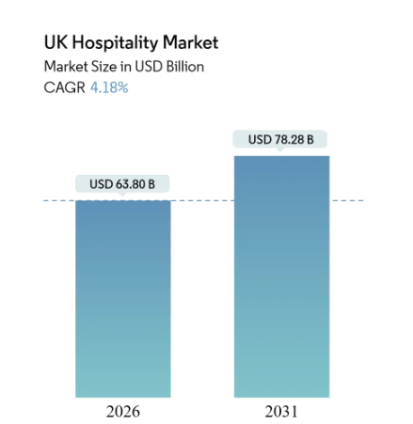
Figure 1.1: Hospitality Department in UK
(Source: Mordor Intelligence, 2025)
This particular figure indicated the hospitality sector revenue generation which is 63.80 billion USD in the UK and it will increase to 78.28 billion USD in 2031 (Mordor Intelligence, 2025). This revenue upliftment in the UK shows Novotel Wembley growth, thus improvement in operational excellence is significant for the company.

1.2 Case Study Overview
Novotel is an independent travel brand offering 100,000 hotels worldwide, this brand has been operating in over 200 plus countries and 2000 plus cities. Among all these branches in this report Novotel Hotel in Wembley has been considered in this case study. This organization provides best deals, perfect rooms, inclusive service and strict focus is kept in case of privacy (Novotel, 2026). This research particularly aims to identify the effectiveness of the hospitality department in this particular hotel which affects its operational efficiency. Even in this report both internal and external impact will be analysed that affect the operation of this particular hotel of Novotel.

1.3 Aim and Objective
Aim
The research aims to critically analyse the effectiveness of the hospitality department of Novotel Hotel in the WEMBLEY for managing quality, efficiency, and guest satisfaction, which operates in an international hotel brand.
Objectives
- To analyse the roles and responsibilities of the hospitality department within Novotel Hotel in the WEMBLEY
- To determine the impact of front office service providers on managing service quality and improving guest satisfaction
- To use the PESTLE and SWOT frameworks for determining external and internal factors of the hospitality industry where Novotel Hotel operates
- To provide some recommendations for improving the hospitality services of Novotel Hotel using advanced technologies, providing employee training, and ensuring workload management

1.4 Research Question
- What are the roles and responsibilities of the hospitality department within Novotel Hotel in Wembley?
- How is the front office service provider managing the service quality and improving guest satisfaction within the company?
- How to apply PESTLE and SWOT framework for analysing internal and external factors within the hospitality industry where Novotel hotel operates?
- What are the recommendations for improving the hospitality services of Novotel Hotel using advanced technologies, providing employee training, and ensuring workload management?

Chapter 2: Literature Review

2.1 Roles and responsibility of the hospitality department in Novotel hotel
As per roles and responsibility in the hospitality department, front office roles are very common which guides costumes with check-in and check-out, alongside complete event management (JBIHM, 2024). In the case of Novotel suitable staff has been included who have inclusive training so that customers from various backgrounds can be tackled. Housekeeping management ensures cleanliness, hygiene and maintenance of the guest room and public areas, experts within the company are also present which keeps the rooms and public area clean. Food and beverage areas are also controlled by the hospitality staff in a company and in Novotel they have professional training for which they are able to serve good quality foods and beverages for the customers (Accor, 2026). Novotel of Wembley includes suitable customer service employees; they take account of all sorts of customer complaints and maintain suitable guest relations within the organisation. The leading and development program has been also included within the company led by suitable trainers and this supports operational excellence across the company (Accor, 2025). Event and conference coordinators across the company know various languages which attract professional clients to arrange one.

2.2 Impact of front office service provider on managing guest stabilization and service quality
Novotel has included suitable training for the front office staff within the company as they are the first person to contact and maintain guest stabilisation and service quality across the company (Kumar, 2018). Front office services identify the requirements of all the customers and pass the information to other operating staff so that service quality is particularly retained (Lyfe Hotel, 2025). Even the front office staff are effective to maintain efficient check-in of the staff so that guest stabilization with the company is particularly retained. They are even responsible for handling complaints so that customer satisfaction is retained effectively.

2.3 Application of Pestle and Swot framework for evaluating internal and external factors
PESTLE Analysis
Factors | Description
Political | 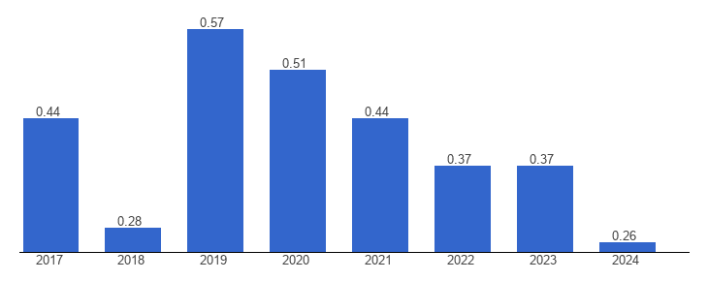  Figure 2.1: Political Stability Index of UK  (Source: The Global Economy, 2025)  This particular figure indicates about the political stability index of the UK which is 0.26 as per 2024 reflecting about less political tension within the country (The Global Economy, 2025). This is an ideal opportunity for the company Novotel to improve its service segment so that the company can reach the maximum number of customers at once. Even the company will be able to prioritize expansion strategy at least under political pressure.
Economic | 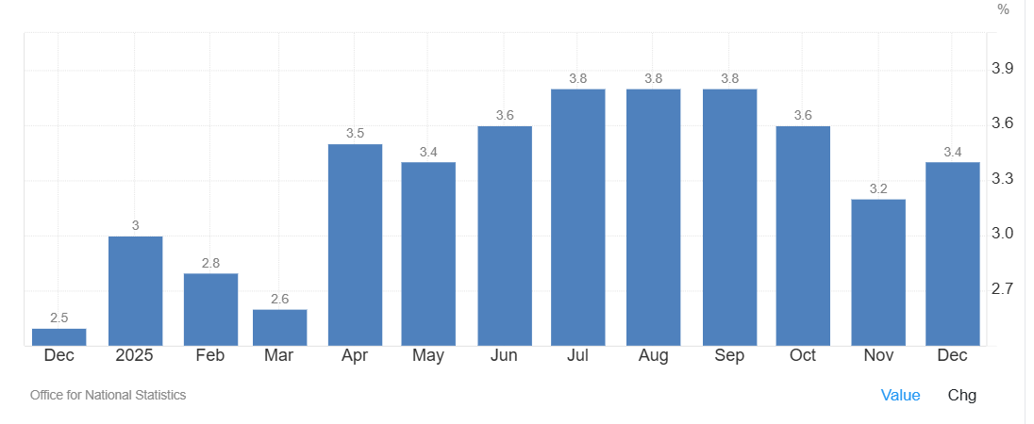  Figure 2.2: Inflation rate of UK  (Source: Trading Economics, 2025)  This figure shows the inflation rate of the UK which is 3.4% as per December, 2025 (Trading Economics, 2025). This inflation value was high up to 3.8 during August and fluctuation in the inflation value indicates an unstable market. Due to high inflation the price of raw materials, service and goods will be in the UK and it will affect the profit margin of Novotel in case of operation.
Social | The number of inbound tourists in the UK is 39 million as per 2024, representing growth of around 3% compared to 2023 (Statista Research Department, 2024). This particular factor is an opportunity for the company Novotel as it will get various international customers within the company. Evolving operational excellence in this particular branch will retain their choice in other nations also.
Technological | The technology innovation output ranking of the UK is 4th among all other countries, this indicates people are advanced in modern technology and they can make use of technology for bookings (WIPO, 2024). This is an opportunity for the company to include digital service such as self-check in and digital offering as customers can select.
Legal | The corporate taxation of the UK is 25% as per 1st April 2025, this fact denotes that companies have to pay 25% of their total revenue generation in this country (PWC, 2024). This is a factor of threat for the company as it will particularly reduce the profit margin of the company which affects the operational aspect of the company.
Environmental | The UK government has included an environmental act of 2021 which all the companies operating in the company need to follow for reduction of their emission (UK Government, 2021). This is another factor of threat as the company Novotel needs to invest in emission neutral that may reduce investment in customer support.
Table 1: PESTLE Analysis
(Source: Developed by learner)
SWOT Analysis
Strenth | Weakness
- Novotel is an independent travel company that operates in more than 200 countries and more than 2000 locations, with 100,000 hotels worldwide.  - This company offers the finest rates, ideal accommodations, inclusive service, and a strong privacy policy (Novotel, 2026). | - In one of the hotels, Novotel staff was affected due to a chemical leak in the pool, 16 members were in hospital after the chlorine leak at the pool, indicating negligence in staff safety (British Broadcasting Company, 2022).  - Even Novotel has been subjected to the issue of Covid-19 outbreak at the hotel indicating not following proper hygiene rules and this has affected the reputation of the brand (British Broadcasting Company, 2021).
Opportunity | Threats
- The GDP of the UK is 3643.83 billion US dollars, this indicates people of the UK are quite rich to experience luxury service of Novotel in their vacation within the country (Trading Economics, 2023).  - In the UK there are 54.8 million social media users that is 79% of the total population, this is ideal for the company operating in London as they can market their new offers using social media platforms such as Facebook, Instagram, TikTok etc (McNamee, 2025). | - Novotel particularly experiences competition in the UK from Premier Inn, Travelodge, Motel One, Holiday Inn etc (Statista Research Department, 2025). This is a major threat for the company.  - As per 3rd quarter of 2025 there have been 4.4 million data breaching cases, this is a major threat for the companies operating in the UK and they need to maintain additional safety features (Statista, 2025).
Table 2: SWOT Analysis
(Source: Developed by learner)

2.4 Providing recommendation to the Novotel hotel in Wembley
- Inclusion of staff training and safety as a part of operational excellence
A chemical leak in one of the hotels' pools endangered Novotel employees; 16 of them were hospitalized following the chlorine leak, demonstrating a lack of attention to staff safety (British Broadcasting Company, 2022). This particular issue can be effectively tackled by the company based on providing training to all the employees regarding safety while operating at Novotel Hotel. This company experiences high traffic from the inbound tourist and staff making a suitable safety atmosphere is important as a part of operational efficiency.
- Inclusion of proper hygiene maintenance as it is in dependent as per preset situation is consider
Even Novotel has experienced a COVID-19 epidemic at the hotel, which indicates that the hotel is not adhering to adequate hygiene regulations. This has negatively impacted the brand's reputation (British Broadcasting Company, 2021). As per such issue is considered in case of this company, training needs to be provided to the employees so that hygiene factor is maintained. For example inclusion of digital payment system, self-check-in system for the customers and inclusion of hygiene equipment. Due to the inclusion of such a strategy it can be concluded that operational excellence can be achieved effectively.
2.5 Literature gap
Ionescu (2023), has mentioned about the total quality management required for improving the quality products and service provided, in this data source the case example of Novotel in Wembley has been mentioned. Borrett (1991) has published a book long before based on the leisure service UK, including critical information about the subject. However, none of the previous data sources are directly linked to the operational excellence of hotel Novotel in Wembley indicating the literature gap that will be covered.

Chapter 3: Methodology

3.1 Philosophy
Research philosophy is reflected as the knowledge, nature as well as assumptions required in the research. The last layer of the onion indicates about 4 types of research philosophy : positivism, interpretivism, realism and pragmatism. Positivism is the gold philosophy from which others have been derived. This philosophy is required for including real-time information within the research and it allows covering a wide range of situations within a short period of time (Alharahsheh and Pius, 2020). Third objectives include accounting of both internal and external factors which may affect the operation of Novotel. This required covering a wide range of situations, for this reason positivist philosophy has been selected.

3.2 Approach
Research approach is denoted as the method which is engaged with data collection and analysis. Deductive research approach is initiated with theory followed by hypothesis, observation and confirmation. Deductive research approach for linking concepts with the variables of the research appropriate for achieving objectives (Casula et al., 2021). In case of this particular research concept of operational excellence needs to be linked with real-time company Novotel, roles and responsibilities across the hospitality department are required to be identified. For linking concepts with variable deductive approaches has been selected in the research.

3.3 Data Collection
Data collection is the most important part of the research as it is required for including all sorts of information within the research. There are two types of data collection strategy that is primary data collection via interview and survey along with secondary data collection from journals, articles, websites, case studies etc. In this research primary data collection strategy has been selected as it is appropriate for accounting specific information and maintaining quality of the research (Roh et al. 2019). In this particular research activities of front house staff is required to be identified for the company and this is only possible using primary data collection. In this particular research information has been collected from 20 individuals of Novotel as per survey is involved, 10 questions have been asked to each of them that are specific to the objective of the research. In case of this research participants have been selected randomly using simple random sampling so that there is no scope of biases in case of the research.

3.4 Data Analysis
Data Analysis is another suitable part of the methodology and this part is required for analysing all sorts of information that has been collected via the data collection process (Li et al., 2020). In case of this research primary data collection strategy has been used and information has been collected via survey method. This type of data collection only includes qualitative data which has been analysed by qualitative analysis. As a part of discussion secondary information from literature has been subjected for reliability.

3.5 Ethical consideration
Ethical Consideration is another important part of the research required for maintaining ethical structure. As a part of such consideration consent form has been taken from all the individuals and permission from the company is also taken. All the information has been stored using cloud storage and “The data protection act 2018” has been completely maintained in the research.

Chapter 4: Findings and Discussions

4.1 Findings

4.1.1 Presentation of Findings
Question 1: What is your current role at Novotel Hotel, Wembley?
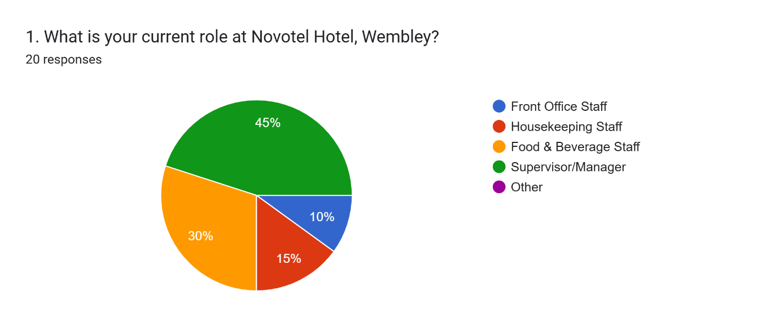
According to above graph, 45 % of the respondents occupy supervisory or managerial roles, 30 % of the respondents work in the food and beverage industry, 15 % in the housekeeping industry, and 10 % in the front-office industry. Most of the respondents (45%) were managers implies that the results of the survey are mostly representative of the views of individuals with managerial functions of operation oversight, performance monitoring, and departmental coordination. The inclusion of food and beverage staff (30 percent) offers good operational insights into a major department in the guest-service that speed of service and coordination have a direct impact on customer satisfaction. Housekeeping representation (15%) provides the insights related to the efficiency of the room service and turnaround time, and the proportion of the front-office is rather low (10%), which suggests that the operational insights associated with guests might be somewhat underrepresented.
Question 2: Hospitality Industry experience
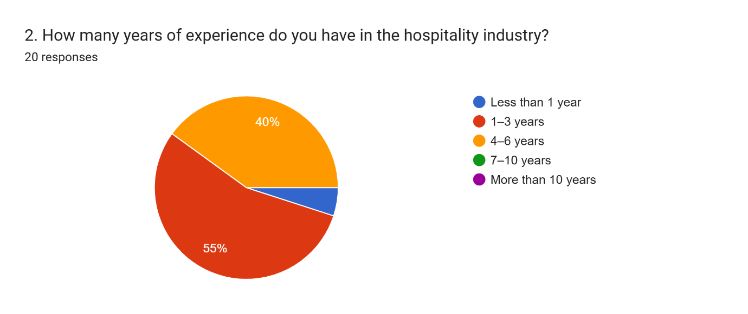
The above graph indicates that 55% of the respondents have experience in the hospitality sector within the range of 1-3 years, 40% have a range of 4-6 years, and 5 % have less than 1 year. This distribution shows that 95 % of the respondents have moderate professional experience, which presupposes that the data represent practice-based operations exposure and not a surface acquaintance with the workplace practices. The employees who have 1-3 years experience (55) are probably involved in service-delivery activities thus in a better position to assess the efficiency of operations and effectiveness of workflow. The 4-6 years (40 percent) is more mature in operational viewpoints especially on the consistency of processes, service recovery, and how the departments coordinate. The percentage of newer employees (5%) is low allows reducing the risk of biased answers due to inexperience.
Question 3: Daily Operations Effectiveness
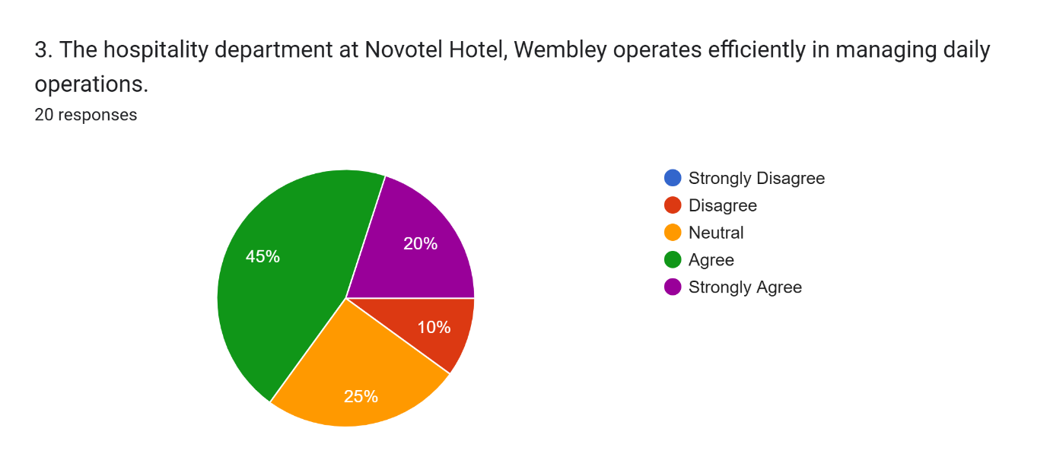
The above graph reveals that 45 % of the respondents feel that the hospitality department is efficient and 20 % strongly believe that the department is efficient giving it a positive rating of 65. In the meantime, one out of every four people is neutral and another out of every four is in opposition. Most of the respondents express that the operational systems, workflow coordination, and service-delivery processes are effective in the department. Nevertheless, the 25% neutral data indicate that it is possible that not every department or shift will experience equally high operational efficiency, which could be explained by the workload variability or difficulties in communication. The there is still a 10 % difference is an indication that some of the bottlenecks, including delays in coordination or staffing, still exist.
Question 4: Clarity of Roles and Responsibilities
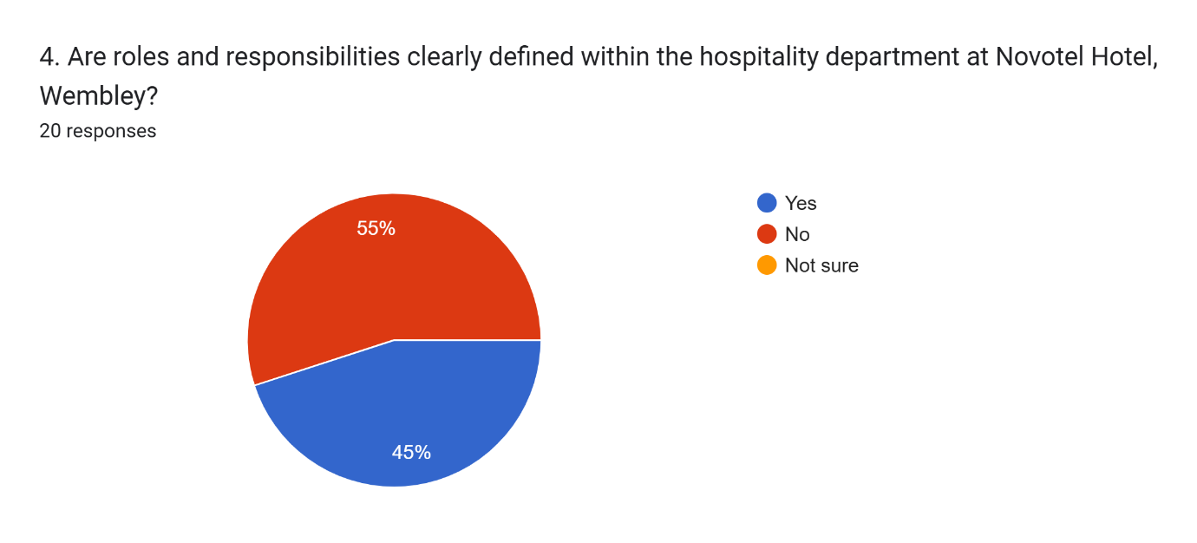
The above graph shows that 55 % of the respondents believe that roles and responsibilities are not clear to them but 45 % respondents believe that they are clearly outlined. Most of the perceptions of role ambiguity give an impression that there is a possibility that some employees are confused with regard to the allocation of tasks, reporting lines or ownership; this is likely to occur in the times when operations are in full swing. Loose role constructions may trigger workplace inefficiencies, service delays or duplication of tasks and hence negatively impact the overall service quality. The 45 % of the respondents that affirm distinct duties suggest that some of the departments can adopt well-organized roles, although the ability to be such is not applied consistently throughout the hospitality operating.
The results indicate a need to have polished job descriptions, effective presentation of departmental roles, and operational principles in order to make sure that employees understand their roles, hence improving coordination and maximizing operational efficiency in Novotel Wembley.
Question 5: Effectiveness of Complaints Handling
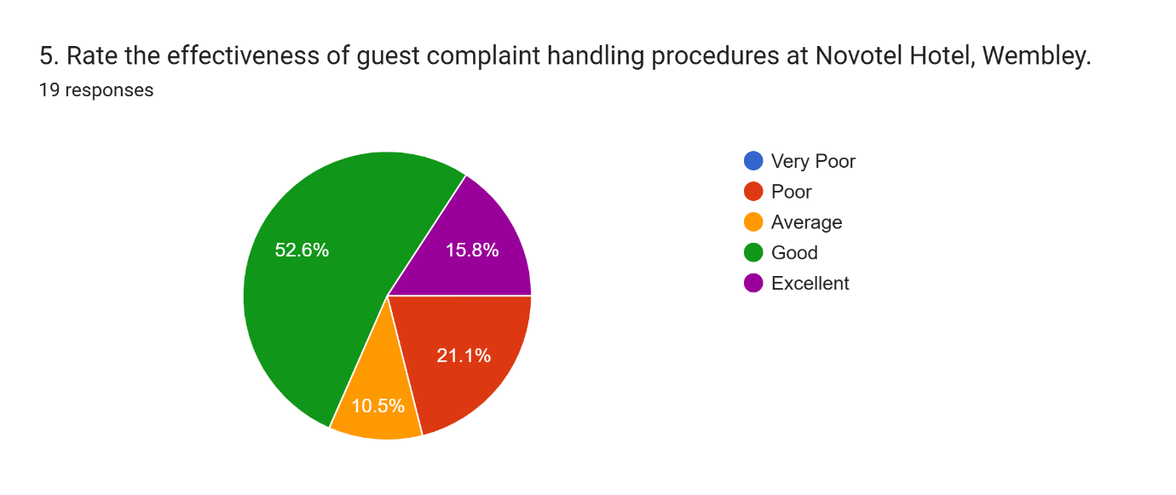
The above graph indicates that 52.6 % of the respondents rate complaint handling to be good, 15.8 % as excellent, 21.1 % as poor, and 10.5 % as average. The overall positive assessment of 68.4% indicates that the processes related to complaints management at the Novotel Wembley, in general, are effective and help to maintain the level of guest satisfaction. The respondents rating the system as excellent (15.8) will most probably receive powerful service-recovering processes and managerial intervention in time. The 21.1% poor rating, however, suggests a variation in service-recovery efficacy among departments, which could be due to the difference in the training of the staff, the efficiency of communication or work pressure. The average responses of 10.5 % also suggest that there is an opportunity to improve the operations.
The reinforcement of standardized protocols of complaint handling, better training of employees to service recovery, as well as faster communication of escalation channels, may increase consistency in resolving complaints and boost overall operational efficiency.
Question 6: The Factors that affect Operational Effectiveness
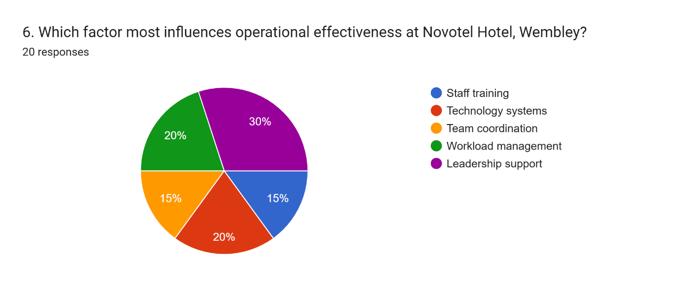
The above graph shows that 30% of the respondents have indicated that leadership support is the most effective factor that impacts operational effectiveness, with workload management (20%), technology systems (20%), staff training (15%), and team coordination (15%). The support of leadership (30) stands out showing how employees believe that managerial advice, clarity of communication, and efficiency in decision-making have a direct influence on the results of operations. Leaders are central to the allocation of resources, motivation of employees, and ensuring that operations standards are upheld thus explaining the attributing premium. The significance of effective workforce planning and digital infrastructure in maintaining smooth operational processes is emphasized by workload management and technology systems, which are at 20%. The staff training and team coordination is attributed lower (15% each) indicates that, though it is also important, employees consider leadership direction and planning to be more important.
Question 7: Adequacy of Employee Training
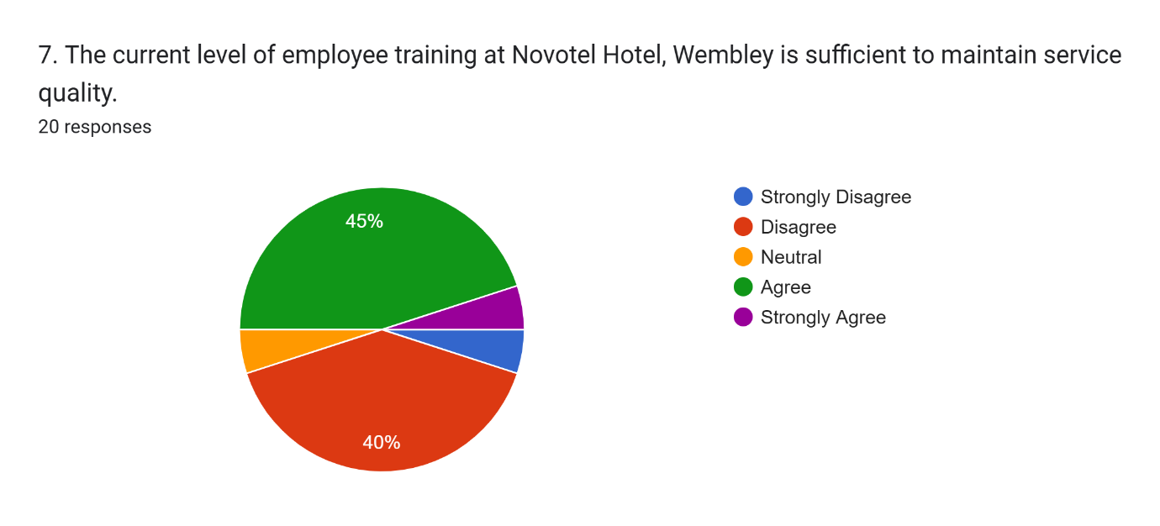
The above graph shows that 45 % of the respondents believe that employee training is enough to sustain the quality of its services, 40 % do not agree, 10 % are indifferent and 5 % strongly agree. The the percentage of agree and strongly agree are almost equal (50%), whereas the disagreement is quite low (40%), indicates the lack of consistency in the training experience, depending on the department. Agreeing respondents (45%) could have enjoyed a properly organized onboarding and operational trainings that will allow them to perform effectively. On the other hand, the amount of disagreement (40%), rather large, indicates that a considerable percentage of the respondents consider training to be insufficient, which may be explained by a shortage of refresher programmes, lack of role-specific training, or absence of constant skills development. The neutral answers (10) also indicate doubt about the effectiveness of training.
System enlargement of continuous professional development programs, role-based training programs, and periodical service-quality workshops may enhance the competence of the employees and may strengthen the functioning of the hospitality department.
Question 8: Effect of Workload Pressure on Service Delivery
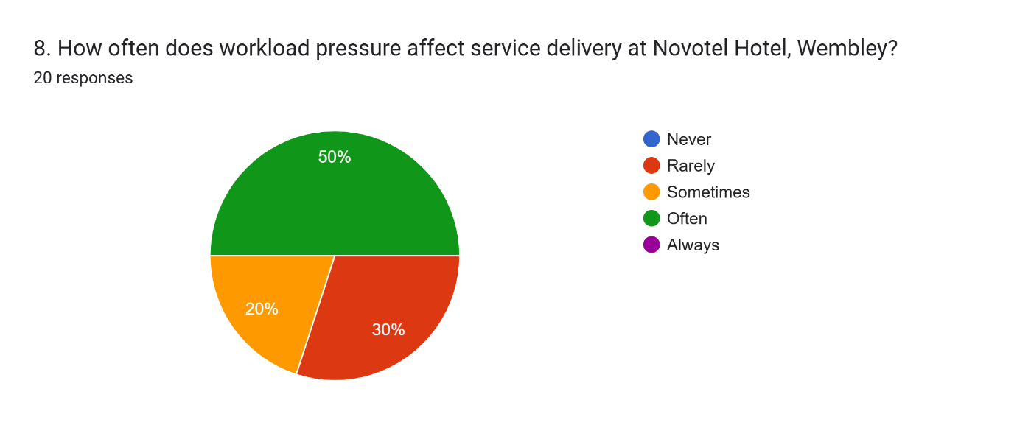
The above graph indicates that 50% of the respondents often get under the pressure of workload that impacts service delivery, 2 out of 10 occasionally, and 3 out of 10 rarely. It can be concluded that staffing allocation and changes in demand have a major effect on operational performance, as half of the respondents frequently have to deal with workload-related issues. The high workload pressure may increase the time of response to the service provision, employee stress, and service delivery inconsistencies, especially during the peak seasons like the months of high occupancy or event seasons. The 20% who report occasional effect indicates variation of the work load intensity with the operational demand. The rare impact of 30% reporting is that some departments or shifts well plan their workforce and workload. Advanced workforce planning, flexible scheduling mechanisms, and demand-forecasting initiatives may level the workload distribution and optimize the operational process.
Question 9: Operational Improvement
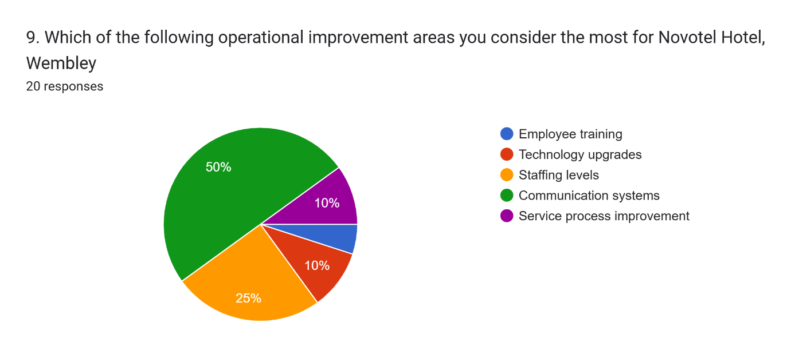
The above graph explains that half of the respondents give communication systems as the most essential area they need to improve followed by staffing, technology upgrades, service process improvements and employee training respectively (25, 10, 10 and 5). The the majority of employees focus on communication systems (50%) implies that they consider the problem of interdepartmental coordination a significant barrier to operations, which can impact efficiency and service provision. The lack of efficient communication may trigger response delays and miscommunication among the teams, as well as reduced operational efficiency. The second most important issue (25%): staffing This is an issue that highlights the role of workforce shortages or unequal distribution in the inefficiencies of the operations. There are also technology upgrades and process improvements (10 % each) that indicate the need to have constant operational modernization.
Question 10: The total Operational Effectiveness Rating
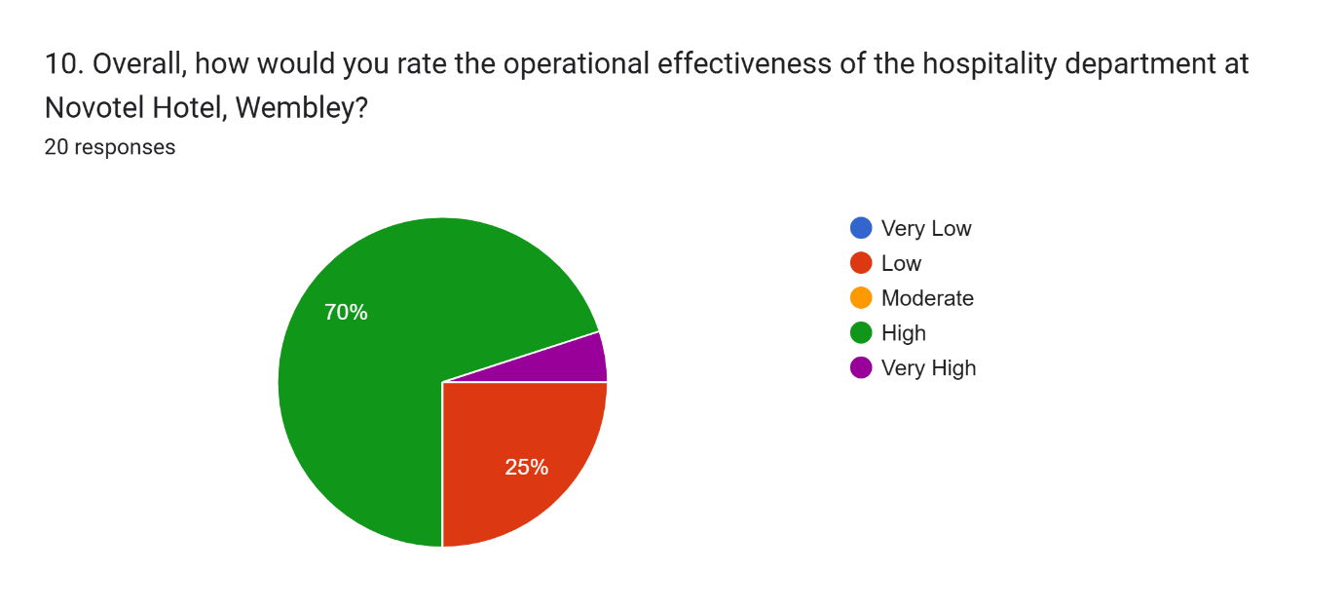
The above graph indicates that 70 % of the respondents are rated on operational performance as high, 25 % as moderate and 5 % as very high and no one rated as low or very low. The distribution indicates an overall positive feeling about the performance of operations in the hospitality department of Novotel Wembley. The 70% of the respondents rated it highly may indicate that most of them are of the opinion that the operational systems, workflow processes and service standards are working well. The moderate 25% score implies that there are still some operational issues, which may be workload management, communication system, or even the sufficiency of training as was reported in the previous survey results. The 5 % very high mark refers to a small group of people who view operations as being at a superior level in their performances.

4.1.2: Discussion on Findings
The findings showed that the operational performance of the hospitality department in Novotel Hotel Wembley was generally rated as positive with most of the employees reporting that day to day running was efficient and service delivery process was working well. In managerial, food and beverage, housekeeping, and front-office departments, the respondent distribution showed that operational performance was affected by the coordination of operations across the functions and not by the individual operational division (Kumar, 2018). The results also identified that leadership support, communication systems, and workforce planning were also important in the forming of operational efficiency. Employees admitted that the front-office services including reservation processing, communication with the guests, and handling of complaints were a significant factor affecting the quality of the services and guests satisfaction. However, there were differences in responses, which implied that the experience of operational performance was not consistently similar across all departments or shifts (Vong et al., 2025). The pressure of work during the peak season, the inadequacy of training at times, and communication issues at times affect the pace of service delivery and coordination. The need to increase the level of operational coordination and workforce management strategies was highlighted by the identification of communication systems and staffing allocation as the areas in which the organisation needs to improve significantly. In general, the results reveal that the hospitality department had effective operational systems, but needed specific advancements in communication, workforce planning, and training programmes to ensure the operational performance levels would be constantly high.

4.1.3 Strengths and Weaknesses of Findings
The major strength of the findings is that they involved respondents representing various functional departments in the organisation giving a general organisational view on operational effectiveness. The inclusion of management, operational and service staff members helped obtain the representation of both managerial and operational perspectives, and thus, increased the validity of the analysis (Abdelwahed and Doghan, 2023). The results also resulted in concise understanding operational priorities, such as the leader support, communication systems, and allocation of staff, which allows finding the areas of operational improvement. In addition, the consistency of the operational performance ratings with the identified areas of improvement contributed to the enhancement of the validity of the conclusions.
Even though these strengths are present, the results are limited by a few limitations that reduce the generalisability of the findings. The sample size was quite small which may restrict the generalisability of the results to all the hotel departments. The fact that the respondents who were predominantly managers as compared to the frontline staff may have been biased given that managers could judge the operational systems in a different manner compared to the employees who have direct contacts with the guests (Zhenjing et al., 2022). Also, the use of self-reported data can create bias in terms of responses, as employees can give socially desirable responses. The following weaknesses imply that the study needs to be supplemented by larger and more balanced samples in the future to increase the strength and external validity of the results.

4.2 Discussion
The functioning of hospitality organisations need to be well coordinated across their departments, their ability to support workforce, integration of technology, and well-organised management systems; all of which help to deliver consistent services (Gomes, Yasin and Lisboa, 2017).

4.2.1 Roles and Responsibilities and Departmental Coordination.
Hospitality activities need to be well coordinated among front office, housekeeping, food and beverage departments as well as supervisory departments. It has been revealed in literature that well-defined roles enhance accountability, minimize delays in operations, and enhance the uniformity in the workflow (JBIHM, 2024). The empirical results indicate that the respondents were attracted to supervisors/managers (45%), food and beverage employees (30%), housekeeping employees (15%), and front office employees (10%), which represents cross-departmental operations. This kind of representation verifies that operational performance relies on coordinated department functioning not just departmental performance.
Nonetheless, the findings also reflect the opinion of 55 % of the employees who think that the tasks and duties are not outlined clearly, which may reflect the structural inefficiency of the distribution of duties or reporting processes. Alblihed and Alzghaibi (2022) stated that operational productivity can also be lowered by role ambiguity since workers might have to take more time to establish duty or liaise work. Enforcement of standard operating procedures of operation, job description and enhancement of communication channels can thus boost coordination of departments, and efficiency of operations. This is in line with theoretical insights that focus on that operational excellence is attained when organisational structures have specific roles and performance expectations that are clearly stipulated (Gomstyn and Jonker, 2024).

4.2.2 Guest Satisfaction and Front Office Service Performance.
Front office activities are at the core of ensuring service quality since it deals with reservations, interactions with guests, and resolving of complaints as well as communication between departments regarding information (Li et al., 2023). The smooth working of the front office has a great impact on customer satisfaction and service delivery uniformity (Kumar, 2018). The results of the empirical study indicate that the majority of the respondents (65 percent) believe that their daily operations are efficient meaning that the operational systems are mostly doing their job well. Also, 68.4 % of the respondents positively rated the processes of handling complaints, which indicated that service recovery systems are, to a large extent, effective in ensuring the guest satisfaction.
About 21 % of the respondents viewed complaint-handling procedures as effective, which means that there is inconsistencies in service recovery performance. These differences can be linked to differences in training of employees, workload pressure or communication systems. According to literature, digital feedback monitoring systems, structured customer service training, and service recovery empowerment are effective in enhancing the performance of complaint resolution (Lyfe Hotel, 2025). Thus, by further refining the staff training programs and introducing real-time technologies that would monitor the complaints, it would also be possible to improve the performance of the service consistency and the guest satisfaction level.

4.2.3 Internal Operational Drivers: Workforce Planning, Training and leadership.
The operational effectiveness is determined by internal organisational factors. The findings find that leadership support (30%) is the most pertinent factor that influences operational performance and then comes workload management (20%), technology systems (20%), staff training (15%), and team coordination (15%). The leadership competency affects the quality of communication, effectiveness in decision making, and motivation of the workforce all of which are vital in ensuring that operations remain productive. A good leadership also makes sure that the organisational resources are well distributed and that the performance standards are always checked (Farmanesh et al., 2023).
The results indicate that 50% of the respondents feel the pressure of workload on service delivery which implies that better staffing allocation and demand forecasting systems should be implemented. The overwhelming workload pressure may slow the speed of services, cause employees to be more tired, and cause adverse impact on quality of the services. Demand predictive and flexible staffing-based workforce scheduling systems have the potential to enhance operational stability and workload balance.
The results of the training adequacy indicate that 50% of the employees feel that the training programs are adequate, and 40 % do not agree, proving that improvement of training efforts should be made. To raise the capability of employees and ensure the consistency of the services, continuous professional development programs, the training of the operational safety, and the training of customer service skills are crucial (Shiri et al., 2023). It is also highlighted in literature that one of the determining factors of operational excellence in hospitality organisations is the workforce capability development (Accor, 2025).

4.2.4 Operational Effectiveness Influences by the External Environment.
External environmental conditions affect the performance of an organisation in terms of operational performance besides internal organisational systems. According to the PESTLE analysis, the UK hospitality sector enjoys the stable political environment and growing tourism demand, which gives the industry favourable prospects of hotel service growth (Statista, 2024). Another opportunity offered by technological progress in the UK is the implementation of automated booking and self-service check-in areas, customer relationship management platforms that contribute to efficient operations (WIPO, 2024).
Nonetheless, economic activities like fluctuations in prices affect the cost of business operation, and organisations need to embrace effective cost-management initiatives (Trading Economics, 2025). The environmental and legal compliance costs also demand organisations to make investments in sustainability activities, which could affect the level of operational expenditure (UK Government, 2021). The SWOT analysis also outlines global brand reputation and reputation of high-quality services by Novotel as the source of their strengths and safety incidents and hygiene-related concerns as the reasons to focus on continuous operation risk management (BBC, 2021; BBC, 2022). These environmental circumstances bolster the essence of sustained operational enhancement plans in order to sustain the competitive edge.

4.2.5 Strategic Implications and operational Improvement Priorities.
The areas of operational improvement, which were concluded during the research, include the significance of communication systems, staffing, technological integration, and employee development programs. 50 % of the respondents identified communication systems as the area of improvement that was most essential and this implies that the organization will need to improve their interdepartmental coordination tools. Lloret et al., (2025) argues that integrated operational dashboards and digital communication platforms can facilitate real-time exchange of information to enhance coordination of services and efficiency of decision-making.
The second area of the most important improvements was staffing (25%), which means that workforce planning strategies need to be better. The workload pressure can be mitigated through flexible staffing paradigms and demand based scheduling systems to enhance service consistency. The use of technology (such as automated booking systems and digital guest management) can be used to facilitate the operations and enhance the accuracy of the services. Abdelwahed and Doghan (2023) suggested that further development of the workforce ability and organisational productivity is provided through the training of employees on the topics of safety compliance, operation procedures, and customer service excellence. All these strategies lead to the sustainability of operations in the long term and excellent service delivery.

4.2.6 Combined Assessment of Operational Excellence.
The combined experience shows that the operational performance in the hospitality department at the Novotel Wembley is quite good in general as 70 % of respondents rated the operational performance as high. Nonetheless, the moderate ratings, provided by 25% of the respondents, indicate the areas of improvement, which are connected to the role clarity, the efficiency of communication, the planning of the workforce, and the training sufficiency. According to Zhenjing et al., (2022), an operational effectiveness is a multidimensional concept that is confirmed by the findings to be dependent on the organisational leadership, competence of the workforce, technological infrastructure, and environmental circumstances.
The enhancement of organisational communication systems, scheduling strategies of the workforce, employee training programs, and digital service technologies will allow the organisation to make improvements in productivity and quality of service (Kim and Jung, 2022). Sustainable operational excellence will also be enhanced by constant observation of the operational performance indicators and provided customer feedback systems.
The hospitality department in the Novotel Wembley has shown that it has effective operational performance with organized service processes and coordination among departments. There are however other operational areas of improvement such as responsibility clarity areas, communication infrastructure, workforce planning systems and employee capability development areas. The organisational restructuring, leadership development, integration of technology and constant training programs to address these aspects of operation will improve operational efficiency and reliability of the services (Vong et al., 2025). The combination of theoretical understanding with the findings of the empirical study proves that operational excellence in hospitality organisations has been reached via matching the organisational systems, workforce potential, and environmental adaptation to allow the organisation to remain competitive in the changing hospitality sector.

Chapter 5: Conclusion and Recommendation

5.1 Conclusion
The study examined operational efficiency of hospitality department in Novotel Hotel Wembley, based on the analysis of departmental functions, performance on front office service delivery, operational elements within and outside the company and the strategies of improvement. The paper established the role of organisational structures, human resource ability, and work systems in service quality, efficiency and satisfaction to the guests. The results indicated that the overall performance of the hospitality department was at an effective level though there were various aspects of operation that needed to be improved to increase performance stability and organisational output. The conclusions are given in line with the purpose of research.

Linking with Objectives
Hospitality Department Roles and Responsibilities.
The operations of the hospitality were based on the well-organized work of front office, housekeeping, food and bevering, supervisory departments. The various departments were involved in the performance of service delivery directly and coordination among the different units was essential in the operation performance. The results indicated that there was an equal representation of 45% supervisors/managers, 30% food and beverage staff, 15% housekeeping staff, and 10% front office workers in the survey, which also indicated cross-departmental participation in operations. The lack of clear ownership of task sometimes had an impact on coordination, a sluggish decision making process and efficiency of workflow. Job roles and reporting systems had to be well documented and the operational coordination improved through the use of standard operating procedures. Accountability would be enhanced with the responsibility structures, and there would be a reduction in duplication of work, and enhanced productivity in the departments. Enhancing the communication systems among the departments would also contribute to the effective management of the work-flow and the consistency of services.

The effects of Front Office Service Providers on the quality of service and guest satisfaction.
The objective considered the influence of front office service providers on the quality of service and satisfaction of the guests. Front office activities controlled reservations, dealing with guests, complaints and information coordination interdepartmental. The front office performance was also efficient, a factor that added to the satisfaction of the guests and the stability of the operations. The results indicated that the effective operation of service operations was observed on a daily basis and that the functioning of the complaint-handling systems was observed in most cases.
The empirical results indicate that the 65 percent of the respondents believe that daily operations are efficient, which shows that the operational systems are generally performing efficiency. Nevertheless, irregularities in service recovery disk were experienced at peak demand times. Sluggishness in order of complaints was at times a quality of service issue. The research found that efficiency of service recovery would be improved through increased front office training programs, better systems of complaint escalation and the use of digital systems to monitor complaints. Allowing front office workers to have the power to make decisions and to have operational support systems would enhance the guest satisfaction results more.

Objective 3: Internal and External Factors PESTLE and SWOT.
The third aim used the PESTLE and SWOT analysis to examine operational factors. The external analysis revealed that there were opportunities in operations due to tourism development, development in technology and peaceful political environment. The economic aspects like inflation and increases in the cost of operation necessitated effective management of resources. The cost management demands and the legal and environmental compliance requirements augmented the operation responsibility and cost management needs. Strong organisational brand reputation and high service systems were found by the internal analysis to be the key strengths. The areas that needed improvement were operational risks associated with safety compliance and coordination challenges. The researched came up with a conclusion that in order to remain competitive, there was a need to watch the outer environmental conditions and ensure that the internal systems of operations were strong. Environmental analysis strategic planning would also help the organisation to react well to the changes and operational risks in the market.

Objective 4: To give recommendations on how the Hospitality Services can be improved.
The areas need improvements in communication systems, staffing allocation, integration of technology and training of employees. Sometimes, communication was inefficient, and it impacted the coordination of various departments. Installing unified digital communication facilities would enhance timely coordination as well as effectiveness in making decisions.
Improvement of workforce planning such as flexible staffing and demand-based scheduling systems would alleviate the pressure on workload and enhance the uniformity of services. The adoption of technology, e.g. automated booking system and electronic guest management system, would simplify the processes within the organization and enhance the speed of services. Through continuous employee training on operational practice, customer service, safety compliance, and use of technology, the ability and output of employees would be enhanced. These would foster operational stability, and service performance.
The hospitality department of Novotel Hotel Wembley was functional but needed specific improvements in terms of responsibility clarity, communication system, workforce planning and training programs. The topics of these areas of operation would be resolved, which would enhance the productivity, consistency of service, and satisfaction of the guests. The efficiency in operation relied on coordination among organisational structures, workforce competence, technology systems and adaptation to the environment. The ongoing monitoring of operations, processes, and development of the workforce would allow the organisation to ensure the quality of the offered services and remain competitive in the long term in the hospitality industry.

5.2 Recommendation
Empowering Organisational Role Clarity and Communication Systems.
The organisation needs to address these shortcomings by adopting strictly documented job descriptions, standardised operations procedures and formal reporting structures that outline the roles played by each and every department. These will help in ensuring that the employees have a clear conception of their operational responsibilities and decision making powers thus reducing duplication of tasks and delays of services. In addition, the hotel needs to introduce coordinated digital communication channels that are able to support real-time communication between front-office, housekeeping, food and beverage, and supervisory staff. The use of operational dashboards that update a live status of room readiness, requests of guests and service requisites would improve the interdepartmental collaboration and minimize response latency. Routine interdepartmental meeting and intensive internal communication training programmes should also be established in order to enhance interaction between staff at the collegial level. Improving role clarity and communication effectiveness will in turn increase the operational output, increase employee confidence when performing tasks and will also ensure that there is a high level of service offerings in the entire hospitality industry.
Installation of Advanced Workforce Planning and Workload Management Systems.
The research recognized workload pressure as a viable operating issue that negatively impacts on service provision, especially during peaks hours. To curb this, the hotel should consider staffing based on demand, with backing of workforce forecasting systems that evaluates the bookings records, seasonal occupancy rates and also the occupancy fluctuation brought about by events. These forecasting systems will enable the management to better plan the number of people to hire and have enough people to perform their work in high-demand seasons. In addition, they should implement flexible scheduling systems such as shift rotation and part-time staffing options during peak seasons to ensure that there is a fair balance in the distribution of workload among employees. Employee workload and productivity indicators that are monitored in the workplace can help managers to implement changes in the number of employees whenever there are operational blockages. Moreover, the fatigue mitigation and increased workforce productivity will be ensured by the introduction of employee well-being programs, i.e. the introduction of scheduled rest breaks and performance support programmes. The reinforcement of these workforce planning systems will enhance the stability of operations, the performance of employees, and the service quality at the same level across all departments.
Improvement of Technology integration and the continuous employee training programs.
Hospitality industry is developing towards digital systems in managing the booking, communication with guests, payment, and coordination of operations. The adoption of state-of-the-art technologies (i.e. automated booking systems, mobile check-in, digital guest service applications, customer relationship management systems, etc.) would facilitate the workflow and reduce service delays. Such technologies would simultaneously enhance the accuracy of the services and allow employees to act timely in response to the requests of the guests. Along with the incorporation of technology, continuous employee training programmes must be implemented, so that the employees have the skills to work in the modern service systems and observe the level of quality. Some of the training programs should include customer service excellence training, safety compliance training, hygiene management, and training on use of digital system. The capability development of the workforce will strengthen the productivity of the employees, the consistency of the services they provide, and the long-term objective of the organisation, aiming at operational excellence.
Novotel employees were put in risk after a chemical leak occurred in one of the hotels' pools; 16 of them were admitted to the hospital after the chlorine leak, indicating a disregard for employee safety (British Broadcasting Company, 2022). By offering all staff safety training while working at the Novotel Hotel, the organization can effectively address this specific issue. This business sees a lot of traffic from both personnel and inbound tourists, so maintaining a safe environment is crucial to operational effectiveness.
A COVID-19 outbreak has even occurred at Novotel, a sign that the establishment is not following proper hygienic standards. The reputation of the brand has suffered as a result (British Broadcasting Company, 2021). Taking this issue into account, this company's personnel must receive training in order to preserve the hygienic element. For instance, providing consumers with a self-check-in system, digital payment systems, and sanitary supplies. Operational excellence can be successfully attained as a result of the implementation of such a plan.

Reference list
Abdelwahed, N.A.A. and Doghan, M.A.A. (2023). Developing Employee Productivity and Performance through Work Engagement and Organizational Factors in an Educational Society. Societies, [online] 13(3), p.65. doi:https://doi.org/10.3390/soc13030065.
Accor (2025). Career Growth & Development. [online] Accor.com. Available at: https://group.accor.com/en/group/people-at-our-heart/career-growth-and-development [Accessed 9 Feb. 2026].
Accor (2026). Guest Service Associate Food and Beverage Service. [online] Accor. Available at: https://careers.accor.com/global/en/job/guest-service-associate-food-and-beverage-service-in-novotel-kolkata-hotel-and-residences-kolkata-india-jid-74552 [Accessed 9 Feb. 2026].
Alblihed, M. and Alzghaibi, H.A. (2022). The Impact of Job Stress, Role Ambiguity and Work–Life Imbalance on Turnover Intention during COVID-19: A Case Study of Frontline Health Workers in Saudi Arabia. International Journal of Environmental Research and Public Health, [online] 19(20), p.13132. doi:https://doi.org/10.3390/ijerph192013132.
Borrett, N. (1991). Leisure Services UK. London: Macmillan Education UK. doi:https://doi.org/10.1007/978-1-349-11621-8.
British Broadcasting Company (2021). Covid outbreak at Newcastle hotel ‘satisfactorily reducing’. [online] 9 Apr. Available at: https://www.bbc.com/news/uk-england-tyne-56689693 [Accessed 9 Feb. 2026].
British Broadcasting Company (2022). Novotel York: Staff taken to hospital after pool chemical leak. BBC News. [online] 16 Apr. Available at: https://www.bbc.co.uk/news/uk-england-york-north-yorkshire-61127006 [Accessed 9 Feb. 2026].
Farmanesh, P., Mostepaniuk, A., Khoshkar, P.G. and Alhamdan, R. (2023). Fostering Employees’ Job Performance through Sustainable Human Resources Management and Trust in Leaders—A Mediation Analysis. Sustainability, 15(19), pp.14223–14223. doi:https://doi.org/10.3390/su151914223.
Gomes, C.F., Yasin, M.M. and Lisboa, J.V. (2017). The effectiveness of hospitality service operations: measurement and implementation concerns. International Journal of Contemporary Hospitality Management, 19(7), pp.560–573. doi:https://doi.org/10.1108/09596110710818301.
Gomstyn, A. and Jonker, A. (2024). Operational Efficiency. [online] Ibm.com. Available at: http://ibm.com/think/topics/operational-efficiency [Accessed 9 Feb. 2026].
Ionescu, R.M. (2023). Total Quality Management (TQM): Improving the Quality of the Products and Services Provided. [online] ResearchGate. Available at: https://www.researchgate.net/publication/367524827_Total_Quality_Management_TQM_Improving_the_Quality_of_the_Products_and_Services_Provided [Accessed 9 Feb. 2026].
JBIHM (2024). Amazing Career in Hospitality and Hotel Industry 2025. [online] JBIHM. Available at: https://jbihm.com/career-in-hospitality-and-hotel-industry/ [Accessed 9 Feb. 2026].
Kim, J. and Jung, H.-S. (2022). The Effect of Employee Competency and Organizational Culture on Employees’ Perceived Stress for Better Workplace. International Journal of Environmental Research and Public Health, [online] 19(8), p.4428. Available at: https://pmc.ncbi.nlm.nih.gov/articles/PMC9032235/.
Kumar, P. (2018). Duties and Responsibilities : Front Office Organisation - Hmhub. [online] HM Hub. Available at: https://hmhub.in/1st-sem-front-office-notes/duties-and-responsibilities-front-office/ [Accessed 9 Feb. 2026].
Li, M., Malik, M.S., Ijaz, M. and Irfan, M. (2023). Employer Responses to Poaching on Employee Productivity: The Mediating Role of Organizational Agility in Technology Companies. Sustainability, [online] 15(6), p.5369. doi:https://doi.org/10.3390/su15065369.
Lloret, Á., Peral, J., Ferrández, A., María Auladell and Muñoz, R. (2025). A Data-Driven Framework for Digital Transformation in Smart Cities: Integrating AI, Dashboards, and IoT Readiness. Sensors, [online] 25(16), pp.5179–5179. doi:https://doi.org/10.3390/s25165179.
Lyfe Hotel (2025). Front Office Associate/Front Desk Assitant/GSA Role at Lyfe Hotels. [online] Lyfe Hotel. Available at: https://www.lyfehotels.com/join-us/front-office-associate-front-desk-assistant-gsa-receptionist/ [Accessed 9 Feb. 2026].
McNamee, S. (2025). Social media statistics in the UK: What businesses need to know in 2025. [online] Sprout Social. Available at: https://sproutsocial.com/insights/social-media-statistics-uk/ [Accessed 9 Feb. 2026].
Mordor Intelligence (2025). Hospitality Industry in the United Kingdom - Growth, Trends, and Forecasts (2020 - 2025). [online] www.mordorintelligence.com. Available at: https://www.mordorintelligence.com/industry-reports/hospitality-industry-in-the-united-kingdom [Accessed 9 Feb. 2026].
Novotel (2026). Novotel London Wembley. [online] Guestreservations.com. Available at: https://www.guestreservations.com/novotel-london-wembley/booking?utm_source=google&utm_medium=cpc&utm_campaign=991006015&gad_source=1&gad_campaignid=991006015&gbraid=0AAAAADiMQMZS7XBqoJlBj4WGit2GOmnSs&gclid=CjwKCAiAqKbMBhBmEiwAZ3UboAnnTPmO6iEkotpsmDS8Mnc2SNazv6f2s9wqomsBcS6g_veO-r1kuhoCSrEQAvD_BwE [Accessed 9 Feb. 2026].
PWC (2024). United Kingdom - Corporate - Taxes on Corporate Income. [online] taxsummaries.pwc.com. Available at: https://taxsummaries.pwc.com/united-kingdom/corporate/taxes-on-corporate-income [Accessed 9 Feb. 2026].
Shiri, R., El-Metwally, A., Sallinen, M., Pöyry, M., Härmä, M. and Toppinen-Tanner, S. (2023). The role of continuing professional training or development in maintaining current employment: A systematic review. Healthcare, [online] 11(21), pp.1–17. doi:https://doi.org/10.3390/healthcare11212900.
Statista (2025). Number of breached records UK Q3 2025| Statista. [online] Statista. Available at: https://www.statista.com/statistics/1386806/uk-number-of-leaked-records/?srsltid=AfmBOorBSEqVil0UTojkl5WETccUxdH8Im_80pWKvOwED9f4VGSN3ds3 [Accessed 9 Feb. 2026].
Statista Research Department (2024). Inbound visits to the UK 2024| Statista. [online] Statista. Available at: https://www.statista.com/statistics/287133/annual-number-of-overseas-visits-to-the-united-kingdom-uk/?srsltid=AfmBOooXCYPW5TWrq4kAV_abpS3eF9PhuTOLkCw8oaiyZ9NFvDtls95B [Accessed 9 Feb. 2026].
Statista Research Department (2025). Most popular hotel brands UK 2025| Statista. [online] Statista. Available at: https://www.statista.com/statistics/951262/most-popular-hotel-brands-uk/?srsltid=AfmBOoo1tag5dihePHIj_aZRVPoWEnx-gJ7RYVylHKpb6F4pVmnQqR7D [Accessed 9 Feb. 2026].
The Global Economy (2025). United Kingdom Political stability - data, chart | TheGlobalEconomy.com. [online] TheGlobalEconomy.com. Available at: https://www.theglobaleconomy.com/United-Kingdom/wb_political_stability/ [Accessed 9 Feb. 2026].
Trading Economics (2023). United Kingdom GDP. [online] Tradingeconomics.com. Available at: https://tradingeconomics.com/united-kingdom/gdp [Accessed 9 Feb. 2026].
Trading Economics (2025). United Kingdom Inflation Rate. [online] Trading Economics. Available at: https://tradingeconomics.com/united-kingdom/inflation-cpi [Accessed 9 Feb. 2026].
UK Government (2021). Environment Act 2021. [online] Legislation.gov.uk. Available at: https://www.legislation.gov.uk/ukpga/2021/30/contents [Accessed 9 Feb. 2026].
Vong, K.C., Udomvitid, K., Ueki, Y., Intalar, N., Pongsathornwiwat, A., Pannakkong, W., Komolavanij, S. and Jeenanunta, C. (2025). Strategic Human Resource Development for Industry 4.0 Readiness: A Sustainable Transformation Framework for Emerging Economies. Sustainability, [online] 17(15), p.6988. doi:https://doi.org/10.3390/su17156988.
WIPO (2024). WIPO - GII 2023. [online] www.wipo.int. Available at: https://www.wipo.int/gii-ranking/en/united-kingdom [Accessed 9 Feb. 2026].
Zhenjing, G., Chupradit, S., Ku, K.Y., Nassani, A.A. and Haffar, M. (2022). Impact of employees’ Workplace Environment on employees’ performance: a multi-mediation Model. Frontiers in Public Health, [online] 10(890400). Available at: https://pmc.ncbi.nlm.nih.gov/articles/PMC9136218/.

Appendix: Questionnaire
1. What is your current role at Novotel Hotel, Wembley?
- Front Office Staff
- Housekeeping Staff
- Food & Beverage Staff
- Supervisor/Manager
- Other
2. How many years of experience do you have in the hospitality industry?
- Less than 1 year
- 1–3 years
- 4–6 years
- 7–10 years
- More than 10 years
3. The hospitality department at Novotel Hotel, Wembley operates efficiently in managing daily operations. (Likert Scale)
- Strongly Disagree
- Disagree
- Neutral
- Agree
- Strongly Agree
4. Are roles and responsibilities clearly defined within the hospitality department at Novotel Hotel, Wembley?
- Yes
- No
- Not sure
5. Rate the effectiveness of guest complaint handling procedures at Novotel Hotel, Wembley.
- Very Poor
- Poor
- Average
- Good
- Excellent
6. Which factor most influences operational effectiveness at Novotel Hotel, Wembley?
- Staff training
- Technology systems
- Team coordination
- Workload management
- Leadership support
7. The current level of employee training at Novotel Hotel, Wembley is sufficient to maintain service quality. (Likert Scale)
- Strongly Disagree
- Disagree
- Neutral
- Agree
- Strongly Agree
8. How often does workload pressure affect service delivery at Novotel Hotel, Wembley?
- Never
- Rarely
- Sometimes
- Often
- Always
9. Which of the following operational improvement areas you consider the most for Novotel Hotel, Wembley
- Employee training
- Technology upgrades
- Staffing levels
- Communication systems
- Service process improvement
10. Overall, how would you rate the operational effectiveness of the hospitality department at Novotel Hotel, Wembley?
- Very Low
- Low
- Moderate
- High
- Very High

