
Master of Business Administration (MBA)
Module: International Business Concepts
Module code: LCMB7034

Beyond Cost Advantage: A Critical Evaluation of Vietnam’s Apparel Industry and Nike’s Operations in a Changing Global Environment

Teacher’s Name: Jean Wang

Student Name: Rabin Hasan
Student ID: 2504378

Word count: 5436
Date of submission: 27 April 2026

Table of Contents
Section 1: Main Report 2
1. Introduction to the Report 2
2. Industry and Country Overview 2
Introduction to the Apparel/Textile Industry in Vietnam 2
Size, Scope, and Economic Importance 3
Competitive Positioning of Key Industry Players 3
3. Michael Porter’s Diamond Model of National Advantage 5
Explanation of Porter’s Diamond Model 5
4. Evaluation of Nike’s Operations in Vietnam 8
Analysis of Key Success Factors in Vietnam 8
Market Attractiveness: A Hofstede-Based Analysis 11
Challenges and Risks for Nike 14
5. Conclusion to the Report 15
Key Findings 15
Recommendations 15
Section 2: Reflective Account 16
Description: What Happened? 16
Feelings: How Did I Feel? 17
Evaluation: What Was Good and Bad? 17
Analysis: What Sense Can I Make of the Situation? 18
Personal Insights and Learning 18
Conclusion of the Reflective Account 19
SMART Action Plan 20
Reference 21

Section 1: Main Report

1. Introduction to the Report
This report discusses the global competitiveness of the apparel and textile industry in Vietnam through a specific discussion of the operations of Nike in Vietnam. Vietnam is a big player in the international apparel business, with the benefits of low labour and trade agreements. However, in spite of these advantages, there are challenges in the country, such as complexities of laws and political instability that can make it difficult for companies to invest long-term in the country (Hoshino, Shimamoto and Todo, 2020). As a big multinational corporation (MNCs), Nike makes the most out of the production capacities of Vietnam and is successful, not without risks. While the application of Porter's Diamond Model to this context does highlight the importance of Vietnam's competitive advantage in such areas as demand conditions and labour availability, there are complexities in the changing regulatory and political environment in Vietnam that this model does not fully address (Teixeira, 2020). The model also disregards the increasing pressure put on MNCs to adapt to the environmental and labour problems that have become an important factor in Nike's brand image and functionality in Vietnam. Therefore, although doing business in Vietnam has a lot of advantages, there are also some limitations that need to be considered.

2. Industry and Country Overview

Introduction to the Apparel/Textile Industry in Vietnam
The Vietnam apparel and textile industry is one of the pillars serving the economy, contributing significantly to national export and labour. The sector enjoys competitive advantages, such as low labour costs, skilled workforce, and access to trade agreements, such as the Comprehensive and Progressive Agreement for Trans-Pacific Partnership or CPTPP (Griffin and Pustay, 2020). Despite these advantages, the industry has a lot of challenges, such as the use of low-cost labour and concerns about labour rights. Vietnam's legal and regulatory regime is still challenging for foreign direct investment (FDI); the Government will need to look more holistically at environment/labor issues. These things throw doubt on the long-term sustainability of the sector (in spite of its short-term success).

Size, Scope, and Economic Importance
The textile and apparel industry in Vietnam is one of the largest contributors to the national economy, with more than $39 billion in exports in 2021 (Ayub, 2025). This accounts for approximately 16% of all of Vietnam's exports and is an important player in the GDP growth. The industry employs more than 2.5 million people, so it has great job potential, especially in rural areas (Huynh, 2024). Despite these contributions, the growth rate of the industry has slowed down due to disruption in the global supply chains and the after-effects of the COVID-19 pandemic. The sector is likely to grow at a 10-12% compound annual growth rate in the coming few years, with a rise and high rate of demand for textile products globally (Lehene, Jaradat and Nistor, 2024). However, its further expansion is subject to overcoming challenges of labour rights as well as environmental sustainability. As the demand increases, likely, the pressures imposed by global consumers and international organisations on the labour practices and the impact on the environment will grow even stronger. Thus, despite the success in the industry, there are structural limitations that may affect the growth of the industry in future if no measures are undertaken to treat them.

Competitive Positioning of Key Industry Players
The type of competition in the Vietnamese apparel and sportswear industry is a hybrid of multinational corporations (MNCs) dominant at the high-end of the market, and domestic companies increasing their presence with cost-sensitive segments (Rafi-Ul-Shan et al., 2018). In reality, the high-end intense competition is represented by the share of international brands such as Nike, Adidas and Puma, at 40% of the sportswear industry (Nike Inc, 2025). However, this is because Vietnam is not a home market but a base for manufacturing.
Nike is a producer leader, rather than a market leader. Nike's supply of footwear and apparel in Vietnam is its key source of supply, with 50-51% and 31% of its footwear and apparel globally produced in Vietnam, respectively (Nike Inc, 2025). This fits with its global cost leadership/manufacturing-efficiency strategies. However, Adidas keeps a more balanced position of both production and market share, controlling around 20% of the Vietnamese sportswear market and dominating some segments of the market (mainly premium). Further, Vietnam accounts for nearly 39-41% of Adidas total footwear production, implying that it is slightly less dependent on Vietnam and still considerable compared to Nike (Wang et al., 2022). This relative scale means Adidas is more likely to have better integration in production processes towards brand building for demand creation than Nike. Puma, while present, is a smaller menace to the head and tail, due to scale and profitability and taps niche lifestyle branding opportunities (Wu et al., 2022). The emerging global players, such as Anta and Under Armour, largely compete in the realms of price and geographic strategies, capitalising on markets catered to by mid-income earners, missed opportunities of high-price western brands. These brands are tapping into the popular athleisure markets worth around USD 1.61 billion in 2024, signalling a weakening of demand for traditional sportswear (Wu et al., 2022).
Indigenous players (including Bitis) are an emerging competitor with particular strength in the mid- to low-end markets. Local businesses account for around 28% of exports, but are structurally disadvantaged by their branding and technological constraints (Rafi-Ul-Shan et al., 2018). Their advantages in cost and localisation lead to competing with MNCs on cost but not branding and innovation. Importantly, there is a dualised competition structure in the sector: MNCs and local firms compete based on branding and technology, and cost and localisation, respectively (Wu et al., 2022). But this presents a problem. Vietnam's importance as a manufacturing hub puts MNCs at risk from cost and policy risks, and constrains domestic firms in non-domestic markets (Rafi-Ul-Shan et al., 2018). Thus, competition and industry positioning in Vietnam is less domestic competition and more strategic positioning on a global stage, warranting a beyond borders approach to the apparel industry.

3. Michael Porter’s Diamond Model of National Advantage

Explanation of Porter’s Diamond Model
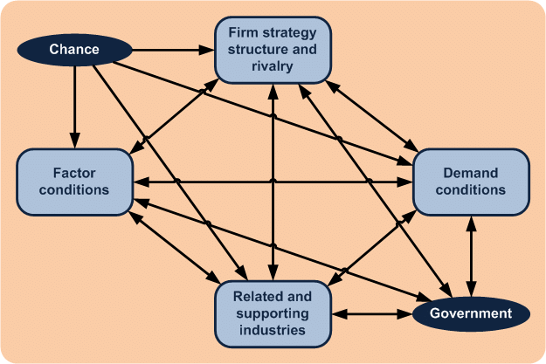
Figure 1: Michael Porter’s Diamond Model
Source: (Tsiligiris, 2018)
Factor Conditions
Steeping the apparel industry in Vietnam are these basic factors: cheap and talented labour, export-processing, ports and industrial capabilities. Hence, the industry exported almost US$44 billion in textiles and garments in 2024, and Nike has 50% of footwear and 28% of apparel manufactured in Vietnam (Nike Inc, 2025). But Porter's model applies only if basic factors are analysed. This low wage cost advantage is an entry competitiveness, but it's not national competitiveness, as wages grow with industrialisation. So, Vietnam should transform the basic factor into an advanced factor (Tsiligiris, 2018). Textile automation, textile engineering, digital supply chain information system, green manufacturing and training programs. Otherwise, we risk becoming a subcontractor and focus on the low-end, low skill activities (design, branding and material development) offshore.
Demand Conditions
Porter refers to "demanding buyers spur firms to innovate" This variable has less influence in Vietnam than the model suggests. Vietnam's demand is growing on the back of urbanisation, young consumers and middle-class buyers, but is still price-conscious and smaller than Nike’s export markets such as the US, Europe and Japan. There, competitiveness is more fostered in export markets than local markets (Lehene, Jaradat and Nistor, 2024). This puts little pressure on innovation in Vietnam. To develop the industry, Vietnam needs to support the development of better-quality local demand by stepping up branding (of local firms and products) and e-commerce; investing in fashion education and raising consumers' awareness of sustainable fashion. If there is a greater demand for high-quality and original designs, local firms will be encouraged to shift in the value chain from low-cost production.
Related and Supporting Industries
The weakness of and key opportunity for the Vietnamese manufacturing sector is the related and supporting industries. The garment assembly industry is highly skilled, but Vietnam is massively dependent on imports for cotton and synthetic fibres, fabrics, chemicals, dyes and equipment. A recent local newspaper article reports that Vietnam imports all cotton, 95% of synthetic fibres and is also highly dependent on fabric imports (Lehene, Jaradat and Nistor, 2024). While Porter argues that the creation of clusters can enhance competitiveness, this is limited without local suppliers and vertical value chain integration. Nike saves on assembly costs in Vietnam, but is vulnerable to input costs and gravity issues, rules of origin and geopolitical uncertainty. It can make more effort to improve its textile, dyeing and finishing, supply, machining services and infrastructure. Backward linkage activities will enable more value added within Vietnam and reduce the need for imported inputs.
Firm Strategy, Structure and Rivalry
Competition in the Vietnamese apparel sector is intense, but mixed. Mistral and Nike are local brands owned by multinational firms (Adidas and Puma) that compete in high-end global value chains through branding, innovation and networks, and local players on price, know-how and low prices. This is a simplification of Porter's framework of national competitiveness: in apparel, it is not local competition, but buyer-driven global value chains that matter (Tsiligiris, 2018). Nike in Vietnam is not in competition with local brands, but with Adidas/Puma and other multinational sportswear manufacturers on cost, speed, quality and sustainability. Vietnam must assist these manufacturers to move from cut-make-trim (CMT) to original design manufacturing (ODM) and own brand manufacturing (OBM). This includes export credits, design, intellectual property, marketing and investment incentives to upgrade technology.
Government
The government is key to Vietnam's advantage. Strong government, industrialisation and trade agreements like the CPTPP and EVFTA have allowed markets to open and a competitive manufacturing environment, as a result of disinvestment from China. But government support doesn't just come in the form of reduced tariffs. The low efficiencies of labour inspections, customs, corruption and environmental standards can make operating an ethical business less attractive (Tsiligiris, 2018). For Nike, the implications are reputational and compliance risks as global brands face challenges in terms of labour issues and greenhouse gas emissions. Vietnam can help the industry with improved labour practice enforcement, switch of customs arrangements, relevant environmental enforcement and incentives for renewable energy. A race-to-the-bottom approach of competing with environmental and labour costs can get you orders, but decreases competitiveness in the long term due to increasing needs for transparency, decent working conditions and a reduction in carbon emissions.
Chance
The chance factor in Porter's model is important for Vietnam, given that recent events have altered apparel sourcing patterns. COVID-19, inflation, supply-chain problems, geopolitical tensions and tariffs are threatening export-led manufacturing. Vietnam has benefited from the China plus one policy, but over-exporting is both a curse and a blessing (Lehene, Jaradat and Nistor, 2024). Proposed tariffs recently exposed how dependent brands are on Vietnam, and how the brand will be impacted by increased import tariffs, such as Nike. Therefore, Vietnam should strive for competitiveness on two fronts, cost and resilience. It needs to diversify its exports, improve its port facilities, customs system and supplier agility. This will mean that Vietnam can adapt to shocks, whether in consumer demand or policy.

4. Evaluation of Nike’s Operations in Vietnam

Analysis of Key Success Factors in Vietnam
Political Environment
Investment, which is made possible by political stability in Vietnam, is a key to success for Nike. The Vietnam Communist Party keeps the risk of chaotic policy changes to policy inconsistencies and even social chaos to a minimum, which is relevant because Vietnam is not a low-cost country, but Nike's largest footwear source (Le, Tran and Nguyen Duc, 2019). Nike's fiscal 2015 report states that Vietnam manufactured 51% of its worldwide footwear and 31% of its apparel, and that it has a supplier network with 98 suppliers and 162 factories working with over 493,000 employees (Nike Inc, 2025). So, political stability is good for the stability of Nike's production and shipment. Vietnam also benefits from Nike in terms of export and jobs, as well as its manufacturing image.
But the political system can be a liability as well. Centralisation can increase policy certainty, but also slow down reforms and openness. According to the Corruption Perception Index 2024, Vietnam scored 40-41 points, placing it at the lower end of the pack (Abderaouf Bouguerra et al., 2025). This doesn't necessarily imply that Vietnam is inhospitable, but it does indicate hazards for investors in bribes, local enforcement and red tape (Le, Tran and Nguyen Duc, 2019). This can result in greater costs and reputational risk for Nike, as its partners don't meet global work standards and expectations. Thus, the political environment is good for stability, not transparency.
If Vietnam can help Nike (and the industry) look good by simplifying customs, improving the enforcement of anti-corruption measures, and increasing the transparency of the labour and environmental inspections, it can imagine its way to success (Le, Tran and Nguyen Duc, 2019). CPTPP and EVFTA enable more trade, but a slow pace hinders it. Nike can help by cooperating with the government in initiatives for supplier compliance, nine inspections and capacity building for scale, not cost advantage, in the medium to long term.
Economic Environment
The economic environment in Vietnam is very suitable for Nike's business model as it is an export growth economy, with low-cost labour and supply chains. In 2024, textiles and garments produced US$44 billion, and the sector is expected to produce US$46 billion in 2025, which shows the market has bounced back from the pandemic (Abderaouf Bouguerra et al., 2025). This offers Nike a strong manufacturing economy rather than a basic manufacturing skill base for export production. The Vietnamese economy also has one of the highest growth indices in Southeast Asia, with manufacturing and foreign direct investment as the highlights (Peterson and Thomas, 2017). For Nike, this is a firm foundation for economies of scale, learning outside and inside to specialise for manufacturers and suppliers for any footwear, apparel, equipment and export cluster.
However, Vietnam's growth is not risk-free. Vietnam has always been a low-cost producer, but costs are rising. That's good for Vietnamese workers and consumers, but it's bad for the low-cost production model that is the lifeblood of Nike. Nike also has Vietnam exposure. Any surplus cost pressures, a downturn in the US and Europe and tariff cuts profits (Peterson and Thomas, 2017). Just recently, the US government exposed the Vietnam-dependent companies, mainly due to cost shocks at Nike.
Vietnam should not be a low-value-added, low-end assembly industry. Vietnam can support this by investing in automation, textile engineering, textile material, logistics and alternative energy. This will allow Vietnam to develop instead of low cost (Schlegelmilch and Szőcs, 2020). The trick for Nike is to make the best use of Vietnam not just as a low-cost supplier, but as a manufacturing supplier. Technologies, equipment, training and supply-chain management would allow Nike to keep its margins, while improving quality and fulfilment.
Legal and Regulatory Factors
Legal and regulatory reform - particularly investment law and regulations, trade, and intellectual property protection - in Vietnam have enhanced the regulatory systems for foreign investors (Asmat, Norhayati and Abdul Latif, 2022). This helps Nike to secure contracts, trademarks, designs and supplier contracts. International trade agreements demand harmonisation of laws with global standards and increase global confidence. Better integration for Malaysia makes it more attractive as an export site and allows more sophisticated foreign investment.
But the issue lies not with the law, but its enforcement. The employment rights, overtime regulation, punctual payment, safety and unions are crucial for export processing. This is a concern for Nike because apparel reputation is world-embedded and labour issues in a supplier's factory are viewed through the global lens (Daniels and Sullivan, 2011). Cheap manufacturing can lose value in the absence of the rule of law. Piracy and intellectual property infringement can also be a concern, especially for a luxury brand which has a strong design, image and logos.
Vietnam can assist in making the industry more competitive by not only offering policies but also enhancing implementation. Not only are transparent labour inspections, sanctioning "unfair" factories, and expedited IP cases helpful for Vietnam in shifting from a cheap, low-wage labour subcontractor to a sustainable producer (Clarke-Sather and Cobb, 2019). Nike can take the lead in this area by doing "more". By striving harder to audit, set up grievance channels, provide fair labour practices and be transparent, it can reduce reputational risk and stand out. In doing so, it should consider legal compliance a benefit.
Cultural Factors
Nike is facing challenges in effective and strategic labour practices in Vietnam's cultural and labour environment. It has a young, manufacturing culture-oriented and disciplined workforce to support its labour-intensive footwear and apparel production (Luo, 2009). The high power difference, low individualist and slightly long-term cultural orientation identified by Hofstede characterise Vietnam. These features promote discipline, coordination and continuity. Cultural traits are conducive towards productivity and efficiency in supplier factories.
And these traits can mask problems. High power distance may lead to the under-reporting of any bullying, poor working conditions and discrimination. Collectivism encourages co-operation, but also "peer pressure" (Arrigo, 2020). So, conforming to the factory culture does not guarantee job satisfaction. Nike may have greater success if it limits oppressive shop-floor discipline.
Vietnamese urbanisation and youth stimulate future market opportunities for international sport brands, but the Vietnamese are value-oriented consumers. Nike's "premium" strategy should lead to image sales, but price sensitivity will favour local and regional manufacturers (Luo, 2009). This makes Vietnam a better destination for production than a market for premium consumers. Nike will prosper if it customises offerings, harnesses digital, and offers value for money with brand premium. Vietnam can assist by improving tactical skills, encouraging productivity and raising societal standards (Luo, 2009). Nike will be successful if it is productive and virtuous: skills development, safety, voice and cultural promotion. It is an excellent place for Nike to make its products, provided that skills, trust and ethical practices are part of the equation.

Market Attractiveness: A Hofstede-Based Analysis
To assess the attractiveness of the market, the Hofstede Model can be applied.
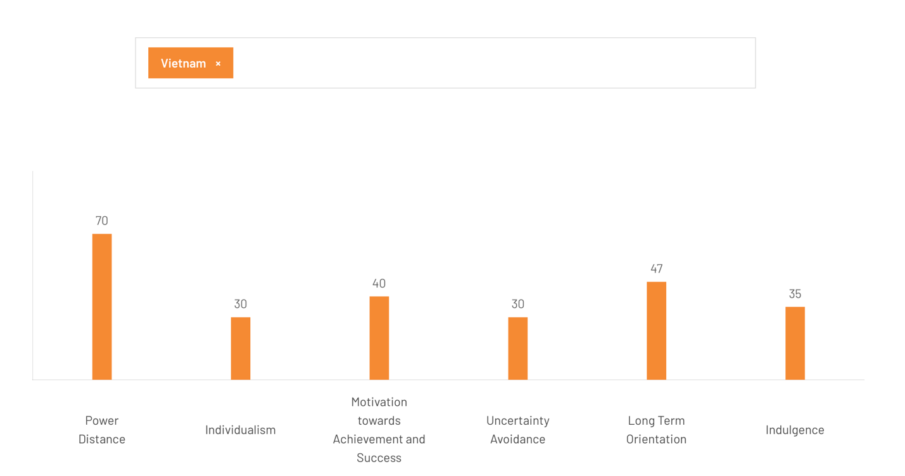
Figure 2: Hofstede Model
Source: (Hofstede Insights, 2025)
A cultural take on Vietnam through Hofstede's theory is a stronger predictor for the market attractiveness of Nike in Vietnam than broad macro-environmental factors. Hofstede's theory offers insights into the Vietnamese cultural environment as a production-efficient but market-limited context, requiring a different approach.
Vietnam's large power distance (70) facilitates the communication efficiency of Nike's production network, by encouraging acceptance of hierarchy (Hofstede Insights, 2025). This improves the efficiency of low-cost labour-intensive manufacturing systems, following Nike's low-cost strategy. But this trait complicates communication-upwards, reducing labour transparency. Thus the stability of business comes with risk of reputation, particularly in a hostile external environment concerned with labour practices (Macchion et al., 2018). So the market is variable as cultural tolerance of hierarchy structure is local stability and international weakness. The low individualism (30) indicates a collectivist culture which has substantial implications on the marketplace and the workplace (Hofstede Insights, 2025). For manufacturing, it increases group cohesion and performance. Yet, for marketing purposes, it narrows the ability for Nike to exploit individual archetypes that promote individual creativity. Instead, consumer behaviour is collective and brand identification is through social acceptance and culture (Tsiligiris, 2018). It consequently opposes globalised marketing themes and favours local branding efforts. This means Vietnam's attractiveness as a consumer market is limited without localisation by Nike of brand positioning according to identity structures.
Vietnam's average masculinity (40) suggests a balance of achievement and concern for social issues (Hofstede Insights, 2025). While Nike's positioning (quality, performance and competition) meets the achievement goals, increased attention to social and environmental concerns translates to less tolerance for exploitation. Hence, consumers want brands to be aspirational and, at the same time responsible (Wu et al., 2022). So competiveness will be driven by both performance and integrity. Nike may suffer depreciation from not fulfilling these new consumer demands. The low uncertainty avoidance (30) means a better acceptance of uncertainty and change, leading to high flexibility in manufacturing and supply chains (Hofstede Insights, 2025). This bodes well for Nike in terms of adjusting to global market fluctuations and product variability. However, this also means there is lower institutional enforcement as well as regulatory enforcement, increasing the risk of institutional and regulatory enforcement issues (Le, Tran and Nguyen Duc, 2019). So while greater flexibility enhances efficiency, it also weakens institutions, which poses a problem for the sustainability of markets.
The high long-term orientation (47) of Vietnam supports persistence, resilience and patience. This complements Nike's long-term investments in factories and suppliers (Hofstede Insights, 2025). It but also means customers and other stakeholders will prefer persistence to short-term profits. As such, Nike will likely focus on progressive improvements rather than goals in the short term (Tsiligiris, 2018). This cultural trait contributes to the importance of stability in business practices as branding and reputation is progressive trust. Finally, low indulgence (35) is an indication of a value-oriented culture with low indulgence (Hofstede Insights, 2025). This will negatively impact Nike's luxury pricing, as aspirational consumption is lower and value seeking higher. This means product and market growth will be constrained without a value proposition (Le, Tran and Nguyen Duc, 2019).

Challenges and Risks for Nike
Nike has several challenges in the Vietnamese operations, many of which are due to the changing economic, political, and cultural variables, as well as labour-related issues.
Fluctuating Labour Costs: With the growth of the economy in Vietnam, labour costs will increase. As per the latest news, the average monthly salary for people working in the textile and apparel industry has been increasing at a rate of 10-15% each year since 2017 (Abderaouf Bouguerra et al., 2025). This trend may have the potential to destroy the competitive advantage that Nike is currently enjoying due to low labour costs. Nike may have to think about automation in order to ensure cost efficiency, but this would require a great deal of investment in terms of technology and skills training (Peterson and Thomas, 2017). Another possibility may be to move the production to other low-cost countries. However, some challenges exist, including the logistical cost, disruptions to the supply chain, and potential cultural barriers in new regions.
Political Instability: While Vietnam is politically stable, there is the possibility that shifts in political policies may occur or unforeseen disruptions could have a major effect on the operations of Nike. The step taken by the government to implement new tariffs or change the labour regulations might lead to more operational expenses for Nike (Daniels and Sullivan, 2011). Local corruption or inefficiencies in the bureaucracy are also persistent risks and can cause delays in the business process or additional and hidden costs. Furthermore, Vietnam's one-party system can sometimes cause a sudden change in government priorities that can have a direct impact on Nike's ability to properly forecast its operations for the long term.
Labour Unrest: Nike has had labour unrest in the past due to the reliance on low-wage labour in Vietnam. Issues like dissatisfaction of workers with wages and labour conditions have led to strikes and protests in different factories. Such unrest may lead to the closing of factories, and it will disrupt the supply chain of Nike along with the production timelines (Asmat, Norhayati and Abdul Latif, 2022). While Nike has made efforts to improve the working conditions over the years, the increasing pressure for improving labour standards - and higher wages in Vietnam - is a challenge that is here to stay. Nike needs to try to solve these issues more proactively so as not to sustain damage to their brand reputation or their labour force depleted.
Legal and Regulatory Risks: Nike is at risk for legal and regulatory risks due to the inconsistent enforcement of labour laws and intellectual property (IP) theft. Although Vietnam has made strides to improve the labour regulations, enforcement still remains poor, and Nike can be sued over violations of worker rights (Schlegelmilch and Szőcs, 2020). Also, the protection laws for IP are still in development in Vietnam, and consequently, the potential for counterfeiting and thievery of IP in Nike's product line is greater, particularly in the local market. These legal and regulatory risks not only challenge the businesses at every operational level, but also pose huge risks to their reputation, as Nike's brand image is not only associated with quality and innovation.

5. Conclusion to the Report

Key Findings
Vietnam's apparel industry has major competitive advantages of being low labour costs, a proficient workforce and beneficial trade agreements such as CPTPP. These factors make Vietnam a good player in global apparel manufacturing. Taking advantage of the cost efficiency in Vietnam, Nike has effectively set up their position as a global leader by making use of this. However, the increased labour costs and demands for sustainability pose a threat to Nike's cost advantage and standing in the market in the long term (Clarke-Sather and Cobb, 2019). Additionally, risks are also found in the legal and regulatory environment in Vietnam, especially regarding labour rights and the enforcement of intellectual property rights, which could impact Nike's brand image and operations.

Recommendations
For Nike, the key to achieving continued growth in Vietnam is in adapting to the higher cost of labour through investment in automation and improvement in the local supply chains. Nike should also step up the efforts to sustainability, considering the consumer demand for environmentally friendly products, especially now that Adidas is in the lead for this (Luo, 2009). Vietnam's changing legal landscape requires Nike to step up its game in local compliance, to ensure that it is in compliance with labour laws, and that the intellectual property is ensured so that its reputational and functional risks are reduced (Peterson and Thomas, 2017). For other MNCs who are looking into Vietnam for expansion purposes, having an understanding of the dynamic political, economic and social factors is important. Adapting business models to the labour conditions of the country, as well as to environmental compliance, will be key to long-term success in the country.

Section 2: Reflective Account
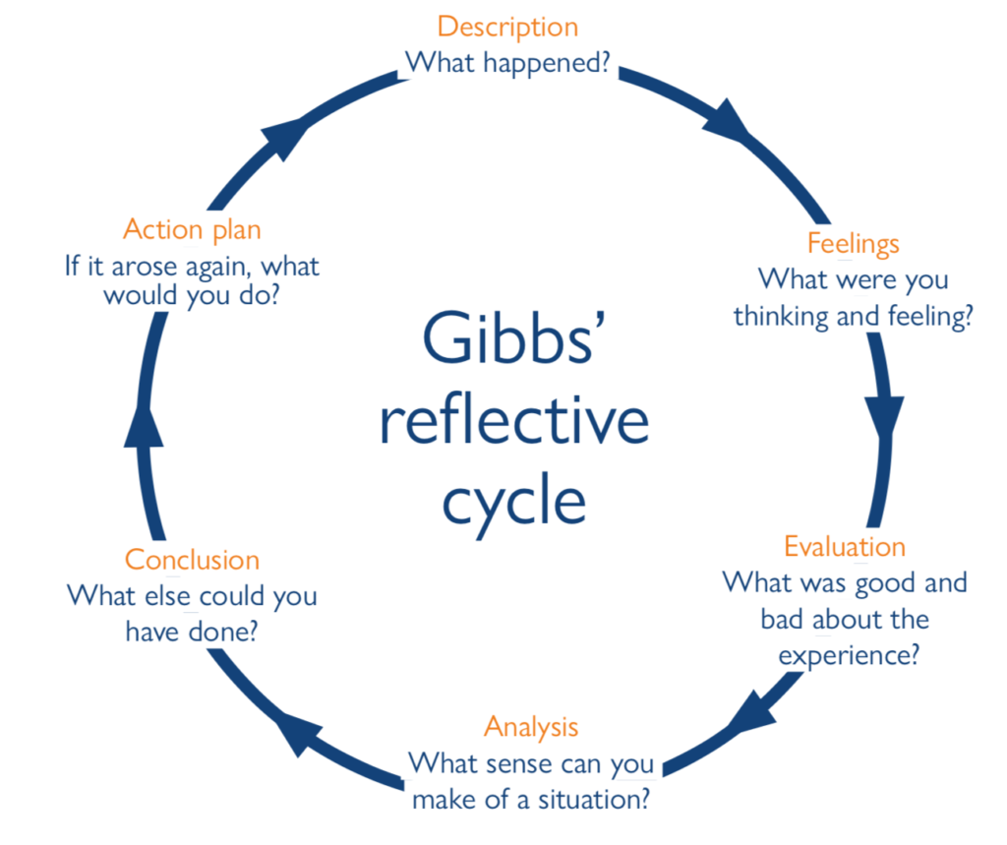
Figure 3: (Whitfield, Staritz and Morris, 2020)
Source: (Nurlatifah, Purnawarman and Sukyadi, 2023)

Description: What Happened?
For this assignment, I did a lot of research about Nike's operations in Vietnam, as it is its competitive advantage in terms of the apparel industry. I used some theoretical frameworks in the analysis of the economic, political and legal context in Vietnam and in Nike's business strategies, including Porter's Diamond Model and the PESTLE analysis (Nurlatifah, Purnawarman and Sukyadi, 2023). I was gathering information from different secondary sources such as government reports, academic articles, industry databases, etc. I have used these sources to analyse the opportunities and challenges that Nike faces in Vietnam, including labour costs, regulatory risks, and competition with other brands like Adidas and Puma.

Feelings: How Did I Feel?
At the beginning of the assignment, I was pretty sure about the use of well-known models such as Porter's Diamond to analyse the competitiveness of Vietnam. However, as I went along the way, I began to feel overwhelmed by the complexity of the task, and particularly got a whack in the face with the lack of brush-on information about the laws related to labour and enforcement thereof (Nurlatifah, Purnawarman and Sukyadi, 2023). I became frustrated when reading about a lack of current available source information about Nike's sustainability in Vietnam, and was challenged to use the model to its fullest extent. Despite all these disappointments, I felt proud when I was able to resolve the spaces by putting other frameworks and literature together.

Evaluation: What Was Good and Bad?
What Worked Well:
- The use of Porter's Diamond was successful in structuring Vietnam’s competitive advantages analysis (Potter, 2015).
- PESTLE analysis gave me an overview of the macro-environment as a whole, and I was able to look at the factors such as political stability, economic growth, and any legal challenges.
- The secondary data sources that I have used, such as reports from the Ministry of Industry and Trade of Vietnam, gave me reliable information about the economic status of the country and the trade relations (Potter, 2015).
What Didn’t Work Well:
- Labour rights issues and intellectual property concerns in Vietnam were challenging and tough to analyse in depth due to the absence of detailed and updated data (Potter, 2015).
- Porter's Diamond Model had failed to consider the complexities of Nike's ethical issues and sustainability, which play vital roles in the business world today (Potter, 2015).
- Sourcing of data on the political environment was difficult because much of the data was not regularly updated or detailed enough to give an in-depth analysis.

Analysis: What Sense Can I Make of the Situation?
The issues that I had in trying to analyse data make this point - the limitation of having only theoretical models like Porter's Diamond for such analysis. These models are helpful and beneficial, but do not capture the whole essence of the ethical and social dynamics and aspects of business (e.g. sustainability and labour practices), which are increasingly important for global business nowadays (Trimasse, 2025). The problems experienced with accessing information on labour laws and the enforcement of intellectual property in Vietnam, respectively, indicated the importance of using primary and secondary data to make the analysis richer. I realised that more up-to-date sources and direct knowledge of local actors would have provided me with a better picture of the operations and struggles that Nike has had to face in Vietnam.

Personal Insights and Learning
Skills Gained
This assignment made me a better student of how to apply theories to a real-world business application. I gained valuable experience in the analysis of the competitive advantages of countries and the evaluation of the impact of global business strategies (Trimasse, 2025). Using models such as Porter's Diamond allowed me to better understand the way that industries change and the importance of national competitive factors in corporate strategy. I also gained greater skills in critical thinking, particularly in the fit of theoretical models to actual data to models, and those areas where models fail to fit data. Additionally, I have learned about the importance of sustainability in the current business strategies (Nurlatifah, Purnawarman and Sukyadi, 2023). The challenges I encountered in finding information about Nike's efforts to be more sustainable in Vietnam emphasised the importance of considering ethical aspects of evaluating corporate operations. This experience has made me investigate the business strategies, not only through the traditional financial metrics, but also by considering wider social and environmental impacts.
Improvement Areas
Although I successfully used Porter's Diamond Model and PESTLE analysis, I understand that I could have given more analysis to the labour laws and intellectual property concerns. Given the attention that the world is starting to focus on alleged violations of labour rights and intellectual property theft, a more detailed discussion of the state of Vietnam's legal system would have been stronger in my report (Potter, 2015). Moreover, the use of sustainability frameworks could have provided a more holistic perspective on the operations of Nike, especially as the company faces increasing pressure to be held accountable for its environmental impact and social responsibility. In future assignments, I will try to go deeper into how ethical business practices can be integrated into my theoretical analysis. Furthermore, I could have worked better on my ways of gathering data by having more primary sources, such as interviews/writing case studies from Nike's local suppliers (Nurlatifah, Purnawarman and Sukyadi, 2023). This would have provided a more complex picture and would have been helpful to validate some of the statements found in the secondary sources. I also realised that I may have organised my data collection process before my study and saved myself from the delays and gaps in research.

Conclusion of the Reflective Account
Reflecting upon this assignment has been useful to realise the importance of striking a balance between the theoretical models and practical experiences in assessing complex issues such as labour practices and sustainability in multinational operations (Potter, 2015). While Porter's Diamond Model was a good foundation in drawing a strong basis for analysis in the context of the competitive advantages of Vietnam, there was the need to add other models to address the changing nature of the global business. In the future research, I will be able to focus more on gathering primary data and consider more on the concept of sustainability and ethics in my analysis in gaining a more holistic understanding of the operations of multinational corporations.

SMART Action Plan
Action | Specific | Measurable | Achievable | Relevant | Time-Bound
Primary Data Collection | Conduct interviews with experts and suppliers (Trimasse, 2025). | At least 3 primary sources. | Use professional networks to arrange interviews. | Enhances data depth (Trimasse, 2025). | Complete within 2 weeks.
Expand Legal Analysis | Focus on labor laws and IP regulations. | Analyze 3 key sections of legal data. | Consult legal sources on Vietnam’s framework (Trimasse, 2025). | Provides legal insights for Nike. | Complete within 1 week.
Sustainability Framework | Apply Triple Bottom Line to assess Nike’s sustainability (Trimasse, 2025). | Implement TBLin 2 sections. | Refer to Nike’s sustainability reports. | Addresses growing sustainability concerns (Trimasse, 2025). | Complete in next 3 assignments.
Data Organization | Create a structured research system. | Develop a research database. | Use tools like Notionor Evernote. | Increases research efficiency. | Complete within 1 week.
Table 1: SMART Action Plan
Source: Self-made, Based on (Trimasse, 2025)

Reference
Abderaouf Bouguerra et al. (2025) ‘MNEs engagement with environmental sustainability in an emerging economy: Do dynamic capabilities and entrepreneurial orientation matter?’, International business review, 34(2), pp. 102298–102298. Available at: https://doi.org/10.1016/j.ibusrev.2024.102298.
Arrigo, E. (2020) ‘Global Sourcing in Fast Fashion Retailers: Sourcing Locations and Sustainability Considerations’, Sustainability, 12(2). Available at: https://doi.org/10.3390/su12020508.
Asmat, N.A.T., Norhayati, Z. and Abdul Latif, S.A. (2022) Multidisciplinary perspectives on cross-border trade and business. Hershey, PA: Business Science Reference.
Ayub, F. (2025) ‘Key Trends in the Market Entry Strategies of the USA Footwear MNEs, encompassing Brand Localization, Digital Engagement and Dynamic Capabilities’, Research Journal for Social Affairs, 3(5), pp. 423–456. Available at: https://doi.org/10.71317/rjsa.003.05.0340.
Clarke-Sather, A. and Cobb, K. (2019) ‘Onshoring fashion: Worker sustainability impacts of global and local apparel production’, Journal of Cleaner Production, 208, pp. 1206–1218. Available at: https://doi.org/10.1016/j.jclepro.2018.09.073.
Daniels, R. and Sullivan, D. (2011) International business. Harlow: Pearson.
Griffin, R.W. and Pustay, M.W. (2020) International business: A managerial perspective. 9th edn. Harlow: Pearson.
Hofstede Insights (2025) Country comparison tool - Vietnam, Theculturefactor.com. Available at: https://www.theculturefactor.com/country-comparison-tool?countries=vietnam (Accessed: 12 April 2026).
Hoshino, T., Shimamoto, D. and Todo, Y. (2020) ‘Accounting for Heterogeneity in Network Formation Behaviour: An Application to Vietnamese SMEs’, Oxford Bulletin of Economics and Statistics, 82(5), pp. 1042–1067. Available at: https://doi.org/10.1111/obes.12360.
Huynh, N.-T. (2024) ‘Status and challenges of textile and garment enterprises in Vietnam and a framework toward industry 3.5’, International Journal of Logistics Research and Applications, 27(2), pp. 1–12. Available at: https://doi.org/10.1080/13675567.2022.2147490.
Le, Q.A., Tran, V.A. and Nguyen Duc, B.L. (2019) ‘The Belt and Road Initiative and Its Perceived Impacts on the Textile and Garment Industry of Vietnam’, Journal of Open Innovation: Technology, Market, and Complexity, 5(3), p. 59. Available at: https://doi.org/10.3390/joitmc5030059.
Lehene, C.F., Jaradat, M. and Nistor, R.L. (2024) ‘An interdisciplinary and multilevel analysis of local economy determinants and their impact on firm performance—Considering Porter’s diamond model, clusters, and industry’, Systems, 12(3), p. 82. Available at: https://doi.org/10.3390/systems12030082.
Luo, Y. (2009) ‘Political risk and country risk in international business: Concepts and measures’, in Rugman, A.M. (ed.) The Oxford handbook of international business. Oxford: Oxford University Press.
Macchion, L. et al. (2018) ‘Strategic approaches to sustainability in fashion supply chain management’, Production Planning & Control, 29(1), pp. 9–28.
Nike Inc (2025) ANNUAL REPORT ON FORM 10-K, https://investors.nike.com. Nike Inc. Available at: https://s1.q4cdn.com/806093406/files/doc_financials/2025/ar/Nike-Inc-2025_10K.pdf (Accessed: 12 March 2026).
Nurlatifah, L., Purnawarman, P. and Sukyadi, D. (2023) ‘The implementation of reflective assessment using Gibbs’ reflective cycle in assessing students’ writing skill’, Nucleation and Atmospheric Aerosols, 2621(1). Available at: https://doi.org/10.1063/5.0143375.
Peterson, M.F. and Thomas, D.C. (2017) Cross-cultural management: Essential concepts. 4th edn. Thousand Oaks: SAGE.
Potter, C. (2015) ‘Leadership Development: an Applied Comparison of Gibbs’ Reflective Cycle and Scharmer’s Theory U’, Industrial and Commercial Training, 47(6), pp. 336–342. Available at: https://doi.org/10.1108/ICT-03-2015-0024.
Rafi-Ul-Shan, P.M. et al. (2018) ‘Relationship between sustainability and risk management in fashion supply chains’, International Journal of Retail & Distribution Management, 46(5), pp. 466–486. Available at: https://doi.org/10.1108/ijrdm-04-2017-0092.
Schlegelmilch, B.B. and Szőcs, I. (2020) Rethinking business responsibility in a global context: Challenges to corporate social responsibility, sustainability and ethics. Cham: Springer.
Teixeira, N.M. (2020) Management control systems and tools for internationalization success. Hershey, PA: IGI Global.
Trimasse, N. (2025) ‘The use of reflective reports in higher education’, Reflective Practice, 26(1), pp. 1–18. Available at: https://doi.org/10.1080/14623943.2024.2424520.
Tsiligiris, V. (2018) ‘An adapted Porter Diamond Model for the evaluation of transnational education host countries’, International Journal of Educational Management, 32(2), pp. 210–226. Available at: https://doi.org/10.1108/ijem-03-2017-0076.
Wang, C.-N. et al. (2022) ‘A Study of Performance Evaluation for Textile and Garment Enterprises’, Processes, 10(11), p. 2381. Available at: https://doi.org/10.3390/pr10112381.
Wu, Z. et al. (2022) ‘Knowledge roadmap of sustainable development in the textile and apparel industry: a scientometric analysis’, Fashion and Textiles, 9(1). Available at: https://doi.org/10.1186/s40691-022-00308-6.

