BA (HONS) LEADERSHIP AND MANAGEMENT SKILLS IN THE WORKPLACE
MODULE CODE: LCLM6005
MODULE TITLE: INDEPENDENT PROJECT
TITLE: THE IMPACT OF LEADERSHIP STYLE ON EMPLOYEE PERFORMANCE WITHIN THE BEAUTY INDUSTRY OF THE UK
STUDENT NAME: Camelia Daniela Popa
STUDENT ID: 2312338
SUPERVISOR NAME: Chinomso Nwagboso

METHODOLOGY POSTER
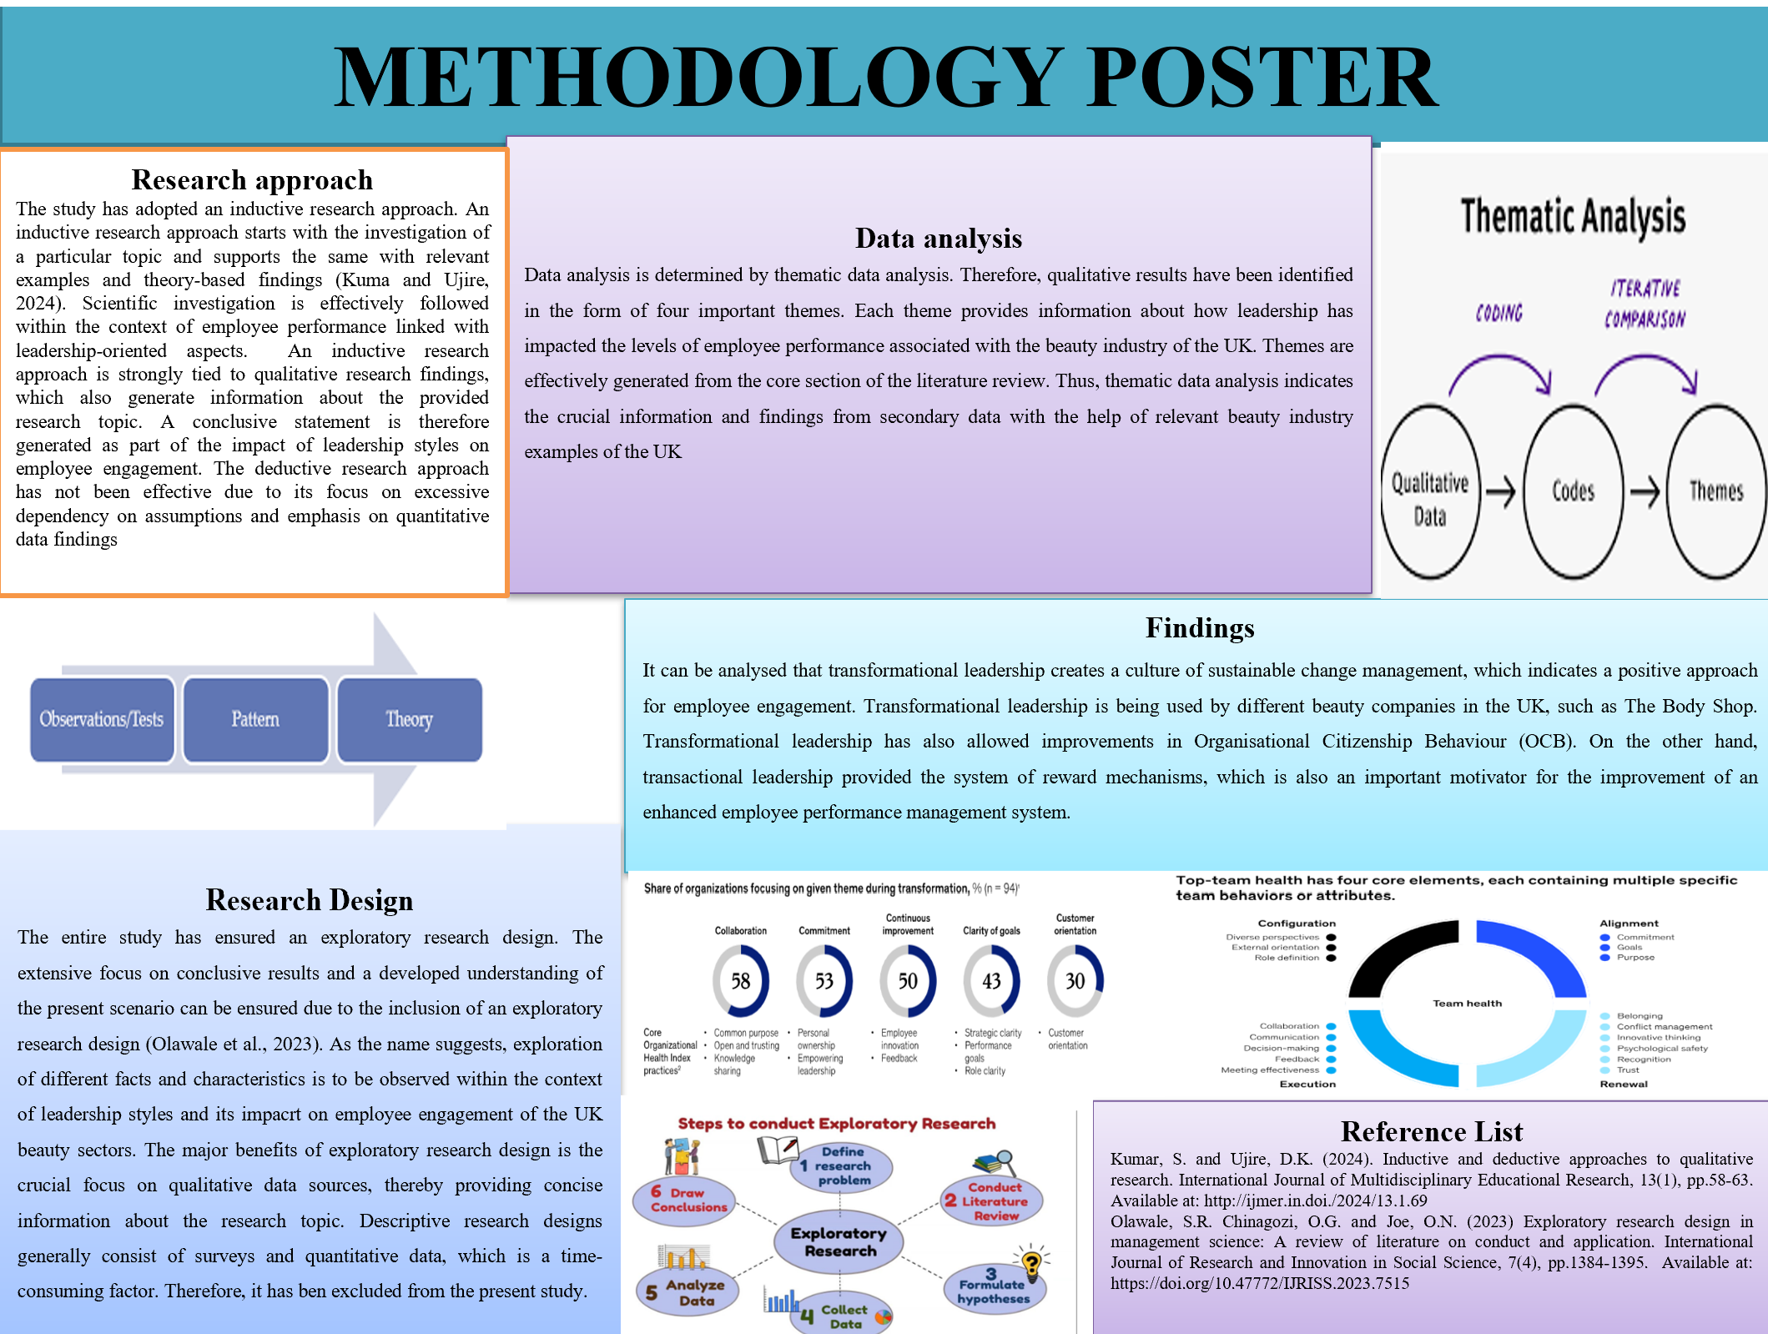

Research approach
The study has adopted an inductive research approach. An inductive research approach starts with the investigation of a particular topic and supports it with relevant examples and theory-based findings (Kumar and Ujire, 2024). Scientific investigation is effectively followed within the context of employee performance linked with leadership-oriented aspects. An inductive research approach is strongly tied to qualitative research findings, which also generate information about the provided research topic. A conclusive statement is therefore generated as part of the impact of leadership styles on employee engagement. The deductive research approach has not been effective due to its excessive dependency on assumptions and emphasis on quantitative data findings.

Research design
The entire study has ensured an exploratory research design. The extensive focus on conclusive results and a developed understanding of the present scenario can be ensured due to the inclusion of an exploratory research design (Olawale et al., 2023). As the name suggests, exploration of different facts and characteristics is to be observed within the context of leadership styles and their impact on employee engagement in the UK beauty sector. The major benefits of an exploratory research design are the crucial focus on qualitative data sources, thereby providing concise information about the research topic. Descriptive research designs consist of surveys and quantitative data, which is a time-consuming factor. Therefore, it has been excluded from the present study.

Data collection
The study has followed a secondary data collection system. Secondary data has been collected from different peer-reviewed journals, website channels, and justifiable key industry reports. A keyword-based searching system has been applied to observe and determine secondary data. Relevant keywords include transformational leadership, transactional leadership, and employee performance. A reliable database of Google Scholar is used to extract journals and articles that are considered peer-reviewed, having pre-defined links. Data have also been collected from 2022 onwards to ensure the reliability and consistency of available information sources. The inclusion of secondary data sources, therefore, provides crucial information about the impact of leadership style on employee performance in the UK beauty sector.

Data analysis techniques
Data analysis is determined by thematic data analysis. Therefore, qualitative results have been identified in the form of four important themes. Each theme provides information about how leadership has impacted the levels of employee performance associated with the beauty industry in the UK. Themes are effectively generated from the core section of the literature review. Thus, thematic data analysis indicates the crucial information and findings from secondary data with the help of relevant beauty industry examples in the UK.

Findings
It can be analysed that transformational leadership creates a culture of sustainable change management, which indicates a positive approach for employee engagement. Transformational leadership is being used by different beauty companies in the UK, such as The Body Shop. Transformational leadership has also allowed improvements in Organisational Citizenship Behaviour (OCB). On the other hand, transactional leadership provided the system of reward mechanisms, which is also an important motivator for the improvement of an enhanced employee performance management system.

Reference List
Kumar, S. and Ujire, D.K. (2024) ‘Inductive and deductive approaches to qualitative research.’ International Journal of Multidisciplinary Educational Research, 13(1), pp.58-63. Available at: http://ijmer.in.doi./2024/13.1.69
Olawale, S.R. Chinagozi, O.G. and Joe, O.N. (2023) ‘Exploratory research design in management science: A review of literature on conduct and application.’ International Journal of Research and Innovation in Social Science, 7(4), pp.1384-1395. Available at: https://doi.org/10.47772/IJRISS.2023.7515

