A Scenic Assessment of 5 Gower Beaches

Table of Contents
- Introduction………………………………………………………………………………….3
  - Site Description………………………………………………………………….….4
- Methodology………………………………………………………………………………...5
- Results……………………………………………………………………………………….7
- Discussion…………………………………………………………………………………...9
4.1 An Evaluation of Scenic Assessment Tools…………………………………….….10
4.2 Recommendations for Site Management…………………………….…………….11
5.0 Conclusion………………………………………………………………………………….11

References…………………………………………………………………………………...….12

List of Figures
- Location of beaches……………………………………………………………….…..4
- A bar chart representing the results of the scenic assessment………………………...8
- A bar chart representing the overall results for the scenic assessment…………….…8

List of Tables
- Beach rating checklist……………………………………………………………..….5
- Factor assessment result………………………………………………………..…..…7
- SWOT analysis for Rhossili, Port Eynon, Langland, and Swansea Bay……….....….9

1.0 Introduction
Coasts are complex areas in which the land, sea, and atmosphere meet (Haslett, 2016, p.1). They are of great ecological, economic and social importance. Not only are beaches areas of interest ecologically, but they also offer a place of residence and many recreational opportunities for communities. In addition, they serve as a natural defence against erosion and coastal flooding (Pranzini and Williams. 2013, p.200). For the reasons previously stated, it is pivotal that such landscapes are managed. In order to manage beaches, they must be assessed. Several different scenic rating systems are used by academics and professionals when assessing beaches due to the multidisciplinary nature of such landscapes. These tools aim to simplify the complexity of beach environments (Cagilaba, 2005); by considering both physical and human variables obtained on from site observations and transferring them into statistics (Clamp, 1976) and are an important tool for management and classification (Botero et al, 2013, p.1733).
A key aspect of evaluating scenery is the of the idea of perception. When assessing any coast, an effort to remain objective should be made. However, many scenic assessments have been based upon subjective analysis (Mooser et al, 2018, p.5). They are often put under scrutiny for this, as one person’s perception of a landscape will almost certainly differ from another’s; leading to different outcomes within the assessment. It is important that the implications of this are considered when analysing the validity of results.
Many schemes and models have been produced within this field; each using different methods to assess beaches (Rangel-Buitrago, 2018). Notable work is that of: Fines (1968) who used photographs for assessing landscapes and Robinson et al (1967) who used ‘best/worst’ ratings to document landscape values.
More recently, Chaverri (1989) identified 113 variables and divided them into ‘positive’ and ‘negative.’ Each is then given a score from 0-4 (bad-good), in which they are summed together to create a final score.
BARE (Bathing Area Registration and Evaluation) framework evaluates beaches by collecting data using the BARE Registration Form (Williams and Micallef, 2009, p.195). The form consists of five sections, which are as follows: background information, rating of parameters, evaluation of ratings for beach user priority concerns, and classification system.
LANDMAP uses GIS (geographical information system) to create five-layer data sets of core information. These spatial datasets include: Geographical Landscape, Landscape Habitats, Visual and Sensory, Historic Landscape, and Cultural Landscape. GIS layers this information to show characteristics, qualities and components of landscapes. This tool is able to assist with natural resource planning and sustainable decision-making, whilst remaining objective (Natural Resources Wales, 2019).
CSES (Coastal Scenic Evaluation System) adopts a checklist approach and a 1 to 5-point rating scale. CSES uses public surveys and fuzzy logic for the quantitative evaluation of coastal scenery (METU, 2018). Fuzzy logic is a mathematical model that assists in reasoning vague concepts (Ergin, A. et al, 2004). Research in Turkey, UK, Malta and Croatia used public surveys to assess 26 parameters relating to coasts (Rangel-Buitrago, N. p.67, 2018).
In this study, a checklist approach was utilized in order to assess and rank 5 Gower beaches; from these results, future site-specific management recommendations will be proposed with beach users and the natural environment in mind. To date, there has been little agreement on which scenic assessment tool is the most suitable. This study aims to consider and contrast a variety of methods, whilst taking into account the wider management implications of using such techniques.
1.1 Site description
Four beaches along the South Wales coastline (Fig. 1) formed the study area for this research. All beaches are located in Gower which in 1956 became the first area in the UK to be awarded as an Area of Outstanding Natural Beauty (City and Council of Swansea, 2019). Surrounded by the Atlantic Ocean and Bristol Sea, geologically, the majority of Gower is Old Red Sandstone and Limestone (Brenchley, 2006, p. 200). The Limestone coast supports a variety of plant communities along with grassland and heath (Natural Resources Wales, 2019).
The beaches included in the study are as follows; Rhossili, Port Eynon, Langland, and Swansea Bay. All locations are managed by Swansea Council.
Rhossili Bay is an extensive sandy beach, which has been awarded a Green Coast Award and was voted the best beach in the UK in June 2010. Being popular for water sports, it also benefits from shops, toilets, and a carpark. However, accessibility on to the beach is poor and may not be suitable for all visitors. Rhossili’s cliffs support seabird nesting sites (Natural Recourses Wales, 2019)
Backed by sand dunes, Port Eynon is a south facing sandy bay (Natural Resources Wales, 2019) surrounded by holiday and caravan parks, along with shops, toilets and other facilities. Making it easily accessible therefore popular among tourists and dog walkers. The beach has been awarded a Blue Flag Award, Seaside award, and is Marine Conservation Society Recommended (City and County of Swansea, 2019).
Langland is a sandy beach with rock outcrops that are exposed at low tide. It is one of Gower’s most popular beaches among surfers. A coastal path linking the bay to Caswell Bay makes it a good walking spot. Two carparks make the bay easily accessible for visitors. Langland has also been awarded a Blue Flag Award, Seaside award, and is Marine Conservation Society Recommended (City and County of Swansea, 2019).
Swansea Bay is an urban beach that can be distinguished by its sea wall. The sea wall has many paths leading to the beach, making it accessible. Being close to the city centre of Swansea, the beach benefits from many facilities and is in a convenient location for walkers and visitors, although more traditionally aesthetic beaches are found further west. Swansea bay is a Marine Conservation Society recommended beach and has a Trip Advisor Certificate of Excellence (City and County of Swansea, 2019).
Figure 1
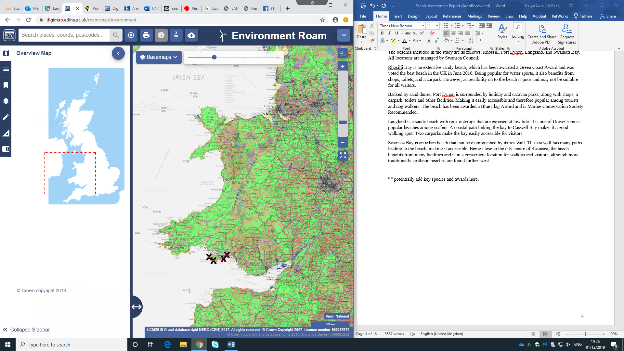
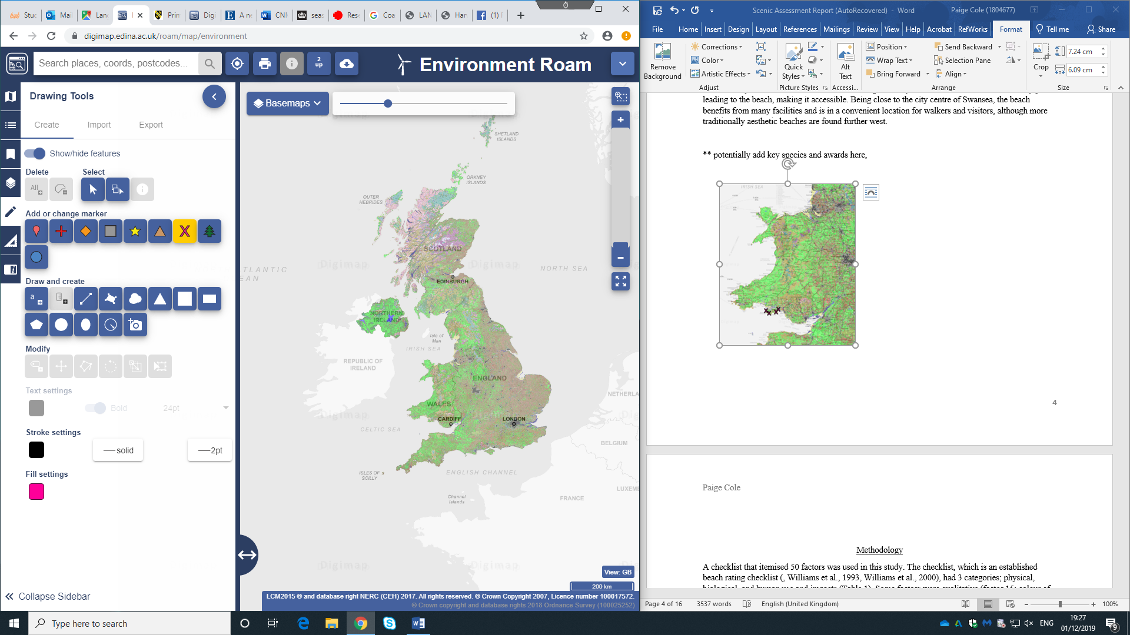
Location of beaches (Didgi Maps, 2019)
1
2
4
3
Key: 1 Rhossili; 2 Port Eynon; 3 Langland Bay; 4 Swansea Bay

2.0 Methodology
A checklist that itemised 50 factors was used in this study. The checklist, which is an established beach rating checklist (Phillips and House, 2009), had 3 categories: physical, biological, and human use and impacts (Table 1). Some factors were qualitative (factor 15: colour of sand) and others quantitative (factor 1: beach width at low tide).
During site visits to each location, the checklist was completed, and a score was given between 1 and 5 for each factor. Evidence from a previous study in Wales, UK, suggests that using a 5-point scoring scale more accurately rates beaches as opposed to a 3-point scoring scale (Williams and Micallef, 2011, p.159). For the quantitate elements of this research the scores were estimated. For example, for question 1 the beach width at low tide was not measured. A total for each location and factor was formed and converted into percentages that have equal weighting, to allow for the raking of the beaches.
This methodology has several advantages, for example, it permits a quantitative comparison between both quantitative and qualitative results. Conversely, the checklist method doesn’t allow for expectations. As stated earlier, scenic assessment tools are based on subjective analysis, this can be considered as a limitation within the research. Another limitation of this method is that it doesn’t consider or assist management within itself.
A SWOT (strengths, opportunities, weakness, threats) analysis was also completed at each location. Each SWOT analysis assists in identifying future management recommendations for each beach.
Table 1
Beach rating checklist
Physical factors | Categories
 | 1 | 2 | 3 | 4 | 5
1. Beach width at low tide | □ Narrow < 10 m | □ 10–30 m | □ 30–50 m | □ 50–100 m | □ >100 m Wide
2. Beach material | □ Cobbles | □ Sand/cobbles | □ Coarse sand | □ | □ Fine sand
3. Beach condition or variation | □ Erosional | □ | □ Stable | □ | □ Depositional
4. Sand softness | □ Hard | □ | □ | □ | □ Soft
5. Water temperature | □ Cold/hot | □ | □ | □ | □ Warm (70–80 °F)
6. Air temperature (midday) | □ <60 >100 °F | □ | □ | □ | □ 80–90 °F
7. Number of sunny days | □ Few | □ | □ | □ | □ Many
8. Amount of rain | □ Large | □ | □ | □ | □ Little
9. Wind speeds | □ High | □ | □ | □ | □ Low
10. Size of breaking waves | □ High/dangerous | □ | □ | □ | □ Low/safe
11. Number of waves/width of breaker zone | □ None | □ 1–2 | □ 3–4 | □ 5 | □ 6+
12. Beach slope (underwater) | □ Steeply sloping bottom | □ | □ | □ | □ Gently sloping bottom
13. Longshore current | □ Strong | □ | □ | □ | □ Weak
14. Rip currents present | □ Often | □ | □ | □ | □ Never
15. Colour of sand | □ Grey | □ Black | □ Brown | □ Light tan | □ White/pink
16. Tidal range | □ Large (>4 m) | □ 3–4 m | □ 2–3 m | □ 1–2 m | □ Small (<1 m)
17. Beach shape | □ Straight | □ | □ | □ | □ Pocket
18. Bathing area bottom conditions | □ Rocky, coggles, mud | □ | □ | □ | □ Fine sand
Biological factors
19. Turbidity | □ Turbid | □ | □ | □ | □ Clear
20. Water colour | □ Grey | □ | □ | □ | □ Clear
21. Floating/suspended human material (sewage, scum) | □ Plentiful | □ | □ | □ | □ None
22. Algae in water (amount) | □ Infested | □ | □ | □ | □ Absent
23. Red tide | □ Common | □ | □ | □ | □ None
24. Smell (e.g. seaweed, rotting fish) | □ Bad odours | □ | □ | □ | □ Fresh salty air
25. Wildlife (e.g. shore birds) | □ None | □ | □ | □ | □ Plentiful
26. Pests (biting flies, ticks, mosquitoes) | □ Common | □ | □ | □ | □ No problem
27. Presence of sewage/runoff outfall lines on/across the beach | □ Several | □ | □ | □ | □ None
28. Seaweed/jellyfish on the beach | □ Many | □ | □ | □ | □ None
Human use and impacts
29. Trash and litter (paper, plastic, nets, ropes, planks) | □ Common | □ | □ | □ | □ Rare
30. Oil and tar balls | □ Common | □ | □ | □ | □ Rare
31. Glass and rubble | □ Common | □ | □ | □ | □ Rare
32. Views and vistas Local scene | □ Obstructed | □ | □ | □ | □ Unobstructed
33. Views and vistas Far vistas | □ Confined | □ | □ | □ | □ Unconfined
34. Buildings/urbanism | □ Overdeveloped | □ | □ | □ | □ Pristine/wild
35. Access | □ Limited | □ | □ | □ | □ Good
36. Misfits (nuclear power station; offshore dumping) | □ Present | □ | □ | □ | □ None
37. Vegetation/trees (nearby) | □ None | □ | □ | □ | □ Many
38. Well-kept grounds/promenades or natural environment | □ No | □ | □ | □ | □ Yes
39. Amenities (showers, chairs, bars, etc.) | □ None | □ | □ | □ | □ Some
40. Lifeguards | □ None | □ | □ | □ | □ Some
41. Safety record (deaths) | □ Some | □ | □ | □ | □ None
42. Domestic animals (e.g. dogs) | □ Much | □ | □ | □ | □ None
43. Noise (cars, nearby highways, trains) | □ Much | □ | □ | □ | □ Little
44. Noise (e.g. crowds, radios) | □ Much | □ | □ | □ | □ Little
45. Presence of seawalls, riprap, concrete/rubble | □ Large amount | □ | □ | □ | □ None
46. Intensity of beach use | □ Overcrowded | □ | □ | □ | □ ample open space
47. Off-road vehicles | □ Common | □ | □ | □ | □ None
48. Floatables in water (garbage, toilet paper) | □ Common | □ | □ | □ | □ None
49. Public safety (e.g. pickpockets, crime) | □ Common | □ | □ | □ | □ Rare
50. Competition for free use of beach (e.g. fishermen, boats, water-skiers) | □ Many | □ | □ | □ | □ Few

3.0 Results
Table 2
Factor assessment result
Factor | Rhossili | Port Eynon | Langland | Swansea Bay
1 | 5 | 4 | 4 | 5
2 | 5 | 5 | 5 | 5
3 | 3 | 3 | 2 | 1
4 | 4 | 5 | 5 | 5
5 | 2 | 2 | 2 | 2
6 | 1 | 2 | 2 | 2
7 | 2 | 1 | 2 | 2
8 | 2 | 5 | 2 | 2
9 | 2 | 3 | 3 | 4
10 | 3 | 2 | 4 | 5
11 | 5 | 5 | 4 | 5
12 | 5 | 5 | 4 | 5
13 | 5 | 3 | 4 | 5
14 | 4 | 4 | 3 | 3
15 | 4 | 4 | 4 | 3
16 | 4 | 3 | 1 | 1
17 | 2 | 4 | 5 | 2
18 | 5 | 5 | 1 | 1
19 | 2 | 4 | 4 | 4
20 | 3 | 3 | 5 | 2
21 | 5 | 5 | 5 | 2
22 | 5 | 5 | 1 | 5
23 | 5 | 5 | 5 | 5
24 | 4 | 5 | 4 | 1
25 | 1 | 1 | 2 | 1
26 | 5 | 5 | 5 | 3
27 | 5 | 5 | 5 | 1
28 | 5 | 4 | 1 | 1
29 | 5 | 4 | 5 | 1
30 | 5 | 5 | 5 | 2
31 | 5 | 5 | 2 | 2
32 | 5 | 4 | 2 | 1
33 | 5 | 5 | 2 | 1
34 | 4 | 4 | 3 | 1
35 | 1 | 4 | 4 | 5
36 | 5 | 5 | 5 | 4
37 | 2 | 3 | 5 | 3
38 | 5 | 4 | 3 | 1
39 | 4 | 3 | 4 | 5
40 | 1 | 1 | 2 | 1
41 | 5 | 5 | 5 | 5
42 | 5 | 1 | 2 | 4
43 | 5 | 5 | 5 | 1
44 | 5 | 5 | 5 | 1
45 | 4 | 3 | 1 | 1
46 | 5 | 5 | 2 | 4
47 | 5 | 5 | 5 | 4
48 | 5 | 5 | 5 | 4
49 | 5 | 5 | 5 | 2
50 | 5 | 5 | 4 | 2

Table 2 represents the beach assessments for the 4 beaches. The scores for each factor, for each beach, have been converted into percentages. For example, the maximum possible score for physical factors (1-18) is 90 (18 x 5), Rhossili received a score of 63 and therefore has a score of 70% for physical factors. The results for each factor on each beach are illustrated in the figure 2.

Figure 2:
A bar chart representing the results of the scenic assessment.

The results (figure 2) obtained in this study indicate that Port Eynon scored best for physical factors (72%), while Swansea Bay and Langland as joint worst with a score of 63%. The results for biological factors as seen in figure 1 illustrates Port Eynon, once again, scoring the best (84%) and Swansea bay the worst (50%). It is apparent from Figure 2 that Rhossili received the highest score for human use and impact (91%), closely followed by Port Eynon with 87%. Swansea bay scored the lowest for this factor, with 51%.
Figure 3:
A bar chart representing the overall results for the scenic assessment.

Looking at the overall scores (figure 3) it is possible to see that Rhossili scored the highest in the scenic assessment, closely followed by Langland, with just one point between the two. Then Port Eynon, followed by Swansea Bay.

Table 3
SWOT analysis for Rhossili, Port Eynon, Langland, and Swansea Bay.
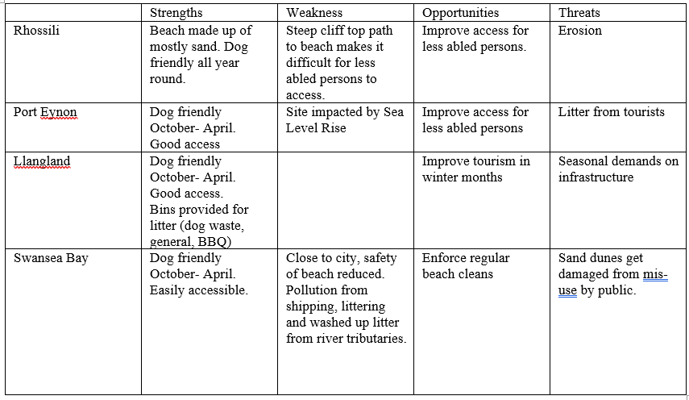
4.0 Discussion
Port Eynon had the highest score for physical factors. This could be due to factors like the size of the beach and sand softness. With that being said, it is necessary to consider the limitations within the methodology used when considering the validity of the results for physical factors and the answer to quantitative questions (for example, 1- beach width at low tide) were estimated.
The lowest scoring beach for biological factors was Swansea Bay. There are several possible explanations for this result. It would be possible to hypothesise that this is a consequence of Swansea Bay being in an urban area along with its marina and the shipping industry that it holds. For question 20, water colour, Swansea Bay scored 2. The traffic of boats and vessels passing through Swansea may impact the water colour, making it grey. This theory is backed up by the results for question 21 (Floating/suspended human material [sewage, scum]) in which Swansea Bay scored 2, the lowest scoring beach for this question. Sewage and waste from the surrounding population will pollute the water.
The results showed that Rhossili scored the highest in the human use and impacts factor, scoring 5 for many questions including: 58,28,14,42,42,44,48,49, and 50. Each of these questions relate to the use of the beach. Rhossili is a rural beach therefore it has less visitors and is better kept. This statement is consistent with the results present in the study; for question 46 (intensity of beach use) Rhossili scored 5. This links to the results for the questions previously mentioned as the lower the beach intensity the less noise (e.g. cars, nearby highways, trains, crowds, radios) and trash and litter (paper, plastic, nets, ropes, planks). Swansea Bay had the lowest score for this factor, with 51%. Swansea Bay is an urban beach resulting in higher intensity of beach use and thusly more noise and concrete, explaining why Swansea Bay ranked the worst in this section.

Overall, the data illustrates that Rhossili beach scored the highest, therefore according to this method is the best beach. However, this data must be interpreted with caution for several reasons.
Although Swansea Bay scored the lowest for human impact and use overall, it scored the highest for some individual questions. For example, question 35: Access, Swansea Bay scored 5/5. This is due to the many paths leading to the beach from the sea wall. For some visitors, especially less abled persons, this may be one of their main priorities when visiting a beach. When analysing the results, it is important to consider individual questions, as well as the totalled result. This could be considered a limitation of using this method as it may prevent users from seeing anomalies like this.
4.1 An Evaluation of Scenic Assessment Tools
When evaluating scenic assessment tools there are several key aspects that must be considered. As mentioned previously, this checklist method relies on subjective analysis. This can impact the validity of results. There are several other scenic assessment tools that rely less on subjective analysis, and therefore produce more valid results. It is also crucial to consider the wider management implications of using such techniques.
Like the method used in this study, The BARE Framework also takes the form of a checklist. However, data is collected via a combination of desk studies and field-based work; quantitative elements within the evaluation are measured, not estimated, thusly improving the accuracy of the results. Having five sections means that this assessment tool is more thorough. From a management perspective this technique has been said to more appropriate as it adopts a more holistic approach. The system claims to allow the ‘development of site-specific beach management plans based on the identification of priority management issues particular for each beach site’ (Williams and Micallef, 2009, p.195). Although this approach is arguably more in-depth it may not be a viable option for many professionals and academics as it requires more time and resources.
As stated earlier, LANDMAP is a tool that uses GIS to show characteristics, qualities and components of landscapes. Subjectivity is avoided and objectivity is achieved by using datasets of recorded information. When compared to the checklist method used this this study, LANDMAP could be argued to be more accurate. Additionally, this technique could be more efficient for management purposes as the data is already within the system meaning time and money is saved. On the other hand, it may be the case that a better understanding of a coast is gained from completing fieldwork. Meaning can be lost through the use of cartography and choropleth maps. Meaning that could be considered crucial when suggesting management recommendations. Although this method is more reliable than the method used in this study the pros of physically going to a site may benefit professionals and academics when ranking and managing beaches.
Much like the scenic assessment tool used in this study, CSES uses a checklist approach and a 1 to 5-point rating scale. Where this method differs is in the use of public surveys and the calculation of the results. Although public surveys also rely on subjective analysis a wider range of view-points are observed meaning that the results are more representative. As stated previously, CSES uses fuzzy logic to analyse coastal landscapes and attain quantifiable results. By using fuzzy knowledge less subjective results are produced from subjective questions. In theory, fussy logic could be applied to this study.

4.2 Recommendations for Site Management
From the research completed there are several site management recommendations to be made. The SWOT analysis (table 3) completed for each beach is a useful tool when proposing site management recommendations. A key point within coastal management in considering costal and marine users. Although Swansea Bay ranked the lowest in the scenic assessment being an urban beach, it is very popular among the public. Footfall damages the sand dunes, a soft engineering strategy in beach management. I would argue that further dune fencing, and marram grass planting is the best course of action in stabilising the dunes. Rhossili Bay is the only beach in the study that allows dogs all year round but is also the least accessible due to the steep cliff top path. Port Eynon is popular among tourists due to the holiday homes and facilities surrounding it. The beach is more accessible than Rhossili but there is no wheelchair access. A potential recommendation for Rhossili and Port Eynon would be to improve this access to it is accessible to all beach users.

- Conclusion
This study has set out to assess and rank five Gower beaches, whilst considering management. A key finding within the study is that perception of beaches varies in academics, professionals and beach users. Beaches that scored low within the assessment may be a preferred beach for some users (Swansea Bay). There are many ways of assessing beaches, each with their own positives and drawbacks. These findings are subject to limitations, the most significant being the variations of perception within scenic assessments, making them subjective which impacts results. Further research could concentrate on how much accessibility to a beach impacts visitors’ likelihood of visiting. This research could add to the understanding of visitors needs and preferences, and their perception of beaches.

References
- Alexis Mooser, Giorgio Anfuso, Carlos Mestanza 2 and Allan Thomas Williams. (2018) ‘Management Implications for the Most Attractive Scenic Sites along the Andalusia Coast (SW Spain)’, Sustainability, 10(5), pp.4. DOI https://doi.org/10.3390/su10051328
- Botero et al. (2013) ‘Perception of coastal scenery along the Caribbean littoral of Colombia’, Journal of Coastal Research, 2(65), pp1733-1738. DOI: 1681906677
- Brenchley, P.J. (2006) The Geology of England and Wales. 2nd edn. Bath: The Geological Society
- Cagilaba, V. (2005) Literature Review of Beach Awards and Rating Systems. Available at: https://www.waikatoregion.govt.nz/services/publications/tr200524/ (Accessed: 30th October 2019).
- Chaverri R., (1989). ‘Coastal Management: The Costa Rica Experience.’, Symposium on Coastal and Ocean Management, 89(5), pp. 1112- 1124.
- City and Council of Swansea (2019) The Gower Peninsula Available at: https://www.visitswanseabay.com/destinations/gower-peninsula/ (Accessed: 1st November 2019)
- City and County of Swansea. (2019) Port Eynon Bay Beach. Available at: https://www.visitswanseabay.com/listings/port-eynon-bay-beach/ (Accessed: 2nd December 2019)
- Clamp, P. (1976) ‘Evaluating English Landscapes- Some Recent Developments.’ Environment and Planning. 8(1), pp. 79-92. DOI: 10.1068/a080079
- Digimap (2019) ‘Location of beaches’ [PDF map], Scale 1:200,000, OS Strategi [geospatial data], Updated 2019, Ordnance Survey, GB. Using: EDINA Digimap Ordnance Survey Service, Created: October 2019
- Ergin, A. Karaesmen, E. Micallef, A, Williams, A.T. (2004) ‘A New Methodology for Evaluating Coastal Scenery: Fuzzy Logic Systems.’ Area, 36. (4) pp.367-87. Available at: https://web-b-ebscohost-com.ezproxy.uwtsd.ac.uk/ehost/pdfviewer/pdfviewer?vid=1&sid=ad68edc3-76fb-4123-8e4a-4ea01fcdeb60%40sessionmgr101 (Accessed: 31st November 2019)
- Fines, K.D. (1986) Landscape evaluation. A research project in East Sussex Regional Studies 2(1), pp41-55. DOI: 10.1080/09595236800185041
- Haslett, S (2016) Coastal Systems. 3rd edn. Cardiff: University of Wales Press.
- METU. (2018) Coastal Scenic Evaluation System (CSES) User’s Manual. Turkey: Department of Civil Engineering Ocean Engineering Research Centre. Available at: http://users.metu.edu.tr/cses/csesV12018/cses-V1-2018-manual-v01.pdf (Accessed: 28th November 2019)
- Natural Resources Wales (2019) GOWER & HELWICK COASTAL WATERS. Available at: https://naturalresources.wales/media/674503/mca-25-gower-and-helwick-coastal-waters_final.pdf (Accessed: 25th November 2019)
- Natural Resources Wales. (2019) LANDMAP- the Welsh landscape baseline. Available at: https://naturalresources.wales/guidance-and-advice/business-sectors/planning-and-development/evidence-to-inform-development-planning/landmap-the-welsh-landscape-baseline/?lang=en (Accessed: 1st November 2019)
- Phillips, M.R. and House, C. (2009): "An Evaluation of Priorities for Beach Tourism: Case Studies from South Wales, UK." Tourism Management 30.2 176-84.
- Pranzini and Williams (2013) Coastal Erosion and Protection in Europe. 1st edn. Oxon: Routledge.
- Rangel-Buitrago, N. (2018) Coastal Scenery: Evaluation and Management. 27(1) Switzerland: Springer
- Robinson D G, Laurie I C, Wager J F and Traill A L (1976) Landscape evolution: the landscape evaluation research project. Manchester University: Manchester
- S.P Leatherman (1998) America’s best beaches. Miami: Florida International University
- Williams and Micallef (2009) Beach Management: principles and practice. 1st edn. London: Earthscan

