Table of contents

Introduction …………………………………………………………… 1
  - Communication………………………………………………….... 2
Communication process……………………………………………….3-4
Theories of communications ………………………………………… 4
- Berlo ……………………………………………………………. 4
- Shannon & weaver……………………………………………...5
- Schramm…………………………………………………………6
Noise ……………………………………………………………………. 7
Communication in the workplace……………………………………...8
Verbal communications v nonverbal communications………………8
Examples of workplace communications…………………………….8
2.1
Assessing own communication skills ………………………………...9
Feedback on communication skills ………………………………….10
PDP………………………………………………………………………11
References………………………………………………………………12

1.1
What is communication?

Communication is the exchange of several interactions of information with another person, these may include, speaking with each other, body language, sign language, body gestures, or using online platforms.

Elements of face-to-face communication -

The table above shows us that the main forms of communication we do as a society are, verbal communication but also through usage of nonverbal communication this explains that how we communicate isn’t just by how we talk to one another, but how our body language and body gestures can be a form of communication, with our vocal tone or quality of the way we speak.
There are several other ways in which we can communicate with others, we can use online platforms which could be an email platform, chat rooms or social media platforms, written communication is another form we as a whole society use, may this form be by letters or a newspaper article.

A Communication process-

A communication process is the way in which a person sends information on to another, where the information tends to go through several channels in order to get to the person that the information is intended for.
Barriers along the way can influence the messaged being delivered in the correct way, which can happen at anytime along the way and more than once. This is often called noise.
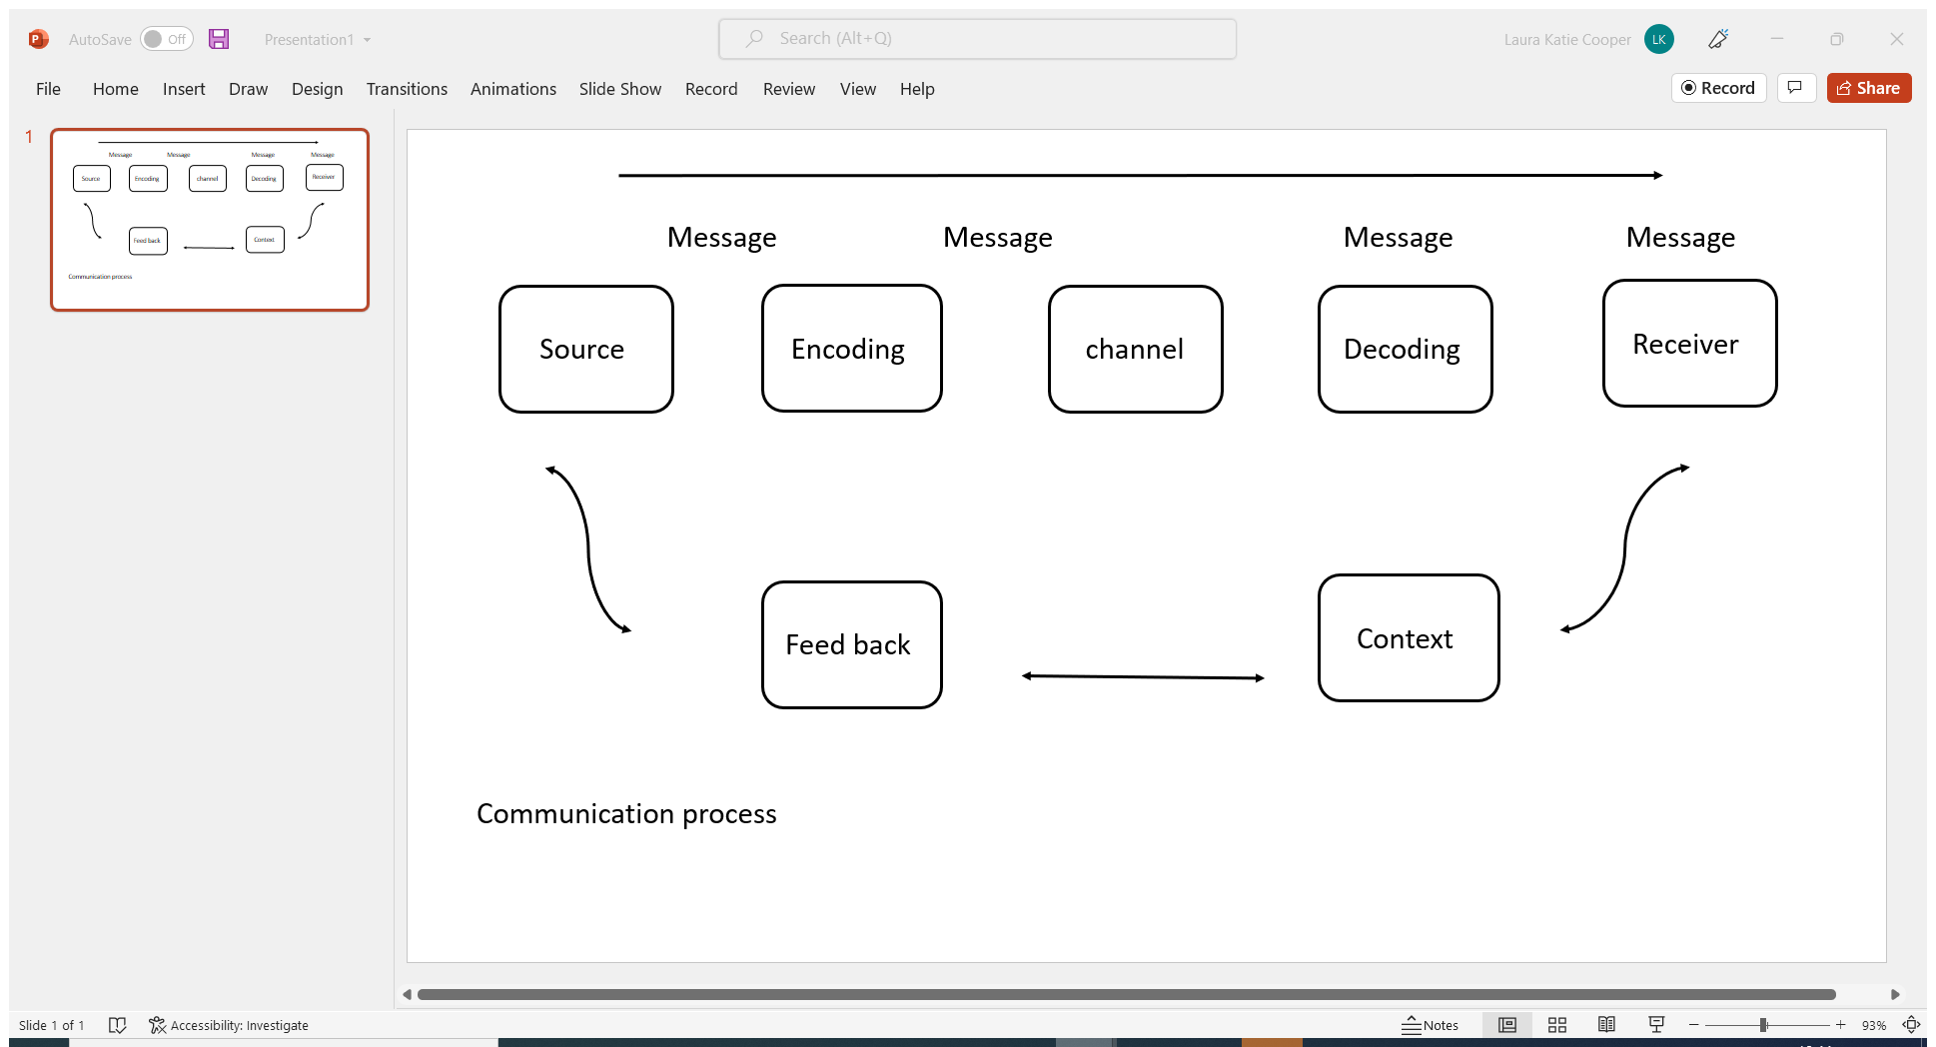
Source- the source of the communication process is the sender; the sender must have a reason as to why the need to convey a message across to another.
Message – the message of the communication process is the information of communication that is needed to be conveyed over to another.
Encoding- the encoding of communication process is when you take a message and encode into a format in what is suitable to the audience with whom are intended to hear your message.
Channel- the channel of communication process is when the source chooses the method in how communication is portrayed for the benefit of the audience. (For example, an email or phone call)
Decoding- the decoding of communication process is when a message is received and how someone takes the information in, so for instance if we have a face-to-face interaction the decoding process would be the ability to listen and take the information in and process the message accurately.
Receiver – the receiver communication process is when the audience has received the message and they have got their own views, opinions and perspectives.
Context- the context communication process is several barriers in what can affect effective communication, this can include the relationship in whom the audience is, or the general environment.
Feedback- the feedback of the communication process is the response that you receive back, did the audience receive the message on what was attended to be received, the feedback all depends on how the message was formatted across and if there was information that required feedback.

1.2- theories of communication.
There are several theories of the communication cycle, the theories that I will be looking into, and understanding and explain on the importance of communication into workplace are.
- Shannon and weaver
- Schramm
- Berlo
David Berlo- SMRC model
In 1960 David Berlo used the basis Shannon-weaver model of communication and developed it into their perspective of the model of communications where SMRC model of communications was developed in “the process of communication”.

SMRC model of communications is based on face-to-face communication, where cultural and social settings are taken into consideration also the environment all around the setting where communication is taken place.

(berlo, 1960 )
Shannon and weaver model of communication

In 1949 Claude Elwood Shannon and Warren Weaver came up with the theory of model of communication in a “the mathematic in communication theory” in 1949.
They came up with model that included 5 steps.
This communication model between machines ended up setting the explanation of how we communicate as a whole society.

(shannon, 1963)

The Mathematical Theory of Communication

Shannon and weaver 1949
The image of the model of communication above explains how Shannon-weaver’s 5 steps of transmission of message are delivered.
Information source is the message that is transmitted, then reaches encoding which is when the message is encoded into a signal format suitable for the channel to use, to arrive at decoder to then change the signal into information to then arrive at destination.
Shannon-weaver’s model of communication set the basis of a model of communication for others to then interpret their own views of a communication cycle.

Schramm model- Wilbur Schramm

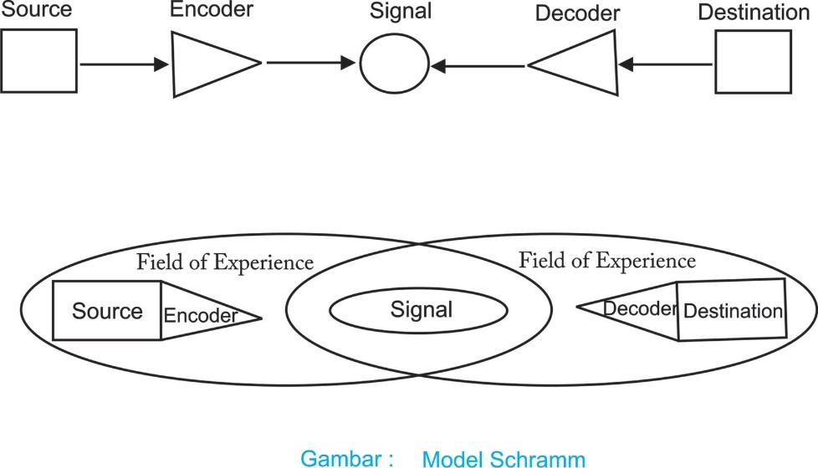
Diagram a

Diagram b

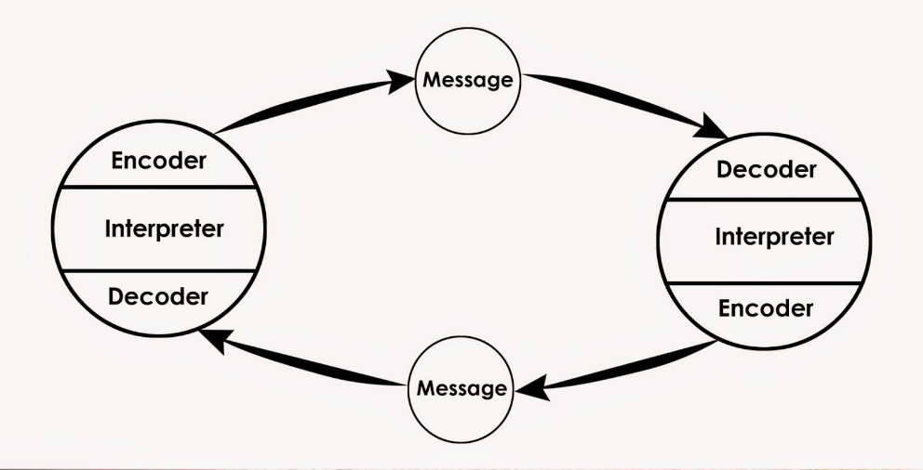
Diagram c

Schramm d 1955

(Schramm Wilbur 1954)

Wilbur Schramm proposed 3 completely different models of communication in 1954 in an article “how communication works”
diagram A, Wilbur Schramm’s works is very similar in the thoughts of the way in which communication works to the Shannon-weaver theory in how the way communication works and what channels communication travel through.
Diagram B, Wilbur Schramm’s theory of model of communication is that to truly have a complete understanding of one’s communication is to have a shared experience.
Diagram 3, This model of communication that’s been constructed by Wilbur Berlo is called the feedback loop, where this implies that’s to have effective communication between one and another there is always a constant need for feedback and based of face-to-face interaction.

Noise
Noise is a term used to describe barriers that can interfere with the clear delivery of any form of communication and disturb the message that is being delivered, there are numerous different forms of ‘noise’ which depends on what type of environmental setting the communication takes place, the four main types of noise barriers that could affect effective communication are:
Physical noise -physical noise is physical noise that disrupts communication so it could be background music or a dog barking.
Physiological noise- physiological noise essentially means biology, for example there could be a hearing impairment, or the feeling of being unwell.
Psychological noise- psychological noise is a mental or emotional barrier that affects communication, for example there could be something on your mind which affects concentration, the feeling of nerves or anxiety.
Sematic- sematic noise could mean a difference of languages, words used that a person does not have the complete understanding.

For example, while working in a kitchen setting there a several forms of noise that would interfere in me preforming my job role, our main form of communication from the kitchen to the front of house staff downstairs would be the usage of radios, the usage of radios to communicate was a big barrier in having clear communication, the front of house staff would have very loud music being played in the venue from being a nightclub-restaurant.

Communication in the workplace
Communication in the workplace, we different forms may this be verbal communication, nonverbal or written communication we also use different ways to communicate, may this be face to face conversations, emails or online meetings with one or more individuals
While you’re communicating with another individual or more, there are a few measures which can be used to improve on how we communicate clearly, for instance if you are the sender of the message, the message needs to be clear, have the correct grammar, the correct use of language for that one individual needs, be clearly spoken if vocal communication has been used with the positive body language to accompany. Clear objectives given for the reason of communication, open mindedness to questions of uncertainty.
When you’re the receiver of communication there are a few steps to ensure that an individual has your full concentration in verbal communication, show good eye contact, and body language, stay engaged, don’t interrupt and ask any question with anything your unsure of.
Verbal and nonverbal communication
The importance of verbal communication is that its our main form, weather its vocal, written. This is how we can get our communication across most accurately to ensure that full understanding has been achieved. If any problems do arise, then this is the best scenario in which can be solved.
The importance of understanding nonverbal communication is to have understand in how our bodies can communicate for us even without us knowing, so for example if we don’t contain eye contact or remain interactive by giving body movements this could cause problems, as this shows that an individual isn’t fully involved in the discussion.
Our levels of verbal and nonverbal communication will be different with whom we are communicating with, for example when you communicate with a friend, you’re most likely to be more interactive rather than with your superior.
Own workplace communication
I would say my communication in the workplace is relatively strong but need improving, vocal communication is most used through the kitchen, where this may be through speaking to one and other or through radio system that is in place. Messaging services are also used with all key information being expressed to staff, orders are placed over phone call for ingredients and sent on an email. Handover and record keeping sheets are completed daily for key information between day-to-day staff, with weekly team meetings being held for all.

2.1 Assessing communication skills

Topic | Assessing my own communication skills
Vocal tones used, language. | I believe I do use the correct language and mannerism when I talk but often find myself stutter.
Written- correct use of grammar and spelling. | I think I have an average use of written communication skills; I quite often get little spelling mistakes wrong.
Body language – is body language in line with what you say. | Nerves are a big problem with my body language, as I start to fidget and get distracted easily, may seem like I’m not paying attention on times due to this.
Clarity- are you clear in how you communicate | When I find I stutter I often get myself more worked up, which can cause communicating problems.
Listen-do you listen? | I’m a good listener but often find myself interrupting others while they speak.
Communicator- do you think you communicate effectively? | I believe my communication needs a lot of improvement, may this be in the way I communicate with another or with my body language

Feedback sheet-
Skill | Assessment | Below average | Average | Good | Very good | Feedback comments.
Structure | Did I follow the correct topic? |  |  |  |  | Followed correct structure on topics
Vocal | Was the vocal clear and understanding? |  |  |  |  | Vocals got muddled up on times and not clear enough.
Visual aid | Was visual aid used appropriately? |  |  |  |  | Didn’t refer to images, just pictures on the screen
grammar | Was there correct use of grammar? |  |  |  |  | grammar use was ok, few spelling mistakes
Body language | did I keep eye contact?  Keep focus? |  |  |  |  | Eye contact wasn’t kept, fidgeting and kept reading of screen
Information | Was there enough information provided? |  |  |  |  | Information provided was ok but could’ve had a few more facts.
Analyse feedback-

I agree with the feedback I have received from presenting a presentation, nerves got the better of me, I had a few technical problems while presenting which is all down to myself when I should’ve been better prepared, which will help my be more prepared for next time, I found myself getting muddled up and losing my place which resulted in unclear communication on times, I have learnt a lot on presenting this presentation and in conclusion I need to be better prepared in how I choose to present with practice, speak more directly to my audience with being clearly spoken, with use of prompt cards to keep my body language in check.

Objectives  Goals to improve on? | Lacking?  How am I lacking? | Action  How will I improve and by? | Time frame  What time scale
Clarity- be clear on how I speak to another individual | Muddled up in vocal communication | Speak more slowly, usage of the correct words. | 2nd April – 2nd July
Listen more with communication | Interruption of others | Listen more to others and wait until their finished until I speak | 2nd April – 2nd may
Learn more about communication skills | The different ways in communication i.e. nonverbal and verbal | Study more about communication skills as a manager | 2nd April – 2nd July
Body language | Distraction easy, loss of eye contact between another | Give my full focus on an individual while communicating | 2nd April – 2nd July
Personal development plan- communicating as a manager

References

Berlo.
Effective communication skills. 2012a. MTD Training & Ventus Publishing Aps.
Effective communication skills. 2012b. MTD Training & Ventus Publishing Aps.
MA, F., 2015. Information communication. San Rafael, California: Morgan & Claypool Publishers.
MAUND, A., SCHRIEK, M. and TINKLER, P.K., 2017. Certificate in higher education: skills for the workplace student yearbook. London: Sage.
MDEL SCHRAMM.
PANDE, N., 2020. SMCR Model.
R.
SCHRSMM WILBUR, 1954. how communication works.
SHANNON CLADYE E, 1949. the mathematical theory of communication. university of Illinois press.
shannon_weaver_model.

