Qualification: CIPD Diploma in Applied Human Resources

Module Name: Using a Research Approach in Human Resources – 5C1HR

Word Count: 775

Student Name: Catherine Evans
Student Number: 1919841
CIPD Membership Number: 49835269

By signing below, I confirm that the work/evidence presented is my own, unaided work. I understand the regulations pertaining to candidate malpractice and the action that may be taken as a result.

Signed: C. A. Evans
Date: 14/10/2020

1.1

Human Resource research is an integral part of HR and leads to knowledge and understanding of areas, replacing the slower road of trial and error. (Dale Yoder nd). The research process requires the collation of information, analysing data, conclusion and recommendation.

The first stage is to identify an area of research and Anderson (2013) suggests that HR Professionals take time to think carefully about their subject area. Potential areas are areas that can be of concern to the organisation, areas that the researcher has a particular interest in, areas that have been researched previously or areas that the researcher has easy access to. Once the area has been identified the researcher can formulate their aim and objectives.

To find out what is currently known in the research area one of the most important sources of data is an academic literature review as suggested by Anderson (2013) and Horn (2012). The researcher needs to read up on their subject area to evaluate what is already known and what secondary data is available ie. data that already exists.
Primary data, which is new data is then sourced by using surveys, interviews, focus groups or observation. The differing data types which are qualitative (words and meanings) and quantitative (numbers and statistics) are then analysed before conclusions and recommendations can be made.

Stages of the research process. Anderson (2013)

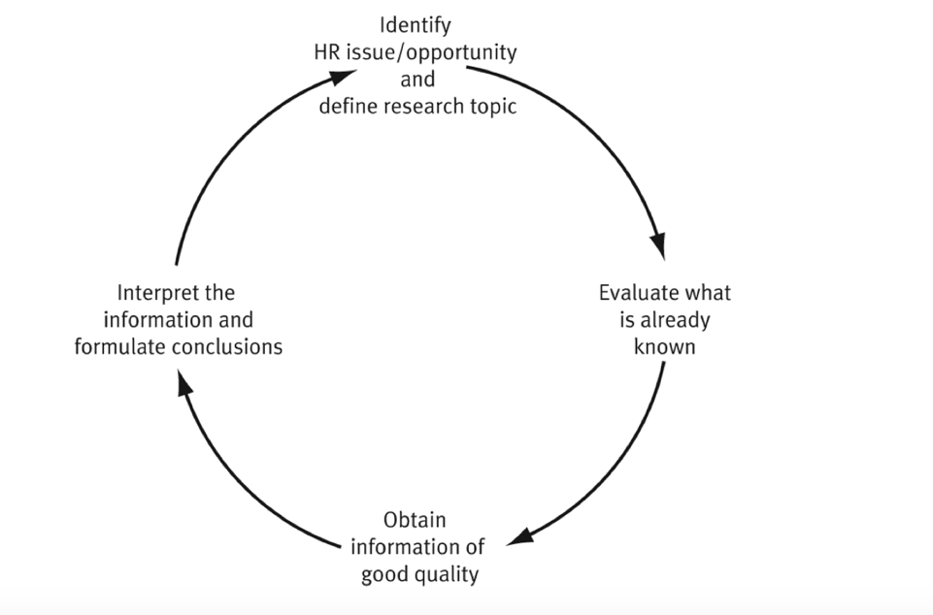

1.2

Once the researcher has their topic they must then plan the research project journey. As recommended by Bryman and Bell (2015) the research design must meet three basic criteria:
- Reliable
- Replicable
- Valid

There are four research designs as recommended by Anderson (2013)

Cross Sectional - a collection of data from a group or individuals at a set point in time. This is useful for identifying patterns or trends within an organisation as they can be repeated in the future. The quality of data collected will depend on the quality of survey or interview questions. The BMJ (2014) notes that this type of research when repeated could be difficult to assess as differing groups of participants have differing opinions.

Case Study is used for a specific detailed real-life investigation such as organisational culture. Research is carried out by interviewing or observing employees. Yin (1984) highlights that they can however be too long, difficult and produce large amounts of qualitative data.

Action research can be used to solve a particular problem by understanding and promoting change. Taylor & Woodhams (2016) details that this can however be time consuming descriptive research rather than explaining why things are that way.

Comparative research allows for comparisons between different groups or organisations. It is an investigative process which allows organisations to build on wisdom and errors of others, figuring out what works well and what doesn’t and borrowing ideas accordingly therefore saving valuable time. Viget (2017) Unfortunately not all environments have a sufficient amount in common to make this type of research successful.

Taylor & Woodhams (2016) points out that neither of the research designs are any better or worse, but differing designs are more appropriate in differing situations as can be seen below.
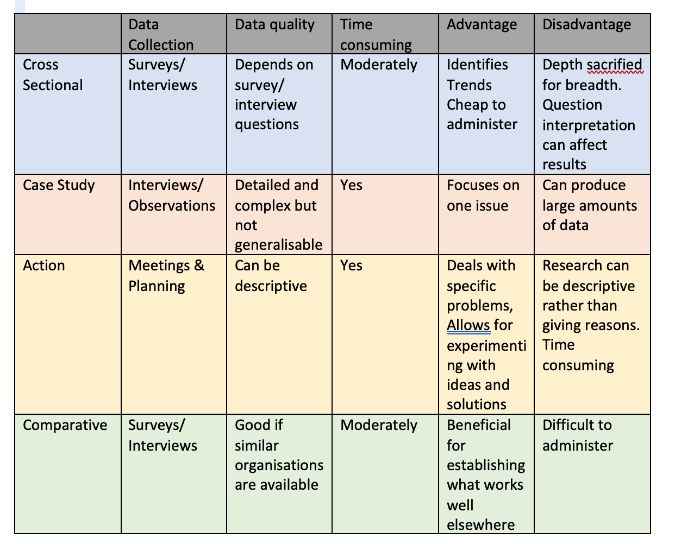
1.3
Human Resource research evaluates current HR practices and performance in order to recommend improvements. The new CIPD Profession Map has ‘Evidence-based’ as one of the main three values and when providing a business case to amend an organisational practice, key stakeholders require robust evidence from a variety of sources to ensure credibility.
According to SHRM (2015) culture and relationships have been shown to be an important as financial rewards that come with a role. Cross Sectional research would assist in finding out what the employees think and comparative research would compare similar businesses and what they do to keep their employees satisfied. Within Dyfed Powys Police we regularly use staff surveys to research these areas.
A study by Pessiglione et al (2007) tells us that humans adapt their effort depending on the amount of reward expected. This allows for two comparative research opportunities as job descriptions and salaries across similar organisations could be compared along with researching benefit and reward plans. Cross sectional research surveys would establish what rewards employees expect.
Minority ethnicity applicants need to send 60% more job applications to gain the same interest level as majority applicants as researched by Personnel Today (2019). Action research along with case studies can be used in order to understand and promote change to eliminate discrimination, allowing for actions to be monitored to check effectiveness over time.
CIPD 2015 tell us that more research is required around recruiting strategies as the approaches to recruitment become more evidence-based by using comparative and cross sectional research in order to attract and retain talent.

Bibliography

Anderson, V (2013) Research methods in human resource management. 3rd ed. London: Chartered Institute of Personnel and Development

BMJ (2014) Cross Sectional Studies, available at:
https://www.researchgate.net/profile/Philip_Sedgwick/publication/275427950_Cross_sectional_studies_advantages_and_disadvantages/links/589a11f5aca2721f0db11fd3/Cross-sectional-studies-advantages-and-disadvantages.pdf – accessed 26/09/2020

Bryman, A and Bell, E (2015) Business research methods. 4th ed. Oxford. Oxford University Press

CIPD (2017) In search of the best available evidence, available at:
https://www.cipd.co.uk/Images/in-search-of-the-best-available-evidence_tcm18-16904.pdf – accessed 02/10/2020

CIPD (2015) The behavioural science of recruitment and selection, available at:
https://www.cipd.co.uk/Images/a-head-for-hiring_2015-behavioural-science-of-recruitment-and-selection_tcm18-9557.pdf – accessed 03/10/2020

Horn, R (2012) Researching and writing dissertations, a complete guide for business and management students. 2nd ed. London: Chartered Institute of Personnel and Development

HR Research report, nd, available at:
https://www.businessmanagementideas.com/human-resource-management-2/hr-research/20360 - accessed 06/10/2020

Jurnal Kemanusiaan (2007) Case Study as a research method, available at:
http://scholar.google.co.uk/scholar_url?url=https://jurnalkemanusiaan.utm.my/index.php/kemanusiaan/article/download/165/158&hl=en&sa=X&ei=dsl5X5DnFpOdmwHF7KeAAQ&scisig=AAGBfm1Huvr9cviHU8uV3x20Izl3ihZa8w&nossl=1&oi=scholarr – accessed 06/10/2020

Personnel Today (2019) available at:
https://www.personneltoday.com/hr/study-finds-alarming-discrimination-against-minority-ethnic-candidates/, accessed 14/10/2020

Pessiglione et al (2007), How the brain translates into money, available at:
https://www.ncbi.nlm.nih.gov/pmc/articles/PMC2631941/ - accessed 07/10/2020

SHRM (2015), Employee job satisfaction and engagement, available at:
https://www.shrm.org/hr-today/trends-and-forecasting/research-and-surveys/Documents/2016-Employee-Job-Satisfaction-and-Engagement-Report.pdf - accessed 14/10/2020

Taylor & Woodhams (2016), Studying Human Resource Management, 2nd Edition, Chartered Institute of Personal and Development: The Broadway, London

Viget, (2017) The Advantage of Comparative Research, available at:
https://www.viget.com/articles/the-advantage-of-comparative-research/ - accessed 07/10/2020

