

Programme: BSc Health and Social Care
Module: Changemakers: Creativity and Value Creation
Module code: BMHP5014

Student name: Alexandra Elena Galiceanu
Student number: 2330542

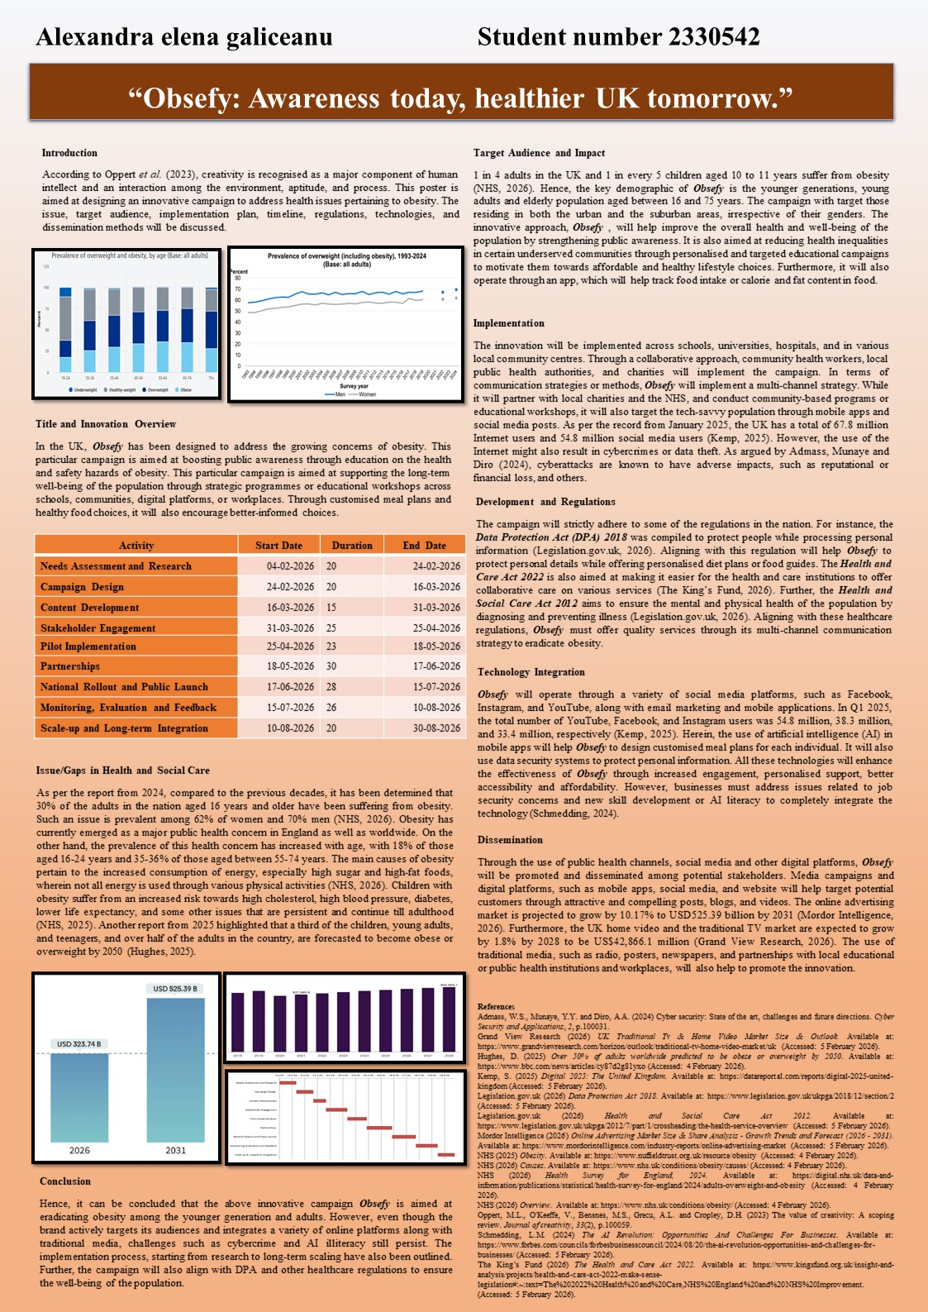
Table of Contents
Written Pitch 4
Introduction 4
Implementation plan 5
Value, Feasibility & Recommendations 6
References 8

Written Pitch

Introduction
Raising awareness about obesity among UK people involves the implementation of ideas for the innovation process. The Obsefy awareness campaign mainly focuses on reducing obesity prevalence risk by promoting, for instance, a healthier diet. I will raise further awareness regarding obesity among the people within the UK. The stakeholders for this campaign will be NHS leaders, policymakers, and organisation heads. In the nation, in every 4 adults, around 1 and around 1 in every 5 children aged 10 to 11 are surviving with obesity (NHS, 2026). The awareness campaign will target the adults who are aged 16-75, families with children and communities with higher deprivation scores. The main focus of this campaign will be on encouraging healthier food choices, increased physical activity and weight loss to prevent long-term disease.

Figure 1: Logo of the campaign
(Source: Created by the learner)
The key components of the campaign will be education, behavioural support and policy-driven structure. The campaign will use positive and motivational messaging to encourage small changes rather than drastic ones. This will highlight that being overweight is the second biggest preventable cause of cancer after smoking. Educational content will be provided to reduce the sugar intake and manage portion sizes, often aimed at parents (Christensen et al., 2022). The campaign will use mass media to connect weight to immediate health dangers and long-term risks. It will mainly direct people to connect with the awareness program. This will work with local authorities, primary schools, and commercial partners.
My campaign will provide significant information and awareness, and it will have a significant impact, which can enhance the public's knowledge and a better understanding that obesity is a significant risk factor. It will inspire individuals to take small and sustainable actions. It will support the policy changes for legislative actions and promote healthier environments. Obesity is the main risk factor for severe disease, which can be difficult and an immediate health priority (Mohajan and Mohajan, 2023). Stigma remains the largest challenge to seeking care, which needs a shift in narrative toward testing it as a chronic disease. Increased awareness is needed around new medical treatments.

Implementation plan
The innovation campaign will be used across schools, universities, hospitals and commercial partners. The campaign will have a significant impact through a collaborative approach with the help of community health workers, local public health authorities and charities. The implementation plan will need a comprehensive approach to raise awareness about obesity in the UK. The campaign will target the health-conscious audience, such as adults, parents, children and high-risk communities, to understand the drivers and barriers to healthy weight. It will partner with the NHS, local councils, charities and health community groups. It will be highlighted through TV ads, social media, radio spots and posters. I will test the campaign in the West Midlands before national rollout to measure effectiveness and refine the approach.
Experts will be engaged in eating disorders and people with lived experience to review materials to minimise harm to vulnerable groups. It will be launched at the beginning of the year. I will evaluate social media sentiment and public response to analyse the feedback. I will mainly focus on the key terms such as excess weight and health rather than obesity. It will recognise individual action, which should be supported by environmental changes. The key stakeholders will be NHS leaders, policymakers, health care professionals and organisation heads. I will partner the campaign with the weight management and physical partners, media and retail partners and academic partners. The key resources will be digital tools, marketing and communication materials and training building. An online weight management plan and activity tracker will be the key online tools that I will use. Social media marketing will be leveraged, and digital screens will be utilised for marketing and communication materials (Chakraborty and Jain, 2022). A specific training will be provided for the healthcare professionals on having constructive conversations about weight and using non-stigmatising language.
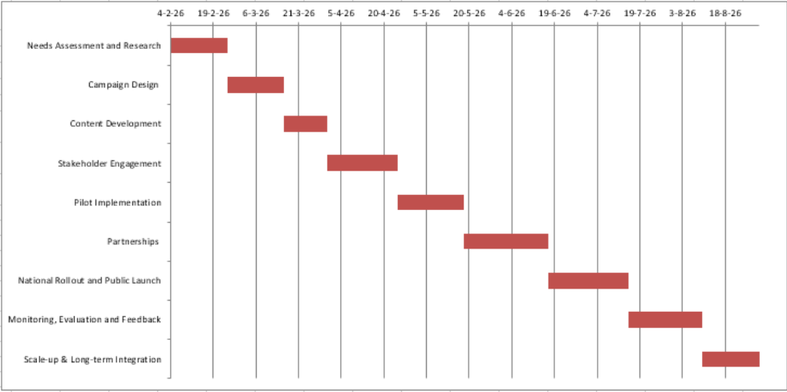
I will ensure the personal data and information of the patients remain safe. For this, the Data Protection Act 2018 will be adhered to. This is an act that will secure the data and information of the participants and patients (Legislative.gov.uk, 2026). I will obtain explicit and informed consent when processing sensitive health information such as BMI and health status. It will collect the minimum amount of personal data that is necessary for the campaign. This will align with the NHS regulations and advice on weight management. The campaign will offer customised advice, which will be provided by qualified professionals.
Figure 2: Timeline
(Source: Created by the learner)

Value, Feasibility & Recommendations
The campaign aims to reduce obesity-related hospital admissions, obesity-related illness and mental health issues. It will promote a healthier lifestyle by encouraging weight management tools, which result in healthier shopping habits. It will help to understand obesity as a complex, chronic disease which needs long-term care. The campaign aims to support the children’s diets annually. The principal lifestyle drivers of ill-health and disease will be addressed by the strategy. However, it can lead to comfort eating, as public health messaging often backfires by causing shame. The modern UK environment makes healthy choices complex. High-fat, salt and sugar foods are highly promoted and often cheaper than healthier options. The audience believes that obesity is merely a lack of willpower and ignores genetic and metabolic factors (Goldkorn et al., 2025). Many individuals fail to recognise themselves as having an average BMI. I will provide realistic solutions, such as replacing obese people with people living with obesity. It will mainly focus on health, energy and mental well-being. It will be an advocate or policy change, which includes restricting junk food advertising rather than just telling consumers to eat better. Future scaling will be included and integrated with AI for customised nutrition and using wearable technology to monitor activity in real-time. The efforts of the company will have a significant motivation for some individuals. I will encourage my audience to move from passive understanding to active and evidence-based behaviour change. The main objective is to engage with online and evidence-based tools. It will connect with the community and national weight-loss support groups.

References
Chakraborty, A. and Jain, V. (2022) Leveraging digital marketing and integrated marketing communications for brand building in emerging markets. In Marketing Communications and Brand Development in Emerging Economies Volume I: Contemporary and Future Perspectives (pp. 281-305). Cham: Springer International Publishing.
Christensen, B.J., Bestle, S.M.S., Trolle, E., Biltoft-Jensen, A.P., Matthiessen, J. and Lassen, A.D. (2022) A qualitative evaluation of social aspects of sugar-rich food and drink intake and parental strategies for reductions. International Journal of Environmental Research and Public Health, 19(18), p. 11647.
Goldkorn, M., Schwartz, B. and Monterosso, J. (2025) Views Among the General Public on New Anti‐Obesity Medications and on the Perception of Obesity as a Failure of Willpower. Obesity Science & Practice, 11(2), p. e 70041.
Legislative.gov.uk (2026) Data Protection Act 2018. Available at: https://www.legislation.gov.uk/ukpga/2018/12/contents (Accessed: 5 February 2026).
Mohajan, D. and Mohajan, H.K. (2023) Obesity and its related diseases: a new escalating alarming in global health. Journal of Innovations in Medical Research, 2(3), pp. 12-23.
NHS (2026) Overview. Available at: https://www.nhs.uk/conditions/obesity/ (Accessed: 5 February 2026).

