Traian Cristian Roibulescu Student ID : 2215953 Lecturer : Kathryn Flynn
Module : International Meetings Management for the Hotel Industry BMIH6007

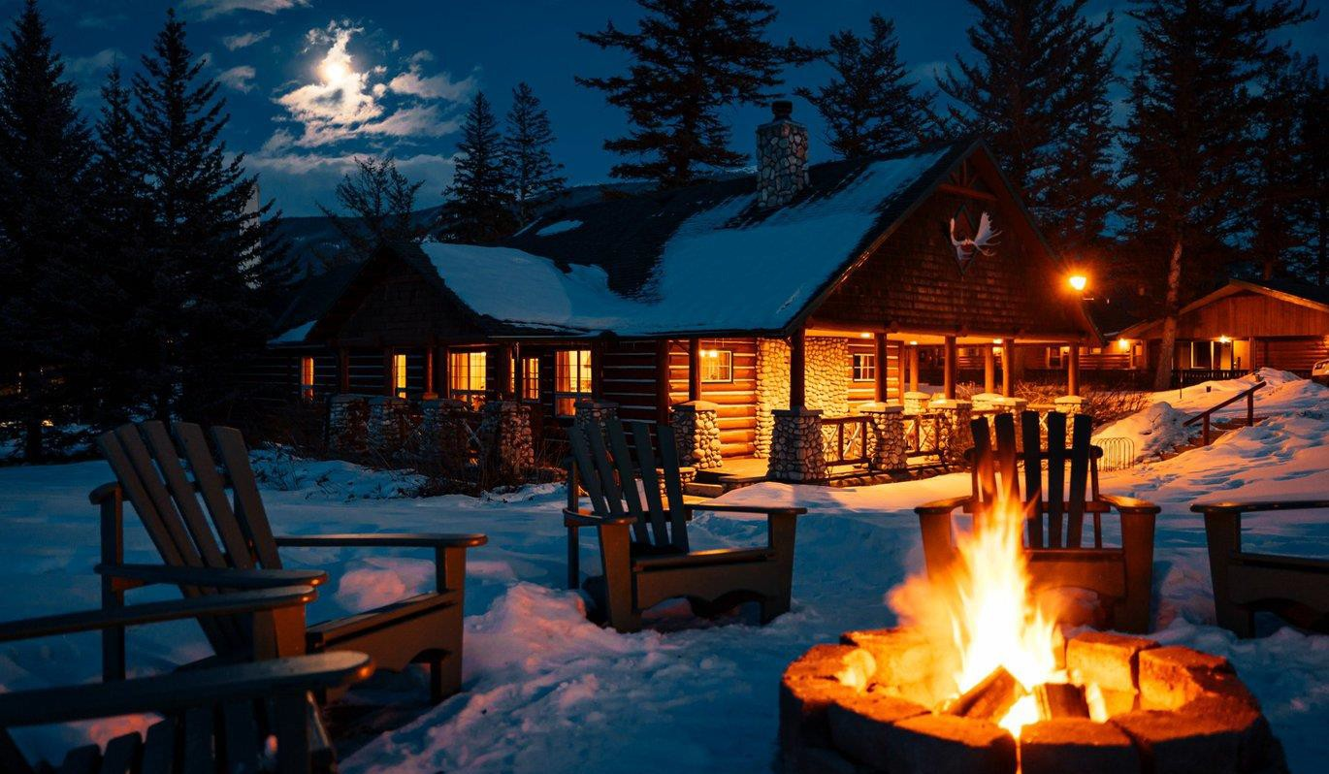

A Winter Wonderland Event in the Bucegi Mountains, Sinaia
Revitalizing the Local Economy Through Festivities

Sponsored by Marriott Hotels, Mandy Foods Romania, and the
Sinaia Local Council

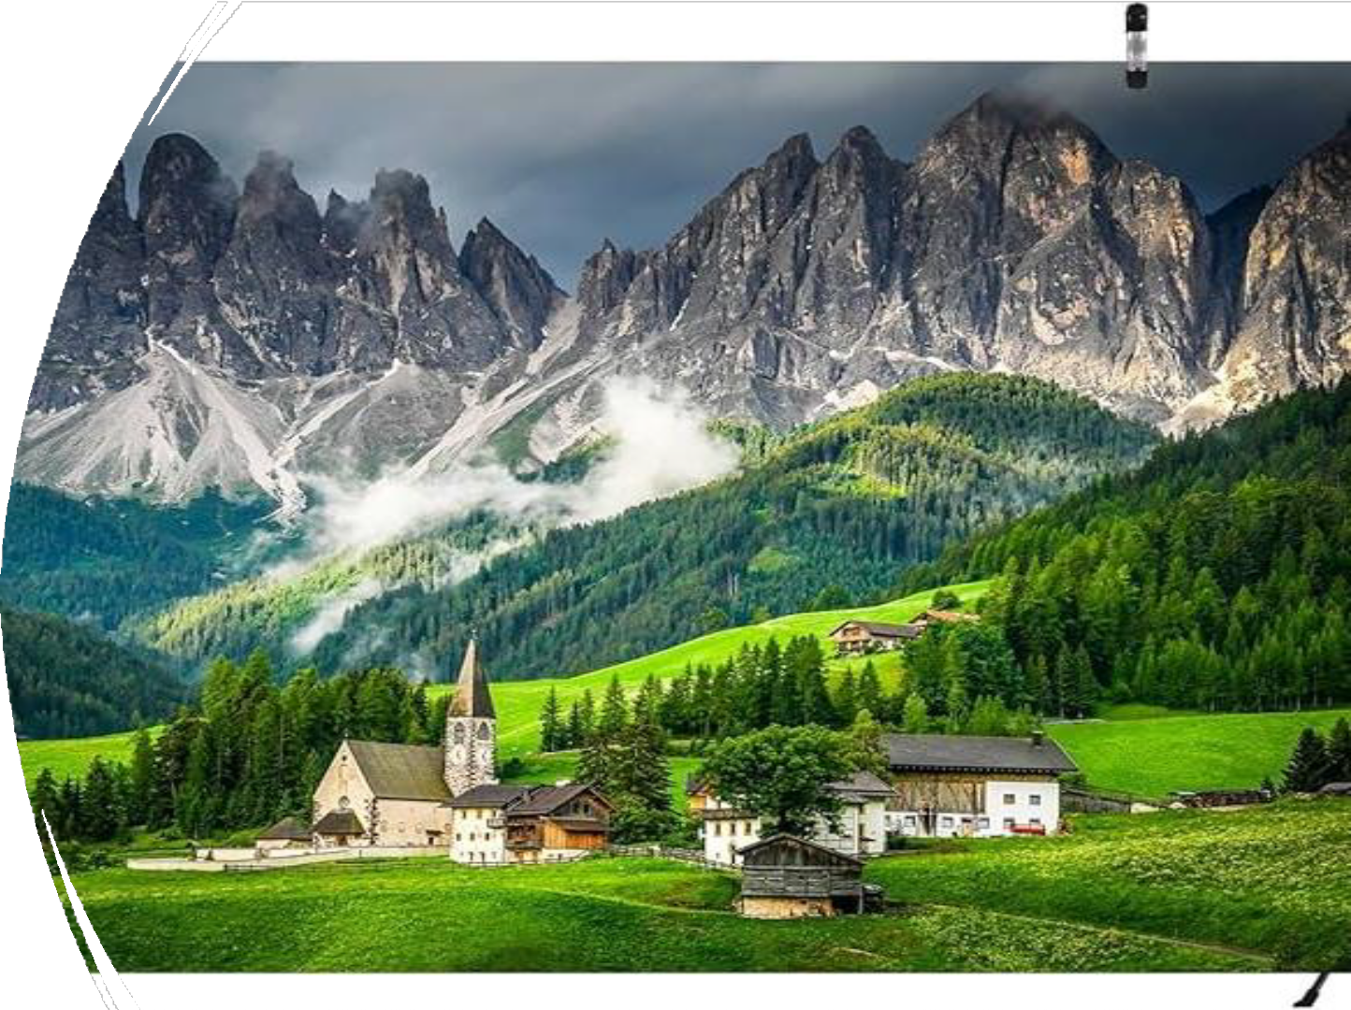

Introduction

- Event Date: 12/06/2024 –
01/06/2025
- Location: Bucegi Mountains, Sinaia
- "An enchanting event that combines winter sports, family fun, traditional Romanian cuisine, and a meaningful social impact."

Sponsored by Marriott Hotels, Mandy Foods Romania, and the Sinaia Local Council


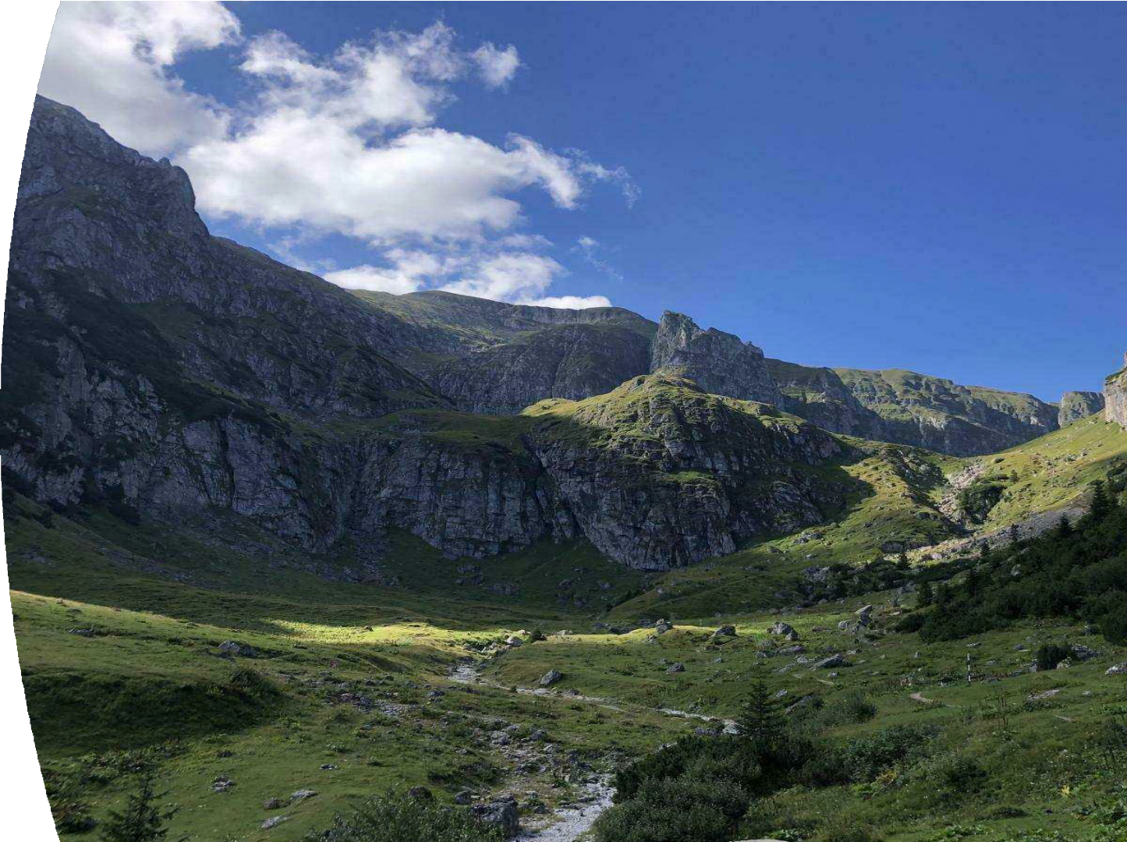

Attractions and Layout

- Cozy mountain cottages
- Ski slopes for all levels
- Amusement park
- Traditional Romanian meal festival

Sponsored by Marriott Hotels, Mandy Foods Romania, and
the Sinaia Local Council

Objectives & Stakeholders

  - Revitalize the local economy
  - Highlight Romanian culture
  - Provide diverse winter entertainment for all ages
  - Contribute to local charities
  - Marriott Hotels, Sinaia Local Council, Local Vendors, Rossignol, Traian Roibulescu

Sponsored by Marriott Hotels, Mandy Foods Romania, and the Sinaia Local Council

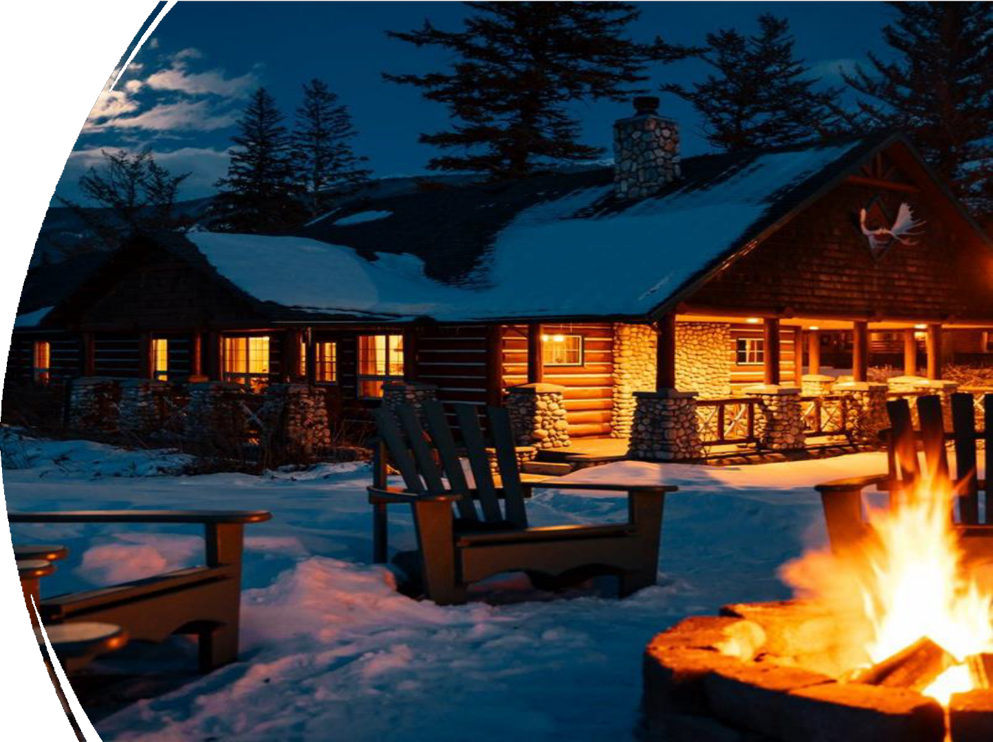

Stay in Luxury
Cottages

- Options: Standard, Luxury with Hot Tub, Family Cottage
- Pricing:
- Standard Cottage (4 persons): 1,200 RON per night
- Luxury Cottage with Hot Tub (4 persons): 1,800 RON per night
- Family Cottage (6 persons): 2,200 RON per night
- Partnership with Marriott Hotels for exclusive accommodations

Sponsored by Marriott Hotels, Mandy Foods Romania, and the Sinaia Local Council

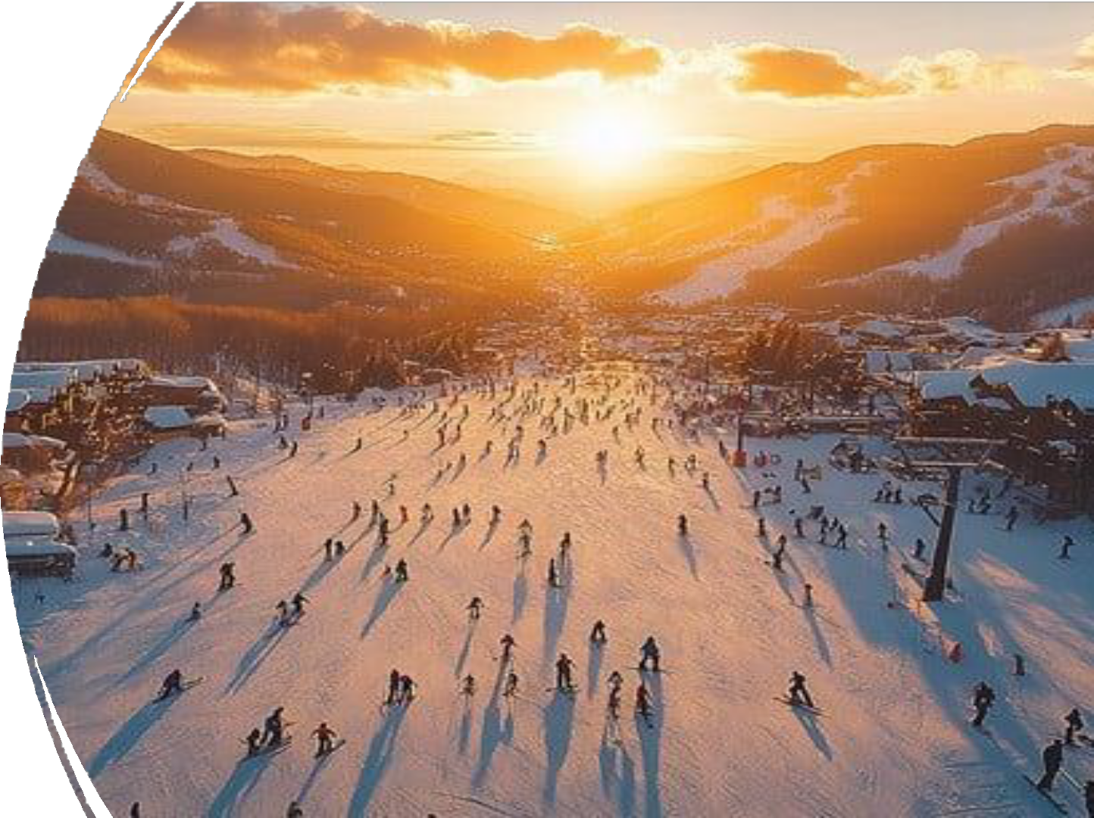

Skiing &
Snowboarding

- Ski slopes suited for all levels
- Ski instructors for beginners
- Advanced runs for experienced
skiers
- Convenient location behind the cottages

Sponsored by Marriott Hotels, Mandy Foods Romania, and the Sinaia Local Council

  - Ferris wheel, ice skating, bumper cars, carousel

Fun for Families and Groups
  - Accessible pricing:
  - Ice Skating: 30 RON per person
  - Bumper Cars: 20 RON per ride
  - Ferris Wheel: 25 RON per person
  - Carousel Ride: 15 RON per person

Sponsored by Marriott Hotels, Mandy Foods Romania, and the Sinaia Local Council


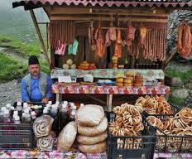

A Culinary Celebration
- Authentic Romanian cuisine: sarmale, papanasi, vin fiert, and more
- Affordable pricing, supporting
local vendors
- Live folk music and artisan goods
- Pricing: Vin fiert – 12 RON, Sarmale – 30 RON




Social Responsibility

- A percentage of proceeds supports local charities
- Charity raffles and donation
opportunities for attendees
- Empowering the community through education, health care, and social services

Sponsored by Marriott Hotels, Mandy Foods Romania, and the Sinaia Local Council

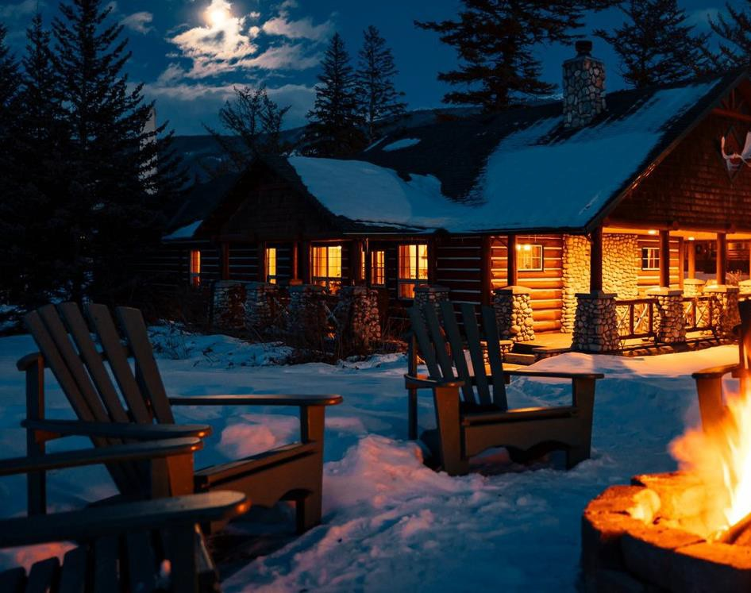


Join Us in Sinaia!

- Experience the magic of a winter wonderland while supporting local communities."
- Call to Action: Purchase tickets and accommodations early to secure your spot!

Sponsored by Marriott Hotels, Mandy Foods Romania, and the Sinaia Local Council

  - Budget Bucket List (2024) Sinaia Available at: Sinaia: Romania's Winter Wonderland | Budget

Reference list
Bucket List (Accessed: 8 October 2024)
  - Rferl.org (2023) Bucharest Comes Alive With Festival Of Winter Traditions Available
at: Bucharest Comes Alive With Festival Of Winter Traditions (rferl.org) (Accessed: 8 October 2024)

  - Bram (2023) Winter In Romania: Amazing Places To Visit In Romania In Winter Available at: Winter In Romania: Amazing Places To Visit In Romania In Winter (chasingthedonkey.com) (Accessed: 8 October 2024)

  - Cernaianu D. (2024) Celebrating Romania: A Guide To Cultural Festivals And Events Available at: A Comprehensive Guide to Cultural Festivals and Events- Holiday to Romania - take your holiday to the next level! (Accessed: 9 October 2024)
  - Airbnb (2024) Holiday Rentals in Bucegi Mountains Available at: Bucegi Mountains Holiday
Rentals & Homes - Prahova, Romania | Airbnb (Accessed: 9 October 2024)

  - Ski Resort Sinaia (2024) Ski Holidays Including Lift Pass Available at: Ski resort Sinaia - Skiing Sinaia (Accessed: 9 October 2024)

  - https://www.google.com/url?sa=i&url=https%3A%2F%2Fwww.pinterest.com%2Fpin%2Ftradi tional-romanian-food-shack-960-x-700-- 518688082094880173%2F&psig=AOvVaw1K80fN5Y3rm0skRtWpr7Mf&ust=17290183503610
00&source=images&cd=vfe&opi=89978449&ved=0CBcQjhxqFwoTCMjZirbFjokDFQAAAAAdA AAAABAE

  - https://www.google.com/imgres?q=charity&imgurl=https%3A%2F%2Fres.cloudinary.com%2 Fparallax- agency%2Fimage%2Fupload%2Fc_fill%252Cq_auto%252Cf_auto%252Cw_993%252Ch_668% 2Fstatamic%2Fsots-uploads%2FArticles%2FFundraising-news%2Fgiving-to- charity.jpg&imgrefurl=https%3A%2F%2Fsimononthestreets.co.uk%2Fnews%2Ftop-5-simple- ways-to-get-involved-with-charity-without-it-being-an-effort&docid=h- H3lwjfpqDfCM&tbnid=hXI9sH1xDUTJ9M&vet=12ahUKEwixiOjTxY6JAxVWAnUBHQd5CGcQM3 oECHwQAA..i&w=993&h=668&hcb=2&ved=2ahUKEwixiOjTxY6JAxVWAnUBHQd5CGcQM3oE CHwQAA

  - https://www.google.com/url?sa=i&url=https%3A%2F%2Fstockcake.com%2Fi%2Fsunset-ski- slopes_1295092_1160327&psig=AOvVaw0gJU4IO5T29PLd2P5psAHO&ust=17290184405010 00&source=images&cd=vfe&opi=89978449&ved=0CBQQjRxqFwoTCKCNiOHFjokDFQAAAAAd AAAAABAE

  - https://www.google.com/url?sa=i&url=https%3A%2F%2Fvisitorcenter.ro%2Fproduct%2Fbuc egi-mountains%2F&psig=AOvVaw2nh-LGb6-0- myIIINF4XjY&ust=1729018469970000&source=images&cd=vfe&opi=89978449&ved=0CBQQj RxqFwoTCIDSkO_FjokDFQAAAAAdAAAAABAE

Sponsored by Marriott Hotels, Mandy Foods Romania, and the Sinaia Local Council

RomaniaExprience (2023) 25 Amazing Traditional Romanian Foods Available at: https://www.romaniaexperience.com/20-amazing- romanian-foods-you-must-try-in-this-lifetime/ (Accessed: 9 October 2024)
Romania Travel Blog (2023) 8 Attractions in Bucegi Mountains to visit Available at: https://www.secretromania.com/attractions-in-

bucegi-mountains/ (Accessed: 9 October 2024)
RomaniaExperience (2023) 11 Best Things to Do in Sinaia, Romania Available at: https://www.romaniaexperience.com/best-things-to- do-in-sinaia-romania/ (Accessed: 10 October 2024)
Romania-Insider (2023) Romanian Tourism Ministry drafts 2023-2035 development strategy Available at: https://www.romania- insider.com/romania-toruism-strategy-2023-2035 (Accessed 10 October 2024)
Europe in Winter (2022) 17 Wonderful Places to Visit in Romania in Winter Available at: https://europeinwinter.com/romania-in-winter/

(Accessed: 10 October 2024)
Info Travel Romania (2024) Sinaia Available at: https://www.infotravelromania.ro/sinaia-en.html (Accessed: 10 October 2024)
Romanian Friend (2024) Romania in Winter: Weather Available at: https://www.romanianfriend.com/blog/romania-in-winter-what-to-do (Accessed: 10 October 2024)
Eventify (2024) How You Can Organize Sustainable Green Events: A Complete Guide Available at: https://eventify.io/blog/guide-to-

sustainable-events (Accessed: 10 October 2024)
Event Hub (2024) Amplifying Engagement: The Role of Technology In Modern Event Marketing Available at: https://blog.eventshub.app/technology-in-event-marketing/ (Accessed: 10 October 2024)
Rivermate (2024) Romania Health and Safety Standards Available at: https://www.rivermate.com/guides/romania/health-and-safety (Accessed: 11 October 2024)
HSC (2024) Promoting Cultural Events and Festivals in Local Communities Available at: https://www.hscommunities.com/post/promoting-cultural-events-and-festivals-in-local-communities (Accessed: 11 October 2024)

Sponsored by Marriott Hotels, Mandy Foods Romania, and the
Sinaia Local Council

