

LEVEL 7 ASSIGNMENT SPECIFICATION

Student name: | CHAN Sau Lin | Student number: | 1605723
Programme: | DBA
Module: | Quantitative Research Methods | Module Level: | 7
Module code: | SBPD7010 | Contribution to Overall Module Assessment (%): | 40%
Lecturer: | Prof Lee Ngok | Internal Verifier:
Assignment Title: | Project Report | Assignment No : | 1 of 2
Hand Out Date: | 3 Feb 2018 | Submission deadline: | 5 Nov 2017
Referencing: | In the main body of your submission you must give credit to authors on whose research your work is based. Append to your submission a reference list that indicates the books, articles, etc. that you have read or quoted in order to complete this assignment (e.g. for books: surname of author and initials, year of publication,title of book, edition, publisher: place of publication).
Disclosure: | I declare that this assignment is all my own work and that I have acknowledged all materials used from the published or unpublished works of other people. All references have been duly cited.
Student’s Signature: | CHAN Sau Lin | Date: | 8 Apr 2018
Turnitin: Lecturer to tick to indicate if an electronic version of the assignment must be submitted to Turnitin. Note: the Turnitin version is the primary submission and acts as a receipt for the student. All students MUST submit their assessments by the specified deadline. Late submissions will be subject to penalties. |  |  | YES

Perception of product values and user experience

1. Overview

This paper introduces the research proposal and preliminary findings from the pilot tests of a study, mainly quantitative, on the impact of product values on user experience.

Humans have been using tools/products since ancient times. Positive user experience is appreciated by individuals, and cherished by business because it is believed to create customer value and satisfaction, contributing to customer loyalty and business sustainability. In what ways can businesses invest their efforts in building positive user experiences? How should product development be managed to deliver positive user experiences? What values of the products are “valued” by the consumers and users, not only by the enterprises and designers?

There have been numerous studies on consumer behavior and user experience, which are very often skewed towards certain aspects while neglecting the others. For instance, firstly, there are more studies on pre-purchase than post-purchase consumer behaviours, hence paying more attention to the selling rather than the using of the products. Secondly, user experience (UX) literature and education programmes tend to focus on the study of interaction with digital interfaces more than physical products. Thirdly, various models on user experience and/or user behaviour emphasise different aspects and views, such as the Technology Acceptance Model (TAM) focusing on utilitarian aspects and the ultimate user decision of use or not-use of the product, the Kansei approach focusing on the emotional qualities, and the Theory of Reasoned Action (TRA) and Theory of Planned Behaviour (TPB) with the social concern. There seems lacking a comprehensive model which integratively addresses the different product values and the corresponding user experience and satisfaction. Fourthly, most commonly used product development models and tools stand from the point of view of the business or the product developer (possible the designer) rather than the users. These tools may recommend taking in users’ views intermittently such as in the research stage and the prototype testing stage, but not really help to identify or bridge possible communication gaps between the designer and the user. Although there are some studies on the communication models between designers and users, most are on the theoretical rather than practical level.

With the limited time and scale of this assignment, the proposed study would not aim at address all the above concerns. It would focus on identifying the product values valued by users in relation to user experience, in terms of perceived satisfaction and intention for continuous use of the product. The conceptual framework will try to build a holistic view taking into consideration the positive aspects of the related models about user experience and consumer behaviour. The study will also take a preliminary look at the possible differences between the views of designer users and non-designer users. The findings of the study are expected to provide hints for product developers to gear towards designing products with better user values, and for the researchers or tool developers to design better product development tools so as to enhance the ultimate user experience.

2. Literature Review

User experience

Donald Norman, a respected scholar and professional in user experience and design psychology, was among the first to use the term “user experience” in the 1990s, when he named the group he headed at Apple Computer “the User Experience Architect’s Office” (Norman, 2013; Bard, 2016). As defined (Norman, 2013; Winter, 2015), the broad sense of product user experience involves the user’s interaction with the brand before, during and after purchase (Figure 1), including consumers’ reaction to the advertisements, the experience of shopping, unpacking, reading the manual, assembling the parts (if necessary), using the product, evaluating the usability, and contemplating future uses. Norman (1988, 2013) illustrated such experiential stages in the user “action cycle”. The marketing literature and textbooks have largely covered studies on the before- and during- purchase consumer behaviour in topics of marketing and promotion strategies (such as Edell&Burke, 1987; Lee&Mahony, 2004; Dellaert&Stremersch, 2005; Decker&Gnibba-Yukawa, 2010; Nichols&Schumann, 2012), and purchase decision models (such as McFadden, 1986; Ghoshal&Boatwright, 2009; Ghoshal, 2010; Huang&Dubinsky, 2014; Huang, Hong &Chang, 2015), etc. However, the after-purchase user experience is inadequately addressed. Yet, the after-purchase user experience usually lasts for the longest period of time, leaves the deepest impression, and creates a large part of the customer value and satisfaction. The enhancement of after-purchase user experience hence deserves more attention by researchers and businesses, and will be the focus of the proposed research.

 |  | Marketing | Retail experience | Product utility
 | Consumer behaviour / User experience
 |  | Pre- purchase | Purchase | Post- purchase
 |  | User satisfaction
 |  | Customer loyalty
 |  | Business sustainability

Figure 1: Overview of the consumer-business interfaces in the business environment

As “user experience” grows in importance in the recent decades, the product design/engineering education programmes seem lagging behind in the explicit incorporation of the topic as a core component in the curricula as it should be. The user experience (UX) researchers and advocators,as well as the specialised interaction design programmes offered by institutes like Carnegie Mellon University (Carnegie Mellon University, 2017), focus on the study of interaction with digital interfaces more than physical products. The situation is similar in Hong Kong and most developed countries of Asia (Lin, 2007; UXmatters, 2011).The UX Hong Kong was hosting its 7th conference cum workshops in February 2017 (UXHK, 2017), with discussions mostly around human-computer interaction (HCI) experience. The Hong Kong Polytechnic (PolyU) University launched the Interaction Design (MDes) programme (PolyU Design, 2017a) in recent years with core subjects in HCI and related user experience.

Donald Norman (1988, 2013), being among the first to use the term “user experience” in the 1990s, published the book “The Psychology of Everyday Things” in 1988, which was later renamed “The Design of Everyday Things”, and renewed in 2013 to keep up with the evolvement of technology and lifestyles. The book discussed about user experience and the underpinning psychological factors although the term “user experience” was not explicitly used in the 1988 version. Norman’s user experience model (Figure 2) has comprehensive considerations involving different stages, levels of responses, and recommended design principles (discoverability, feedback, conceptual model, affordances, signifiers, mappings, and constraints). Norman’s depositions have been among the most comprehensive models conceptualising user experience andmost cited by scholars since the publication of the book “The Psychology of Everyday Things”. However, it appears more an insightful theoretical model than a practical application model.
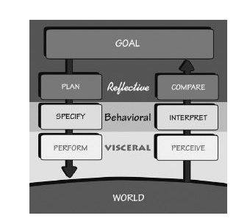
Figure 2: Norman’s user experience model showing different levels of user responses and stages of the action cycle (Norman, 1988, 2013)

After the benchmark set by Norman, many researchers and scholars have investigated and written about human-centred design and user experience. Among the somehow digital interface biased focus of most studies, the “Universal Principles of Design” by Lidwell, Holden and Butler first published in 2003, Susan Weinschenk’s “100 Things Every Designer Needs to Know About People” published in 2011 and her “100 More Things Every Designer Needs to Know About People” published in 2016 did provide some useful references on how user experience could be enhanced with a better understanding of the underpinning psychological principles for design.

Lidwell, Holden, and Butler (2010, p. 11) identified in the preface of the book “Universal Principlesof Design” that “Courses in psychology and anthropology were glaringly absent from myundergraduate and graduate design education. Indeed, a deeper understandingof human behavior and a scholarly approach to design were almost entirely overlooked.”
So the book aimed to “enhance usability, influence perception, increase appeal, make betterdesign decisions, and teach through design”. The 2010 edition included 125 principles indexed under the above five aims, illustrated with basic theories and application examples, drawn from products, graphics, computer interfaces, etc (Lidwell, Holden&Butler, 2010).

Weinschenk (2011, 2016) pointed out that “the totality of your audience’s experience is profoundly impacted by what you know – or don’t know – about them”. For users/audience to enjoy the experience, the product/system/service should address how they thought and decided, and what motivated them to click, purchase, or act as “desired”. The psychological principles/facts/traps covering physio-psychological, cognitive, behavioural and social aspects were illustrated with research studies and/or real life examples of user experiences.

Lidwell, Holden, and Butler’s 125 “Universal Principlesof Design”, together with Weinschenk’s “100 Things Every Designer Needs to Know about People” and “100 More Things Every Designer Needs to Know about People”, provided rich collections of design and real life examples, or research studies, on how psychological factors influenced user experiences. However,Lidwell, Holden, Butler, and Weinschenk’s over300 “principles” and “things” were only loosely grouped. It is left to the readers to identify the potential association across the psychological principles/facts/traps.

Peter Morville (2004) formulated the UX Honeycomb as a tool for product/system managers and developers to better define priorities in developing and managing user experiences. Morville advocated that products/systems had to satisfy users’ needs beyond usability in order to create valuable experiences.

The Honeycomb model weaved together important UX values (Figure 3) including:useful, usable,desirable,findable,accessible,credible, and valuable.

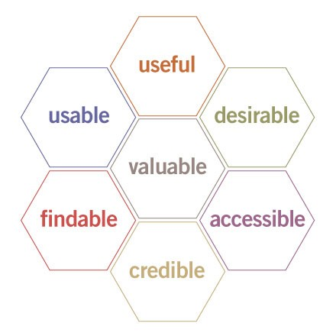
Figure 3: Peter Morville’s UX Honeycomb (Morville, 2004)

Both models from Morville and Norman examined the affective/hedonic and cognitive/ utilitarian aspects of user experience. Morville emphasised on addressing user experience beyond usability, to make the product/system “desirable”, and efficiency to go side-by-side with “image, identity, brand, and other elements of emotional design”; which echoed with Norman’s three levels of user responses, visceral, behavioural and reflective, associated respectively with the sensory impressions, the product usability, and overall cognitive weighing of the experience. However, while Norman’s model might be found too abstract for application, Morville’s model only specified the goals and criteria for good user experience providing no hints of the “how” question.

In the current literatures including those reviewed above, there is little discussion on practically how psychological considerations and physical considerations could be integrated in addressing the emotional and utilitarian aspects of user experience. There were researchers who applied Norman’s cognitive action model to investigate specific topics. Wrigley proposed a “visceral hedonic rhetoric framework” and a corresponding tool(Figure 4) for designers’ reference expanding on Norman’s visceral level of cognition (Wrigley, Popovic & Chamorro-Koc, 2009; Wrigley, 2011; Wrigley, 2013). Her “visceral hedonic rhetoric design tool” (Wrigley, 2011) listed fourteen attributes and their relative strengths drawing upon the descriptive “first impressions” of participants on products in an experimental setup. The fourteen attributes ranked from the strongest were: colour, size, shape, intrigue, material, perceived usability, portability, perceived function, novelty, analogy, brand, quality, texture, and gender. The findings were logical, somehow expected, whereas the attributes might alert product developers the areas of concern but give little directional hints. Wrigley’s empirical study only focused on the visceral level of user responses, and the behavioural and reflective levels of responses were not addressed or followed up. Here may be a potential for further research.
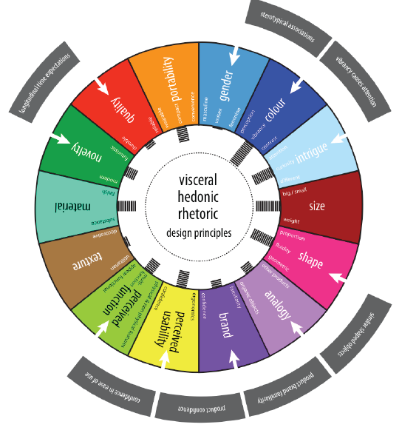
Figure 4: The Visceral Hedonic Rhetoric Design Tool (Wrigley, 2011)

In the search for application models for guiding product R&D in enhancing user experience, apart from Wrigley’s attempt, related attempts could be found with Cagan and Vogel’s style-technology positioning map, the social-economic-technology (SET) framework, and the value opportunity chart for product value analysis and goal planning in the seven aspects of emotion, aesthetics, product identity, impact, ergonomics, core technology, and quality (Cagan & Vogel, 2002, 2012). Although Cagan and Vogel’s proposed models apparently address both psychological and physical concerns for product R&D, their proposition of driving product value through superior style and technology had over-simplified the mechanisms and chemistries in the product-user interaction. Also, their SET framework and opportunity chart, orienting more from the producer’s than user’s point of view, were not user experience focused.

Other studies investigating the emotional impacts of user expereince, such as the Kansei model (Nagamachi, 2010; Lottum et al., 2006), tended to approach the emotional and psychological aspects of product development in their own right, separated from the utilitarian and physical aspects. The considerations should not be straight-forward injections of psychological input into the affective aspect, and physical input into the utilitarian aspect, neglecting the intertwining nature of the psychological and physical considerations and their cross-playing roles in creating enjoyable user experiences.

User behaviour studies

There have been a number of fundamental theories/models commonly applied to explain human behaviour and the acceptance of new technology (with the products or systems using the technology). The Theory of Reasoned Action (TRA) (Fishbein & Ajzen, 1975) states that “attitude towards behaviour” and “subjective norm” are the main predictors for various human behaviours, where “subjective norm” refers to the perception of how your important ones think you should behave. The Theory of Planned Behaviour (TPB) (Ajzen, 1991) extended TRA by adding an additional predictor “perceived behavioural control” (Figure ?). In contrast to the attitude and social focuses of the TRA and TPB models, Davis (1985) developed the Technology Acceptance Model (TAM) stressing the utilitarian benefits of “perceived usefulness” and “perceived ease of use” as drivers for behavioural intention (Figure ?). Later there have been some integrating efforts (Venkatesh et al., 2003), such as the TAM2 which extended TAM by incorporating the “subjective norm” as an additional predictor, and the United Theory of Acceptance and Use of Technology (UTAUT) based on eight models including TAM and TPB (Figure ?).

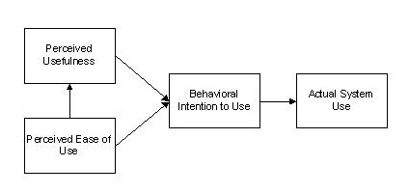
Figure 5: Technology Acceptance Model (TAM) (Venkatesh et al., 2003)

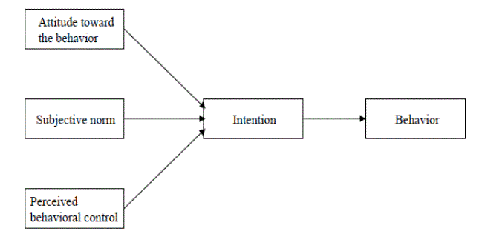
Figure 6: Theory of Planned Behaviour (TPB) (Ajzen, 1991)

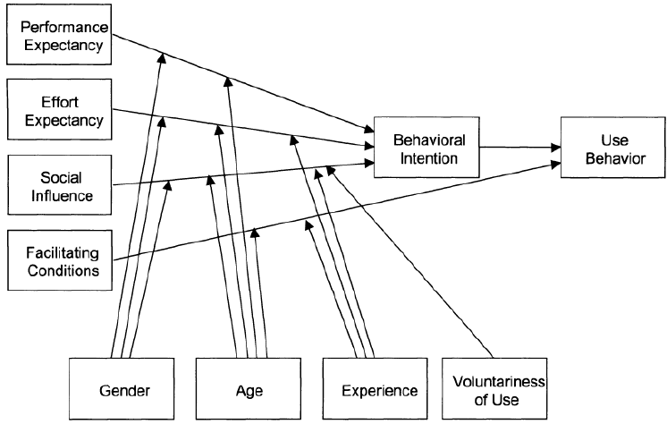
Figure 7: United Theory of Acceptance and Use of Technology (UTAUT) (Venkatesh et al., 2003)

Despite all the attempts to combine different elements into a “perfect” model, there seems not a single model which can practically applied to address all relevant aspects for enhancing user experience. They either do not demonstrate a holistic view of the user values (essentially including hedonic, utilitarian, and social values), or too complicated (apparently or actually) for application such as the UTAUT, or concern only with the decision to use but not the satisfaction during and after use.

Designer-product-user communication

Apart from understanding the users’ valued product values, concerns that follow can be: whether the designer can design the product to fit the user values, whether the product performs like what the designer intends it to do, whether the users understand and use the product as the designer thinks…… Some previous literature has pointed out the problem or suggested some ideal communication models, but few has proposed or demonstrated applicable methodologies for the solutions.

Norman’s (1986) Theory of Action not only describes the stages of user responses, but also illustrates the discrepancies between the mental models of designers and users as the phenomena of the “gulf of execution” and “gulf of evaluation” (Figure 8). It is noted that users develop a mental model from their perception of the products created by the designer, but not from the mental model held in the designer’s mind.

Crilly, Maier and Clarkson (2008) proposes an integrated ideal model of the relationship between designer intent and consumer experience. The visceral hedonic rhetoric design dialogue framework was then developed by Wrigley (2013) from Crilly, Moultrie, and Clarkson’s design dialogue framework (Crilly, Moultrie, & Clarkson, 2008) (Figure 9).

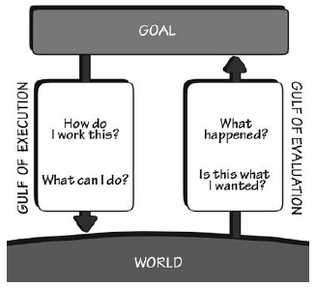
Figure 8: Norman’s action model illustrating the “gulf of execution” and “gulf of evaluation” between designers and users (Norman, 1988, 2013)

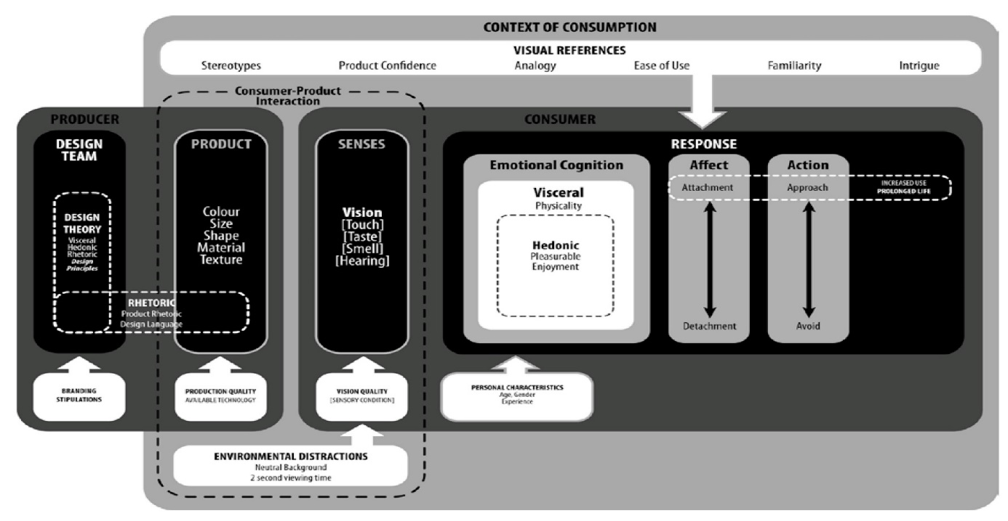
32

Figure 9: The visceral hedonic rhetoric design dialogue framework (Wrigley, 2013) developed from Crilly, Moultrie, and Clarkson’s design dialogue framework (Crilly, Moultrie, & Clarkson, 2008)

Product semantics was another concept related to the communication between products and users. Krippendorff (1989, 2006) suggested that the “symbolic qualities” of man-made forms communicated with the users (and the community) in different contexts. However, the actual application of semantics in product development projects was often reduced to the application of the Semantic Differential Method (SDM) by defining pairs of antonymous adjectives and drawing up the semantic space (such as in Petiot & Yannou, 2003), which seemed not contributing much to enhance user experience.

Some researchers did work more empirically in identifying the differences in the perception of designers and users. For examples, Cata and Martz (2015) compare mobile apps’ usability characteristics for designers and users through two surveys, and Chamorro-Koc, Popovic, and Emmison (2009) applied a visual approach asking designers and non-designers to suggest by drawing their ideal designs of products like handheld camera for underwater use and GPS handsets. The studies have yielded some useful information for the concerned product categories, but it is doubtful whether the findings can be generalised for application in other industries and products. On the other hand, the more user-inclusive approaches of participatory design being promoted in recent years may suit more for the social innovation, that is designing for the community or social well-being, rather than for designing commercial products due to the confidentiality issue.

As discussed in the literature review, there has been little study on how hedonic, utilitarian and social considerations could be integrated in addressing user experience and user behaviour. In the prior literatures, user experience/behaviour related studies are either theoretical-based and abstract without providing practical guide for implementation, or approaching the hedonic / utilitarian / social aspects of product values separately, or being focused on web and digital, rather than tangible product, user interfaces. Tools for promoting user-designer communication and understanding are also rare.

Research questions and research framework

In view of the lack of an easy-to-understand and apply model / framework for providing a holistic view of the relationship between user experience and behaviour in response to product values and designer-user communication, the related topic will be explored for my dissertation research. Meanwhile for the research project of the current module assignment, it will focus on identifying the product values valued by users in relation to user experience, in terms of perceived satisfaction and intention for continuous use of the product. The research framework will try to build a holistic view taking into consideration the positive aspects of the related models about user experience and consumer behaviour. The study will also take a preliminary look at the possible differences between the views of designer users and non-designer users as a base for future investigation of designer-user communication. The findings of the study are expected to provide hints for product developers to better understand the users’ values and needs, to gear towards designing products with better user values, and for the researchers or tool developers to design better product development tools so as to enhance the ultimate user experience.

Based on the above review and needs identified, the proposed research aims at finding the solution for the questions of:
What are the product values valued by users?
What product values may improve user experience in terms of perceived satisfaction and intention for continuous use of the product?

To answer these questions, a research framework is drawn up with a set of hypotheses formulated to verify the framework. The framework in Figure 10 illustrates the possible causal relations between the variables, symbolising the hypotheses.

With reference to prior studies in user experience, the user/customer perceived values towards products can be conceptualised and measured in two dimensions: the affective or hedonic dimension derived from the sensations of the experience, and the cognitive or utilitarian dimension derived from the functions performed by products (Batra and Ahtola, 1990; Zaichkowsky, 1994; Voss, Spangenberg and Grohmann, 2003). Previous literature (Mouri, 2005; Wang, 2009; Deng, Turner, Gehling, and Prince, 2010; Mugge, Schifferstein, and Schoormans, 2010; Lai and Tam, 2011; Amin, 2016) also suggested positive correlations between perceived product/customer value (or perceived product performance) and user satisfaction.

The dimension of social values is developed from the “subjective norm” in the user behaviour models of Theory of Reasoned Action (TRA) and Theory of Planned Behaviour (TPB) (Ajzen, 1991). The dimensions of “usefulness” and “ease of use” in the Technology Acceptance Model (TAM) (Venkatesh et al., 2003) have been incorporated into the measurement items of the utilitarian variable.

The dimension of innovativeness is especially added to test whether it will raise the distinction, if any, between the perception of designer-users and non-designer users.

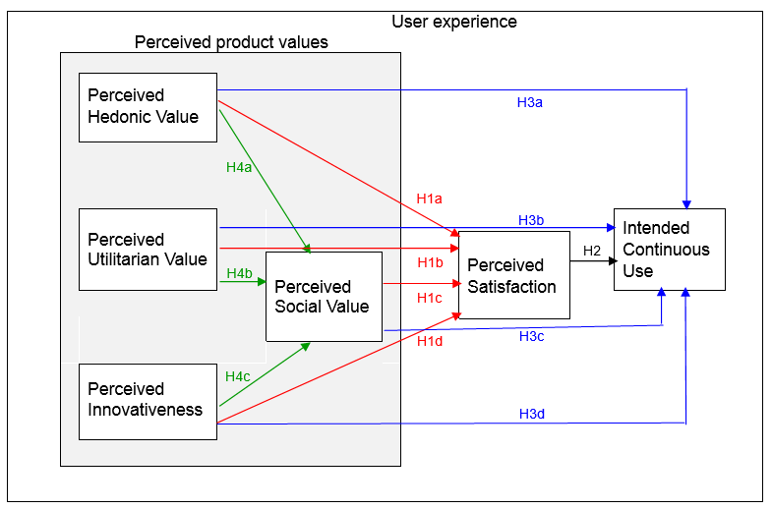

Figure 11: Research Framework for evaluating the impact of the perceived product values on consumers’ satisfaction and intended continuous use of the product

The hypotheses for testing are:

H1: | A product with high perceived values leads to a higher perceived satisfaction for users.
 | H1a: | A product with high perceived hedonic value leads to a higher perceived satisfaction for users.
 | H1b: | A product with high perceived utilitarian value leads to a higher perceived satisfaction for users.
 | H1c: | A product with high perceived social value leads to a higher perceived satisfaction for users.
 | H1d: | A product with high perceived innovativeness leads to a higher perceived satisfaction for users.
H2: | A product with high perceived satisfaction leads to a higher rate of intended continuous use for the product.
H3: | A product with high perceived values leads to a higher rate of intended continuous use for the product.
 | H3a: | A product with high perceived hedonic value leads to a higher rate of intended continuous use for the product.
 | H3b: | A product with high perceived utilitarian value leads to a higher rate of intended continuous use for the product.
 | H3c: | A product with high perceived social value leads to a higher rate of intended continuous use for the product.
 | H3d: | A product with high perceived innovativeness leads to a higher rate of intended continuous use for the product.
H4: | A high rating in other perceived product values leads to a higher perceived social value.
 | H4a: | A high rating in perceived hedonic values leads to a higher perceived social value.
 | H4b: | A high rating in perceived utilitarian values leads to a higher perceived social value.
 | H4c: | A high rating in perceived innovativeness leads to a higher perceived social value.
H5: | There are differences in the perception of designer-users and non-designer-users towards the product values, user satisfaction, and intended continuous use for the product.
 | H5a: | There are differences in the perception of designer-users and non-designer-users towards the perceived hedonic value of a product.
 | H5b: | There are differences in the perception of designer-users and non-designer-users towards the perceived utilitarian value of a product.
 | H5c: | There are differences in the perception of designer-users and non-designer-users towards the perceived social value of a product.
 | H5d: | There are differences in the perception of designer-users and non-designer-users towards the perceived innovativeness of a product.
 | H5e: | There are differences in the perception of designer-users and non-designer-users towards the perceived satisfaction from a product.
 | H5f: | There are differences in the perception of designer-users and non-designer-users towards the intended continuous use for a product.
3. Research philosophy and methodology

The positivist research paradigm is mainly taken in this research.

With regard to ontology, the positivist paradigm (Gall, Gall & Borg, 2007) emphasizes manner to predict pattern of behaviour. Hence this research attempts to find out the causal relationships of product values, satisfaction and intended continuous use perceived by the users.

In respect of epistemology, the interpretive paradigm (Gall, Gall & Borg, 2007) posits that researchers should be objective, non-interactive and bias free. In reality, zero might be impossible and hence measures should be taken to minimise the influence of the possible biases on the research results. Such measures taken in this research will be discussed in “data collection” of Section F and “data analysis” of Section G.

Concerning methodology, a deductive approach and quantitative methods are mainly used. A survey is to be conducted for testing the proposed hypotheses, and a pilot test has been carried out in this assignment to verify the research design and instruments before going for the full-scaled survey. However, like most social research (Trochim, 2006), this study does involve both deductive and inductive methods at different stages. Interviewing with the sample users when designing the questions and measurement items for the survey is an example of inductive method.

Measurement and scale development

The following processes have been taken in developing the measurement items and scales (Churchill, 1979):

Step 1 – Specify domains of constructs

Four of the six constructs in the research framework (Figure 10) are developed from the user experience domain as mentioned in research framework section, which include perceived hedonic value, perceived utilitarian value, perceived satisfaction, and intended continuous use. One construct of social value is developed from the subjective norm in the TRA and TPB models of the human behaviour domain. The newly added construct of perceived innovativeness in fact relates to both domains.

Step 2 – Generate sample of items

Interviews have been conducted with a few sample users to collect views on the concepts and dimensions, and the literature has been referred to in generating the sample of measurement items.

In the draft questionnaire, the measurement of the “perceived hedonic value” and “perceived utilitarian value” has mainly applied the Hedonic/Utilitarian (HED/UT) Scale of Voss, Spangenberg and Grohmann (Voss, Spangenberg and Grohmann, 2003) for its high validity and reliability tested by the repeated studies by Voss and Spangenberg themselves, and other researchers (such as Crowley, Spangenberg, and Hughes, 1992; Spangenberg, Voss, and Crowley, 1997; Voss, Spangenberg and Grohmann, 2003; Mouri, 2005).

In addition, the “usefulness” and “ease of use” from TAM are added to the measurement items for perceived utilitarian values.

The measurement items for “perceived social values” have made reference to the subjective norm in the TRA and TPB model, as well as the “socialness of the object” scale of Wang et al. (2007). The original items are adjusted to fit the product use scenarios, and expanded to a total of eight items, so that four items measure “self identity” and four items measure “group relation”.

The measurement items for the added “perceived innovativeness” have made reference to the likert scale of novelty from Huang (2003). The statements for the likert scale questions have been modified with some adjustments into pairs of opposite adjectives for the semantic differential scale questions.

The measurement items for “perceived satisfaction” has taken reference of the “satisfaction scales” of Oliver and Swan (1989) and Spreng, MacKenzie and Olshavsky (1996), and the scale for measuring “anticipated satisfaction” of Shiv and Huber (2000).

The measurement items for “intended continuous use” has firstly taken reference of the Continance Intention scale of Bhattacherjee (2001), which are later modified after the pre-test.

Step 3 – Collect data (pre-test)

The first draft questionnaire was tested with a few sample users.

As there have been varied views on whether the measurement items for the same construct should be grouped, to avoid confusion, or mingled with items of other constructs, to avoid respondents guessing the objective of the measurements and give biased answers (Goodhue & Loiacono, 2002), I have tried both approaches with the different products in the pre-test questionnaire.

Step 4 – Purify measure

After the pre-test, it was found that the measurement items grouped according to constructs have resulted in more sensible results, especially for the items using negative statements. Hence in the questionnaire for the next round of pilot-run (Appendix 1), most of the measurement items are grouped, except that the items for self identity and group relation within the social values are mixed.

Another reason for not mixing the measurement items for hedonic and utilitarian values is that the perception for hedonic values should come first as impressions, without much cognitive reasoning.

For the same reason, the more sensational measurement items, such as “feeling good” and “very pleased”, within the perceived satisfaction group are shifted up to go before the others.

After the pre-test, the measurement items for “intended continuous use” firstly taken reference of the Continance Intention scale of Bhattacherjee (2001) have been changed, because the respondents have different interpretation of the degree of certainty with the phrases “I intend to continue”, “I will keep on”, “I would continue” and “I believe I will continue”. They are replaced with phrases of more straight-forward and easily recognised degree of certainty: “Certainly I will continue”, “Most likely I will continue”, “Probably I will continue”, and “I will not continue” which is a negative statement.

Finally, two negative statements are kept in the questionnaire: “I will not continue using the product”; and “The product does not relate to me” to check against the other positive statement of “I find connection with the product”. The negative statements were incorporated to check the reliability of the respondents’ answers and their attention/seriousness when answering the questions.

Step 5 – Collect date (pilot-test)

The questionnaire was put online at Google Forms at this stage, and collected a total of 22 responses, 11 from designer-users and 11 from non-designer-users.

Sampling:

As the products use for testing in the survey are mostly daily used items (laptop computer, electrical toothbrush, alarm clock), most people in the college or working age groups would have experience of using same or similar category products. Moreover, the classification questions (asking on the use history, education, occupation, age, etc) at the end of the questionnaire help to screen the possibility of any respondents who are likely not to understand how the products work.

The sampling at the pilot-test stage was mainly purposive and convenient sampling due to the limited schedule for the assignment. As one of the objectives of the research is to compare the perception of designer-users and non-designer-users on product values and satisfaction, designers are invited to respond to the survey through the “Product Design Forums”, the “LinkedIn” network and my own networks while general users are invited through other public forums and my own networks.

For the future full-scaled research, sampling from wider coverage of respondents can be explored, despite it is difficult to have really random sampling especially for the designer group.

The local government statistics of “Number of establishments, persons engaged and vacancies analysed by industry sub-class” (Census and Statistics Department, Hong Kong Special Administrative Region, 2016a) recorded a population of 2050 industrial designers practising in Hong Kong in 2015. These industrial designers are scattered working in design agencies, manufacturing firms, and other organisations. A comprehensive list of this population does not exist, hence ruling out the possibility of real random sampling if so desired. There are a number of local design bodies, among which the Industrial Designers Society of Hong Kong (IDSHK) is the one body grouping the professional designers and associated professionals with product development focus. However the membership coverage of the IDSHK is quite limited. Therefore, apart from inviting participants through the professional bodies, invitations will also be sent to identified product developers/designers through other networks, such as professional social platforms like LinkedIn.

Step 6 – Assess reliability and validity

The Cronbach’s Alpha coefficients have been checked with the measurement items for all constructs. The results are summarised in Table 1 below. The Cronbach’s Alpha tests show good “internal consistency reliability” for the measurement scales with all values above 0.7.

Checking of factor loading is another way of checking the reliability, but this requires a larger sample size to work and can be conducted for the future full-scaled survey.

As discussed, two negative statements have been incorporated in the questionnaire to help checking the validity of the survey responses. It is a form of triangulation for verifying the responses to the positive and negative statements asking the same thing.

Descriptive statistics (Appendix 3) and correlation tests (Appendix 4) of the pilot-test results have been generated to check against abnormal phenomena and observe the general trends and relations. Other aspects of reliability (e.g. internal reliability, external reliability) and validity (e.g. internal validity, external validity, test validity, face validity) may be further checked in the full-scale survey. Care should be also be taken to control potential confounding effect between the factors (Health Knowledge, 2016) in the future full-scale test.

Step 7 – Develop norms

Norms may be identified from the analyses of the pilot-test results, but due to the small sample size of the pilot-test, phenomena apparent as norms may not be true norms in the population or with a larger sample.

Table 1: Checking reliability of measurement scales with Cronbach’s Alpha tests (details in Appendix 2)

Variable with measurement items |  | Number of items | Cronbach’s Alpha
Perceived Hedonic Value (PHV1-8) | Items 1-8 of question A1 in questionnaire (Appendix 1) | 8 | .90
Perceived Utilitarian Value (PUV1-8) | Items 9-16 of question A1 in questionnaire | 8 | .90
Perceived Social Value (PSV1-9) | Items 1-9 of question A3 in questionnaire | 9 | .94
Perceived Innovativeness (PI1-4) | Items 17-20 of question A1 in questionnaire | 4 | .78
Perceived Satisfaction (PS1-4) | Items 1-4 of question A2 in questionnaire | 4 | .85
Intended Continuous Use (ICU1-4) | Items 10-13 of question A3 in questionnaire | 4 | .96

Analysis and findings

Descriptive statistics (Appendix 3)
Various mean scores of the constructs are compared across the three product. It is found Product 3 has been rated lower than the other two products.

Correlation analyses (Appendix 4)

Correlation analyses are conducted for an overview of the relations and to guide the order of predictor variables in the regression process – the predictor with the higer correlation goes first (refer to demo below).

Multiple regression analyses (Appendix 5)

Multiple regression analyses have been conducted to verify the causal relationship between the consumers’ perceived product values and their perceived satisfaction and intended continuous use with the products.

A number of multiple regression analyses (Statistica, 2016) are applied to verify the existence and strength of the projected causal relationships for each product: (1) from the various “perceived product values” (predictor/independent variables) to the “perceived satisfaction” (criterion/dependent variable); (2) from the “perceived product values” to the “intended continuous use”; and (3) from the other 3 perceived product values to the “perceived social value”.

Simple regression analyses (Statistica, 2016) are applied to verify the existence and strength of the possible causal relationships: from “perceived satisfaction” to “intended continuous use”.

The multiple/simple regression analyses have preliminarily identified which is/are the best predictor(s) for the dependent variables. However, the results may have certain variation with a significantly larger sample, such as possibly showing more significant predictors. Since there is the general rule that the number of respondents should be 20 times the number of variables to make the prediction accurate.

The steps taken to proceed with the multiple regression tests are demonstrated below with Product A.

Table 3 to Table 6 summarise the regression test results for Hypothesis 1 to 4, whereas Figure 12 to 14 illustrate the supported hypotheses in the research framework for Product A to C respectively. The survey findings show that the causal relations vary among different product categories. For example, perceived innovativeness has a significant impact on perceived social value for Product A, but not Product B and C. A possible reason is that laptop computers will be used outside the home with friends and business partners, but toothbrush brush and alarm clocks are merely used at home. There are common findings across all three products which include:
- Perceived hedonic value has significant impact on satisfaction but not intended continuous use.
- Perceived satisfaction has significant impact on intended continuous use.
- Perceived social value has significant impact on intended continuous use.

Product A – Testing Hypothesis 1
Demonstration of process (Pierce & Gardner, 2011) of multiple regression tests (with Product A)
Step 1 – Regress the dependent variable Perceived Satisfaction (PS) on the independent variable with the strongest correlation with PS, which is Perceived Utilitarian Value (PUV) from the correlation table in Appendix 4.
Step 2 – As Step 1 shows the statistical significance of the Beta Coefficient of the tested independent variable <0.05, regress the dependent variable Perceived Satisfaction (PS) on the independent variables with the first and second strongest correlation with PS, which are Perceived Utilitarian Value (PUV) and Perceived Hedonic Value (PHV) from the correlation table in Appendix 4.
Step 3 – As Step 2 shows an increase of R Square and the statistical significances of the Beta Coefficients of the tested independent variables <0.05, regress the dependent variable Perceived Satisfaction (PS) on the independent variables with the first, second and third strongest correlation with PS, which are Perceived Utilitarian Value (PUV), Perceived Hedonic Value (PHV), and Perceived Social Value (PSV) from the correlation table in Appendix 4.
Step 4 – Since Step 3 shows no increase of R Square and the statistical significance of the Beta Coefficient of the lastly added independent variable is >0.05, the regression test for Hypothesis 1 is stopped here with the independent variables Perceived Utilitarian Value (PUV) and Perceived Hedonic Value (PHV) recognised as significant predictors for the dependent variable Perceived Satisfaction (PS).

Table 2: Demonstration of process of multiple regression tests (with Product A)
Dependent Variable: Perceived Satisfaction (PS)
 | Independent Variables | R | R² | Change in R² | F | Significance of F | Model
Step 1 | Perceived Utilitarian Value (PUV) | .89 | .79 |  | 74.54 | <.05 (.000) | Supported
Step 2 | Perceived Utilitarian Value (PUV)  Perceived Hedonic Value (PHV) | .93 | .87 | .08 | 62.06 | <.05 (.000) | Best supported model
Step 3 | Perceived Utilitarian Value (PUV)  Perceived Hedonic Value (PHV)  Perceived Social Value (PSV) | .93 | .87 | .00 | 41.44 | <.05 (.000) | Model not supported since no increase of R² & Beta of PSV >.05

Independent Variables | Beta Coefficient (Standardized) | Significance | Valid Predictors
Perceived Utilitarian Value (PUV) | .68  (with 2 independent variables) | <.05 (.000)  (with 2 independent variables) | Supported
Perceived Hedonic Value (PHV) | .35  (with 2 independent variables) | <.05 (.003)  (with 2 independent variables) | Supported
Perceived Social Value (PSV) | .12  (with 3 independent variables) | > .05 (.357)  (with 3 independent variables) | Not supported

Table 3: Testing Hypothesis 1 with multiple regression
Dependent Variable: Perceived Satisfaction (PS)
Product | Independent Variables | R | R² | F | Significance of F
A | Perceived Utilitarian Value (PUV)  Perceived Hedonic Value (PHV) | .93 | .87 | 62.06 | <.05 (.000)
B | Perceived Hedonic Value (PHV) | .83 | .68 | 43.08 | <.05 (.000)
C | Perceived Hedonic Value (PHV) | .91 | .84 | 102.06 | <.05 (.000)

Product | Independent Variables  – Valid Predictors | Beta Coefficient (Standardized) | Significance
A | Perceived Utilitarian Value (PUV) | .68 | <.05 (.000)
 | Perceived Hedonic Value (PHV) | .35 | <.05 (.003)
B | Perceived Hedonic Value (PHV) | .83 | <.05 (.000)
C | Perceived Hedonic Value (PHV) | .91 | <.05 (.000)

Table 4: Testing Hypothesis 2 with multiple regression
Dependent Variable: Intended Continuous Use (ICU)
Product | Independent Variables | R | R² | F | Significance of F
A | Perceived Satisfaction (PS) | .73 | .53 | 23.00 | <.05 (.000)
B | Perceived Satisfaction (PS) | .86 | .75 | 59.19 | <.05 (.000)
C | Perceived Satisfaction (PS) | .79 | .62 | 33.30 | <.05 (.000)

Product | Independent Variables  – Valid Predictors | Beta Coefficient (Standardized) | Significance
A | Perceived Satisfaction (PS) | .73 | <.05 (.000)
B | Perceived Satisfaction (PS) | .86 | <.05 (.000)
C | Perceived Satisfaction (PS) | .79 | <.05 (.000)

Table 5: Testing Hypothesis 3 with multiple regression
Dependent Variable: Intended Continuous Use (ICU)
Product | Independent Variables | R | R² | F | Significance of F
A | Perceived Social Value (PSV)  Perceived Utilitarian Value (PUV) | .89 | .79 | 36.80 | <.05 (.000)
B | Perceived Social Value (PSV)  Perceived Utilitarian Value (PUV) | .92 | .84 | 49.50 | <.05 (.000)
C | Perceived Social Value (PSV) | .89 | .79 | 75.57 | <.05 (.000)

Product | Independent Variables  – Valid Predictors | Beta Coefficient (Standardized) | Significance
A | Perceived Social Value (PSV) | .59 | <.05 (.001)
 | Perceived Utilitarian Value (PUV) | .37 | <.05 (.028)
B | Perceived Social Value (PSV) | .62 | <.05 (.000)
 | Perceived Utilitarian Value (PUV) | .35 | <.05 (.026)
C | Perceived Social Value (PSV) | .89 | <.05 (.000)

Table 6: Testing Hypothesis 4 with multiple regression
Dependent Variable: Perceived Social Value (PSV)
Product | Independent Variables | R | R² | F | Significance of F
A | Perceived Innovativeness (PI)  Perceived Utilitarian Value (PUV) | .86 | .74 | 26.86 | <.05 (.000)
B | Perceived Hedonic Value (PHV) | .80 | .64 | 35.66 | <.05 (.000)
C | Perceived Utilitarian Value (PUV) | .90 | .81 | 87.31 | <.05 (.000)

Product | Independent Variables  – Valid Predictors | Beta Coefficient (Standardized) | Significance
A | Perceived Innovativeness (PI) | .53 | <.05 (.001)
 | Perceived Utilitarian Value (PUV) | .44 | <.05 (.006)
B | Perceived Hedonic Value (PHV) | .52 | <.05 (.000)
C | Perceived Utilitarian Value (PUV) | .90 | <.05 (.000)

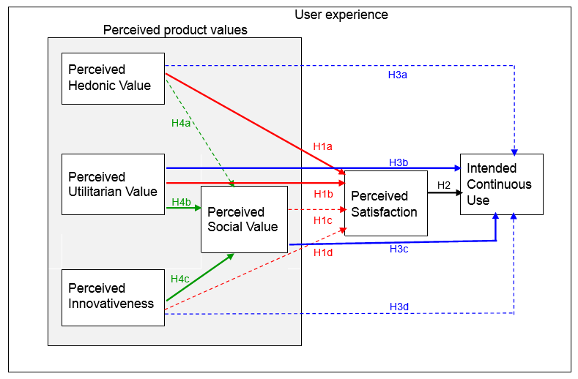
Figure 12: Conceptual Framework showing the impact of the perceived product values on consumers’ satisfaction and intended continuous use of Product A (causal relations with statistical significance in the pilot study are shown in bold solid lines)

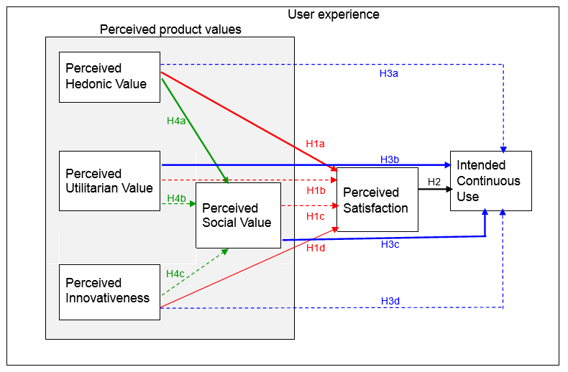
Figure 13: Conceptual Framework showing the impact of the perceived product values on consumers’ satisfaction and intended continuous use of Product B (causal relations with statistical significance in the pilot study are shown in bold solid lines)

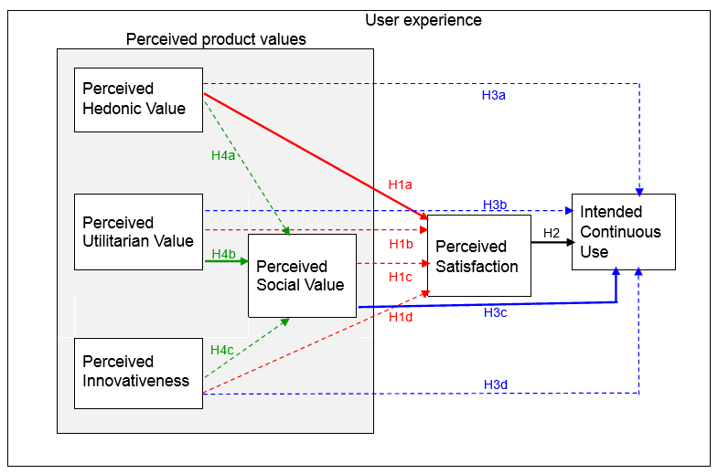
Figure 14: Conceptual Framework showing the impact of the perceived product values on consumers’ satisfaction and intended continuous use of Product C (causal relations with statistical significance in the pilot study are shown in bold solid lines)

Independent samples t-tests (Appendix 6)

Independent samples t-tests are conducted to verify that designer and non-designer consumers have different perceptions on product values, satisfaction, or intended continuous use. The results do not support any differences since the significance values are all >0.05. This may be due to the fact that the designers are rated the items in the role of users in the survey. A better approach to compare their difference may be using products actually designed by the particular designer(s) being tested.

Other possible analyses

Other analytical tools such as the Structural Equation Modelling (SEM) may be considered. SEM is a multivariate statistical analysis technique for analysing structural relationships (Statistics Solutions, 2016). Combining tools like factor analysis and multiple regression analysis, SEM can estimate the multiple interrelated dependencies in a single analysis. Other advantages include the possible inclusion of co-variates and intervening variables, and the provision of goodness-of-fit indices apart from chi-square (such as TLI/NNFI and RMSEA) and modification indices which project the possible area(s) for improving the model fit (Hox and Bechger, 1998). It is worth to analyse the data with different tools for triangulating the results where appropriate. Ultimately, the analytical tools should be chosen to fit the purpose, rather than for its advancedness or trendiness.

Ethical considerations

Although the issues to be studied in this research are not of a particularly sensitive nature, the basic ethical requirements (Bouma, 2000) will be taken care of, including confidentiality of data, anonymity of participants’ identity (Rotondi,1989), and right for participants to withdraw from the research.

In the case of an online survey, it is commonly recognized that completing and submitting the survey implies consent given by the participants.

Further discussion of the limitations and further research will be included in the “reflection” part.

Bibliography

Aguirre-Urreta, M., & Marakas, G. M. (2008). Comparing conceptual modeling techniques: A critical review of the EER vs. OO empirical literature. Database for Advances in Information Systems, 39(2), 9-32.
Albert, W., 2013. Measuring the user experience: Collecting, analyzing, and presenting usability metrics (2nd ed.). Elsevier Science.
Almasri, A. K. M. (2015). A hybrid proposed framework based on quality factors (QF) and technology acceptance model (TAM) for mobile learning process : Higher education students in jordanian universities. International Journal of Information, Business and Management, 7(3), 200-212. Retrieved from https://search-proquest-com.eproxy.vtclib9.vtc.edu.hk/docview/1687611314?accountid=29075
An investigation of mobile learning readiness in higher education based
on the theory of planned behavior
Jongpil Cheon a,*, Sangno Lee b, Steven M. Crooks a, Jaeki Song b,c
Computers & Education 59 (2012) 1054–1064
Bansal, H. S., Taylor, S. F., & James, Y. S. (2005). "Migrating" to New Service Providers: Toward a Unifying Framework of Consumers' Switching Behaviors. Journal Of The Academy Of Marketing Science, 33(1), 95-115. doi:10.1177/0092070304267928
Bard, J., 2016. UX design defined. Retrieved from http://uxdesign.com/ux-defined
Bhattacherjee, A. (2001) Understanding Information Systems Continuance: An Expectation-Confirmation Model. MIS Quarterly, 25, 351-370.
Booth, A. R., Norman, P., Harris, P. R., & Goyder, E. (2014). Using the theory of planned behaviour and self-identity to explain chlamydia testing intentions in young people living in deprived areas. British Journal Of Health Psychology, 19(1), 101-112. doi:10.1111/bjhp.12036
Bouma, G.D., 2000. Ethics in human research. The research process (4th ed.) pp. 190-202. Melbourne, Australia: Oxford University Press.
Burke, P. F., 2013. Seeking simplicity in complexity: The relative value of ease of use (EOU) based product differentiation. Journal of Product Innovation Management, 30(6), pp.1227-1241.
Cagan, J. & Vogel, C. M., 2002. Creating breakthrough products: Innovation from product planning to program approval. New Jersey: Pearson Education.
Cagan, J. & Vogel, C. M., 2012. Creating breakthrough products: revealing the secrets that drive global innovation. 2nd ed. New Jersey: Pearson Education.
Carnegie Mellon University, School of Design, 2017. Master of Design. Retrieved from http://design.cmu.edu/content/master-design
Cata, Teuta and Martz, Ben (2015) "Comparing Mobile APPs Usability Characteristics for Designers and Users," Journal of International Technology and Information Management: Vol. 24 : Iss. 4 , Article 4.
Available at: http://scholarworks.lib.csusb.edu/jitim/vol24/iss4/4
Chamorro-Koc, M., Popovic, V., Emmison, M., 2009. Human experience and product usability: Principles to assist the design of user-product interactions. Applied Ergonomics, 40(4), pp.648-656.
Chan, S. L., 2017a. An action model systematically integrating the psychological and physical considerations into product R&D for enhancing user experience, Research Proposal. Swiss Business School, unpublished.
Chan, S. L., 2017b. Submission to Assignment of SBPD7001 Approach to Research and Academic Communication, Assignment. University of Wales – Trinity Saint David, unpublished.
Chan, S. L., 2017c. Current local practices in product R&D for enhancing user experience – Assignment of SBPD7002 Qualitative Research, Assignment. University of Wales – Trinity Saint David, unpublished.
Churchill, G. (1979). A paradigm for developing better measures of marketing constructs. Journal of Marketing Research, 16, pp.64-73.
Coroflot, 2017. Product Designer salaries in Hong Kong – Design Salary Guide at Coroflot. Retrieved fromhttp://www.coroflot.com/designsalaryguide/product-designer/hong-kong
Creswell, J.W. & Miller, D.L., 2000. Determining validity in qualitative inquiry. Theory Into Practice, 39(3), pp. 124-130.
Creswell, J.W., 2007. Qualitative inquiry and research design: Choosing among five approaches (2nd ed.). London: Sage.
Crilly, N., Maier, A. & Clarkson, P. J., 2008. Representing artefacts as media: Modelling the relationship between designer intent and consumer experience.International Journal of Design, 2(3), pp.15-27.
Dale L. Goodhue, D.L., & Loiacono, E.T. (2002). Randomizing Survey Question Order Vs. Grouping Questions by Construct: An Empirical Test of the Impact On Apparent Reliabilities and Links to Related Constructs. Proceedings of the 35th Hawaii International Conference on System Sciences.
Davis, L., Ajzen, I., Saunders, J. & Williams, T. (2002). The Decision of African American
Students to Complete High School: An Application of the Theory of Planned Behavior. Journal of Educational Psychology
De Medeiros, I. L. & Batiz, E.C., 2012. The inclusion of ergonomic tools in the informational, conceptual and preliminary phases of the product design methodology. Work, 41,pp.1016-1023.
Decker, R. & Gnibba-Yukawa, K., 2010. Sales forecasting in high-technology markets: A utility-based approach.Journal of Product Innovation Management, 27(1), pp.115-129.
Dellaert, G. C. & Stremersch, S., 2005. Marketing mass-customized products: Striking a balance between utility and complexity. Journal of Marketing Research, 42,pp.219-227.
Demirbilek, O. & Sener, B., 2003. Product design, semantics and emotional response. Ergonomics, 46(13/14), pp.1346-1360.
Ducharme, M. K., Licklider, B. L., Matthes, W. A. & Vanatta, R. A., 1995. Conceptual and Analysis Criteria: A Process for Identifying Quality Educational Research. Des Moines, IA: The FINE Foundation.
Easterby, M., Thorpe, R. & Lowe, A., 1991. The philosophy of research design. Management research: An introduction (pp.21-43). London, UK: Sage.
Edell, J. A. & Burke, M. C., 1987. The Power of feelings in understanding advertising effects. Journal of Consumer Research, 14,pp.421-433.
Elaver, R., 2012. Form, function, emotion: Designing for the human experience. Proceedings of the 14th International Conference on Engineering and Product Design Education, Antwerp, Belgium, 6-7 September.
Evans, M. & Sommerville, S., 2007. Seeing is believing: The challenge of product semantics in the curriculum. Proceedings of the 9th International Conference on Engineering and Product Design Education, Newcastle, United Kingdom, 13-14 September.
Fishbein, M., & Ajzen, I. (1975). Belief, attitude, intention, and behavior: An introduction to theory and research. MA: Addison-Wesley. Retrieved at http://people.umass.edu/aizen/f%26a1975.html
Flanagan, P., 2016. ‘Visceral design: Sites of intra-action at the interstices of waves and particles’, in Marcus, A., ed., Design, user experience, and usability: Novel user experiences. Proceedings of the 5th International Conference, DUXU 2016, held as part of HCI International 2016, Toronto, Canada, 17-22 July, pp.3-15. Switzerland: Springer.
Gall, M.D., Gall, J.P. & Borg, W.R., 2007. Educational research: An introduction (8th ed.). Pearson / Allyn & Bacon.
Gemino, A., and Wand, Y. (2004), “A Framework for
Empirical Evaluation of Conceptual Modeling
Techniques,” Requirements Engineering, Vol. 9,
pp. 248-260.
Ghoshal, T. & Boatwright, P., 2009. Unwrapping the good news: Packaging pays, and “how”! The role of packaging in influencing product valuation. Advances in Consumer Research, 8, pp.254-256.
Ghoshal, T., 2010. Nonconscious factors influencing attitude/behavior/judgment of product and sequences.Dissertation. Tepper School of Business, Carnegie Mellon University.
Goffin, K. & Micheli, P., 2010. Maximizing the value of industrial design in new product development. Research – Technology Management, September-October 2010,pp.29-37.
Han, S. H. & Hong, S. W., 2003. A systematic approach for coupling user satisfaction with product design. Ergonomics, 46(13/14), pp.1441-1461.
Hardeman, W., Johnston, M., Johnston, D. W., Bonetti, D., Wareham, N. J., & Kinmonth, A. L. (2002). APPLICATION OF THE THEORY OF PLANNED BEHAVIOUR IN BEHAVIOUR CHANGE INTERVENTIONS: A SYSTEMATIC REVIEW. Psychology & Health, 17(2), 123.
Hassenzahl, M. & Tractinsky, N., 2006. User experience – a research agenda. Behaviour & Information Technology, 25(2), pp. 91-97.
Huang, W. Y. & Dubinsky, A. J., 2014. Measuring customer pre-purchase satisfaction in a retail setting. The Service Industries Journal, 34(3), pp.212-229.
Huang, Y., Hong, J. & Chang, H. H., 2015. The impact of power on reliance on feelings versus reasons in decision making. Asia-Pacific Advances in Consumer Research, 11(156). Research Collection, Lee Kong Chian School Of Business, Singapore Management University.
Iqbal, S., & Zeeshan, A. B. (2015). An investigation of university student readiness towards M-learning using technology acceptance model. International Review of Research in Open and Distance Learning, 16(4) Retrieved from https://search-proquest-com.eproxy.vtclib9.vtc.edu.hk/docview/1754594277?accountid=29075
Knox, K., 2004. A researcher’s dilemma – Philosophicaland methodological pluralism.Electronic Journal of Business Research Methods, 2(2), pp.119-128.
Kraft, C., 2012. User experience innovation: User centered design that works. New York: Apress.
Kreifeldt, J. G., 2000. Ergonomic Product Design Course Format (ENP 161 – Human factors in product design) [Science Database]. Proceedings of the Human Factors and Ergonomics Society Annual Meeting 2000, 2.
Krippendorff K., 1990. ‘Product semantics: A triangulation and four design theories’, in Vakeva, S., ed., Product Semantics '89: Proceedings from the Products Semantics '89 Conference, 16-19 May. Helsinki: University of Industrial Arts, pp.a1-a23.
Krippendorff, K. & Butter, R., 1984. Product semantics: Exploring the symbolic qualities of form. Innovation, 3(2), pp.4-9.
Krippendorff, K., 2006. The semantic turn: A new foundation for design. Taylor & Francis.
Kwon, K. S., 1999. Human Sensibility ergonomics in product design. International Journal of Cognitive Ergonomics, 3(1), pp.51-62.
Lee, H. (2013). Predicting and Understanding Undergraduate Students' Intentions to Gamble in a Casino Using an Extended Model of the Theory of Reasoned Action and the Theory of Planned Behavior. Journal Of Gambling Studies, 29(2), 269-288. doi:10.1007/s10899-012-9302-4
Lee, H. S. & Mahony, M. O., 2004. Sensory evaluation and marketing: Measurement of a consumer concept. Food Quality and Preference, 16,pp.227-235.
Leech, J., 2013. Psychology for designers. Penarth: Five Simple Steps.
Leech, J., 2016, March. Designing user interfaces using psychologicalprinciples. User Experience Hong Kong 2016.
Lidwell, W., Holden, K. & Butler, J., 2010. Universal principles of design: 125 ways to enhance usability, influence perception, increase appeal, make better design decisions, and teach through design. Beverly, Massachusetts: Rockport Publishers.
Lin, J. Y. 林季誼., 2007. The current situation of illustrator incubation in colleges and universities in Taiwan台灣各大學院校插畫人才培育之現況. Taiwan: National Taiwan University of Science and Technology台灣: 國立台灣科技大學. Retrieved from http://pc01.lib.ntust.edu.tw/ETD-db/ETD-search/view_etd?URN=etd-0724107-130415
Lottum, C. et al., 2006. Features of Kansei engineering characterizing its use in two studies: Men’s everyday footwear and historic footwear. Quality Reliability Engineering International, 22(6),pp. 629-650.
Meister, D., 1999. The history of human factors and ergonomics. Mahwah, N.J.: Lawrence Erlbaum Associates.
Morville, P., 2004. User experience design. Retrieved from http://semanticstudios.com/user_experience_design/
Mugge, R., Schifferstein, H. N. J. & Schoormans, J. P. L., 2010. Product attachment and satisfaction: Understanding consumers' post-purchase behavior. Journal of Consumer Marketing, 27(3), pp.271-282.
Nagamachi, M., 2010. Kansei/Affective Engineering. Taylor and Francis Group.
Nichols, B. S. & Schumann, D. W., 2012. Consumer preferences for assimilative versus aspirational models in marketing communications: The role of product class, individual difference, and mood state. Journal of Marketing Theory and Practice, 20(4),pp.359-375.
Nielsen, J., 1995.10 usability heuristics for user interface design. Retrieved from https://www.nngroup.com/articles/tenusabilityheuristics/
Norman, D. A. & Nielsen, J., 2016. The definition of user experience. Retrieved from https://www.nngroup.com/articles/definition-user-experience/
Norman, D. A., 1988. The psychology of everyday things. New York: Basic Books.
Norman, D. A., 2004. Emotional design: Why we love (or hate) everyday things. New York: Basic Books.
Norman, D. A., 2013. The design of everyday things: Revised and expanded edition. New York: Basic Books.
Oliver, R. L., & Swan, J. E. (1989). Consumer perceptions of interpersonal equity and satisfacti. Journal of Marketing, 53(2), 21. Retrieved from https://search-proquest-com.eproxy.vtclib9.vtc.edu.hk/docview/227810576?accountid=29075
Oliver, R. L., & Swan, J. E. (1989). Consumer perceptions of interpersonal equity and satisfaction. Journal of Marketing, 53(2), 21. Retrieved from https://search-proquest-com.eproxy.vtclib9.vtc.edu.hk/docview/227810576?accountid=29075
Oran, D. P., 1991. Apply psychology to product design. Machine Design, 63(22), pp.37.
ORGANIZATIONAL BEHAVIOR AND HUMAN DECISION PROCESSES 50, 179-211 (1991)
The Theory of Planned Behavior
ICEK AJZEN
Peter, J. P. & Olson, J. C., 1999. Introduction to affect and cognition. Consumer behavior and marketing strategy. McGraw-Hill Irwin.
Petiot, J-F. & Yannou, B., 2003. How to comprehend and assess product semantics – A proposal for an integrated methodology. Proceedings of the 14th International Conference on Engineering Design, Stockholm, Sweden, 19-21 August.
Pierce, J.L & Gardner, D.J. (2011). A data analysis primer. In Pierce, J.L. & Newstrom, J.W., ed., Leaders and the leadership process. NY: McGraw-Hill / Irwin.
PolyU Design, 2017a. Interaction Design (MDes). Retrieved from http://www.sd.polyu.edu.hk/en/study-detail/interaction-design
PolyU Design., 2017b. Multimedia and Entertainment Technology (MSc).Retrieved from http://www.sd.polyu.edu.hk/en/study-detail/multimedia-and-entertainment-technology
Poor, G. M., Jaffee, S. D., Leventhal, L. M., Ringenberg, J., Klopfer, D. S., Zimmerman, G. & Klein, B. A., 2016. Applying the Norman 1986 user-centered model to post-WIMP UIs: Theoretical predictions and empirical outcomes. ACM Transactions on Computer-Human Interaction, 23(5), Article 30, pp.1-33.
Publications for Cara Wrigley. 2017. Retrieved from sydney.edu.au/architecture/about/people/publications/cara.wrigley.pdf
Read, W., Robertson, N., & McQuilken, L. (2011). A novel romance: The technology acceptance model with emotional attachment. Australasian Marketing Journal, 19(4), 223-229. Retrieved from https://search-proquest-com.eproxy.vtclib9.vtc.edu.hk/docview/899256529?accountid=29075Ð
Rodgers, P. & Milton, A., 2011. Product Design. Laurence King Publishing.
Salmon, P. M., Stanton, N. A. & Walker, G. H., 2007. Human factors methods: A practical guide for engineering and design. Ashgate Publishing.
Salvendy, G., 2012. Handbook of human factors and ergonomics (4th ed.). John Wiley & Sons.
Saunders, M., Lewis, P. & Thornhill, A., 2012. Research methods for business students (6th ed.). Pearson.
Singh, A., 2013. Managing emotion in design innovation. Taylor and Francis Group.
Smith, R. A., & Biddle, S. H. (1999). Attitudes and exercise adherence: Test of the Theories of Reasoned Action and Planned Behaviour. Journal Of Sports Sciences, 17(4), 269-281. doi:10.1080/026404199365993
Sprott, David, Sandor Czellar, and Eric Spangenberg (2009), “The Importance of a General Measure
of Brand Engagement on Market Behavior: Development and Validation of a Scale,” Journal of
Marketing Research, 46 (1), 92-104.
Thomas, T. D., Singh, L., & Gaffar, K. (2013). The utility of the UTAUT model in explaining mobile learning adoption in higher education in guyana. International Journal of Education and Development using Information and Communication Technology, 9(3), 71-87. Retrieved from https://search-proquest-com.eproxy.vtclib9.vtc.edu.hk/docview/1491114969?accountid=29075
Tilley, A. R. & Henry Dreyfuss Associates., 1993. The measure of man and woman: Human factors in design. Watson-Guptill.
UXHK., 2017. UXHK 2017. Retrieved from http://uxhongkong.com/
UXmatters., 2011. User experience design in Asia. Retrieved from http://www.uxmatters.com/mt/archives/2011/01/user-experience-design-in-asia.php
Venkatesh, V., & Davis, F. D. (1996). A model of the antecedents of perceived ease of use: Development and test. Decision Sciences, 27(3), 451-481. Retrieved from https://search-proquest-com.eproxy.vtclib9.vtc.edu.hk/docview/198099257?accountid=29075
Venkatesh, V., Morris, M. G., Davis, G. B., & Davis, F. D. (2003). USER ACCEPTANCE OF INFORMATION TECHNOLOGY: TOWARD A UNIFIED VIEW. MIS Quarterly, 27(3), 425-478.
Weinschenk, S., 2011. 100 things every designer needs to know about people. CA: New Riders.
Weinschenk, S., 2016. 100 more things every designer needs to know about people. CA: New Riders.
Winter, J., 2015. What is user experience? Retrieved from https://www.usertesting.com/blog/2015/08/13/what-is-user-experience/
Wrigley, C., 2011. Visceral hedonic rhetoric. Dissertation. School of Design, Faculty of Built Environment and Engineering, Queensland University of Technology.
Wrigley, C., 2013. Design dialogue: The visceral hedonic rhetoric framework. Design Issues, 29(2), pp. 82-95.
Wrigley, C., Popovic, V.& Chamorro-Koc, M., 2009. Amethodological approach to visceral hedonic rhetoric. In Proceedings of theInternational Association of Societies of Design Research Conference 2009, 18-22, September 2009, COEX, Seoul.
Xu, W., 2014. Enhanced ergonomics approaches for product design: A user experience ecosystem perspective and case studies. Ergonomics, 57(1), pp.34-51.
Yates, J. S., 2004. Doing social science research. London: Sage Publications in association with the Open University Press.
You, H. C. & Chen, K., 2003. A comparison of affordance concepts and product semantics. Paper presented at the Asian Design Conference.

Online questionnaire on perception of product values, satisfaction, and the intension of continuous use

Questionnaire on perception of product values and satisfaction

Dear Respondent:

This questionnaire seeks your opinion on the perceived values and satisfaction from a number of selected products / product concepts.

This research study is part of a postgraduate Business Administration programme in the University of Wales Trinity Saint David, UK. The information sought in this questionnaire will be treated as confidential and will be used only for the purpose of academic research.

The questionnaire is composed of two sections:
- Section 1 shows you three products from A to C in descriptive and visual forms. Please answer the questions related to each product after reviewing the description.
- Section 2 asks you a few simple questions for classification purpose only.

Your cooperation is critical to the successful completion of this research project. Thank you very much for your time and assistance.

Section 1

PRODUCT A: Razar Project Linda
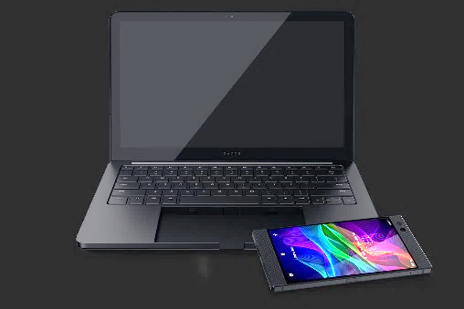 | Features:  - 120Hz Razer phone integrating with laptop (with 0.59-inch thick aluminum case and 13.3” Quad HD touch display)  - The phone docks into laptop and connects with a key press.  - The laptop touch display supports gaming, entertainment, design works, or multiple apps running side by side.  - For gaming, the setup provides the mouse for precise control, the built-in keyboard for quick action trigger, and the phone as a second display for menus and maps, etc.  - The laptop charges the phone with its built-in power bank while docked, and provides 200GB internal storage to house local apps, games, media, and offline phone backups.  (Razar, 2018)
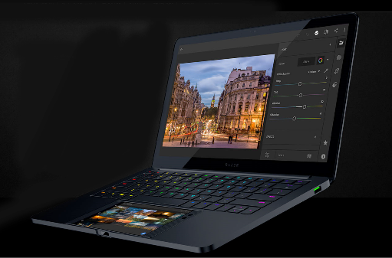
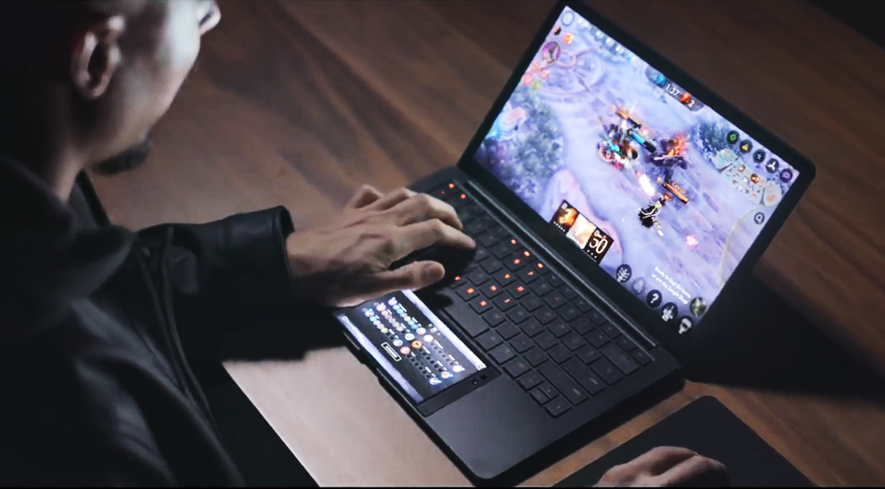

A1. | Considering the Product A, I think it is:  (please check one appropriate circle on each line below)
 | Extremely | Quite | Slightly | Neutral | Slightly | Quite | Extremely
Poor-looking |  |  |  |  |  |  |  | Good-looking
Unattractive |  |  |  |  |  |  |  | Attractive
Unappealing |  |  |  |  |  |  |  | Appealing
Boring |  |  |  |  |  |  |  | Fun
Dull |  |  |  |  |  |  |  | Exciting
Disgusting |  |  |  |  |  |  |  | Delightful
Unthrilling |  |  |  |  |  |  |  | Thrilling
Unenjoyable |  |  |  |  |  |  |  | Enjoyable
Useless |  |  |  |  |  |  |  | Useful
Difficult-to-use |  |  |  |  |  |  |  | Easy-to-use
Inefficient |  |  |  |  |  |  |  | Efficient
Ineffective |  |  |  |  |  |  |  | Effective
Unfunctional |  |  |  |  |  |  |  | Functional
Unhelpful |  |  |  |  |  |  |  | Helpful
Unnecessary |  |  |  |  |  |  |  | Necessary
Impractical |  |  |  |  |  |  |  | Practical
Unimaginative |  |  |  |  |  |  |  | Imaginative
Unsurprising |  |  |  |  |  |  |  | Surprising
Conventional |  |  |  |  |  |  |  | Novel
Uninnovative |  |  |  |  |  |  |  | Innovative

A2. | If I use the Product A, I would be:  (please check one appropriate circle on each line below)
 | Extremely | Quite | Slightly | Neutral | Slightly | Quite | Extremely
Feeling bad |  |  |  |  |  |  |  | Feeling good
Frustrated |  |  |  |  |  |  |  | Contented
Very displeased |  |  |  |  |  |  |  | Very pleased
Very dissatisfied |  |  |  |  |  |  |  | Very satisfied

A3. | Considering the Product A, I think:  (please circle the appropriate scale from 1 to 7 below)
 | Strongly disagree |  |  |  |  |  | Strongly agree
I find connection with the product. (SI) | 1 | 2 | 3 |  | 4 | 5 | 6 | 7
Using the product give me talking points in social life. (SR) | 1 | 2 | 3 |  | 4 | 5 | 6 | 7
Owning the product makes me feel differently about myself. (SI) | 1 | 2 | 3 |  | 4 | 5 | 6 | 7
My family members will like this product. (SR) | 1 | 2 | 3 |  | 4 | 5 | 6 | 7
Using the product, I feel more positive about myself. (SI) | 1 | 2 | 3 |  | 4 | 5 | 6 | 7
Using the product makes me stand out among my friends. (SR) | 1 | 2 | 3 |  | 4 | 5 | 6 | 7
Using the product, I feel proud of myself. (SI) | 1 | 2 | 3 |  | 4 | 5 | 6 | 7
My friends will like this product. (SR) | 1 | 2 | 3 |  | 4 | 5 | 6 | 7
The product does not relate to me. (SI) | 1 | 2 | 3 |  | 4 | 5 | 6 | 7
Probably I will continue using the product. | 1 | 2 | 3 |  | 4 | 5 | 6 | 7
Most likely I will continue using the product. | 1 | 2 | 3 |  | 4 | 5 | 6 | 7
Certainly I will continue using the product. | 1 | 2 | 3 |  | 4 | 5 | 6 | 7
I will not continue using the product. | 1 | 2 | 3 |  | 4 | 5 | 6 | 7

 | * negative statement

PRODUCT B: Philips Sonicare DiamondClean Smart Rechargeable Electric Toothbrush
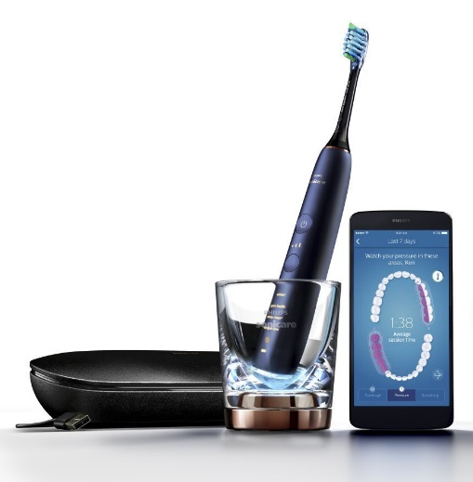 |  |  | Features:  - Uses sonic technology with up to 31,000 brush strokes per minute; sweeping motions drive fluid deep into the hard-to-reach areas, such as the tight spaces between teeth and along gum line.  - 4 different smart brush heads automatically pair with the appropriate brushing mode when snapped onto handle: Clean / Deep Clean, White, Gum Health, Tongue Care.  - 3 intensity levels: higher setting to boost cleaning or lower one for more-sensitive mouths.  - Smart scrubbing sensor and pressure sensor remind user if scrubbed or pressed too hard. These, together with the location sensor, provide real time feedback and personalized coaching via user’s mobile phone.  - Pre-set timers help user follow dental recommended brushing time and ensure thorough brushing for different parts of teeth.  - Charging glass and USB charging travel case – a single full charge supports two weeks of regular use.  - The toothbrush tracks how long and hard the user brushes with each brush head, and alert user when it's time to replace.  (Amazon, 2018a; Philips, 2018)
 |  | 
 | 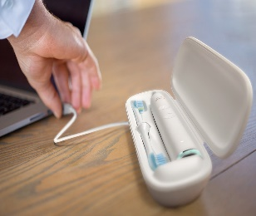

B1. | Considering the Product B, I think it is:  (please check one appropriate circle on each line below)
 | Extremely | Quite | Slightly | Neutral | Slightly | Quite | Extremely
Poor-looking |  |  |  |  |  |  |  | Good-looking
Unattractive |  |  |  |  |  |  |  | Attractive
Unappealing |  |  |  |  |  |  |  | Appealing
Boring |  |  |  |  |  |  |  | Fun
Dull |  |  |  |  |  |  |  | Exciting
Disgusting |  |  |  |  |  |  |  | Delightful
Unthrilling |  |  |  |  |  |  |  | Thrilling
Unenjoyable |  |  |  |  |  |  |  | Enjoyable
Useless |  |  |  |  |  |  |  | Useful
Difficult-to-use |  |  |  |  |  |  |  | Easy-to-use
Inefficient |  |  |  |  |  |  |  | Efficient
Ineffective |  |  |  |  |  |  |  | Effective
Unfunctional |  |  |  |  |  |  |  | Functional
Unhelpful |  |  |  |  |  |  |  | Helpful
Unnecessary |  |  |  |  |  |  |  | Necessary
Impractical |  |  |  |  |  |  |  | Practical
Unimaginative |  |  |  |  |  |  |  | Imaginative
Unsurprising |  |  |  |  |  |  |  | Surprising
Conventional |  |  |  |  |  |  |  | Novel
Uninnovative |  |  |  |  |  |  |  | Innovative

B2. | If I use the Product B, I would be:  (please check one appropriate circle on each line below)
 | Extremely | Quite | Slightly | Neutral | Slightly | Quite | Extremely
Feeling bad |  |  |  |  |  |  |  | Feeling good
Frustrated |  |  |  |  |  |  |  | Contented
Very displeased |  |  |  |  |  |  |  | Very pleased
Very dissatisfied |  |  |  |  |  |  |  | Very satisfied

B3. | Considering the Product B, I think:  (please circle the appropriate scale from 1 to 7 below)
 | Strongly disagree |  |  |  |  |  | Strongly agree
I find connection with the product. (SI) | 1 | 2 | 3 |  | 4 | 5 | 6 | 7
Using the product give me talking points in social life. (SR) | 1 | 2 | 3 |  | 4 | 5 | 6 | 7
Owning the product makes me feel differently about myself. (SI) | 1 | 2 | 3 |  | 4 | 5 | 6 | 7
My family members will like this product. (SR) | 1 | 2 | 3 |  | 4 | 5 | 6 | 7
Using the product, I feel more positive about myself. (SI) | 1 | 2 | 3 |  | 4 | 5 | 6 | 7
Using the product makes me stand out among my friends. (SR) | 1 | 2 | 3 |  | 4 | 5 | 6 | 7
Using the product, I feel proud of myself. (SI) | 1 | 2 | 3 |  | 4 | 5 | 6 | 7
My friends will like this product. (SR) | 1 | 2 | 3 |  | 4 | 5 | 6 | 7
The product does not relate to me. (SI) | 1 | 2 | 3 |  | 4 | 5 | 6 | 7
Probably I will continue using the product. | 1 | 2 | 3 |  | 4 | 5 | 6 | 7
Most likely I will continue using the product. | 1 | 2 | 3 |  | 4 | 5 | 6 | 7
Certainly I will continue using the product. | 1 | 2 | 3 |  | 4 | 5 | 6 | 7
I will not continue using the product. | 1 | 2 | 3 |  | 4 | 5 | 6 | 7

 | * negative statement

PRODUCT C: Nanda Home Runaway Alarm Clock
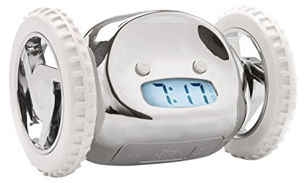 |  | Features:  - Runs away beeping when the set time comes. Jumps from 3 feet high.  - The user has to get up to catch it in order to stop the alarm.  - Option to snooze once, or turn off wheels and use like a conventional alarm clock.  - Available in aqua, black, chrome, gold, red, white.  (Amazon, 2018b)

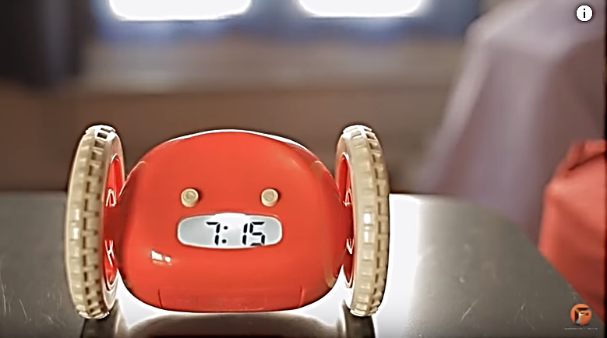 |  |  | 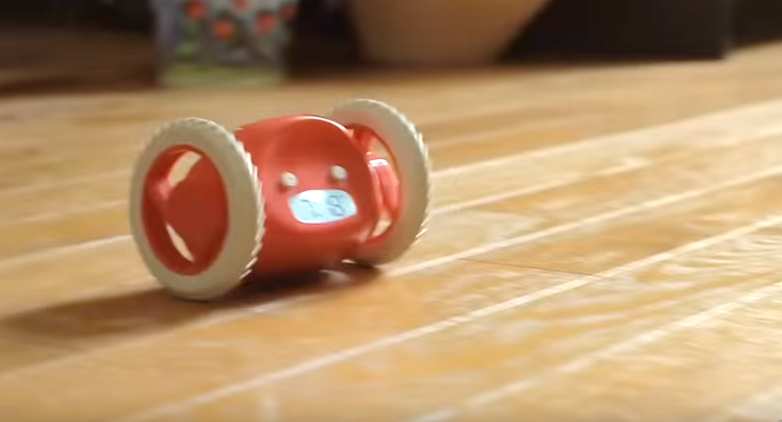

C1. | Considering the Product C, I think it is:  (please check one appropriate circle on each line below)
 | Extremely | Quite | Slightly | Neutral | Slightly | Quite | Extremely
Poor-looking |  |  |  |  |  |  |  | Good-looking
Unattractive |  |  |  |  |  |  |  | Attractive
Unappealing |  |  |  |  |  |  |  | Appealing
Boring |  |  |  |  |  |  |  | Fun
Dull |  |  |  |  |  |  |  | Exciting
Disgusting |  |  |  |  |  |  |  | Delightful
Unthrilling |  |  |  |  |  |  |  | Thrilling
Unenjoyable |  |  |  |  |  |  |  | Enjoyable
Useless |  |  |  |  |  |  |  | Useful
Difficult-to-use |  |  |  |  |  |  |  | Easy-to-use
Inefficient |  |  |  |  |  |  |  | Efficient
Ineffective |  |  |  |  |  |  |  | Effective
Unfunctional |  |  |  |  |  |  |  | Functional
Unhelpful |  |  |  |  |  |  |  | Helpful
Unnecessary |  |  |  |  |  |  |  | Necessary
Impractical |  |  |  |  |  |  |  | Practical
Unimaginative |  |  |  |  |  |  |  | Imaginative
Unsurprising |  |  |  |  |  |  |  | Surprising
Conventional |  |  |  |  |  |  |  | Novel
Uninnovative |  |  |  |  |  |  |  | Innovative

C2. | If I use the Product C, I would be:  (please check one appropriate circle on each line below)
 | Extremely | Quite | Slightly | Neutral | Slightly | Quite | Extremely
Feeling bad |  |  |  |  |  |  |  | Feeling good
Frustrated |  |  |  |  |  |  |  | Contented
Very displeased |  |  |  |  |  |  |  | Very pleased
Very dissatisfied |  |  |  |  |  |  |  | Very satisfied

C3. | Considering the Product C, I think:  (please circle the appropriate scale from 1 to 7 below)
 | Strongly disagree |  |  |  |  |  | Strongly agree
I find connection with the product. (SI) | 1 | 2 | 3 |  | 4 | 5 | 6 | 7
Using the product give me talking points in social life. (SR) | 1 | 2 | 3 |  | 4 | 5 | 6 | 7
Owning the product makes me feel differently about myself. (SI) | 1 | 2 | 3 |  | 4 | 5 | 6 | 7
My family members will like this product. (SR) | 1 | 2 | 3 |  | 4 | 5 | 6 | 7
Using the product, I feel more positive about myself. (SI) | 1 | 2 | 3 |  | 4 | 5 | 6 | 7
Using the product makes me stand out among my friends. (SR) | 1 | 2 | 3 |  | 4 | 5 | 6 | 7
Using the product, I feel proud of myself. (SI) | 1 | 2 | 3 |  | 4 | 5 | 6 | 7
My friends will like this product. (SR) | 1 | 2 | 3 |  | 4 | 5 | 6 | 7
The product does not relate to me. (SI) | 1 | 2 | 3 |  | 4 | 5 | 6 | 7
Probably I will continue using the product. | 1 | 2 | 3 |  | 4 | 5 | 6 | 7
Most likely I will continue using the product. | 1 | 2 | 3 |  | 4 | 5 | 6 | 7
Certainly I will continue using the product. | 1 | 2 | 3 |  | 4 | 5 | 6 | 7
I will not continue using the product. | 1 | 2 | 3 |  | 4 | 5 | 6 | 7

 | * negative statement

Section 2

These last questions are for classification purpose only (the information cannot and will not be used to identify individuals):
1. | How often do you use an alarm clock? (please choose one closest answer)
□ More than once a day
□ Once a day
□ One to a few times a week
□ Less frequent than the above
□ Never

2. | How often do you brush your teeth? (please choose one closest answer)
□ More than twice a day
□ Twice a day
□ Once a day
□ One to a few times a week
□ Less frequent than the above
□ Never

3. | How often do you use an electric toothbrush? (please choose one closest answer)
□ More than twice a day
□ Twice a day
□ Once a day
□ One to a few times a week
□ Less frequent than the above
□ Never

4. | How often do you use a mobile phone? (please choose one closest answer)
□ Many times a day
□ A few times a day
□ A few times a week
□ A few times a month
□ Less frequent than the above
□ Never

5. | How often do you use a laptop computer? (please choose one closest answer)
□ More than 5 hours a day
□ 2 to 5 hours a day
□ 1 to less than 2 hours a day
□ A few hours a week
□ Less frequent than the above
□ Never

6. | Occupation (you may tick more than one box if appropriate):
 | □ Student  □ Business  □ Catering  □ Clerical  □ Construction  □ Consultant  □ Design  □ Education  □ Finance | □ IT  □ Manufacturing  □ Medical  □ Product R&D  □ Retail  □ Service  □ Housewife  □ Retired  □ Others: please specify _________________
7. | If you have indicated that your occupation involves design in Q6, please check the design field below:
□ Not applicable for me
□ Fashion Design
□ Multimedia Design
□ Product Design
□ Spatial Design
□ Visual Communication Design
□ Others – please specify: _________________

8. | Education:
□ Primary school or below
□ Secondary school
□ Matriculation / pre-college
□ University / tertiary
□ Post-graduate

9. | Please specify major area(s) of your pre-college / university / tertiary / post-graduate education (you may tick more than one box if appropriate):
□ Arts
□ Business
□ Design
□ Education
□ Engineering
□ IT
□ Medical
□ Science
□ Tourism / Hospitality
□ Social Science
□ Others – please specify: _________________

10. | City of origin:
□ Hong Kong
□ Others – please specify: _________________

11. | Gender :
□ Male
□ Female
□ Others

12. | Marital status:
□ Single
□ Married
□ Divorced / Separated
□ Others

13. | Age:
□ 15 or below
□ 16 – 17
□ 18 – 25
□ 26 – 35
□ 36 – 45
□ 46 – 55
□ 56 – 65
□ 66 or above

Thank you for your participation.
Your comments are valuable. Please give your other comments below, on the products or
on the questionnaire, if any:
The researcher can be contacted for enquiry at: cslcchk@gmail.com – You may leave your email address below for possible following-up or for understanding more about the research study:
For your information, comparison will be made between responses from different groups of respondents.

Product References:
Amazon. (2018a). Philips Sonicare DiamondClean Smart rechargeable electric toothbrush. Retrieved from https://www.amazon.com/Philips-Sonicare-DiamondClean-Rechargeable-toothbrush/dp/B06XSH2RNQ/ref=dp_ob_title_hpc?th=1
Amazon. (2018b). Clocky, the original runaway alarm clock on wheels. Retrieved from https://www.amazon.com/Clocky-Original-Runaway-Alarm-Wheels/dp/B004MSMUGI
Philips. (2018). Sonicare DiamondClean Smart Sonic electric toothbrush with app. Retrieved from https://www.philips.com.hk/en/c-p/HX9924_42/sonicare-diamondclean-smart-sonic-electric-toothbrush-with-app#see-all-benefits
Razar. (2018). Project Linda. Retrieved from https://www.razer.com/projectlinda

Perceived Hedonic Value (PHV1-8): Items 1-8 of question A1 in questionnaire (Appendix 1)
Case Processing Summary
 |  | N | %
Cases | Valid | 22 | 100.00
 | Excluded | 0 | .00
 | Total | 22 | 100.00

Reliability Statistics
Cronbach's Alpha | N of Items
.90 | 8

Item-Total Statistics
 | Scale Mean if Item Deleted | Scale Variance if Item Deleted | Corrected Item-Total Correlation | Cronbach's Alpha if Item Deleted
PHV1 | 33.45 | 33.31 | .69 | .89
PHV2 | 33.50 | 35.02 | .69 | .89
PHV3 | 33.55 | 32.93 | .78 | .88
PHV4 | 34.27 | 32.68 | .69 | .89
PHV5 | 34.09 | 32.18 | .81 | .87
PHV6 | 34.00 | 32.67 | .74 | .88
PHV7 | 34.73 | 35.26 | .56 | .90
PHV8 | 33.50 | 35.88 | .53 | .90

Perceived Utilitarian Value (PUV1-8): Items 9-16 of question A1 in questionnaire (Appendix 1)

Case Processing Summary
 |  | N | %
Cases | Valid | 22 | 100.00
 | Excluded | 0 | .00
 | Total | 22 | 100.00

Reliability Statistics
Cronbach's Alpha | N of Items
.90 | 8

Item-Total Statistics
 | Scale Mean if Item Deleted | Scale Variance if Item Deleted | Corrected Item-Total Correlation | Cronbach's Alpha if Item Deleted
PUV1 | 31.55 | 46.26 | .65 | .90
PUV2 | 31.50 | 51.12 | .33 | .92
PUV3 | 32.18 | 38.44 | .81 | .88
PUV4 | 31.82 | 43.01 | .70 | .89
PUV5 | 31.77 | 44.47 | .74 | .89
PUV6 | 32.00 | 40.86 | .80 | .88
PUV7 | 33.00 | 41.24 | .72 | .89
PUV8 | 32.64 | 40.81 | .82 | .88

Perceived Social Value (PSV1-9): Items 1-9 of question A3 in questionnaire (Appendix 1)

Case Processing Summary
 |  | N | %
Cases | Valid | 22 | 100.00
 | Excluded | 0 | .00
 | Total | 22 | 100.00

Reliability Statistics
Cronbach's Alpha | N of Items
.94 | 9

Item-Total Statistics
 | Scale Mean if Item Deleted | Scale Variance if Item Deleted | Corrected Item-Total Correlation | Cronbach's Alpha if Item Deleted
PSV1 | 30.41 | 106.25 | .74 | .93
PSV2 | 31.05 | 128.71 | -.02 | .97
PSV3 | 31.00 | 107.62 | .75 | .93
PSV4 | 31.32 | 100.04 | .91 | .92
PSV5 | 31.59 | 96.44 | .94 | .92
PSV6 | 30.82 | 100.16 | .90 | .92
PSV7 | 30.82 | 95.87 | .90 | .92
PSV8 | 31.36 | 93.19 | .93 | .92
PSV9 | 30.91 | 100.47 | .83 | .93

Perceived Innovativeness (PI1-4): Items 17-20 of question A1 in questionnaire (Appendix 1)

Case Processing Summary
 |  | N | %
Cases | Valid | 22 | 100.00
 | Excluded | 0 | .00
 | Total | 22 | 100.00

Reliability Statistics
Cronbach's Alpha | N of Items
.78 | 4

Item-Total Statistics
 | Scale Mean if Item Deleted | Scale Variance if Item Deleted | Corrected Item-Total Correlation | Cronbach's Alpha if Item Deleted
PI1 | 12.05 | 12.43 | .37 | .81
PI2 | 12.77 | 9.33 | .62 | .71
PI3 | 12.23 | 8.56 | .64 | .69
PI4 | 12.32 | 8.04 | .72 | .65

Perceived Satisfaction (PS1-4): Items 1-4 of question A2 in questionnaire (Appendix 1)

Case Processing Summary
 |  | N | %
Cases | Valid | 22 | 100.00
 | Excluded | 0 | .00
 | Total | 22 | 100.00

Reliability Statistics
Cronbach's Alpha | N of Items
.85 | 4

Item-Total Statistics
 | Scale Mean if Item Deleted | Scale Variance if Item Deleted | Corrected Item-Total Correlation | Cronbach's Alpha if Item Deleted
PS1 | 13.68 | 7.66 | .83 | .76
PS2 | 13.73 | 9.26 | .57 | .86
PS3 | 14.18 | 7.77 | .77 | .79
PS4 | 14.18 | 6.92 | .67 | .84

Intended Continuous Use (ICU1-4): Items 10-13 of question A3 in questionnaire (Appendix 1)

Case Processing Summary
 |  | N | %
Cases | Valid | 22 | 100.00
 | Excluded | 0 | .00
 | Total | 22 | 100.00

Reliability Statistics
Cronbach's Alpha | N of Items
.96 | 4

Item-Total Statistics
 | Scale Mean if Item Deleted | Scale Variance if Item Deleted | Corrected Item-Total Correlation | Cronbach's Alpha if Item Deleted
ICU1 | 12.23 | 25.99 | .93 | .94
ICU2 | 12.36 | 24.81 | .97 | .93
ICU3 | 12.50 | 26.64 | .91 | .95
ICU4 | 12.68 | 26.89 | .81 | .98

Keys:
> | Larger than overall mean
< | Smaller than overall mean

PRODUCT A

DESCRIPTIVES
Valid cases = 22; cases with missing value(s) = 0.
Variable | N | Mean | Std Dev | Variance | Minimum | Maximum
Perceived Hedonic Value | 22 | 4.84 > | .82 | .68 | 2.88 | 6.25
Perceived Utilitarian Value | 22 | 4.58 < | .93 | .87 | 1.88 | 6.00
Perceived Social Value | 22 | 3.88 < | 1.27 | 1.60 | 1.44 | 5.78
Perceived Innovativeness | 22 | 4.11 < | 1.00 | .99 | 1.75 | 5.75
Perceived Satisfaction | 22 | 4.65 > | .92 | .84 | 1.50 | 5.75
Intended Continuous Use | 22 | 4.15 < | 1.69 | 2.86 | 1.00 | 6.75

PRODUCT B

DESCRIPTIVES
Valid cases = 22; cases with missing value(s) = 0.
Variable | N | Mean | Std Dev | Variance | Minimum | Maximum
Perceived Hedonic Value | 22 | 4.67 > | .92 | .85 | 2.63 | 6.00
Perceived Utilitarian Value | 22 | 5.02 > | 1.20 | 1.43 | 2.25 | 7.00
Perceived Social Value | 22 | 3.85 < | 1.26 | 1.59 | 1.11 | 5.44
Perceived Innovativeness | 22 | 4.60 > | 1.06 | 1.12 | 1.75 | 6.00
Perceived Satisfaction | 22 | 4.61 > | 1.18 | 1.40 | 1.50 | 6.25
Intended Continuous Use | 22 | 4.52 < | 1.55 | 2.39 | 1.00 | 6.75

PRODUCT C

DESCRIPTIVES
Valid cases = 22; cases with missing value(s) = 0.
Variable | N | Mean | Std Dev | Variance | Minimum | Maximum
Perceived Hedonic Value | 22 | 4.00 < | 1.26 | 1.58 | 1.38 | 6.13
Perceived Utilitarian Value | 22 | 3.82 < | 1.49 | 2.23 | 1.00 | 6.25
Perceived Social Value | 22 | 3.24 < | 1.36 | 1.85 | 1.00 | 5.67
Perceived Innovativeness | 22 | 4.02 < | 1.52 | 2.30 | 1.00 | 6.50
Perceived Satisfaction | 22 | 3.76 < | 1.52 | 2.32 | 1.00 | 6.00
Intended Continuous Use | 22 | 3.22 < | 1.59 | 2.54 | 1.00 | 6.00

OVERALL

DESCRIPTIVES
Valid cases = 22; cases with missing value(s) = 0.
Variable | N | Mean | Std Dev | Variance | Minimum | Maximum
Perceived Hedonic Value | 22 | 4.50 | .81 | .66 | 2.79 | 5.63
Percieved Utilitarian Value | 22 | 4.76 | 1.15 | 1.31 | 2.67 | 6.33
Percieved Social Value | 22 | 4.65 | .87 | .76 | 3.00 | 6.33
Perceived Innovativeness | 22 | 4.44 | 1.04 | 1.07 | 2.33 | 6.00
Perceived Satisfaction | 22 | 4.48 | 1.02 | 1.04 | 2.33 | 6.00
Intended Continuous Use | 22 | 4.71 | .95 | .90 | 2.33 | 6.00

PRODUCT A

Correlations (Twotail Sig.)

 |  | Perceived Hedonic Value | Perceived Utilitarian Value | Perceived Social Value | Perceived Innovativeness | Perceived Satisfaction | Intended Continuous Use
Perceived Hedonic Value | Pearson Correlation | 1.00 | .60 | .59 | .46 | .76 | .42
 | Sig. (2-tailed) |  | .003 | .004 | .033 | .000 | .053
 | N | 22 | 22 | 22 | 22 | 22 | 22
Perceived Utilitarian Value | Pearson Correlation | .60 | 1.00 | .74 | .56 | .89 | .80
 | Sig. (2-tailed) | .003 |  | .000 | .007 | .000 | .000
 | N | 22 | 22 | 22 | 22 | 22 | 22
Perceived Social Value | Pearson Correlation | .59 | .74 | 1.00 | .78 | .76 | .86
 | Sig. (2-tailed) | .004 | .000 |  | .000 | .000 | .000
 | N | 22 | 22 | 22 | 22 | 22 | 22
Perceived Innovativeness | Pearson Correlation | .46 | .56 | .78 | 1.00 | .57 | .65
 | Sig. (2-tailed) | .033 | .007 | .000 |  | .006 | .001
 | N | 22 | 22 | 22 | 22 | 22 | 22
Perceived Satisfaction | Pearson Correlation | .76 | .89 | .76 | .57 | 1.00 | .73
 | Sig. (2-tailed) | .000 | .000 | .000 | .006 |  | .000
 | N | 22 | 22 | 22 | 22 | 22 | 22
Intended Continuous Use | Pearson Correlation | .42 | .80 | .86 | .65 | .73 | 1.00
 | Sig. (2-tailed) | .053 | .000 | .000 | .001 | .000
 | N | 22 | 22 | 22 | 22 | 22 | 22

PRODUCT B

Correlations (Twotail Sig.)

 |  | Perceived Hedonic Value | Perceived Utilitarian Value | Perceived Social Value | Perceived Innovativeness | Perceived Satisfaction | Intended Continuous Use
Perceived Hedonic Value | Pearson Correlation | 1.00 | .86 | .80 | .65 | .83 | .78
 | Sig. (2-tailed) |  | .000 | .000 | .001 | .000 | .000
 | N | 22 | 22 | 22 | 22 | 22 | 22
Perceived Utilitarian Value | Pearson Correlation | .86 | 1.00 | .77 | .48 | .77 | .83
 | Sig. (2-tailed) | .000 |  | .000 | .025 | .000 | .000
 | N | 22 | 22 | 22 | 22 | 22 | 22
Perceived Social Value | Pearson Correlation | .80 | .77 | 1.00 | .58 | .78 | .89
 | Sig. (2-tailed) | .000 | .000 |  | .004 | .000 | .000
 | N | 22 | 22 | 22 | 22 | 22 | 22
Perceived Innovativeness | Pearson Correlation | .65 | .48 | .58 | 1.00 | .44 | .34
 | Sig. (2-tailed) | .001 | .025 | .004 |  | .043 | .119
 | N | 22 | 22 | 22 | 22 | 22 | 22
Perceived Satisfaction | Pearson Correlation | .83 | .77 | .78 | .44 | 1.00 | .86
 | Sig. (2-tailed) | .000 | .000 | .000 | .043 |  | .000
 | N | 22 | 22 | 22 | 22 | 22 | 22
Intended Continuous Use | Pearson Correlation | .78 | .83 | .89 | .34 | .86 | 1.00
 | Sig. (2-tailed) | .000 | .000 | .000 | .119 | .000
 | N | 22 | 22 | 22 | 22 | 22 | 22

PRODUCT C

Correlations (Twotail Sig.)

 |  | Perceived Hedonic Value | Perceived Utilitarian Value | Perceived Social Value | Perceived Innovativeness | Perceived Satisfaction | Intended Continuous Use
Perceived Hedonic Value | Pearson Correlation | 1.00 | .94 | .83 | .78 | .91 | .75
 | Sig. (2-tailed) |  | .000 | .000 | .000 | .000 | .000
 | N | 22 | 22 | 22 | 22 | 22 | 22
Perceived Utilitarian Value | Pearson Correlation | .94 | 1.00 | .90 | .76 | .89 | .86
 | Sig. (2-tailed) | .000 |  | .000 | .000 | .000 | .000
 | N | 22 | 22 | 22 | 22 | 22 | 22
Perceived Social Value | Pearson Correlation | .83 | .90 | 1.00 | .78 | .87 | .89
 | Sig. (2-tailed) | .000 | .000 |  | .000 | .000 | .000
 | N | 22 | 22 | 22 | 22 | 22 | 22
Perceived Innovativeness | Pearson Correlation | .78 | .76 | .78 | 1.00 | .82 | .69
 | Sig. (2-tailed) | .000 | .000 | .000 |  | .000 | .000
 | N | 22 | 22 | 22 | 22 | 22 | 22
Perceived Satisfaction | Pearson Correlation | .91 | .89 | .87 | .82 | 1.00 | .79
 | Sig. (2-tailed) | .000 | .000 | .000 | .000 |  | .000
 | N | 22 | 22 | 22 | 22 | 22 | 22
Intended Continuous Use | Pearson Correlation | .75 | .86 | .89 | .69 | .79 | 1.00
 | Sig. (2-tailed) | .000 | .000 | .000 | .000 | .000
 | N | 22 | 22 | 22 | 22 | 22 | 22

OVERALL

Correlations (Twotail Sig.)

 |  | Perceived Hedonic Value | Percieved Utilitarian Value | Percieved Social Value | Perceived Innovativeness | Perceived Satisfaction | Intended Continuous Use
Perceived Hedonic Value | Pearson Correlation | 1.00 | .81 | .77 | .82 | .87 | .81
 | Sig. (2-tailed) |  | .000 | .000 | .000 | .000 | .000
 | N | 22 | 22 | 22 | 22 | 22 | 22
Percieved Utilitarian Value | Pearson Correlation | .81 | 1.00 | .75 | .89 | .80 | .87
 | Sig. (2-tailed) | .000 |  | .000 | .000 | .000 | .000
 | N | 22 | 22 | 22 | 22 | 22 | 22
Percieved Social Value | Pearson Correlation | .77 | .75 | 1.00 | .64 | .77 | .74
 | Sig. (2-tailed) | .000 | .000 |  | .001 | .000 | .000
 | N | 22 | 22 | 22 | 22 | 22 | 22
Perceived Innovativeness | Pearson Correlation | .82 | .89 | .64 | 1.00 | .83 | .87
 | Sig. (2-tailed) | .000 | .000 | .001 |  | .000 | .000
 | N | 22 | 22 | 22 | 22 | 22 | 22
Perceived Satisfaction | Pearson Correlation | .87 | .80 | .77 | .83 | 1.00 | .88
 | Sig. (2-tailed) | .000 | .000 | .000 | .000 |  | .000
 | N | 22 | 22 | 22 | 22 | 22 | 22
Intended Continuous Use | Pearson Correlation | .81 | .87 | .74 | .87 | .88 | 1.00
 | Sig. (2-tailed) | .000 | .000 | .000 | .000 | .000
 | N | 22 | 22 | 22 | 22 | 22 | 22

PRODUCT A

Product A – Testing Hypothesis 1

Step 1 – Regress the dependent variable Perceived Satisfaction (PS) on the independent variable with the strongest correlation with PS, which is Perceived Utilitarian Value (PUV) from the correlation table in Appendix 4.

REGRESSION 1
Model Summary (Perceived Satisfaction)
 | R | R Square | Adjusted R Square | Std. Error of the Estimate
 | .89 | .79 | .78 | .43

ANOVA (Perceived Satisfaction)
 |  | Sum of Squares | df | Mean Square | F | Sig.
 | Regression | 13.86 | 1 | 13.86 | 74.54 | .000
 | Residual | 3.72 | 20 | .19
 | Total | 17.58 | 21

Coefficients (Perceived Satisfaction)
 |  | Unstandardized Coefficients |  | Standardized Coefficients
 |  | B | Std. Error | Beta | t | Sig.
 | (Constant) | .66 | .47 | .00 | 1.39 | .178
 | Perceived Utilitarian Value | .87 | .10 | .89 | 8.63 | .000

Step 2 – As Step 1 shows the statistical significance of the Beta Coefficient of the tested independent variable <0.05, regress the dependent variable Perceived Satisfaction (PS) on the independent variables with the first and second strongest correlation with PS, which are Perceived Utilitarian Value (PUV) and Perceived Hedonic Value (PHV) from the correlation table in Appendix 4.

REGRESSION 2
Model Summary (Perceived Satisfaction)
 | R | R Square | Adjusted R Square | Std. Error of the Estimate
 | .93 | .87 | .85 | .35

ANOVA (Perceived Satisfaction)
 |  | Sum of Squares | df | Mean Square | F | Sig.
 | Regression | 15.25 | 2 | 7.62 | 62.06 | .000
 | Residual | 2.33 | 19 | .12
 | Total | 17.58 | 21

Coefficients (Perceived Satisfaction)
 |  | Unstandardized Coefficients |  | Standardized Coefficients
 |  | B | Std. Error | Beta | t | Sig.
 | (Constant) | -.29 | .48 | .00 | -.60 | .552
 | Perceived Utilitarian Value | .66 | .10 | .68 | 6.49 | .000
 | Perceived Hedonic Value | .39 | .12 | .35 | 3.36 | .003

Step 3 – As Step 2 shows an increase of R Square and the statistical significances of the Beta Coefficients of the tested independent variables <0.05, regress the dependent variable Perceived Satisfaction (PS) on the independent variables with the first, second and third strongest correlation with PS, which are Perceived Utilitarian Value (PUV), Perceived Hedonic Value (PHV), and Perceived Social Value (PSV) from the correlation table in Appendix 4.

REGRESSION 3
Model Summary (Perceived Satisfaction)
 | R | R Square | Adjusted R Square | Std. Error of the Estimate
 | .93 | .87 | .85 | .35

ANOVA (Perceived Satisfaction)
 |  | Sum of Squares | df | Mean Square | F | Sig.
 | Regression | 15.36 | 3 | 5.12 | 41.44 | .000
 | Residual | 2.22 | 18 | .12
 | Total | 17.58 | 21

Coefficients (Perceived Satisfaction)
 |  | Unstandardized Coefficients |  | Standardized Coefficients
 |  | B | Std. Error | Beta | t | Sig.
 | (Constant) | -.15 | .50 | .00 | -.30 | .768
 | Perceived Utilitarian Value | .59 | .13 | .61 | 4.65 | .000
 | Perceived Hedonic Value | .36 | .12 | .32 | 2.96 | .008
 | Perceived Social Value | .09 | .09 | .12 | .95 | .357

Step 4 – Since Step 3 shows no increase of R Square and the statistical significance of the Beta Coefficient of the lastly added independent variable is >0.05, the regression test for Hypothesis 1 is stopped here with the independent variables Perceived Utilitarian Value (PUV) and Perceived Hedonic Value (PHV) recognised as significant predictors for the dependent variable Perceived Satisfaction (PS).

Product A – Testing Hypothesis 2

Regress the dependent variable Intended Continuous Use (ICU) on the independent variable Perceived Satisfaction (PS)

REGRESSION
Model Summary (Intended Continuous Use)
 | R | R Square | Adjusted R Square | Std. Error of the Estimate
 | .73 | .53 | .51 | 1.18

ANOVA (Intended Continuous Use)
 |  | Sum of Squares | df | Mean Square | F | Sig.
 | Regression | 32.13 | 1 | 32.13 | 23.00 | .000
 | Residual | 27.95 | 20 | 1.40
 | Total | 60.08 | 21

Coefficients (Intended Continuous Use)
 |  | Unstandardized Coefficients |  | Standardized Coefficients
 |  | B | Std. Error | Beta | t | Sig.
 | (Constant) | -2.14 | 1.33 | .00 | -1.60 | .124
 | Perceived Satisfaction | 1.35 | .28 | .73 | 4.80 | .000

Product A – Testing Hypothesis 3

Step 1 – Regress the dependent variable Intended Continuous Use (ICU) on the independent variable with the strongest correlation with ICU, which is Perceived Social Value (PSV) from the correlation table in Appendix 4.

REGRESSION 1

Model Summary (Intended Continuous Use)
 | R | R Square | Adjusted R Square | Std. Error of the Estimate
 | .86 | .73 | .72 | .89

ANOVA (Intended Continuous Use)
 |  | Sum of Squares | df | Mean Square | F | Sig.
 | Regression | 44.08 | 1 | 44.08 | 55.10 | .000
 | Residual | 16.00 | 20 | .80
 | Total | 60.08 | 21

Coefficients (Intended Continuous Use)
 |  | Unstandardized Coefficients |  | Standardized Coefficients
 |  | B | Std. Error | Beta | t | Sig.
 | (Constant) | -.29 | .63 | .00 | -.47 | .646
 | Perceived Social Value | 1.14 | .15 | .86 | 7.42 | .000

Step 2 – As Step 1 shows the statistical significance of the Beta Coefficient of the tested independent variable <0.05, regress the dependent variable Intended Continuous Use (ICU) on the independent variables with the first and second strongest correlation with ICU, which are Social Value (PSV) and Perceived Utilitarian Value (PUV) from the correlation table in Appendix 4.
REGRESSION 2

Model Summary (Intended Continuous Use)
 | R | R Square | Adjusted R Square | Std. Error of the Estimate
 | .89 | .79 | .77 | .81

ANOVA (Intended Continuous Use)
 |  | Sum of Squares | df | Mean Square | F | Sig.
 | Regression | 47.76 | 2 | 23.88 | 36.80 | .000
 | Residual | 12.33 | 19 | .65
 | Total | 60.08 | 21

Coefficients (Intended Continuous Use)
 |  | Unstandardized Coefficients |  | Standardized Coefficients
 |  | B | Std. Error | Beta | t | Sig.
 | (Constant) | -1.93 | .89 | .00 | -2.17 | .042
 | Perceived Social Value | .78 | .21 | .59 | 3.82 | .001
 | Perceived Utilitarian Value | .66 | .28 | .37 | 2.38 | .028
Step 3 – As Step 2 shows an increase of R Square and the statistical significances of the Beta Coefficients of the tested independent variables <0.05, regress the dependent variable Intended Continuous Use (ICU) on the independent variables with the first, second and third strongest correlation with ICU, which are Perceived Social Value (PSV), Perceived Utilitarian Value (PUV), and Perceived Hedonic Value (PHV) from the correlation table in Appendix 4.

REGRESSION 3

Model Summary (Intended Continuous Use)
 | R | R Square | Adjusted R Square | Std. Error of the Estimate
 | .91 | .83 | .80 | .75

ANOVA (Intended Continuous Use)
 |  | Sum of Squares | df | Mean Square | F | Sig.
 | Regression | 49.96 | 3 | 16.65 | 29.62 | .000
 | Residual | 10.12 | 18 | .56
 | Total | 60.08 | 21

Coefficients (Intended Continuous Use)
 |  | Unstandardized Coefficients |  | Standardized Coefficients
 |  | B | Std. Error | Beta | t | Sig.
 | (Constant) | -.62 | 1.06 | .00 | -.58 | .567
 | Perceived Social Value | .89 | .20 | .67 | 4.49 | .000
 | Perceived Utilitarian Value | .83 | .27 | .46 | 3.03 | .007
 | Perceived Hedonic Value | -.51 | .26 | -.25 | -1.98 | .063

Step 4 – Despite Step 3 shows an increase of R Square, the statistical significance of the Beta Coefficient of the lastly added independent variable is >0.05, the regression test for Hypothesis 3 is stopped here with the independent variables Perceived Social Value (PSV) and Perceived Utilitarian Value (PUV) recognised as significant predictors for the dependent variable Intended Continuous Use (ICU).

Product A – Testing Hypothesis 4

Step 1 – Regress the dependent variable Perceived Social Value (PSV) on the independent variable with the strongest correlation with PSV, which is Perceived Innovativeness (PI) from the correlation table in Appendix 4.

REGRESSION 1

Model Summary (Perceived Social Value)
 | R | R Square | Adjusted R Square | Std. Error of the Estimate
 | .78 | .61 | .59 | .81

ANOVA (Perceived Social Value)
 |  | Sum of Squares | df | Mean Square | F | Sig.
 | Regression | 20.38 | 1 | 20.38 | 30.72 | .000
 | Residual | 13.27 | 20 | .66
 | Total | 33.64 | 21

Coefficients (Perceived Social Value)
 |  | Unstandardized Coefficients |  | Standardized Coefficients
 |  | B | Std. Error | Beta | t | Sig.
 | (Constant) | -.19 | .75 | .00 | -.25 | .805
 | Perceived Innovativeness | .99 | .18 | .78 | 5.54 | .000

Step 2 – As Step 1 shows the statistical significance of the Beta Coefficient of the tested independent variable <0.05, regress the dependent variable Perceived Social Value (PSV) on the independent variables with the first and second strongest correlation with PSV, which are Perceived Innovativeness (PI) and Perceived Utilitarian Value (PUV) from the correlation table in Appendix 4.

REGRESSION 2
Model Summary (Perceived Social Value)
 | R | R Square | Adjusted R Square | Std. Error of the Estimate
 | .86 | .74 | .71 | .68

ANOVA (Perceived Social Value)
 |  | Sum of Squares | df | Mean Square | F | Sig.
 | Regression | 24.85 | 2 | 12.43 | 26.86 | .000
 | Residual | 8.79 | 19 | .46
 | Total | 33.64 | 21

Coefficients (Perceived Social Value)
 |  | Unstandardized Coefficients |  | Standardized Coefficients
 |  | B | Std. Error | Beta | t | Sig.
 | (Constant) | -1.64 | .78 | .00 | -2.09 | .049
 | Perceived Innovativeness | .68 | .18 | .53 | 3.77 | .001
 | Perceived Utilitarian Value | .60 | .19 | .44 | 3.11 | .006

Step 3 – As Step 2 shows an increase of R Square and the statistical significances of the Beta Coefficients of the tested independent variables <0.05, regress the dependent variable Perceived Social Value (PSV) on the independent variables with the first, second and third strongest correlation with PS, which are Perceived Innovativeness (PI), Perceived Utilitarian Value (PUV), and Perceived Hedonic Value (PHV) from the correlation table in Appendix 4.

REGRESSION 3

Model Summary (Perceived Social Value)
 | R | R Square | Adjusted R Square | Std. Error of the Estimate
 | .87 | .75 | .71 | .68

ANOVA (Perceived Social Value)
 |  | Sum of Squares | df | Mean Square | F | Sig.
 | Regression | 25.24 | 3 | 8.41 | 18.02 | .000
 | Residual | 8.40 | 18 | .47
 | Total | 33.64 | 21

Coefficients (Perceived Social Value)
 |  | Unstandardized Coefficients |  | Standardized Coefficients
 |  | B | Std. Error | Beta | t | Sig.
 | (Constant) | -2.11 | .94 | .00 | -2.24 | .037
 | Perceived Innovativeness | .65 | .18 | .51 | 3.53 | .002
 | Perceived Utilitarian Value | .50 | .22 | .37 | 2.31 | .033
 | Perceived Hedonic Value | .21 | .23 | .14 | .91 | .375

Step 4 – Despite Step 3 shows an increase of R Square, the statistical significance of the Beta Coefficient of the lastly added independent variable is >0.05, the regression test for Hypothesis 4 is stopped here with the independent variables Perceived Innovativeness (PI) and Perceived Utilitarian Value (PUV) recognised as significant predictors for the dependent variable Perceived Social Value (PSV).

PRODUCT B

Product B – Testing Hypothesis 1
The logics and steps follow those of Product A.

REGRESSION 1

Model Summary (Perceived Satisfaction)
 | R | R Square | Adjusted R Square | Std. Error of the Estimate
 | .83 | .68 | .67 | .68

ANOVA (Perceived Satisfaction)
 |  | Sum of Squares | df | Mean Square | F | Sig.
 | Regression | 20.04 | 1 | 20.04 | 43.08 | .000
 | Residual | 9.30 | 20 | .47
 | Total | 29.34 | 21

Coefficients (Perceived Satisfaction)
 |  | Unstandardized Coefficients |  | Standardized Coefficients
 |  | B | Std. Error | Beta | t | Sig.
 | (Constant) | -.33 | .77 | .00 | -.43 | .672
 | Perceived Hedonic Value | 1.06 | .16 | .83 | 6.56 | .000

REGRESSION 2

Model Summary (Perceived Satisfaction)
 | R | R Square | Adjusted R Square | Std. Error of the Estimate
 | .85 | .72 | .69 | .65

ANOVA (Perceived Satisfaction)
 |  | Sum of Squares | df | Mean Square | F | Sig.
 | Regression | 21.23 | 2 | 10.62 | 24.87 | .000
 | Residual | 8.11 | 19 | .43
 | Total | 29.34 | 21

Coefficients (Perceived Satisfaction)
 |  | Unstandardized Coefficients |  | Standardized Coefficients
 |  | B | Std. Error | Beta | t | Sig.
 | (Constant) | .07 | .77 | .00 | .09 | .932
 | Perceived Hedonic Value | .71 | .26 | .56 | 2.77 | .012
 | Perceived Social Value | .32 | .19 | .34 | 1.67 | .111

Product B – Testing Hypothesis 2
The logics and steps follow those of Product A.

REGRESSION

Model Summary (Intended Continuous Use)
 | R | R Square | Adjusted R Square | Std. Error of the Estimate
 | .86 | .75 | .73 | .80

ANOVA (Intended Continuous Use)
 |  | Sum of Squares | df | Mean Square | F | Sig.
 | Regression | 37.55 | 1 | 37.55 | 59.19 | .000
 | Residual | 12.69 | 20 | .63
 | Total | 50.24 | 21

Coefficients (Intended Continuous Use)
 |  | Unstandardized Coefficients |  | Standardized Coefficients
 |  | B | Std. Error | Beta | t | Sig.
 | (Constant) | -.70 | .70 | .00 | -1.00 | .331
 | Perceived Satisfaction | 1.13 | .15 | .86 | 7.69 | .000

Product B – Testing Hypothesis 3
The logics and steps follow those of Product A.

REGRESSION 1

Model Summary (Intended Continuous Use)
 | R | R Square | Adjusted R Square | Std. Error of the Estimate
 | .89 | .79 | .78 | .73

ANOVA (Intended Continuous Use)
 |  | Sum of Squares | df | Mean Square | F | Sig.
 | Regression | 39.65 | 1 | 39.65 | 74.93 | .000
 | Residual | 10.58 | 20 | .53
 | Total | 50.24 | 21

Coefficients (Intended Continuous Use)
 |  | Unstandardized Coefficients |  | Standardized Coefficients
 |  | B | Std. Error | Beta | t | Sig.
 | (Constant) | .33 | .51 | .00 | .64 | .529
 | Perceived Social Value | 1.09 | .13 | .89 | 8.66 | .000

REGRESSION 2

Model Summary (Intended Continuous Use)
 | R | R Square | Adjusted R Square | Std. Error of the Estimate
 | .92 | .84 | .82 | .65

ANOVA (Intended Continuous Use)
 |  | Sum of Squares | df | Mean Square | F | Sig.
 | Regression | 42.15 | 2 | 21.07 | 49.50 | .000
 | Residual | 8.09 | 19 | .43
 | Total | 50.24 | 21

Coefficients (Intended Continuous Use)
 |  | Unstandardized Coefficients |  | Standardized Coefficients
 |  | B | Std. Error | Beta | t | Sig.
 | (Constant) | -.67 | .61 | .00 | -1.09 | .288
 | Perceived Social Value | .76 | .18 | .62 | 4.24 | .000
 | Perceived Utilitarian Value | .45 | .19 | .35 | 2.42 | .026

REGRESSION 3

Model Summary (Intended Continuous Use)
 | R | R Square | Adjusted R Square | Std. Error of the Estimate
 | .92 | .84 | .81 | .67

ANOVA (Intended Continuous Use)
 |  | Sum of Squares | df | Mean Square | F | Sig.
 | Regression | 42.20 | 3 | 14.07 | 31.50 | .000
 | Residual | 8.04 | 18 | .45
 | Total | 50.24 | 21

Coefficients (Intended Continuous Use)
 |  | Unstandardized Coefficients |  | Standardized Coefficients
 |  | B | Std. Error | Beta | t | Sig.
 | (Constant) | -.51 | .79 | .00 | -.64 | .528
 | Perceived Social Value | .78 | .20 | .64 | 3.90 | .001
 | Perceived Utilitarian Value | .51 | .25 | .39 | 2.05 | .055
 | Perceived Hedonic Value | -.12 | .34 | -.07 | -.34 | .737

Product B – Testing Hypothesis 4
The logics and steps follow those of Product A.

REGRESSION 1

Model Summary (Perceived Social Value)
 | R | R Square | Adjusted R Square | Std. Error of the Estimate
 | .80 | .64 | .62 | .77

ANOVA (Perceived Social Value)
 |  | Sum of Squares | df | Mean Square | F | Sig.
 | Regression | 21.41 | 1 | 21.41 | 35.66 | .000
 | Residual | 12.01 | 20 | .60
 | Total | 33.42 | 21

Coefficients (Perceived Social Value)
 |  | Unstandardized Coefficients |  | Standardized Coefficients
 |  | B | Std. Error | Beta | t | Sig.
 | (Constant) | -1.26 | .87 | .00 | -1.44 | .164
 | Perceived Hedonic Value | 1.09 | .18 | .80 | 5.97 | .000

REGRESSION 2

Model Summary (Perceived Social Value)
 | R | R Square | Adjusted R Square | Std. Error of the Estimate
 | .82 | .67 | .63 | .76

ANOVA (Perceived Social Value)
 |  | Sum of Squares | df | Mean Square | F | Sig.
 | Regression | 22.36 | 2 | 11.18 | 19.21 | .000
 | Residual | 11.06 | 19 | .58
 | Total | 33.42 | 21

Coefficients (Perceived Social Value)
 |  | Unstandardized Coefficients |  | Standardized Coefficients
 |  | B | Std. Error | Beta | t | Sig.
 | (Constant) | -1.19 | .86 | .00 | -1.39 | .180
 | Perceived Hedonic Value | .71 | .35 | .52 | 2.00 | .060
 | Perceived Utilitarian Value | .35 | .27 | .33 | 1.28 | .216

PRODUCT C

Product C – Testing Hypothesis 1
The logics and steps follow those of Product A.

REGRESSION 1

Model Summary (Perceived Satisfaction)
 | R | R Square | Adjusted R Square | Std. Error of the Estimate
 | .91 | .84 | .83 | .63

ANOVA (Perceived Satisfaction)
 |  | Sum of Squares | df | Mean Square | F | Sig.
 | Regression | 40.71 | 1 | 40.71 | 102.06 | .000
 | Residual | 7.98 | 20 | .40
 | Total | 48.68 | 21

Coefficients (Perceived Satisfaction)
 |  | Unstandardized Coefficients |  | Standardized Coefficients
 |  | B | Std. Error | Beta | t | Sig.
 | (Constant) | -.67 | .46 | .00 | -1.45 | .161
 | Perceived Hedonic Value | 1.11 | .11 | .91 | 10.10 | .000

REGRESSION 2

Model Summary (Perceived Satisfaction)
 | R | R Square | Adjusted R Square | Std. Error of the Estimate
 | .92 | .84 | .83 | .63

ANOVA (Perceived Satisfaction)
 |  | Sum of Squares | df | Mean Square | F | Sig.
 | Regression | 41.06 | 2 | 20.53 | 51.15 | .000
 | Residual | 7.63 | 19 | .40
 | Total | 48.68 | 21

Coefficients (Perceived Satisfaction)
 |  | Unstandardized Coefficients |  | Standardized Coefficients
 |  | B | Std. Error | Beta | t | Sig.
 | (Constant) | -.51 | .49 | .00 | -1.05 | .306
 | Perceived Hedonic Value | .83 | .31 | .69 | 2.67 | .015
 | Perceived Utilitarian Value | .25 | .26 | .24 | .94 | .361

Product C – Testing Hypothesis 2
The logics and steps follow those of Product A.

REGRESSION

Model Summary (Intended Continuous Use)
 | R | R Square | Adjusted R Square | Std. Error of the Estimate
 | .79 | .62 | .61 | 1.00

ANOVA (Intended Continuous Use)
 |  | Sum of Squares | df | Mean Square | F | Sig.
 | Regression | 33.29 | 1 | 33.29 | 33.30 | .000
 | Residual | 20.00 | 20 | 1.00
 | Total | 53.29 | 21

Coefficients (Intended Continuous Use)
 |  | Unstandardized Coefficients |  | Standardized Coefficients
 |  | B | Std. Error | Beta | t | Sig.
 | (Constant) | .11 | .58 | .00 | .18 | .857
 | Perceived Satisfaction | .83 | .14 | .79 | 5.77 | .000

Product C – Testing Hypothesis 3
The logics and steps follow those of Product A.

REGRESSION 1

Model Summary (Intended Continuous Use)
 | R | R Square | Adjusted R Square | Std. Error of the Estimate
 | .89 | .79 | .78 | .75

ANOVA (Intended Continuous Use)
 |  | Sum of Squares | df | Mean Square | F | Sig.
 | Regression | 42.14 | 1 | 42.14 | 75.57 | .000
 | Residual | 11.15 | 20 | .56
 | Total | 53.29 | 21

Coefficients (Intended Continuous Use)
 |  | Unstandardized Coefficients |  | Standardized Coefficients
 |  | B | Std. Error | Beta | t | Sig.
 | (Constant) | -.15 | .42 | .00 | -.36 | .720
 | Perceived Social Value | 1.04 | .12 | .89 | 8.69 | .000

REGRESSION 2

Model Summary (Intended Continuous Use)
 | R | R Square | Adjusted R Square | Std. Error of the Estimate
 | .90 | .81 | .79 | .73

ANOVA (Intended Continuous Use)
 |  | Sum of Squares | df | Mean Square | F | Sig.
 | Regression | 43.04 | 2 | 21.52 | 39.92 | .000
 | Residual | 10.24 | 19 | .54
 | Total | 53.29 | 21

Coefficients (Intended Continuous Use)
 |  | Unstandardized Coefficients |  | Standardized Coefficients
 |  | B | Std. Error | Beta | t | Sig.
 | (Constant) | -.35 | .44 | .00 | -.80 | .432
 | Perceived Social Value | .72 | .27 | .62 | 2.65 | .016
 | Perceived Utilitarian Value | .32 | .25 | .30 | 1.30 | .210

Product C – Testing Hypothesis 4
The logics and steps follow those of Product A.

REGRESSION 1

Model Summary (Perceived Social Value)
 | R | R Square | Adjusted R Square | Std. Error of the Estimate
 | .90 | .81 | .80 | .60

ANOVA (Perceived Social Value)
 |  | Sum of Squares | df | Mean Square | F | Sig.
 | Regression | 31.67 | 1 | 31.67 | 87.31 | .000
 | Residual | 7.25 | 20 | .36
 | Total | 38.92 | 21

Coefficients (Perceived Social Value)
 |  | Unstandardized Coefficients |  | Standardized Coefficients
 |  | B | Std. Error | Beta | t | Sig.
 | (Constant) | .09 | .36 | .00 | .26 | .798
 | Perceived Utilitarian Value | .82 | .09 | .90 | 9.34 | .000

REGRESSION 2

Model Summary (Perceived Social Value)
 | R | R Square | Adjusted R Square | Std. Error of the Estimate
 | .90 | .82 | .80 | .62

ANOVA (Perceived Social Value)
 |  | Sum of Squares | df | Mean Square | F | Sig.
 | Regression | 31.72 | 2 | 15.86 | 41.85 | .000
 | Residual | 7.20 | 19 | .38
 | Total | 38.92 | 21

Coefficients (Perceived Social Value)
 |  | Unstandardized Coefficients |  | Standardized Coefficients
 |  | B | Std. Error | Beta | t | Sig.
 | (Constant) | .21 | .47 | .00 | .43 | .668
 | Perceived Utilitarian Value | .91 | .26 | 1.00 | 3.57 | .002
 | Perceived Hedonic Value | -.11 | .30 | -.11 | -.38 | .710

Product A – Testing Hypothesis 5

T-TEST
Group Statistics
 | Designer or Non-designer User | N | Mean | Std. Deviation | S.E. Mean
Perceived Hedonic Value | Designer Users | 11 | 4.86 | .71 | .21
 | Non-designer Users | 11 | 4.83 | .96 | .29
Perceived Utilitarian Value | Designer Users | 11 | 4.69 | .72 | .22
 | Non-designer Users | 11 | 4.47 | 1.13 | .34
Perceived Social Value | Designer Users | 11 | 4.22 | 1.14 | .34
 | Non-designer Users | 11 | 3.54 | 1.34 | .40
Perceived Innovativeness | Designer Users | 11 | 4.14 | 1.13 | .34
 | Non-designer Users | 11 | 4.09 | .90 | .27
Perceived Satisfaction | Designer Users | 11 | 4.75 | .60 | .18
 | Non-designer Users | 11 | 4.55 | 1.17 | .35
Intended Continuous Use | Designer Users | 11 | 4.66 | 1.50 | .45
 | Non-designer Users | 11 | 3.64 | 1.78 | .54

Independent Samples Test
 |  | Levene's Test for Equality of Variances |  | t-test for Equality of Means
 |  |  |  |  |  |  |  |  | 95% Confidence Interval of the Difference
 |  | F | Sig. | t | df | Sig. (2-tailed) | Mean Difference | Std. Error Difference | Lower | Upper
Perceived Hedonic Value | Equal variances assumed | 1.12 | .303 | .07 | 20.00 | .944 | .03 | .36 | -.72 | .78
 | Equal variances not assumed |  |  | .07 | 18.35 | .944 | .03 | .36 | -.73 | .78
Perceived Utilitarian Value | Equal variances assumed | 1.18 | .290 | .56 | 20.00 | .585 | .22 | .40 | -.62 | 1.07
 | Equal variances not assumed |  |  | .56 | 16.95 | .586 | .22 | .40 | -.63 | 1.08
Perceived Social Value | Equal variances assumed | .36 | .553 | 1.29 | 20.00 | .211 | .69 | .53 | -.42 | 1.80
 | Equal variances not assumed |  |  | 1.29 | 19.52 | .211 | .69 | .53 | -.42 | 1.80
Perceived Innovativeness | Equal variances assumed | .27 | .608 | .10 | 20.00 | .918 | .05 | .44 | -.86 | .95
 | Equal variances not assumed |  |  | .10 | 19.01 | .918 | .05 | .44 | -.87 | .96
Perceived Satisfaction | Equal variances assumed | 1.82 | .192 | .52 | 20.00 | .612 | .20 | .40 | -.62 | 1.03
 | Equal variances not assumed |  |  | .52 | 14.94 | .614 | .20 | .40 | -.64 | 1.05
Intended Continuous Use | Equal variances assumed | .60 | .449 | 1.46 | 20.00 | .161 | 1.02 | .70 | -.44 | 2.49
 | Equal variances not assumed |  |  | 1.46 | 19.44 | .162 | 1.02 | .70 | -.45 | 2.49

Product B – Testing Hypothesis 5

T-TEST
Group Statistics
 | Designer or Non-designer User | N | Mean | Std. Deviation | S.E. Mean
Perceived Hedonic Value | Designer Users | 11 | 4.65 | .88 | .27
 | Non-designer Users | 11 | 4.69 | 1.01 | .30
Perceived Utilitarian Value | Designer Users | 11 | 4.93 | 1.38 | .42
 | Non-designer Users | 11 | 5.12 | 1.04 | .31
Perceived Social Value | Designer Users | 11 | 3.76 | 1.37 | .41
 | Non-designer Users | 11 | 3.95 | 1.20 | .36
Perceived Innovativeness | Designer Users | 11 | 4.64 | 1.32 | .40
 | Non-designer Users | 11 | 4.57 | .78 | .24
Perceived Satisfaction | Designer Users | 11 | 4.48 | 1.42 | .43
 | Non-designer Users | 11 | 4.75 | .94 | .28
Intended Continuous Use | Designer Users | 11 | 4.25 | 1.77 | .53
 | Non-designer Users | 11 | 4.80 | 1.32 | .40

Independent Samples Test
 |  | Levene's Test for Equality of Variances |  | t-test for Equality of Means
 |  |  |  |  |  |  |  |  | 95% Confidence Interval of the Difference
 |  | F | Sig. | t | df | Sig. (2-tailed) | Mean Difference | Std. Error Difference | Lower | Upper
Perceived Hedonic Value | Equal variances assumed | .91 | .351 | -.11 | 20.00 | .915 | -.04 | .40 | -.89 | .80
 | Equal variances not assumed |  |  | -.11 | 19.64 | .915 | -.04 | .40 | -.89 | .80
Perceived Utilitarian Value | Equal variances assumed | .36 | .553 | -.35 | 20.00 | .730 | -.18 | .52 | -1.27 | .91
 | Equal variances not assumed |  |  | -.35 | 18.63 | .730 | -.18 | .52 | -1.28 | .91
Perceived Social Value | Equal variances assumed | .11 | .749 | -.35 | 20.00 | .733 | -.19 | .55 | -1.34 | .96
 | Equal variances not assumed |  |  | -.35 | 19.67 | .733 | -.19 | .55 | -1.34 | .96
Perceived Innovativeness | Equal variances assumed | 1.44 | .245 | .15 | 20.00 | .884 | .07 | .46 | -.89 | 1.03
 | Equal variances not assumed |  |  | .15 | 16.30 | .884 | .07 | .46 | -.91 | 1.05
Perceived Satisfaction | Equal variances assumed | .87 | .361 | -.53 | 20.00 | .601 | -.27 | .51 | -1.34 | .80
 | Equal variances not assumed |  |  | -.53 | 17.30 | .602 | -.27 | .51 | -1.35 | .81
Intended Continuous Use | Equal variances assumed | .16 | .696 | -.82 | 20.00 | .422 | -.55 | .66 | -1.93 | .84
 | Equal variances not assumed |  |  | -.82 | 18.49 | .422 | -.55 | .66 | -1.94 | .85

Product C – Testing Hypothesis 5

T-TEST

Group Statistics
 | Designer or Non-designer User | N | Mean | Std. Deviation | S.E. Mean
Perceived Hedonic Value | Designer Users | 11 | 3.83 | 1.39 | .42
 | Non-designer Users | 11 | 4.17 | 1.16 | .35
Perceived Utilitarian Value | Designer Users | 11 | 3.76 | 1.52 | .46
 | Non-designer Users | 11 | 3.89 | 1.54 | .46
Perceived Social Value | Designer Users | 11 | 3.34 | 1.45 | .44
 | Non-designer Users | 11 | 3.13 | 1.33 | .40
Perceived Innovativeness | Designer Users | 11 | 3.68 | 1.87 | .57
 | Non-designer Users | 11 | 4.36 | 1.03 | .31
Perceived Satisfaction | Designer Users | 11 | 3.55 | 1.73 | .52
 | Non-designer Users | 11 | 3.98 | 1.33 | .40
Intended Continuous Use | Designer Users | 11 | 3.30 | 1.54 | .46
 | Non-designer Users | 11 | 3.14 | 1.72 | .52

Independent Samples Test
 |  | Levene's Test for Equality of Variances |  | t-test for Equality of Means
 |  |  |  |  |  |  |  |  | 95% Confidence Interval of the Difference
 |  | F | Sig. | t | df | Sig. (2-tailed) | Mean Difference | Std. Error Difference | Lower | Upper
Perceived Hedonic Value | Equal variances assumed | .22 | .642 | -.62 | 20.00 | .541 | -.34 | .54 | -1.48 | .80
 | Equal variances not assumed |  |  | -.62 | 19.37 | .541 | -.34 | .54 | -1.48 | .80
Perceived Utilitarian Value | Equal variances assumed | .02 | .903 | -.19 | 20.00 | .852 | -.12 | .65 | -1.48 | 1.24
 | Equal variances not assumed |  |  | -.19 | 20.00 | .852 | -.12 | .65 | -1.48 | 1.24
Perceived Social Value | Equal variances assumed | .19 | .665 | .36 | 20.00 | .724 | .21 | .59 | -1.02 | 1.45
 | Equal variances not assumed |  |  | .36 | 19.85 | .724 | .21 | .59 | -1.02 | 1.45
Perceived Innovativeness | Equal variances assumed | 4.05 | .058 | -1.06 | 20.00 | .303 | -.68 | .64 | -2.03 | .66
 | Equal variances not assumed |  |  | -1.06 | 15.51 | .306 | -.68 | .64 | -2.05 | .69
Perceived Satisfaction | Equal variances assumed | 2.05 | .167 | -.66 | 20.00 | .519 | -.43 | .66 | -1.80 | .94
 | Equal variances not assumed |  |  | -.66 | 18.75 | .520 | -.43 | .66 | -1.81 | .95
Intended Continuous Use | Equal variances assumed | .21 | .650 | .23 | 20.00 | .821 | .16 | .70 | -1.29 | 1.61
 | Equal variances not assumed |  |  | .23 | 19.77 | .821 | .16 | .70 | -1.29 | 1.61

