University of Wales Trinity St David
School of Engineering

Combustion Emissions, Calculations and Mapping for Efficiency

Powertrain and Sustainability
M3X8824

Phillip Bristow P144394

22/02/2018

Contents
1 Contents ii
2 Table of Figures iii
3 Table of Tables iii
Table of Equations iii
1 Introduction 1
1.1 Aims and Objectives 1
1.2 Assumptions 1
2 High Performance Normally Aspirated Engine 3
2.1 Fuelling Maps 3
2.1.1 Lambda 3
2.1.2 Lambda Map 3
2.1.3 Fuel Equivalence Ratio 6
2.2 Ignition Maps 6
2.2.1 Start-up/Cranking 7
2.3 Emissions Control 7
3 1.2 Litre GDI Turbo Engine 8
3.1 Hardware and Knock Limitations 8
3.2 Burn Duration 8
3.3 Engine Temperature Control 8
3.4 Brake Specific Fuel Consumption 8
4 Conclusion 9
5 Appendix 10
5.1 Air:Fuel Ratio 10
6 References 11

Table of Figures
Figure 1:Lambda Sensor Feedback (Lambda Power, 2018) 2
Figure 2: Catalytic Converter Conversion Efficiency (James D Halderman, 2006) 3
Figure 3: Lambda 3D Map 3
Figure 4:Point of Peak Pressure (Megasquirt, 2018) 6
Figure 5: Spark Timing Advance Curve (Probst, 1991) 6
Figure 6: 3D Ignition Map 7
Figure 7: Average Max Pressure 9
Figure 8: Ignition Timing - BTDCF 10
Figure 9: Ignition Timing -BTDCF 10
Figure 10:Angle of Max Pressure (ATDCF) 11
Figure 11: Exhaust Lambda 13
Figure 12: Air Mass (Kg/h) 14

Table of Tables
Table 1: Lambda Map 2
Table 2: Volume % Carbon Monoxide 3
Table 3: Laminar Flame Speed Map 4
Table 4:Flame Speed Values (Heywood, 1988) 4
Table 5: Fuel Equivalence Ratio Map 5
Table 6: Ignition Timing Map 5
Table 7: Cranking Enrichment Map 8
Table 8: Burn Duration (Seconds) 12
Table 9: Power (Kw) 13
Table 10: Fuel Flow (Kg/h) 14
Table 11: Air Flow 15
Table 12: BSFC 15
Table 13: Air:Fuel Ratio 16

Table of Equations
Equation 1:Lambda Equation (Bosch, 2006) 2
Equation 2: Laminar Flame Speed (Heywood, 1988) 4
Equation 3: Fuel Equivalence Ratio from Lambda 5
Equation 4: Burn Duration (Degrees) 11
Equation 5: Burn Duration (Seconds) 11
Equation 6: Power (Kw) 13
Equation 7: Fuel Flow (Kg/h) 14

Introduction

Aims and Objectives
The aim of this study is to calibrate a naturally aspirated, high-performance vehicle to pass the emission requirements while also maintaining performance. This will be done by creating fuelling and ignition maps to suit the specification. Data from a 1.2 Litre GDI Turbo experimental engine will also be analysed with particular attention to strategies for knock and hardware limitations, the changes in burn duration, fuelling strategies for temperature control, and an evaluation of the best brake specific fuel consumption (BSFC).

Assumptions
- Homogenous Mixture
- Fuel used is Isooctane
- Tested with the NEDC drive cycle due to available data
- Peak Pressure at 16° after TDC
- The engine is Port Injected

High Performance Normally Aspirated Engine

Fuelling Maps

Lambda
The Lambda value of an engine is a representation of the ratio of Oxygen present in perfect stoichiometric combustion compared to the Oxygen that is actually present. Perfect combustion where all Oxygen is consumed is represented by a Lambda value of 1, when the mixture contains more Oxygen than what is needed for combustion it is a lean mixture and will have a Lambda value higher than 1, whereas if there is not enough Oxygen for the mixture is rich and the Lambda value will be lower than 1 (Austin CC, 2018). Lambda can be calculated using Equation 1:
$$λ=\frac{induction air mass}{theoretical air requirement}$$
Equation 1:Lambda Equation (Bosch, 2006)
The Lambda is measured by a sensor in the exhaust, when there is more oxygen present the sensor encounters higher resistance and so produces a lower voltage, this result is the fed back to the ECU and modifications to the engine fuelling are made (Lambda Power, 2018). This relationship can be seen in Figure 1.
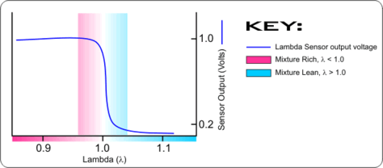
Figure 1:Lambda Sensor Feedback (Lambda Power, 2018)

Lambda Map
Table 1: Lambda Map
Table 1 shows a Lambda map for a high-performance naturally aspirated engine, the map is represented in 3D graphical form in Figure 3. It has been calibrated to pass the NEDC drive cycle but to still perform effectively. To pass the NEDC testing the engine must have low emissions, this is best achieved when lambda is equal to 1, at this value the 3-way catalyst is most effective, (Figure 2). This is further reinforced by Table 2 which shows the percentage of Carbon Monoxide released at each RPM and Load.
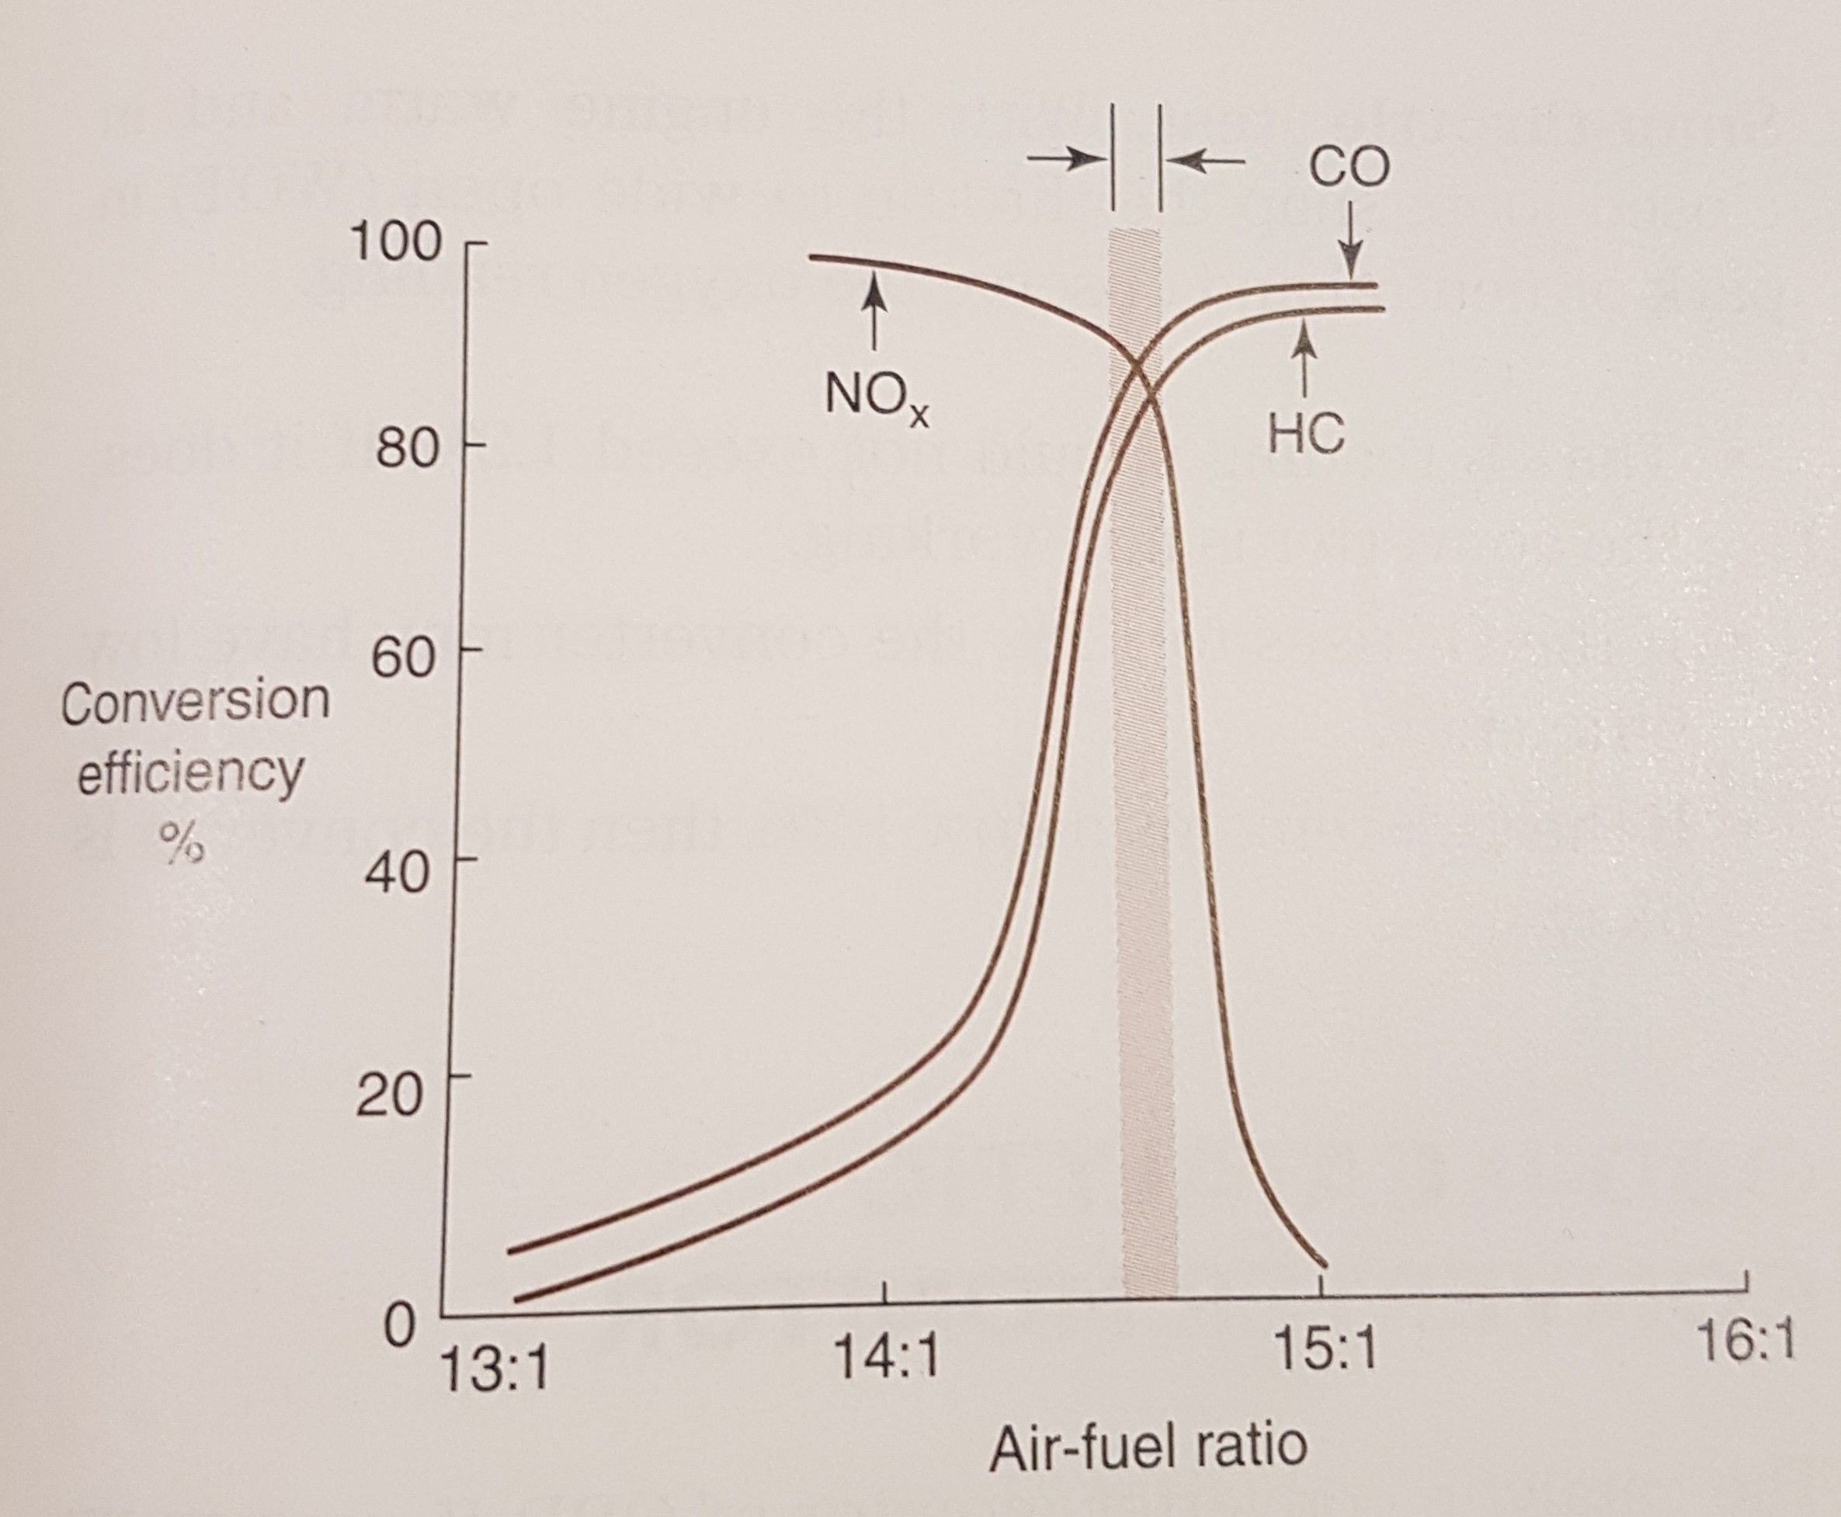
Figure 2: Catalytic Converter Conversion Efficiency (James D Halderman, 2006)
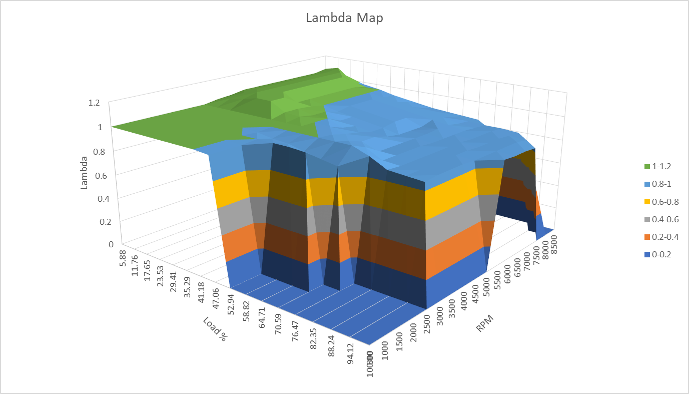
Figure 3: Lambda 3D Map
Table 2: Volume % Carbon Monoxide
As the NEDC cycle only tests part loads up to 3500RPM, the rest of the map is free to be adapted. At high RPM and load up to around 25%, the engine has been calibrated to run lean, this is due to this part of the map been used mainly during deceleration, therefore it would be wasteful to use extra fuel, it also causes the fuel to build up in the exhaust and then explode when it reaches a stoichiometric value, giving the vehicle a “sporty” sound. It is worth noting that the mixture has not been leaned further due to the reduction in flame speed but increase in temperature, causing potential knock.
Table 3: Laminar Flame Speed Map
The loads highlighted blue in Table 1 show the distribution of max power. The max power is obtained using the laminar flame speed. The Laminar Flame Speed is calculated using Equation 2.
$$SL=Bm+Bλ{(\frac{1}{λ}-\frac{1}{λm})}^{2}$$
Equation 2: Laminar Flame Speed (Heywood, 1988)
The values for which are found in Table 4:
Table 4:Flame Speed Values (Heywood, 1988)
The max power is found where the lambda is equal to λ_{m.} As can be seen, the engine has been calibrated so that the max power occurs at around 70% of the load at RPMs of 2500 to 6500. The lambda values between the lean deceleration area and the max power values show a gradual enrichment of the fuel mix to give a smooth acceleration. For the areas of high RPM and high load there is considerable over fuelling, this is to aid in the cooling down of the cylinder, the temperature is reduced by over fuelling due to the extra mass added to the combustion products and lowering the intake temperature with increased evaporation. Over fuelling is more important at 6500RPM than at 8500RPM as the flame speed is slower, allowing more time for the unburned zone to prematurely combust causing knock.

Fuel Equivalence Ratio
Table 5: Fuel Equivalence Ratio Map
Fuel Equivalence Ratio is the inverse of the Lambda and is defined as the ratio of the actual Air:Fuel Ratio to the Stoichiometric Air:Fuel Ratio. It is worked out from the lambda values in Equation 3.
$$\frac{1}{λ}$$
Equation 3: Fuel Equivalence Ratio from Lambda

Ignition Maps
Table 6: Ignition Timing Map
Table 6 shows the ignition map of the engine, a 3D map of the ignition timing can be seen in. The values within the table represent degrees of crank angle. If the values are positive, then they are before TDC, if they are negative, they are After TDC. Ignition timing is used to ensure that complete combustion, and as a result peak pressure, occurs at the right time, there is a sweet spot where the piston has reached TDC of its compression stroke and is about to begin the expansion stroke, this is known as Maximum Brake Torque (MBT) Timing and can be seen in Figure 4 . This usually occurs around 17° After TDC.
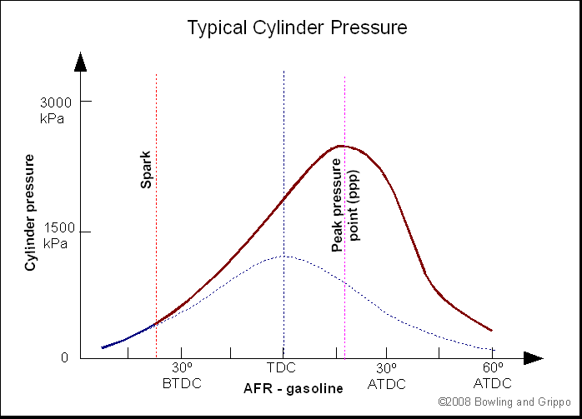
Figure 4:Point of Peak Pressure (Megasquirt, 2018)
The ignition and combustion do not occur instantly, there is delay of around 2-3 milliseconds (Edgar, 2007), this burning time is relatively constant throughout the RPM range (James D Halderman, 2006) . To maintain MBT timing, the ignition needs to be advanced or retarded depending on the situation. If the ignition is advanced too far, then combustion will occur before the piston reaches TDC resulting in a high amount of negative work, early timing can also cause the ignition of multiple parts of the mixture within the cylinder causing knock, it can also make cranking slow and jerky. If the ignition is too far retarded, the piston will have already begun its downward travel and so there will be reduced power and performance, it will also result in a poor fuel economy. An ideal ignition timing trend can be seen in Figure 5.
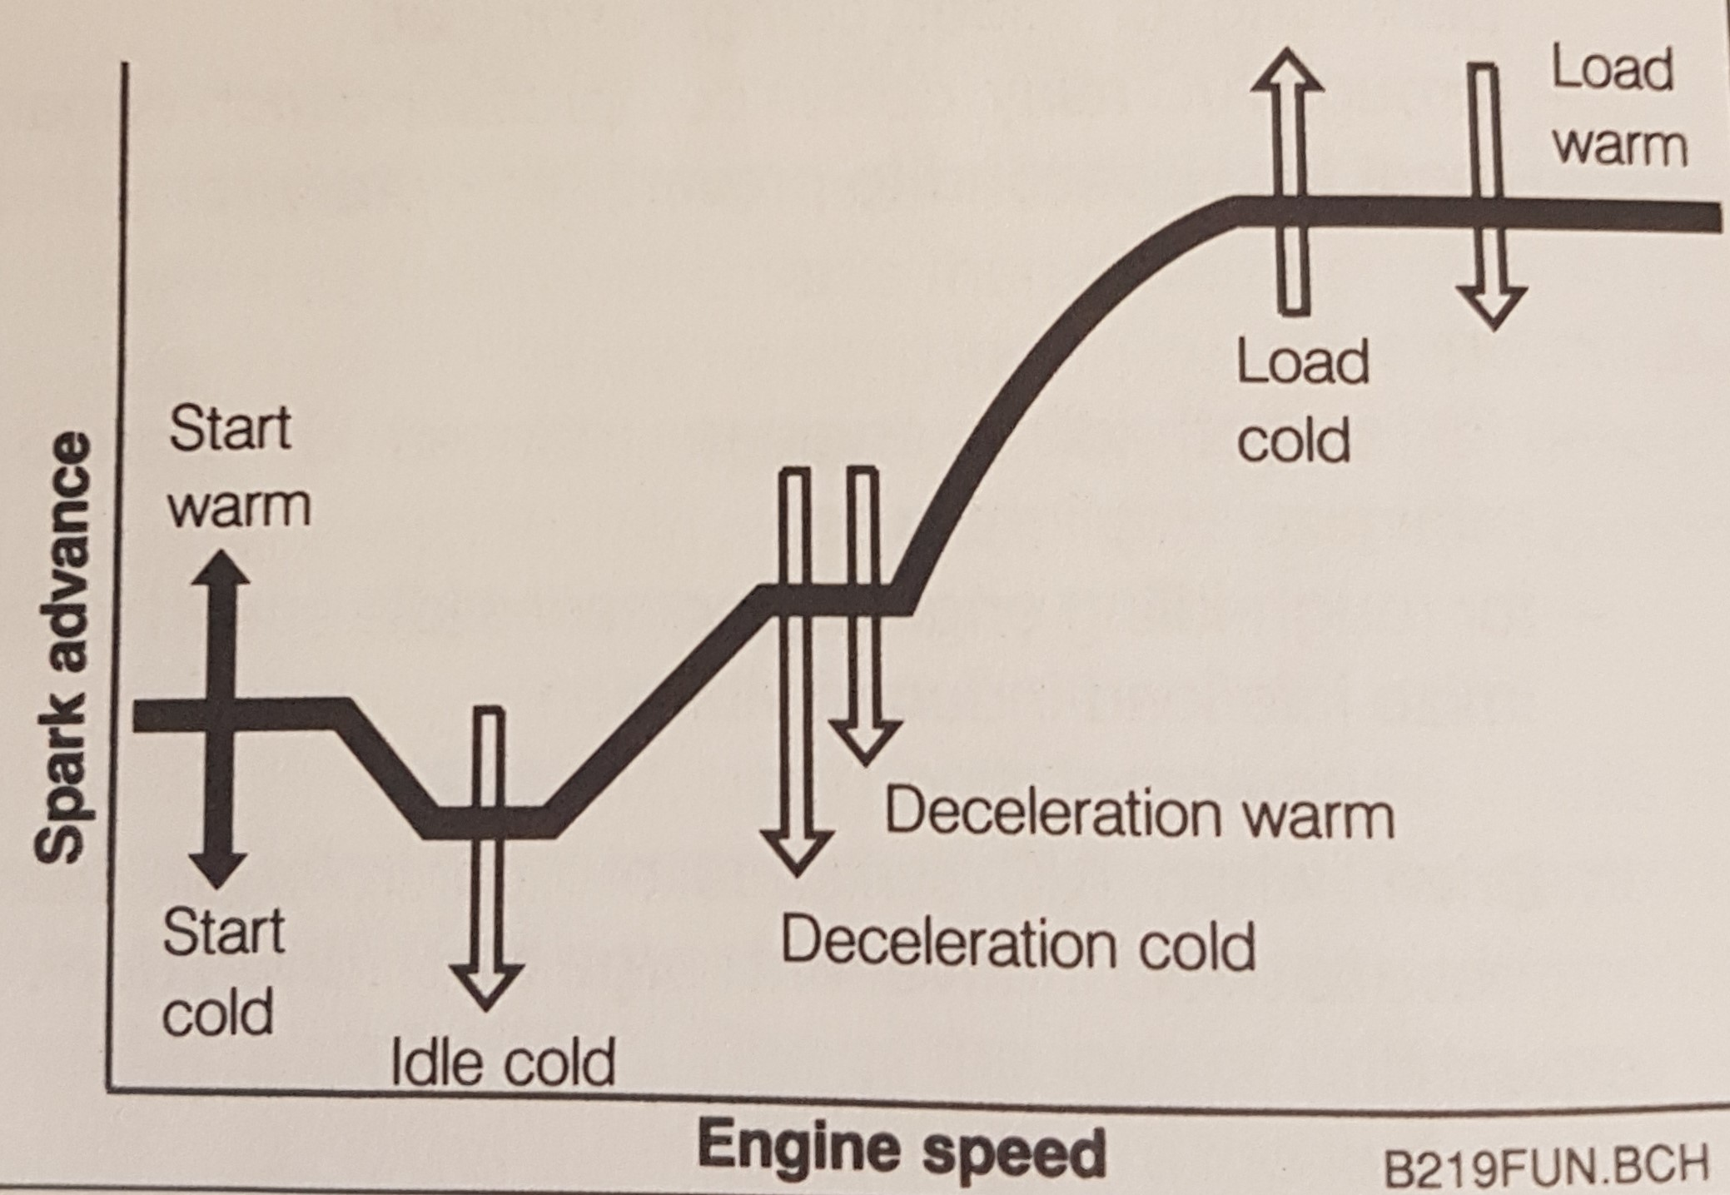
Figure 5: Spark Timing Advance Curve (Probst, 1991)

As can be seen from Table 6 at load 5.8% the ignition timing is significantly retarded past MBT, at the lower engine speeds of 800-1500RPM the spark is retarded ATDC. This area is where the engine is idling and more air is allowed in to ensure stable combustion but to prevent overrevving and providing too much power during engine braking.
As RPM increases, more air flows into the engine, resulting in a faster flame speed. The spark timing is then required to be advanced to maintain MBT timing. As the engine speed is increased from 800 to 3500RPM the flame speed is not fast enough to keep up with the increasing engine speeds, this results in further advancing of the ignition timing. After 3500 RPM the flame can keep pace therefore ignition timing is maintained.
At the higher loads throughout the upper range of RPMs the ignition timing is retarded to compensate for the high temperatures caused by increased flame speed and also to limit the chances of knock occurring.
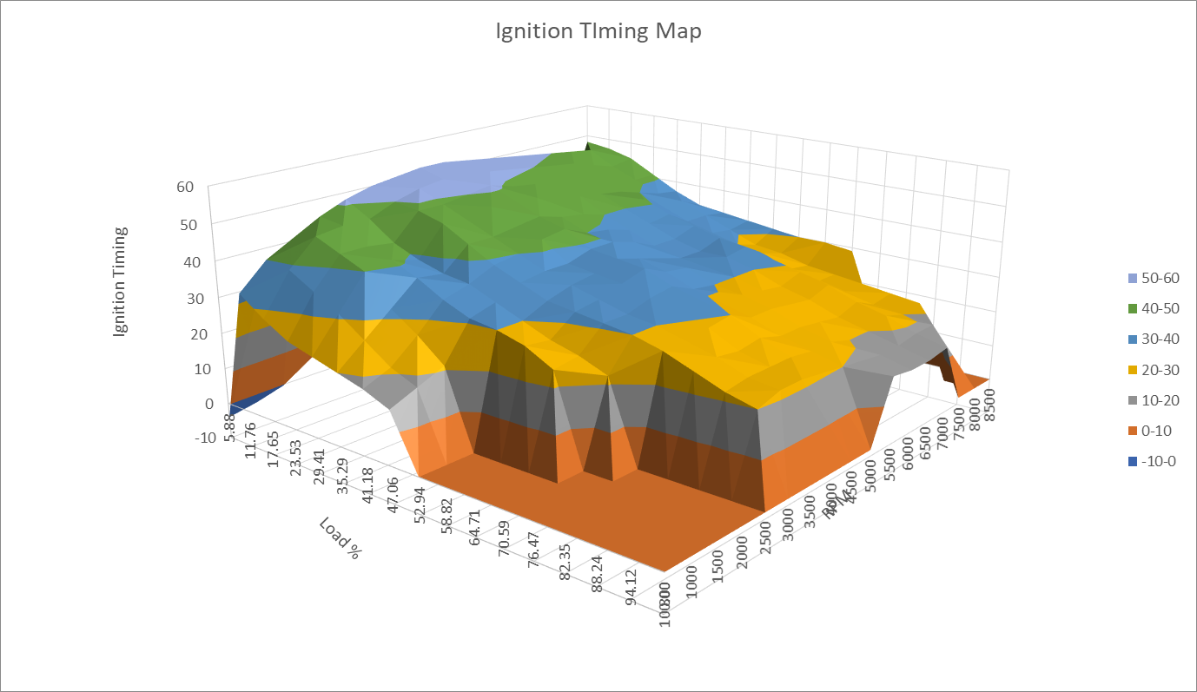
Figure 6: 3D Ignition Map

Start-up/Cranking
Table 7: Cranking Enrichment Map
A separate map is used to define the parameter required for start-up or cranking, the cranking map for the engine is shown in Table 7, the values within the map are added onto the base maps . At start-up there is very low airspeed which means that fuel drops out of the air stream before it reaches the combustion chamber, low temperatures present during start-up can also cause condensation. As a result of this more fuel is injected into the engine, the colder the temperature the higher the percentage of fuel added, the duration of injection is also increased to allow for the extra fuel to be injected. The cold temperatures also cause a slower flame speed, and so a further ignition advance is required to compensate for this. These enrichments only last for around 25 cycles otherwise it may cause wet spark plugs. (Walker, 2008)

Emissions Control
During the NEDC drive cycle it is assumed that lambda is equal to one. It is however still possible for excessive emissions to be created. There are many reasons why this is possible:
- The ignition timing may be incorrect. If the ignition timing is too far advanced the levels of NOx will increase due to the increase in cylinder temperature.
- Hydrocarbons are a result of incomplete combustion, for this study it was assume that the air: fuel mixture was homogenous, however in reality the mixture within the cylinder is a mixture of lean, stoichiometric and rich patches, which results in areas of incomplete combustion and as a result, higher emissions. This can be caused by many factors including injector positioning and combustion chamber profile.
These effects of these problems can be solved by ensuring that the ignition timing is correct through testing, also the addition of EGR to the mixture will lower the cylinder temperature and therefore the NOx produced.

1.2 Litre GDI Turbo Engine

Hardware and Knock Limitations
The 1.2 Litre GDI engine has a maximum value of pressure that it can withstand, any pressures higher than this and the engine will fail to work effectively. This is known as the engine hardware limit. The hardware limit of the 1.2 Litre GDI engine is 140 Bar (Dave Hancock, 2008).
As can be seen from Figure 7, the maximum pressure that the engine reaches is 118.8 Bar, which gives is 21.2 bar below the maximum hardware limit. This extra pressure allowance gives some flexibility if knock is to occur.
From Figure 8 a further strategy to reduce knock is clear. The Ignition timing at the high loads has been retarded to combat the higher temperatures and prevents the conditions for knock.

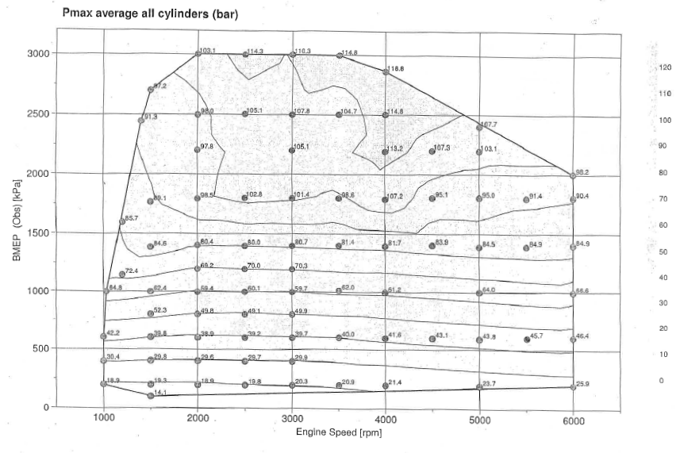
Figure 7: Average Max Pressure
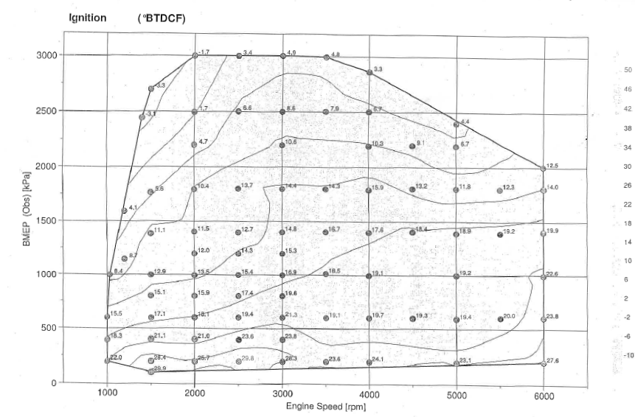
Figure 8: Ignition Timing - BTDCF

Burn Duration
Figure 9: Ignition Timing -BTDCF
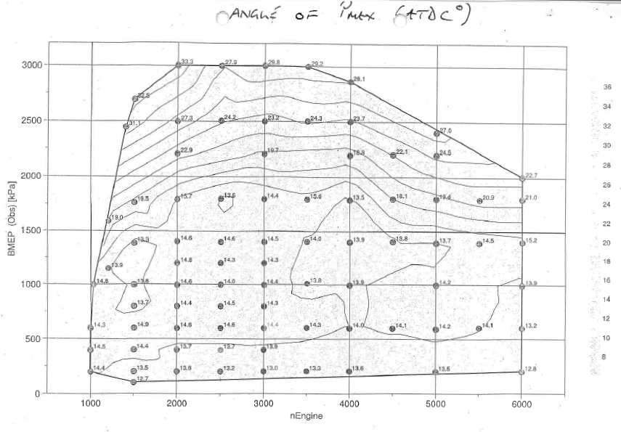
Figure 10:Angle of Max Pressure (ATDCF)
To work out the burn duration in degrees, Equation 4 is used.
$$Burn Duration (°)=Ignition Timing+Angle of Max Pressure$$
Equation 4: Burn Duration (Degrees)
To convert the burn duration from degrees to seconds, Equation 5 is used.
$$Burn Duration \left(Secs\right)=\frac{Burn Duration (°)}{360}-\frac{60}{RPM}$$
Equation 5: Burn Duration (Seconds)
From these calculations it is possible to create a map of burn duration (Secs) shown in Table 8. As can be seen that as RPM increases, the burn duration becomes shorter, for example at 1000RPM, the burn duration peaks at 6 milliseconds, while at 6000RPM the burn duration has shorten to 0.9 milliseconds. From the massive reduction in burn duration it can be inferred that the flame speed has increases with RPM. The high loads at the mid-range RPMs also show a reduction in flame speed from that of low loads, however the reduction in burn duration is not as dramatic as changing the RPM.
Table 8: Burn Duration (Seconds)

Engine Temperature Control
Engine Temperatures can be controlled by using the fuel. From Figure 11 it can be seen that throughout the majority of the lambda map, the air: fuel mixture is stoichiometric where lambda is equal to 1. However, at the higher loads at higher RPMS, such as those between 4000-6000RPM and 2000-3000 KPa BMEP the lambda value drops, indicating an enrichment of the air fuel mixture. At these Loads it is likely that the engine temperatures have risen to a level that could encourage knock, therefore the addition of extra fuel aids in cooling the cylinder down through higher mixture mass and evaporation.

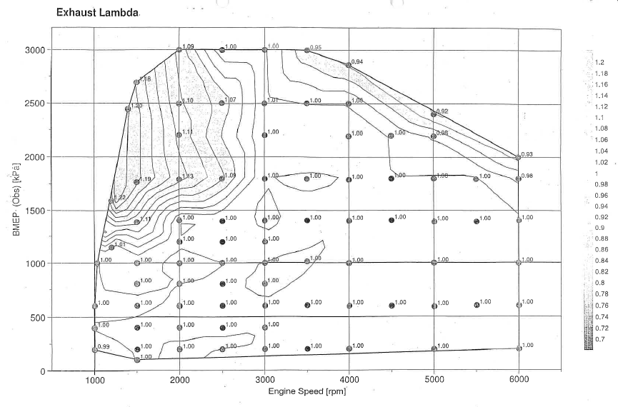
Figure 11: Exhaust Lambda

Brake Specific Fuel Consumption
The Brake Specific Fuel Consumption (BSFC) is the measured rate of fuel flow over a time period. It is used to measure how efficiently an engine is running. It is measured in g/Kw.h and so can be interpreted as the mass of fuel required to produce 1 KW of power for 1 hour. The more efficient and engine is the less fuel it will use and so the BSFC will be lower.
To work out the BSFC from the data provided the following steps were taken:
The Power in KW is calculated using Equation 6.
$$Power \left(Kw\right)=BMEP×Engine Displacement×\frac{RPM}{120}$$
Equation 6: Power (Kw)

Table 9: Power (Kw)
The Flow of fuel per hour then needs to be calculated using
$$Fuel Flow \left(Kg/h\right)=\frac{Air Mass}{Stoichiometric A:F Ratio×λ}$$
Equation 7: Fuel Flow (Kg/h)
Table 10: Fuel Flow (Kg/h)
The Air Mass can be seen in Figure 12 and Table 11.
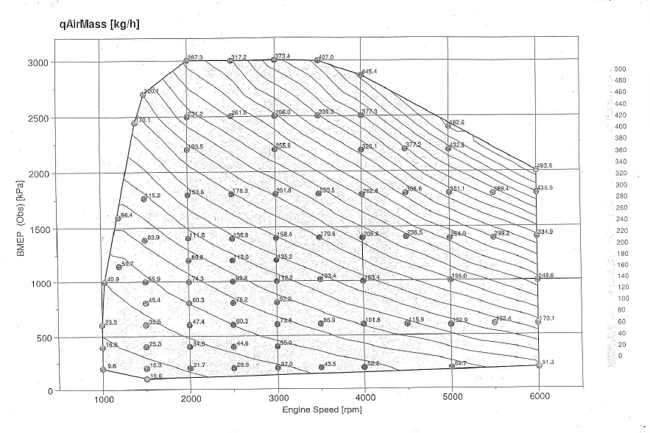
Figure 12: Air Mass (Kg/h)
Cross referencing the figure extracted from Figure 11 and Figure 12 it can be seen that the lambda value is equal to 1.
Table 11: Air Flow

Using the calculated values for Fuel flow and Power, it is possible to obtain the BSFC, for this calculation the Fuel Flow is converted to gms/h.
$$BSFC=\frac{Fuel Flow}{Power}$$

Table 12: BSFC
From the calculations it can be seen that the lowest value of BSFC is at 2000 RPM at 12500Kpa BMEP.

Conclusion
To conclude, it can be learnt from this study that there are many ways to alter an engines performance through fuelling and ignition timing. There is no correct way to calibrate an engine as it depends on what the user specification is, for example one user may prefer as much power as possible, whereas another may want to achieve as much fuel economy as possible. These goals will both require incredibly different maps. There is however a wrong method to calibrate an engine that can result in dire consequences such as knock, high emissions and low performance.

Appendix

Air:Fuel Ratio
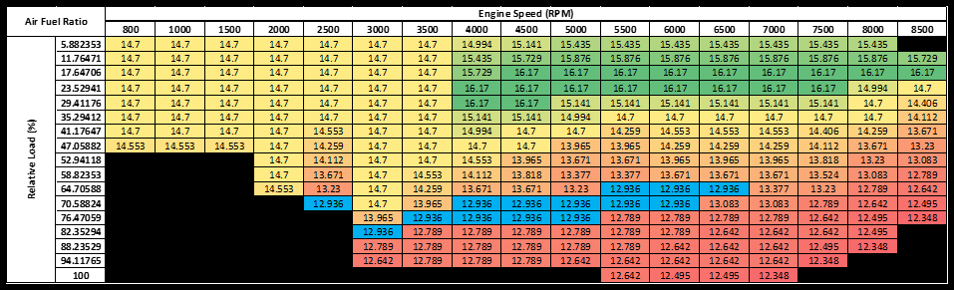
Table 13: Air:Fuel Ratio

References
Austin CC. (2018, 02 21). Lambda as a Diagnostic Tool. Retrieved from Austin CC: http://www.austincc.edu/wkibbe/lambda.htm
Bosch, R. (2006). Gasoline-Engine Management. Chichester: John Wiley and Sons.
Dave Hancock, N. F. (2008). A New 3 Cylinder 1.2L Advanced Downsizing Technology Demonstrator Engine. Detroit: SAE International.
Edgar, J. (2007, 09 11). Getting the Ignition Timing Right. Retrieved from Autospeed: http://www.autospeed.com/cms/article.html?&title=Getting-the-Ignition-Timing-Right&A=109132
Heywood, J. B. (1988). Internal Combustion Engine Fundamentals (15th ed.). New Dehli: McGraw Hill Education (India) Private Limited.
James D Halderman, J. L. (2006). Automotive Fuel and Emissions Control Systems. New Jersey: Pearson Prentice Hall.
Lambda Power. (2018, 02 21). Tech Notes. Retrieved from Lambda Power: https://secure.lambdapower.co.uk/TechNotes/Tech-5.asp
Megasquirt. (2018, 02 22). Principles of Tuning Programmable EFI Systems. Retrieved from MegaManual: http://www.megamanual.com/begintuning.htm
Probst, C. O. (1991). Bosch Fuel Injection and Engine Management. Cambridge: Robert Bentley inc.
Walker, D. (2008). Engine Management. Yeovil: Haynes Publishing.

