Nicholas Liam Gelstharp – 2211042
Data Warehousing & Data Mining – Data Mining

Data mining is the process of investigating data in order that understanding can be drawn from significant amounts of information. Data mining is completed using machine learning and statistical analysis where the aim is to uncover valid, novel and potentially useful patterns and insights from the data that has been processed [1] [2]. Data mining is become increasingly relevant and useful within workplace environments as there is now an abundance of data being gathered and stored within the systems used, and traditional methods of analysis are not providing insight at the levels expected of a modern day workplace.
The process of data mining is often described through the KDD framework which describes the stages as shown in the figure below [2].

A further methodology that describes the process of data mining in more business oriented process is the CRISP-DM which consists of business understanding, data understanding, data prep, modelling, evaluation and then deployment [3]. Both of these are useful in understanding what is involved in the process of data mining with KDD describing the more technical approach.
Businesses will use data mining for many different reasons, but generally it is to gain a better understanding of how their business operates and how people are interacting with their services. For example Amazon will use data mining to look at the patterns of behaviour displayed by their customers, in order to gain additional sales where people buy common items and improve customer engagement and satisfaction [4]. Netflix uses data mining to recommend shows based on what other customers have watched and liked, aiming to improve satisfaction and boost retention.
Within this report the student performance dataset has been utilised to complete data mining activities. The student performance dataset represents student achievement in secondary education of two Portuguese schools and includes 32 features such as school, sex, age and address where factors related to social, family and academia were all collected. There are two datasets provided on for Mathematics and one for the Portuguese language. The original purpose of this dataset was to discover how data mining could be used to predict student performance.
The key attributed within the datasets are labelled as G1, G2 and G3. G1 represents a grade for the first period, G2 represents data for the second period and G3 is the final grade achieved. The reasons that these are the key attributes are that the original studies used G1 and G2 to be able to predict the outcome of G3, though this was obviously not the only analysis or factors used within the applied machine learning algorithms.
There are no missing values within the datasets provided which means that the process of cleaning the data is simpler. The activity completed as part of this report is to predict student outcomes and identify student groupings. With this in mind, the most important features are G1, G2 and G3 as were the original authors. Other likely features that will impact grades are studytime, failures, schoolsup, famsup, higher and absences as these are all very likely to have a correlation to the G3 final outcome field. For the activity of discovering groupings of students the key features there may be age, sex and address.
This means that the other features such as mother or fathers job, whether or not they attended nursery, if they do extra curricular activities, if they have a romantic relationship will be less likely to have correlation with G3 attainment or be helpful in grouping. However, discarding this information prior to completing the machine learning analysis would be unwise as it is not significant amounts which means it will not materially slow the process down for either aspect of analysis, and furthermore it may uncover groupings or correlations that were not anticipated, and so to get the most thorough results it would be prudent to analyse the entire datasets as provided and not discard anything initially.
Both of the databases have been provided in CSV format which was downloaded and then imported into Excel Tables.
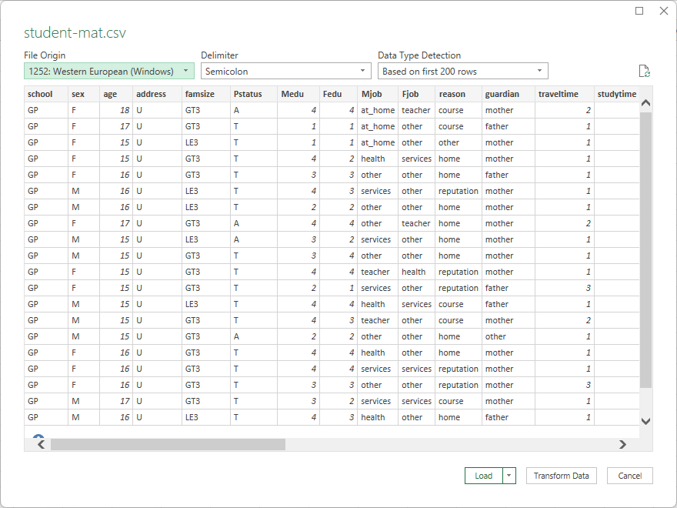
The first pre-processing activity was to check for any blank or null values were present which there were not. This was then immediately followed by exploring each of the columns to ensure that all of the information had been entered consistently across both of the databases as otherwise the analysis would be impacted as features may appear less frequently to the machine learning algorithms if they had variance but meant the same thing. These checks all indicated that the data was captured and stored in a consistent manner with no manual intervention needed. However, as both of the databases separately were developed consistently, the decision was made to combine them into a single data source. The reason for this was that for the machine learning algorithms they require test data and comparing to actual results, by joining both of the separate databases together the amount of training and results data can be expanded hopefully resulting in more accurate predictions. The data was provided for 2 topics, but it is not the topics that are particulate interesting, it is the correlation between features and overall end result, which also means that joining the data together would be appropriate. The joining of the datasets was achieved in Excel but copying the data from one and appending it to the other, creating a new database with a combined 1044 rows of information. A new column called Source was added to signify where the original data came from, so that this could also be analysed if needed.
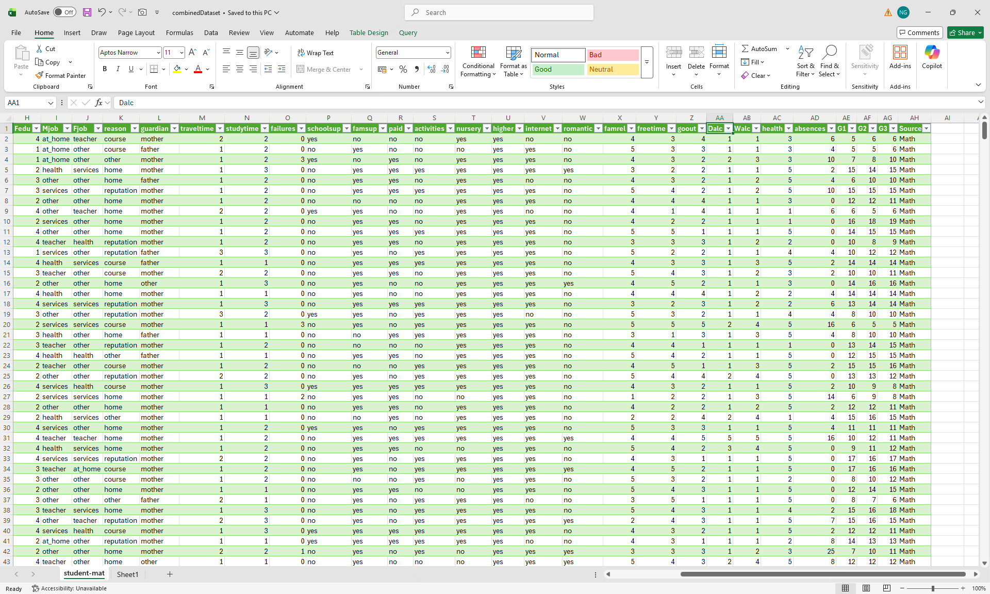
After creating one combined dataset, the next step for pre-processing was to convert the .csv information into an .arff file for Weka to be used for analysis. The simplest way to achieve this was to use the tool built into Weka. First the .csv file was opened within the software
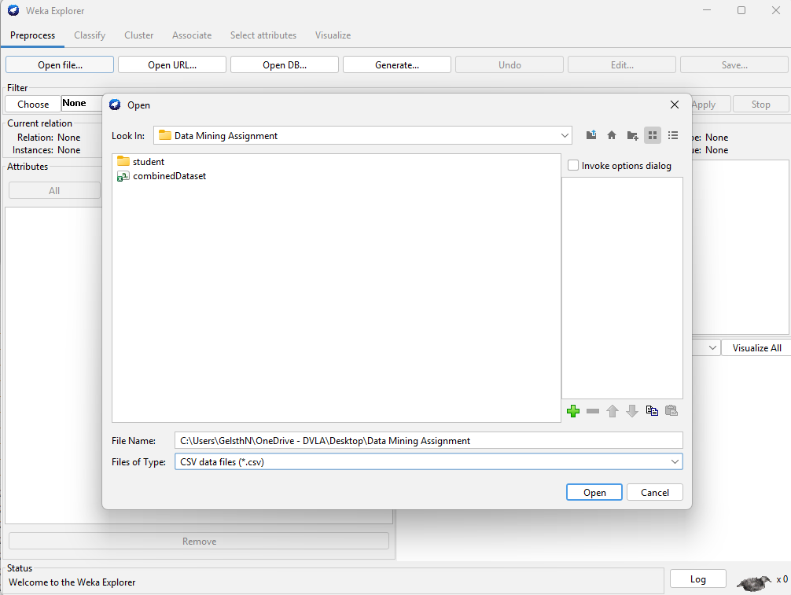
Then once it was opened choosing the save option and selecting the file type arff successfully converted the .csv file into a .arff file ready to be analysed using Weka and its machine learning algorithms.
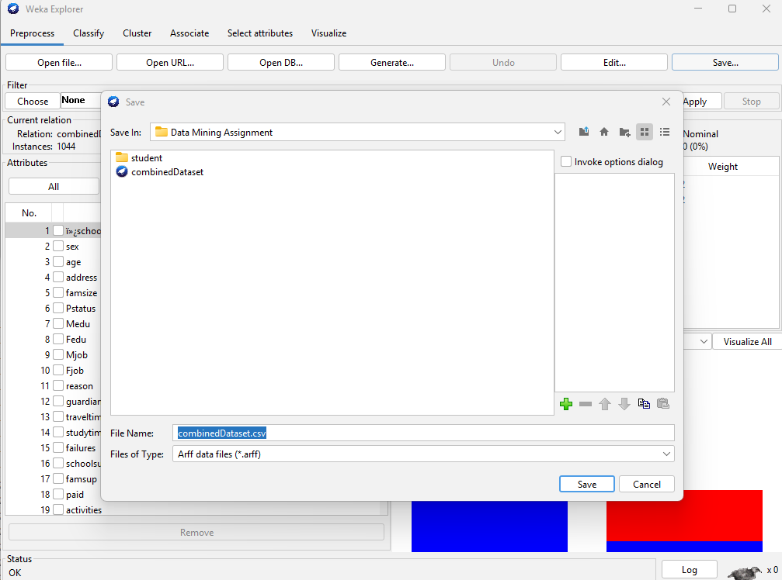.
Now that the data was in the correct format, it could be opened within Weka for analysis. Upon opening the data I can see that the Class attribute that has automatically been selected is the new column that was created called Source. The class attribute is important as it will be the attribute that the machine learning algorithms predict, and so as the aim of the predictive element of this task was to predict the Final outcome (G3). This needed to be updated in the preprocess tab to the correct column
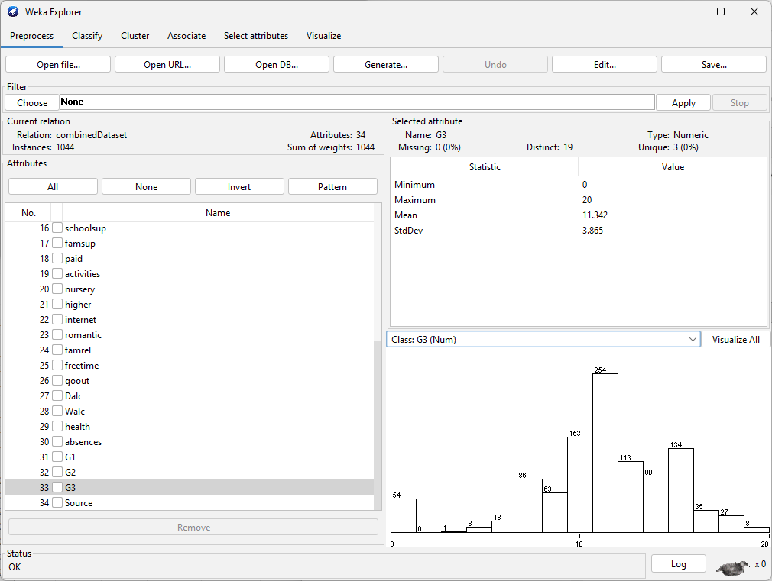
Once the class was selected, each of the columns needed to be checked in order to ensure that the conversion into Weka had been successfully completed and that no column had been misclassified during the process which could have an impact on the analysis of the data. This check was completed with no further actions required, confirming that the import has been successful
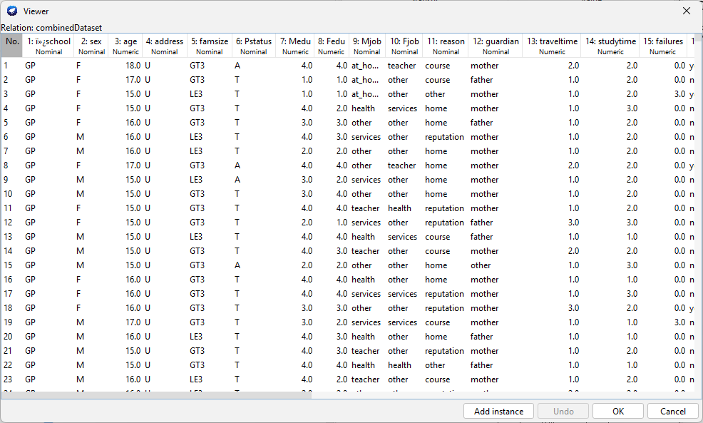.
The first piece of analysis that needed to be completed was to be able to use a regression algorithm to be able to predict column G3 which represents the final mark that was achieved by the students. The first run was completed using the M5P decision tree algortihm. This was chosen as it works well with numeric and categorical data and it clearly shows which attributes have influenced the predictions which is perfect for this scenario. The first run was completed using the default settings within the software to get a baseline and check that everything runs as it should
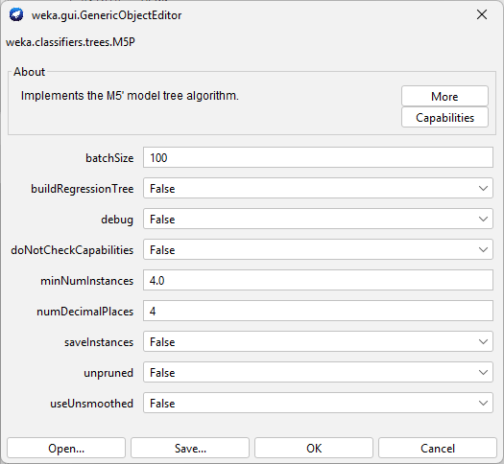
The results are shown in fig 1 below
=== Run information ===

Scheme: weka.classifiers.trees.M5P -M 4.0 -num-decimal-places 4
Relation: combinedDataset
Instances: 1044
Source
Test mode: 10-fold cross-validation

Number of Rules : 10

Time taken to build model: 0.51 seconds

=== Cross-validation ===
=== Summary ===

Correlation coefficient 0.917
Mean absolute error 0.934
Root mean squared error 1.542
Relative absolute error 33.0072 %
Root relative squared error 39.8973 %
Total Number of Instances 1044
Fig 1

These results show that the model was able to achieve a Correlation coefficient of 0.917 between the predicted and actual G3 (final values) which clearly shows that this model is able to predict very accurately the final grade. The model also clearly shows that the most important features in being able to predict the final grade are G1 and G2 which represent interim marks achieved by the students. And so the higher scores that the students achieve, the more likely they are to achieve a high grade in the end. It also reveals that features like romantic, nursery and activities are low impact on predicting G3. For the second run the amount of instanced per leaf was changed from the original value of 4 to 2 to see the impact on the overall accuracy, this will produce more leaves but could potentially result in overfitting. The Summary of the results is shown in fig2 below
== Cross-validation ===
=== Summary ===

Correlation coefficient 0.917
Mean absolute error 0.934
Root mean squared error 1.542
Relative absolute error 33.0072 %
Root relative squared error 39.8973 %
Total Number of Instances 1044
Fig 2

These results are almost identical to the original run and so another run was completed this time changing the number of leaves to 10, this will result in fewer leaves and show reduce overfitting, but does risk underfitting. The results are shown in fig 3 below
=== Run information ===

Scheme: weka.classifiers.trees.M5P -M 10.0 -num-decimal-places 4
Relation: combinedDataset
Instances: 1044

Number of Rules : 7

Time taken to build model: 0.05 seconds

=== Cross-validation ===
=== Summary ===

Correlation coefficient 0.9187
Mean absolute error 0.922
Root mean squared error 1.5264
Relative absolute error 32.5829 %
Root relative squared error 39.493 %
Total Number of Instances 1044
Fig 3

This time the Correlation coefficient has had a slight increase, whilst the error rates across the board are lower meaning that this model has marginally improved performance on the previous 2 examples. In order to try and further improve performance some further pre-processing of the data was completed. The CorrelationAttributeEval model was used within Weka to establish which features were needed and which were not. The results are shown in Fig 4 below
=== Attribute Selection on all input data ===

Search Method:
Attribute ranking.

Attribute Evaluator (supervised, Class (numeric): 33 G3):
Correlation Ranking Filter
Ranked attributes:
0.9107 32 G2
0.8091 31 G1
0.2366 21 higher
0.2015 7 Medu
0.1872 34 Source
0.1616 14 studytime
0.1598 8 Fedu
0.1271 1 ï»¿school
0.1177 4 address
0.1071 22 internet
0.0984 23 romantic
0.0793 16 schoolsup
0.0741 9 Mjob
0.0679 11 reason
0.0612 5 famsize
0.0545 24 famrel
0.0494 18 paid
0.0399 20 nursery
0.034 19 activities
0.0324 10 Fjob
0.0315 2 sex
0.0307 6 Pstatus
0.0229 12 guardian
0.0133 17 famsup
-0.0457 30 absences
-0.0649 25 freetime
-0.0801 29 health
-0.0979 26 goout
-0.1026 13 traveltime
-0.1157 28 Walc
-0.1253 3 age
-0.1296 27 Dalc
-0.3831 15 failures
Fig 4

This again confirms that G2 and G1 are the primary indicators of being able to predict G3. But also that sex, Pstatus, guardian, famsup, nursery and activities had little to no bearing on being able to predict G3. For this reason these were removed in the anticipation that this may mean fewer branches in the tree, which could make it easier to interpret and also improve the accuracy by removing this unnecessary information. In addition to this a new column was added called outcome, in this text was added so that anything above 16 was marked as good pass, anything over 10 was marked as pass, anything else was marked as a fail. This would allow for categorical analysis and the use of classification models. These categories were chosen as the overall marks were out of 20. This new information was called combinedDatasetV2. The highest performing model (10 leaves) was re-run and produced the results in Fig 5
Number of Rules : 13

Time taken to build model: 0.05 seconds

=== Evaluation on test split ===

Time taken to test model on test split: 0 seconds

=== Summary ===

Correlation coefficient 0.9478
Mean absolute error 0.7899
Root mean squared error 1.1862
Relative absolute error 29.4247 %
Root relative squared error 32.346 %
Total Number of Instances 355
Fig 5

This has again resulted in a stronger Correlation coefficient, and a lower error rate across the board indicating that these changes have further enhanced the performance of the model. With the addition of the outcome column classification model could now be utilised. J48 was chosen using default values, and maintaining the percentage split. The results are shown in Fig 6
Time taken to build model: 0 seconds

=== Evaluation on test split ===

Time taken to test model on test split: 0 seconds

=== Summary ===

Correctly Classified Instances 355 100 %
Incorrectly Classified Instances 0 0 %
Kappa statistic 1
Mean absolute error 0
Root mean squared error 0
Relative absolute error 0 %
Root relative squared error 0 %
Total Number of Instances 355

=== Detailed Accuracy By Class ===

TP Rate FP Rate Precision Recall F-Measure MCC ROC Area PRC Area Class
1.000 0.000 1.000 1.000 1.000 1.000 1.000 1.000 Fail
1.000 0.000 1.000 1.000 1.000 1.000 1.000 1.000 Pass
1.000 0.000 1.000 1.000 1.000 1.000 1.000 1.000 Good Pass
Weighted Avg. 1.000 0.000 1.000 1.000 1.000 1.000 1.000 1.000

=== Confusion Matrix ===

a b c <-- classified as
75 0 0 | a = Fail
0 243 0 | b = Pass
0 0 37 | c = Good Pass

Fig 6

This resulted in a 100% accurate model, which is actually an indication that the model is an error that has been caused by the inclusion of. As outcome was created using G3, the model is able to always predict it easily. In order to get the classification model working. G3 was removed and the following results were achieved
Time taken to build model: 0 seconds

=== Evaluation on test split ===

Time taken to test model on test split: 0 seconds

=== Summary ===

Correctly Classified Instances 314 88.4507 %
Incorrectly Classified Instances 41 11.5493 %
Kappa statistic 0.7467
Mean absolute error 0.1126
Root mean squared error 0.2654
Relative absolute error 34.1662 %
Root relative squared error 66.5072 %
Total Number of Instances 355

=== Detailed Accuracy By Class ===

TP Rate FP Rate Precision Recall F-Measure MCC ROC Area PRC Area Class
0.787 0.043 0.831 0.787 0.808 0.759 0.926 0.745 Fail
0.942 0.241 0.895 0.942 0.918 0.727 0.837 0.885 Pass
0.703 0.006 0.929 0.703 0.800 0.789 0.892 0.695 Good Pass
Weighted Avg. 0.885 0.175 0.885 0.885 0.882 0.740 0.862 0.836

=== Confusion Matrix ===

a b c <-- classified as
59 16 0 | a = Fail
12 229 2 | b = Pass
0 11 26 | c = Good Pass
Fig 7

These results show that the model was able to predict 78.7% of fails accurately, 94.2% of Passes and 70.3% of Good Passes with an overall accuracy of 88%. A further test was run where the data was pre-processed to remove G1 and G2, to see if it could predict the outcome without any interim grades. The results are in fig 8 below
=== Summary ===

Correctly Classified Instances 208 58.5915 %
Incorrectly Classified Instances 147 41.4085 %
Kappa statistic 0.0973
Mean absolute error 0.3039
Root mean squared error 0.4963
Relative absolute error 92.2284 %
Root relative squared error 124.3735 %
Total Number of Instances 355

=== Detailed Accuracy By Class ===

TP Rate FP Rate Precision Recall F-Measure MCC ROC Area PRC Area Class
0.413 0.168 0.397 0.413 0.405 0.242 0.603 0.301 Fail
0.728 0.679 0.700 0.728 0.714 0.051 0.476 0.661 Pass
0.000 0.075 0.000 0.000 0.000 -0.092 0.471 0.100 Good Pass
Weighted Avg. 0.586 0.508 0.563 0.586 0.574 0.077 0.502 0.526

=== Confusion Matrix ===

a b c <-- classified as
31 42 2 | a = Fail
44 177 22 | b = Pass
3 34 0 | c = Good Pass
Fig 8

This has drastically reduced the accuracy from 88% to 58%, but the Kappa statistic is 0.0973 which means that this model is virtually useless in predicting and over 41% of results were misclassified. Though the experiment in itself was interesting.
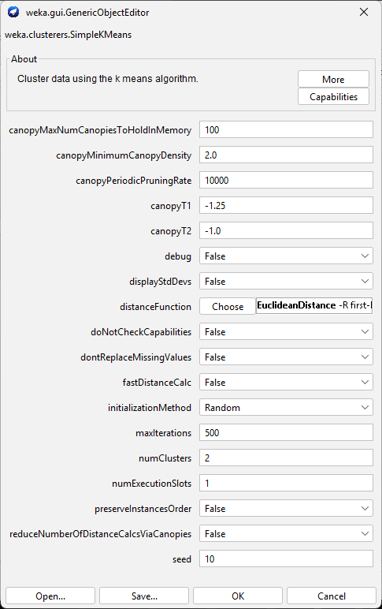

The next activity to be completed was to identify student groupings. To do this the original data was used, where all of the data was intact but combined as it those columns discarded for the previous machine learning algorithms could be useful in clustering. SimpleKMeans was the algorithm used in Weka using the default values to begin with and in order to get a baseline measurement from the algorithm. The results of this show in fig 8 below

Number of iterations: 9
Within cluster sum of squared errors: 6514.922638146838

Initial starting points (random):

Cluster 0: GP,M,15,U,GT3,T,2,3,other,other,home,mother,1,3,0,yes,no,yes,no,no,yes,yes,no,5,3,2,1,2,5,4,11,10,11,Math
Cluster 1: GP,M,17,U,GT3,T,2,3,other,other,course,father,2,1,0,no,no,no,no,yes,yes,yes,no,5,2,2,1,1,2,4,12,12,13,Math

Missing values globally replaced with mean/mode

Final cluster centroids:
Cluster#
Attribute Full Data 0 1
(1044.0) (317.0) (727.0)
==============================================
ï»¿school GP GP GP
sex F F F
age 16.7261 16.5426 16.8061
address U U U
famsize GT3 GT3 GT3
Pstatus T T T
Medu 2.6034 3.0946 2.3893
Fedu 2.3879 2.8107 2.2036
Mjob other other other
Fjob other other other
reason course home course
guardian mother mother mother
traveltime 1.523 1.347 1.5997
studytime 1.9703 2.1703 1.8831
failures 0.2644 0.1893 0.2971
schoolsup no no no
famsup yes yes yes
paid no yes no
activities no yes no
nursery yes yes yes
higher yes yes yes
internet yes yes yes
romantic no no no
famrel 3.9358 4.0126 3.9023
freetime 3.2011 3.2019 3.2008
goout 3.1561 3.1167 3.1733
Dalc 1.4943 1.4543 1.5117
Walc 2.2845 2.2334 2.3067
health 3.5431 3.5615 3.5351
absences 4.4349 5.571 3.9395
G1 11.2136 11.388 11.1376
G2 11.2462 11.4416 11.1609
G3 11.342 11.2429 11.3851
Source Port Math Port

Time taken to build model (full training data) : 0.03 seconds

=== Model and evaluation on training set ===

Clustered Instances

0 317 ( 30%)
1 727 ( 70%)
Fig 8

This has separate the entire student base into 2 categories, but not in a way that is particularly meaningful or useful in a business context. For that reason the model was changed to apply 3 clusters as shown in Fig 9 below, this has made 3 clusters, the first is what could be labelled the average student as it encompasses most students and also they appear to have the average amount of studytime, absences etc. The second cluster are high achieving students, though the cluster shows high absences which could require more insight from the business as this is not an expected correlation. The third cluster is student is with a high failure rate, low studytime, low internet access, rural and these are clearly underachievers.
Time taken to build model (full training data) : 0.05 seconds

=== Model and evaluation on training set ===

Clustered Instances

0 301 ( 29%)
1 549 ( 53%)
2 194 ( 19%)
Fig 9

Although this has produced useful clusters, again the G1, G2, and G3 were removed from the data in order to see if there were clusters of students within the data that did not relate to academic outcome. With this removed the outcomes are shown below in fig 10
Cluster 0: GP,M,15,U,GT3,T,2,3,other,other,home,mother,1,3,0,yes,no,yes,no,no,yes,yes,no,5,3,2,1,2,5,4,Math
Cluster 1: GP,M,17,U,GT3,T,2,3,other,other,course,father,2,1,0,no,no,no,no,yes,yes,yes,no,5,2,2,1,1,2,4,Math
Cluster 2: GP,M,17,R,GT3,T,1,2,at_home,other,home,mother,1,2,0,no,no,no,no,yes,yes,no,no,3,1,3,1,5,3,4,Math

Final cluster centroids:
Cluster#
Attribute Full Data 0 1 2
(1044.0) (293.0) (542.0) (209.0)
=========================================================
ï»¿school GP GP GP MS
sex F F F F
age 16.7261 16.4846 16.7269 17.0622
address U U U R
famsize GT3 GT3 GT3 GT3
Pstatus T T T T
Medu 2.6034 3.1229 2.6218 1.8278
Fedu 2.3879 2.843 2.3579 1.8278
Mjob other other other at_home
Fjob other other other other
reason course home course course
guardian mother mother mother mother
traveltime 1.523 1.3413 1.4391 1.9952
studytime 1.9703 2.1536 1.9557 1.7512
failures 0.2644 0.1775 0.2546 0.4115
schoolsup no no no no
famsup yes yes yes no
paid no yes no no
activities no yes no yes
nursery yes yes yes yes
higher yes yes yes yes
internet yes yes yes no
romantic no no no no
famrel 3.9358 4.0102 3.9077 3.9043
freetime 3.2011 3.1433 3.2066 3.2679
goout 3.1561 3.0785 3.2011 3.1483
Dalc 1.4943 1.4369 1.5037 1.5502
Walc 2.2845 2.2082 2.2952 2.3636
health 3.5431 3.57 3.5185 3.5694
absences 4.4349 5.6689 4.3358 2.9617
Source Port Math Port Port

Time taken to build model (full training data) : 0 seconds

=== Model and evaluation on training set ===

Clustered Instances

0 293 ( 28%)
1 542 ( 52%)
2 209 ( 20%)
Fig 10

This did not result in any new clusters from being found, but it is still useful as it shows that the original findings were not related solely to academic performance which does provide the school with some interesting clustering which is mainly driven by parental education, travel time, study time, failures, internet access and absences.
The business recommendations that I would make based on these findings are that as G1 and G2 are by far the strongest indicators of success, having some sort of intervention or early warning associated with these would be a good idea, with support given at the G1 stage in order to be able to produce better outcomes in the end. Interventions applied could be measured at G2 to see if they have worked, and the chance of success can be fairly accurately determined using machine learning models once both G1 and G2 are input which means planning for results and perhaps resits could be done in advance as well. From the clustering machine learning algorithms the actionable business recommendations would be to put in place pre-emptive measures for students that fit the profile of low achieving, such as those with longer travel time, less internet access and lower parental education. This could be through funding equipment which could reduce the internet access issue and also potentially assist with the longer driving distances if remote learning could take place on the journey to school, or even away from the classroom. These measured could result in higher achieving students overall which would help the business.
Upon reflection each of the machine learning algorithms and Weka have all performed very well in analysing the data provided and it has both been able to produce very accurate predictive modelling and also useful cluster of students both of which could easily be used by the business to take action in order to put in early warning systems or interventions based on established risk factors produced by the algorithms. The advantages of using Weka and the algorithms used with the data is that they are easily able to quickly produce results with the quantity of the data, the data provided was also in great shape for analysis which meant processing time was short. The disadvantages are that the data should be gathered over a significant period of time in order to produce larger training samples and produce better results. If this task was to be performed again I would spend much more time in trying more algorithms and experimenting more thoroughly with the hyperparameters to get the models performing to the absolute best of their ability, as well as further experimenting with the features included and derived in order to also further improve the quality and recommended business outcomes.

References

[1] | J. Holdsworth, “What is Data Mining,” IBM, [Online]. Available: http://www.ibm.com/topics.data-mining. [Accessed 11 March 2026].
[2] | U. M. Fayyad, G. Piatetsky-Shapiro and P. Smyth, “From Data Mining to Knowledge Discovery in Databases,” IEEE Computer Society Technical Committee on Data Engineering Bulletin, vol. 21, no. 1, pp. 37-54, 1998.
[3] | P. Chapman and e. al, CRISP-DM 1.0: Step by Step data mining Guid, Chicago: SPSS INC, 2000.
[4] | G. Linden, B. Smith and J. York, “Amazon.com recommendaitons: Item to Item collaborative filtering,” IEEE Internet Computing, vol. 7, no. 1, pp. 76-80, 2003.

