Florin Ene
Student ID: 2310120
Module: LCBB5014 DATA HANDLING & BUSINESS INTELLIGENCE
Lecturer: Nassir Ibrahim
Assignment title: Coursework individual report
(Excelcare - BI, DW, DM)

Table of Contents

1. Introduction 4
2. Trends in BI, DW, and DM 4
Business Intelligence (BI) 4
Data Warehousing (DW) 5
Data Mining (DM) 5
3. Data Warehousing in the Organisation Applications 5
Improving Organisational Data Access and Efficiency 5-6
Enhancing Organisational Decision-Making 6
Supporting Sales Reporting and Business Strategy 6-7
4. Data Mining Techniques 7
Clustering 7
Classification 7-8
5. Predictive Analysis 8-9
6. Ethical and Data Security Considerations 10
6.1 GDPR……………………………………………………………………………………10 7. Reporting and Dashboard Solutions…………………………………………………….. 10-11
8. Conclusion 11-12
9. References 13-14
10. Appendices 15-17
Appendix 1: BI Architecture 15
Appendix 2: CRISP-DM Model 16
Appendix 3: Data flow between DW and BI tools 17

Executive Summary
This report examines how Business Intelligence can aid in making strategic decisions at Excelcare. It compares major technologies such as data warehousing, data mining, and predictive analytics tools. Techniques of clustering and classification are evaluated based on enhancing patient care and resource planning. Real-time monitoring and automated reporting are suggested to use Power BI dashboards. The report prioritises the values of ethical practices, compliance with GDPR, and data protection. It has been found that BI enhances operational efficiency, accuracy of forecasts, and speed of decisions. Some of these recommendations are the use of predictive tools, monitoring of key KPIs, and the incorporation of dashboards into the existing systems. Altogether, the use of these BI solutions will enable Excelcare to make correct decisions, prioritise resources, and improve the quality of service to patients.

1. Introduction
Excelcare is a medium-sized healthcare organisation that is in the United Kingdom (excelcareholdings.com, 2025). It offers residential and nursing services as well as dementia care to older people. The firm aims to provide high-quality, safe, and person-centred care at its facility. This report describes how Business Intelligence, Data Warehousing, and Data Mining can assist Excelcare in strategic decision-making. It also emphasises the application of such tools in enhancing efficiency, accuracy of data, and patient outcomes. The rationale is to demonstrate how information-based practices can empower decision-making. The report also contains an overview of existing trends, data warehousing usage, and appropriate data mining techniques. It also suggests predictive analysis tools and ethical and data safety issues. Lastly, it proposes dashboard solutions to facilitate real-time reporting and continuous performance monitoring.

2. Trends in BI, DW, and DM

Business Intelligence (BI)
Business Intelligence refers to the act of making use of data in making business decisions. It assists managers in analysing previous information and making decisions concerning the future. One of the current trends is self-service BI, real-time reporting, and cloud-based solutions. These tools facilitate easier access and sharing of insights among the users. The use of AI is also assisting businesses in predicting and planning (Chen et al. 2021). Numerous healthcare companies utilise BI to monitor patient outcomes and resource utilisation. As an example, BI dashboards can be applied by Excelcare to track the quality and performance of care. BI helps to make evidence-based decisions and enhance interdepartmental communication.

Data Warehousing (DW)
A data warehouse is an area where data from various sources is saved in a safe location. It is easy to access, facilitates queries, and enhances decision-making. Cloud data warehousing has become popular due to its cost efficiency and scalability. Real-time ETL processes are useful in making data combinations quicker and accurate reporting. For example, Coca-Cola uses data warehousing for global sales reporting to track regional demand changes. In the architecture of Kimball, a DW combines data marts to support the flexibility of analysis (Kimball and Ross, 2019). In the case of Excelcare, DW has the potential to combine patient, financial, and staffing data. This helps in the consolidation of data, lessening duplication as well as speeding up the reporting process. This information can help managers to plan services and manage resources more effectively.

Data Mining (DM)
Data Mining refers to the process of identifying patterns and trends in huge data sets. It assists organisations to know how to behave, predict and optimise operations. Common trends include AI-driven algorithms, predictive analytics, and automation in pattern detection. CRISP-DM model offers a well-defined data mining project model (Schröer et al. 2021) (Refers to Appendix 2). DM has the potential to detect the risk factors in patients or predict service requirements in healthcare. DM can help Excelcare to analyse patient trends and minimise readmissions. Such practices enable the organisations to make strategic and clinical decisions. Data mining facilitates constant enhancement and policy planning based on data.

3. Data Warehousing in the Organisation Applications

Improving Organisational Data Access and Efficiency
A data warehouse is a central respiratory system used to store and gather information from various sources to enable reporting and analysis. It incorporates both past and present data, and this enables organisations to access information rapidly. This system enhances the ease of accessing data because several databases are combined under a single database. There is no need to search in different systems to find accurate information for employees. Al-Okaily et al. (2023) assert that 67% of organisations employ data warehousing in enhancing operational efficiency. At Excelcare, the data warehouse collects the data of the departments, such as patient services, finance, and HR. This will aid the staff to get an updated record of patients, billings, and staffing details in real time. Excelcare saves time by eliminating redundancy and automating processes, which will ensure accurate data collection and enhance coordination among all healthcare units.

Enhancing Organisational Decision-Making
Data warehousing enables companies to make improved strategic decisions due to the availability of accurate, historical, and trend-based data. Visual dashboards and analysis tools help decision-makers to extract key patterns. It enables the management to research patient admission, care outcomes, and the trends of costs over time. Santosh Kumar Singu (2022) notes that companies that utilise data warehouses can make business decisions 30% quicker. In Excelcare, managers access warehouse-based data to predict patient demand and allocate resources. They can recognise the most active periods of the service, follow the results of treatment, and optimise the staffing strategies. Proper reporting would enable the leaders to align the operational goals with patient care requirements to enhance planning and service delivery.

Supporting Sales Reporting and Business Strategy
The properly designed data warehouse reinforces the business strategy as it provides detailed reports, which can be used in the planning and budgeting processes. Excelcare analyses the revenue of its service by department and region with the help of its data warehouse. This assists in knowing which units in care produce more income and which require improvement. The finance department relies on sales and billing information to predict monthly sales and provide achievable financial goals. Automated reporting minimises manual work and assists managers in tracking performance more effectively. A survey conducted by McKinsey (2022) found that companies that use well-developed data warehousing systems have a 20% higher forecast accuracy. Excelcare can plan strategic growth, control costs, and provide better healthcare services by enhancing reporting speed and the quality of data.

4. Data Mining Techniques
Data mining assists organisations in identifying valuable patterns and predictions in large datasets. In the case of Excelcare, it assists in making decisions and enhancing patient care. Using some of the most important techniques, such as clustering and classification, the organisation will be able to examine trends, forecast results, and control resources more efficiently to reach healthcare and operational objectives.

Clustering
Clustering possesses common characteristics into groups. It aids Excelcare in establishing patient segments that share similar health conditions or service requirements. As an example, patients may be classified as per age, type of illness, or cost of treatment. This will assist in improved service planning and resource allocation among the departments. Clustering enables the managers to study patient flow and enhance care efficiency. It can identify the seasonal demand trend of various medical services.
K-means clustering is easily supported by tools such as RapidMiner and Python Scikit-learn. Clustering also assists Excelcare in tailoring health programs and forecasting demand for future service. Tamer et al. (2022) suggest that clustering enhances the segmentation of patients and hospital planning. This will ensure improved forecasting and operational efficiency at Excelcare.

Classification
Classification categorises data based on some characteristics or labels into predefined categories. It can be applied in forecasting patient outcomes and determining the level of health risks. Classification provides the ability to forecast readmission rates or the success of the treatment in Excelcare. This assists the doctors in prioritising the high-risk patients and planning the follow-up care effectively. The use of techniques such as Decision Trees and Random Forests gives intuitive predictions based on rules. Classification aids in the objective of the organisation to help patients and provide them with safety. It also enhances decision-making through the analysis of historical records of patients and results of their treatment. Tools like SPSS Modeller and Microsoft Power BI combine classification tools conveniently. Mishra et al. (2022) assert that healthcare data analysis can be made more accurate through classification. Through the classification, Excelcare gets a more comprehensive control over the quality of services and patient outcomes.

5. Predictive Analysis
Predictive analysis assists Excelcare in predicting patient demand, service requirements, and results. Power BI, SPSS, Excel, and RapidMiner are some of the tools that can be used with healthcare data. All tools have various features, usability, and integration into organisational systems. Key differences are summarised in the table below.
Tool | Features | Usability | Integration with Systems | Automation/Forecasting Capabilities
Power BI | Interactive dashboards, real-time data analysis | User-friendly, suitable for managers | Connects with databases and cloud systems | Automates reporting and provides predictive trends
SPSS | Statistical modelling, regression, classification | Moderate learning curve | Integrates with data warehouses | Forecasting, trend analysis, predictive modelling
Excel | Basic forecasting, charts, and data analysis | Very easy to use | Limited direct integration | Simple trend analysis, manual automation
RapidMiner | Machine learning, clustering, predictive modelling | Requires some technical knowledge | Connects with multiple data sources | Automates predictive workflows and reporting

Among these alternatives, Power BI is suggested to Excelcare. It offers real-time dashboards, visual reporting, and automated forecasting, which fit both operational and strategic decision-making requirements.
This has integration with the data warehouse, which enables smooth updates of patient, staffing, and finance systems. Managers can use Power BI without any real technical expertise. It facilitates checking on patient flow, allocation of resources, as well as performance of services. It can also generate automated weekly and monthly review meeting reports (Sharma and Sarkar, 2022). Excelcare would be able to plan the staffing requirements, cost management, and patient care outcomes effectively with predictive analytics capability. Using Power BI will allow Excelcare to enhance the quality of data-driven decision-making, minimise the manual reporting and forecasting work. This tool is integrated with usability and advanced predictive features of healthcare management (Refers to Appendix 3).

6. Ethical and Data Security Considerations
Exelcare is confronted with serious ethical and data security issues in the implementation of analytical tools. GDPR offers a legal framework, and adherence to it cannot ensure ethical practice. The ownership of patient data, as well as consent, is a major concern when integrating data. Integrating numerous sources will be efficient in terms of operations, but it will also bring issues of privacy and transparency. Role-based access controls and encryption minimise breach threats and safeguard sensitive records.
Internal and external threats
The possibility of internal misuse by the employees is still an unsolicited weakness that must be controlled.
Firewalls and intrusion detection systems are cybersecurity tools that minimise external threats.
Nevertheless, these tools need constant updating and the involvement of the staff to be effective. Sahu et al. (2025) believe that human error is one of the primary risks, even with sophisticated technical protective measures. By using automated data collection, the efficiency is enhanced, but there is a higher risk of errors or unintended disclosure. Predictive analytics can also introduce bias, which will influence patient care decision-making. Excelcare needs to evaluate both technical and organisational protection critically to maintain reliability. Accountable use of data requires the use of staff training, monitoring, and ethical review. Opening up regarding the use of data will increase trust between the patients and the organisation. These measures can be integrated to enable Excelcare to strike a balance between efficiency, compliance, and ethical responsibility.

7. Reporting and Dashboard Solutions
BI dashboards like Power BI can be utilised by Excelcare to report. These dashboards gather information from various sources and provide it visually to managers. These enable employees to access patient, financial, and operational information under a single platform. Dashboards could be tailored to show important information within a short time for decision-makers (Rahman et al. 2025). The integration with the Excelcare data warehouse makes the update automatic and real-time.
These dashboards are useful in facilitating quick and informed decision-making. The managers will be able to monitor patient admissions, staff distribution, and service delivery daily. The visual displays aid in the recognition of trends and possible problems before they get out of hand. The dashboards allow resource utilisation and financial performance tracking (Eyeregba et al. 2024). Real-time reporting eliminates delays in communication and enhances general planning of operations. They also facilitate predictive analysis, whereby Excelcare can forecast the demand for patients.
Key performance indicators (KPIs) for Excelcare dashboards include:
- Patient admission rates by day and department
- Average treatment duration per patient
- Staff-to-patient ratio for each care unit
- Monthly service revenue by department
By tracking these KPIs, Excelcare will be able to gauge performance relative to the target. Managers can modify the schedule of the staff in relation to the trends of patient admissions. Operational and financial indicators are useful in enhancing resource allocation and cost efficiency. Dashboards also give an idea of service quality and patient outcomes. Through these tools, Excelcare will be able to ensure high standards of care and maximise operational efficiency.

8. Conclusion
Conclusively, this report identifies the advantages of Business Intelligence to Excelcare. Data warehousing enhances effective access to patient, financial, and operational data. The use of clustering and classification methods helps in improving forecasting and planning of the demand for services. With the aid of predictive analytics and dashboards, real-time monitoring and informed decision-making can be realised. Ethical and data protection have been implemented to be compliant with GDPR and to protect sensitive data. Through BI tools, Excelcare can enhance patient care, resource allocation, and operational performance. In general, Business Intelligence plays a strategic role in helping to facilitate informed decisions, sustain the quality of services, and ultimately attain sustainable growth in the healthcare industry.

9. References
Al-Okaily, A., Al-Okaily, M., Teoh, A.P. and Al-Debei, M.M., 2023. An empirical study on data warehouse systems effectiveness: the case of Jordanian banks in the business intelligence era. EuroMed Journal of Business, 18(4), pp.489-510.
Chen, D.Q., Preston, D.S. and Swink, M., 2021. How big data analytics affects supply chain decision-making: An empirical analysis. Journal of the Association for Information Systems, 22(5), pp.1224-1244.
excelcareholdings.com, 2025. Our Family, Caring for Yours
Available at: https://www.excelcareholdings.com/
Accessed on: (1st October 2025)
Eyeregba, M.E., Mokogwu, C., Ewim, S.E. and Olorunyomi, T.D., 2024. Integrating visual reporting, analytics, and sustainable dashboards to support decision-making and growth in small and medium enterprises (SMEs). International Journal of Frontiers in Science and Technology Research, 7(2), pp.90-99.
Kimball, R. and Ross, M., 2019. The Data Warehouse Toolkit: The Definitive Guide to Dimensional Modelling, Ed. Wiley.
McKinsey, 2022. AI-driven operations forecasting in data-light environments
Available at: https://www.mckinsey.com/capabilities/operations/our-insights/ai-driven-operations-forecasting-in-data-light-environments
Accessed on: ( 1st October 2025)
Mishra, S., Shaw, K., Mishra, D., Patil, S., Kotecha, K., Kumar, S. and Bajaj, S., 2022. Improving the accuracy of ensemble machine learning classification models using a novel bit-fusion algorithm for healthcare AI systems. Frontiers in Public Health, 10, p.858282.
Rahman, M.A., Alam, M.S. and Mrida, M.S.H., 2025. How interactive dashboards improve managerial decision-making in operations management. American Journal of Advanced Technology and Engineering Solutions, 1(01), pp.122-146.
Sahu, M., Maurya, P. and Krishnaveni, S., 2025. Healthcare 5.0: Enabling Technologies and Potential Use Cases. In Industry 5.0: Key Technologies and Drivers (pp. 303-327). Cham: Springer Nature Switzerland.
Santosh Kumar Singu, 2022. "Impact of Data Warehousing on Business Intelligence and Analytics", ESP Journal of Engineering & Technology Advancements 2(2): 101-113.
Schröer, C., Kruse, F. and Gómez, J.M., 2021. A systematic literature review on applying the CRISP-DM process model. Procedia computer science, 181, pp.526-534.
Sharma, N. and Sarkar, D., 2022. Healthcare Data Analytics Using Power BI. International Journal of Software Innovation (IJSI), 10(1), pp.1-10.
Tamer, Y.T., Karam, A., Roderick, T. and Miff, S., 2022. Know thy patient: a novel approach and method for patient segmentation and clustering using machine learning to develop holistic, patient-centred programs and treatment plans. NEJM Catalyst Innovations in Care Delivery, 3(4).

10. Appendices

Appendix 1: BI Architecture
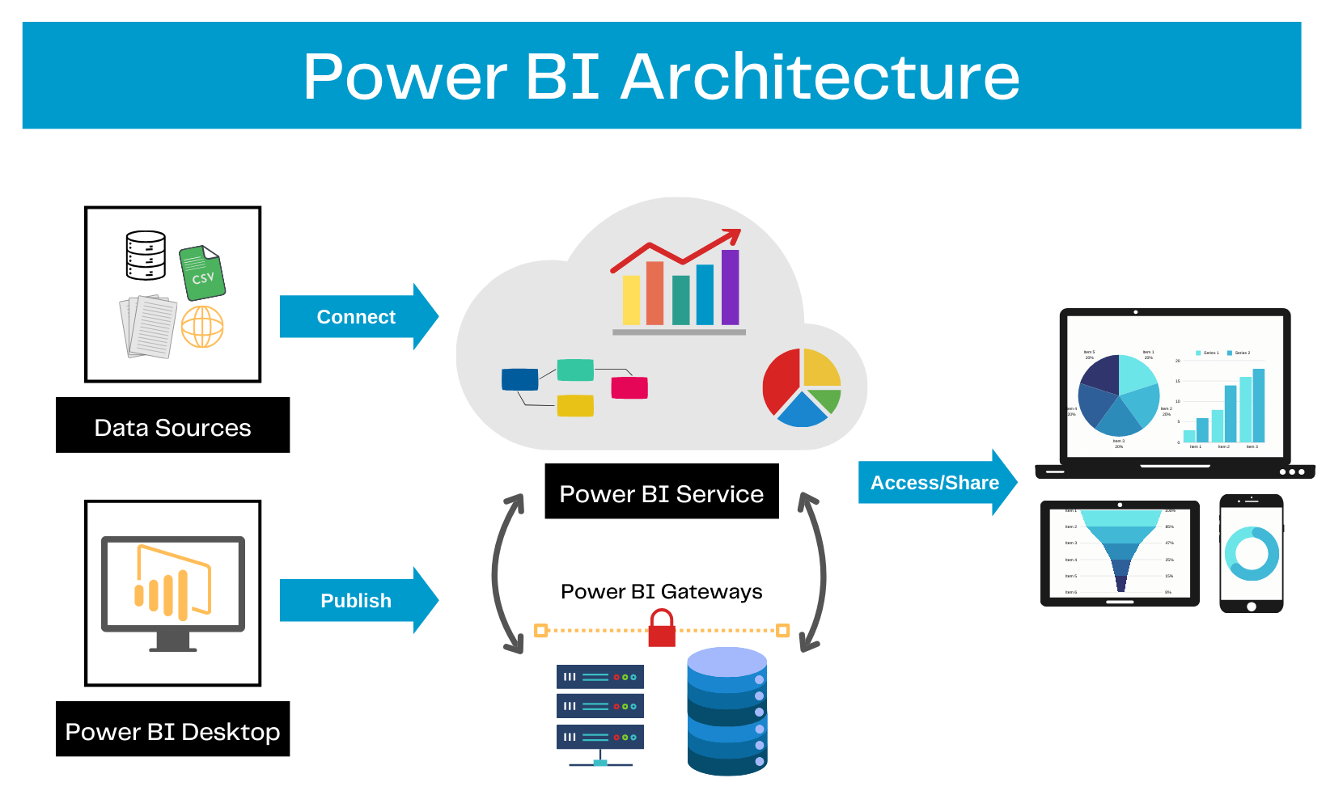

Appendix 2: CRISP-DM Model
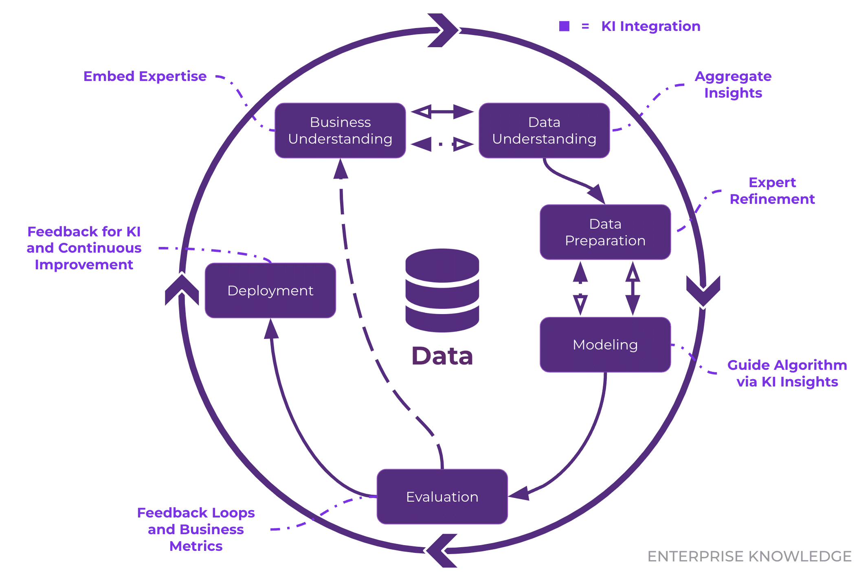

Appendix 3: Data flow between DW and BI tools


