

Student Name: Rohankumar Rajeshbhai Patel

Student ID: 2530043

Module Name: Human Capital Management

Module Code: LCMB7023

Lecturer’s Name: Gladius Kulothungan

Work Count: 2651

Term 1

Table of Contents:
1. Task A: Socialisation, Identity and Business Activism 3
1.1 Traditional Onboarding versus Strategic Organisational Socialisation 4
1.2 Structured Socialisation Framework for Helios Urban Mobility 4
1.3 Organisational Identification, Ethical Professionalism and Business Activist Mindset 6
2. Task B: Innovative Job Design Strategy 7
2.1 Job Design Challenges at Helios Urban Mobility 7
2.2 Application of the Job Characteristics Model 8
2.3 Job Crafting and Employee-Driven Role Innovation 8
2.4 Skills-Based Architecture and Internal Talent Marketplace 9
2.5 Intrinsic Motivation and Innovation Outcomes 10
3. Task C: Reflective Report 11
3.1 Use of AI as a Decision-Support Tool 11
3.2 Preserving Critical Human Judgement 11
3.3 Personal Capability Development Plan 11
References 12

1. Task A: Socialisation, Identity and Business Activism

1.1 Traditional Onboarding versus Strategic Organisational Socialisation
What's customary is that onboarding be administrative and focus only on the short-term and be an orientation for the new employee. This type of onboarding solves the documentation backlog and gets new employees compliant, assigned IT, and exposed to their new role and job. This is all a step in the right direction, but does not address the slow ramp-up, the poor engagement and the attrition of graduates at Helios Urban Mobility. The CIPD (2025) recommends quick onboarding that addresses employee integration and role clarity. This reduces the backlog for the new hire and makes them more productive. This type of onboarding has a positive impact on the attrition of new employees and improves the employer brand.
Strategic organizational socialization is the effect it has on how new workers internalize the organization, how it affects their sense of self, and their psychological relationship with work. Examining the effect of socialization tactics, Van Maanen and Schein (1979) state that the first act of learning the values, roles, and the acceptable behavior of the organization is taught to the newcomers by socialization tactics. For Helios, AI-enabled smart mobility will demand technical skill in addition to ethical, cross-border, and innovative thought and action. According to the psychological contract theory, it is believed that the employee and employer develop some sort of contract (Rousseau, 1995). If graduates that join Helios with the expectations of development, meaning, and innovative thought and action find the support lacking, the psychological contract will be breached increasing disengagement and turnover.
For this reason, Helios must go beyond a “first-week induction” model and develop a strategic socialization system. Helios must connect new entrants to meaning, team identity, ethics, stakeholder influence, and socialization. Social identity theory also states that if people think of an organization as a part of themselves, they will have a higher level of commitment to the organization (Ashforth and Mael, 1989). Socialization that achieves this, gives a sense of belonging to the organization, whereas socialization that is only informative does not.

1.2 Structured Socialisation Framework for Helios Urban Mobility
To achieve this, Helios must have a socialization system that is structured and has three levels: pre-boarding, the first three months, and the first year. The effect of this will be positive since Helios operates in London, Berlin, and Singapore. The newcomers will gain clear roles and cultural and organizational identity, from the start. Technological Change, economic volatility and uncertainty, the Green Transition, and demographic changes are the most influential factors in the World Economic Forum (2025) report that outlines the major shifts in the labor market by 2030. These make developing structured capabilities an imperative for Helios as a technology-based firm.
During the pre-boarding phase, Helios will provide a digital welcome pack which includes the new hire’s role expectations and a welcome statement from Helios senior leaders about Helios’s mission to strengthen ethical, sustainable, urban mobility. Helios will assign each new hire a peer buddy pre-boarding, strengthening the psychologic contract by demonstrating Helios’s commitment to the new hire.
Helios will implement a formal learning journey for the new hire’s first 90 days. The first week will emphasize Helios’s culture, values, safety and ethics, and the company’s dedication to diverse stakeholders. The first month will include shadowing, product walk-throughs, and meetings to prepare the team for client engagement with the city–government. By day 60, the new hire will complete a mobility impact project. By day 90, the new hire will have a formal review with their manager on the new hire’s Helios role. According to Gallup (2025), the new hire’s role clarity, and the new hire’s commitment to Helios, will depend on the formal review and the Helios socialization system.
To extend Helios socialization beyond the new hire’s first year, Helios will implement graduate mentoring, cross-location collaboration, innovation sprints, and quarterly career conversations. The Helios socialization system will be evaluated on the new hire’s ramp-up time, 90-day retention, engagement, psychological safety, and graduate turnover. Helios’s goal will be to reduce the average ramp-up time to 4-5 months within one year. It justifies the link from socialisation to business-related outcomes, employee identity and the long-term strategic renewal of the organisation.
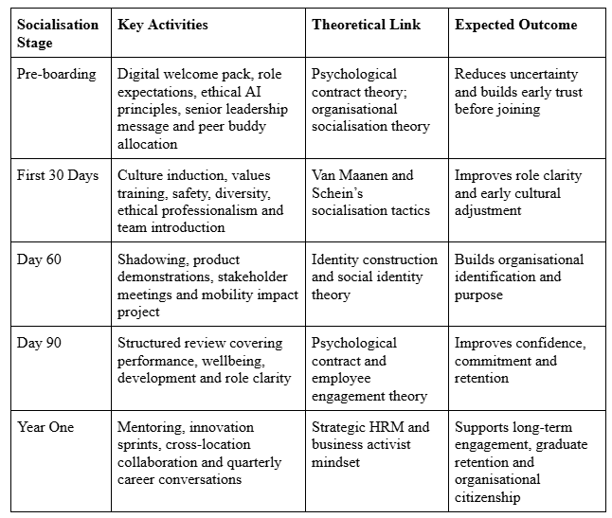
Table 1: Strategic Socialisation Framework for Helios Urban Mobility

1.3 Organisational Identification, Ethical Professionalism and Business Activist Mindset
Helios should increase the organisational identification of employees by linking them to a living purpose of creating smart mobility systems that improve the quality of life in cities, reduce the carbon footprint and support public sector decision making. Identification can be enhanced through the use of stories, leadership communication, team rituals and the active, public and overt recognition of employees who provide social value. Ashforth and Mael (1989) suggested that membership of an organisation is perceived as meaning and defining, and employees therefore identify more with that organisation. For Helios, new employees should learn not only “what we do”, but also “why we do it”.
Ethical professionalism also matters because Helios employs AI-integrated systems for city infrastructure. The new employees need to undertake scenario-based training of interference and safety of AI, as well as ethics of public accountability and innovation. Ethics cannot be a checklist for compliance but will be through design reviews and will be part of project controls and performance, thereby supporting professional judgement and protecting Helios from reputational loss and operational risk.
The business activist mindset means employees should understand both commercial and societal value. Ulrich and Brockbank (2005) state that HR should create value by linking people's practices with business outcomes. Stakeholder capitalism, in the view of Freeman (1984), means organisations must take into account their employees, customers, communities, investors and society at large. At Helios, business activism can be brought to life through cross-functional projects whereby graduates collaborate with the Engineering, HR, Sustainability, Finance and Client teams. Employees should be given opportunities to challenge existing practices they view to be inefficient, propose value adding practices and take into account the needs and interests of various stakeholders while undertaking business decisions.
To support this perspective, Helios should incorporate “citizenship behaviours” in their appraisal and promotion processes. This could include making ethical decisions, contributing positively to customers, and sharing knowledge, among other things. Managers should also demonstrate activist behaviours by having conversations around sustainability, fairness and public trust in addition to talking about profit and faster delivery. This would also aid in developing engagement, commitment, responsibility, and strategic awareness among the new hires in the organisation.

2. Task B: Innovative Job Design Strategy

2.1 Job Design Challenges at Helios Urban Mobility
Helios Urban Mobility requires an innovative job design strategy as its existing people challenges indicate that work may be unstructured poorly in a way that demotivates and makes it difficult for staff to learn and therefore increases the likelihood that staff will leave. The encouraging news is that the company operates in areas that require employees to have technical skills and expertise in AI-enabled electric mobility and smart infrastructure analytics, along with creativity, ethical judgement and the ability to collaborate across functions. However, poor engagement, high attrition of graduates and long ramp-up times indicate that employees may not be experiencing sufficient autonomy, role clarity, developmental opportunities, or a meaningful connection to the outcomes of the organisation. This is highly concerning in a technology-driven labour market that is moving toward digital transformation and where the skill and work requirements for AI and automation, along with the green transition, will be completed by 2030 (World Economic Forum, 2025). The World Economic Forum indicates that the intersections of technological change, economic volatility, demographic transformations, and the green transition are the dominant forces reshaping labour markets according to employer surveys in 55 countries.

2.2 Application of the Job Characteristics Model
Redesigning work at Helios can easily be built around the Job Characteristics Model. Hackman and Oldham (1976), identify the five core job dimensions of skill variety, task identity, task significance, autonomy and feedback. We believe that Helios can enhance skill variety by having employees work on different tasks in Engineering, Data Analytics, Sustainability, Client engagement, and Product Testing. Creating cross-functional teams will give employees exposure to different business problems and will help reduce some of the repetitive and robotic work that employees currently do. Task identity can be enhanced by giving employees the full responsibility of the module, which in this case could be designing the smart mobility feature, testing the feature, and then presenting the feature to others, instead of just completing some of the siloed tasks that may be required of the Feature.
Due to Helios’s work with city governments and public infrastructures, task significance carries more weight as employees should easily be able to see the impacts of their work on creating safer, cleaner, and more efficient urban mobility. Client impact briefings, user stories, and sustainability reports will help achieve this. Helios can also implement agile squads in order to enhance the autonomy of employees by giving employees the freedom to determine the best way to solve the technical and operational problems, while remaining within the governance boundaries. Feedback should be provided from managers, peers, city clients, data dashboards and end users.
This theory is appropriate since Helios requires an employee base that cares about the innovation and not so much the instruction. According to Parker, Morgeson and Johns (2017), work design is of utmost importance when considering the wellbeing and performance of the employees and the overall efficiency of the organization. Helios should therefore undertake the five Job Characteristics Model frameworks and redesign the roles with low motivation by incorporating more autonomy, project ownership, learning diversity, and increased feedback.

2.3 Job Crafting and Employee-Driven Role Innovation
Helios should motivate job crafting alongside formal job redesign. Job crafting is when employees alter their work and relationships in a way that increases the meaning of their work (Wrzesniewski and Dutton, 2001). This is crucial to Helios as employees are the driving force of innovations from the observation of issues and opportunities that go undetected by higher management. A graduate data analyst, for instance, may team up with the sustainability unit to yield carbon-reduction results, while an engineer may engage with client-oriented teams to comprehend which city users are interacting with the smart transport system.
Every 6 months, Helios should hold job crafting sessions as a part of the formal job redesign. Employees may assess which work activities and tasks stimulate them, what work-related challenges they may pursue and even which skills they lack. Managers may support alterations of mentoring, cross-unit participation or engagement in an innovation sprint. Balancing the intentional shaping of work with goal setting is important (Tims, Bakker and Derks, 2012). While Helios may encourage the intentional shaping of work, the organization must also hold a guiding position to support the shaping of work within the organization to support the goals.

2.4 Skills-Based Architecture and Internal Talent Marketplace
Helios needs to bring about a skills-based framework backed by an internal talent marketplace. With traditional job frameworks, mobility can be limited as employees are identified primarily by their job titles. Conversely, skills-based frameworks see employees as a blend of their technical skills, human skills, interests, and potential for growth. According to Deloitte (2022), traditional jobs can inhibit agility, innovation and the employee experience; skills-based organizations center skills over fixed jobs within workforce decisions.
For Helios, this would create a flexible system of skills coverage which would include AI modeling, data ethics, systems design, project management, stakeholder communication, sustainability analytics, and global mobility. An internal talent marketplace would give employees the opportunity to work on a variety of short-term projects and innovation challenges within client work spread across London, Berlin, and Singapore. This would provide visible development encouragement and retain talented employees.
This framework encompasses verified skills, a flexible labor market, and active support for mobility from managers. Employees would be able to apply for internal roles like, “Singapore smart-infrastructure pilot”, “AI ethics review team”, or “Berlin e-mobility analytics sprint”. This would make the workforce more agile, and less siloed, and strengthen the alignment of employee growth with business strategy.
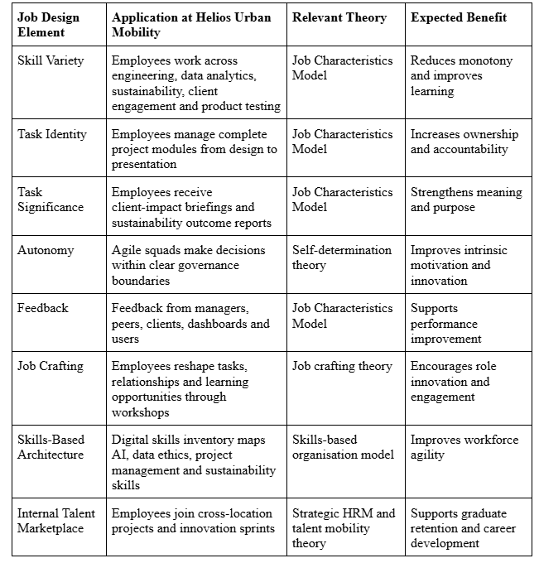
Table 2: Innovative Job Design Strategy for Helios Urban Mobility

2.5 Intrinsic Motivation and Innovation Outcomes
This framework also supports intrinsic motivation as it increases meaning, autonomy, competence, and growth. Those components are also the high motivators, according to the self-determination theory (Deci and Ryan, 2000). In Helios, enriched jobs, job crafting and skill-based mobility would allow staff the opportunity to feel trusted, competent, and connected to a greater cause. Outcomes of innovation would improve since staff would gain greater exposure to cross-functional challenges, city-client requests and evolving technologies. In the long term, Helios would measure the outcomes through engagement scores, rates of internal mobility, innovation submissions, retention of graduates, enhanced productivity and improved ramp-up time.

3. Task C: Reflective Report

3.1 Use of AI as a Decision-Support Tool
I will utilize AI as a decision-support tool by considering it as an advanced analysis tool in the field of HR, while preserving my own professional judgment. In the setting of Helios Urban Mobility, AI can assist with the planning and analysis of engagement, mapping of skills and models for predicting attrition, as well as personalization of learning. It can, for example, analyze employee surveys, model the skills gaps in London, Berlin, Singapore, and provide suggestions for improvement to both the employee onboarding process and the design of jobs, all of which represents the growing significance of AI and other technologies, as well as data literacy for the jobs of the future, while maintaining a priority for critical thinking and analytical skills.
In HR, the fairness and employee-centred nature of decisions requires that, unlike in some other fields, AI be used to assist in making comparisons, designing scenarios, and forming a diagnosis, but not to make decisions on its own. The OECD provides recommendations on the transparency of AI systems, and the systems’ integrity and design, as well as on the accountability of those who develop and operate the systems. Given these recommendations, my use of AI would focus on quality of sources, challenging the assumptions, comparing outputs to the academic sources, and providing suggestions through the ethical lens.

3.2 Preserving Critical Human Judgement
Within a “human-in-the-loop” paradigm, critical human judgement can be preserved by embedding AI alongside people. This means that the output of AI can be insights; however, people retain the responsibility of interpretation, ethics and decisions. In Helios, managers are expected to appreciate the employee voice, organisational culture and the situational context before accepting AI’s predictions about attrition, performance, and potential. The principles of the OECD demand that AI actors are accountable and maintain the traceability of AI-related decisions (OECD, 2024).

3.3 Personal Capability Development Plan
To strengthen my future employability, I will develop four capabilities. First, I will enhance my data literacy by learning to interpret HR dashboards and engagement and workforce analytics. I want to incorporate data and evidence in HR decisions rather than solely relying on my opinions. Second, I want to develop my AI augmentation skills by learning to ethically and responsibly employ generative AI in the contexts of research, summarization, scenario development and HR policy analysis. Third, I will enhance my strategic influencing skills by focusing on stakeholder communications and developing business cases and employing persuasive techniques grounded in robust evidence. This is essential as HR professionals have to influence and work with leaders at all levels and external partners. Fourth, I will improve my understanding of global mobility by focusing on cross-border employment and global workforce issues to Helios' locations of London, Berlin and Singapore. The capabilities I want to develop strengthen the future labour market as the World Economic Forum (2025) predicts that future employers will value analytical skills, resilience, leadership, and the ability to continually learn and adapt, especially with the proliferation of technology.

References
- Ashforth, B.E. and Mael, F. (1989) ‘Social identity theory and the organization’, Academy of Management Review, 14(1), pp. 20–39.
- CIPD (2025) Induction. London: Chartered Institute of Personnel and Development.
- Deci, E.L. and Ryan, R.M. (2000) ‘The “what” and “why” of goal pursuits: Human needs and the self-determination of behavior’, Psychological Inquiry, 11(4), pp. 227–268.
- Freeman, R.E. (1984) Strategic Management: A Stakeholder Approach. Boston: Pitman.
- Gallup (2025) U.S. Employee Engagement Sinks to 10-Year Low. Washington, DC: Gallup.
- Gallup (2026) State of the Global Workplace 2026. Washington, DC: Gallup.
- Hackman, J.R. and Oldham, G.R. (1976) ‘Motivation through the design of work: Test of a theory’, Organizational Behavior and Human Performance, 16(2), pp. 250–279.
- Jones, R., Cantrell, S., Griffiths, M. and Hiipakka, J. (2022) The Skills-Based Organization: A New Operating Model for Work and the Workforce. Deloitte Insights.
- OECD (2024) OECD AI Principles. Paris: Organisation for Economic Co-operation and Development.
- Parker, S.K., Morgeson, F.P. and Johns, G. (2017) ‘One hundred years of work design research: Looking back and looking forward’, Journal of Applied Psychology, 102(3), pp. 403–420.
- Rousseau, D.M. (1995) Psychological Contracts in Organizations: Understanding Written and Unwritten Agreements. Thousand Oaks: Sage.
- Tims, M., Bakker, A.B. and Derks, D. (2012) ‘Development and validation of the job crafting scale’, Journal of Vocational Behavior, 80(1), pp. 173–186.
- Ulrich, D. and Brockbank, W. (2005) The HR Value Proposition. Boston: Harvard Business School Press.
- Van Maanen, J. and Schein, E.H. (1979) ‘Toward a theory of organizational socialization’, Research in Organizational Behavior, 1, pp. 209–264.
- World Economic Forum (2025) The Future of Jobs Report 2025. Geneva: World Economic Forum.
- Wrzesniewski, A. and Dutton, J.E. (2001) ‘Crafting a job: Revisioning employees as active crafters of their work’, Academy of Management Review, 26(2), pp. 179–201.

