Q. Using a Mediterranean shipwreck site, or type of archaeological assemblage, consider how this site or material can be interrogated to demonstrate maritime connectivity within and possible beyond the Mediterranean region.
Maritime connectivity within the Mediterranean can be described as the maritime routes connecting the Mediterranean region. When examining the different elements of maritime connectivity within the Mediterranean we must first consider the basis on which these routes were built: the introduction of shipbuilding within Mediterranean communities. Furthermore, as we can investigate the reason for the beginning of maritime routes within the Mediterranean it is crucial we consider how each individual community began shipbuilding to meet the needs of themselves and their people.
Ancient Egyptian shipbuilding began from the third dynasty onwards just as regular Nile side ship-yards appear in correlation with the progress of “great stone building projects [that began being] developed which were the property of Kings, Dignitaries or Temples” (Strouhal: 1992, P.178). Shipbuilding primarily began in Ancient Egypt due to a necessary requirement when pyramids and temples began to be built, as it became increasingly difficult to move raw materials overland, therefore they turned to the heart of Ancient Egypt, The Nile River. Moreover,
[t]he development of Nile shipping was aided by the fact the current flows northward the prevailing wind comes southward from the Mediterranean and when there is enough of a breeze therefore a ship can sail most of the way upstream” (Strouhal: 1992, P.176).
When looking at ancient Egyptian history today we can be certain shipbuilding had a significant impact on society as “on occasion it took 4,500 men only 14 days to transport 80 gigantic stone blocks” (Strouhal: 1992, P.176) from one site within Ancient Egypt to another, which can be considered a major technical innovation as it allowed the development and building of many or all the great monuments we know today.
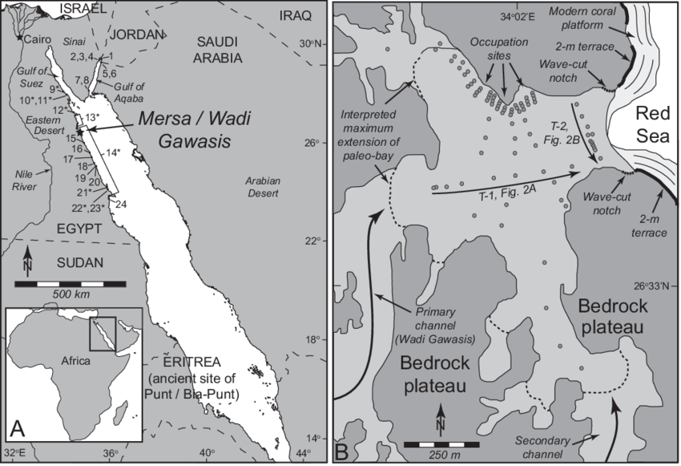
When examining specific examples of maritime connectivity within the Mediterranean, a significant site that has recently been discovered is the ancient harbour of ‘Saww’ at Mersa/ Wadi Gawasis which was “located at the base of a fossil coral terrace at the northern end of the Wadi Gawasis about 23 km south of the modern town of Safaga and 50 m North of Quseir” (Brad, Fattovich: 2011, P.107) on the Red Sea Coast. When examining this site, it can be indicated that this ancient harbour was an “open protected bay with a maximum area of 560,000 m2 with a depth of approximately 6-8 m” (Bard, Fattovich: 2010, P.3).
In the 1970s “Abdel Monem Sayed of the University of Alexandria identified the remains of this Middle Kingdom harbour known anciently as ‘Saww’” (Bard, Fattovich: 2010, P.1). According to Sayed at the site of Mersa Gawasis they discovered some small stela and fragments of stela that were made from limestone and badly weathered. Moreover, this site also has “special importance because it bears the cartouches of Senusret I (ca. 1956-1911 B.C)” (Sayed: 1978, P.70) the second Pharaoh of the twelfth dynasty, which allows us to date the creation of this harbour to the 12th dynasty Middle Kingdom. Significantly, two small inscriptions remain which ensure this site has great importance as it mentions the name of Punt, and “it is inscribed with a hieroglyphic text recording an order issued by Senusret I to his vizier Antefoker to build ships to be sent to the region of Punt” (Sayed: 1978, P.70), in later texts it describes ships that “were built in Coptos for an expedition to Punt with over 3,700 men” (Bard, Fattovich: 2010, P.1). An inscription found by Sayed, described an expedition to the harbour “who not only carried the dissembled ships across the Desert in a 10-day track but also brought all of the equipment supplies and food needed for the expedition” (Brad, Fattovich: n.d, P.26). Although Sayed did not find any remains of significant structures at this site, it was suggested due to this stela that it is possible voyages from Egypt to Punt set sail from this port; it is also significant as it is possible that Hatshepsut’s famous voyage to Punt began from this harbour. (Bard, Fattovich: 2011, P.129)
Figure 1
Furthermore, it is based on the discoveries made by Sayed which led to the re-investigation of this site by the University of Naples and Boston University in 2001, under the supervision of Kathryn Brad and Rodolfo Fattovich (Bard, Fattovich: 2010, P.1). Significant fieldwork was then carried out consisting of systematic surface surveying and mapping of the site, differential GPS, “extensive excavations [and] geophysical surveying by magnetometer and electromagnetic induction” (Bard, Fattovich: 2011, P.107). It is significant to note that the ancient harbour of Saww was located near “the shortest overland route from the Nile Valley in Upper Egypt to the Red Sea” (Bard, Fattovich: 2010, P.1). It was also significant at this time that due to many supposedly seafaring expeditions to obtain exotic raw materials including incense, ebony, elephant ivory and gold in the regions in the southern Red Sea, (Bard, Fattovich: 2010, P.1) This suggests that although not within the Mediterranean region, Egypt from as early as the late first intermediate period began to obtain maritime connectivity within the southern Red Sea. Although there are a small number of material finds within this site we are able to date this harbour with certainty, due to radiocarbon dating of many of the objects found to “c.2000 and 1600BC, which are consistent with the use of the Harbour” (Fattovich: 2012, P.5) to the beginning of the 12th dynasty and the early Middle Kingdom.
When examining this archaeological site, it can be made clear that the choosing of this site as a harbour for expeditions producing maritime connectivity to the Red Sea was one of strategic placement, as in the late 3rd to this mid-second millennium BC this harbour was a “large lagoon within and embayment delimited by fossil choral terraces over 10 m high with an outlet for seafaring ships” (Bard, Fattovich: 2010, P.1). Another reason for strategic placement was that large ships could pass through the channel “at the mouth of the bay which was 10 m depth and 115 m wide” (Bard, Fattovich: 2010, P.3). We can also infer the Northern Terrace was the main focus of this harbour as it provided protection to the large ships in the harbour from northern winds.
Throughout this site, within many seasons of excavation many significant archaeological finds were discovered: “in particular excavation at this site revealed abundant evidence for seafaring in the 12th dynasty: ship timbers, anchors, ropes, cargo boxes, administrative devices, inscribed stela, ceramics and lithics remain” (Fattovich: 2012, P.4). Although it would be difficult to assess every object, we can focus mainly on objects connoting maritime connectivity within the Mediterranean region and beyond. It is significant to note that along this site up to 8 man-made caves or galleries were discovered by Brad and Fattovich. One of the most important finds was outside caves 3-5:
whole ship timbers planks and decking of cedar wood including one complete deck beam, 3.29 m long that reflects the hull shape and shorter planks with bevelled ends and planks that had been lashed were also excavated” (Brad, Fattovich: n.d, P.25).
The use of cedar wood is of great significance to maritime connectivity with Egypt and the Mediterranean as it was one of the primary imports to Egypt from the early dynasties onwards: “their need for a long plank from the earliest dynastic period stimulated overseas voyages to the Levant coast for a Meru” (Mc Grail: 2009, P.17) or cedar wood which was traded and exchanged from Egypt with the Lebanon highlands. We may also make assumptions that this cedar wood was imported from Lebanon through the Nile Delta and then brought up River to Coptos were there was a shipbuilding site. The discovery of these timbers within caves 3 to 5 also confirms that “ships were disassembled outside the caves” (Brad, Fattovich: n.d, P.26) and placed within the caves for safekeeping, which suggests this harbour was used temporarily and when needed for expeditions to Punt and the wider Red Sea.
Another example of maritime connectivity with wood finds at this site is “charcoal pieces identified in an industrial area not only cedar but also to species of oak and pine” (Brad, Fattovich: n.d, P.26). These species of oak and pine were clearly brought to Egypt from Southwest Asia, which suggests Egypt had many trade routes of timber and wood all throughout the Mediterranean as it was a raw material not native to Egypt, and was one of the first and most used building materials within shipbuilding and others craft specialisations. Moreover, it is significant to note another important group of objects discovered at the ancient harbour, although these objects do not connote connectivity within the Mediterranean and beyond, which still do suggest that at all times this harbour was prepared for expeditions to the southern Red Sea. In the cave 5 known as the ‘Rope Cave’, “an estimated 26 to 30 coils of rope from ships were found inside” (Brad, Fattovich: 2011, P.113), these ropes were left coiled and ready to be used possibly for rigging on standards ships. This significant material culture suggests many of these cubes were used as storage or craft specialisation workshops in wait of the next seafaring expedition.
Furthermore, another significant object that was excavated at this site was “one knife -shaped plank that had been fastened to other timbers by tents and joints and secured by copper bands” (Brad, Fattovich: n.d, P.25). The use of copper within this plank can be used as an example of maritime connectivity as copper was foreign to the land of Egypt: copper was traded and exchanged through maritime connectivity between Egypt and Cyprus (Mc Grail: 2009, P.17). When excavating this site, we must not only consider that Egypt exported materials to the southern Red Sea but also they brought back with them exotic materials from a foreign land: the remains of 43 wooden cargo boxes were discovered well preserved outside caves six and seven, with clay sealings (Brad, Fattovich: n.d, P.26). Although only two inscriptions are visible today we can clearly see these are commodities from the reign of Amenemhat IV containing “the wonderful things of Punt” (Brad, Fattovich: n.d, P.26). This evidence suggests that although the harbour was temporary, voyages from Egypt to the southern Red Sea came from direct order from the Pharaoh.
This site, like many others in the Ancient Near East, produced a wide range of ceramic remains from all throughout the 12th dynasty and beyond; the two most significant finds were potsherds from two distinct regions. Two Minoan potsherds were found in the area between a shrine and the entry to caves three: “one was identified as MMIB Protopalatial Karmares class and the other as a MMIIIA Fine Buff Crude Ware” (Fattovich: 2012, P.9); this suggests Egypt had maritime collective routes with the island of Crete. Another potsherd was found with wares suggested to be from “the western coast of Yemen and the Aden region in southern Yemen” (Brad, Fattovich: n.d, P.26), this indicates contacts from Egypt with the southern red Sea region and possible navigation into the Gulf of Aden. Another significant example of maritime connectivity using ceramics is charcoal taken from a hearth associated with cooking and the temporary camp of workers at the harbour, which correlates that some of this charcoal is made up of “Canaanite ceramics at the top of the deposit covering the entry of cave 3” (Brad, Fattovich: 2011, P.116). This find again signifies that Egypt had created trade and exchange routes (possibly maritime or overland routes) with modern day Palestine. Within a large area of the harbour, along the Western Terrace, evidence of man-made camps were discovered as “24 shallow pits sometimes with post holes and hearths may have been foundations of small huts or tents” (Fattovich: 2012, P.7), which was most likely the living quarters of sailors before and after expeditions. It is also significant to indicate “the occurrence of Egyptian bowls with decoration imitating Nubian motifs suggests the presence of Medjaw soldiers at this site” (Fattovich: 2012, P.7).
Finally, it is noteworthy to address not only the physical material culture produced from this site but also the ethnographic evidence of the different individuals that lived or worked within this harbour. Moreover, ideas can be proposed that the “workers and sealers [that use this site on day-to-day basis] may have included Egyptian, Levantine and Nubian people” (Fattovich: 2012, P.14), this evidence is nearly certain due to the significant discoveries of objects coming from throughout the surrounding regions to Egypt. We can make conclusions that although this site was only temporarily used, it was “embedded in international trade system of the Bronze Age” (Fattovich: 2012, P.14)
In conclusion, when looking at maritime connectivity within the Mediterranean region we can consider many aspects, and although this site of the ancient harbour at Mersa/Wadi Gawasis is not within the Mediterranean, it does confirm that items brought to this site such as timbers, ceramics and personal materiality could not be possible without the interconnections and many maritime routes of trade and exchange that Egypt had with the regions of the Mediterranean Sea. With this evidence we can confirm that this was the harbour used for “seafaring expeditions to the southern Red Sea in the 12th dynasty” (Brad, Fattovich: 2011, P.129) and also confirms that “the discovery of the blades of ship rudders associated with ceramics dating to the early 18th dynasty, supports the hypothesis that the Egyptians were navigating in the red Sea at the time of Hatshepsut” (Brad, Fattovich: 2011, P.129) demonstrating that Egypt was centre to many maritime routes, and obtained connections throughout the Mediterranean and the Red Sea.
Final Word Count: 2285

Bibliography

Brad. K, Fattovich. R (2010) ‘Spatial use of the twelfth dynasty harbour at Mersa/Wadi Gawasis for the seafaring expeditions to Punt’, Journal of Ancient Egyptian Interconnections, Volume 2:3, Pages 1-13.
Brad. K, Fattovich. R (2011) ‘The Middle Kingdom Harbor at Mersa/Gawasis’, Journal of the American Research Centre in Egypt’ Volume 47, Page 105-129.
Brad. K, Fattovich. R ‘Mersa/Wadi Gawasis, an Egyptian Harbor on the Red Sea’ available on URL: http://glendash.com/WadiGawasis-AnEgyptianHarbor.pdf, [Accessed on 17/03/18]
Fattovich. R (2012) ‘Egypt’s trade with Punt: New discoveries on the Red Sea coast’, British Museum Studied in Ancient Egypt and Sudan, Issue 18, Page 1-59.
Mc Grail. S (2009) ‘Boats of the World: From Stone Age to Medieval Times’ Oxford University Press.
Sayed. H. A. M. A (1978) ‘The recently discovered port on the Red Sea shore’, The Journal of Egyptian Archaeology, Volume 64, Page 69-71.
Strouhal. E (1992) ‘Life in Ancient Egypt’, (Cambridge Press, Opus Publishing, London)

Images
Figure 1-
A: Map of Red Sea showing location of Mersa/Wadi Gawasis (MWG) (26°33′05″N, 34°02′08″E) at head of Wadi Gawasis, ephemeral river system with drainage area.
B: Study area map of MWG. Sediment core locations are given as grey filled circles with two core transects.
Available on URL: https://www.researchgate.net/figure/A-Map-of-Red-Sea-showing-location-of-Mersa-Wadi-Gawasis-MWG-263305N-340208E_fig1_273441660, [Accessed on 19/03/18].

