
Fundementals of cunstruction technology
Assignment 1

December 18, 2021
Liam evans
2110014

Contents
The history of Swansea Docks 2
Site Investigation recommendations 3
Review of previous borehole log at site 6
Foundation Type 7

City and County of Swansea have chosen to enter into a joint agreement with Marriot Hotels to create a new restaurant and ice-cream parlour (with manager’s apartment) on Swansea foreshore, in the position indicated. The site is located between County Hall and the Marriot Hotel and is illustrated on the attached images. The building, which is to share parts of the car park of both of the existing adjacent facilities, is to have a GIA (Gross Internal Area) at ground floor level of approximately 300 square metres.
The building is to contain the restaurant, café bar, ice-cream parlour, kitchen, food-stores etc. At second floor level, there is to be a self-contained manager’s apartment and staff welfare facilities. This project is procured via a Design and Build contract.

You are to assume that you work as a junior construction professional, requested to initiate a preliminary study for a full site investigation as part of the feasibility stage of the project.

As a junior construction professional, I have been requested to initiate a preliminary study for a full site investigation as part of the feasibility stage of the project. My aims for this task are to dig deeper into the site in question on a larger scale and also to the fine details. What I mean by this is to look at the historical background of the site but then also look at bore hole sample taken to get a real understanding of this patch of land. After breaking down this information, I intend to be able to come up with a foundation detail for the proposed restaurant and ice cream parlor. The proposed building is a 300m2 restaurant with a manager’s apartment sitting on the second floor. It lies on the Swansea foreshore adjacent to the existing Marriot hotel.

The history of Swansea Docks
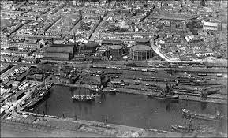
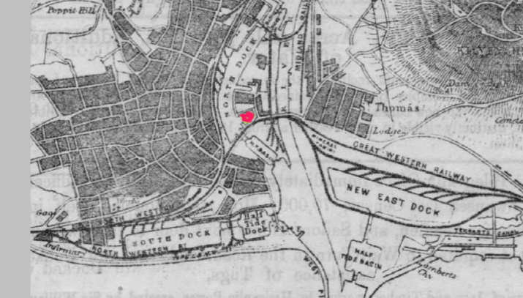
Looking at the site in more detail, it is well known that Swansea was once very rich in industry. The south dock of Swansea lies just 100m away from the site the proposed building intends to sit on. ‘Construction of Swansea's South Dock began in 1852 and was officially opened seven years later in 1859’ (coflein, 2021). Swansea being very industry heavy has led to some difficulties when we are looking to build in the modern day. Ground contamination would be one of those issues. There would have been a large emphasis on fossil fuels such as oil and coal being exported and used as a tool at the docks.
History Points, 2020. Available at https://historypoints.org/index.php?page=swansea-marina.
Photo of the south dock where the site is situated. SwanseaDocks. Available at http://swanseadocks.co.uk/oldsite/North%20Dock%20write%20up.htm

Site Investigation recommendations
Given the historical background of the site, there is some investigation needed in order to ensure safety of constructing the building. Prior to any sort of investigation works that are done by the specialist contractor, local authorities will need to call to the site. With welfare and health and safety of all species being a large concern, this is often the case with construction. Signs of animals burrowing or nesting in nearby trees will be an issue needing to be resolved before putting a shovel in the ground. Another concern that may need to be searched for are bombs. With Swansea being heavily bombed in the world war unexploded bombs in the ground will be a major cause for concern. Appropriate authorities in this field will need to be contacted before the commencement of excavations.
Consideration to the geographical location of the is also very important. This being picked up on the desktop study. The site is situated on the south shore being exposed to the sea. The site will therefor be exposed to heavy rainfall and even flooding on some occasions. This is likely to have an impact on the top layers of strata being sands of sorts or fine gravels.
After all appropriate authorities are contacted and the site is cleared of any concerns they may have picked up on it is time for the site investigation. Without this investigation taking place we are guessing what the ground type is or whether the ground is contaminated or not. A simple desktop study will allow us to have some sort of expectation of what we will find. ‘A desktop study is the first part of the site investigation process. It involves a desk-based collation of documentary data’ (wessonenvironmental, 2017). This meaning that information will be able to be gathered from online resources. Information such as the site’s previous uses, whether the area is in a flood plain and so on. Having this information can give a brief understanding on what to expect from the piece of land.
One of my recommendations that I would give to a specialist contractor would be to take a sample of the ground. My reasoning for this is due to the site’s past use, it is likely that there will be a lot of made-up ground. As the docks used to be such vast area compared to how it is now, there will have been a lot of infilling to make up this ground. This may have been from surrounding buildings that were no longer needed for example. Rubble and other hardcore will not give a stable enough surface for us to lay the foundation. When looking at what the foundations are to be layed on, we are looking for undisturbed ground. ‘The foundation can not be poured until undisturbed ground has been found.’ (Planning portal, Building regulations, 2021). In order for the foundations and in turn the building to be constructed we must know how far down we will need to excavate until we find undisturbed ground.
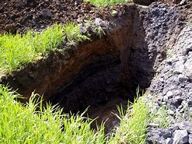
The method I recommend the specialists use will be to excavate an initial trial pit on the site. This initial dig will show whether the ground is made up or not. Having this information early will then lead us on to what the next steps we take are. The reason I would recommend they take this route first is this will prove that the ground is made up. Before going to the expense of digging boreholes meters below the ground, the trial pits will show the shallow profile of the ground. ‘Trial pits are commonly used to investigate shallow ground conditions to develop an understanding of the profile of soils within the ground.’ (Design buildings, 2021). This will be carried out by a regular excavator such as a JCB or something of the like.

Following from the trial pit, I believe further excavation will be needed to reach undisturbed ground. The reason being not only as the ground may be made up, but the ground conditions may also be a fine aggregate such as sand as the site is so close to the shore. Boreholes across the site would be my favored option for this. ‘A borehole is the generalized term for any narrow shaft drilled in the ground, either vertically or horizontally.’ (Harding environmental) We use boreholes for different reasons, these include being ‘part of geotechnical investigation or environmental site assessments.’(Harding environmental) Samples are taken from the ground and are then taken to a laboratory to be tested in order to determine their physical properties. This will show us at what depths different materials are, allowing us to make a judgement on how deep we are needing to excavate for our foundations and more importantly what type of foundation we are needing to use.
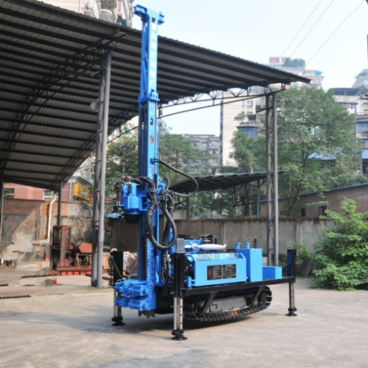
In order to excavate the borehole, we will need to decide on which type of rig will be most appropriate. Things like access, contours of the ground are considered when deciding what type to use. By taking these factors into account I believe that the most qualified rig for the role would be a highway rig. This is due to the ease of access of the chosen site and the contour of the site being relatively flat. As seen in the photo the legs allow the rig to be stabilized and also perfectly level ensuring the sample is taken vertically. This must be accurate as the depths will not be correct if the rig is not drilling vertically. The way in which the rig positions the drill is by GPS. This gives us the most accurate measurements and leaves the scope for error minimal.
Google Images, 2021

Due to the location of the site, I am expecting there to be a point in which the ground type is sand or a very coarse soil. The reason this is important is because it is not a self-supporting matter. This needs to be taken into account when planning for the excavation. The borehole may need to be lined with a temporary casing or the excavation may collapse. The depth of the excavation is something I believe will be very important in the investigation. Knowing that there will be made up ground and making the presumption of finer aggregates, a depth of more than 5 meters I believe is crucial. Given the diversity of ground types expected, the greater the extend of investigation is needed. If we are to discover that there is no stable ground for the first 3 meters, then we will then need to turn the attention to deeper foundation types such as piling.

Review of previous borehole log at site
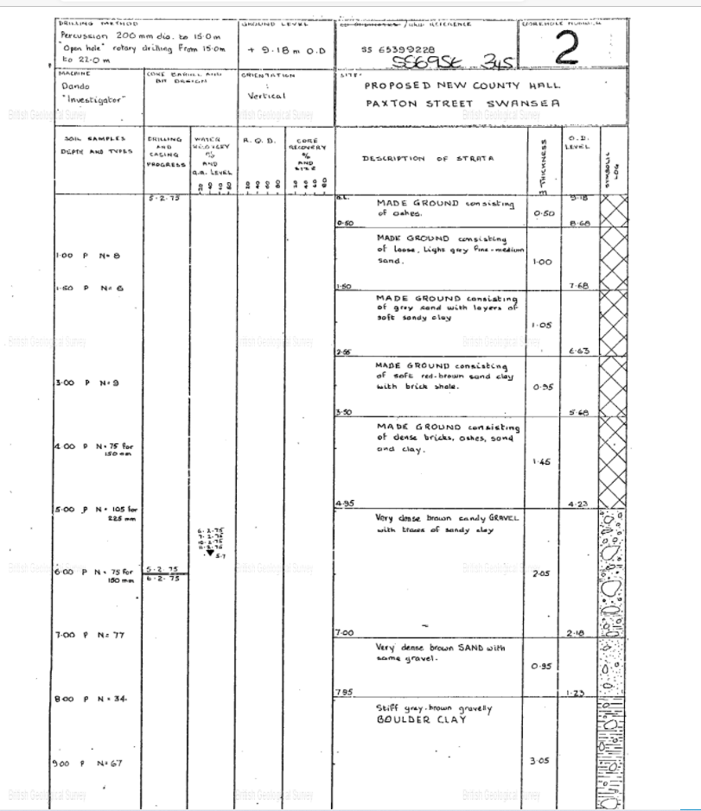
Through online research I have been able to discover a previous investigation that has been done very near to the site proposed. This log investigation was done in due to ‘proposed new county hall’ (British Geological Survey, 1976). As stated in the investigation, ‘percussion to 15m, rotary drilling from 15m to 22m) These depths are highlighting what I was recommending in needing to investigate at a big depth. Reading the chart detailed, the first 4.95 meters are all made up ground. This consisting of ‘ash, sand, sandy clay and bricks’ (British Geological Survey, 1976) As previously stated in my desktop study, I was expecting there to be fine aggregate such as sand due to the location of the site. This strata does not make for a good base when trying to build as it is not self-supportive. Further down the log the ground is made up of bricks, this again was picked up previously due to the historical background of the site. This brick will have condensed over time but will also not give the stable base in order to build. Beneath these layers of made up ground we do discover ‘very dense sandy gravel’. This gravel, much like the sand is not the self-supportive matter we are looking for. With the depth of investigation currently being 7 meters and yet to find stable ground, the choices of foundation type is narrowing. The next ground type we discover is ‘stiff boulder clay’ which is nearing the type of ground we would be looking for when wanting to find the base for our foundation. This clay lasts for 3.05 meters and then goes on to be ‘very stiff boulder clay’. There is a note in the log which states ‘open hole drilling due to pebbles falling in hole – coring not possible’ (British Geological Survey, 1976) Thus meaning that the strata is not completely stable up until this point which indicates it is no god as a base for the foundation. This then takes us down to 18.6 meters deep to reach ‘grey mudstone’ which is a solid base and would be perfect to lay the foundations on.

Foundation Type
The foundation is the first component to the building which is key to get correct. This may be down to the type of foundation, the depth of the foundation and the strata supporting the foundation. With the proposed building being 300 square meters and two story there is criteria that the foundations must meet. Raft foundations is an option that fits the criteria of not needing a solid strata in order to support the walls. The raft foundation is a reinforced slab ranging between the thickness of 150mm – 300mm. This spreads the enite load of the building across the entrire slab and transfers to the ground. This type of foundation is used when ground conditions are poor. Steel beems and thickened areas can be added to transfer this load. This method though would be eliminated from consideration due to the size of the building we are intending on constructing. Being 300m2 it is not feasable to havwe a raft this big. Considering this, it leaves us with only one option, piled foundations. The point of a foundation is to ‘provide support for structures, transferring their load to layers of soil or rock that have sufficient baring capacity and suitable settlement characteristics’ (Design Buildings, 2021). As we are hitting grey mudstone this means we are getting the load transferred successfully to solid strata. Piled foundations are made of ‘long slender, columnar elements typically made from steel or reinforced concrete’ (Atkinson, 2007). The way I would lay these piles would be by boring the hole and then pouring the piles in situ concrete. This method is often used where there are surrounding buildings and as the site is near the Marriot Hotel this is what I would opt for.
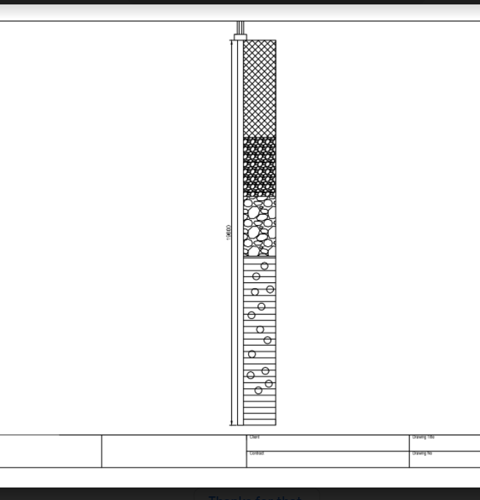
As seen in my diagram on AutoCAD, the piles are taken down until there is solid, self supportive strata underneath. As of BS EN S1, ‘Piles are to be vertical, unless designes otherwise’. This would take the load vertically down and transferred safely from the whole weight of the building. They must also be ‘installed by an appropriate specialist under engineer’s supervision’. These standards are out in place by NHBC to ensure that all aspects of building are meeting a certain standard. Enforcing this are building inspectors who will call to site at key points of the construction phase and making sure all criteria is met. I would design the foundation to be the piling down to the above strata, then sat above these piles would be pile caps on top. These would be almost like a large strip foundation with reinforced concrete on top. This would supply the building with the satrength that is needed. Generally piling is known for being the most expensive form of foundation due to the extensive excavating needed. Due to the logistics of the site it would not be possible to use any other type. The layers of made up ground and aggregates in the top layers are the reason for this. Raft foundations is an option that fits the criteria of not needing a solid strata in order to support the walls. The raft foundation is a reinforced slab ranging between the thickness of 150mm – 300mm. This spreads the enite load of the building across the entrire slab and transfers to the ground. This type of foundation is used when ground conditions are poor. Steel beems and thickened areas can be added to transfer this load. This method though would be eliminated from consideration due to the size of the building we are intending on constructing. Being 300m2 it is not feasable to havwe a raft this big.

References

Coflein (2020) Available at: https://coflein.gov.uk/en/site/580/ (Accessed): 19/12/2021
Wesson Environmental (2017) Available at: https://wessonenvironmental.co.uk/services/desktop-study/ (Accessed):19/12/2021

Planning Portal (2021) Available at:
https://www.planningportal.co.uk/info/200130/common_projects/17/extensions/5#:~:text=Building%20Regulations%3A%20Foundations.%20Foundations%20are%20required%20to%20transmit,another%20depending%20on%20the%20circumstances%20of%20each%20case. (Accessed): 19/12/2021
Design Buildings (2021) Available at: https://www.designingbuildings.co.uk/wiki/Trial_pit (Accessed): 19/12/2021
Harding Environmental (2018) Available at: https://www.hardingenvironmental.co.uk/well-drilling/what-is-a-borehole/ (Accessed): 23/12/2021
British Geological Survey (2019) Available at: http://scans.bgs.ac.uk/sobi_scans/boreholes/370246/images/10677923.html (Accessed): 24/12/2021
NHBC (2021) Available at: http://nhbccampaigns.co.uk/landingpages/techzone/previous_versions/2010/Part4/section5/sitework.htm#S11 (Accessed): 02/01/2021
Design Building (2020) Available at: https://www.designingbuildings.co.uk/wiki/Pile_foundations (Accessed): 02/01/2021

