Scott Burgess - 1350316
University of Wales Trinity Saint David
Computer ARchitecture and Operating Systems
Operating Systems Assignment

Contents
Introduction 2
1 – Key Functions of General Operating Systems 2
Process Management 2
Memory Management 3
File System Management 4
Device Management 4
Security and Access Control 5
Networking 5
Resource Monitoring 6
Error Handling 6
2 – Use of Windows OS CLI Commands 7
Process Management 7
File & Directory Management 8
Network Testing / Monitoring 9
User Management 10
Task Scheduling 10
3 – Use of Linux OS CLI Commands 11
Process Management 11
File & Directory Management 12
Network Testing / Monitoring 12
User Management 13
Task Scheduling 14
4 – Use of Windows OS Scripts 15
5 – Use of Linux OS Scripts 21
Conclusion 23
Appendices 27
Tutorial Activity 27
Lecture Activities 28
Online Certified Course 29

Introduction
This report examines the main functions of general-purpose operating systems and demonstrates the practical use of Windows and Linux command-line tools and scripting languages. It also discusses process management, file handling, user management, task scheduling, and network administration using practical examples.
There are different types of Operating Systems (OS), which are designed to meet the needs of the user. These operating systems are core pieces of software which allow the user to operate their devices, managing hardware resources, memory and to execute other software applications [1].

1 – Key Functions of General Operating Systems
General Purpose, or Desktop, Operating Systems are designed to enable the user to run multiple software applications or complete tasks. These are generally installed on personal computers, or within an educational or employment environment. Uses of General Purpose OS include using word processing applications, browsing the web or communicating via email. Highly used versions of these operating systems include Microsoft Windows, Linux and MacOS [2]
General operating systems allow users to manage a computer’s hardware and software through the use of several key functions, all of which help to ensure the computer system runs smoothly and efficiently.

Process Management
One key function is process management, which helps the operating system to organise and manage multiple tasks and programmes whilst ensuring they run smoothly and keep things optimised [3]
The Task Manager application provides the user with a list of running processes and applications, and how the operating system is allocating resources such as CPU time or memory usage.
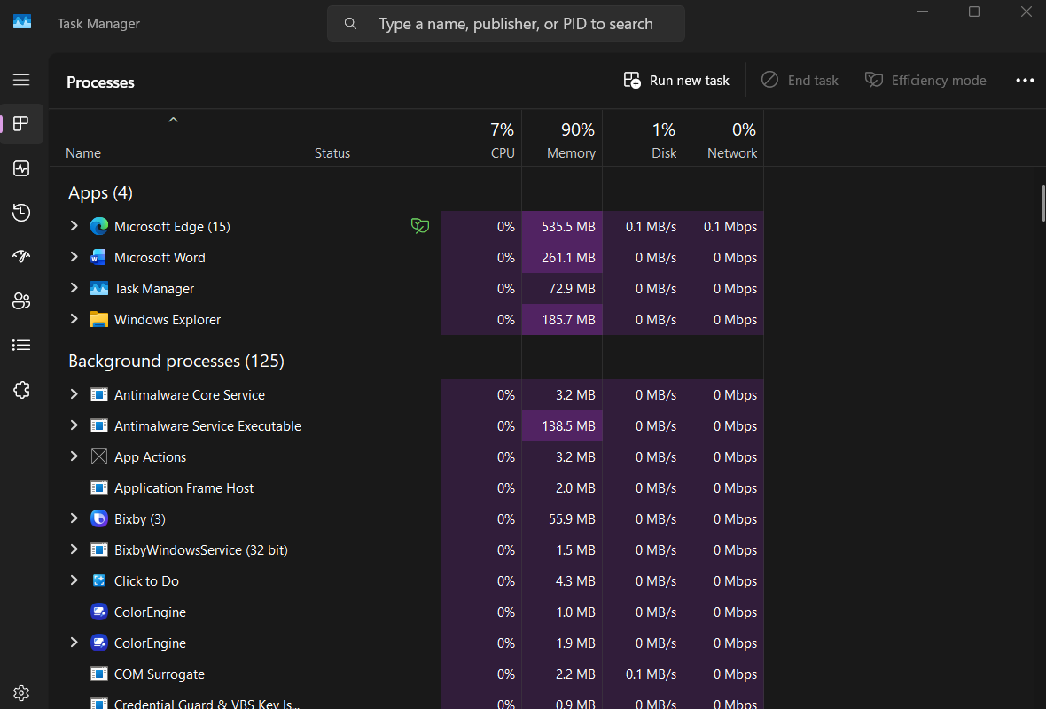

Memory Management
Memory management is a key function which is responsible for controlling how RAM is allocated to different applications. The operating system ensures that each application has enough memory to run properly and helps to prevent them from affecting each other’s performance [4]. This is displayed in the task manager tool in Windows, as shown below.
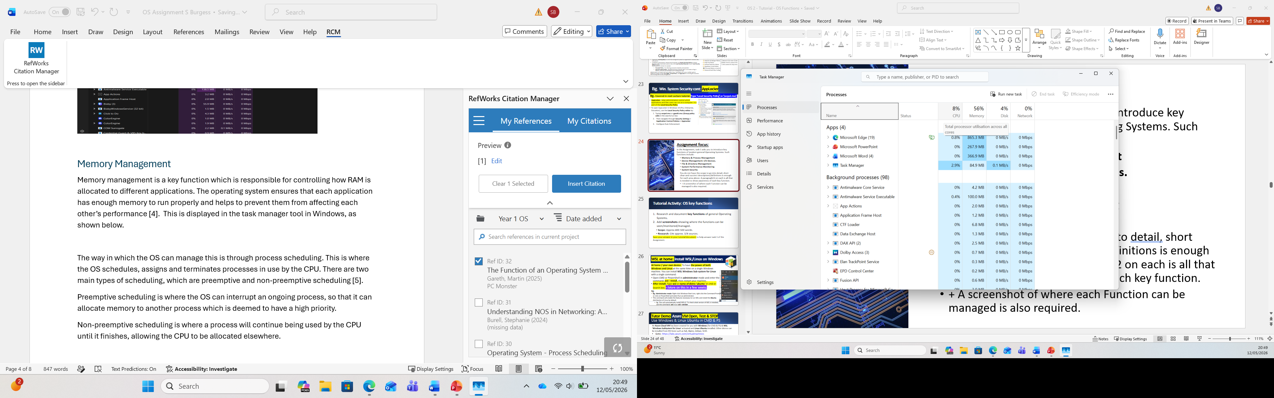
The way in which the OS can manage this is through process scheduling. This is where the OS schedules, assigns and terminates processes in use by the CPU. There are two main types of scheduling, which are preemptive and non-preemptive scheduling [5].
Preemptive scheduling is where the OS can interrupt an ongoing process, so that it can allocate memory to another process which is deemed to have a high priority.
Non-preemptive scheduling is where a process will continue being used by the CPU until it finishes, allowing the CPU to be allocated elsewhere.

File System Management
File system management is another function which allows the user to organise storage, files and folders. This includes controlling file permissions, storage locations and access methods [6]. The File Explorer tool in Windows provides this functionality, as shown below.
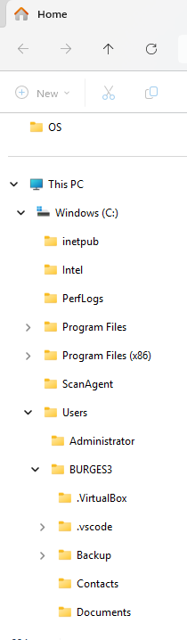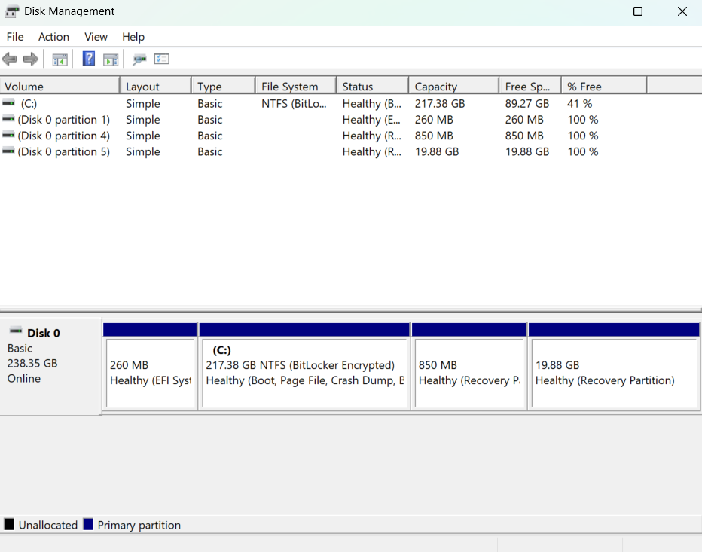

Device Management
Another function of the OS is device management. This controls communication between the operating system and hardware devices through the use of drivers. Hardware devices can be either input or output devices such as printers, keyboards and storage devices, where the OS will ensure the devices are working correctly and can communicate with applications [6].
In Windows, the device manager tool can be used to inspect and update drivers, as shown below.
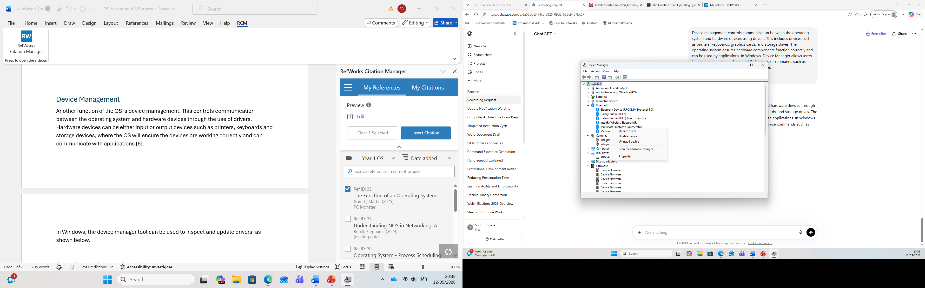

Security and Access Control
Security and access control functions help to protect the system from unauthorised access and manage what users are allowed to do. OS can set up usernames, passwords and permissions in order to control which files, folders and settings that specific users can access.
One of the key components of an OS is the kernel, which plays a key role in managing system resources and allowing hardware and software to communicate. Therefore, it is vital to have security in place to protect the kernel from unauthorised access and malicious actions [7].
Features such as User Account Control and administrator privileges can be used in Windows for security and access control as shown below.
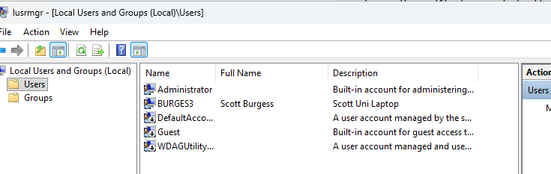

Networking
Networking is a function of the OS which allows computers to connect to the internet and local networks. The OS will manage the computer’s network settings, allowing it to communicate with other devices, such as printers or servers, and transfer data across a network [8]. Windows offers the Network and Sharing Centre tool, which allows the user to view and troubleshoot network settings as shown below.
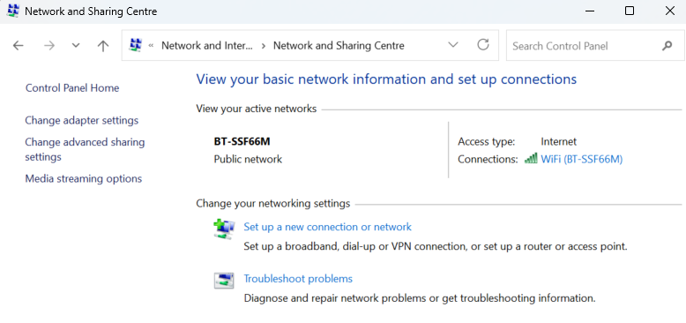

Resource Monitoring
Resource monitoring is a function allowing the user to track how the computer system is performing and how resources are being used. This includes checking CPU and memory usage, disk activity and network performance [9]. This is shown using the Resource Monitor and reliability tools in Windows pictured below.
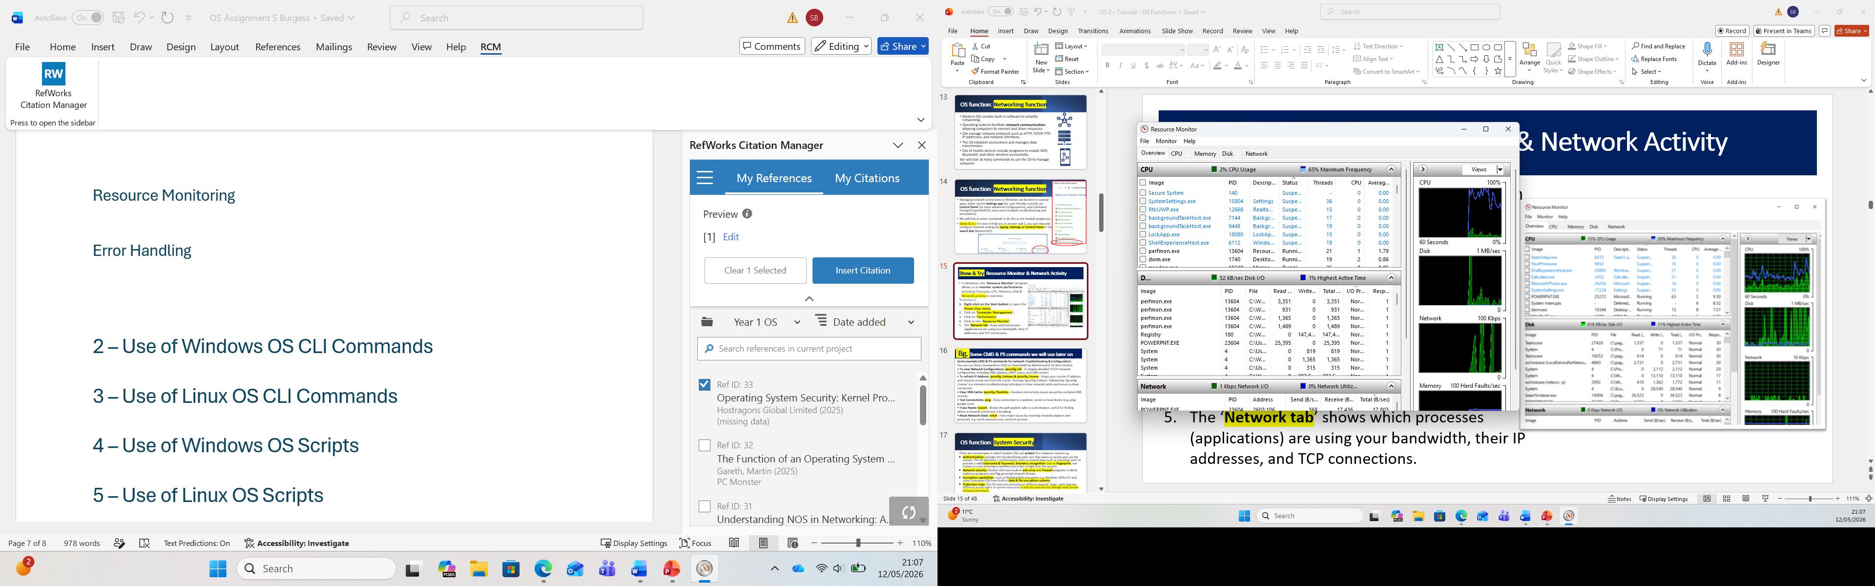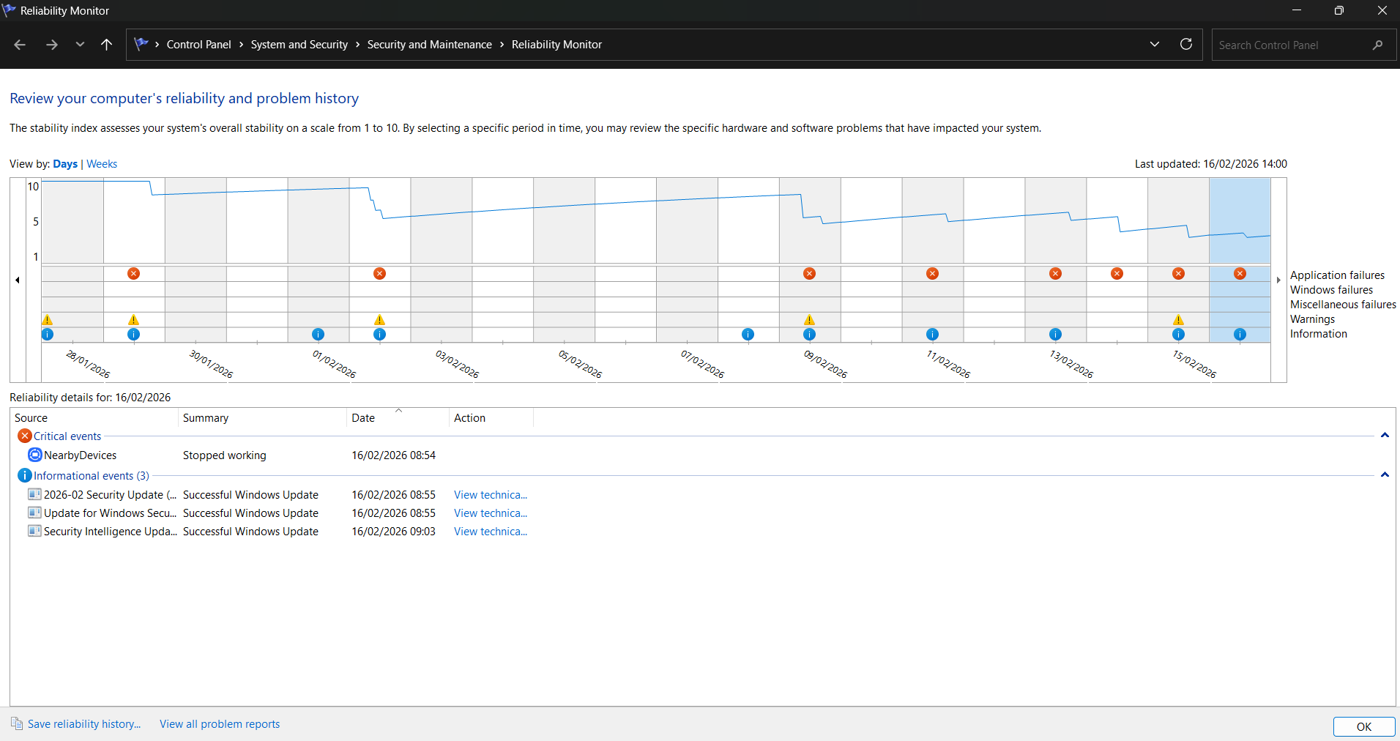

Error Handling
The OS can also provide the function of error handling, which detects, records and responds to system errors. This function helps to keep the system stable and can support troubleshooting in the event of an error, which can help maintain reliability and security [10].
The Event Viewer tool in Windows stores logs of any errors which have occurred, helping to identify hardware or software issues as shown below.
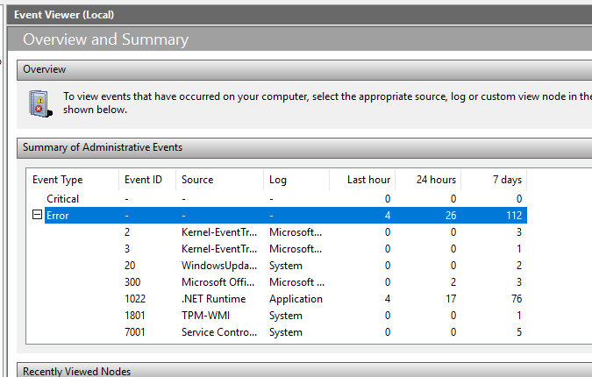

2 – Use of Windows OS CLI Commands
This section will look at a variety of Windows OS CLI Commands using PowerShell.

Process Management
- Get-Process “notepad++”
This command displays details of processes named notepad++, including CPU and memory usage [11].
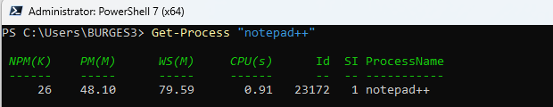
- Get-Help Stop-Process -Online
This command launches the online Microsoft guide for the Stop-Process command in a web browser [12].
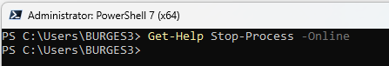
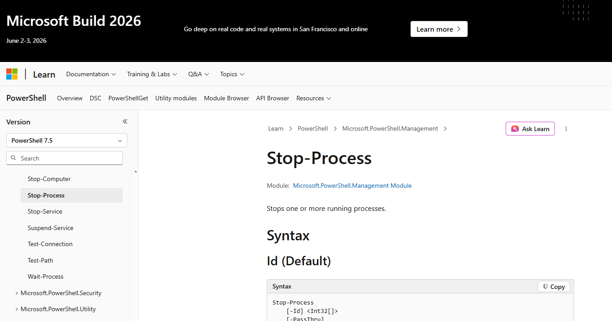
- Start-Process calculator.exe -WindowStyle Minimized
This command launches the calculator application in a minimised window [13].
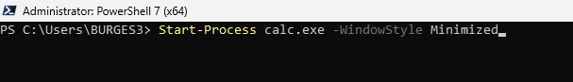
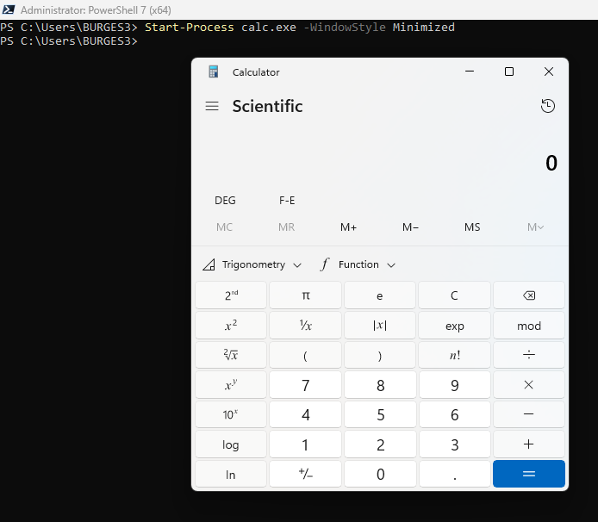

File & Directory Management
The commands in this section manage files and folders.
- Get-ChildItem $Home
This command shows all the files and folders in the home directory, displaying the user’s personal folder [14].
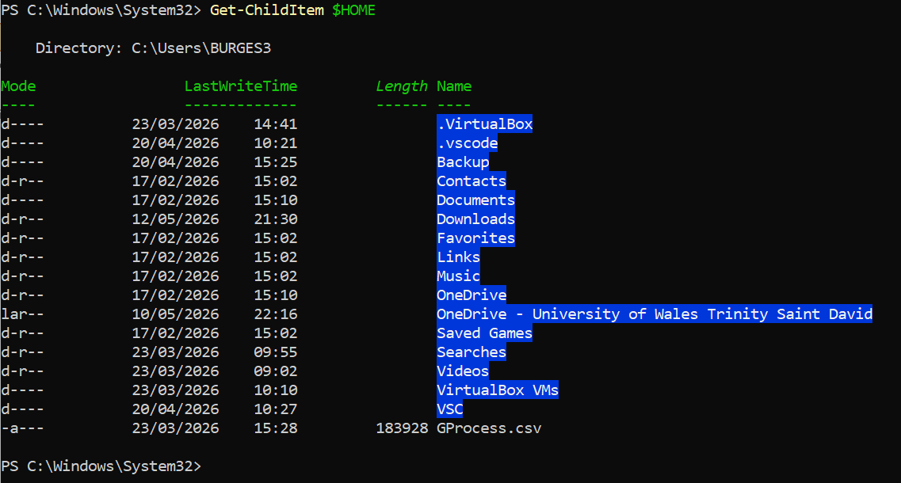
- New-Item -Path $HOME -Name "example.txt" -ItemType File
This command creates a new file called “example” which will be saved to the home folder [15].
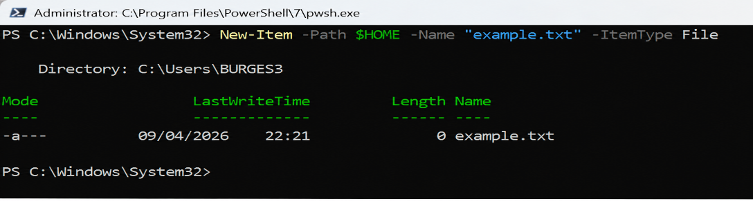
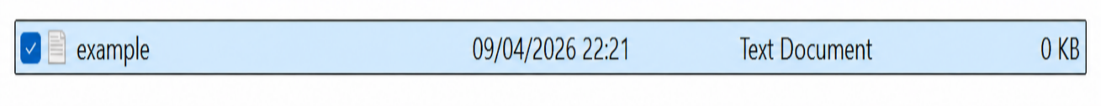
Rename-Item -Path "$HOME\example.txt" -NewName "newname.txt"
This command will rename the file “example.txt” to “newname.txt” in the home directory [16].
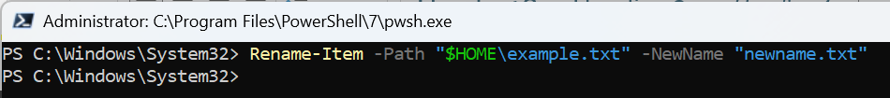

Network Testing / Monitoring
- Test-Connection google.com -Count 4
This command tests the network connection between the computer and the webpage “google.com”. The -Count 4 switch specifies that the test should send 4 ping requests before stopping. The output shows whether the connection status is successful [17].
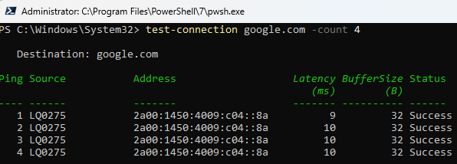
- Get-NetIPConfiguration
This command requests a display of the computer’s network information, including the IP address, default gateway, and DNS server information [17].
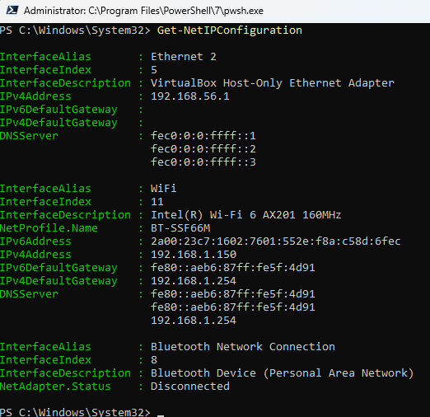

User Management
- Get-LocalUser
This command will display a list of all local user accounts on the computer, and whether they are enabled or not [18].
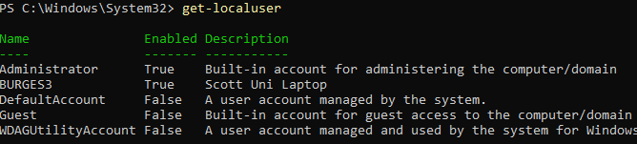

Task Scheduling
- Get-ScheduledTask
This command displays a list of all scheduled tasks which are either ready to run or are currently running [18].
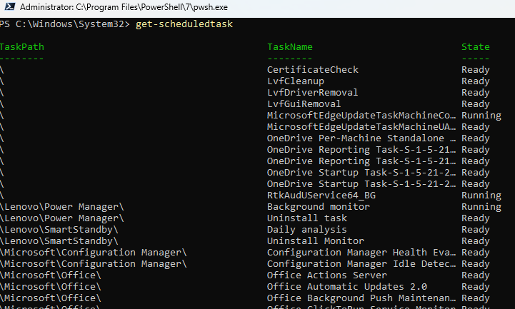

3 – Use of Linux OS CLI Commands

Process Management
- Ps aux
This command displays a list of running processes, along with their ID, CPU and memory usage [19].
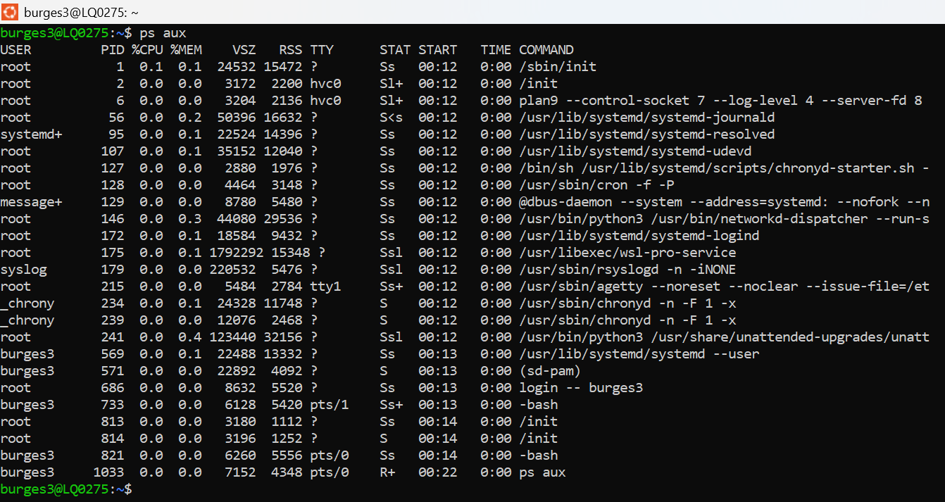

- Kill by PID
The command shown below displays a temporary background process of sleep being created. The ps command then displays the running processes, including sleep and its PID.
The kill 1216 command is then used to terminate the process successfully [20].
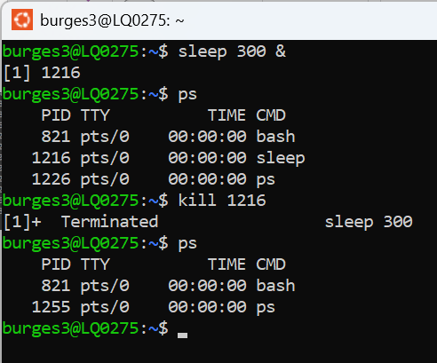

File & Directory Management
- touch
This command creates an empty file with a specified name, as shown below [21].
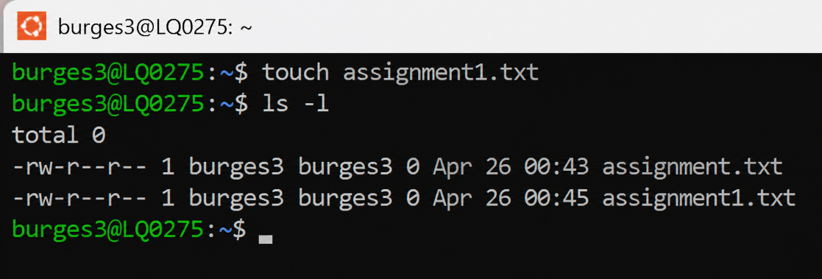

- chmod
This command allows permissions of the owner, group or others, for a specific file to be modified, allowing or removing the ability to read, write or execute [21].
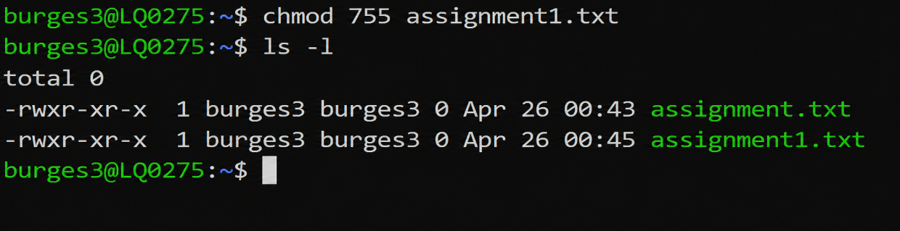

- mkdir
This command allows the user to create a new directory with the name specified [22].
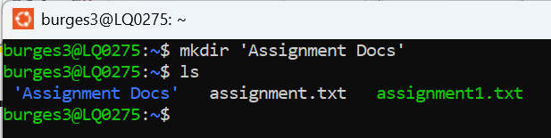

Network Testing / Monitoring
- ping
Similar to the Windows Test-Connection command, the ping command shown below tests the computer’s network and internet connectivity. The command -c 4 confirms that only four packets are sent, before the command stops [21].
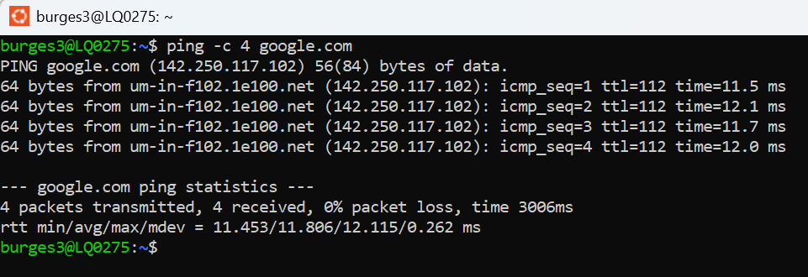

User Management
- useradd
The useradd command creates a new user account to the directory, with the name instructed after the command [23].
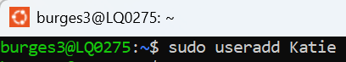

- getent passwd
This command creates a list of information relating to the users stored on the system, and includes the username, ID and directory [24].

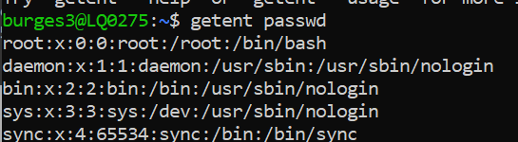
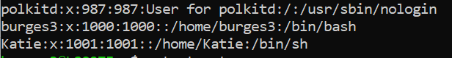
- userdel
The userdel command allows a user to be deleted from the system. The image below shows the command followed by the username, which is then removed from the directory upon execution [23].

Task Scheduling
- crontab
The crontab commands provide a user the ability to create, edit or delete scheduled tasks. The crontab -e command opens the editor, where a user can add a line in order to set a specific task. For example, 0 9 * * 1 ping -c 4 google.com >> ~/pingcheck.log can be added which means that at 9:00am every Monday, a ping test will be conducted to google.com sending four packets, where the results will be saved in a log file. The crontab -l command will then list any scheduled tasks [25]. This is displayed in the image below.
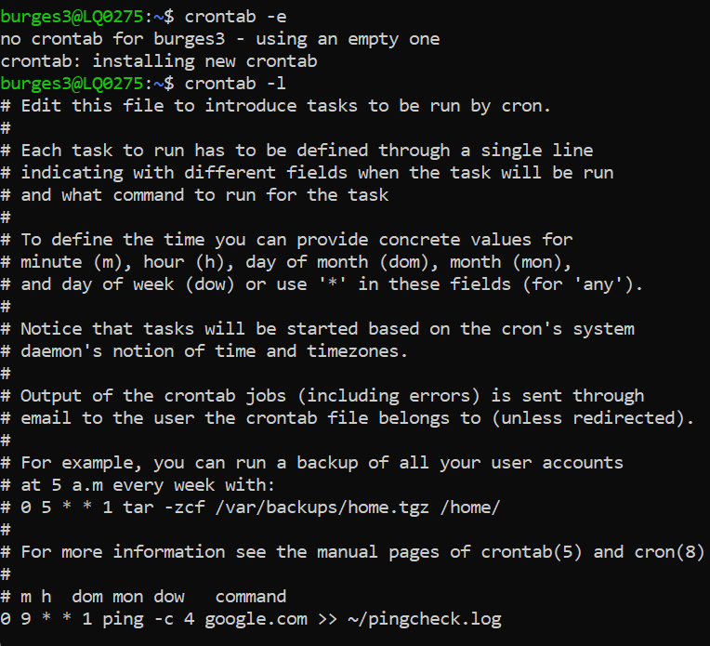

4 – Use of Windows OS Scripts
The below Windows OS Scripts is created for PowerShell using the Visual Studio Code tool.
The script starts by using the Show-Menu function, which helps to create and display a number of options to the user in the style of a menu.
A do while loop is then added to ensure that the menu will repeat and display until the user selects to exit the program. This prevents the need for the script to be restarted after each option is selected [26].
An input variable is used to store the input entered by the user.
Option 1 on the menu will display the current username.
Option 2 uses the get-childitem command to display the files and folders which are in the directory.
Option 3 conducts a test-connection command, sending four packets to Google to check that there is an internet connection.
Option 4 then allows the user to exit the script, where a closing message is displayed.
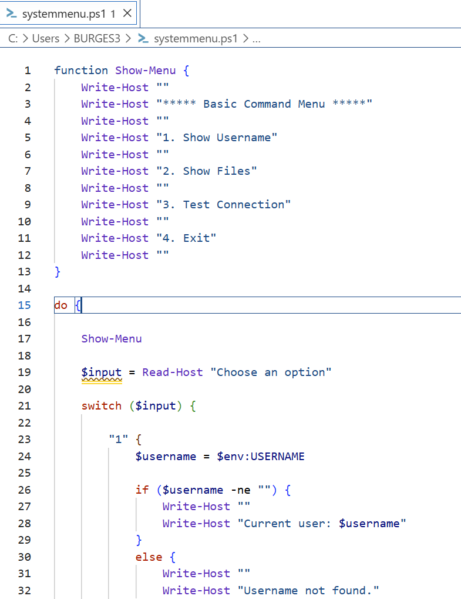
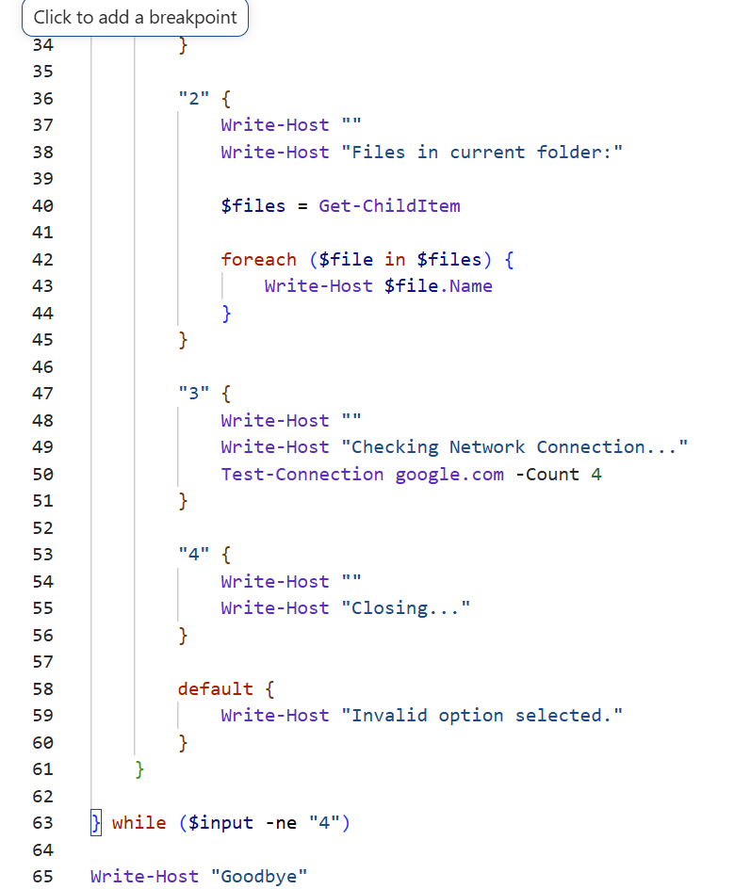
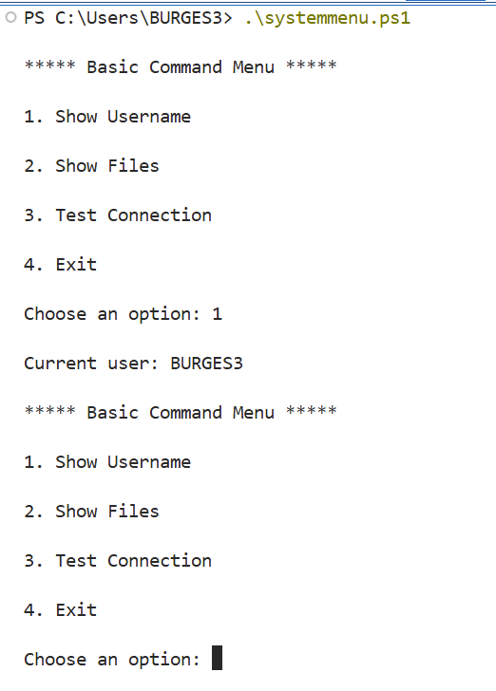
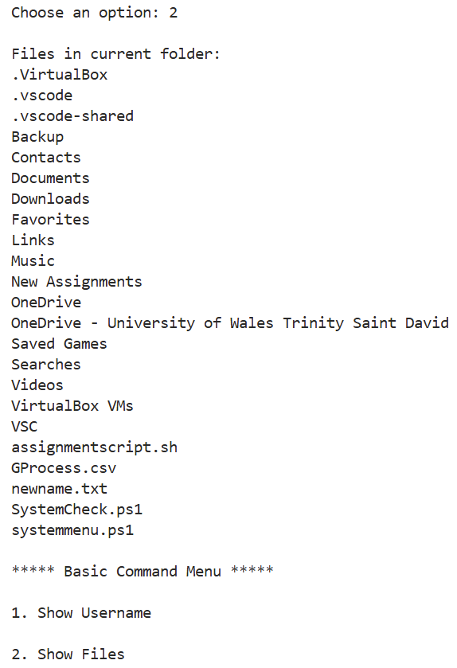
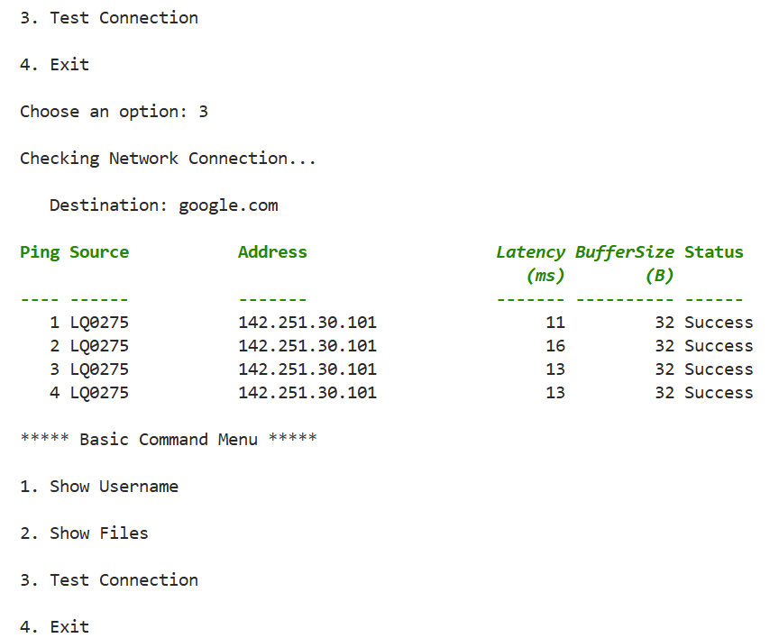
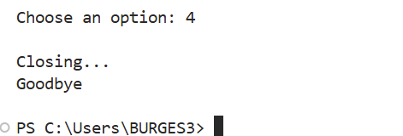

5 – Use of Linux OS Scripts
The script below demonstrates a combination of file management, directory management and permission control into a single script.
It starts by defining a variable called “folder”, which stores the directory “New Assignments”, meaning the full directory name does not need to be fully typed throughout the remainder of the script.
The touch command then creates two new text files called “Assignment 3.txt” and “Assignment 4.txt”, followed by an amendment of permissions using the chmod command. The chmod grants the owner full read, write and execute permissions, whilst the group and other users are read and execute only.
An if statement is added to the script, which means that a check will be carried out to see if the directory already exists. If it does not exist, the mkdir command creates the directory and displays the confirmation of “Directory created successfully”. If it does exist, then the message “Directory already exists” will be displayed.
The script then executes a for loop for the mv command, which moves the specified files into the directory simultaneously.
Finally, the ls -l command displays the contents of the directory, confirming the files have been moved and their permissions updated accordingly. An echo statement is then displayed to confirm the script has been carried out successfully.
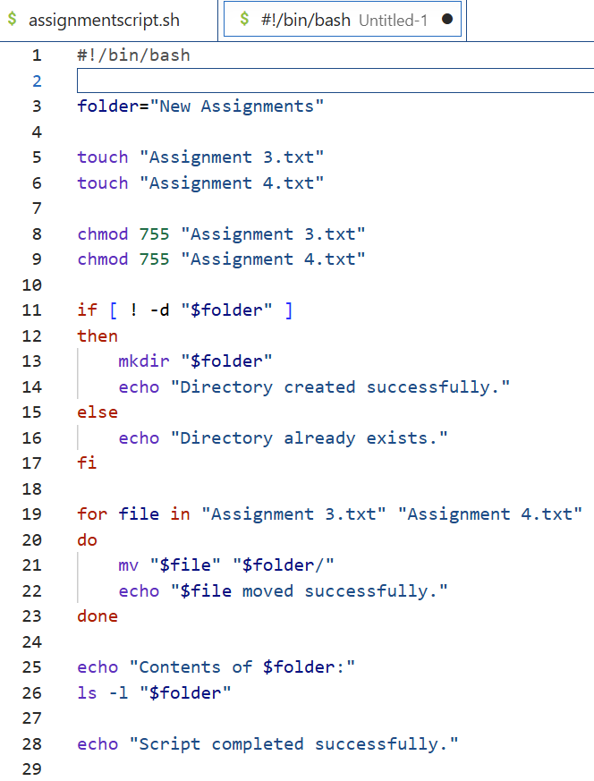
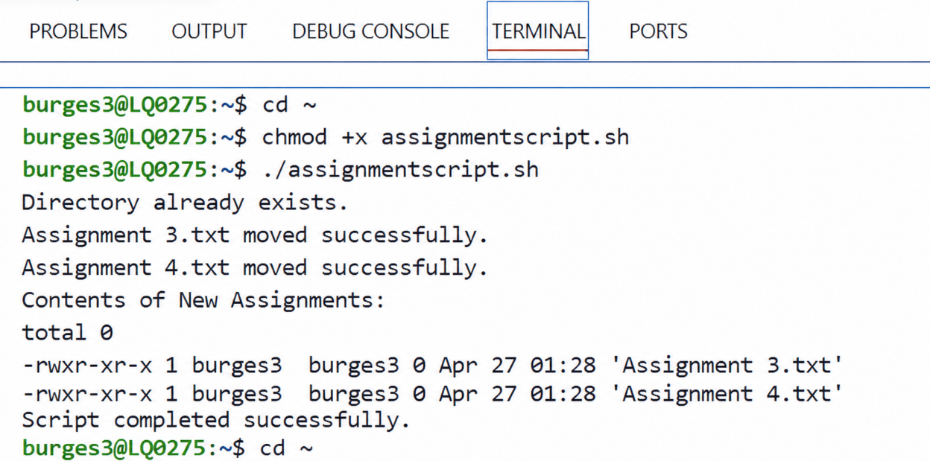

Conclusion
Overall, this assignment has highlighted and demonstrated some of the main functions of modern operating systems and explored the use of commands and scripting within both a Windows and Linux OS. Both Windows and Linux OS have important features to allow the user to manage functions such as processing, networking and security, which are all essential to modern computing systems and IT administration.
The commands throughout this report demostrate how users can manage systems efficiently, as well as providing automation to help boost performance and reduce the need for the user to complete repetitive administration tasks manually.

References
[1] R. Bazuku, A. Anab, S. Gymerah and I. Mohammed, "An Overview of Computer Operating Systems and Emerging Trends," pp.162, 2023,
[2] M. E. Shacklett and S. J. Bigelow, "What is an operating system (OS)." TechTarget. Accessed: 02 02 2026. [Online]. Available: https://www.techtarget.com/whatis/definition/operating-system-OS
[3] V. Saharawat."Process Management In Operating System: Introduction, Importance & Key Functions Explained" (Oct 102025). Accessed: Mar 12, 20262026, [Blog]. Available at: https://pwskills.com/blog/process-management-in-operating-system/
[4] R. Malleboyina. "Operating Systems — Day 8: Memory Management in OS." Medium. Accessed: Mar 12 2026. [Online]. Available: https://medium.com/@rajiimalleboyina/operating-systems-day-8-memory-management-in-os-924679d5e153
[5] "Operating System - Process Scheduling." Accessed: Mar 12 2026. [Online]. Available: https://www.tutorialspoint.com/operating_system/os_process_scheduling.htm
[6] M. Gareth."The Function of an Operating System in a Computer Managing Resources" PC Monster. (Oct 92025). Accessed: Mar 12, 20262026, [Blog]. Available at: https://pcmonster.co.uk/the-function-of-an-operating-system-in-a-computer-managing-resources/
[7] Hostragons Global Limited."Operating System Security: Kernel Protections and Security Mechanisms - Hostragons®" (Sep 52025). Accessed: Mar 12, 20262026, [Blog]. Available at: https://www.hostragons.com/en/blog/operating-system-security-kernel-protections-security-mechanisms/
[8] S. Burell. "Understanding NOS in Networking: A Beginner's Guide." Accessed: Mar 12 2026. [Online]. Available: https://wraycastle.com/blogs/knowledge-base/what-is-nos-in-networking
[9] C. Marcho. "Using Resource Monitor to Troubleshoot Windows Performance Issues Part 1 | Microsoft Community Hub." techcommunity.microsoft.com. Accessed: Mar 12 2026. [Online]. Available: https://techcommunity.microsoft.com/blog/askperf/using-resource-monitor-to-troubleshoot-windows-performance-issues-part-1/375008
[10] "Error Handling in Operating System." geeksforgeeks.org. Accessed: Mar 12 2026. [Online]. Available: https://www.geeksforgeeks.org/operating-systems/error-handling-in-operating-system/
[11] "Get-Process." learn.microsoft.com. [Online]. Available: https://learn.microsoft.com/en-us/powershell/module/microsoft.powershell.management/get-process?view=powershell-7.6&utm_source=chatgpt.com
[12] "Get-Help - PowerShell Command | PDQ." Accessed: Apr 6 2026. [Online]. Available: https://www.pdq.com/powershell/get-help/
[13] "Start-Process." learn.microsoft.com. [Online]. Available: https://learn.microsoft.com/en-us/powershell/module/microsoft.powershell.management/start-process?view=powershell-7.6
[14] "PowerShell Get-ChildItem Tutorial." serveracademy.com. Accessed: Apr 9 2026. [Online]. Available: https://www.serveracademy.com/blog/powershell-get-childitem-tutorial
[15] K. Horvatin. "PowerShell Create File Tutorial: A Step-by-Step Guide | Netwrix." Accessed: Apr 9 2026. [Online]. Available: https://netwrix.com/
[16] "Rename-Item." learn.microsoft.com. Accessed: Apr 9 2026. [Online]. Available: https://learn.microsoft.com/en-us/powershell/module/microsoft.powershell.management/rename-item?view=powershell-7.6
[17] "Hands-On Guide To PowerShell Scripts For Network Testing » ITU Online IT Training" (Apr 82026). Accessed: Apr 9, 20262026, [Blog]. Available at: https://www.ituonline.com/blogs/hands-on-guide-to-powershell-scripts-for-network-testing/
[18] J. Blackwell. "Essential PowerShell Commands: A Cheat Sheet for Beginners." Accessed: Apr 9 2026. [Online]. Available: https://netwrix.com/
[19] "How to Use the ps aux Command in Linux." Accessed: Apr 25 2026. [Online]. Available: https://www.linode.com/docs/guides/use-the-ps-aux-command-in-linux/
[20] T. Carrigan, "Linux Command Basics: 7 commands for process management," December 2 2020, Available at: https://www.redhat.com/en/blog/linux-command-basics-7-commands-process-management.
[21] "Top 100 Linux Commands Cheat Sheet [With examples]" Zentyal Linux Server. (August 282024). Accessed: Apr 25, 20262026, [Blog]. Available at: https://www.zentyal.com/news/linux-commands/
[22] T. Mildenberger."Linux Navigation and File Management" Contabo Blog. (Sept 152023). Accessed: Apr 26, 20262026, [Blog]. Available at: https://contabo.com/blog/linux-navigation-and-file-management/
[23] R. Rafacz. "How to Add Users to a Group in Linux." Accessed: Apr 26 2026. [Online]. Available: https://www.pluralsight.com/resources/blog/software-development/linux-add-user-command
[24] SrongDM Team. "How to List Users in Linux (9 Methods with Examples)." strongdm.com. Accessed: Apr 26 2026. [Online]. Available: https://www.strongdm.com/blog/how-to-list-users-linux
[25] D. Watkins. "Scheduling tasks with the Linux cron command | Opensource.com." Accessed: Apr 26 2026. [Online]. Available: https://opensource.com/article/22/3/scheduling-tasks-linux-cron
[26] "Create a User Menu in a PowerShell Script." business.com. Accessed: Apr 24 2026. [Online]. Available: https://www.business.com/articles/powershell-interactive-menu/

Appendices

Tutorial Activity
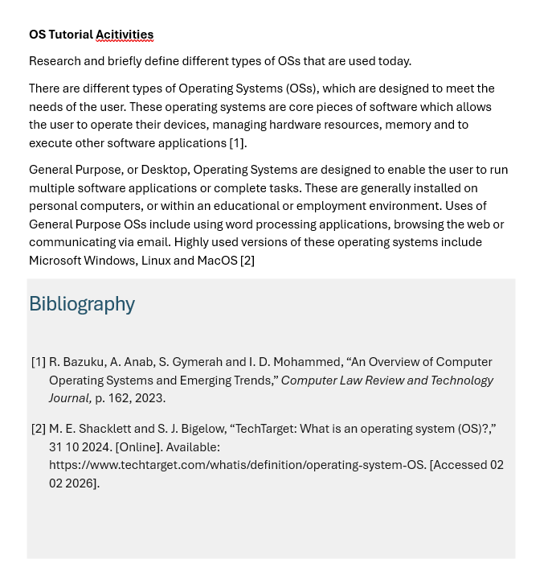

Lecture Activities
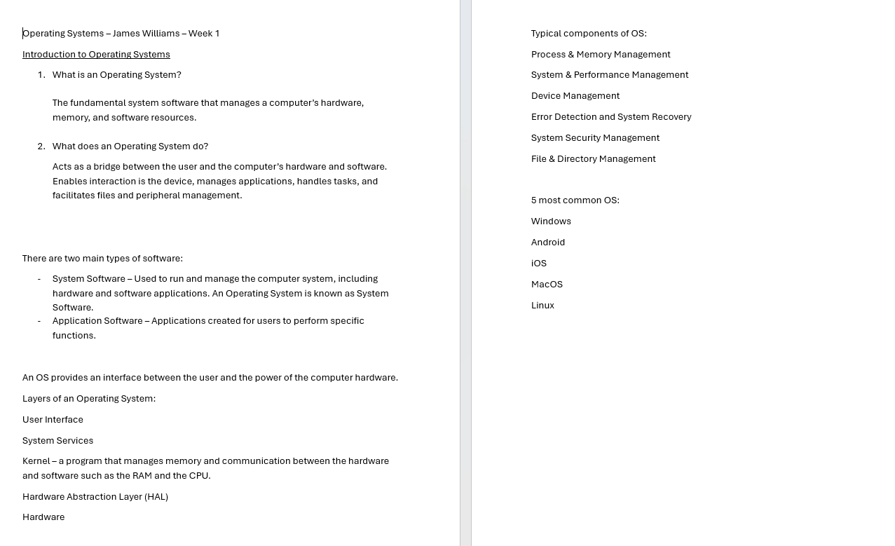
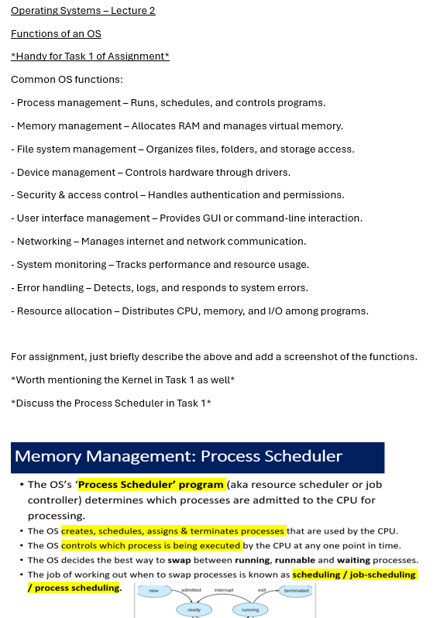

Online Certified Course




