Professional skills and Health and Safety in Construction (ACBB4003)

Why Have You Chosen Construction?

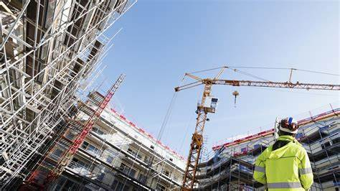

Kaleb Bartholomew
(2305793)
Date: 14/11/2023
Table of Contents
Why Have You Chosen Construction? 1
What is Construction? 2
Types of construction 3
House building and renovation: 3
Commercial and industrial construction: 3
Infrastructure construction: 3
Off-site manufacture: 4
Construction and I 5
Quantity Surveying 5
Conclusion 6
References 7

What is Construction?

To put it simply, whenever something is being built, it is known to be ‘under construction’, construction is the techniques and industry involved in the creation of structures aiding in the development of society. It encompasses the art and science of assembling materials and resources to build, shape, and transform our surroundings. Construction is a vital industry, creating buildings and spaces that connect communities, provide jobs, and improves society. From towering skyscrapers to intricate bridges and highways, construction plays a pivotal role in shaping our world.

Types of construction

House building and renovation:
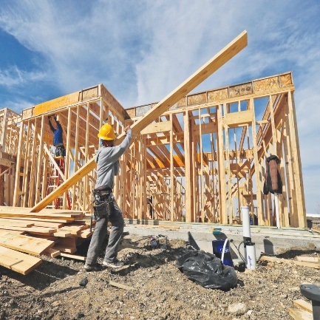
This is a type of construction where houses are built, renovated or updated. Plans are drawn up and a singular house or a group of houses are built by a chosen company in efforts to be as time efficient as possible. The houses, when completed must be safe to live in and waste and energy efficiency must be considered.
Commercial and industrial construction:
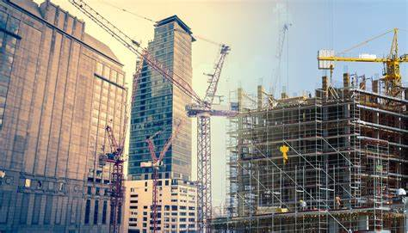
This is a type of construction where buildings used for commercial or industrial purposes are built. These buildings are constructed for a specific purpose and as such require certain materials that suit this purpose. The buildings are designed to be safe, energy efficient and able to serve their intended purpose.
Infrastructure construction:
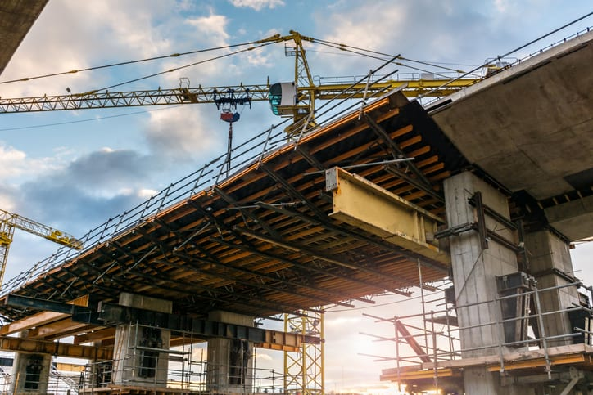
This is a type of construction where anything that helps link towns, cities and rural areas are built such as power systems, roads and bridges etc. It is seen as building services or facilities, rather than homes or commercial buildings, this construction type is essential to a country’s economy.

Off-site manufacture:
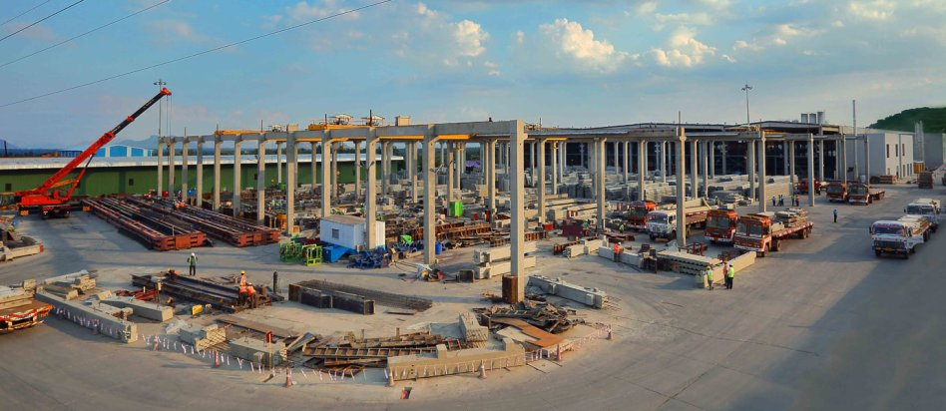
This is a type of construction where plans and materials are designed and developed to increase the efficiency of the project. Also, some materials are kept here as well as prebuilt parts that will be needed in the project.

Construction and I

My Dad is a Civil Engineer and so I have always been exposed to construction from a young age. A few years ago, I started accompanying my father on different construction sites, where I would see how concrete is being mixed, see how walls are plastered, listen to discussions and conversations on the operation and success of the various projects as well as observing the building of walls and columns etc. On these visits I would see empty plots of land transform into a work of art where a completely new and modern piece of infrastructure would replace the previous empty space. This exposure opened my eyes to the wonderful world of construction, I enjoyed seeing the completion of the different projects from the start to the finish. It brought about a sense of satisfaction and joy to see what a few pieces of materials can achieve when used in the right way. Over the next few years my love for construction continued to grow, I have even participated in building the foundation of my home where I helped mix concrete and lay blocks. This was a great experience it helped me to be exposed to another aspect of construction which is the labour needed for its completion, it gave me a sense of understanding as to the difficulties and pressure faced by labourers. As a result of this when I continued to visit the different projects with my dad, I would not only pay attention to the buildings being constructed but also to the persons constructing the buildings and it has helped to change my perspective on how I view the construction industry.
I have always loved Mathematics and I knew that I wanted to study something that deals with numbers. It was only last year where I started delving deeper into the different fields associated with construction and that is where I found Quantity Surveying. Quantity Surveying ties in my love for Math and my passion for construction in a way where I can see the full process of the construction project being carried out and still have an important role in its success and completion. I am from St. Vincent and the Grenadines, which is in the Caribbean, quantity surveyors are few and far between back home and it is a vital part of the industry that we are missing. This is another reason I have gravitated towards Quantity Surveying as it is a necessity for the development of my country, and it is also an area where I won’t have to worry about finding a job. I am looking forward to starting a career down a path where I have a passion for both aspects of it.

Quantity Surveying

A Quantity surveyor is responsible for estimating the cost of materials and labour required for a construction project, as well as ensuring that the project meets legal and quality standards, they are sometimes termed as a financial guardian because they protect the finances from the beginning to the end of the project. A key part of the role will be to liaise with a range of other teams working on the project, helping it to stay on track. Once work begins, they oversee the ongoing costs of the project and evaluate ways to improve the client’s investment, which includes producing regular reports. As they become more experienced throughout their career, they offer expert advice to the client and play an essential role in life cycle costing, cost planning, procurement and tendering, contract administration, and commercial management. Quantity surveyors can work as specialists in one area or play an active role in several areas over the course of a project.

Conclusion

There isn’t much to say other than I have a passion for construction and a love for Math which I think sets me up well for a successful future in Quantity Surveying. I am looking forward to the journey ahead.

References

Construction | History, Types, Examples, & Facts | Britannica
What is a quantity surveyor? | Salary, skills and more | RICS
What Is A Quantity Surveyor? Salary, Skills & Role | Go Construct
What is Construction? (constructionreviewonline.com)
What Is Construction? [Different Types & Importance] | Go Construct

