Module Code: LCHS7000
Module Title: Social Epidemiology and Public Health Development
Assignment Title: Component 2 Analytical Report

Lecturer’s Name: Jolly Nwankwo

Student Name: Md Jewel Ahmad
Student ID: 2504951

Table of Contents
Task 1: Social Epidemiological Analysis of Disability-Related Health Inequalities in the UK 3
1. Introduction 3
2. Background and Major Inequality Problems. 3
3. National Response to Reduce Health Inequalities. 6
4. The Group is sponsored by organisations. 6
5. Conclusion 7
Task 2: Epidemiological Analysis of Liver Cirrhosis Among Adults in the North East of England 8
1. Introduction 8
2. The Risk Factors and Epidemiology. 9
3. Identification of Affected/At-Risk Groups and Needs Assessment. 10
4. Surveillance and Measures of Public Health. 11
5. Design and Evaluation of Interventions. 12
6. Advantages and weaknesses of the Epidemiological Approach. 13
7. Conclusion 14
References 15

Task 1: Social Epidemiological Analysis of Disability-Related Health Inequalities in the UK
Title: Disability and Health Inequalities in the UK: A Social Epidemiological Perspective

1. Introduction
In this report, the term health inequalities are discussed in relation to working-age adults with disabilities in the United Kingdom, which are defined as people with long-term physical, sensory, cognitive, or functional impairments. Structural disadvantage, discrimination, socioeconomic exclusion, and impediments to access to healthcare increase the risks and health outcomes of this population are markedly worse. It examines major disease burdens, social determinants, national policy response, and the contribution of charities and ends with suggestions on how to tackle the existing inequality in health-related disability.

2. Background and Major Inequality Problems.
Physical and mental health outcomes of disabled working-age adults are significantly worse than those of the overall population because of interplay of social, economic, and environmental factors instead of impairment. These inequalities exhibit patterned impoverishment which can be avoided and unfair.
Increased rates of mental ill health.
Anxiety and depression are very high in disabled adults. Recent estimates in the UK have indicated that a larger proportion of disabled adults (42 per cent) report moderate to severe depressive symptoms as opposed to 11 per cent of the non-disabled adults (UK Health Security Agency, 2023). Such difference is a cumulative distinction in exposure to discrimination, exclusion, and chronic stressors, as emphasised by Aitken et al. (2022). These outcomes are mediated by barriers to participation such as workplaces that cannot be accessed and social stigma. Part of the solution to these disparities can be strengthening community mental health services and implementing changes in the workplace.

Increased Cases of Chronic Disease
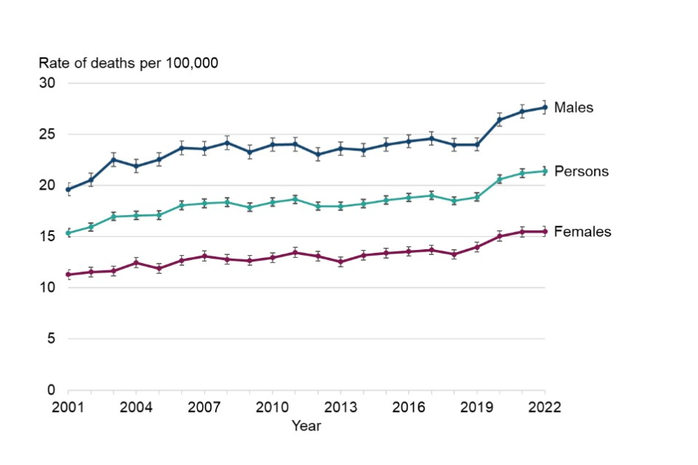

Figure 1 Liver Disease Mortality Trends (WHO, 2023)
There is a high probability of long-term conditions like diabetes, cardiovascular disease and chronic pains in disabled adults. Comparative data on smoking between disabled groups and non-disabled populations show that this disease burden is upstream, as disabled adults were up to 15 per cent more likely to smoke than non-disabled adults in a 21-country European study (Disney et al., 2020). Specific screening and preventive programmes would prove helpful.
Increased Mortality and Hospitalisation
The death rate among the disabled is still very high. Research findings in high-income countries indicate that disabled adults of working age face high risks of preventable hospitalisation and preterm mortality (Kavanagh et al., 2021). This is a manifestation of late identified diagnosis, fractured care streams, and the navigation barrier. It is important to address the issue of service accessibility and, especially, reasonable adjustments, and coordinated care models as the means to decrease the number of preventable deaths.

Poverty, Unemployment and Low Income
Disability is also a cause and a result of poverty. The disabled adults in the UK have nearly doubled chances of residing in low-income households with an employment gap of over 28 percent (Office for Health Improvement and Disparities, 2023). There is evidence of close relationships between poor socioeconomic status and poor health outcomes (Politzer et al., 2019). To deal with these inequalities, policies that encourage inclusive working and income compensations should be in place.
Housing and Overcrowding
Adult disabled persons have higher chances of residing in unsuitable housing, crowdy or housing of low quality. This elevates the risk of the environment including damp and cold climate and limited movement which worsens chronic illnesses. Kennedy and Wood (2020) emphasise that inaccessible environments are considered as a structural determinant of health among disabled individuals. Some of the solutions involve increasing the availability of housing stock and grants on home adaptation.
Social Isolation, Discrimination and Nonparticipation.
Social isolation is also very high among the adults with disabilities, which is an indication of stigma, inaccessible transport and social exclusion (World Health Organization, 2023). In Rwanda, Kiregu et al. (2016) have shown the effect of social exclusion in health disparity, which remains the same trend in any world setting. The barriers of participation have been known to reinforce poor mental health, decrease physical activity and worse well-being. These historical inequalities can be minimised through community inclusion programmes and anti-discrimination measures.

3. National Response to Reduce Health Inequalities.
United Kingdom has come up with a number of national frameworks that work towards minimising the unequal outcome of disabled people. The Equality Act 2010 has been considered as the main law enabling the protection of disabled individuals against discrimination in employment, education, and access to various services. It requires fair modifications to eliminate barriers to participation and thus as a measure to counter the structural disparities that are found in epidemiological studies (Burkhauser et al., 2016). Even though the Act has enhanced anti-discrimination protection, implementation is inconsistent in various sectors, so it is not as powerful.
Moreover, the NHS Long Term Plan also has the promise to make mental health services more available, increase care in the community, and decrease unnecessary hospitalisation of vulnerable populations (World Health Organization, 2023). These steps are aimed at reducing diagnostic and treatment disparities that overwhelm disabled adults. Service demands and workforce shortage have however reduced the implementation pace which diminishes the intensity of effect.

4. The Group is sponsored by organisations.
Scope is a national disability charity that offers advocacy, information service and policy research based on the challenges of disabled adults. Its fundamental goal is to attain social equality by campaigning against discrimination, lack of accessible services and lack of employment. Scope provides direct access to work, cost management, and health and social care through the provision of helplines, work support programmes, and financial advice to disabled people.
Another organisation, Mind, which is a large mental health charity, is also instrumental in helping disabled adults that experience psychological conditions. Mind has nationwide helplines, local peer-support networks and stigma and mental health literacy specific programmes. Its policy practise has an impact on the creation of available mental health services and better care trajectories of individuals with complex needs. In adults with high mental health burdens who have a disability, the advocacy and services of Mind minimise impediments of early intervention and encourage self-management.

5. Conclusion
Disabilities among working-age adults lead to much greater burdens of mental ill health, chronic disease, premature mortality, poverty, and social exclusion, and this is mostly due more to structural disadvantage than to impairment. The policies at national level like the Equality Act and the NHS Long Term Plan are also designed to decrease these inequalities yet there are gaps in implementation. Such charities as Scope and Mind offer important advocacy and support. The elimination of health disparities associated with disability needs to be more policy-enforced, focused on prevention services as well as comprehensive and co-produced approaches to public health.

Task 2: Epidemiological Analysis of Liver Cirrhosis Among Adults in the North East of England
Title: Liver Cirrhosis in the North East of England: An Epidemiological Analysis

1. Introduction
Liver cirrhosis is a chronic hepatic disease, a complicated form of which is marked by irreversible fibrosis, architectural and fibrillar distortions, and a gradual deterioration of the hepatic activity. It has serious social and health implications such as disability, lower quality of life, stigma, lost productivity, and high rates of mortality (Liu and Chen, 2022). Cirrhosis is the leading cause of premature mortality in non-communicable and non-infectious causes, and it has been reported that it claims more than two million lives every year globally (Marcellin and Kutala, 2018). The burden of liver disease in Europe has been on the rise, with a large share of regional differences being marked by alcohol and metabolic reasons (Pimpin et al., 2018). The mortality of liver disease in the United Kingdom has increased fourfold compared to the 1970s with North East registering the highest rates of cirrhosis incidence and hospitalisation in the country.

2. The Risk Factors and Epidemiology
Liver cirrhosis is overrepresented in the socioeconomically disadvantaged population, and there are a high age, sex, and regional difference in the incidence of liver cirrhosis. Cirrhosis has become a growing problem in the world because of the growing alcohol intake, viral hepatitis, and non-alcoholic fatty liver disease (NAFLD), and it causes the death of more than two million people each year (Liu and Chen, 2022). The trend in high-income nations is more prone to metabolic risk factors thus infectious etiologies. The burden of liver diseases has increased significantly in Europe, and alcohol-related liver disease has contributed to some of the largest avoidable mortality rates (Pimpin et al., 2018). The change in epidemiology is reflected in the United Kingdom, in which cirrhosis mortality increased threefold in the United Kingdom since the 1970s, and the North East continued to be a steady outlier with its rates being well above the national ones (Newton et al., 2015).
The distribution of risk is disproportional, as men are more exposed and died because of different alcohol consumption and work-related exposures (Rowe, 2017). Centrality is given to deprivation; the incidence of cirrhosis in the most deprived English localities is several times greater than in the most affluent ones; this trend is very acute in the North East, with socioeconomic disadvantage being deeply rooted there (Corris et al., 2020). The trend in NAFLD has resulted in a leading cause of chronic liver disease due to increased prevalence of obesity and diabetes. NAFLD is a disease that occurs in more than 25 per cent of adults globally, and the progression to cirrhosis in individuals with metabolic syndrome is more significant (Younossi et al., 2016).
The risk factors of cirrhosis bring a close relationship with greater societal determinants. A low level of income, unstable jobs, and lack of housing make one prone to unhealthy drinking and metabolic diseases. Low access to preventive services, late diagnosis, and health literacy aggravate the disease in poor populations (Hernandez et al., 2021). Environmental exposures and neighbourhood deprivation overlap with behavioural risk factors, which supports inequalities in health noted in the North East.

3. Identification of Affected/At-Risk Groups and Needs Assessment
Epidemiological researches give fundamental information on the most affected populations of cirrhosis. Descriptive research has indicated uniform rises in the mortality due to cirrhosis throughout Europe and North America, with geographical disparities being steep with the drinking habits, and socioeconomic status (Marcellin and Kutala, 2018).
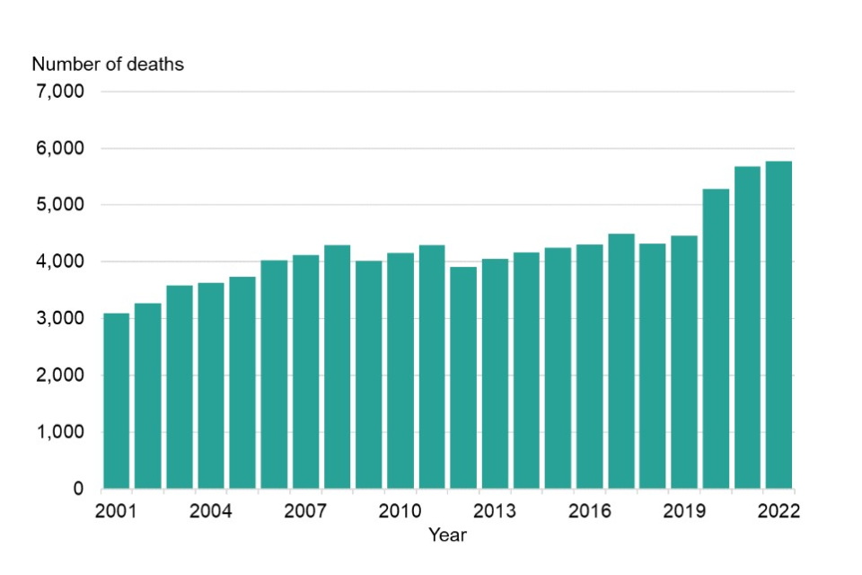

Figure 2 Liver Disease Mortality Trends (NHS Digital, 2022)

The disproportionately high risk of cirrhosis in the middle-aged adult population and in lower socioeconomic status individuals with a greater burden of chronic liver disease has been shown by population-based analyses in the United States (Scaglione et al., 2015), which has also been observed in England (where deprived areas, such as the North East, are characterised by the higher burden of chronic liver disease) (Newton et al., 2015). The close links between the development of harmful alcohol consumption, obesity, diabetes, and chronic liver disease are confirmed through analytical designs (cohort and case-control designs) that identify modifiable and non-modifiable determinants (Younossi et al., 2020).
A health needs assessment denotes that adults aged 3564 in the North East are a high-risk group with high levels of alcohol and metabolic disorder and long-term deprivation of the area (Corris et al., 2020). The area has increased admissions in the hospital due to alcohol-related illnesses compared to other English regions, indicating a large untapped demand. The obstacles to the early diagnosis of liver disease are low health literacy, poor awareness of liver disease symptoms, and poor screening habits in primary care. The prevalence of viral hepatitis is lower and disproportionately represented by migrants and other people with a risk of previous exposure, who tend to have limited access to timely testing (Bath et al., 2019). The needs assessment also indicates the lack of access to organised lifestyle interventions, specialist hepatology capacity, and late presentation with advanced disease, which enhances possibilities of mortality and strain of the healthcare system.

4. Surveillance and Measures of Public Health
The epidemiology forms the basis of monitoring cirrhosis by providing systematic monitoring of the incidence and prevalence as well as the mortality and the disability-adjusted life years (DALYs). The available estimates of the Global Burden of Disease indicate an escalating morbidity of liver diseases in England, especially in the areas that have experienced long term deprivation (Newton et al., 2015). Hospital episode statistics, mortality registries, viral hepatitis reporting, and laboratory notifications are some of the common surveillance methods used to conduct routine surveillance in the UK. Examples of sentinel surveillance systems like HOSTED that was developed to track the spread of infectious diseases indicate the potential usefulness of passive surveillance models to track household and community-level risk factors that are associated with the progression of liver disease (Hall et al., 2021). Such systems have mainly found their applications in the infectious disease but demonstrate that there is a possibility of more effective monitoring of chronic diseases.
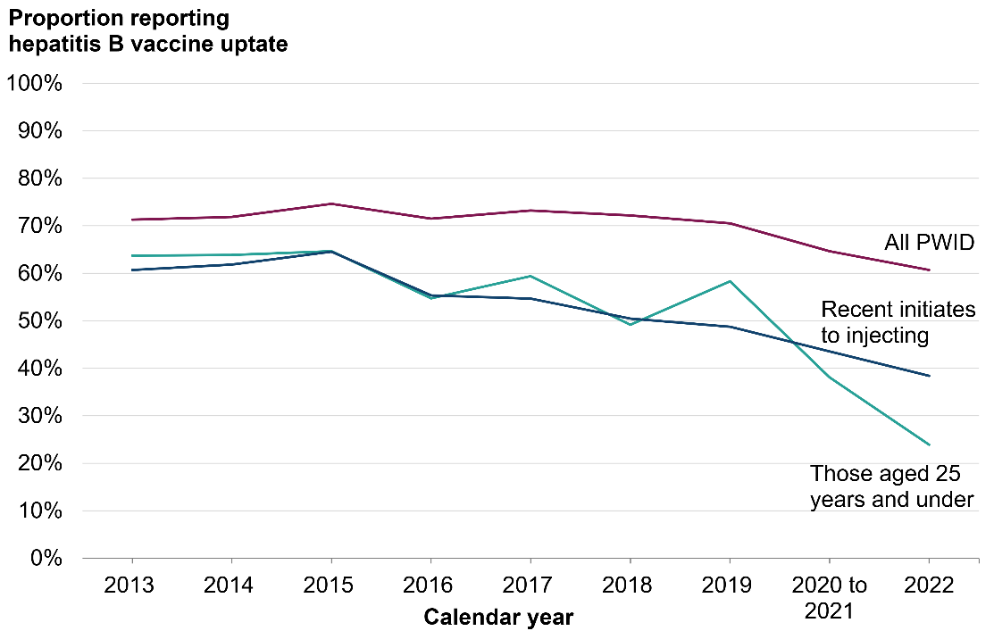

Figure 3 Hepatitis B Vaccination & Hepatitis C Testing Rates (UK) (NHS Digital, 2022)

The North East strategies on addressing cirrhosis in its public health cover the three realms of protection, prevention, and promotion (Hughes and Gorton, 2015). Some of the protection mechanisms are alcohol licencing regulation, minimum unit pricing debate and environmental strategies which aim at lessening harmful drinking environments (NHS Digital, 2022). Despite the fact that minimum unit pricing is not applied in England, in Scotland, it has also been shown that alcohol-related harm can be reduced (Rowe, 2017). Prevention includes primary prevention like immunisation against hepatitis B, hepatitis C selective testing, screening of metabolic risks, and weight loss programmes. Secondary prevention involves special liver functional examination in the primary care and non-invasive fibrosis in high-risk groups.
Epidemiological evidence has indicated that the interventions should be tailored to North East social environment where alcohol misuse, obesity and socioeconomic deprivation are high and aggravate disease burden, complicate disease control measures.

5. Design and Evaluation of Interventions
An integrated behavioural, clinical and structural based intervention in North East should yield a comprehensive approach to cirrhosis. The target population in the proposed programme- Liver Health North East (LHNE) is the minimisation of the occurrence of cirrhosis and the diagnosis of the condition at an earlier stage by the use of specific outreach, increased screening and management. The target group is the adults aged 35-64 residing in the areas with a high level of deprivation, which can be explained by the epidemiological evidence of a high risk (Corris et al., 2020). The major elements are systematic risk screening in primary care with non-invasive fibrosis tools; cultural adaptation lifestyle support, which is aimed at reducing alcohol, controlling weight and diabetes; and community-based outreach with the help of voluntary organisations. Clinical pathways would provide connexions between the people who are screened to the services of hepatology with the advanced disease being referred in a fast-track manner.
Process measures would be evaluated like programme uptake, screening coverage and fidelity of the lifestyle intervention delivery. The outcome measures would consist of a decrease in hazardous drinking, increased levels of improved metabolic markers, earlier diagnosis, and increased quality of life. The impact measures would monitor a decrease in hospital admissions, emergency presentations as well as in untimely deaths.

6. Advantages and weaknesses of the Epidemiological Approach
The epidemiological method on cirrhosis has a number of strengths. Big data of population size allow conducting effective analysis of incidence, prevalence, and mortality rates among the regions and demographic categories (Rowe, 2017). Longitudinal data can be used to investigate the course of the disease, exposure to risks, and outcomes to facilitate specific measures. Epidemiology does allow the comparison of nations and regions, identifying the determinants in the structure and informing policy (Pimpin et al., 2018).
Nonetheless, there should be restrictions. The lack of diagnosis and late presentation cause the prevalence to be underestimated significantly, particularly in most deprived communities. Cohort and case-control studies might experience the selection bias, and missing data and inconsistent coding of routine data sets impact accuracy (Younossi et al., 2020). The unavailability of granular data at the neighbourhood level limits the insight into the micro-environmental determinants.

7. Conclusion
Liver cirrhosis is a key social health issue where there are increasing rates with growing inequalities especially in the North East of England. Epidemiology is at the core to determine high risk groups, disease burden, and direct interventions. It is of paramount importance to strengthen regional prevention by means of the systematic screening, community outreach, and changing of risk-factors. Strategies that need to be put in place in the future should focus on putting in place more surveillance, raising awareness about cirrhosis, and integrating care pathways to minimise preventable morbidity and mortality.

References
Adeloye, D., Auta, A., Fawibe, A., Gadanya, M., Ezeigwe, N., Mpazanje, R. G., ... and Adewole, I. F. (2019). Current prevalence pattern of tobacco smoking in Nigeria: a systematic review and meta-analysis. BMC Public Health, 19(1), 1719.
Aitken, Z., Bishop, G. M., Disney, G., Emerson, E., and Kavanagh, A. M. (2022). Disability-related inequalities in health and well-being are mediated by barriers to participation faced by people with disability. A causal mediation analysis. Social Science and Medicine, 315, 115500.
Bath, R. E., Emmett, L., Verlander, N. Q., and Reacher, M. (2019). Risk factors for late HIV diagnosis in the East of England: evidence from national surveillance data and policy implications. International journal of STD and AIDS, 30(1), 37-44.
Burkhauser, R. V., Daly, M. C., and Ziebarth, N. R. (2016). Protecting working-age people with disabilities: experiences of four industrialized nations. Journal for Labour Market Research, 49(4), 367-386.
Corris, V., Dormer, E., Brown, A., Whitty, P., Collingwood, P., Bambra, C., and Newton, J. L. (2020). Health inequalities are worsening in the North East of England. British Medical Bulletin, 134(1), 63-72.
Disney, G., Gurrin, L., Aitken, Z., Emerson, E., Milner, A., Kavanagh, A., and Petrie, D. (2020). Hierarchical models for international comparisons: smoking, disability, and social inequality in 21 European countries. Epidemiology, 31(2), 282-289.
Friis, R. H., and Sellers, T. (2020). Epidemiology for public health practice. Jones and Bartlett Learning.
Hall, J. A., Harris, R. J., Zaidi, A., Woodhall, S. C., Dabrera, G., and Dunbar, J. K. (2021). HOSTED—England’s Household Transmission Evaluation Dataset: preliminary findings from a novel passive surveillance system of COVID-19. International journal of epidemiology, 50(3), 743-752.
Hernández, B., Voll, S., Lewis, N. A., McCrory, C., White, A., Stirland, L., ... and Hofer, S. M. (2021). Comparisons of disease cluster patterns, prevalence and health factors in the USA, Canada, England and Ireland. BMC Public Health, 21(1), 1674.
Hughes, G. J., and Gorton, R. (2015). Inequalities in the incidence of infectious disease in the North East of England: a population-based study. Epidemiology and Infection, 143(1), 189-201.
Islami, F., Siegel, R. L., and Jemal, A. (2020). The changing landscape of cancer in the USA—opportunities for advancing prevention and treatment. Nature Reviews Clinical Oncology, 17(10), 631-649.
Kavanagh, A., Fortune, N., Disney, G., Aitken, Z., and Badji, S. (2021). 1074The role of epidemiology in improving the health of people with disability. International Journal of Epidemiology, 50.
Kennedy, J., and Wood, E. G. (2020). Disability-based disparities in social determinants of health among working-age adults: Evidence from the 2018 National Health Interview Surveys. Collaborative on Health Reform and Independent Living.
Keum, N., and Giovannucci, E. (2019). Global burden of colorectal cancer: emerging trends, risk factors and prevention strategies. Nature reviews Gastroenterology and hepatology, 16(12), 713-732.
Khan, M. S., Shahid, I., Bennis, A., Rakisheva, A., Metra, M., and Butler, J. (2024). Global epidemiology of heart failure. Nature Reviews Cardiology, 21(10), 717-734.
Kiregu, J., Murindahabi, N. K., Tumusiime, D., Thomson, D. R., Hedt-Gauthier, B. L., and Ahayo, A. (2016). Socioeconomics and major disabilities: Characteristics of working-age adults in Rwanda. PLoS One, 11(4), e0153741.
Liu, Y. B., and Chen, M. K. (2022). Epidemiology of liver cirrhosis and associated complications: Current knowledge and future directions. World journal of gastroenterology, 28(41), 5910.
Marcellin, P., and Kutala, B. K. (2018). Liver diseases: A major, neglected global public health problem requiring urgent actions and large‐scale screening. Liver International, 38, 2-6.
Newton, J. N., Briggs, A. D., Murray, C. J., Dicker, D., Foreman, K. J., Wang, H., ... and Davis, A. C. (2015). Changes in health in England, with analysis by English regions and areas of deprivation, 1990–2013: a systematic analysis for the Global Burden of Disease Study 2013. The Lancet, 386(10010), 2257-2274.
NHS Digital (2022) Statistics on alcohol, England 2022. Leeds: NHS Digital.
Office for Health Improvement and Disparities (2023) Liver disease: profiles and indicators. London: OHID.
Pimpin, L., Cortez-Pinto, H., Negro, F., Corbould, E., Lazarus, J. V., Webber, L., ... and Easl hepahealth Steering Committee. (2018). Burden of liver disease in Europe: epidemiology and analysis of risk factors to identify prevention policies. Journal of hepatology, 69(3), 718-735.
Politzer, E., Shmueli, A., and Avni, S. (2019). The economic burden of health disparities related to socioeconomic status in Israel. Israel journal of health policy research, 8(1), 46.
Reichard, A., Stransky, M., Brucker, D., and Houtenville, A. (2019). The relationship between employment and health and health care among working-age adults with and without disabilities in the United States. Disability and rehabilitation, 41(19), 2299-2307.
Roth, G. A., Huffman, M. D., Moran, A. E., Feigin, V., Mensah, G. A., Naghavi, M., and Murray, C. J. (2015). Global and regional patterns in cardiovascular mortality from 1990 to 2013. Circulation, 132(17), 1667-1678.
Rowe, I. A. (2017). Lessons from epidemiology: the burden of liver disease. Digestive diseases, 35(4), 304-309.
Scaglione, S., Kliethermes, S., Cao, G., Shoham, D., Durazo, R., Luke, A., and Volk, M. L. (2015). The epidemiology of cirrhosis in the United States: a population-based study. Journal of clinical gastroenterology, 49(8), 690-696.
UK Health Security Agency (2023) Hepatitis C in England: 2023 report—Working to eliminate hepatitis C as a public health problem. London: UKHSA.
Wangdi, K., Wetzler, E., Marchesini, P., Villegas, L., and Canavati, S. (2022). Cross-border malaria drivers and risk factors on the Brazil–Venezuela border between 2016 and 2018. Scientific reports, 12(1), 6058.
World Health Organization (2023) Global status report on alcohol and health 2023. Geneva: WHO.
Younossi, Z. M., Koenig, A. B., Abdelatif, D., Fazel, Y., Henry, L., and Wymer, M. (2016). Global epidemiology of nonalcoholic fatty liver disease—meta‐analytic assessment of prevalence, incidence, and outcomes. Hepatology, 64(1), 73-84.
Younossi, Z. M., Stepanova, M., Younossi, Y., Golabi, P., Mishra, A., Rafiq, N., and Henry, L. (2020). Epidemiology of chronic liver diseases in the USA in the past three decades. Gut, 69(3), 564-568.

