  BUSINESS WALES COVID -19 SUPPORT FOR BUSINESSES.  KNOWLEDGE MANAGEMENT | Nelly Myles (1710690)  PROJECT PLANNING AND MANAGEMENT IN WORKPLACE

BUSINESS WALES COVID -19 SUPPORT FOR BUSINESSES.  KNOWLEDGE MANAGEMENT | Nelly Myles (1710690)  PROJECT PLANNING AND MANAGEMENT IN WORKPLACE

Table of Contents
INTRODUCTION 1
INTITIATION PHASE 2
PLANNING STAGE 6
PROJECT EXECUTION 12
MONITORING AND EVALUATION 13
PROJECT CLOSURE 14
RECOMMENDATIONS 18
REFERENCES 19

INTRODUCTION
Business Wales is a free service that provides impartial, independent support and advice to people starting, running and growing a business in Wales. With regional centres across Wales, they offer a mixture of online and face-to-face support, as well as training workshops and individual advice. Their Aim is to help Businesses to grow and maximise their potential. During the recent months businesses in wales have been hit by the effects of the Covid-19 Pandemic and the Organisation has started a project to help business during this difficult period. According to the project management Institute defines a project as a “temporary endeavour” undertaken to create a unique product or service “The support that is available is temporary financial assistance and for a period of six months unlike the usual operations which is mainly advisory. The Covid-19 is a unique pandemic never experienced before making this a project.

This the paper will be looking at the project Management. “Project management is a critical practice that applies knowledge or process, skills, tools deliverables, and techniques to project activities to ensure a solid path to project success by meeting goals and requirements” (Harned, 2020). The paper will look into the project cycle which contains five steps the Initiation, Planning, Execution, monitoring and evaluation and Closure stage.

INTITIATION PHASE

Project initiation is the first project stage which usually entails generation of the concept behind a new project (project conceptualization). The primary purpose of the project initiation stage is to establish the scope of project, the aims and objectives discover its boundaries and specify what project deliverables are expected to be produced. (Mcconnell, Linman, Linman and Team, 2020) The project Scope of the project is the wok that must be performed to deliver a product, service or result with the specified features and functions.
The management tool that summarises this visually is called the Quad chart. “A quad chart is a form of technical documentation used to briefly describe an invention or other innovation through writing, illustration and/or photographs. Such documents are described as "quad" charts because they are divided into four quadrants laid out on a landscape perspective.”. (Quad chart, 2020) In the Project business wales the Quad chart picture below illustrates the Aims and objectives of the Project, Identifies the stakeholders, Desired /critical result outcomes, and success factors motivational factors for this instance the authors passion for business and entrepreneurship.

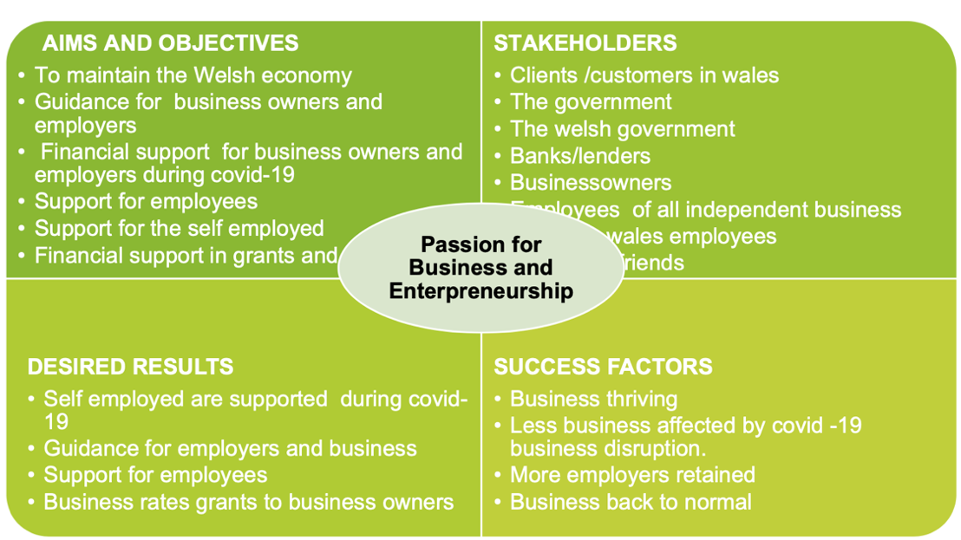

Another factor that is looked at in the initiation stage is the stakeholders. Stakeholders are all members of the project as well as all interested entities that are internal or external (PMI, 5,2013). Below is a table of the stake holders the level of influence, stake holder’s perspective and action/role. To help in the identification the author used the acronym UCASSADO which stands for User, Customer, Audience, Supporter, Supplier, Driver, Other as a tool in in the identification. In the process the stakeholders are categorised into External and internal stakeholders, The Analysis helps in Ranking the stakeholder’s interests and power. The Analysis ensures no audiences are left out.
Influence | Stakeholders | Stakeholders perspective | Action
High | Welsh government  (sponsor) /Drivers | Providing financial funding loans and grants. | Business website hub specially formulated for this purpose.  £2bn allocated for resilience fund
High | U.K.  Government  (sponsor)Drivers | Providing information and guidelines.  Providing business bounce bank loans | Liaising with the Welsh Government. Subscribing to news updates
High | Business owners  (observers) | Main beneficiary of the project. Provide feedback through surveys of the products provided.  Engaging with clients, running their business for those who are able to work from home. | Staying home and follow guidelines involving their specific business  Subscribing business Wales website for latest news. Engaging in webinars, courses, newsletters, surveys provided online.  Moving business online where applicable.
Medium | Employees  (supporter) | Providing services to business | Work remotely where applicable  Use zoom meetings  Engage with business online offering  Webinars, courses,  Answer queries online
High | Banks/lenders  (financial institution)  Driver | They provide a medium to pay business | Prepare application forms and criteria of approving grants
Medium | Customers (users of the project products)  (observer) | Provide income for business | Engage them online  Follow government guidelines when operating business such. Wearing protective clothing i.e. masks and gloves Use of sanitizer. Follow social distancing rules
Medium | Suppliers | Providing P.P.E | Sourcing and buying supplies
Low | Family  (observer) | Jobs create income for families to survive l Families provide emotional support to the stakeholders involved | Keep families informed and updated on the latest regulations
Low | Media  (0bserver) | Information services | Get media adequately informed.

Below on picture figure 2-7 illustrates the relationship between the project, the project team and various stakeholder.
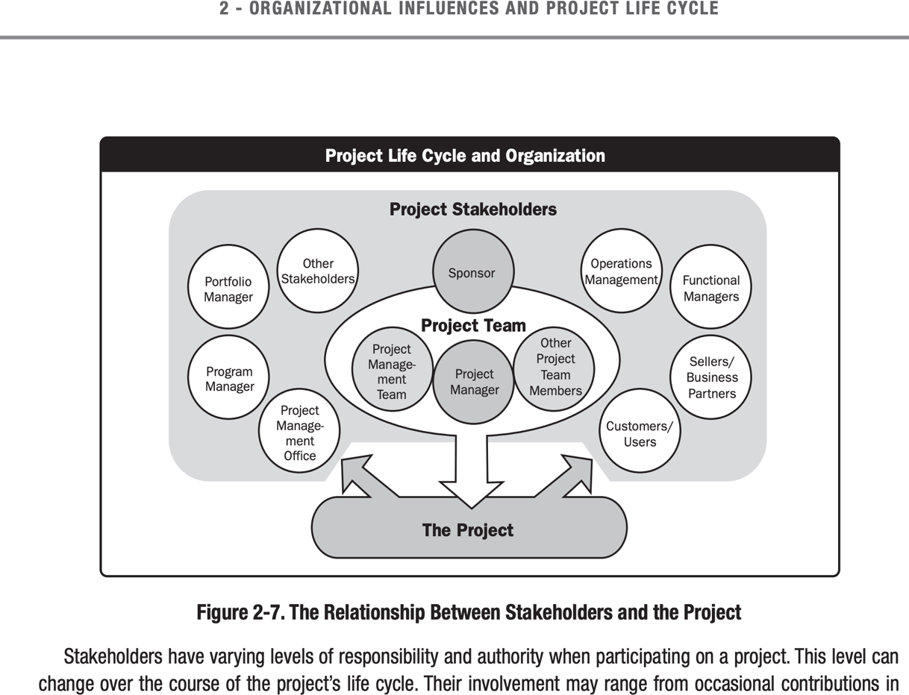

To avoid overwhelming the stakeholders with the information or under informing them it is important to prioritise the stakeholders and engage them in different levels. For stakeholders who have high power and interest should be managed closely while in contrast stakeholders with less power and interest should be kept informed. This can be done in the identification stage when stakeholders are classified into Primary stakeholders – those that are directly affected by the impact project either negatively or positively. And Secondary stakeholders- the Audiences or intermediaries.
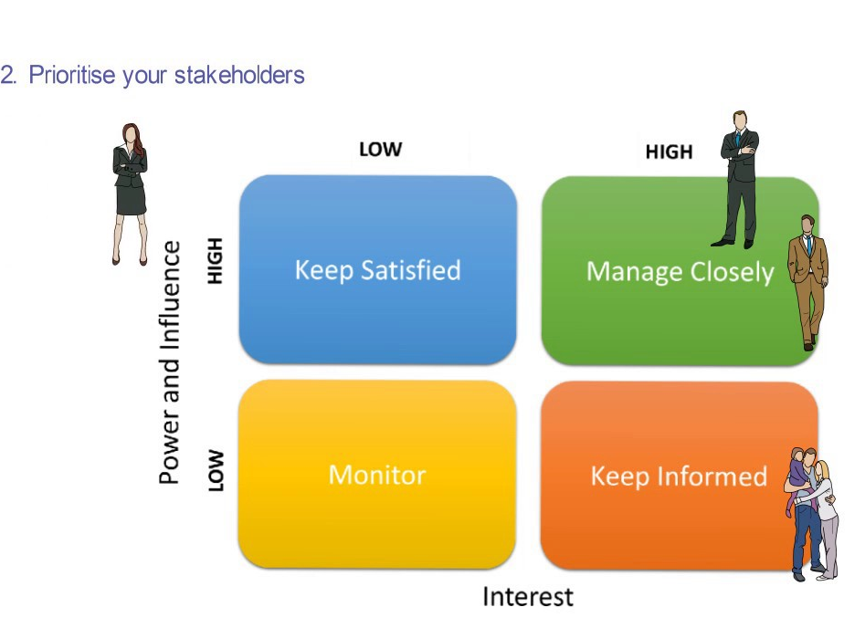

When to involve the stakeholders. The Graph below illustrates showing that That the drivers communicate a lot in this case they have been a lot of zoom meetings, emails, regular updates online and newsletters via post and online.

Examples of drivers –are the Welsh government They have high power and interest in the overall project. Supporter- Operational stakeholders the staff and people who will authorise resources i.e. the people in finance, Observers users i.e. the clients, business owners.

PLANNING STAGE
In the planning stage it is aimed to review the aim and objectives of the project, to list the project scope, anticipate potential problems and do the right activities at the right order correctly first time. For this process a planning cycle offers a framework for projects up to a certain level. Since this is a six-month project this can be applicable however larger projects, over longer period of time need more formal approach.
The tools and techniques used to analysis this project is the use of the risk analysis which help identify any potential pitfalls, its likelihood and mitigation. In this report the risks have been identified as loss of jobs due to the lockdown, unknown period of the pandemic, the sustainability of the funding, risk of reinfection from people going to work this has been tabled below.

Figure 1. The planning cycle (mindtools)
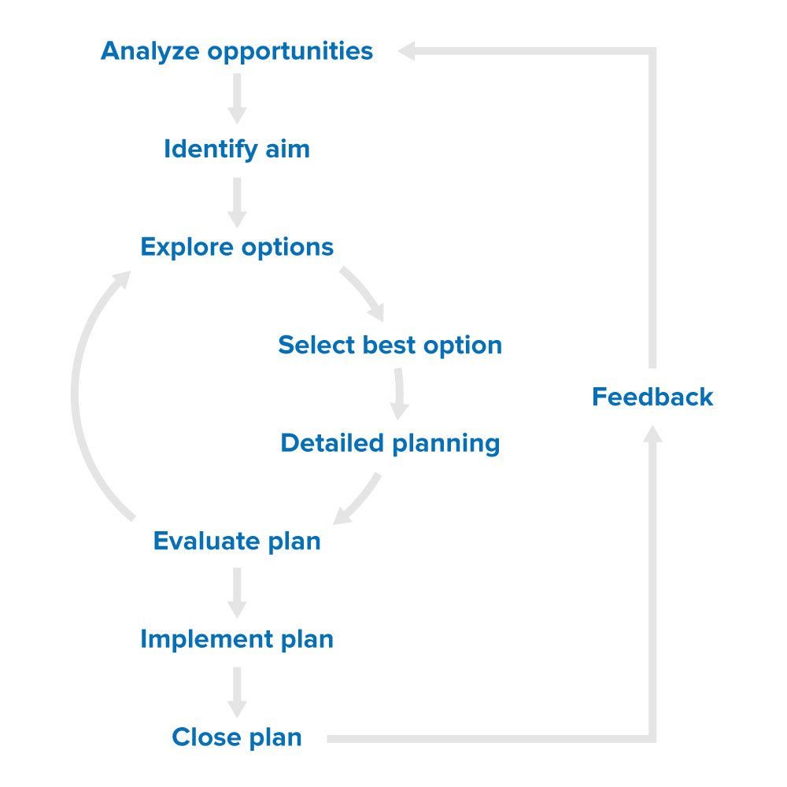

Risk Analysis Table
IMPACT | LIKELIHOOD | RISK | MITIGATION
H | H | LOSS OF JOBS | Job Retention Scheme  To help support employers with salary government covering 80%  Grants given  Loans made available  Training programs and webinars to help clients move business  online where possible
H | H | Unknown period of pandemic | Increase funds/resources for programs above.  Prepare guidelines to ease return to work on sectors that can start work
H | H | Collapse of the economy | Start easing the lockdown  Increase time for receiving furloughed allowance
H | l | People going to work when sick | Allow statutory sick allowance to everyone  Allow employees to work from home where

In addition to the use of Risk assessment, Risk analysis grid is the Boston Grid created by Bruce Henderson in 1970s is a tool that is used to analyse risk and help in distribution of recourses, Originally the grids were labelled the Cash cows, Dogs, Stars, and problem children. In this project it can be used to look at which services in the project to keep and which to let go. (Innovation-portal.info. 2020.)

Another tool used is the SWOT analysis and some of the strengths identified are well trained staff who will work well as the supporters of the project. Further to this using PESTLE analysis identified the role of the global economic impact and the use and importance of technology in the organisation more than ever before.

For a more detailed plan the use of Gantt chart is essential. Gantt charts was invented by Henry Gantt in (1861-1919) He invented it as a visual tool to show scheduled and actual progress of projects (Gantt Chart History | Project Scheduling, 2020) A Gannt chart is a project management tool assisting in the planning and scheduling of projects of all sizes.( APM, 2020).
Gantt charts are particularly useful for simplifying complex projects. Project timelines and tasks are converted into horizontal bar charts showing start and end dates, dependencies, scheduling deadlines and milestones. This is a useful tool to help track tasks. Makes it possible to check on progress with a glance. The author shows the Gannt chart below of business wales. Using the Gantt chart in the project the deliverables the time was visually accessible.
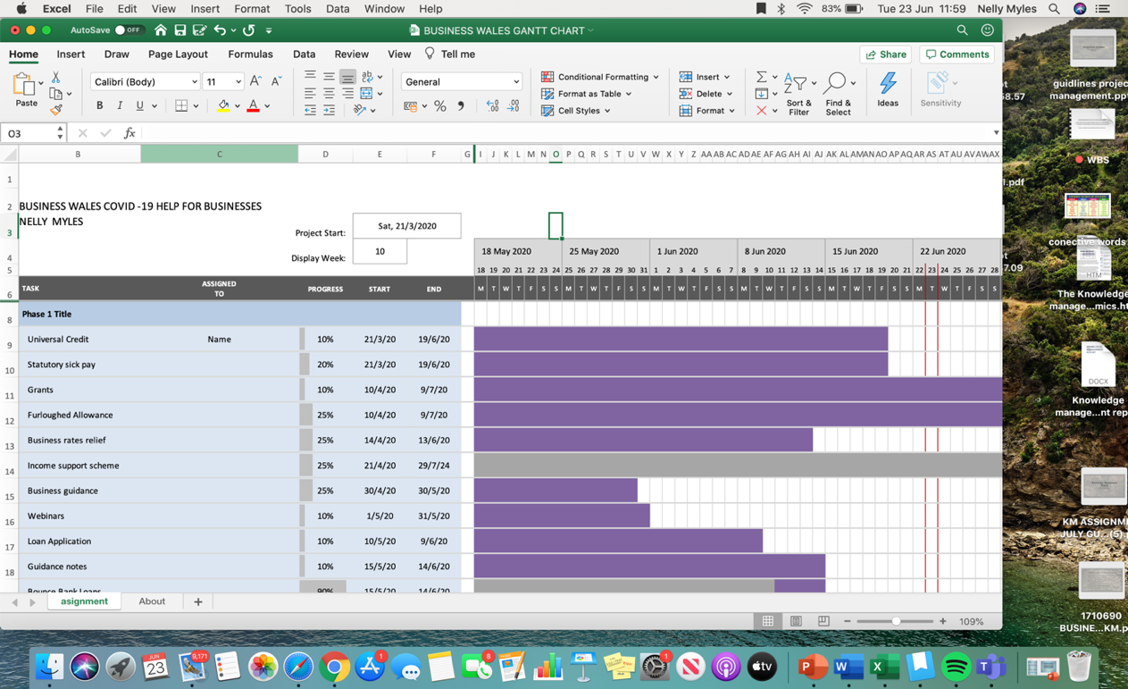

The process of subdividing project deliverables and project work into smaller, more manageable components. The work Breakdown structure

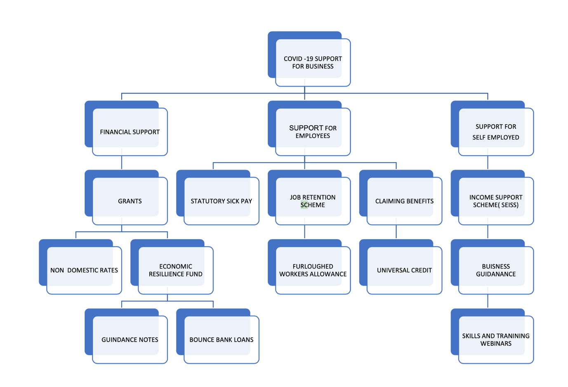

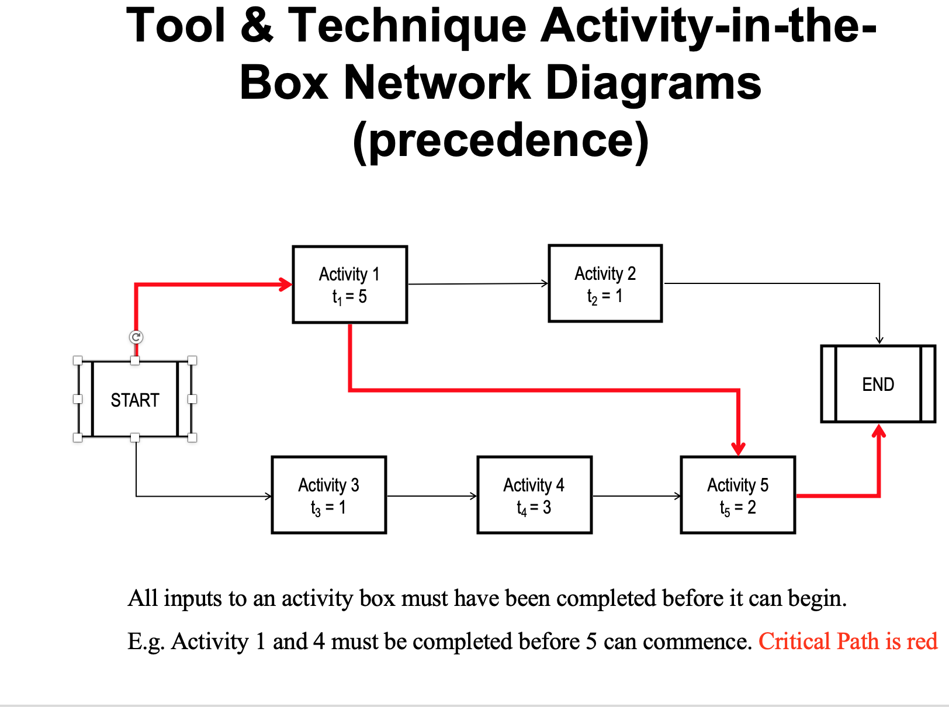
critical Path Analysis this are the activities that take longest to complete

Some The tasks involved are: The communication’s team was formed to deal with any queries, send communication to all stakeholders, job delegation for different deliverables, change management teams and procedure assigned

PROJECT EXECUTION

Project execution is the third phase of the project life cycle and one of the most vital of the project phases. It is the phase where you will construct your deliverables and present them to your customer and key holders (project manager ,2019) This is “when the rubber meets the road “The Key process performance where
- Managing the team Due to the Covid-19 all the workers were working from home. Following assignments to different deliverables teams have thrived with good leadership.
- The team has looked again at the quad chart and aligned the objectives during the execution
- Communications have been kept with all stakeholders using their website, communication within staff have used zoom, emails. Data has been collected and monitor during the execution process.
- Staff have been kept motivated and rewarded with flexible hours for the targets being met.
- Change Management despite the thorough planning some sectors where not covered in the funding criteria and this has to me incorporated into the main project subsequently this
destabilised the iron triangle.
The time cost the time and the services are linked. In this project time for the services was increased which affected the cost of the project. The Government had to increase additional funding. Subsequently Iron triangle maintained its equilibrium notably this still remains a high risk due to the time/period of the COVID – 19 being imminent.

MONITORING AND EVALUATION

The monitoring has taken place all through the project
Monitoring is “a regular systematic collection, analysis, reporting and use of information about programme policies and services. “
This is an internal process carried out by project managers and staff it takes place continuously during the project. This help, manage risks, track progress and most of the time it is qualitative.
For Business wales Project will be monitoring
- The number of applicants.
- The availability of funding and if it is sustainable.
- Productivity of staff and engagement.
- The number of business engaging on online training and webinars.
- The number of visitors using their website and looking for information and guidelines on dealing with effects of COVID – 19 on their business.

The method use will be through
- Zoom meeting specifically to monitor progress weekly
- Emails
- Data from website
- Compilation of financial report

Evaluation

Evaluation Process is the systematic and impartial assessment of expected achievement (results lab,2020)

The data from the monitoring process is an essential process This is an external process. the information is received

- Analysed synthesised to determine the findings
- Interpretation to find what the findings mean
- Judgement to determine how the findings should be valued based on the aim and objectives of the project.
Recommendations to determine what claims are indicated if any (Milstein and Wetterhall, 2000)

Being this is an on-going project this will be a mid project evaluation This process will be

PROJECT CLOSURE
“Kolb shows how reflection on an experience leads the individual to form concepts about that experience, and to be able to generalise from one experience to another”
(Williams et al., Reflective Writing)

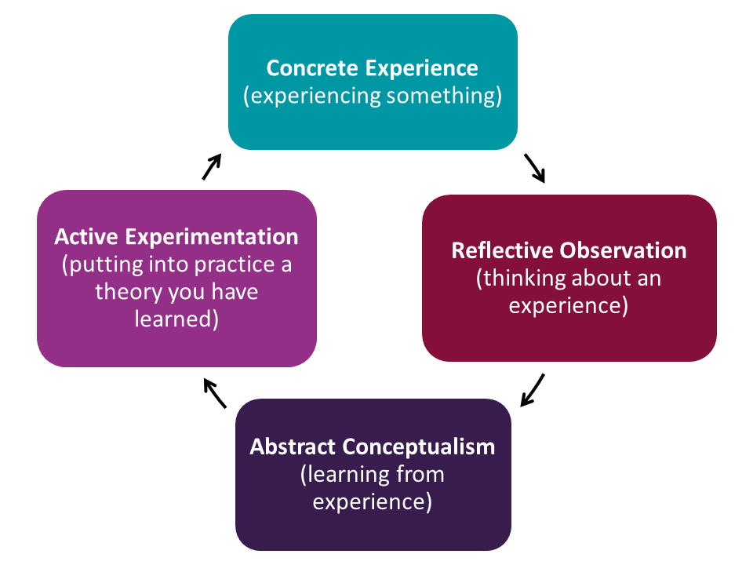
Using Kolb’s model, the paper is going to reflect on some of the tools used during project management. Some of the tools.

- Quad chart,
- Work Breakdown Structure (WBS),
- Network diagrams
- Iron Triangle
- Kolb reflective cycle
- Gantt Chart
- Stakeholders analysis

One of the most vital tools was the stakeholder’s analysis in this project neglecting to use the tool meant waste of time and resources on efforts that stakeholders would not support. Having to analyse them correctly gave the project the best chance of success. The information and resources where distributed effectively the stakeholders were treated accordingly. On the other hand, The stake holders analysis is best done on a continuous basis as interest of shareholders change and focusing on only the most important stakeholders other factors can be overlooked In addition to the stakeholders analysis the Quad chart gave important visual information at a glance keeping the projects actions aligned to the objectives unlike the Quad chart the Gantt chart linked the task and the time showing the milestones achieved visibly both were vital for this project.. As well as the tools discussed the Iron triangle (Barnes,1969) the important challenging fact was managing the different constraints of the scope the budget and time to maintain the equilibrium. The project had to either increase time or more resources to maintain the quality of the deliverables, so the trade-offs needs excellent management skills Importantly the tools exhibit the essence of starting with the end in mind and having an overview of the project cycle. It should be noted that for the project to be successful good leadership is absolutely important and some of the qualities/attributes and skills of a good project manager are

- Effective communication
- leadership
- Good decision maker
- Negotiation
- Influencing
- Trust and team building
- Conflict management
- Coaching
- motivation
- Competence
- Works well under pressure
- Empathetic

On reflecting on the project, the author took Belbin test.

Following the authors result of the Belbin. This was to have a greater understanding of her strengths and weakness which leads to more effective communication and competences. This was done by filling in a self-perception inventory and asking for feedback.
The results revealed strengths and weakness has illustrated to the figure 6 below. The personal strengths for the author was motivation, working well under pressure and good at team building. After undertaking this exercise, the author feels more confident in project management activities.
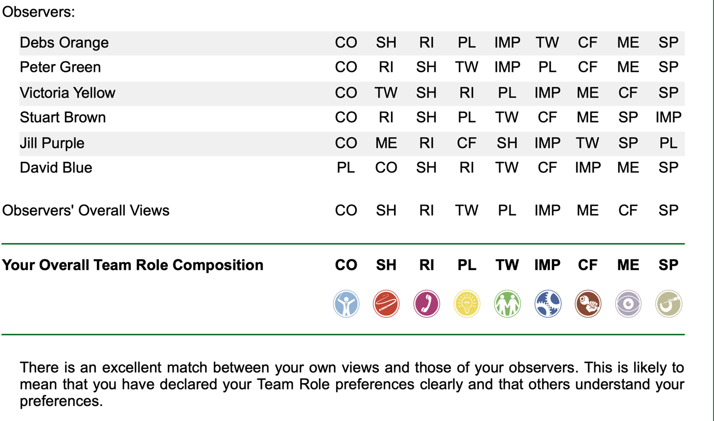
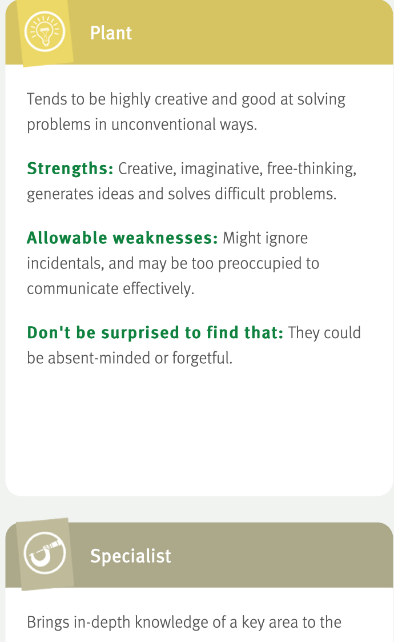

Figure 6

RECOMMENDATIONS

Self-development plan
However, following the test revealed some gaps in the Belbin test the author realises the need to enrol in a leadership course to improve the qualities that are missing like good communication skills., organisation skills, competence in project roles,

Project gaps

- Poor change management. (Management: perspective and practice. )
When caring out the evaluation changes had to take place but since this what not exhausted in the planning stage cause a lot of deal and no established process of approving the action. The process in place need to be updated and a team has been set to do the task

- Communication and vocabulary
Another issue raised during the monitoring and evaluation is communication. When carrying out surveys, questionnaires and material needing feedback. The vocabulary should be simple enough to be understood by everyone. so, everybody is on one page. Complex concepts should be broken down and made more understandable.

REFERENCES

Belbin.com. (2020). [online] Available at: <https://www.belbin.com/media/1206/jo-pink-self-perception-plus-observers-report.pdf> [Accessed 3 July 2020].

Businesswales.gov.wales. 2020. Business Wales | Supporting Businesses in Wales. [online] Available at: <https://businesswales.gov.wales> [Accessed 22 May 2020].
En.wikipedia.org. 2020. Quad Chart. [online] Available at: <https://en.wikipedia.org/wiki/Quad_chart> [Accessed 22 June 2020]. Ganttchart.com. 2020.
Gantt Chart History | Project Scheduling. [online] Available at: <http://www.ganttchart.com/history.html> [Accessed 23 June 2020].

Harned, B., 2020. What Is Project Management: Definition and Terms | Project Management Guide. [online] Teamgantt.com. Available at: <https://www.teamgantt.com/guide-to-project-management/what-is-project-management> [Accessed 22 May 2020].
Innovation-portal.info. 2020. The Boston Matrix | Innovation Portal. [online] Available at: <http://www.innovation-portal.info/toolkits/the-boston-matrix/> [Accessed 1 July 2020].
McConnell, E., Linman, D., Linman, D. and Team, M., 2020. Project Initiation Stage – Project Initiation Document (PID). Duties of Project Owner and Project Team. [online] Mymanagementguide.com. Available at: <https://mymanagementguide.com/project-initiation-stage-project-initiation-document-pid-duties-of-project-owner-and-project-team/> [Accessed 22 June 2020].
Milstein, B. and Wetterhall, S., 2000. A Framework Featuring Steps and Standards for Program

Evaluation. Health Promotion Practice, [online] 1(3), pp.221-228. Available at: <https://moodle.uwtsd.ac.uk/pluginfile.php/292579/mod_resource/content/1/frame%20work.pdf>

Proposal for NGOs. 2020. Monitoring and Evaluation (M&E): A Step by Step Guide - Proposalforngos. [online] Available at: <https://proposalsforngos.com/what-is-monitoring-and-evaluation/> [Accessed 3
July 2020].

results lab. 2020. Monitoring And Evaluation. [online] Available at: <https://www.youtube.com/watch?v=X2ZzpuE1us4> [Accessed 3 July 2020].

Technical Services. 2020. A Brief History Of Knowledge Management - TVS Integrated Technical Services. [online] Available at: <http://www.tvsits.com/white-papers-articles/brief-history-knowledge-management/> [Accessed 30 June 2020].

Johnsthomas.wikidot.com. 2020. A Brief History Of Knowledge Management - @John S. Thomas. [online] Available at: <http://johnsthomas.wikidot.com/a-brief-history-of-km> [Accessed 30 June 2020].

Free-management-ebooks.com. 2019. Project Executing Processes. [online] Available at: <http://www.free-management-ebooks.com/faqpm/processes-04.htm> [Accessed 2 July 2020].

vliet, v., 2011. What Is The Knowledge Management Value Chain Model | Toolshero. [online] toolshero. Available at: <https://www.toolshero.com/management/knowledge-management-value-chain/> [Accessed 27 June 2020].
results lab. 2020. Monitoring And Evaluation. [online] Available at: <https://www.youtube.com/watch?v=X2ZzpuE1us4> [Accessed 3 July 2020].

