Week eleven session two exam questions/answers
Question 1.
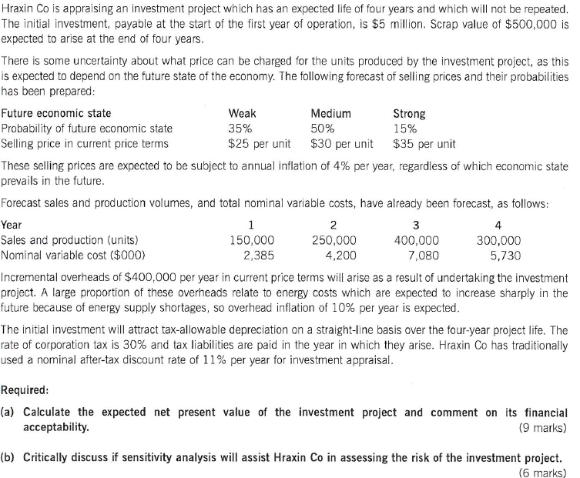(c) Explain the difference between risk and uncertainty in the context of investment appraisal, and describe how sensitivity analysis and probability analysis can be used to incorporate risk into the investment appraisal process. (10 marks)
34 marks

Answers Question 1 (a)
Workings
Mean or average selling price = ($25 x 0.35) + ($30 x 0.5) + ($35 x 0.15) = $29 per unit
 |  | Year 1 |  | Year 2 |  | Year 3 |  | Year 4
Inflated (4%) unit selling price ($ per unit | 29 x 1.04 = | $30.16 | 30.16 x 1.04 = | $31.37 | 31.37 x 1.04 = | $32.62 | 32.62 x 1.04 = | $33.93
Sales volume/production (units per year) |  | 150,000 |  | 250,000 |  | 400,000 |  | 300,000
Sales revenue ($000/year) | 150,000 x $30.16 = | $4,524 | 250,000 x $31.37 = | $7,843 | 400,000 x $32.62 = | $13,048 | 300,000  X $33.93= | $10,179
Year overhead inflated ($000/year) | $400  X 1.1 =  Overhead x 10% inflation | $440 | $440 x 1.1 = | $484 | $484 x 1.1 = | $532 | 532 x 1.1 = | $586

Capital Allowances
Total tax allowable depreciation = initial investment $5 m - $500,000 scrap
Annual allowable depreciation = $4.5m/4 = $1.125m per year
Annual cash flow from tax-allowable depreciation = $1.125m x 0.3 (corporation tax 30%) = $338,000 per year
Actual answer
Year | 1 | 2 | 3 | 4
 | $000 | $000 | $000 | $000
Revenue  From workings | $4,524 | $7,843 rounded up | $13,048 | $10,179
Variable cost  Given to us no need to work out | ($2,385) | ($4,200) | ($7,080) | ($5,730)
Contribution =  Revenue – variable cost | $2,139 | $3,643 | $5,968 | $4,449
Overhead cost  From workings | ($440) | ($484) | ($532) | ($586)
Cash flow before tax  Contribution – overhead cost | $1,699 | $3,159 | $5,436 | $3,863
Tax  Cash before tax x 0.30 (30% corporation tax) | ($510) | ($948) | ($1,631) | ($1,159)
Depreciation benefits  From workings | $338 | $338 | $338 | $338
Cash flow after tax  Cash flow before tax – tax + depreciation benefits | $1,527 | $2,549 | $4,143 | $3,042
Scrap value |  |  |  | $500
Project cash flow  Cash flow after tax + scrap value | $1,527 | $2,549 | $4,143 | $3,542
Discount @ 11% | 0.901 | 0.812 | 0.731 | 0.659
Present values  Project cash flow x discount rate | $1,376 | $2,070 | $3,029 | $2,334
 |  | $000
Present value of future cash flows  Add all years present values |  | $8,809
Initial investment |  | (£5,000)
Expected Net Present value (ENPV)  Present value of all cash flows – initial investment |  | $3,809

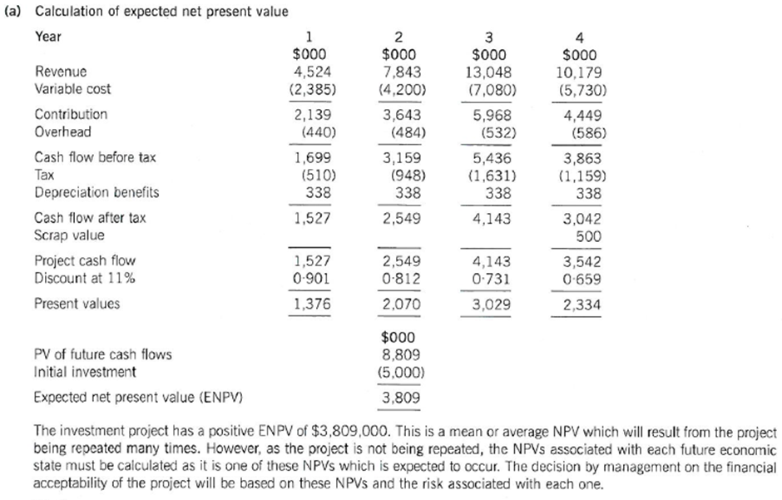

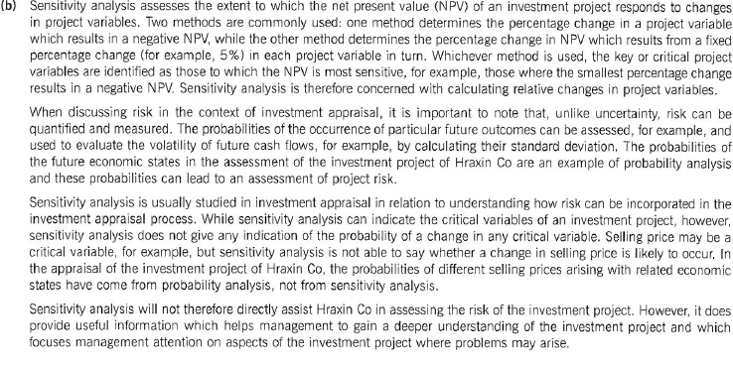(c ) Risk refers to the situation where probabilities can be assigned to a range of expected outcomes arising from an investment project and the likelihood of each outcome occurring can therefore be quantified. Uncertainty refers to the situation where probabilities cannot be assigned to expected outcomes. Investment project risk therefore increases with increasing variability of returns, while uncertainty increases with increasing project life. The two terms are often used interchangeably in financial management, but the distinction between them is a useful one.
Sensitivity analysis assesses how the net present value of an investment project is affected by changes in project variables. Considering each project variable in turn, the change in the variable required to make the net present value zero is determined, or alternatively the change in net present value arising from a fixed change in the given project variable. In this way the key or critical project variables are determined. However, sensitivity analysis does not assess the probability of changes in project variables and so is often dismissed as a way of incorporating risk into the investment appraisal process.
Probability analysis refers to the assessment of the separate probabilities of a number of specified outcomes of an investment project. For example, a range of expected market conditions could be formulated and the probability of each market condition arising in each of several future years could be assessed. The net present values arising from combinations of future economic conditions could then be assessed and linked to the joint probabilities of those combinations. The expected net present value (ENPV) could be calculated, together with the probability of the worst-case scenario and the probability of a negative net present value. In this way, the downside risk of the investment could be determined and incorporated into the investment decision.

Question 2.

Beta Co is considering an investment project that will have an expected life of four years and is a one off not to be repeated investment. The initial investment will cost $4.5m, payable at the start of the project. The scrap value is estimated to be $500,000.

There is some uncertainty about what price the company can charge but they have been able to forecast the following sales prices with associated probabilities.

Future Economic State Weak Medium Strong

Probability 30% 50% 20%
Selling Price $26 per unit $31 per unit $36 per unit

These selling prices are expected to change at a rate of 4% inflation on an annual basis, commencing in the first year.

Forecast sales and production and nominal variable costs are as follows:

Year 1 2 3 4

Sales and Production 145,000 255,000 410,000 310,000

Nominal variable costs ($000) 2,480 4,250 7,100 5,750

Incremental overheads of $450,000 are payable each year and because of rising energy costs they are expected to increase at a rate of 8% per annum, starting from year 1.

The initial investment will attract capital allowances on a straight line basis over the four year project life. Corporation tax is currently 25% and Beta has a cost of capital of 10 % for projects of this type.

Required:

- Calculate the expected net present value of this investment from the viewpoint Beta Co. State clearly any assumptions that you make.
(20 marks)

- What further information and analysis might be useful in the evaluation of this project (10 marks)

- Calculate the internal rate of return for this project and comment on its usefulness.
(10 marks)

- Critically discuss how Gamma PLC might adjust the cost of capital for an overseas project. (10 marks)

(Total Marks = 50)
Answers
Question 2 (a)
Workings
Mean or average selling price = ($26 x 0.30) + ($31 x 0.5) + ($36 x 0.20) = $30.5 per unit
 |  | Year 1 |  | Year 2 |  | Year 3 |  | Year 4
Inflated (4%) unit selling price ($ per unit | 30.5 x 1.04 = | $31.72 | 31.72 x 1.04 = | $32.99 | 32.99 x 1.04 = | $34.31 | 34.31 x 1.04 = | $35.68
Sales volume/production (units per year) |  | 145,000 |  | 255,000 |  | 410,000 |  | 310,000
Sales revenue ($000/year) | 145,000 x $31.72 = | $4,599 | 255,000 x $32.99 = | $8,412 | 410,000 x $34.31 = | $14,067 | 310,000  X $35.68= | $11,061
Year overhead inflated ($000/year) | $450  X 1.08 =  Overhead x 8% inflation | $486 | $486 x 1.08 = | $525 | $525 x 1.08 = | $567 | 567 x 1.08 = | $612

Capital Allowances
Total tax allowable depreciation = initial investment $4.5 m - $500,000 scrap
Annual allowable depreciation = $4m/4 = $1m per year
Annual cash flow from tax-allowable depreciation = $1m x 0.25 (corporation tax 25%) = $250,000 per year
Actual answer
Year | 1 | 2 | 3 | 4
 | $000 | $000 | $000 | $000
Revenue  From workings | $4,599 | $8,412 | $14,067 | $11,061
Variable cost  Given to us no need to work out | ($2,480) | ($4,250) | ($7,100) | ($5,750)
Contribution =  Revenue – variable cost | $2.119 | $4,162 | $6,967 | $5,311
Overhead cost  From workings | ($486) | ($525) | ($567) | ($612)
Cash flow before tax  Contribution – overhead cost | $1,633 | $3,637 | $6,400 | $4,699
Tax  Cash before tax x 0.25 (25% corporation tax) | ($408) | ($910) | ($1,600) | ($1,175)
Depreciation benefits  From workings | $250 | $250 | $250 | $250
Cash flow after tax  Cash flow before tax – tax + depreciation benefits | $1,475 | $2,977 | $5,050 | $3,774
Scrap value |  |  |  | $500
Project cash flow  Cash flow after tax + scrap value | $1,475 | $2,977 | $5,050 | $4,274
Discount @ 10% | 0.909 | 0.826 | 0.751 | 0.683
Present values  Project cash flow x discount rate | $1,341 | $2,459 | $3,793 | $2,919
 |  | $000
Present value of future cash flows  Add all years present values |  | $10,512
Initial investment |  | (£4,500)
Expected Net Present value (ENPV)  Present value of all cash flows – initial investment |  | $6,012

The investment project has a positive ENPV of $6,012,000. This is a mean or average NPV which will result from the project being repeated many times. However, as the project is not being repeated, the NPV associated with each future economic state must be calculated as it is one of these NPV’s which is expected to occur. The decision by management on the financial acceptability of the project will be based on these NPV’s and the risk associated with each one.

Question 2 (b)
Analysis of the following areas should be considered:
- Currency risk;
- Political risk;
- Rates of interest;
- Restraints on Gearing (local);
- Tax rules;
- Accuracy of cash flows;
- Choice of 4 year planning horizon;
- Reliability of Capital Asset Pricing Model (CAPM);
- Political and economic factors;
- Sensitivity analysis of key variables.

Question 2 (c)
So now we have to work out the NPV using a different discount rate to that used in part (a) then we can use both NPVs to work out the IRR (Internal rate of return).
Year | 1 | 2 | 3 | 4
 | $000 | $000 | $000 | $000
Revenue  From workings | $4,599 | 8,412 | 14,067 | 11,061
Variable cost  Given to us no need to work out | ($2,480) | ($4,250) | ($7,100) | ($5,750)
Contribution =  Revenue – variable cost | $2,119 | $4,162 | $6,967 | $5,311
Overhead cost  From workings | ($486) | ($525) | ($567) | ($612)
Cash flow before tax  Overhead – overhead cost | $1,633 | $3,637 | $6,400 | $4,699
Tax  Cash before tax x 0.25 (25% corporation tax) | ($408) | ($910) | ($1,600) | ($1,175)
Depreciation benefits  From workings | $250 | $250 | $250 | $250
Cash flow after tax  Cash flow before tax – tax + depreciation benefits | $1,475 | $2,977 | $5,050 | $3,774
Scrap value |  |  |  | $500
Project cash flow  Cash flow after tax + scrap value | $1,475 | $2,977 | $5,050 | $4,274
Discount @ 20% | 0.833 | 0.694 | 0.579 | 0.482
Present values  Project cash flow x discount rate | $1,299 | $2,066 | $2,924 | $2,060
 |  | $000
Present value of future cash flows  Add all years present values |  | $8,279
Initial investment |  | (£4,500)
Expected Net Present value (ENPV)  Present value of all cash flows – initial investment |  | $3,779

Now we work out the IRR (Internal rate of return)
Using the NPV worked out in part (a) of this question and the one we have just worked out in this question above.
Steps to using the IRR – IRR equation are shown below
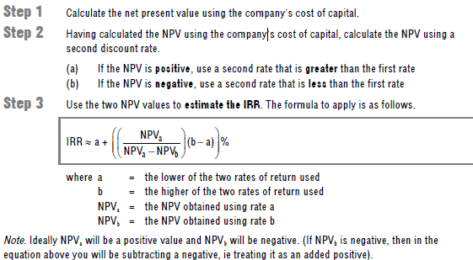
a = 10% (from part (a))
b = 20% (from part (c))
NPVa = 5,071 (from part (a))
NPVb = 3,078 (from part (c))
IRR = 10 + (6,012 ) x (20 – 10)
6,012 – 3,779
IRR = 36.9%
So NPV will equal zero when the cost of capital is equal to 36.9% for this project.
The internal rate of return (IRR) method is to calculate the exact DCF rate of return which the project is expected to achieve, in other words the rate at which the NPV is zero. If the expected rate of return (the IRR or DCF yield) exceeds a target rate of return, the project would be worth undertaking (ignoring risk and uncertainty factors).

Question 2 (d)
The following have to be considered and evaluated:
- Opportunity costs
- Methods of financing
- Effects of taxation
- Adjusted Present Value (APR)
- Systematic and unsystematic risk
- International portfolio diversification
- Beta values

