Quality tools and root cause analysis
During this assignment I will be analysing data show from the defect table and concluded what problems seem to occur, why they are occurring and what can be done to prevent them from occurring again. I will be doing research into sand casting and vertical drilling machines and making referenced to my research within this assignment. I will be using tools such as pareto and I will also use a fishbone diagram, also known as the Ishikawa diagram, to allow me to identify the potential causes of the problem and then get to the root cause. A diagram such as this will let me depict my findings allowing me to analyse the data in more depth. The process of sandcasting is used for moulding shapes of metals on both a small and large scale. “Sand casting, the most widely used casting process, utilizes expendable sand molds to form complex metal parts that can be made of nearly any alloy. Because the sand mold must be destroyed in order to remove the part, called the casting, sand casting typically has a low production rate. The sand-casting process involves the use of a furnace, metal, pattern, and sand mold. The metal is melted in the furnace and then ladled and poured into the cavity of the sand mold, which is formed by the pattern. The sand mold separates along a parting line and the solidified casting can be removed.” https://www.custompartnet.com/wu/SandCasting

Figure 1
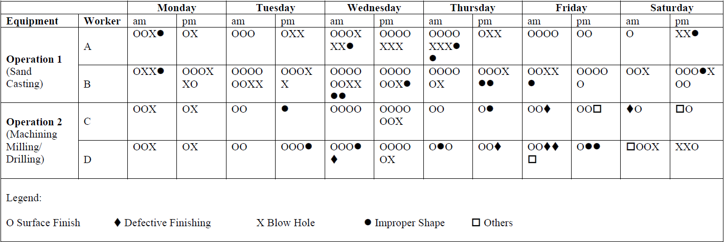
Figure 2
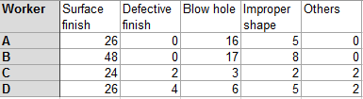

From looking at the drill base unit process defect data sheet it is clear to see that surface finishing has the highest frequency of defects, a total of 124 from all workers which, in comparison, is far greater than defective finishing, blow holes, improper shape and others. I have simply tallied up the data provide in figure 1 and put it into a table in excel which is shown in figure 2. Furthermore, there seems to be a greater occurrence of defects of surface finishing on Wednesday’s, in particular surface finishing and blow holes. There may be many reasons as to why there seems to be many defects on a regular basis such as competence of the workers who are sand casting (A&B) and the workers using the vertical drilling machine (C&D). If the workers are not fully competent in the tasks they are undertaking, then it will be inevitable that defects or non-conformities to occur within the product itself. It is also worth noting that worker B has a substantially a greater number of defects across the week in comparison to workers A, C and D. Therefore, an assumption can be made that worker B is operating on machinery or using equipment that isn’t up to standard or outdated. It seems this could be a result of irregular maintenance checks on the machine that worker B is using. Blow holes are the second most common defect formed from the process of sand casting and milling. Blow holes are caused when gases entrapped on the surface of the casting due to solidifying metal, a rounded or oval cavity is formed called as blowholes. These defects are always present in the cope part of the mold. Causes of this can be excessive moisture in the sand, low permeability of the sand, sand grains are too fine, the sand has been rammed too hard or insufficient venting is provided. https://www.mechanicalbooster.com/2017/11/casting-defects.html

The left axis of the pareto chart is the count of the defect type and the bars are in ranked order the furthest on the left being the bar with the highest count of defects whilst the vertical axis on the right is depicting the percent. the cumulative line is showing the addition of the percentage of the bar from left to right. The main purpose of a pareto chart is to specifically highlight the defects that have the highest occurrence so that the problems can then be addressed accordingly. We can see that, going from left to right, surface finish has the highest count of 74 defects in operation 1 accounting for 62% of the defects. Blow holes is the second largest with a count of 33 and totalling 27% of the issues. Improper shape has a count of 13 whilst defective finishing and other have a count of 0. Therefore, to drastically reduce the number of defects that are occurring, it would be a notion to get to the root cause as to why there is an alarmingly high amount of surface finishing defects. A reason that the surface finishing is the biggest problem facing sand casting is the size as well as the shape of the sand. “Both the size as well as the shape of the sand particles will determine the surface finish achieved for sand casted products. Finer particles will produce a better surface finish, but it is important to note that as the sand particles become finer and the surface finish improves, the permeability of the sand used, becomes worse.” https://www.chinasavvy.com/surface-finish-and-sand-types#surfacefinish

From looking at the above chart again, we can clearly ser that surface finishing is the highest for operation 2 with a count of 26 within this week. This accounts for 50% of the defects. Blow holes are second again with a significantly low count of 9, accounting for 17% of the defects. Improper shape is third with a count of 7 defects which is 12% of the weekly defects. Defective finishing and other has a total of count of 10 defects totalling to 19% of the defects in this week for operation 2. Having looked at both charts, it is evident that surface finishing for both operations is the area which needs to be addressed, along with blow holes, to drastically reduce the number of defects and non-conformities that are occurring. This can be tackled by using a standardised approach to the type of sand that is being used for operation 1 to improve the surface finishing.

From analyzing figure 1 in more depth, the data implies there are a lot more defects occurring on Wednesday’s than there is on Saturdays. For example, on Wednesday worker B had 7 surface finishing defects and on Saturday that figure dramatically reduced to 1 defect. There is also a reduction in the surface finishing defects for worker B in the same area. We can see that on Wednesday worker A had 13 defects for surface finish, whereas on Saturday that figure decreased to 7. This figure is still high, but there is a fair decrease nonetheless. In fact, on Wednesday, there is a total of 33 defects and on Saturday there is a total of just 14 defects. This is a difference of 19 which is a massive difference. Therefore, this implies there is a problem on Wednesday. This could be a result of a greater demand for the product on that particular day in comparison to Saturdays which can result in more pressure being exerted on both workers A and B to perform to get the product finished and out to the customer, which can result into mistakes being made, thus a more frequent number of defects occurring.

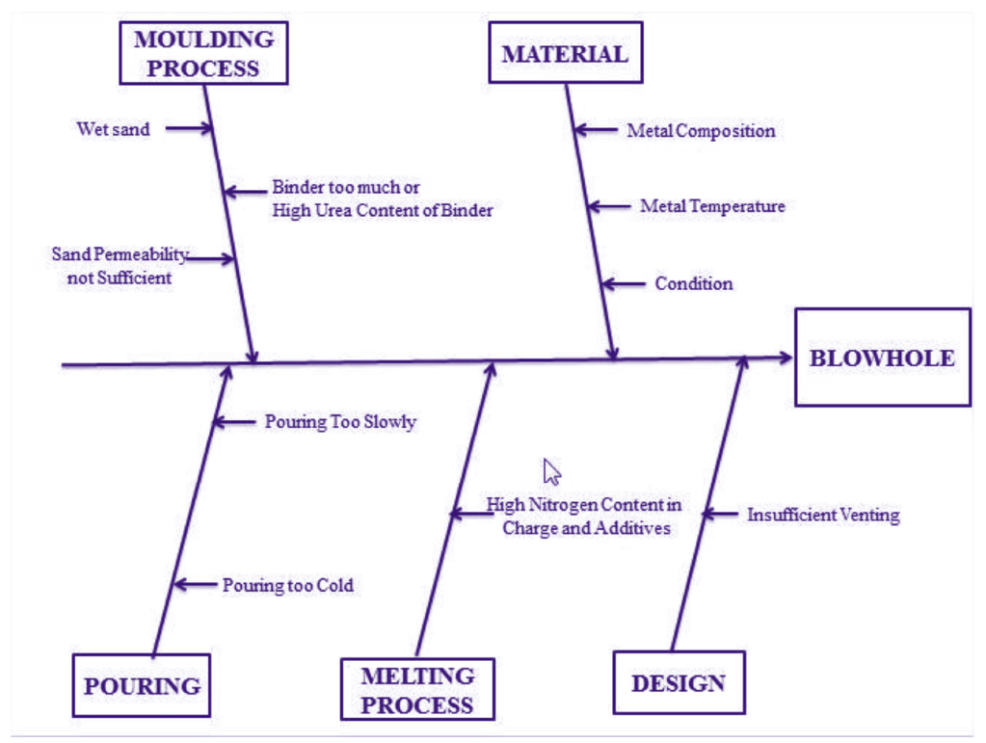

After conducting the pareto charts, we have come up with this fishbone diagram. This diagram is a brainstorm resulting in the ideas from the workers A, B, C and D to identify the possible causes for blow holes. The main problem with a cause and effect diagram is that it is based on subjective opinions rather than objective facts. After doing an in-depth analysis, I have noticed that the sand that was used for both workers had in fact sufficient moisture in it throughout the week for it to cause blow holes. It can therefore be suggested that the sand is to be stored in a location where there is absolutely no chance of any ingress of water, and even put a cover of tar polling as an extra layer to take extra precautions. If this doesn’t work, I would then suggest an alternative to the supplier of the sand, as there is potential that the moisture is coming from their end of the process which is resulting in the blow holes being formed down the line here. Furthermore, I have highlighted a difference in the temperature at which the metal is being poured into the mould which can result in the metal cooling at different rates. This should be standardized and confirmed with management as to what the exact temperatures of pouring are to be with a maximum and minimum deviation to help assist the workers.

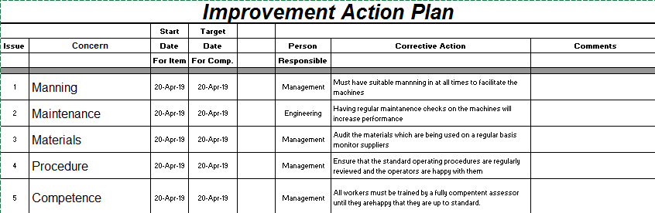
To conclude, action planning is a process which will help you to focus your ideas and to decide what steps you need to take to achieve goals that you may have. It is a statement of what you want to achieve over a given period. Preparing an action plan is a good way to help you to reach your objectives thus reducing the total amount of defects that occur during a given week. Ultimately, this will save the company money as there will be more orders that are suitable going to the customer. Moreover, it will boost the morale within the working environment as the workers will now feel they are contributing to a successful company which will only be good for the business. Developing a solid action plan is fundamental to a business or a department within a business for improvement so they can recover on the areas where they have been audited. The first concern is manning whereby there must always be suitable manning at the machines to ensure that the product is being made correctly. It could be suggested to employ another person at each station to assist with the operator as when there is a high demand on certain days, the other person can assist the main operator, ensuring the product is correct first time, thus minimising the total amount of defects. The second issue that is picked up is maintenance of the machines. If the machines are not maintained properly then it is going to be inevitable that they will start to either malfunction or not work to their optimum. Consequently, it is up to the engineering manager to ensure that all machines are checked on a weekly basis minimum and new parts ordered if required. Next, materials need to be checked thoroughly on a daily as poor selection of suppliers of material, such as sand, can lead to non-conformities further down the line, making it essential that the correct materials are purchased from a reliable supplier. Number 4 on the action plan is procedure. It is essential that the there is a standard operating procedure for all workers to follow, so the best possible results should be achieved every time if the correct steps are followed. This leads on to action number 5 which is competence. It is critical for the business that the workers are fully trained and competent and confident to carry out and complete the task that is in front of them. This comes down to the worker being trained by an assessor who is also fully competent within the given area. If all of these actions are followed and completed, then I believe that the business will start to see less defects overall.

Links to references
https://www.custompartnet.com/wu/SandCasting
https://www.mechanicalbooster.com/2017/11/casting-defects.html
https://www.chinasavvy.com/surface-finish-and-sand-types#surfacefinish

