Analyse the impacts of socio-economic force on employees’ performance management and monitoring in different work modes: Hospitality HR’s perspective

Module title: Personnel Resourcing and Development
Module code:BMIH5005
Lector name: Helen Lee
Student name: Daniel Fieraru
Student ID: 2232199
Table of Contents
Introduction and Background 3
Research Background 3
Aims and Objectives 4
Research Questions 4
Discussion of Literature 4
Socio-economic forces that have a potential impact on the hospitality industry 4
The performance metrics for adapting the socio-economic alterations 5
The relationship between employee well-being and productivity based on the socio-economic challenges 6
Evaluation and Conclusion 7
References 9

Introduction and Background

Research Background
The study on the impact of socio economic factors deals with employee performance and monitoring of hospitality industry based on the pensiveness of HR professionals. The research on the present dynamic of innovative landscape of HR professional deals with the socioeconomic forces in terms of generating a modern strategy of performance management practices. The differentiation in the work module has prevalent in this industry to create a particular hospital on the adaptability and presentation of HR factor. The involvement of economic fluctuations and cultural shift deals with the extension of labour market trained to adjust the workforce and its influence in hospitality industry (Shibata, 2022). The understanding of various factors deals with the tailoring of performance management approach to align with diverse challenge based on a particular node of work. The traditional settling of office and remote work has generated a particular hybrid model for the HR professionals in terms of assessing the present performance management tactic to monitor the father mechanism and engagement of effective modes. These involved in the presentation of present key performance to generate a particular feedback mechanism and socioeconomic alteration for a particular ethical dimension.
Moreover, on the other side, the socio economic alteration has provided a particular feedback mechanism in terms of recognising the employee monitoring for the balance between productivity expectation and employee well-being. The integration of technology act as an emerging factor in terms of aspiring the key fact of HR approach in the management of performance for hospitality industry based on the liberating of digital tools for remote tracking. However, on the other side the particular defecation of challenges related with the shape of social economic forces enhances the employee experience based on the cultural activity and amplification of socio economic forces (Fatima and Elbanna, 2023). The HR professional need to implement an inclusive fact for managing the strategies in terms of accounting the cultural belonging for enlarging a diverse background. The HR management of hospitality industry need to respond on a proactive approach to identify the modern practices that involve technological adaptation and embarrassment of diversity. The HR professionals of various Organisation in the hospital industry has contributed its residence and success of employees based on an ever changing mode of industrial culture.

Aims and Objectives
The main aim of this research is to analyse the impacts of Socioeconomic factors on employee performance in the management and monitoring of various work modes based on the perspective of HR in the hospitality industry.
The objectives of this research are stated as follows:
- To identify the important socio-economic forces that have a potential impact on the hospitality industry.
- To analyse the performance metrics for adapting the socio-economic alterations.
- To determine the relationship between employee well-being and productivity based on the socio-economic challenges.

Research Questions
- What are the important socio-economic forces that have a potential impact on the hospitality industry?
- What are the performance metrics for adapting to the socio-economic alterations?
- What is the relationship between employee well-being and productivity based on the socio-economic challenges?

Discussion of Literature

Socio-economic forces that have a potential impact on the hospitality industry
The hospital industry acts as a particularly sensitive array of socio economic forces based on the significant operations. The shaping of modern forces in the industry landscape has generated an influence of consumer behaviour and overall business strategies. Economic decisions act as a major factor of Downtown to reduce the consumer spending and travel strategies to impact on the demand of various Hospitality services. Based on the economic challenges of various individuals the business needs to create a discretionary factor of hotel booking and visiting of restaurants on a related activity of this industry. The disparities and income of distribution has put forward the service accommodation of consumers based on the winding of wealth gap to create a particular demand of budget friendly values. However, the luxurious segment of the hospitality industry has generated a particular fluctuation in the labour market to involve the unemployment rate and skill shortages that have a positive impact on the cost and availability of workers (Rydzik and Kissoon, 2022). The generation of the high labour market has increased the market competition for potential driving of wages and talent based on an alteration of operational cost. The rapid change in the technology has influenced the consumer expectation to create a modern wave of business operation in terms of continuous adaptation of Technology advancement and particular reservation system. The hospital industry needs to adopt a particular technological advancement based on the reservation system and generation of mobile applications to create a particular contact list service on a competitive value of evolving preferences. The pandemics and natural disasters act as a Geo political tension for the HR system of the hospitality industry in terms of identifying the profound effect of travel pattern and operations.
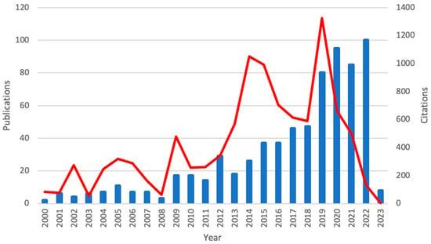
Figure 1: Potential impact of socioeconomic factors on the hospitality industry
(Source: Cooke et al. 2022)
The pandemic instance has generated a drastic impact on industry to restrict the lockdown factor and shift of business model. The demography shift involves the alteration in family’s fracture and using population for the change in cultural diversity to enhance the experiences and services of customers. The hospitality industry needs to adopt The preferences and accommodation of diverse groups for the increase in awareness issues for environmental and sustainable practices that shape the customer values. Moreover, the hospital industry has forecasted the pressure of adopting eco-friendly initiative in terms of reducing carbon footprint for an implementation of Sustainable practices in terms of attracting the conscious policies. The implementation of various government policies and the shift of regulation has created a Geo political dynamics to enhance the international tourism value based on a modern business operation facility (Cooke et al. 2022). The particular fact of political instability and regulatory alteration needs to affect the investment and growth for cultural norms in terms of expecting a proper preference. The determination of trends in food tourism and experimental travel has created a unique value and personalised experience for the offering of hospitality establishment in terms of emphasizing the Wellness impact and services of consumer seeking options. The growth in the emphasis of Wellness and health has created an essential impact on Hospitality Services to align with healthy Lifestyle based on the influence of food and accommodation.

The performance metrics for adapting the socio-economic alterations
Adaptation of socio economic changes has created a modern dynamic in the hospitality industry that needs a particular establishment of performance mattresses to align with the dynamic factor of this sector. The application of these performance metrics is essential for decision making as well as strategic planning (Van Doorn and Chen, 2021). The monitoring of various Occupancy rates deals with the god of modern demand and accommodation that fluctuate the intermediate shift and customer behaviour. The fluctuations and indication of shift has generated a particular tracking of customer satisfaction based on the review and survey to alter the guest experience based on the successful adaptation of circumstances.

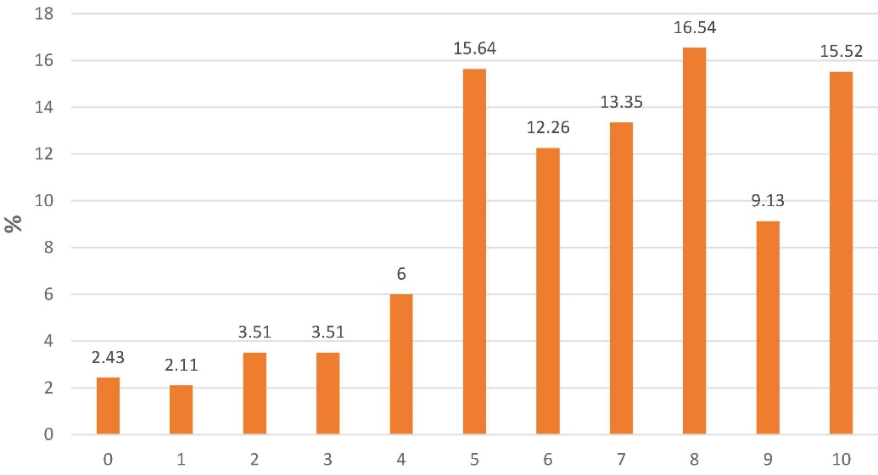
Figure 2: Socioeconomic determinants to impact the alterations in Hospitality industry
(Source: Van Doorn and Chen, 2021)
Moreover, on the other side the productivity matrices act as a major factor in terms of optimising the staffing level and controlling of higher productivity value. The financial indicator and evaluation of customer strategy act as a major consumption pattern to derive the economic downturn and market share for the comparison of competitive landscape. Moreover, the particular indication of challenges based on the retaining of economic uncertainty acts as a major factor of booking percentage to adopt the particular insight of technological advancement (Mejjad et al. 2022). The improvement and response of alteration has provided sustainable practices in the CSR initiative to provide a community engagement that reflects on the environmental and social responsibility. The particular adaptation on implementation of performance metrics deals with the inventory turnover for supplier performance in terms of determining the waste reduction and community engagement.

The relationship between employee well-being and productivity based on the socio-economic challenges
Socioeconomic problems, such as economic downturns or uncertainty, can cause financial stress among employees. Financial stability has a direct influence on well-being, and employees who are under financial difficulty may be distracted or less engaged at work. Addressing financial well-being with supporting measures such as financial education or assistance programmes might boost productivity. Socioeconomic issues might impact job demands and expectations. Employees under economic pressure may be forced to work longer hours, resulting in burnout and a decrease in general well-being. Striking a work-life balance, made possible by flexible work arrangements, may improve well-being while also contributing to higher productivity by avoiding burnout. Socioeconomic barriers may limit access to healthcare resources (Druzhynina et al. 2020). Organisations that engage in complete wellness programmes, including mental health assistance, can reduce the negative impact of socioeconomic issues on employee well-being. Improved health and well-being are frequently associated with improved productivity because people are better prepared to deal with working pressures. Economic uncertainty and job instability have a profound impact on employee well-being. Organisations that prioritise open communication and implement job security safeguards can help to create a healthy work environment. Job satisfaction, which is strongly related to well-being, is a significant predictor of productivity. Employees who are satisfied with their jobs are more inclined to put up their best efforts.
The rise of remote labour, fueled by socioeconomic causes such as the COVID-19 epidemic, has its own set of issues. Isolation, blurring work-life boundaries, and a lack of social engagement can all influence one's well-being. Organisations that address these difficulties proactively, such as via remote work rules, mental health assistance, and virtual team-building activities, can preserve or improve employee well-being and, as a result, productivity. Socioeconomic issues might disproportionately affect people from various origins. Organisations that support diversity and inclusion programmes foster a healthy working culture (Rasul et al. 2021). Inclusive practices provide a sense of belonging and have a beneficial influence on employee well-being by fostering a workplace in which all employees feel appreciated and supported, resulting in higher productivity. The relationship between the productivity and employee will be deals with tight facts of socioeconomic issues based on the exhibition on various inclusive programs. The organisation needs to recognise the difficulties on a proactive base to generate a workplace involvement in terms of privatizing the issues of employees in a particular upset of negative effects. Moreover the productivity of altering the social economic condition acts as a major factor in terms of generating a positive relationship between employee and Organisation success for the administration of socioeconomic issues.

Evaluation and Conclusion
The conclusions of this study will highlight how economic decisions play a significant role in Downtown in reducing consumer spending and travel patterns, which have an influence on the demand for various hospitality services. Based on the economic constraints of diverse persons, the company must establish a discretionary element for hotel booking and restaurant visits as a linked activity in this industry. Disparities in income distribution have prompted customers to seek service accommodations based on the narrowing of the wealth gap, resulting in a special need for budget-friendly values. The demographic shift entails changing the structure of families and using population to reflect changes in cultural variety in order to improve customer experiences and services. The hotel sector must adapt varied groups' preferences and accommodate them in order to raise knowledge about environmental and sustainable practices that affect client values. Furthermore, the hospital business has anticipated the need to undertake eco-friendly initiatives aimed at lowering carbon footprints and implementing sustainable practices in order to attract aware policies. Financial stability has a direct impact on well-being, and employees experiencing financial difficulties may be distracted or less engaged at work. Addressing financial well-being through supportive measures such as financial education or assistance programmes may increase productivity. Socioeconomic factors may influence employment demand and expectations. Employees under economic pressure may be obliged to work longer hours, resulting in burnout and a decline in overall well-being. Striking a work-life balance, enabled by flexible work arrangements, may promote well-being while also contributing to improved productivity by preventing burnout.

References
Cooke, F.L., Dickmann, M. and Parry, E., 2022. Building sustainable societies through human-centred human resource management: Emerging issues and research opportunities. The InTernaTIonal Journal of human resource managemenT, 33(1), pp.1-15.
Druzhynina, V., Likhonosova, G., Lutsenko, G. and Kushal, I., 2020. Innovative technology in terms of socio-economic value diffusion: Accounting and analytical support. European Journal of Sustainable Development, 9(3), pp.476-476.
Fatima, T. and Elbanna, S., 2023. Advancing sustainable performance management in the hospitality industry: A novel framework based on a health-inclusive balanced scorecard. Tourism Management Perspectives, 48, p.101141.
Mejjad, N., Rossi, A. and Pavel, A.B., 2022. The coastal tourism industry in the Mediterranean: A critical review of the socio-economic and environmental pressures & impacts. Tourism Management Perspectives, 44, p.101007.
Rasul, G., Nepal, A.K., Hussain, A., Maharjan, A., Joshi, S., Lama, A., Gurung, P., Ahmad, F., Mishra, A. and Sharma, E., 2021. Socio-economic implications of COVID-19 pandemic in South Asia: emerging risks and growing challenges. Frontiers in sociology, 6, p.629693.
Rydzik, A. and Kissoon, C.S., 2022. Decent work and tourism workers in the age of intelligent automation and digital surveillance. Journal of Sustainable Tourism, 30(12), pp.2860-2877.
Shibata, S., 2022. Digitalization or flexibilization? The changing role of technology in the political economy of Japan. Review of International Political Economy, 29(5), pp.1549-1576.
Van Doorn, N. and Chen, J.Y., 2021. Odds stacked against workers: datafied gamification on Chinese and American food delivery platforms. Socio-Economic Review, 19(4), pp.1345-1367.

