UNIVERSITY OF WALES TRINITY SAINT DAVID
LONDON CAMPUS
Assignment 2
Learning in the Digital Era
Video Link: https://www.youtube.com/watch?v=yx8SppCcw-w

Module Name: Learning in the Digital Era
Module Code: ACCA 4025

Student Name:Ahmad Nooraldeen Ahmad
Student ID:2530993
Group:1

Lecturer’s Name: Name: Koushik Modak

Table of Contents
Introduction 2
Main Body 2
Conclusion 9
References 9

Introduction
This reflection report is on my personal and professional growth as a learner with three related tasks for Assignment 2. This is a self-evaluation of strengths and weaknesses, a Professional Development Plan (PDP) established on the concept of SMART goals and an analysis of the Unit 4 Topic 3: Unpacking Experiences Summary. Throughout the report, Gibbs' Reflective Cycle is employed to examine the experiences and show how reflection can be utilised as a learning tool to encourage ongoing learning, growth and development in relation to further academic and professional objectives.

Main Body
The main body demonstrates an understanding of the subject matter by using Gibbs' Reflective Cycle to analyse my self-evaluation, create a Professional Development Plan and a summary of Unit 4 Topic 3: Unpacking Experiences. It shows how reflective practice in a structured manner can be employed to explore areas of strength and identify areas for improvement and future development.

Video Link: https://www.youtube.com/watch?v=yx8SppCcw-w

Slide 1 COVER PAGE
Slide 2 CONTENTS

Slide 3 INTRODUCTION

Slide 4 MAIN BODY
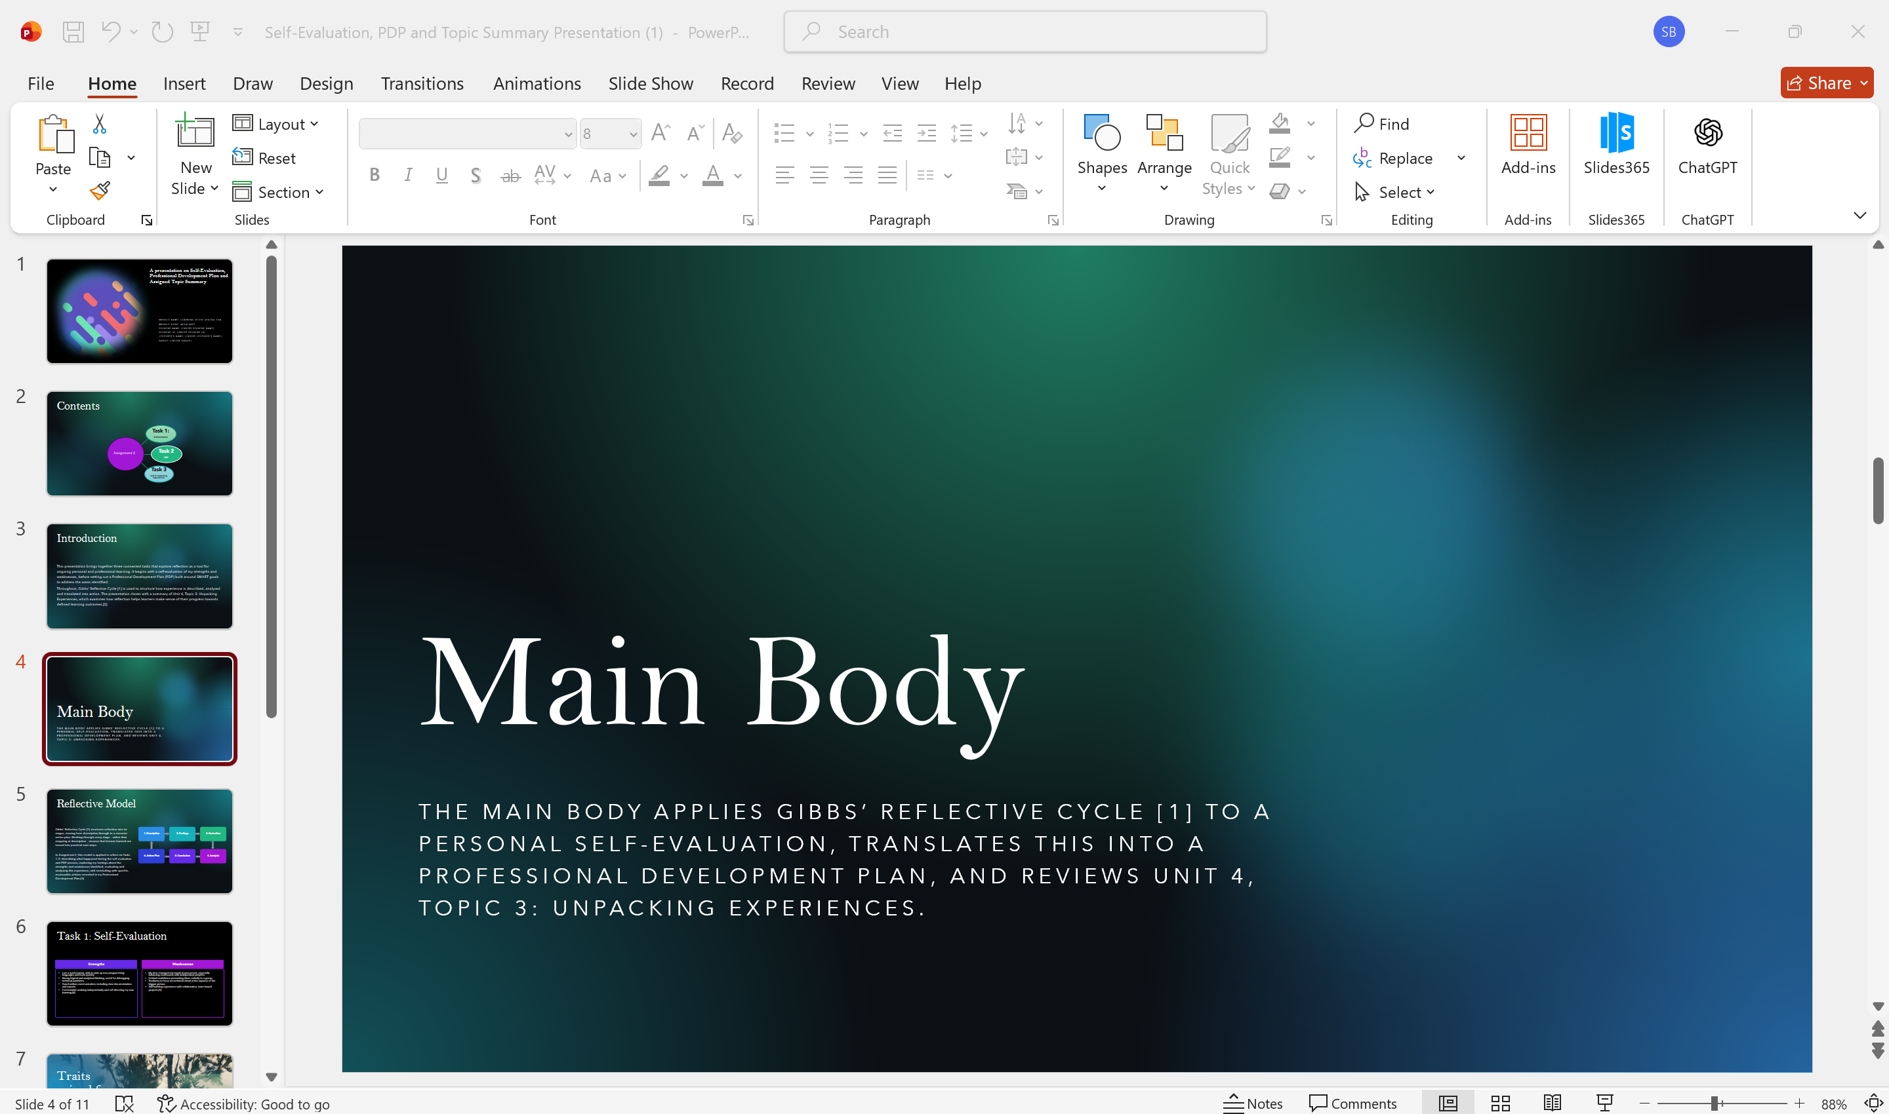

Slide 5 GIBB’s REFLECTIVE MODEL
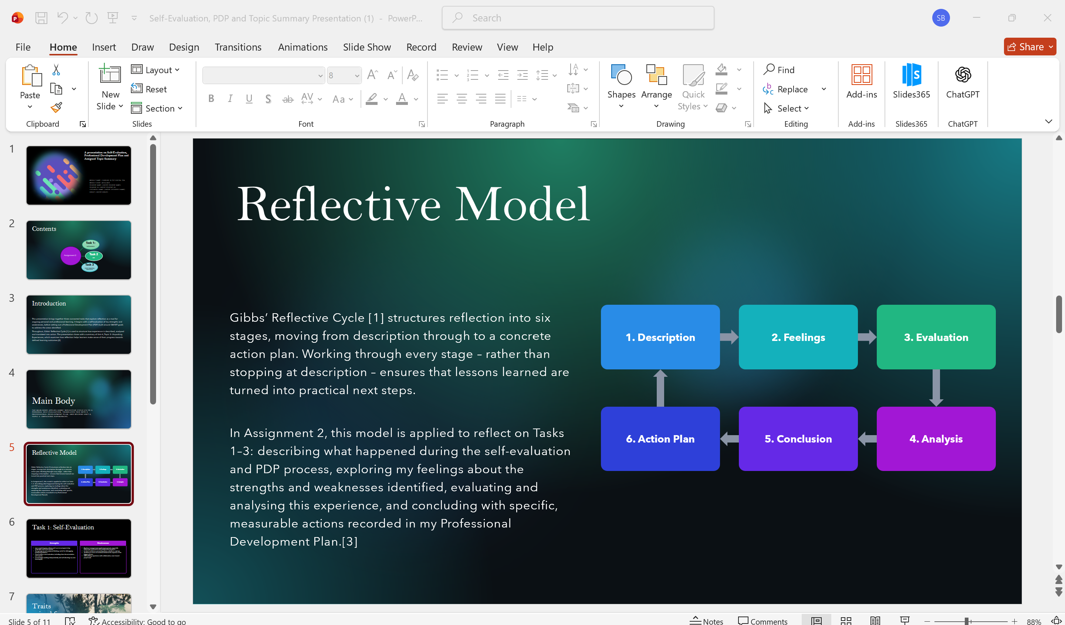
Brief explanation:
The Gibbs Reflective Cycle [1] is a structured approach to reflection that can be broken down into six stages: description, feelings, evaluation, analysis, conclusion, and action plan. The model guides people to reflect on their lived experiences, analyse them critically, and turn it to actionable learning to make it better next time. For Assignment 2, Gibbs’ Reflective Cycle [1] will be used as a focusing device to assess my strengths and weaknesses, in relation to my learning and design specific and measurable personal and professional development actions.[3]

Slide 6 TASK 1: SELF EVALUATION
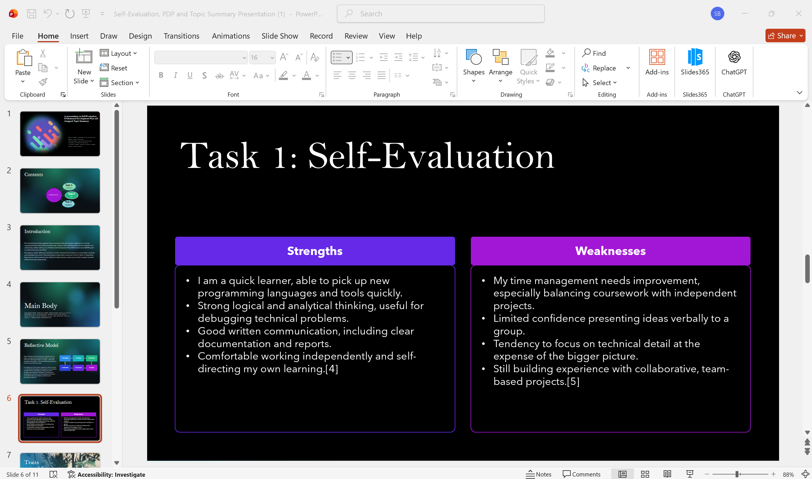

Brief explanation:
A personal SWOT analysis was used as the basis for my own self-evaluation, which enabled me to see what my strengths and weaknesses are in relation to the career prospect of Web Development. I am a quick learner, a good logical analyst, have good communication ability in written format and can solve technical problems easily, which helps with programming and technical problem-solving [4]. My pitfalls are time management, lack of confidence in public speaking and limited experience in a collaborative software development environment. Acknowledging these areas gives me a solid “grounding” to be able to see where and how to dedicate time for personal and professional growth and what skills I need to build in my Professional Development Plan[5].

Slide 7
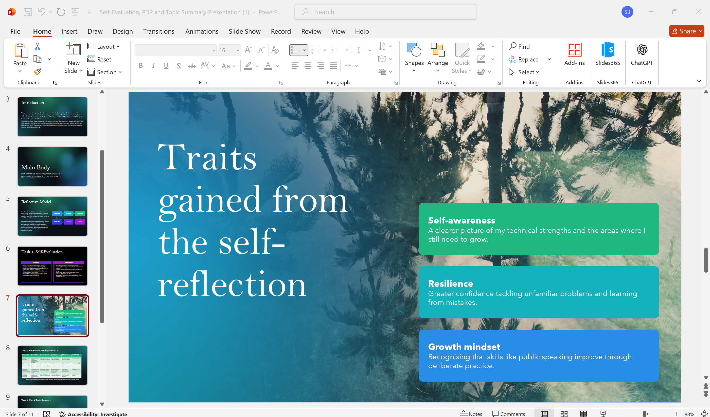


Brief explanation:
The self-evaluation process enabled me to develop some personal attributes that facilitate my learning and career development. Perhaps the most important aspect of being self-aware is being able to figure out where you are strong and where you need to work on your weaknesses. Being resilient gave me more confidence in problem-solving unfamiliar challenges and learning from my errors, and having a growth mindset ensured that I knew that skills like public speaking, teamwork, etc. could be developed through practice and reflection. These traits are excellent stepping stones to the growth of continuous learning and an excellent basis for the achievement of the goals listed in my Professional Development Plan.

Slide 8 PROFESSIONAL DEVELOPMENT PLAN
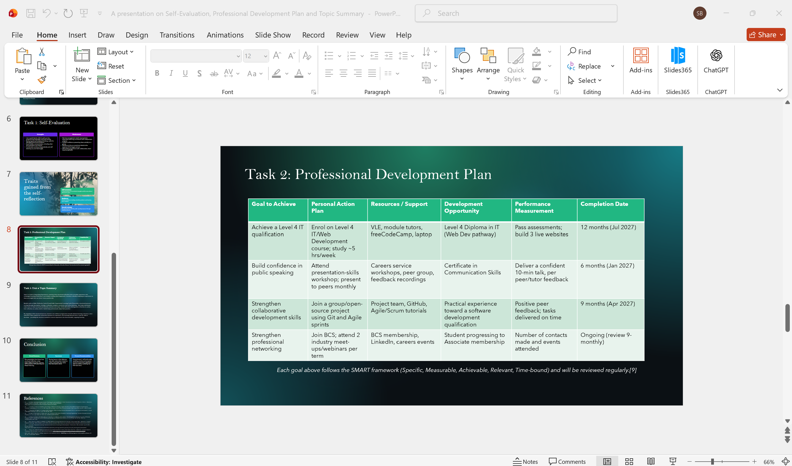
Brief explanation:
My Professional Development Plan is structured around the SMART model [9], which makes sure that each goal is tailored to criteria that are specific, measurable, achievable, relevant and time-bound. My main aims with the plan will be to complete the Level 4 IT qualification, build confidence in public speaking, enhance tool use in collaborative software development and broaden my professional network. All goals have a clear plan of action, resources, support, measurable performance indicators, and target completion date. Regular monitoring and review will take place to monitor progress and feed into continuous professional and personal development where appropriate.

Slide 9 UNIT 4 TOPIC SUMMARY
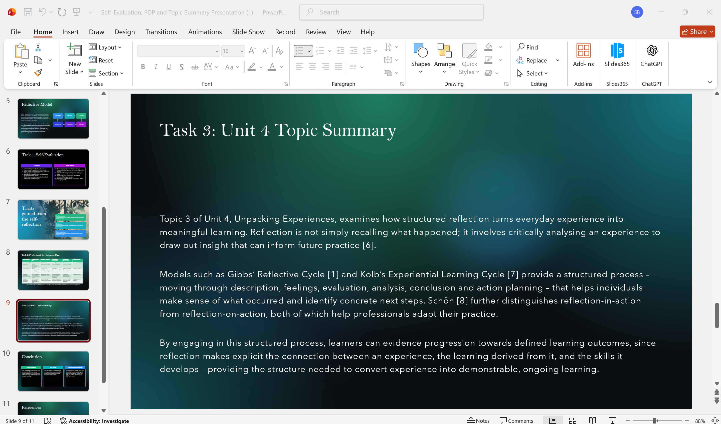
Brief explanation:
I chose Topic 3: Unpacking Experiences in Unit 4 for this presentation because it demonstrates how structured reflection offers opportunities for meaningful learning and makes experiences meaningful. The focus of the topic is on the act of reflecting on an experience and not just recalling the experience [6]. Gibbs' Reflective Cycle [1] and Kolb's Experiential Learning Cycle [7] are two models that present a cycle and guide the individual to reflect on an experience they have just completed and to make sense of the experience, identify a lesson learnt and then formulate practical steps for the individual to take to improve the experience moving forward. The practice of reflective practice, championed by Schön [8], further underscores the significance of learning both in the experience as well as in reflection of more general personal and professional growth.

Slide 10 CONCLUSION

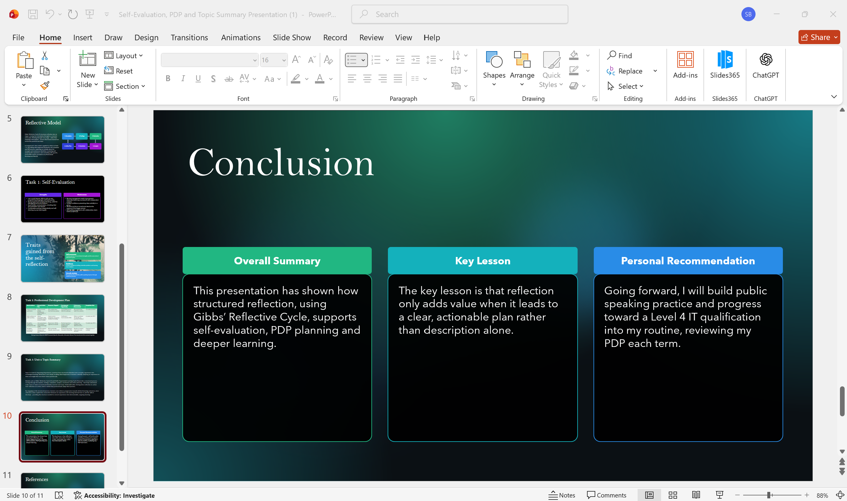

Brief explanation:
In summary, in this presentation, Gibbs' Reflective Cycle was shown to be a tool for self-evaluation, Planning for Professional Development (PDP) plans and ongoing learning. The self-evaluation process was useful to be able to see what I am good at and how to improve it for future development goals; the PDP gave me a clear and attainable goal to aim for. The important point is that reflection should only be useful if it results in tangible practice and quantifiable Learning Outcomes. I will continue to develop my public speaking skills further, study towards level 4 IT and regularly check my Professional Development Plan to ensure personal and professional development.

Slide 11
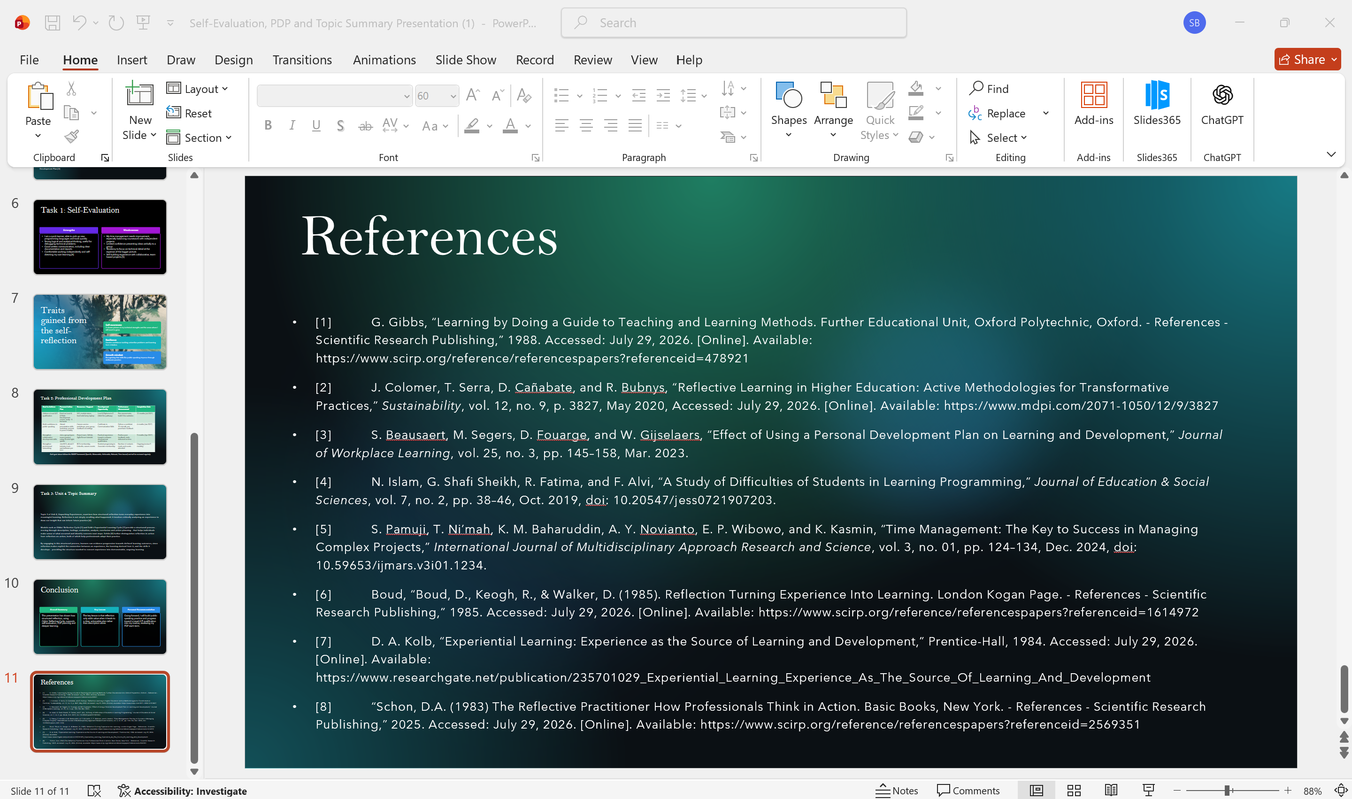

Conclusion
In conclusion, this report has shown the value of reflection for personal and professional growth, development and learning, including self-evaluation, goal setting, and continued learning. Using Gibbs' Reflective Cycle, I have determined my strengths and weaknesses, created my own Professional Development Plan in the SMART format and looked back on what I have learned from tackling problems from experience. Overall, the report emphasises the importance of reflection and the need to take action and strive for continued growth and development as a web developer and lifelong learner.
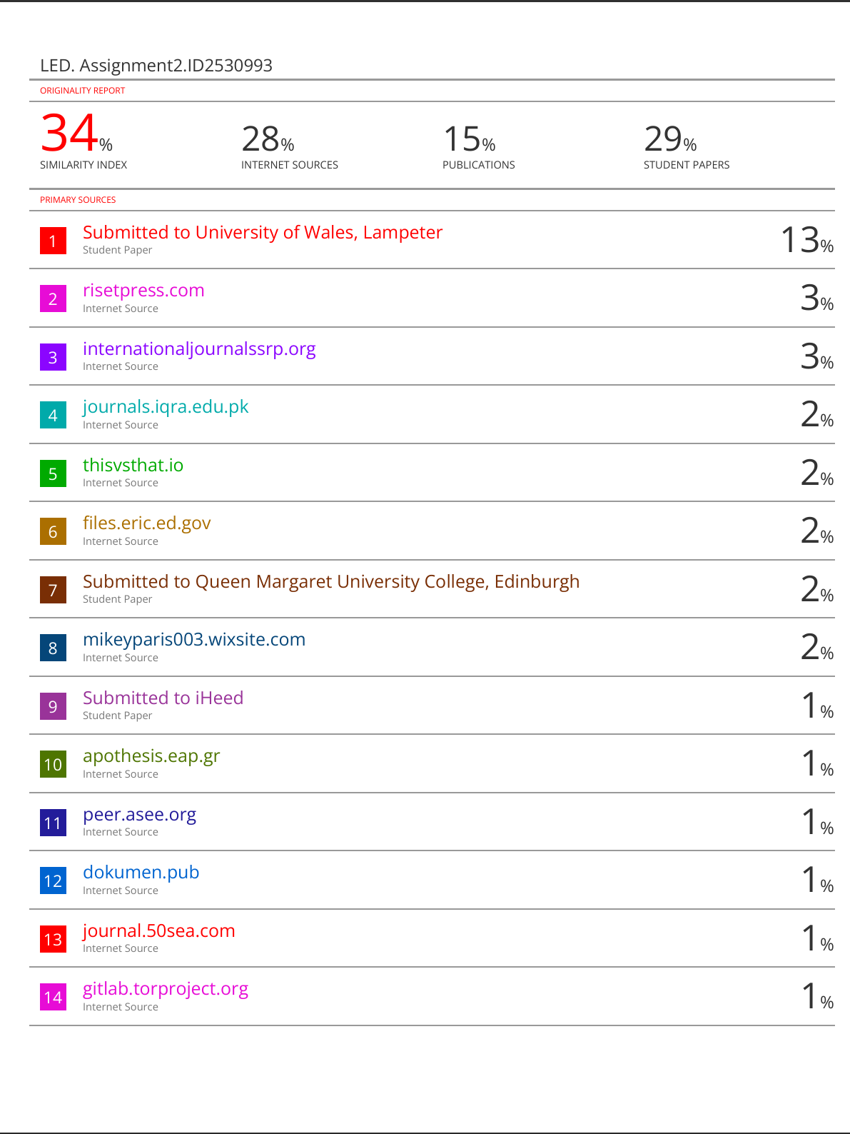

References

- [1] G. Gibbs, “Learning by Doing a Guide to Teaching and Learning Methods. Further Educational Unit, Oxford Polytechnic, Oxford. - References - Scientific Research Publishing,” 1988. Accessed: July 29, 2026. [Online]. Available: https://www.scirp.org/reference/referencespapers?referenceid=478921
- [2] J. Colomer, T. Serra, D. Cañabate, and R. Bubnys, “Reflective Learning in Higher Education: Active Methodologies for Transformative Practices,” Sustainability, vol. 12, no. 9, p. 3827, May 2020, Accessed: July 29, 2026. [Online]. Available: https://www.mdpi.com/2071-1050/12/9/3827
- [3] S. Beausaert, M. Segers, D. Fouarge, and W. Gijselaers, “Effect of Using a Personal Development Plan on Learning and Development,” Journal of Workplace Learning, vol. 25, no. 3, pp. 145–158, Mar. 2023.
- [4] N. Islam, G. Shafi Sheikh, R. Fatima, and F. Alvi, “A Study of Difficulties of Students in Learning Programming,” Journal of Education & Social Sciences, vol. 7, no. 2, pp. 38–46, Oct. 2019, doi: 10.20547/jess0721907203.
- [5] S. Pamuji, T. Ni’mah, K. M. Baharuddin, A. Y. Novianto, E. P. Wibowo, and K. Kasmin, “Time Management: The Key to Success in Managing Complex Projects,” International Journal of Multidisciplinary Approach Research and Science, vol. 3, no. 01, pp. 124–134, Dec. 2024, doi: 10.59653/ijmars.v3i01.1234.
- [6] Boud, “Boud, D., Keogh, R., & Walker, D. (1985). Reflection Turning Experience Into Learning. London Kogan Page. - References - Scientific Research Publishing,” 1985. Accessed: July 29, 2026. [Online]. Available: https://www.scirp.org/reference/referencespapers?referenceid=1614972
- [7] D. A. Kolb, “Experiential Learning: Experience as the Source of Learning and Development,” Prentice-Hall, 1984. Accessed: July 29, 2026. [Online]. Available: https://www.researchgate.net/publication/235701029_Experiential_Learning_Experience_As_The_Source_Of_Learning_And_Development
- [8] “Schon, D.A. (1983) The Reflective Practitioner How Professionals Think in Action. Basic Books, New York. - References - Scientific Research Publishing,” 2025. Accessed: July 29, 2026. [Online]. Available: https://www.scirp.org/reference/referencespapers?referenceid=2569351
- [9] R. Ayoub, “SMART Objectives: A Strategic Approach to Achieving Business Success,” SMART Objectives: A Strategic Approach to Achieving Business Success, Jan. 2017, doi: 10.5281/zenodo.146422 .

