ADVANCED SOFTWARE DEVELOPMENT
Object-oriented Programming with C++
ACCB5011

Rhys Davies | 2008896
Contents
Introduction 3
OOP Concepts and Uses in the Flight Booking System Application 3
What is Object Oriented Programming 3
Classes & Objects 3
Encapsulation 4
Abstraction 4
Inheritance 5
Polymorphism 5
Class Design Concept and Class Diagram 7
Test Plan for Flight Booking System 8
User Manual 9
Getting Started 9
Using the Flight Booking System 9
Search Flights 9
Passenger Details 10
Booking Confirmation 10
Manage Booking 10
Error Messages 10
Application Demonstration 12
Conclusion 13
Netacad C++ Essentials Course 14
References 15

Figure 1 - Classes and Objects 4
Figure 2 - Example: Class and Objects 4
Figure 3 - Example: Encapsulation 4
Figure 4 - Example: Abstraction 5
Figure 5 - Initial Concept of Flight Booking System 7
Figure 6 - Class Diagram 7
Figure 7 - Programme Main Menu 9
Figure 8 - Search Flights and View Flight Details 9
Figure 9 - Enter Passenger Details 10
Figure 10 - Booking Confirmation and Update Details 10
Figure 11 - Manage Booking (without a booking being made) 10
Figure 12 - Error Message: Invalid Input Main Menu 11
Figure 13 - Error Message: Invalid Date Format 11
Figure 14 - Error Message: Invalid Input for Window Seat 11
Figure 15 - Error Message: Passport Number Too Long 11
Figure 16 - Error Message: Passport Number Numerical Input Only 11
Figure 17 - Netacad Programming Essentials in C++ 14

Introduction
The focus of this assignment is to create a simple, user-friendly flight booking application, applying the concepts learned in Object-oriented programming (OOP) with C++. This report will first look at OOP concepts and show their use in the application.
The following sections look at the fundamental OOP concepts and explain how these are applied in the application. A concept diagram and class diagrams will supply a visual representation relationship between different classes that form the main functions of the application.
A test plan will detail the criteria for evaluating the application's performance to check that it functions as expected. A user guide will be provided to explain how to use the application along with a video showcasing the application's features.

OOP Concepts and Uses in the Flight Booking System Application
The following section will look at various oops concepts and how these were implemented in the flight booking programme.

What is Object Oriented Programming
Object Oriented Programming (OOP) is a way of structuring programmes around objects which are like packages of data that have a defined set of features. Objects can be anything from real-world things like cars, processes, people. OOP is often used in manufacturing as it is easy to create programmes that reflect manufacturing processes. Other benefits of using OOP are being able to reuse bits of code to scale programs whilst also making efficient use of memory meaning the programmes run quickly. [1]

Classes & Objects
Classes describe what an object will be like. A class is usually described as being a blueprint for an object but not the object itself. It consists of:
- Attributes
- Functions
A common metaphor used help describe classes in programming is a car. A class named car may have attributes such as:
  - Fuel Type
  - Wheels
  - Top Speed
  - Lights
  - Seats
The items above may be common to all cars, but different car brands which are objects that are derived from a class may use attributes in different ways. [2]
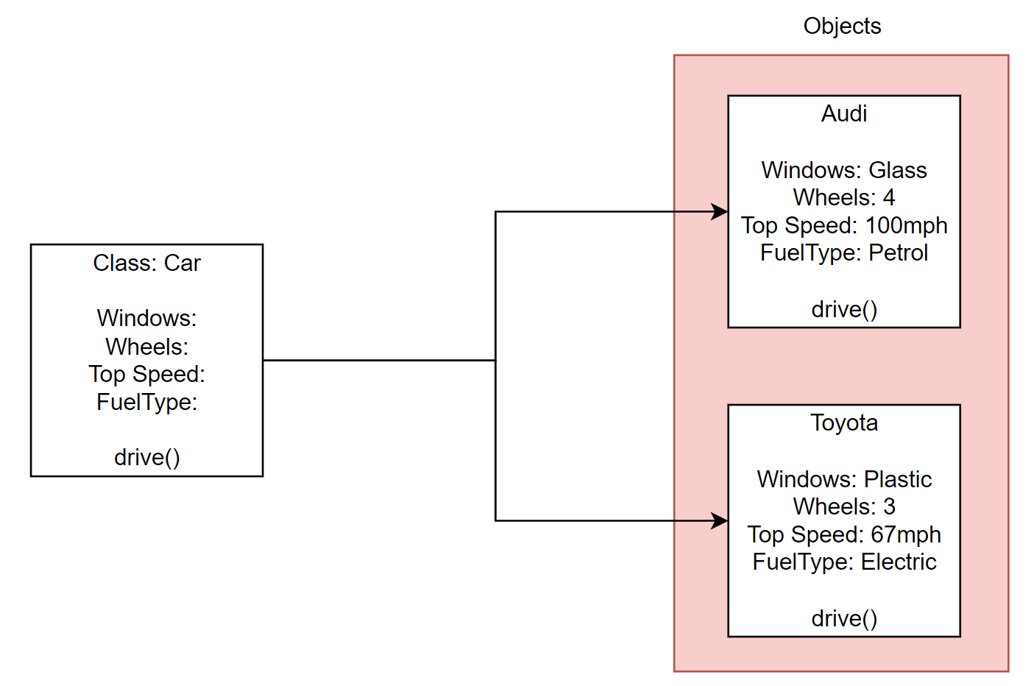
Figure 1 - Classes and Objects
In the program there an example of where classes and objects are used are the flight booking class where it uses objects from flight and passenger to retrieve flight and passenger details.
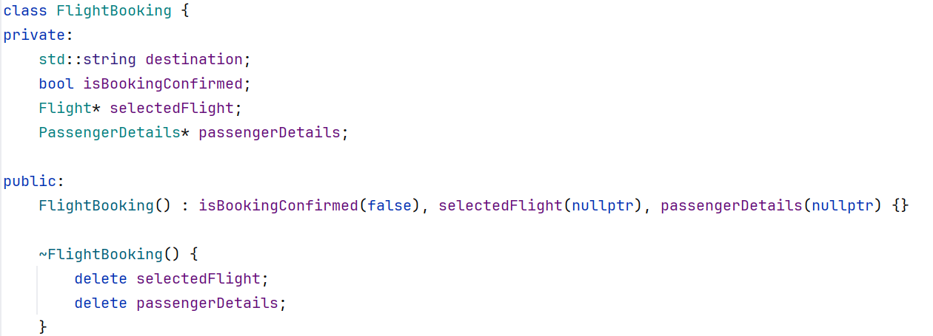
Figure 2 - Example: Class and Objects

Encapsulation
This is the method of hiding important information inside and object and exposing only the necessary information to improve security and avoid any unwanted data corruption.
“Other objects do not have access to this class or the authority to make changes. They are only able to call a list of public functions or methods.” [1]
In the flight booking programme, The Flight class encapsulates details about a flight, including time, origin, and airline.
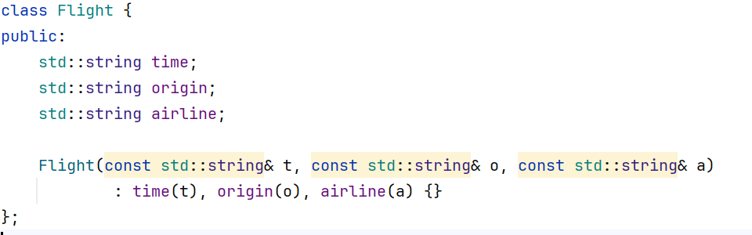
Figure 3 - Example: Encapsulation

Abstraction
The purpose of abstraction is to conceal unnecessary details from the user to enable them to create more complex logic in addition to that provided. There are two types of abstraction in OOPS which are Data Abstraction and Process Abstraction. [3]
In the flight booking programme. Examples include the Flight and PassengerDetails classes where they expose essential methods such as ‘enterDetails’ and ‘displayDetails’ but hide the execution details.
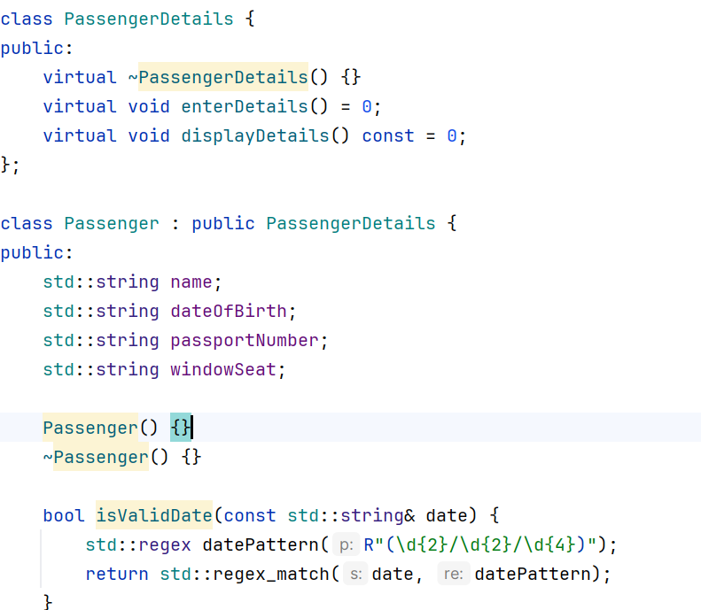
Figure 4 - Example: Abstraction

Inheritance
Inheritance promotes code reusability by creating relationships between classes, enabling a derived class to inherit the properties and behaviours from a base class.
“It’s a programming procedure that allows you to reuse code by referencing the behaviours and data of an object. In other words, a class that inherits from another class shares all the attributes and methods of the referenced class.” [4]
In the flight booking programme. The Passenger class inherits from the PassengerDetails class. This relationship allows Passenger to reuse the common methods defined in PassengerDetails but carry out its own functionality.
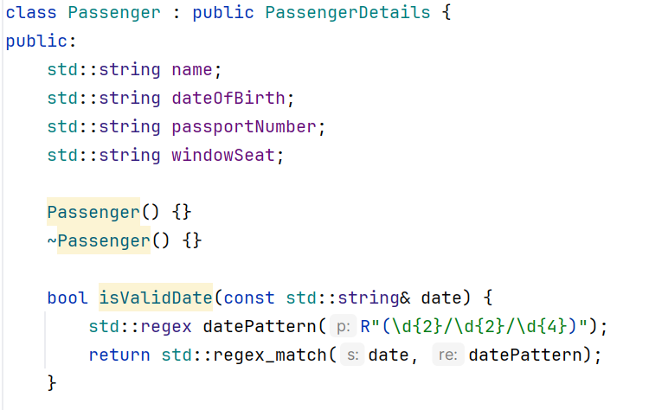

Polymorphism
Polymorphism is where objects which are seemingly the same are being used to perform in separate ways. This enables flexibility in the code It enables flexibility by allowing methods to be overridden in derived classes. [5]
A common descriptor of this can be having a base class of animal with a function to make a sound. Several derived classes may be used such as cow, cat, and dog all with the specific override to enable them to produce the correct noise.
In the flight booking programme, virtual functions are used in the PassengerDetails class. The Passenger class overrides the virtual functions, allowing it to supply a more specific means of entering and displaying details set out in the base class.
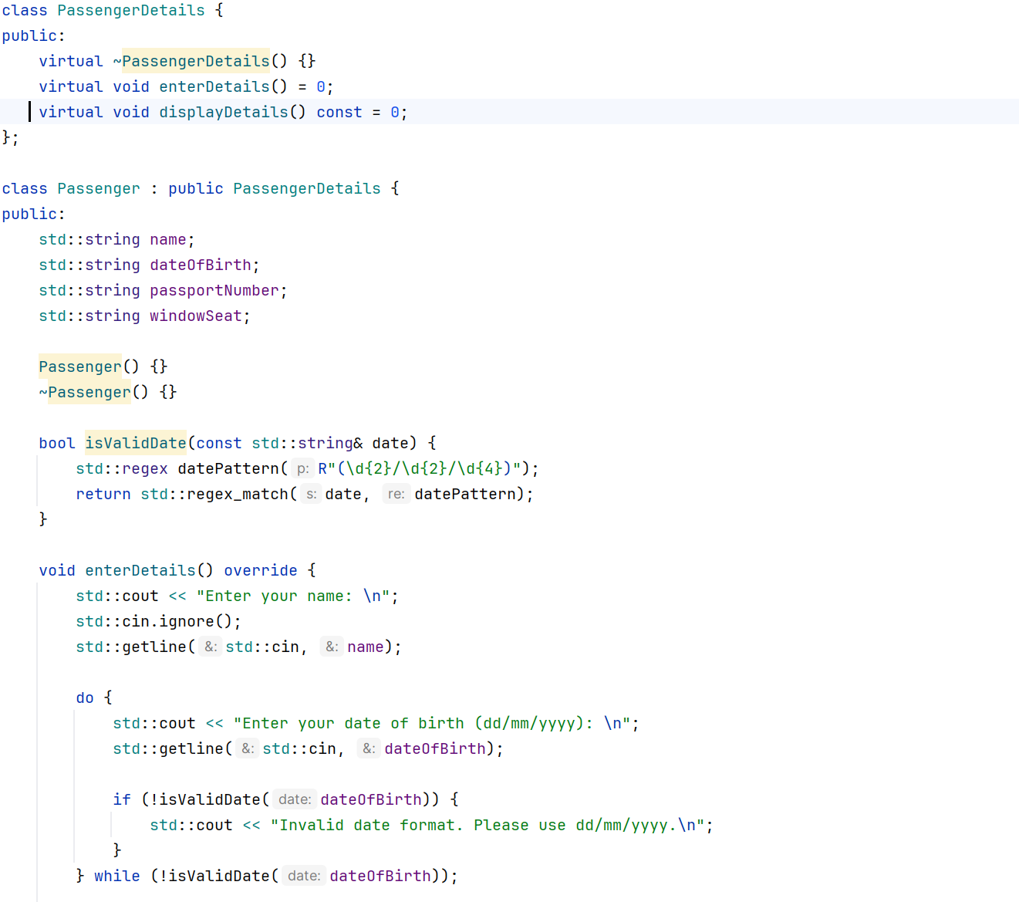

Class Design Concept and Class Diagram
The figure below was created in the design and concept stage of the project to better understand how the application would function practically.
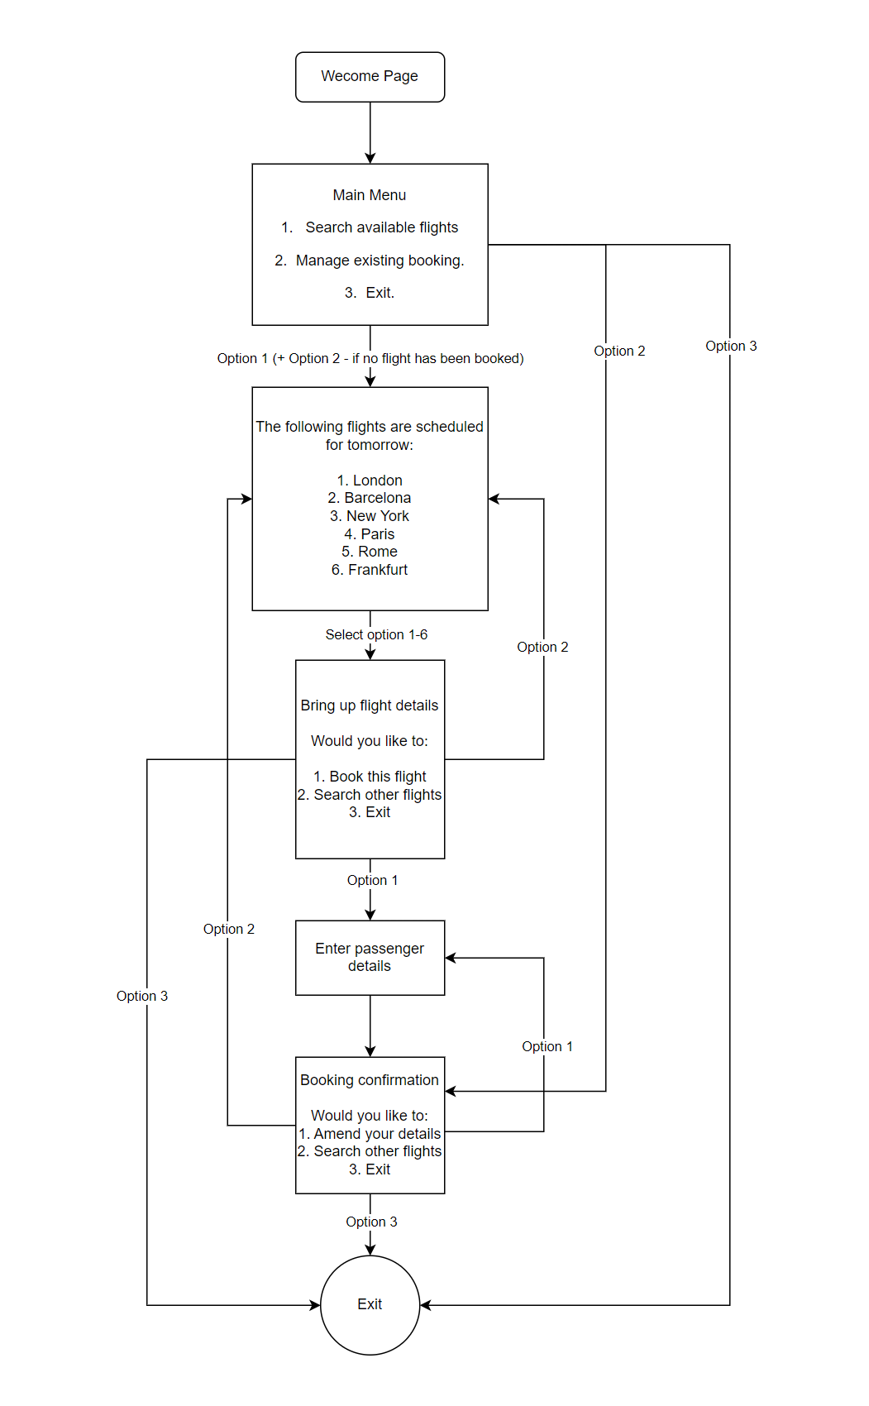
Figure 5 - Initial Concept of Flight Booking System
The figure below shows the relationships between to classes in the application.
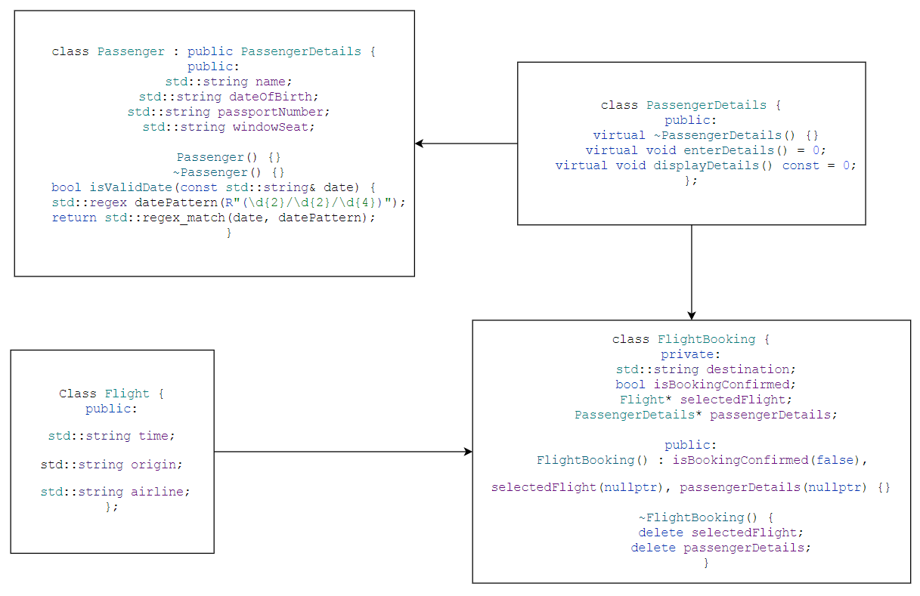
Figure 6 - Class Diagram

Test Plan for Flight Booking System
Item | Objective | Steps | Expected Outcome | Image of actual outcome
Search Available Flights | Confirm that the user can search and select a flight. | - Execute the programme.  - Choose option 1 to search available flights.  - Enter a valid flight choice (1-5) when prompted. | The selected flight details should be displayed. | 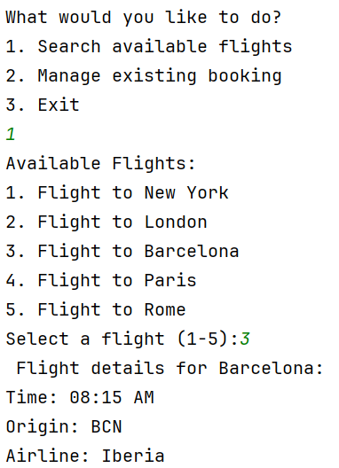
Enter Passenger Details | Confirm that passenger details can be entered correctly. | - After selecting a flight, enter passenger details.  - Confirm valid input for each field. | Passenger details should be accepted without errors. | 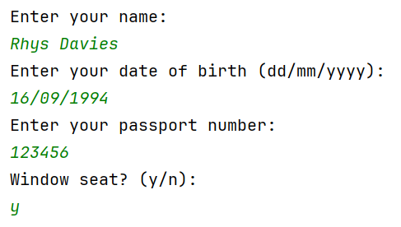
Booking Confirmation | Confirm that booking confirmation works as expected. | - Enter valid passenger details.  - Confirm the booking. | Booking confirmation message should be displayed. | 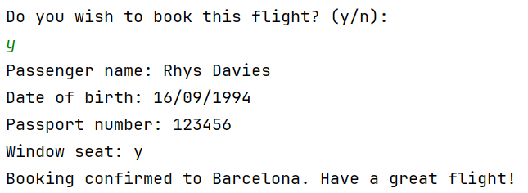
Update Booking | Confirm that a user can update their booking details. | - Confirm a booking.  - Choose to update details.  - Enter new passenger details. | Updated details should be displayed after confirmation. | 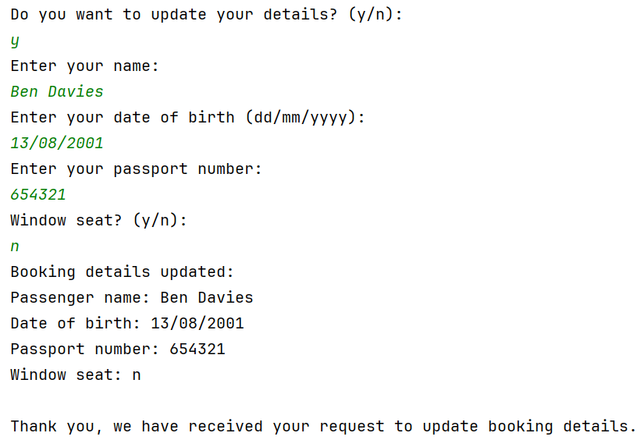
Manage Existing Booking | Test the functionality to manage an existing booking. | - Confirm a booking.  - Choose option 2 to manage the booking. | User should be able to update booking details. | 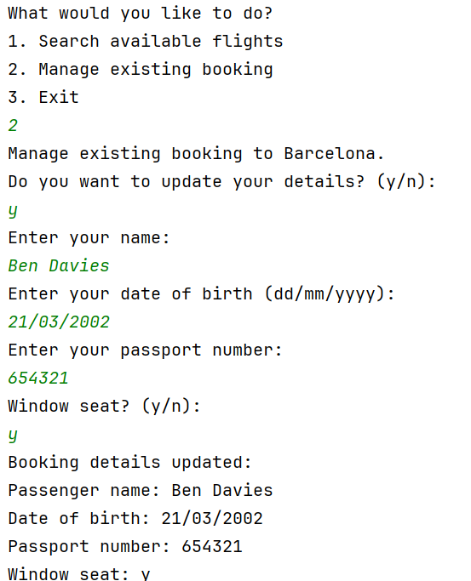
Exit | Confirm the programme can be terminated properly. | - Choose option 3 to exit the programme. | Programme should exit without errors. | 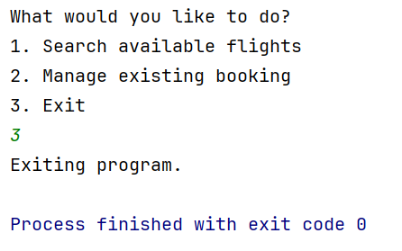
Boundary Testing | Test the programme's behaviour at the boundaries. | - Enter the minimum and maximum valid inputs where applicable. | Programme should handle boundary values correctly. | 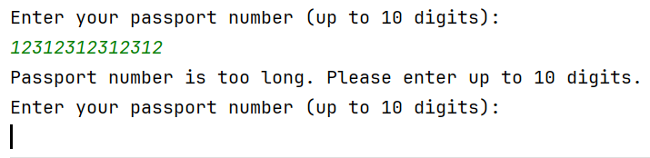

User Manual
The Flight Booking System is a C++ program designed to facilitate the booking and management of flight reservations. This system allows users to:
  - Search and select available flights.
- Enter passenger details.
- Confirm and manage flight bookings.

Getting Started
Before getting started, you must ensure that you have a suitable C++ code compiler. To save installing, it is possible to compile the code using Programiz C++ Online Compiler: https://www.programiz.com/cpp-programming/online-compiler/

Using the Flight Booking System
When you initially run the program, you will be presented with the main menu which is made up of three options:
- Search available flights.
- Manage existing booking.
- Exit programme.
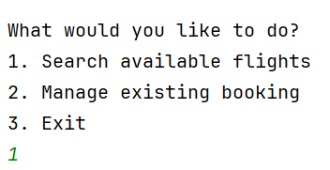
Figure 7 - Programme Main Menu

Search Flights
To search for flights, select ‘Search available flights’ from the main menu and choose a destination by entering a number between 1-5 which will present the flight details such as time, origin, and airline details.
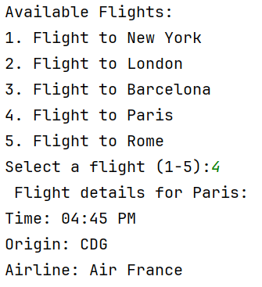
Figure 8 - Search Flights and View Flight Details

Passenger Details
Once you have chosen your flight, you will be asked to enter your details as follows:
- Name
- Date of birth (dd/mm/yyyy)
- Passport number (up to 10 digits)
- Window seat preference (y/n)
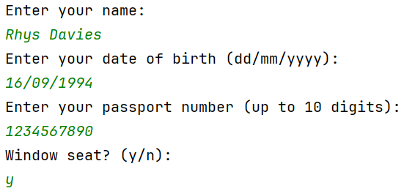
Figure 9 - Enter Passenger Details

Booking Confirmation
Once the details have been entered you will be asked to confirm the booking by entering either 'y' or ‘n’. Selecting ‘y’ will give you a choice to update your details if needed before returning to the main menu.
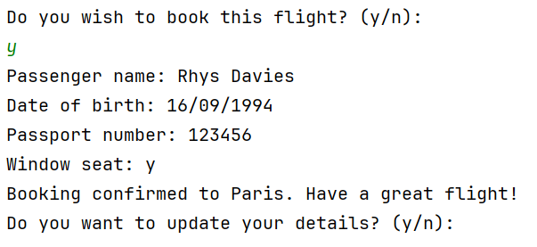
Figure 10 - Booking Confirmation and Update Details

If you select ‘n’ you will be taken back to the main menu.

Manage Booking
If you have made a booking, you may use the manage booking choice on the main menu to edit your details. If a booking has not been made in the current session, you will be prompted to search for a flight.
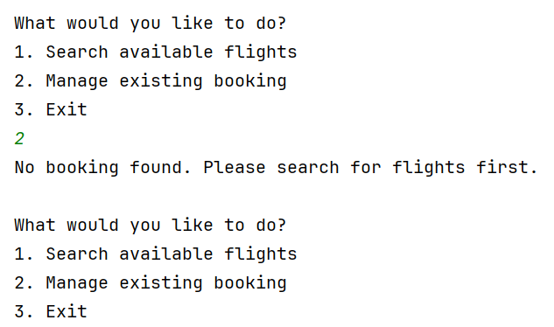
Figure 11 - Manage Booking (without a booking being made)

Error Messages
Invalid choice: The program will display this message for an invalid menu choice.
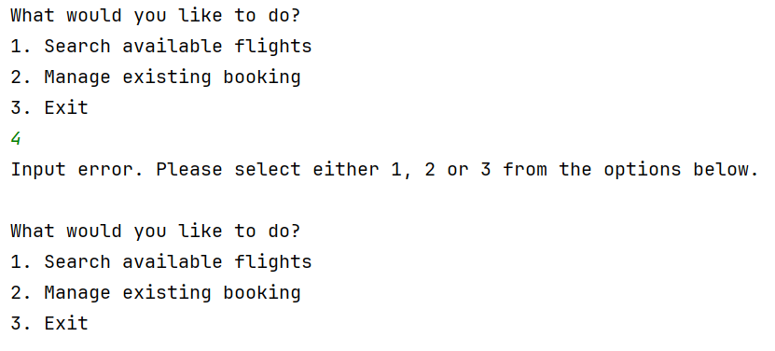
Figure 12 - Error Message: Invalid Input Main Menu
Invalid date format: Shown if the entered date of birth does not match the expected format.
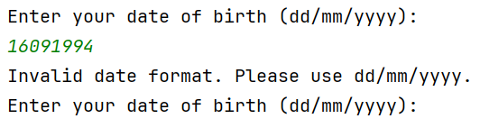
Figure 13 - Error Message: Invalid Date Format
Invalid input: Displayed when an invalid response is given for yes/no questions for window seat choice.
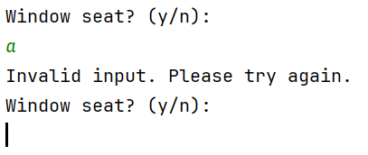
Figure 14 - Error Message: Invalid Input for Window Seat
Invalid input: Too many digits when inputting passport number.
Figure 15 - Error Message: Passport Number Too Long
Invalid input: Numerical value needed for passport number.
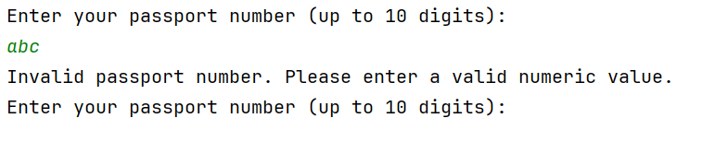
Figure 16 - Error Message: Passport Number Numerical Input Only

Application Demonstration
The application is shown in the following link. https://youtu.be/JAMO3EnGbmg.
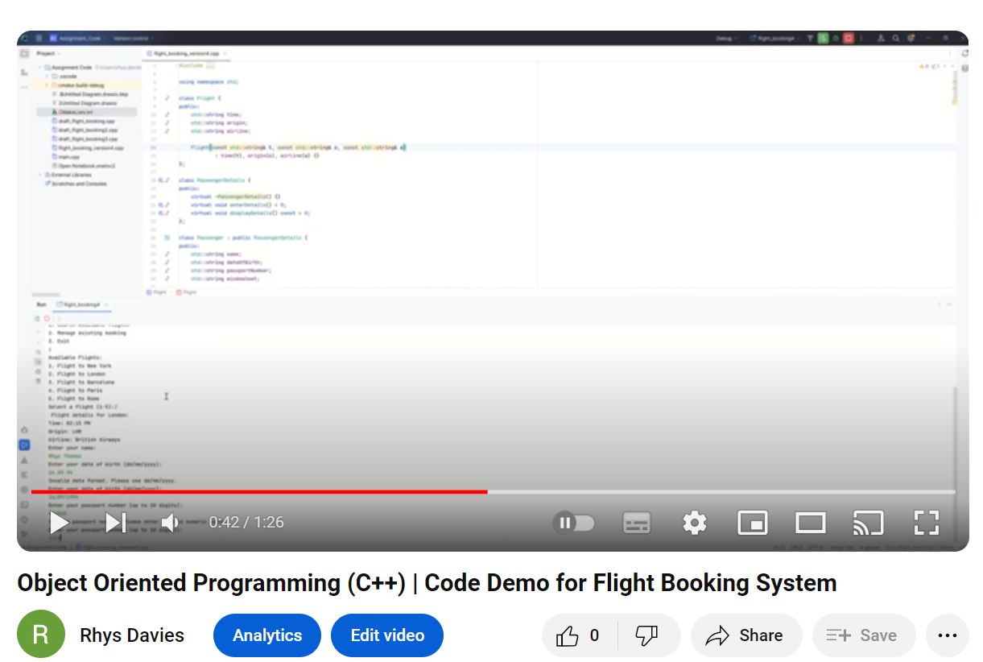

Conclusion
The report looked at OOPS concepts and applied them in the flight booking application. The report has outlined key concepts of OOPS such as classes (blueprints for objects), objects themselves which are the derived from classes.
Other concepts such as abstraction where only the essential details are shared whilst hiding others. Encapsulation was looked at where certain aspects of the code and data stay private and accessed in a particular way.
Inheritance allows the reuse of code which makes the programming process more efficient by reducing repetition and the use of polymorphism where we use a particular code but override aspects of the class to change the outcome of its function.
Overall, OOPS is a practical way of building programmes around really world problems such as the flight booking system. OOPS makes projects easier to develop and maintain, keeps data safe. It helps solve real-world problems, promotes reuse of code, and allows us to write flexible code that works with diverse types of data.

Netacad C++ Essentials Course
The figure below shows that C++ course is completed as of 16 November 2023.
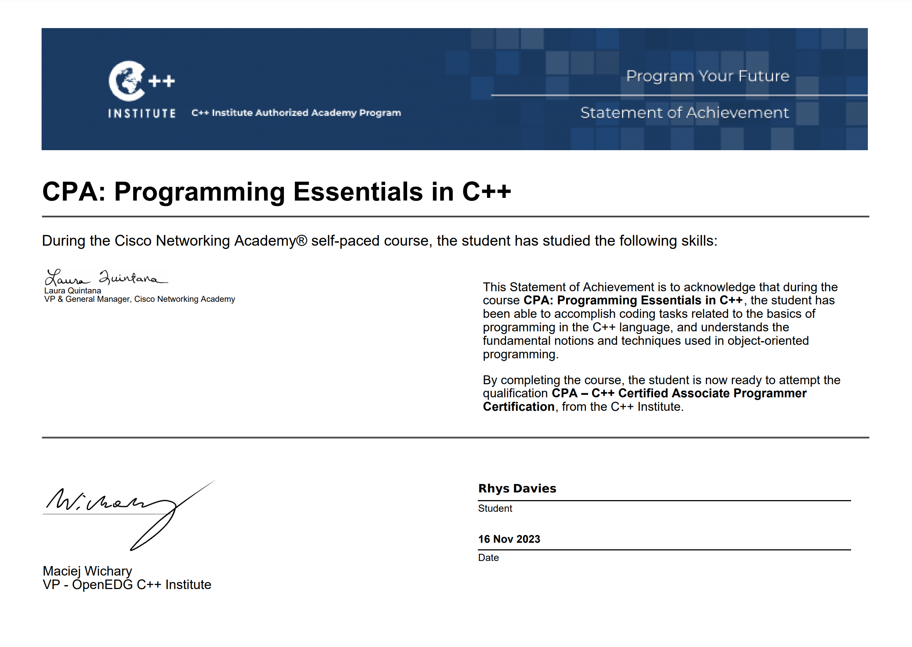
Figure 17 - Netacad Programming Essentials in C++

Appendix A – Assignment Code
#include <iostream>
#include <string>
#include <limits>
#include <regex>
using namespace std;
class Flight {
public:
std::string time;
std::string origin;
std::string airline;
Flight(const std::string& t, const std::string& o, const std::string& a)
: time(t), origin(o), airline(a) {}
};
class PassengerDetails {
public:
virtual ~PassengerDetails() {}
virtual void enterDetails() = 0;
virtual void displayDetails() const = 0;
};
class Passenger : public PassengerDetails {
public:
std::string name;
std::string dateOfBirth;
std::string passportNumber;
std::string windowSeat;
Passenger() {}
~Passenger() {}
bool isValidDate(const std::string& date) {
std::regex datePattern(R"(\d{2}/\d{2}/\d{4})");
return std::regex_match(date, datePattern);
}
void enterDetails() override {
std::cout << "Enter your name: \n";
std::cin.ignore();
std::getline(std::cin, name);
do {
std::cout << "Enter your date of birth (dd/mm/yyyy): \n";
std::getline(std::cin, dateOfBirth);
if (!isValidDate(dateOfBirth)) {
std::cout << "Invalid date format. Please use dd/mm/yyyy.\n";
}
} while (!isValidDate(dateOfBirth));
do {
std::cout << "Enter your passport number (up to 10 digits): \n";
std::cin >> passportNumber;
if (passportNumber.length() > 10) {
std::cout << "Passport number is too long. Please enter up to 10 digits.\n";
} else if (!std::all_of(passportNumber.begin(), passportNumber.end(), ::isdigit)) {
std::cout << "Invalid passport number. Please enter a valid numeric value.\n";
}
} while (passportNumber.length() > 10 || !std::all_of(passportNumber.begin(), passportNumber.end(), ::isdigit));
std::cin.ignore(std::numeric_limits<std::streamsize>::max(), '\n');
do {
std::cout << "Window seat? (y/n): \n";
std::getline(std::cin, windowSeat);
if (windowSeat != "y" && windowSeat != "Y" && windowSeat != "n" && windowSeat != "N") {
std::cout << "Invalid input. Please try again.\n";
}
} while (windowSeat != "y" && windowSeat != "Y" && windowSeat != "n" && windowSeat != "N");
}
void displayDetails() const override {
std::cout << "Passenger name: " << name << std::endl;
std::cout << "Date of birth: " << dateOfBirth << std::endl;
std::cout << "Passport number: " << passportNumber << std::endl;
std::cout << "Window seat: " << windowSeat << std::endl;
}
};
class FlightBooking {
private:
std::string destination;
bool isBookingConfirmed;
Flight* selectedFlight;
PassengerDetails* passengerDetails;
public:
FlightBooking() : isBookingConfirmed(false), selectedFlight(nullptr), passengerDetails(nullptr) {}
~FlightBooking() {
delete selectedFlight;
delete passengerDetails;
}
void searchFlights() {
const std::string destinations[] = {"New York", "London", "Barcelona", "Paris", "Rome"};
const std::string times[] = {"10:25 AM", "02:15 PM", "08:00 AM", "04:00 PM", "12:30 PM"};
const std::string airlines[] = {"Delta Airlines", "British Airways", "Iberia", "Air France", "Alitalia"};
const std::string origin[] = {"JFK", "LHR", "BCN", "CDG", "FCO"};
std::cout << "Available Flights:\n";
for (int i = 0; i < 5; ++i) {
std::cout << i + 1 << ". Flight to " << destinations[i] << "\n";
}
int choice;
std::cout << "Select a flight (1-5): ";
std::cin >> choice;
if (choice < 1 || choice > 5) {
std::cout << "Invalid choice.\n";
return;
}
destination = destinations[choice - 1];
selectedFlight = new Flight(times[choice - 1], origin[choice - 1], airlines[choice - 1]);
std::cout << "Flight details for " << destination << ":\n";
std::cout << "Time: " << selectedFlight->time << "\n";
std::cout << "Origin: " << selectedFlight->origin << "\n";
std::cout << "Airline: " << selectedFlight->airline << "\n";
passengerDetails = new Passenger();
passengerDetails->enterDetails();
askBookingConfirmation();
}
void askBookingConfirmation() {
char answer;
std::cout << std::endl << "Do you wish to book this flight? (y/n): \n";
std::cin >> answer;
if (answer == 'y' || answer == 'Y') {
passengerDetails->displayDetails();
std::cout << "Booking confirmed to " << destination << ". Have a great flight!" << std::endl;
isBookingConfirmed = true;
updateBooking();
}
}
void updateBooking() {
char answer;
std::cout << "Do you want to update your details? (y/n): \n";
std::cin >> answer;
if (answer == 'y' || answer == 'Y') {
passengerDetails->enterDetails();
std::cout << "Booking details updated:\n";
passengerDetails->displayDetails();
std::cout << std::endl << "Thank you, we have received your request to update booking details.";
}
}
void manageBooking() {
if (isBookingConfirmed) {
std::cout << "Manage existing booking to " << destination << ".\n";
updateBooking();
} else {
std::cout << "No booking found. Please search for flights first.\n";
}
}
};
int main() {
FlightBooking booking;
int choice;
do {
std::cout << std::endl << "What would you like to do?" << std::endl;
std::cout << "1. Search available flights\n";
std::cout << "2. Manage existing booking\n";
std::cout << "3. Exit\n";
std::cin >> choice;
switch (choice) {
case 1:
booking.searchFlights();
break;
case 2:
booking.manageBooking();
break;
case 3:
std::cout << "Exiting programme.\n";
break;
default:
std::cout << "Input error. Please select either 1, 2 or 3 from the options below.\n";
}
} while (choice != 3);
return 0;
}

References

[1] | Tech Target, “Object-oriented Programming (OOP),” Tech Target, July 2021. [Online]. Available: https://www.techtarget.com/searchapparchitecture/definition/object-oriented-programming-OOP#:~:text=Classes%20are%20user%2Ddefined%20data,objects%20or%20an%20abstract%20entity.. [Accessed 10 12 2023].
[2] | Enjoy Alogrirthms, “Classes and Objects in Object Oriented Programming,” [Online]. Available: https://www.enjoyalgorithms.com/blog/classe-and-object-in-oops. [Accessed 10 12 2023].
[3] | stackify.com, “OOP Concept for Beginners: What is Abstraction?,” 03 March 2023. [Online]. Available: https://stackify.com/oop-concept-abstraction/. [Accessed 10 12 2023].
[4] | Codecademy.com, “What is Inheritance in Object-Oriented Programming?,” 07 November 2023. [Online]. Available: https://www.codecademy.com/resources/blog/what-is-inheritance/. [Accessed 10 12 2023].
[5] | Microsoft, “Polymorphism,” 01 January 2023. [Online]. Available: https://learn.microsoft.com/en-us/dotnet/csharp/fundamentals/object-oriented/polymorphism. [Accessed 10 12 2023].
[6] | “Project In C++ | Airline Registration System Project In C++ | C++ Project For Beginners |Simplilearn,” Simplilearn, 11 01 2022. [Online]. Available: https://www.youtube.com/watch?v=ZXTwKLtER00. [Accessed 09 12 2023].
[7] | w3schools, “C++ OOP,” [Online]. Available: https://www.w3schools.com/cpp/cpp_oop.asp. [Accessed 10 12 2023].
[8] | geeksforgeeks.org, “Introduction of Object Oriented Programming,” 09 February 2023. [Online]. Available: https://www.geeksforgeeks.org/introduction-of-object-oriented-programming/. [Accessed 10 12 2023].

