18-12-2020
Problem solving and decision making
Employee restructuring
Student name: | Jose Carmona Rodriguez
Student ID: | 1917096
Module No: | BMSW4004
Lecturer: | Afzal Munna

Table of contects
Introduction 2
Employee restructuring. 2
1.The seven steps to solve a problem 3
2.Decision making. 3
2.1 Types of decisions. 4
2.2 Factor affecting decision making 4
2.3 Ingredients for good decision making 4
2.4 P.M.I. decision making 4
2.5 Pestle analysis. 5
2.6 Fishbone analysis 5
2.7 Swot analysis and strategy. 6
3.Solutions 7
4. Implementation 8
conclusion 8
Bibliography 9

Introduction
During this report I will explain one of the more important problem at the workplace. Firstly, I will explain the type of problem we have in my job and it will be analyzed by Fishbone, SWOT and P.M.I. model analysis. Then I will try to find and propose solutions and make decisions to solve the problem, ending with an evaluation and action plan on the problem.

Employee restructuring.
Unfortunately, this problem has been produced by the times of pandemic that we are going through. Basically, the company has fired quite a few people and the majority who have stayed are managers and this is causing problems on daily basis.
Firstly, my workplace is divided into several buildings, but only two of which are currently open. This has generated that the former managers of the other buildings have returned to ours. On the other hand, it should be noted that they went to other buildings seeking to grow in the company and it seems very good to me, but now they have returned and my colleagues who always worked here were fired and now they need to adapt to us. I suppose my director wanted to keep the most prepared people in the company, but what the company did not expect is that now most are managers, and the work environment is becoming increasingly difficult. Everyone wants to give orders and tell you what to do, but on the same time, they do not accept orders for anyone. Many of then talks about others to discredit each other and none seriously wants to work, many just want to supervise. Sometimes I need to do same thing three times because one of then prefer like that, other manager in different way and consecutive. They try to show who is the best, this tires a lot.
This restructuring can have many advantages because all of us who are working can cover any type of work and that helps company a lot, but as previously reflected, the disadvantages in a short-medium term period can be a lot and varied. In a short time, the workplace can find itself tense and with most colleagues unmotivated. I the managers did not think about this.
Advantages:
- We can all work anywhere.
- Make orders.
- Manage the places.
- Learn the skills of other managers and each other.
Disadvantages:
- Intentional miscommunication
- Internal fights.
- Destructive comments.
- Demotivate workers.
- Create a toxic work environment.
- Create stress daily.
- Affect sales and productivity for these types of situations.

Personally, all I do is watch, hear, and keep quiet because I do not want to have problems with anyone in this moment because there is no stability with job, and I cannot risk losing my job. I am dealing with the problem quite well, but I do not know for how long and how much it can affect me in short time. From this kind of reasons, I think is time to find some solutions in advance and make decisions trough these seven next steps.

1.The seven steps to solve a problem
identify the problem, data collection, cause analysis, solution planning and implementation, evaluation of effects, standardisation and evaluate the process. (Bader, 2018)
This will be analyzed in the following points conforming to the problem in my workplace.
1.Identify the problem: many managers together after made restructuration in the team because our buildings are closed actuality.
2. Data collection: They all want to be superior to their peers, want to stand out and compete among themselves, they try to impose their standards, work as little as possible but speak ill of what others do.
3.Cause analysis: This warn may be because they think that in the future can lay off more people, or because they may not finish adapting to the new way of working because the workers are not going to allow them to treat us badly or by force. It is necessary to understand that we were already here and that they have returned to this place again they will have to be the ones who support themselves again. They were the ones who decided to go to different buildings years ago to grow in the company, now they need to adapt.
4. solution planning and implementation:
- Wait for all our buildings to reopen and everyone to go back to their jobs again.
- Have a meeting with entire staff to clarify what our functions are in our workplace.
- Give them more work so they will be busy, more productive and will not have time to criticize everything.
- Send then to furlough until April.
5. Evaluation of effects: All the above alternatives may be feasible, but I think waiting for them to return to their jobs can be very risky because it can lead to problems in this course of time. The other alternatives can be beneficial for both parts (workers and managers) because there would be a better work environment.
6. Standardisation: Removing the option to send my colleagues to furlough again, I think that all the others could carry out to improve the situation.
7. evaluate the process: I believe that following the steps provided can be very satisfactory for everyone because it would improve our working day, we would work happily and the relations between us and sales would improve significantly.

2.Decision making
This is the process used to make decisions starting with the problem, identifying a decision, searching information, and finding various solutions. These guidelines help to make deliberate and considered decisions. (Lebelo, 2019)

2.1 Types of decisions
Routine decisions: these are simple or routine decisions made daily to solve simple problems. Usually are standard decisions and necessary at work to do things in a concrete way.
Adaptive decisions: these types of decisions are applied when something unusual happens and needs to be improved, identifying technical, organizational, and managerial processes. This requires constant work.
Innovate decisions: these decisions are often new and creative that can take years to produce. Usually are invented for the betterment of companies. (Lebelo, 2019)

2.2 Factors affecting decision making
Uncertainty: it usually happens when it is not clear what will happen after the decision is made. This situation occurs sometimes due to the lack of information about the decision taken, creating uncertainty and insecurity.
Risk: these decisions occur when people have knowledge about the problem, but cannot guess the result, creating risk in the exposed.
Certainty: this occurs when you have the knowledge to be able to make an accurate and correct decision, without any risk. (Lebelo, 2019)
More factors affecting decision making should be experience and knowledge, creating thinking, stress, interpersonal conflict, time available, money, energy, routine/non routine, critical nature of work, writing guidelines, attitude in the organization or personal ability of the managers.

2.3 Ingredients for good decision making
- Involve the team
- Delegate
- Brainstorm
- Be creative
- Be objective (Morgan, 2017)

2.4 P.M.I. decision making
The P.M.I. model helps to classify any type of decision as positive, negative, or interesting to clarify doubts about the idea we have in mind. Firstly, the idea is exposed and then we classify it.
- Plus: helps to classify the positive points.
- Menus: helps to classify the negative points.
- Interesting: helps to classify the interesting points of the idea.
Finally, we can score the decision to assess whether it is worth pursuing this idea or not. It is important to examine the interesting column to make sure that the elements in it are positive or negative to make the final decision on the idea. (Lee, 2017).
As can be reflected in the previous point, one of my ideas to solve my problem at work will be to talk to the manager and explain the situation to find a solution. I am going to evaluate this idea to see if it is a good decision.

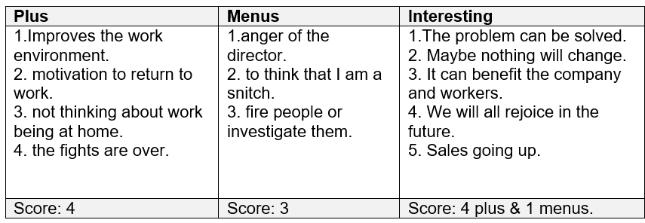
After having analyzed one of my decisions following this model, I can clearly see that this decision is correct and can be applied. 8 plus and 4 menus.

2.5 PESTLE analysis.
To carry out this type of analysis, it is necessary to consider the six factors that compose it and at the same time, think about what may happen to the business in the future.
Each area and the risk level of each category must be investigated, as well its opportunities. (Tredinnick, 2020)
Political factors: this factor analyses how it could affect the environment due the political change. The analysis must consider the changes that might occur in the future.
Economic factors: this includes economic changes affecting a business or its sector and buyer behaviour.
Social factors: refers to the current demographic and cultural changes that could continue for some extra time. It is also good to investigate attitudes.
Technological factors: this depends on the technology used by the company as well as the technology used by its customers.
Legal factors: cover the legal regulatory factors for the business and customers.
Environment factors: this considers how the environment can affect the business, being able to analyze the problem with climate change and how to help reduce emissions. (Tredinnick, 2020)

2.6 Fishbone analysis
This analysis is one of the seven quality circle tools. It helps to find the cause of the problem through six parts where the different possible causes are exposed until reaching the root of the problem. It can also be used to avoid future problems.
The diagram is made in the form of a fish body where the head is the problem, and the bones are the categories with which the problem is analyzed. Categories may vary depending on the industry applied.

These are the six important points to find the root of the problem:
- People: any man or people related causes to the problem?
- Machine: any machine-related problem?
- Method: what is wrong in the method associated that is giving rise to the problem?
- Measurement: any tool or standard error that need rectification?
- Material: what changes in the properties of the material that occurred?
- Environment: what were the environmental conditions (temp, pressure, etc.)?
Once classified and exposed, solutions will be proposed. (Sheikh, 2019)
In my case, I will analyze my problem in this way to clarify the possible causes on my problem with employee restructuring,
People: the people at this point are my colleagues, managers, and director.
Machine: tills, coffee machines, phones, laptops. I classify these elements here because nobody wants to touch any, only the mobile to see Facebook.
Methods: miscommunication or put all the staff together can be reason that causes this problem.
Measurement: clarify types of responsibilities of each worker or specify where we have work can be useful to solve this problem.
Materials: unmotivated, tired, pasotism, superiority are effects caused due to the problem.
Environment: covid-19 or rain can be the causes of having fewer clients. For this reason, workers get bored and complicate things at work.

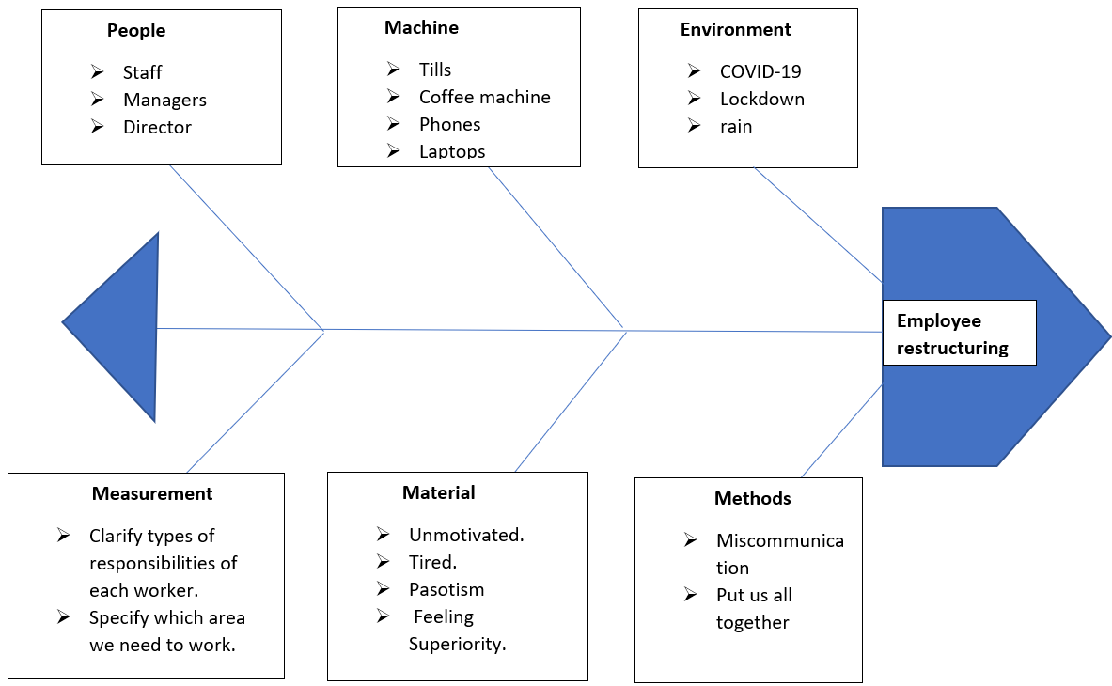

2.7 SWOT analysis and strategy.
This technique is essential for a business plan or some type of problem and allows to create a plan according to the situation, thus being a powerful way to evaluate a project. This form will give us a vision of the strengths, weaknesses, opportunities, and threats.
Strengths and weaknesses are assigned to the internal block and opportunities and threats are assigned to the external block because can be caused by things from outside.
The first step is the internal part finding the strengths, right after the weaknesses, then the external part looking for the opportunities and threats. Finally, try to create a strategy to combat the threats and weaknesses with the strengths and opportunities. (Shewan, 2020).
In the next step I will put it into practice with my work environment and the problem we currently have.
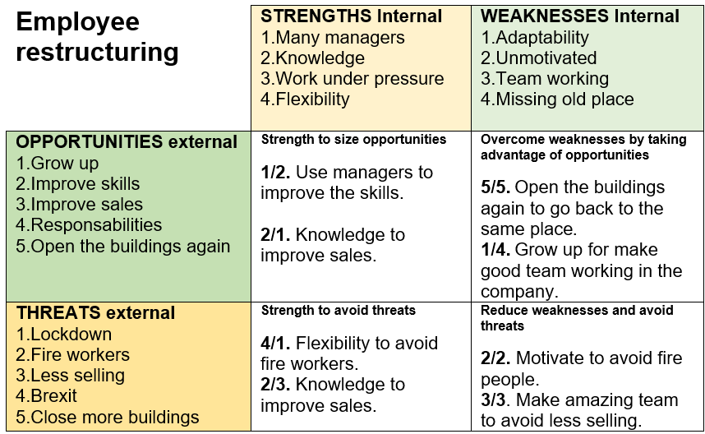

3.Solutions
1. One of the solutions is the one I am using currently using. It consists of waiting for everyone to return to their respective coffee shops when open again.
2. The second option may be the most appropriate because it consists of having a meet with entire staff to clarify what our functions are in our workplace.
3. Another option could be, give them more work, so they will be busy, and they will be more productive and will not have time to criticize everything.
4. The last solution can be, send then to furlough until April because in summer we are off and when we back again in September, they will back to other buildings, them the problem will be over.
The fourth solution is not within my reach. It could be beneficial, but I could not make it effective. On the other hand, the first solution could be very unpleasant because neither of us would be happy at work. However, the second and third options would be appropriate.
On the ne hand, the second consist of talking with my director and have a meeting with all of us. The third is to give manager more work so they do not get bored and then, will stop supervising jobs that do not belong to them.
If these solutions work out well, we could use our strengths to cover our weaknesses such as taking advantage of the fact that we are many managers to create a good teamwork again or take advantage of our flexibility to end adaptability.

4. Implementation
Once all the solutions have been analyzed, the best option is to talk to the director and get everything back to normal. In this way, can also put more work on my managers. If so, it would be covering the second and third solutions and the objective would be fulfilled. If my colleagues find out I spoke with the director, will be no change at all because I do not care, maybe they will appreciate in the future. This decision is certainty.
For my part, if the situation does not change after this, I will continue in silence waiting for all the coffee shop to reopen again in September as reflected in solution number 1. It would be unfair, but I will also do my part to adapt a little more to this situation until everything returns to normal.
Finally, if the situation becomes untenable, I am member of Unison (a company that looks for our rights within the company) I will ask for help and they will read my rights to my colleagues.

conclusion
As has been reflected during this assignment, it is much clear for me how to solve a problem by making effective decisions, using good tools to analyze problems, and clarify which are the best solutions to solve the problem that is affecting me on my workplace.

Bibliography
Bader, A., 2018. Prize. [Online]
Available at: https://prezi.com/p/f69cwxkomuvj/7-steps-problem-solving/
[Accessed 11 December 2020].
Lebelo, B., 2019. eFundi. [Online]
Available at: http://efundi.nwu.ac.za/portal/site/0646fc6a-16f4-46af-80ec-52ec22f34619/tool/6afa7b93-df28-4034-81ad-8c3ca8a89414/blog_view?blogid=0f20b8b46ceac5b7016cf27340c70016
[Accessed 15 December 2020].
Lee, S., 2017. bizfluent. [Online]
Available at: https://bizfluent.com/how-7856406-create-pmi-chart-decisionmaking.html
[Accessed 14 December 2020].
Morgan, P., 2017. The business student´s guide to study and employablity. First ed. London: SAGE.
Sheikh, S. S., 2019. Greycampus. [Online]
Available at: https://www.greycampus.com/blog/quality-management/how-to-use-a-fishbone-diagram
[Accessed 12 December 2020].
Shewan, D., 2020. WordStream. [Online]
Available at: https://www.wordstream.com/blog/ws/2017/12/20/swot-analysis
[Accessed 15 December 2020].
Tredinnick, M., 2020. Practiceweb. [Online]
Available at: https://www.practiceweb.co.uk/knowledge/how-to-improve-your-marketing-strategy-with-a-pestle-analysis/
[Accessed 12 December 2020].

