Animation Production Report of Whispers Beyond Time
Ranshu Guo
2121933
2025.09.02

Contents
Introduction 1
1. Project Background and intention 2
2. Story Outline and world view setting 2
3. Animation production 3
3.1 Pre -Production 3
3.1.1Concept Setting 3
3.1.2 Framing and Narrative Design 4
3.1.3 Character and Scene Original art 4
3.2 Mid-term Production 5
3.2.1 Character Model 5
3.2.2 Scene Production 7
3.2.3 Action Production 8
3.3 Post-production 9
3.3.1 Sequence Frame Animation Synthesis and Output 9
3.3.2 Final picture retouching 10
4. The collaborative exploration of art and technology 10
4.1 Bone Binding 10
4.2 Animation Rendering 11
5. Conclusions and Future Prospects 12
5.1 Core Skills Acquisition 12
5.2 Reflection and Summary 13

Introduction
Whispers Beyond Time) is a proof-of-concept animated short film, aiming to explore the relationship between memory and forgetting through fantastical visual language and poetic narrative structure. The story centers around Ellie, a little girl living at the "end of time". By harvesting people's forgotten moments and weaving them into capes, she reconnects those fading emotions and memories. The film attempts to convey that time does not truly vanish; as long as it is cherished, every moment can gain eternity.

This film blends freehand brushwork with reality in terms of art and technical realization: drawing inspiration from the lonely planet image in "The Little Prince" and the time image in "Alice's Adventures in Wonderland", it constructs floating Spaces, frozen shadows and stardust-like time fragments. In terms of production, Maya is used for modeling and styling design, while Blender is employed for dynamic simulation of particle effects, capes and memory fragments. Then, cycles in blender is utilized for rendering and ambient lighting processing. In the later stage, the immersion and emotional expressiveness of the film are further enhanced through compositing and sound design.

As a proof-of-concept short film, "Time Harvester" not only presents a complete story but also provides a creative and technical blueprint for future series expansion. Through experimental exploration of character prototypes, visual styles and production processes, it laid the foundation for the subsequent development of long-form works or cross-media narratives. The film's intention is to remind people to cherish the minute moments in daily life and understand that forgetting is not disappearance but a kind of quiet preservation.

Key words: 3D Animation production, Proof-of-concept short video, Stylized modeling Cycles engine; Mechanical binding, Visual effects.

1. Project Background and intention
The creation of Whispers Beyond Time originated from the continuous reflection on "time and memory". In contemporary society, the fast-paced life has led to many subtle emotions being overlooked and even gradually forgotten. The film attempts to remind the audience through an allegorical story that forgotten moments do not truly disappear; they still exist deep in the heart, waiting to be reawakened.

The protagonist, Ellie, symbolizes the guardian within the human heart. Her mission is to discover the "time fragments" scattered all over the world (that is, the pocket watches in the film) - those lost smiles, unspoken apologies and gradually fading childhood memories. By picking up these fragments of memory, the film conveys the dialectical relationship between "memory preservation" and "the tenderness of forgetting". Ellie's journey is not only about safeguarding others' memories, but also about her own process of picking up the past that she had unconsciously forgotten.

In terms of artistic reference, "The Time Harvester" was inspired by The Little Prince and Alice's Adventures in Wonderland. The lone star image in The Little Prince gives the film a fairy-tale-like sense of loneliness. The fantastical setting of time in Alice's Adventures in Wonderland provides the film with a surreal visual imagination. These elements are recombined to form a narrative stage that is both unique and of universal significance: the small house standing on the glacier, the beach where I hugged my mother in my memory, and the pocket watch that shines like stardust, all together constitute a stage that is both fantastical and thought-provoking.

Therefore, "Time Harvester" is not merely an experimental animated short film, but rather an artistic exploration of human emotions and the philosophy of time. It is hoped that after the film ends, the audience can reconsider: Have those overlooked moments truly vanished, or are they still hidden deep in their hearts? The ultimate intention of the film lies in conveying a gentle reminder - as long as one protects with heart, even the tiniest moment can transcend oblivion and reach eternity.

2. Story Outline and world view setting
This story constructs a unique space between reality and fantasy. In this world, time does not pass linearly; instead, it shatters, settles, and hangs in the twilight universe in the form of "time fragments". There are two main stages in the film. One is a small house floating at the end of the dark night - it symbolizes the boundary of memory, isolating the outside world's hustle and bustle while also becoming the convergence point of oblivion and recollection. The second one is the memory beach where the female protagonist Ellie hugged her mother in her dream after regaining her memory.

In this world, memory fragments are presented in the form of pocket watches, air can stand still, and emotions manifest in the form of light and dust. The "time fragments" harvested by the protagonist, Ellie, are the fragments that people have left behind: smiles that were never cherished, missed fareadings, and childhood that is gradually fading. She helps people recall the fragments that are about to be forgotten by hanging pocket watches, and then hangs them back in the dark night, giving them new life. This cycle of "hanging - lifting - re-experiencing" is precisely the narrative mechanism of the film and also a metaphor for the way humans preserve their memories.

This setting not only offers a unique visual vocabulary (such as floating planet-like cabins, bright memory beaches, and stardust-like fragments), but also allows the audience to enter a poetic space that is both strange and intimate when watching, thus making it easier for them to resonate with the theme.

3. Animation production

3.1 Pre -Production

3.1.1Concept Setting
In the early development of "Time Harvester", the producer first focused on the concept setting. The theme of the film needs to be expressed through visual symbols and atmosphere, so a large number of sketches and mood boards were made in the early stage. There is a significant gap in the atmosphere between the female protagonist's real space and her memory space as expressed in the story. Then, by referring to the lone star image in "The Little Prince" and the time mechanism in "Alice's Adventures in Wonderland", the unique visual tone of this film was gradually formed: a lonely yet poetic sense of space, as well as the surreal atmosphere of time breaks in the transition between reality and dreams for the female protagonist.

3.1.2 Framing and Narrative Design
Storyboard design is one of the core links in the pre-production stage. There are two versions of the storyboard alone. One provides a detailed explanation of the logic behind the establishment of the world view. However, since the film adopts a narrative without dialogue, the transmission of emotions is completely dependent on the rhythm and composition of the picture itself. Therefore, another version of the storyboard was redrawn. During the creative process, hand-drawn storyboards combined with digital tools are adopted to ensure that each shot not only advances the story but also carries the emotional expectations of the audience. Especially in the crucial scene where Ellie puts on the time cape and returns to the memory fragments, the storyboard provides clear visual cues and narrative rhythm. It can also better distinguish whether the environment where the female protagonist is located is a dream in her memory or reality.Throughout the entire story, the Black Dragon God, as the guide or challenger of the antagonist, his actions and behaviors drive the plot forward. Through interaction with the Black Dragon God, people can understand themes such as nature, life and responsibility, and achieve growth and transformation. Through the above design, the character of the Black Dragon God can not only reflect the depth and uniqueness of Dongba culture, but also display rich emotions and story tension in the animation, enhancing the cultural value and artistic appeal of the work.

3.1.3 Character and Scene Original art
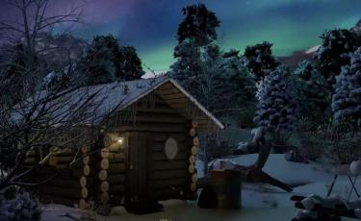
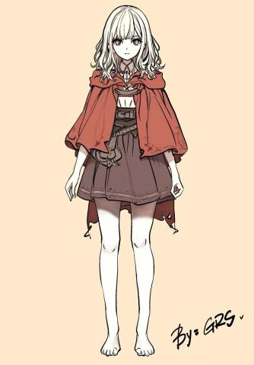
The development of original art for characters and scenes is equally important. Ellie's design has balanced the dual qualities of "innocence" and "guardian" through multiple iterations. The reason why the female lead's hair is designed in different colors, black and white, is that she also lies between reality and memory in the story. The image of the female lead's mother is very simple and unadorned. The design of props such as pocket watches and capes emphasizes their symbolic meanings, enabling them to serve both as narrative tools and as visual images. In terms of scene composition, the floating house and the constantly swaying pocket watch create a sense of space that transcends reality, being both strange and intimate. And the beach filled with the memories of the female protagonist and her mother is bright. It was also incredible for the female protagonist, because she discovered through a pocket watch that suddenly dropped that it was her memory that was about to be forgotten.
Figure2: Scene anticipation
Figure1: Character design

Based on this, the team created an animation preview (Animatic), transforming static storyboards into dynamic images. Rehearsals not only help control the overall duration and rhythm, but also provide intuitive references for subsequent modeling, special effects and rendering. Through the complete preparatory work in the pre-production stage, the visual and narrative direction of the film has been clearly determined, laying a solid foundation for entering the production stage.

3.2 Mid-term Production

3.2.1 Character Model
When making the model of the female lead Ellie, I used Maya as the core software. The construction of the basic model is the cornerstone of the entire production process. During the Blocking stage, the overall proportions and basic structure of the character were established using Maya's polygon modeling tool. However, at this stage, the facial wiring of the model is often rather chaotic and fails to meet the high standards of animation requirements.

A good topological structure is the key to whether a model can deform correctly. For this reason, I focused on re-planning and optimizing the facial wiring, following the direction of the facial muscles and the areas expected to undergo high-intensity deformation (such as around the eyes and the mouth area). All wiring is mainly quadrilateral (Quads), strictly avoiding triangles (Tris) and Poles with multiple sides (Poles), to ensure that the model can achieve smooth and natural deformation during subsequent binding and animation processes, and to prevent surface distortion or animation flaws caused by topological issues.

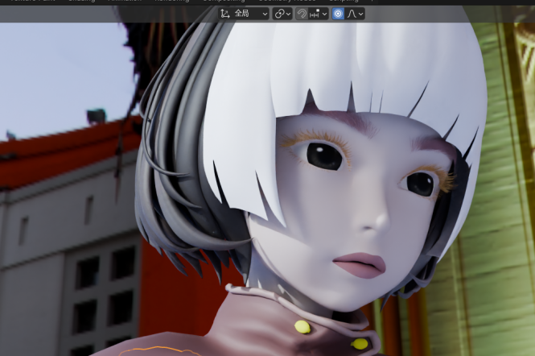
Then the character's hair (such as eyelashes and eyebrows) was made. It mainly relies on its powerful XGen toolset. The key points to mention are the editors used: the noise modifier and the cluster modifier. The former adds the effects of curling, twisting or random lifting to the hair. The latter is more refined than the basic Clumping attribute control, allowing for multi-layer superposition to simulate the relationship between large and small clusters, which will make the character's hair more realistic.
Figure3: Importing the model into blender makes it more obvious.

I'm making clothes for the female lead in Marvelous Designer. First, I import the character model with the A-Pose in place, adjust the height and body shape. The key to making the clothes is pattern making Use the rectangle and polygon tools to draw the front and back pieces, sleeves and other basic garment pieces, just like a tailor drawing patterns on paper, and then connect the edges that need to be pieced together with the sewing tool. Then comes continuous simulation to observe the effect of the ready-made clothes. Of course, when it comes to fabric selection, pure cotton products are preferred. This ensures that there won't be any reflective effects when making animations, whether in maya or blender. After the general shape of the clothes is satisfactory, the details need to be dealt with. For instance, use internal lines to create provincial roads or a cinched waist, and adjust the local tightness with particle distances to control the pleating effect. You can also pose for the character to make the clothes simulate more natural dynamic pleats. Because there are also layers like cape coats on the outside, Marvelous Designer can also calculate the collision between layers well.

At the final stage of the production process, it is very necessary to perform the operation of re-topology. Since the meshes generated by Marvelous Designer through physical simulation usually have a high number of faces and irregular wiring, this feature can convert them into a low-face-number model composed of regular quadrilaterals. When exporting, it is recommended to choose OBJ or FBX format, and be sure to check the UV and texture output options to ensure that the model can carry complete UV layout and color information into the subsequent process. In this way, a solid foundation can be obtained when conducting material refinement and rendering work in software such as Maya or blender.

Overall, the main reason why I chose this software is that it can efficiently and realistically achieve clothing production, especially in handling complex wrinkles. The efficiency of its physical simulation is much higher than that of the traditional manual engraving method.

The other character, the mother, was directly created along with the character in the Maya software. The production process was relatively easy, but the division and cutting between surfaces, as well as the distinction of materials, were still rather complex. Because this character image model is an integrated whole, different effects are produced by dividing the materials of different surfaces, thus giving birth to this character image.

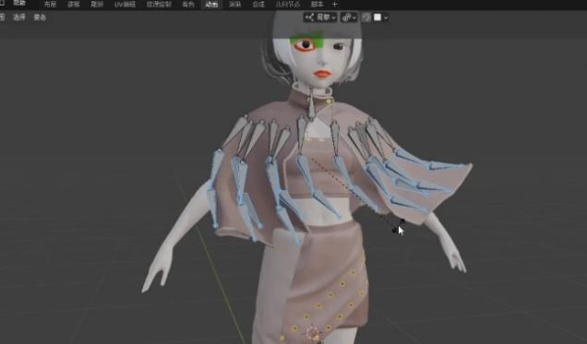
After completing the creation of the two characters, I imported the model made in Maya into blender in obj format to bind the bones for it. Since it is not known whether the animation software Maya will be needed for the later animation production, the models of Maya have also been skeletal bound in the Maya software. Because the character model also has the cloak design, I chose to bind the bones to the cloak in both of my software and artificially controlled the movement trajectory of the cloak.
Figure4: Every crease on the cloak binds the bones.

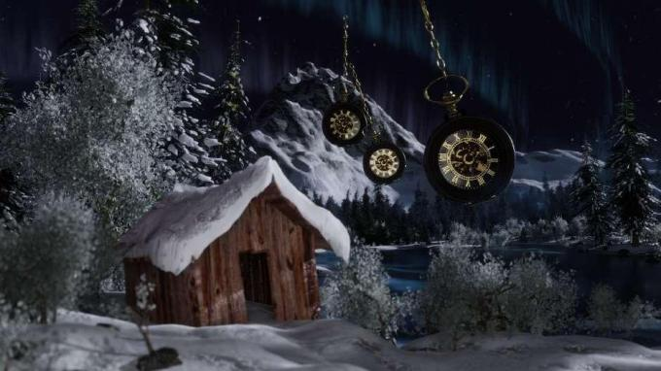
3.2.2 Scene Production
In the implementation of the snow scene shot in this animated short film, I efficiently generated the effect of naturally falling snowflakes based on Blender's particle system and by using the method of object instantiation replacement. First of all, I created three different forms of snowflake shapes as the basic snowflake models and endowed them with materials that are nearly semi-transparent and have a slight bluish-gray tone to simulate the light transmission and color tendency of ice crystals. Then, a planar object was set up at the top of the scene as the emission source. In its particle properties, the "emission" mode was selected and the generation quantity was significantly increased. Of course, I only placed this plane above the camera. To restore the natural dynamics of snowflakes, I significantly reduced the gravitational intensity in the physical properties and added some values to the random force field, making the particles appear to fall slowly with variable trajectories. In addition, by adjusting the curve of particle life value and size changing with age, the natural gradient feeling of snowflakes during their formation and disappearance has been further enhanced. In the final output sequence, the system presents a richly layered and gently moving snow scene atmosphere at a relatively low computational cost, effectively supporting the environmental narrative and emotional expression of the scene. Because this scene is suitable for the beginning of the film, it not only sets the cold and poetic visual tone of the work, but also quietly guides the audience into the emotional space of the story through the combination of technology and narrative.
Figure5: Create the scene

Creating special effects animations is actually a very interesting thing, because when you add node and particle special effects, you will find that the animations in the entire stage become vivid. Especially when dealing with light effects and some model blurriness, it can make the entire picture full of movement and vitality. During the production process, by constantly adjusting parameters and optimizing the node structure, the entire scene can become more natural.

In the bright memory beach scene, as the world view tells of the image of a solitary star, it endows the film with a fairy-tale-like sense of loneliness. Therefore, in the empty scene, there is a model made of a faintly visible planet. To make a clear distinction from the moon, the original lunar surface map was not applied to this animation. Only the transparency of the material was changed and a gradient effect was added. The seawater mainly relies on the mixture of noise wave texture and wave pattern to bring out the undulating details of the water surface. The beach uses a combination of noise wave texture and Voronezh texture to simulate the grains and moisture marks of sand. To make the scene more realistic, I also found some model materials of shells and starfish in the material library and applied them to my own scene. Echoing the planets and small islands behind, create a Utopian world that belongs only to the memories of the female protagonist and her mother.

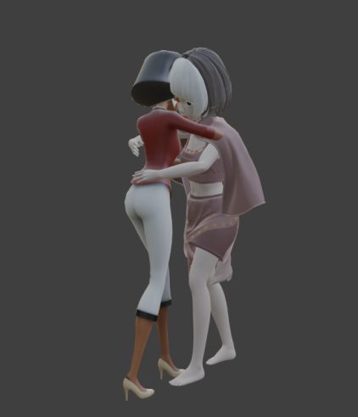
3.2.3 Action Production
This part is relatively easy for me: Find the corresponding materials for the required actions, and apply the Potplayer video software to split each action that appears in this video, so that each frame of the action is marked with the corresponding time point. Whether it is the action used by the character or the action used by the object movement, this method can be used for animation production. This is a good idea for this animated work because in the action setting of each frame, I can also set keyframes for the female lead's cloak to prevent it from penetrating the main body of the character model.
Figure6: All actions are created separately in individual scenes and finally imported into files.

When setting up the action of holding a pocket watch for hand animations in Blender, the dynamic binding of the two can be efficiently achieved through Parenting. In the specific operation, I also bound the pocket watch object to the corresponding skeleton. Just select the pocket watch as the skeleton first, and then add the hand controller or skeleton to establish the association. After that, the movement and rotation of the hand bones will directly drive the pocket watch to follow, while the rotation, zooming and other animations of the pocket watch itself can still be added independently, making the hand swing animation and the pocket watch swing both naturally synchronized and retaining the flexibility of their respective animations. One of the more convenient aspects of blender animation software in post-production animation is that the parent-child set of the hand and the pocket watch will not change due to the animation movement of the pocket watch, so the keyframes of the pocket watch can be set normally.

This approach not only simplifies the animators' production process for complex interactions, avoiding manual alignment of each frame, but also ensures the physical rationality and visual consistency of the animation through hierarchical constraints. It is highly suitable for depicting fine actions such as characters checking the time and shaking pocket watches, enhancing the sense of interaction between props and characters in the narrative.

3.3 Post-production

3.3.1 Sequence Frame Animation Synthesis and Output
During the post-production stage of the animation project, my focus was on the synthesis of sequence frame animations and the output of the final video. The entire process begins with importing the PNG sequence frames rendered by the 3D software frame by frame into After Effects. The PNG format was chosen mainly because of its lossless compression feature. In this way, the details and transparent channels of each frame can be well preserved, laying a good foundation for post-processing.

After entering AE, the main task is to assemble these individual static images on the timeline and do some artistic processing. The first step is always to carefully check the sequence of frames to see if there is any disorder or missing frames, ensuring that the playback is smooth enough. After that, I will use the built-in color grading function of the software to uniformly adjust the contrast, saturation and hue of the entire clip, so that all the shots look consistent in style and conform to the initially set visual effect. Sometimes, depending on the mood and rhythm of the film, some effects such as lens halos, glows or motion blur may be appropriately added to make the picture look more vivid and layered.

After all the adjustments are completed, the final step is to output. I will set the frame rate, resolution and video encoding format according to the project requirements, and then render the finished product into a complete video file. At this point, the entire static sequence process has been successfully completed.

3.3.2 Final picture retouching
After completing the sequence frame synthesis and adding basic special effects, the project entered the final stage of picture polishing. The core objective of this stage is to comprehensively enhance the cinematic feel and artistic expressiveness of the visuals. Through meticulous adjustments to color, light and shadow, and details, it ensures a high degree of unity between the visual style and the narrative of the animation.

The color grading is the key task of this stage. Since the sequence frames output in the early rendering may have slight differences in Color and lightness between different shots, global color correction needs to be performed in After Effects using the Lumetri Color tool. First, I establish a unified base tone, strictly calibrate the black and white fields and midtones with an oscilloscope, eliminate color cast and ensure that the exposure levels of all lenses remain consistent. On this basis, according to the emotional tone set by the script, stylized color grading is implemented for different scenes. For instance, in the fantasy scene where the pocket watch appears, a warmer golden tone tendency is added to the overall picture, and the amber saturation in the dark areas is appropriately enhanced to create a warm and mysterious visual atmosphere. In real scenes, a cold gray-blue tone is adopted, and the sense of alienation is highlighted by reducing saturation and enhancing contrast. This color distinction based on narrative intent effectively enhances the audience's emotional cognition of different times and Spaces.

4. The collaborative exploration of art and technology

4.1 Bone Binding
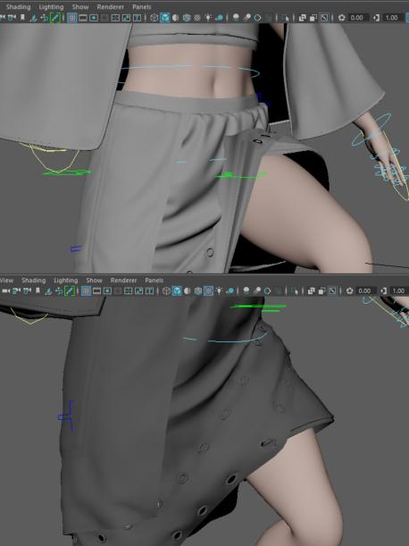
In the process of skeletal binding of character models, combining the two binding methods of Maya and Blender, it has to be admitted that Maya is very professional in this aspect. It uses a system based on nodes and constraints, which is suitable for binding particularly complex characters like those in movies. This is what many large companies in today's society are using, and there are also many plugins. For example, Advanced Skeleton. However, it has quite a few modules and needs to be operated in conjunction with several editor Windows, which takes some effort: the most complicated step is undoubtedly boosting the weight. It is very easy for some production teams.

The idea of Blender is quite different. Its binding, weight drawing and animation all switch within one interface, which is more intuitive and easy to get started with. The most convenient feature is that it comes with a plugin called Rigify. All you need to do is simply place a few main skeletons, and it can automatically generate a set of bindings with complete controllers, which is very friendly for independent production. But to be honest, for me who has tried binding bones to two of the character models, since there is still a cloak design, I chose to bind bones to the cloaks in both cases, artificially controlling the movement trajectory of the cloaks.
Figure7: I imported the effects created by the two software into Maya to check. blender is still more suitable for me.

4.2 Animation Rendering
Before the animation production, I actually made a fabric settlement for the characters' clothes, but this was quite a pressure for the later production of the animation characters' movements. No matter what software it is, the possibility of it crashing and the computer going black is quite high. Therefore, I gave up this production method resolutely after I settled the fabric of the Maya model but didn't save it because it crashed.

Overall, if you are creating your own works or undertaking some stylized projects and want to achieve results quickly, Blender is more convenient to use and incurs lower costs.

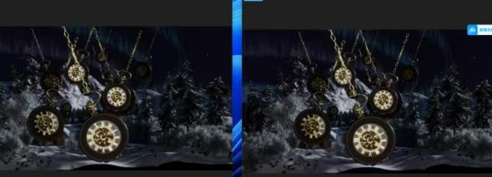
In the middle and later stages of animation production, there were actually some models in the scene of the log cabin that could not be rendered using the Eevee rendering engine. Therefore, the Cycles rendering engine, which takes more time and has a better effect, was ultimately chosen. Of course, Cycles is a physics-based ray tracing renderer that generates images by simulating the actual physical behavior of light in the scene (such as emission, rebound, and absorption). This approach is computationally intensive and slow, but it can produce extremely realistic and physically accurate results. Especially in handling complex lighting interactions, soft shadows and precise global illumination. In this scene of the film, I chose to use material textures with aurora patterns to represent the light in the sky. Although it was not made bit by bit with simulated particles, the Cycles renderer still demonstrated its effect very well. Cycles can handle the color transitions and light changes in textures very delicately, which makes the aurora look not stiff but adds a touch of lively color to the entire scene.
Figure8: These are the rendering results of two values: 400 on the left and 800 on the right. The rendering time for each one is 15 minutes longer.
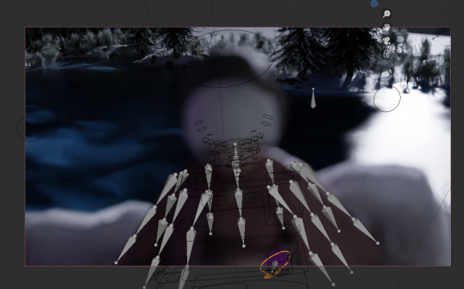
When adjusting the depth of field, I deliberately focused on the position where the swaying pocket watch met the aurora, and the background was slightly blurred. Doing so not only makes the picture look more layered, but also allows the soft glow of the aurora to blend more naturally with the overall atmosphere of the environment. It is no longer merely a pasted "painting", but has become an important part of setting the atmosphere and conveying emotions - either mysterious, dreamy or vast. The presence of the aurora makes the overall tone of the entire segment more distinct and more capable of touching the audience.
Figure9: Due to the depth of field issue, the main object is not clear.

Conclusions and Future Prospects

5.1 Core Skills Acquisition
Firstly, in terms of process integration, from the initial script-writing, the design of camera language, the establishment of consistency between model and character design, the production of special effects animations, to the later rendering, compositing and editing of animations, it ensures a high degree of unity between the final visual effect and the artistic design. This has made my personal animation production process more complete compared to before.

Secondly, in terms of rendering and visual presentation, the team has deeply applied the material and lighting systems of the Cycles renderer. Even if complex visual effects such as auroras are achieved by combining textures with shaders, a high degree of visual completion is still realized through node editing and object understanding calculation. Meanwhile, the post-production addition of realistic depth of field and dynamic blur significantly enhances the cinematic feel and narrative expressiveness of the picture.

What is particularly crucial is the breakthrough in bone binding and prop interaction technology. We adopted a parent-child correlation and constraint system to efficiently solve the dynamic synchronization problem between hand animations and pocket watch props. This method significantly improves the efficiency of animation production while ensuring control accuracy, providing a reliable technical template for subsequent similar interactive animations.

In addition, compared with the previously produced animated short film, due to learning new software for animation production and understanding new rendering modes, the production effect of this animation will be elevated to a higher level.

5.2 Reflection and Summary
During the creation of Whispers Beyond Time, I gradually realized that animation production is not only a combination of technical processes, but also a unity of narrative and artistic expression. As a concept short film without dialogue, its reliance on visual language, rhythm control and musical atmosphere far exceeds expectations. This made me constantly reflect on how to accurately convey emotions through pure visual means in the design of storyboards and the control of rhythm. Especially in key scenes, how to enable the audience to enter the inner world of the characters in a short time is my most profound experience throughout the entire process.

The technical challenges are equally prominent. In the experiment of combining particle special effects with real-time rendering, I found that idealized concepts are often limited by hardware performance and production cycles, and a balance must be struck between picture quality and efficiency. In addition, the fabric simulation and the creation of the light and shadow atmosphere also underwent multiple adjustments before gradually approaching the desired effect. These repeated attempts have made me understand that animation production is a continuous process of compromise and optimization.

Despite its shortcomings, this short film has achieved its original intention as a proof of concept. It proves that the abstract theme of "forgotten moments" can be concretized through animation language, and at the same time verifies the complete process from modeling, special effects to real-time rendering. More importantly, it made me realize that the core of animation does not lie in complex techniques, but in whether sincere emotions can be conveyed through limited means. This process not only accumulated experience but also laid the foundation for future larger-scale project explorations.

