Name: Chris Morris
Student Number: P149915
Module title: Project Management
Document: Assignment 1
Module code: M5X00615
Lecturer: Sue Maw
Contents
Initiation document 2
Project plan 5
References 6

Initiation document
Creating a network for a local charity in Swansea |  |  | Mark here when task has concluded (if applicable)
A description and background to the project
What is the background of the chosen charity?
- Kids Cancer Charity Swansea: a charity created in 1989 which is open in other areas in Wales such as Cardiff and Glamorgan, and specialises in assisting children diagnosed with cancer via fundraising and activities. The presumed chairwoman in Swansea is Judith May. [1]
What is the purpose of this task?
- Improve network structure of charity
- Assist charity in handling data
- Enhance network security within charity
What are the project objectives?  - Produce basic network  - Include wireless networking aspects such as SSH  - Introduce security measures  - Successfully configure network features such as IP addresses |  | How will they will be measured?  - Check progress weekly by creating progress sheet with partner communication; refer to timeline  - Conduct testing to ensure all wireless aspects included  - Conduct feedback to test and ensure all measures met
What is the project scope?
- Limited to Swansea area
Are there any exclusions from this scope?
- Any new stores that are to open outside Swansea
What will be created as a direct result of the task?
- A structured diagram – estimated completion date is January 8th, 2018
- A basic secure wireless network – estimated completion date is January 31st, 2018
- A manual – estimated deadline day is February 15th, 2018
Are there any features that limit the project?
- Budget: £0; empty besides equipment provided on UWTSD Mount Pleasant Campus. If money spent independently, limit is roughly £150
- User knowledge
- Access of equipment
- Bandwidth of charity internet in setting up network
- The size of the network being too small
What variables are being presumed in the process?
- That the client has little knowledge of wireless networking
- That the user has limited experience of computer literacy
- The knowledge of volunteers being low by comparison
- That the client will wish to apply future upgrades
- That the project will be completed on time
- The development team will have sufficient knowledge to complete project
What equipment will be required to ensure a successful project?
- At least one PC at a time per session
- Hardware such as routers and switches to configure network
- Software such as Packet Tracer and Microsoft Project to practice and keep track of project
Why should this project be approved?
What are the potential personal advantages of the project?
- Would improve overall knowledge of networks
- Would obtain experience of handling a long-term project
- Would continue to develop skills such as time management and teamwork
What are the options for charity once created?  • Using it to expand customer database | What other project ideas were considered?  - A network with a larger scale than decided on  - An unmanaged network
What are the project potential drawbacks?  - Network malfunction  - Failure to satisfy computer specifications  - Timetable not adhered to  - Unsuccessful in meeting client needs  - Unclear instructions | What steps can be taken to avoid these drawbacks?  - Constant network testing  - Referring to specification if unsure or not working  - Team meetings to track progress  - Creation of manual detailing process  - Training day for client users  - Asking relevant members of staff for guidance or advice
Who are the individuals involved in the project?
What roles and responsibilities are included?
- Complete appropriate research
- Design network
- Implement network
- Test network
- Implement feedback for network
- Prepare for client training
Who will ensure the project is sponsored?
- UWTSD – As overall organisation
- Sue Maw – As module director
Who oversees the project overall?
- Sue Maw – As module director
How many team members are included and who is the team leader?
- No overall team leader; leadership spread equally towards team trio members for tasks including development and design, will decide who handles tasks before they are commenced
How will the project be structured?
- Top level – Sue Maw, as module director and project sponsor
- Middle level – Team members and charity; team members as network designers, charity as source of feedback
- Bottom level – Network users, who can provide feedback to charity after network has been implemented but do not have the physical capabilities to alter it
How will the preparation for the project be carried out?
What is the time schedule for this project?
- Refer to project plan listed below
How will a consistent quality control be maintained?
- User feedback to ensure client needs are met (check-ups every two days, or after every stage completion)
- Ensuring hardware meets specification
- Ongoing testing during network creation, ensuring each section of configuration is complete before next step commenced
- Adding to progress sheet to ensure timetable is kept to and specification is met
- In-depth research of current network literature in order to provide the most up-to-date technology as possible
How will the network be delivered?
- Team demo to be delivered on a date to be determined between 8th January 2018 and 29th March 2018
- Prior agreement with charity to perform project
- Access to organisational equipment on their premises

Project plan
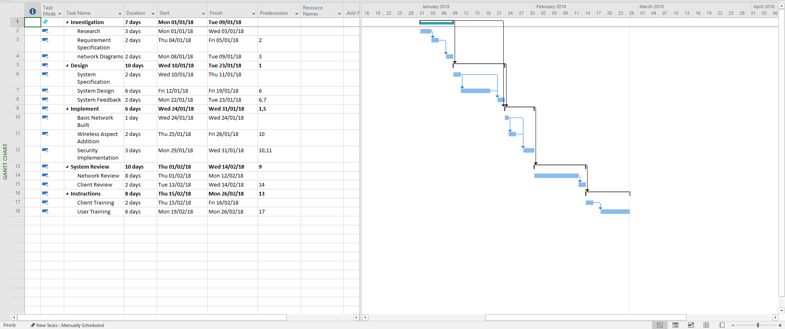
Alongside the document, a Gantt chart was developed which will allow the author and fellow team members to keep track of how successfully the project is developing in terms of its intended schedule. The expectation is that, with sufficient designing, implementation will be the shortest stage of the project. It will begin early into 2018. While some stages link together as shown above, they all flow straight one after the other, with designing and reviewing the system estimated to assume the most time. A team member could update this on behalf of the group and email it, though a drawback could be the necessary email server itself not functioning.

References

[1] Welcome to the Kids Cancer Charity. Available: http://www.christianlewistrust.org/Default.asp

