Marketing Fundamentals

Assignment Name:Blogging to communicate
Student ID: Ana-Maria Budau ( 2030929 )
Module Name and code: LCBB4004 Marketing Fundamentals
Tutor Name: Tushara Balendran
Date of Submission: 07.01.2022
Table of Contents
Introduction 3
SEGMENTATION 4
Targeting and Positioning 5
PRODUCT 6
PRICE 7
PROMOTION 8
PLACE 9
PEOPLE 10
PHYSICAL EVIDENCE 11
PROCESS 12
Conclusion 13
References 14

Introduction
The study is about marketing fundamentals which are essential for every organization in order to communicate with the potential customer and create awareness of the products and services among the people. For the marketing of the product and service organization uses the STP marketing strategy that aids the organizations to reach a wider customer. The major marketing strategy of the product revolves around the 7Ps of marketing which is also known as marketing mix strategy. The blog will include the STP marketing strategy along with the marketing mix strategy.
For this study, the chosen organization is Ocado which is an online grocery supermarket established in 2000. It was founded by Jonathan Fairman, Jason Gissing and Tim Steiner. The headquarter of an organization is in Hatfield, Hertfordshire, UK. Ocado Group plc shows its presence in England and Wales. Ocado Group Plc is a public limited company, listed on the London Stock Exchange (ocadogroup.com, 2022).

SEGMENTATION
Segmentation is an essential element of an STP marketing strategy that refers to the division of potential customer into smaller groups (Moravcikova et al, 2017). Segmentation is done on the basis of four types – Demographic, psychographic, geographic and behavioral segmentation (Jenkins et al, 2021). Ocado as a retail organization segments their target market through all these segmentation types that helps them to reach out the maximum people. The target customer for the Ocado group involves the people from kids to parents. They target every generation and satisfy their customer through good service.
Partners of Ocado group

Fig 1: Partners of Ocado group
Source: ocadogroup.com, 2022
Ocado has partnered with some of the greatest mind and forwards thinking people from retail grocery field. Along with the partner that are on the mission to transform the way people shop at grocery stores (ocadogroup.com, 2022). The clients of Ocado group have spread all around the world and helping to build the Ocado Smart Platform (OSP). The SMART partners behind the leading grocery supermarkets are, AEON, ALCAMPO, BONPREU, COLES, GROUP CASINO, ICA, KROGER and MORRISONS (ocadogroup.com, 2022).
Ocado SMART platform
Ocado Smart Platform (OSP) is known as world class solution for the digital grocery shopping that will help the consumers to purchase the grocery with ease through Ocado’s digital platform. This platform greatly helps to the retailer by making the process faster, flexible and cost efficient. The Smart platform of Ocado will provide the world class experience to the retailer as well as consumer. Ocado has done the nine partnerships across the globe that will improve the online businesses of retailer with limited capital investment and low risk involved.

Fig 2: Ocado smart platform
Source: ocadogroup.com, 2022
Source: ocadogroup.com, 2022

Targeting and Positioning
Being a reputed and leading grocery shops, Ocado target most of the people from England and Wales. The most of the targeted people of Ocado are housewives, bachelors, women and Kids also. Ocado has the wide range of grocery product that people use in day-to-day life. After segmenting the wider people of England and Wales they target their potential customer through several online and offline platforms. Ocado group shows its presence on several social media platforms such as LinkedIn, Facebook, twitter and YouTube (ocadogroup.com, 2022). Through this platform Ocado group promotes the products and engage their potential customer. Ocado platform mainly focus on the online shopping as people are more interested to purchase the product through online platforms rather than offline shopping. This is the reason why Ocado 100 per cent home delivery to their loyal customer (ocadogroup.com, 2022). Ocado retail has serving their loyal customer for twenty years with same enthusiasm and energy.
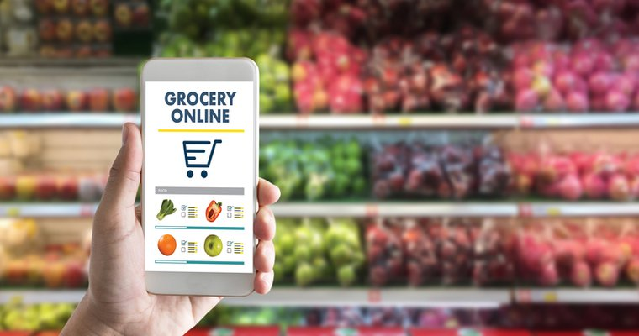
Fig 3: Ocado grocery online
source: ocadogroup.com, 2022
The continuous evolving platform of Ocado group offering the online and home delivery only option to all their astonishing customers. The unique offering on products and services to the customers keeps them ahead in the high competition. Organization always challenges themselves to perform better than yesterday and gives exceptional service to the customers. Ocado group question themselves that how they can revolutionize the shopping experience of the customers so that organization can serve innovative and unique service to the consumers.
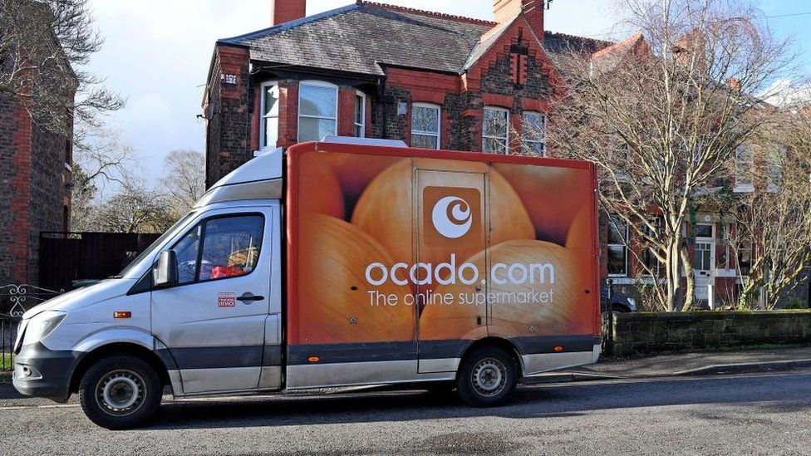
Fig 4: Ocado delivery
source: ocadogroup.com, 2022

PRODUCT
MARKETING MIX 7P’S
As a leading grocery supermarket store, Ocado deals in variety of products such as fruits and nuts, vegetables, seafood, eggs, fish, wines and other grocery and household items. Apart from these major items, Ocado also offers desserts, drinks, cupboards, pet care products, baby products, toiletries, kid’s foods and toys (ocadogroup.com, 2022). Company also focuses on the 100 per cent home delivery service to their amazing customer. The major concentration towards the contactless delivery due to the rising covid cases puts them ahead in the retail industry. Ocado group management works on the customer first policy where they care about the customer by offering them a no touch free home delivery. As a reputed and leading grocery supermarket of UK, Ocado group retail shops offer variety of products to their loyal consumers.
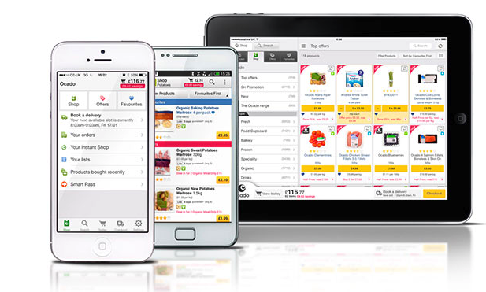
Fig 5: listed products on Ocado’s platform
source: ocadogroup.com, 2022
The product that organization offers to its customers are highly differentiated from its competitors. The uniqueness in the products and services that they offer to their customer are mind boggling and because of this people do not hesitate to pay the price to their services and products. The more emphasize on the quality of products rather than the quantity helps them to reach more people from England and Wales.
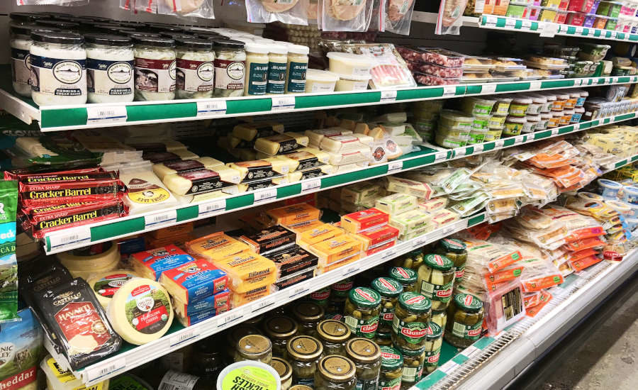
Fig 6: Ocado supermarket
Source: ocadogroup.com, 2022

PRICE
To set the price of several products, Ocado uses competitive pricing strategy that helps them to sustain in this competitive world. The presence of other retail stores in the United Kingdom creates the competition in the retail industry. The price war among the retail companies forced them to lower down the prices of an products so that more and more people will get benefitted (ocadogroup.com, 2022). Ocado believe in the research and development department that provides the proper analysis of market a consumer behavior and based on this organization works on the pricing strategy. Ocado group involves its employee for generating more effective and efficient pricing strategy that could help the organization as well as consumer. Understanding and analyzing the current pricing strategy of products with the strong competitors helps them to decide the competitive price of the products. The some of the premium and unique products, Ocado sold for the higher price as compared to its competitors due to the innovative and unique features of the products. Other than premium and competitive pricing strategy, Ocado focus on the bundle price strategy where they sold the bundled of same products at lower prices than the total single piece of items. This strategy works for the organization where most of the customer purchase the product in bundles to save some money for the next shopping.
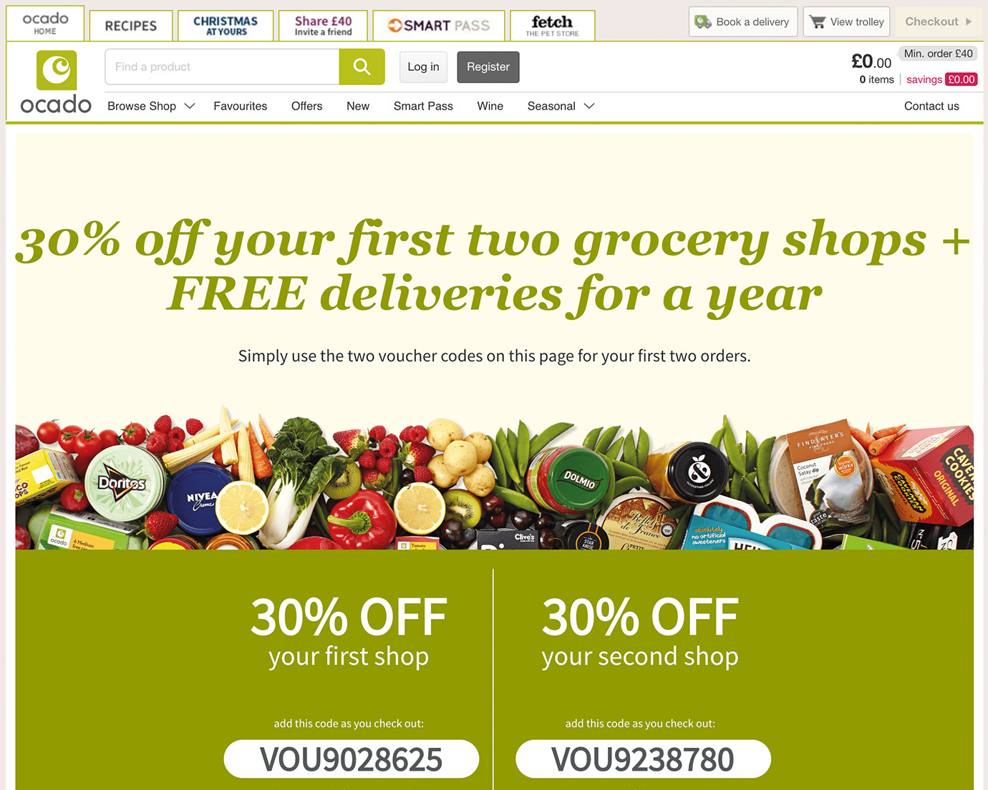
Fig 7: Ocado offers
Source: coupon.direct, 2021
The optional pricing strategy is another strategy that Ocado uses for its specific items. As per the optional pricing strategy, Ocado offers price for the base product and isolate the price of accessories associated with the main products. Apart from this, offering more discount on online platforms increases the sale of the products.
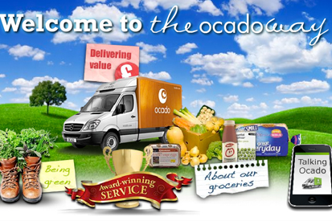
Fig 8: Ocado group products
Source: campaignlive.co.uk, 2019

PROMOTION
Ocado works on different promotional strategy to create the awareness of the products among the potential market. The promotional strategy of an Ocado group increases the demand of products and it ultimately helps the organization. Organization focuses on the quality of the products and for this they kept the fresh foods inside their supermarket so that people will not hesitate to buy the products. This is also a promotional strategy of an Ocado where providing the quality product and service to the consumers helps them in mouth publicity. Use of multiple media channels such as television, billboards and social media platforms to promote the product creates the awareness about the brand and products among the masses. Other than this, the presence of Ocado group on several social media platforms like Facebook, LinkedIn, YouTube and Twitter helps them to engage with the customer (ocadogroup.com, 2022). Posting the discount related posts on the social media handles increases the reach of posts that ultimately generates the good sales for the Ocado group. Organization focuses on various digital marketing techniques to generate the more traffic on the websites and Ocado apps. The smart use of influencer or actor to promote the products of Ocado group improves the brand image as well as awareness of the firm. The emotional advertising campaign of company entice the potential customer to visit the store once and purchase the products from Ocado supermarket.

Fig 7: Ocado offers
Source: ocadogroup.com, 2021
Posting engaging social media posts that are relevant to the target audience enhances the brand as well as product offer awareness among the target audience. The right use of marketing trends and implementing the same improves the brand performance and brings out the good sales for an organization. Apart from this, understanding the customer’s interest and targeting the relevant advertisements to them eventually improves the overall result.

Fig 8: Ocado campaign
Source: adobomagazine.com, 2019

PLACE
The location of the supermarket is so important for an organization as the sales of the products is primarily depends on the place where an organization established its stores. Ocado group always focus on their place as they focus on the quality of their products. The major decision of an organization to sale the products through digital platforms. Ocado has over 500 supermarkets at prime location in England and Whales that drives the major sales for an organization (ocadogroup.com, 2022). This marketing strategy ensures that people should easily get the essential products in any part of the country.

Fig 7: Ocado supermarket
Source: theguardian.com, 2019
Ocado group receives frequent traffic on their supermarkets as well as on websites. The most of the sales Ocado group drives from its online stores as people are more interested in buying through online platforms. It saves the time of consumers as Ocado provide the home delivery to their loyal customers.
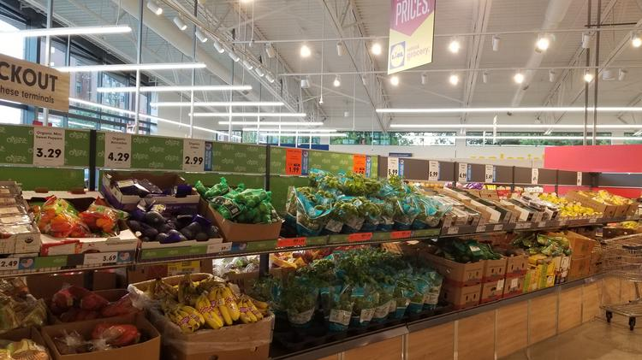
Fig 8: Ocado supermarket
Source: bizjournals.com, 2019

PEOPLE
The people in marketing mix strategy could be employee of the organization or customer of the company. Both plays major role in the development of an organization. Number of employees works under the Ocado group and they are highly trained by the organization that helps the organization in many ways such as handling the customer who visited the supermarket (ocadogroup.com, 2022). The good service to the customer gives them a free mouth publicity that create the awareness about the brand among the people.
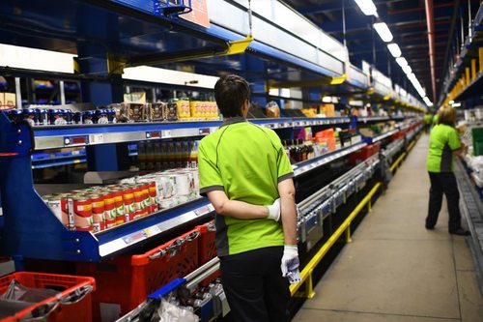
Fig 7: Ocado supermarket
Source: ocadogroup.com, 2021
Employees working in Ocado group and dealing with the supplier plays the significant role in maintaining and developing the supply chain of an organization. People helping the on site customer has the big responsibility to satisfy them with their needs.

Fig 8: Ocado supermarket
Source: ft.com, 2020

PHYSICAL EVIDENCE
The interaction of the customer with the physical products is essential in order to get the idea about the product or service. The decision of whether to buy the product or not depends upon the customers interaction with the products (ocadogroup.com, 2022). Ocado group keeps their product in their supermarket so that people can interact with their product and can take the concrete decision. For the online shopping, organization has listed the product with their image so that potential buyer could make the decision.
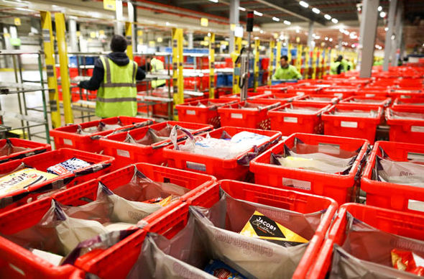
Fig 7: Ocado supermarket
Source: express.co.uk, 2017
Selling the product with different color packaging helps the customer to identify the right product on retail shelves. The special shelves provided by an organization also came with unique design and distinct color.
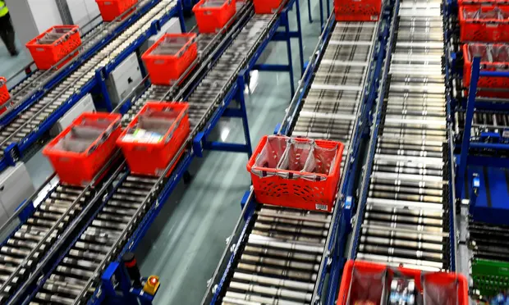
Fig 8: Ocado Conveyor belts transport
Source: theguardian.com, 2020

PROCESS
Ocado makes ensure that their supermarkets never run out of products and for this they kept the enough inventory of the daily household and essential products and to maintain this they follow the strong supply chain process. When they run out of the products, the system installed in organization notify that inventory level in the supermarket are low (ocadogroup.com, 2022).

Fig 7: Ocado product testing
Source: economist.com, 2018
In the online delivery process, Organization received all the orders in their computer system that makes the work easy for the employee of an organization. Based on the orders that are stored in the computer system, the desired product is delivered to the desired person from inventory.
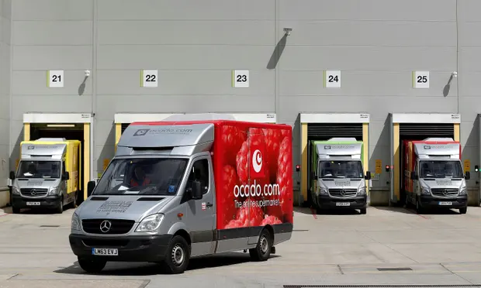
Fig 8: Ocado delivery service
Source: theguardian.com, 2020

Conclusion
The study has covered the essential aspects of the marketing fundamentals where has covered the marketing strategies, segmentation, targeting and positioning of an Ocado group. Ocado Group has focused on the marketing strategy to create awareness of the product among potential customers. For this, they have focused on the product, price, place, promotion, physical evidence, process and people. These marketing mix elements help them to achieve the desired success in the retail industry.

References
ft.com, 2020 ft [online] Ocado steals Tesco crown as UK’s most valuable food retailer Available at: <https://www.ft.com/content/127ef784-ed72-4854-b776-9053d663563b> [Accessed on: 6th January 2022]
Jenkins, E.L., Legrand, S., Brennan, L., Molenaar, A., Reid, M. and McCaffrey, T.A., 2021. Psycho-Behavioural Segmentation in Food and Nutrition: A Systematic Scoping Review of the Literature. Nutrients, 13(6), p.1795.
Moravcikova, D., Krizanova, A., Kliestikova, J. and Rypakova, M., 2017. Green Marketing as the Source of the Competitive Advantage of the Business. Sustainability, 9(12), p.2218.
ocadogroup.com, 2022 ocadogroup [online] Available at <https://www.ocadogroup.com/about-us/ocado-retail> [Accessed on: 6th January 2022]
ocadogroup.com, 2022 ocadogroup [online] Available at: <https://www.ocadogroup.com/> [Accessed on: 6th January 2022]
ocadogroup.com, 2022 ocadogroup [online] Available at: <https://www.ocadogroup.com/our-solutions/our-global-partners> [Accessed on: 6th January 2022]
theguardian.com, 2019 theguardian [Online] M&S confirms talks with Ocado on food delivery service Available at: <https://www.theguardian.com/business/2019/feb/26/m-s-ocado-food-delivery-service-marks-spencer-waitrose> [Accessed on: 6th January 2022]
theguardian.com, 2020 theguardian [Online] Ocado hit by protest vote against pay rise and bonus for directors Available at: <https://www.theguardian.com/business/2020/may/06/ocado-sales-rise-covid-19-online-shopping-surge> [Accessed on: 6th January 2022]

