PAULA BELDA HIGHCOCK

STUDENT NUMBER: P150426
COURSE: BA illustration
MODULE: Creative Research (M5X01599)
TUTOR: Scott Smith
WORDCOUNT: 1978

WORLDBUILDING:
Capitalism in “Spirited Away”
Question 1: “Write a critique of an experience in a built world. What evidence from this critique can be used to show how this experience transforms actual world phenomenon for the audience/participant?”

Spirited Away (2001), one of the finest animation pieces of our time as acclaimed by Kevin Pantoja, writer for Screenrant.com in his article called “The 10 best animated movies of all time, according to IMBD” and I quote <Another fantastic film from the mind of director Hayao Miyazaki, this is the one that many anime fans consider their favourite. Released in 2001, Spirited Away took home the coveted Best Animated Feature prize at the Academy Awards.>

Dave Kehr, renowned American film critic wrote in his column for the The New York Times that Spirited Away was "a masterpiece, pure and simple." That said, this film is complex, enigmatic and somewhat inaccessible, a child’s survival story intertwined with a manifestation against today’s capitalist mindset. Even though it was a “film specifically for 10-year-old girls.”, as Miyazaki said himself, he also went on to say in the same breath “That is why it plays so powerfully for adult viewers”.

This story embraces several worlds within itself.

One of the world’s is seen through the eyes of a young 10 year old girl, Chihiro, yet another female lead which is something Miyazaki frequently leans toward (San in Princess Mononoke 1997, Nausicaá of the Valley of the Wind 1984, Kiki’s Delivery Service 1989). Sometimes referred to as a silent nod in the direction of feminism with his use of strong female characters albeit in their naïve form of a young child - the future of humanity and society.

Then there is the somewhat dark and sexist world which some reviewers claim.
It is rumoured that the story is about child prostitution and, in all honesty, throughout the film there are obvious elements that prove it.
According to this hearsay, they deduct that the arrival of Chihiro to the Bath House is her induction into a brothel, Yubaba (the boss) is a Madame who buys the young heroine, Zeniba is a woman who has already forgotten normal life and NoFace is a client in love with the little girl who seeks to take away her virginity. In this context, the story certainly takes on a morbid meaning.

There’s undoubtedly some logic behind this theory although it is tremendously superficial. Miyazaki is not so obvious although it could well have been intentional because the director affirmed that he accepted a connection with prostitution, but made it clear that he used it as an excellent opportunity to talk about capitalism.

It is therefore my aim in this essay to illuminate Hayao Miyazaki’s use of animation to criticize Japan's history of capitalism.

Spirited Away is probably the film that most firmly depicts Miyazaki’s censure of a capitalist mentality, especially in relation to issues we see in post-modern Japan, namely the loss of spiritual value and identity.

In order to understand Miyazaki’s World Building and show how this converts into current world happenings, it is important to mention the context in which this film was written, produced and brought to life.

This film was the saving grace of Studio Ghibli as it went through its toughest economical crisis. After the release and failure of “My Neighbours the Yamada” (1999) and the huge investment of opening the Ghibli Museum of Mitaka (see image below), money was tight for future investments, including films which they desperately needed to make.
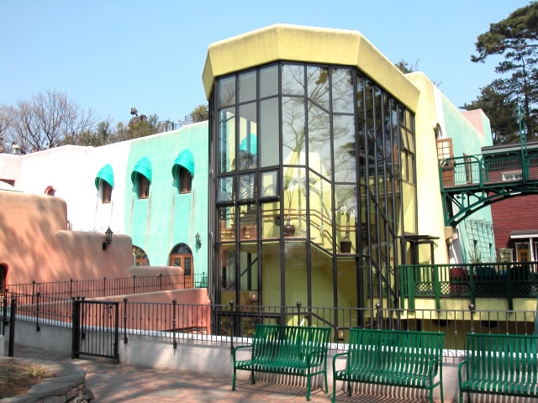

It was during these trying times that Miyazaki mourned the death of his friend and fellow animator Yoshifumi Kondo (1950 - 1998 https://www.imdb.com/name/nm0464911/ ) which lead to his spiritual retreat and time of meditation.

All the above is said to have triggered the “abandoned theme park” world in Spirited Away - he connected and reflected upon his own experience, his life prior to soul-searching and inner discoverance, and the studio’s economical struggles - metaphorically depicted through the closure of the many Theme Parks throughout Japan at the time, and clearly identified when mentioned by Chihiro´s father at the beginning of their adventure “Ha! I knew it! This is one of those theme parks that got shut down after the Japanese crisis” (Spirited Away, 2001, min 6).

Further to mediation, Miyazaki concluded that traditions and spiritualism had fallen behind in the current era and he considered there to be a loss of value in modern society and the lack of balance between them. <The hope of the future is through the true heroes, not the ones with a gift but the ones who, like Chihiro, don´t give up when facing adversity> (Hayao Miyazaki as interviewed by Marta García Villar).
This desire to mix the old (tradition) with the new (technology) is also obvious with the Ghibli studio animation and artistic style. Traditional artistry with technological advantages - working in harmony.

Spirited Away starts with a very real picture of family life: a mother and a father sat at the wheel of their gleaming Audi (European car aka very expensive and exclusive) saloon, Dad is particularly proud of its four-wheel drive as they're speeding towards to a new home in the provinces (rich area).
In the back, hunched and frowning, is Chihiro, a 10-year-old little girl, completely miserable after leaving all her friends and life behind. Chihiro is frightened by the feelings of loneliness that haunt her. She’s clinging to a bouquet of dying flowers that her old friends have apparently given her, and she feels overwhelmed by grief and despair. "My first bouquet, and it's broken," (just like her spirit and life) she moans upon deaf ears.

They get lost along the way, come across an abandoned Theme Park, which is in fact, Yuya, a leisure center built in the spiritual world by a greedy witch (capitalist) called Yubaba.

Without much ado, Chihiro’s parents see tables laden with fine foods, there isn’t anyone around but they are hungry, consider they can pay for it later, “we have money and credit cards” so they begin to eat like pigs.

According to Miyazaki, they represent the immediate avarice of the Japanese when free and open trade came in the 1980s. They lost the sense of time, forget where they are and their status - Chihiro is slow to realize that their change is permanent. Infinite food symbolizes endless products that make humans stupid and distract them from their thoughts.

As well as the above, yet another critique is made by Miyazaki regarding the loss of respect for the past and it is highlighted in that Chihiro’s parents get transformed into pigs and are often referred during the course of the film as “thieves of the guest´s food”.

This is because, in the film, the parent´s sit down without prior invitation to do so and begin to gorge themselves with the food set before them. This is a direct comparison as to how the Japanese take for granted their culture.
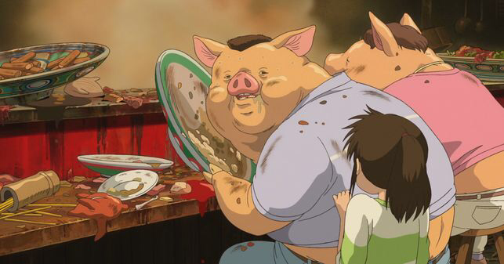

Japanese Twitter user @ 0910noncha published, on July 9, 2016, a tweet in which he said that he had sent to Studio Ghibli several questions about Spirited Away and they had answered him in a very thorough manner.
The alleged letter explains that the transformation into pigs of Chihiro’s parents symbolizes how some human beings become greedy, like many people during Japan's Bubble Economy of the 1980s
According to the letter, these people were the only ones at the time who complained that "we are in a recession and we do not have enough to eat".

This same letter went on to explain that once someone becomes a pig, he no longer returns to being human, but gradually begins to have the "body and soul of a pig," and that this "not only applies to the fantasy world.”

In the real world, the words “capitalist” and “pigs” are used on regular basis, what's more, the symbolism of pigs when referring to capitalism can be found in both art and literature - “Animal Farm” by George Orwell (1945) and “Lord of the Flies” by William Golding (1954)

Yubaba, the witch, is surrounded by elements of European culture. The scenario in which she is presented is different from any other in the film because it evokes the Meiji period 1868 - 1912 when Western capitalist culture slowly took over Japan.
<The Meiji period that followed the Restoration was an era of major political, economic, and social change in Japan. The reforms enacted during the Meiji emperor's rule brought about the modernization and Westernization of the country and paved the way for Japan to become a major international power.> Britannica encyclopedia

In this Meiji restoration, the influx of the Western culture brought to Japan both chaos and growth, represented by the mixing of Japanese identity with Western architecture, philosophy, fashion, and values.

The Meiji decoration in Spirited Away is presented in much of the film as a melancholic element.

In resumen, Chihiro appears for the first time as a child within a nuclear family, which is the basis of capitalist society, providing for their family with their hard-earned money which they have quite clearly worked for. While parents are generally responsible for keeping the family affairs in check, in this case, Chihiro's parents are cursed by Yubaba, therefore passing the responsibility onto Chihiro to get her family back.

Spirited Away depicts Chihiro as a working-class worker, a girl whose childhood was stolen.

An excellent example of wage slavery, is the scene when Chihiro meets Kamaji, the man from the boiler. He presents himself as a "slave of the boiler that heats the bathrooms".

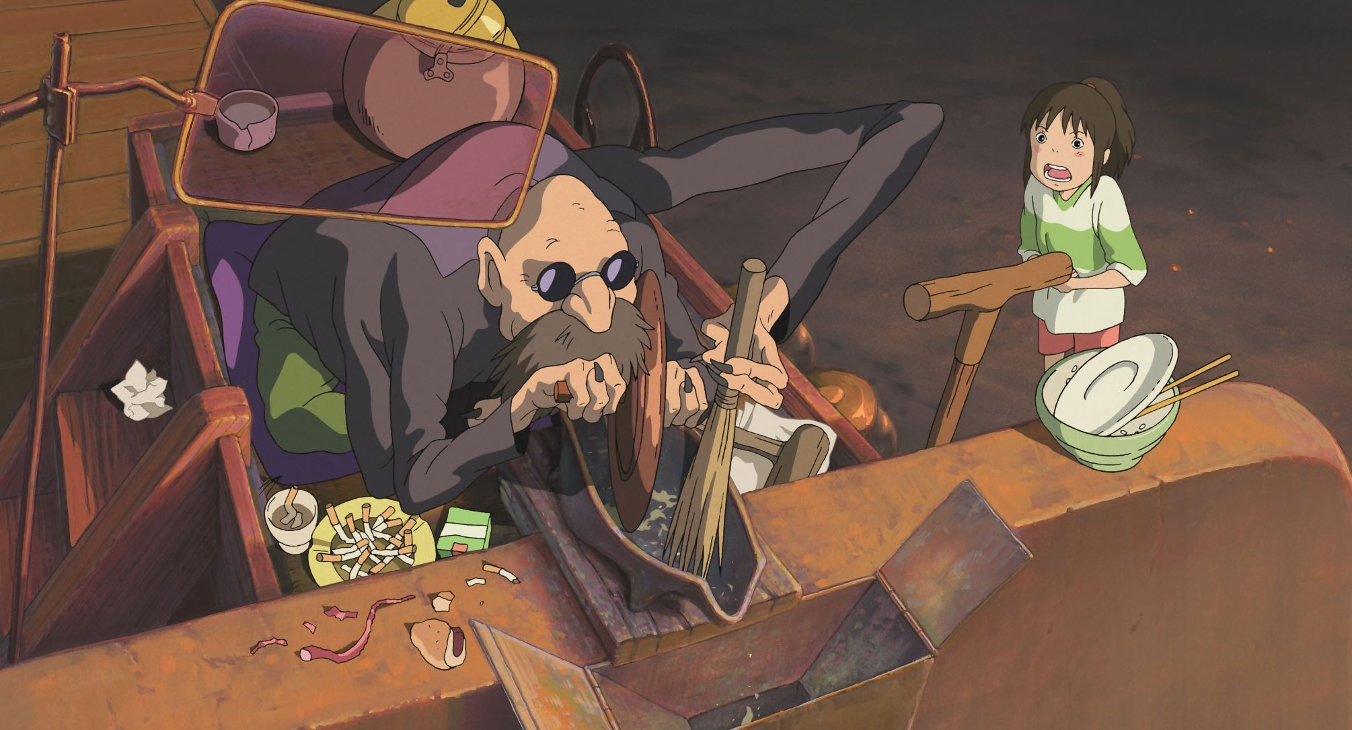

It must be considered that seeing as the whole Bath House is owned and operated by Yubaba, that means that he, therefore, must be a slave to his employer.

When Yubaba takes away Chihiro’s name (identity) by adding "sen", her name literally means "a thousand" - the numerical amount - one of many. This simple action generates a rapid maturity in the little girl, who renounces her childhood without hesitation. It also reveals that once you leave behind the years of innocence, it then becomes a product of value. Miyazaki expresses how, due to social changes, people are assigned a price and if it is not high, it is as if they did not exist.

Immediately after Chihiro gets renamed she is sent to take care of the largest bath tub at the Bath House which is supposedly modelled on the Dogo Onsen
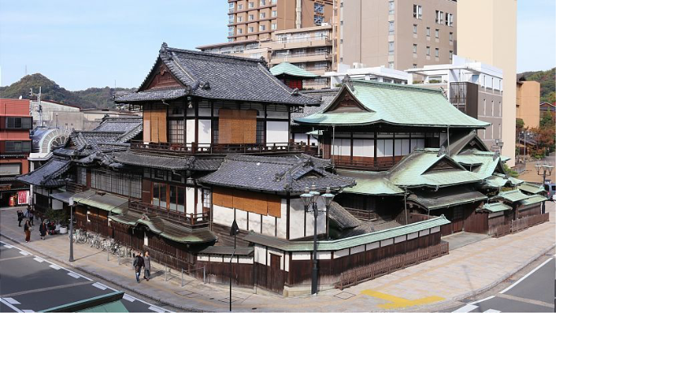
but it could also have been inspired by Notoya Ryokan, Ginzan Onsen
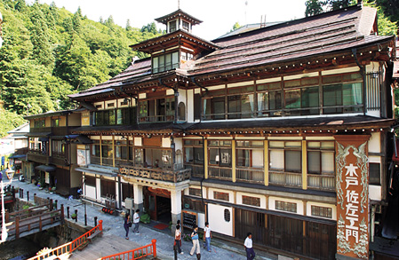

where she meets a Stink spirit, who later gets revealed to be a polluted river with a bike incrusted in its side, suffering because of the “real world’s” irresponsibility, ironically receiving aid from a human girl aka our future society.
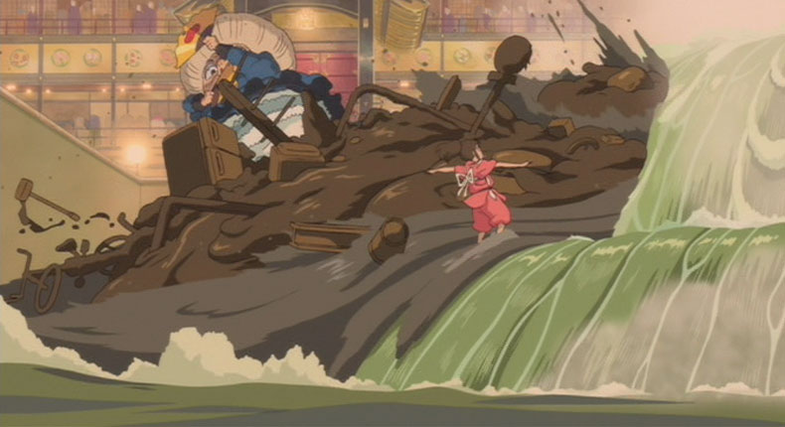
Ending climate change requires the end of capitalism. Have we got the stomach for it?
Written by Phil McDuff for The Guardian

On Tuesday 9th July 2019, Peter Walker, Political correspondent for The Guardian wrote an interesting article with David Attenborough as his main piece.
<The attitude of young people towards tackling the environmental crisis is “a source of great hope”, David Attenborough has told MPs, as he predicted that polluting the planet would soon provoke as much abhorrence as slavery>.

On the other hand, the USA and Japan are the only G7 Nations that refuse to tackle plastic pollution.

In reflection, once the viewer looks past the “child growing into an adult” obviety and comparisons with lesser Disney animations or even the great Alice in Wonderland by Lewis Carroll.

The main theme of the film, as stated on occasion by Miyakazi himself, is the national identity of Japan and how the country has been affected and minimized over the years due to its economic situation - capitalism. The way in which Chihiro desperately wants to return to the way she was before her adventure. Miyazaki affirmed that it is the same feeling of want that Japan has as a society.

In a certain aspect, it longs for the past and wishes to bring it back, with its traditions, customs and identity without capitalism and consumerism.

BIBLIOGRAPHY:
- Spirited Away dir Hayao Miyazaki 2001 Studio Ghibli
- The Art Of Spirited Away dir Hayao Miyazaki 2002 Studio Ghibli Library
- El Viaje de Chihiro by Marta Garcia Villar 2002 Heroes de Papel
- Review of El Viaje de Chihiro by Marta Garcia Villar, lemiaunoir.com
https://www.lemiaunoir.com/resena-viaje-chihiro-marta-garcia-villar/
- Culture section article by Francesc Miró for eldiario.es 17/04/2017 https://www.eldiario.es/cultura/cine/Chihiro-claves-pelicula-animacion-XXI_0_628887284.html
- More than a film by Jesus Jimenez for rtve.es 03/07/2017 http://www.rtve.es/noticias/20170703/viaje-chihiro-mucho-mas-pelicula/1573081.shtml
- Close Look at Spirited Away for Rethoric of Miyazaki blog 04/2014 https://rhetoricofmiyazaki.wordpress.com/2014/04/16/rhetorical-analysis/
- The true and dark meaning of Spirited Away by Alonso Martinez for culturacolectiva.com 09/03/2017 https://culturacolectiva.com/cine/el-oscuro-significado-de-el-viaje-de-chihiro
- The spiritual ourney of Sen and Chihiro by Pilar for japon-secret.com 25/09/2009 https://culturacolectiva.com/cine/el-oscuro-significado-de-el-viaje-de-chihiro
- Princess Mononoke, dir Hayao Miyazaki 1997 Studio Ghibli
- Kiki´s Delivery Service, dir Hayao Miyazaki 1989 Studio Ghibli
- My Neighbors the Yamadas, dir Isao Takahata 1999 Studio Ghibli
- Nausicaa and the Valley of the Wind, dir Hayao Miyazaki 1984 Studio Ghibli
- Animal Farm by George Owell 1945
- Lord of The Flies by William golding 1954
- Tips on World Building by Cuck Sambuchino for writersdigest.com 08/10/2014 https://www.writersdigest.com/guest-columns/tips-on-world-building-for-writers-how-to-make-your-imaginary-world-real
- Best Animated Movies of All Time by Charlie K Welling for iMDb 04/03/2017 https://www.imdb.com/list/ls064574494/
- The new season/movies: A masterpiece of Animation by Dave Kehr for he New York Times 08/09/2002 https://www.nytimes.com/2002/09/08/movies/the-new-season-movies-a-masterpiece-of-animation.html
- Japan’s bubble economy of the 1980s by Jesse Colombo for The Bubble Bubble 04/06/2012 http://www.thebubblebubble.com/japan-bubble/
- Meiji Restoration by Encyclopedia Britnnica 20/07/1998 https://www.britannica.com/event/Meiji-Restoration
- Dogo Onsen for Matsuyama Travel https://www.japan-guide.com/e/e5502.html
- Ending Climate Change requires the end of Capitalism. Have we got the Stomach for it? by Phil McDuff for The Guardian 18/03/2019 https://www.theguardian.com/commentisfree/2019/mar/18/ending-climate-change-end-capitalism
- David Attenborough: polluting planet may become as reviled as slavery by Peter Waler for The Guardian 09/07/2019 https://www.theguardian.com/tv-and-radio/2019/jul/09/david-attenborough-young-people-give-me-hope-on-environment
- The US and Japan arethe only G7 Nations that refue to tackle plastic pollution by Carly Cassella for Science Alert 13/06/2019 https://www.sciencealert.com/us-japan-refused-join-g7-charter-tackle-plastic-pollution-oceans

