ACADEMIC REPORT
Name: Gurduz Ana
Student no: 2029605
Name of the lecturer:Tarila Zuofa

Table of Contents
Introduction 3
Body 3
Time management in team members 3
Open-minded, Encouragement and Expectations 4
Effective communication among team members 5
Ways to improve team communication 5
Conclusion 6
Reference List 7

Introduction
Communication can be understood as sharing ideas, views, problems, thoughts, knowledge to make the receiver understood and when this communication is done more fluently and with an open sense of mind is known as effective communication. In a business organization, workloads are divided into various team and it is the capability of each team for completing the task with precision which is achieved by effective communication (Azizan et al., 2018). There are various ways to achieve effective communication. Building trust by motivating and supporting each other and transparency among each other. Teams with leaders having good communication skills can engage their team members with full potential.

Discussion
Any business organization has different sectors like marketing division, advertisement of a brand, production unit customer help desk, and many more. Each sector consists of one or several teams and each team have a diversity of employee. These employees work at their peak potential with good teamwork which can be achieved by effective communication. Every business organization aspires to build a positive environment in its workplace (Azizan et al., 2018). So, to have this advantage in any workplace should endorse fluent communication in every team. This could help in making bonds with each other and also between leader and employee. A good team always gives better output to their companies and a path of expansion. These effective communication skills could be achieved with change with their mind sense and communication skills.

Time management in team members
Bad management of time does not always render our work harder – it may lead to greater anxiety. Time management consists of a mix of methods and practices which help people define goals, reduce external distractions on results deliberately (Williams, 2018). Importance of time management are-
- Improve team performance- Time management may help people concentrate on the essential functions involved and prevent time-consuming interruptions. If people learn how to block time out of their day for all those key activities, you're going to have a better clue how long each activity needs to go. People will probably discover that you waste considerable time determining what to do or how to do and more time doing essential tasks.
- Produce better work- If a workforce doesn't continuously race to achieve a deadline, it may take an extra effort and think about its job. Time management enables them to prioritize their activities to make sure that every project has ample time to complete (Williams, 2018). Even when they're not eager to complete their task before a fast-coming period, the feeling of accomplishment rises.
- Deliver Work on Time- If a team has to complete a list of tasks before the conclusion of the day, they can always meet their commitments. Numerous people utilize management skills to complete a job over many days or accomplish it in advance of the schedule to give a reserve for potential problems. They won't miss their deadlines if they plan correctly for the time required to finish their task.
- Reduce Stress- Effective time management may help team members prioritize their to-do lists and establish the time necessary for their major activities (Williams, 2018). Emphasizing their chores and taking time to do them might contribute to lowering their anxiety levels. If they have a complete list of chores to perform, it is simple to worry if they know precisely what they have been doing.
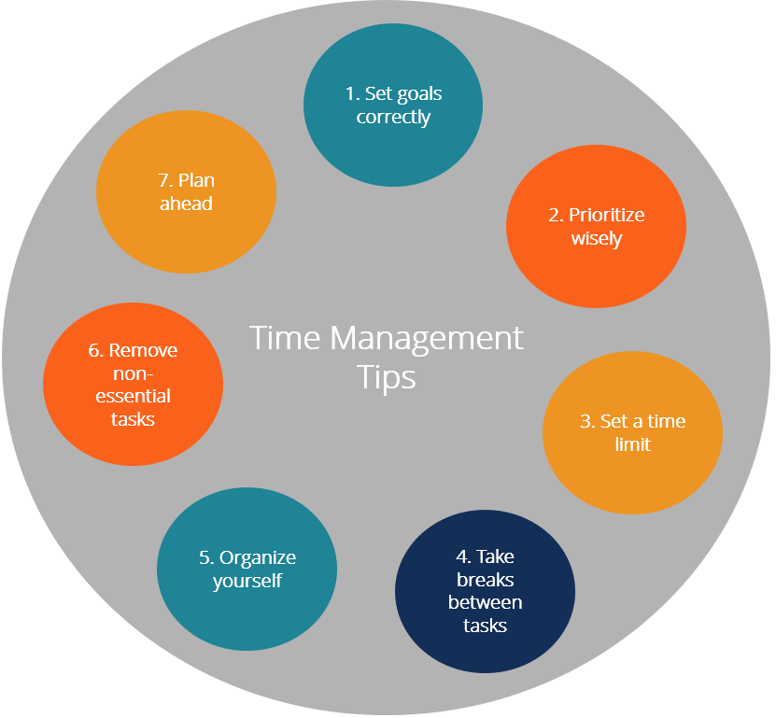
Figure 1: Time management
Source: (Williams, 2018)

Open-minded, Encouragement and Expectations
Being in teamwork means people of different calibre participating in the task in which the best way to share your ideas or opinions is being true to yourself (Bhatti and Ahsan, 2021). This mind sense will create transparency among others and the other employee were to influence and participate much more. It creates a bond of trust so that their weakness and strength will be covered by each other.
Encouraging team members for their work, attempt, or even for their presence of ideas will strengthen their confidence. Communicating in a way to motivate others builds trust among each other. Also, expectations from every team member give them confidence for being on the task as it explains dependence among them. It is the best way to motivate team members for presenting their ideas and views.

Effective communication among team members
Communication is the basis for every element of a company. Communication between two or more individuals is effective to convey, receive and interpret the message successfully. It is the information exchange process among members of the team that takes into consideration what they want to communicate, what they say, and what the intended consumer perceives (Bhatti and Ahsan, 2021). Every team's capacity to communicate well is the most important component. In your capacity as a leader, honestly analysing the emotional intelligence of the team is highly essential. Every method appears to disintegrate. Their team would digress into a meaningless machine without constant lubrication and preventative servicing to maintain the corporation's personnel working to their best (Dubikovsky and Friesel, 2018). The key to creativity is to think about the mission and dedication of the team. Effective communication implies only that - it is a step forward. Communicating with members of the team implies that their performance remains high (Dubikovsky and Friesel, 2018). A member of his team at the end of his rope can be effective whenever it regards to workloads; until he is 'broken.' When this occurs, the employee deficit may cost the firm more than if it examined the member of the team often and found out about the difficulties before difficulties were encountered.
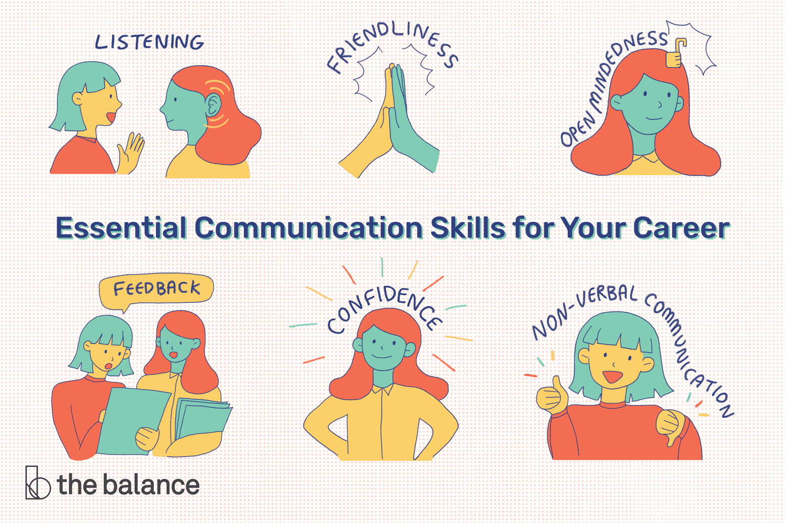
Figure 2: Importance of effective communication
Source: (Dubikovsky and Friesel, 2018)

Ways to improve team communication
- Have An Open-Door Policy- The establishment of an open-door policy creates the precedence that everyone may always make comments, express concerns, and propose suggestions (Shameem, Kumar and Chandra, 2017). This is a crucial component of the team's building confidence. Inaccessible management sends out a message to lower-level workers that they are not as valued. It is important to keep the doors open for dialogue.
- Be Open to Reciprocal Feedback- It is vital to be clear to all parties to make the most of the input available. It is no assistance to anybody to simply "fix this" for a submitted project (Shameem, Kumar and Chandra, 2017). Feedback needs to be precise and detailed to be useful, so that everybody else may benefit from it.
- Understand Diversity Issues- When people from every nationality, ethnicity, ideology, and language work combined, variable refresh combine to create anything extraordinary. However, diversity does not have its problems (Marlow, Lacerenza and Salas, 2017). Effective communication may often be difficult with accents, subtleties, dialects, and cultural pronunciations. Team leaders need first of all to realize that the situation is truly a problem to battle these obstacles. Consider it an opportunity to address the topic with the team members and strategies of overcoming barriers.
- Point out individual strengths and use them well- Please be careful not to communicate in the same way as everyone else. Visuals prefer written communications (mail or virtualized applications) whereas auditors more benefit from a telephone, webcam, or face-to-face conference. When we realize that everyone is distinctive it not only makes it possible to better communicate, it transmits the message to the members of the team that they are regarded as people by companies (Marlow, Lacerenza and Salas, 2017). A valued team member is a team member ready to go far beyond the organization.
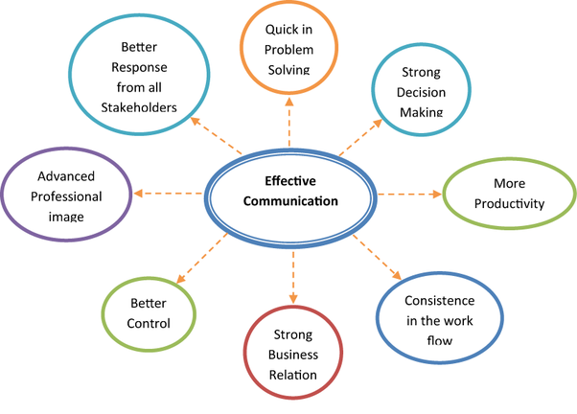
Figure 3: Ways of effective communication
Source: (Marlow, Lacerenza and Salas, 2017)

Conclusion
Many communication obstacles that can be ascribed to the sender or recipient may break down communication. Efficient communication, therefore, involves knowledge of the obstacles. The choice of the correct communication channel is equally essential since it weakens the message by picking the wrong media. Teamwork is gaining growing importance in modern businesses and may offer a strategic edge when it comes to enhanced employee happiness, innovation, and creativity. Competent communication among the team members creates a shared aim amongst teammates that allows them to achieve their objectives. The ability to share can assist members of the team to enhance their sense of connection and improve relations.

Reference List
Azizan, M.T., Mellon, N., Ramli, R.M. and Yusup, S., 2018. Improving teamwork skills and enhancing deep learning via development of board game using cooperative learning method in Reaction Engineering course. Education for Chemical Engineers, 22, pp.1-13.
Bhatti, M.W. and Ahsan, A., 2021. Effective communication among globally distributed software development teams: Development of an “effective communication” scale. In Research Anthology on Recent Trends, Tools, and Implications of Computer Programming (pp. 2014-2039). IGI Global.
Dubikovsky, S. and Friesel, A., 2018, September. Global Virtual Teams, Project Ambiguity, Trust, and Effective Communication in Senior Capstone Courses. In 2018 28th EAEEIE Annual Conference (EAEEIE) (pp. 1-9). IEEE.
Marlow, S.L., Lacerenza, C.N. and Salas, E., 2017. Communication in virtual teams: A conceptual framework and research agenda. Human Resource Management Review, 27(4), pp.575-589.
Shameem, M., Kumar, C. and Chandra, B., 2017, January. Challenges of management in the operation of virtual software development teams: A systematic literature review. In 2017 4th International Conference on Advanced Computing and Communication Systems (ICACCS) (pp. 1-8). IEEE.
Williams, D.P., 2018. Measuring the Effectiveness of an Open Ended Team-Based Induction Task. New Directions in the Teaching of Physical Sciences, (13).

