
Applied Leadership and Management in the Workplace
Module Assignment Submission
Student Name: | Robert Peter Morgan
Student Number: | 0551699
Module No: | BMSK4012
Module Title: | Enterprise and Intrapreneurship

Statement of Confirmation of Authenticity
By the act of making this submission, the student declares that this is the work of the student named above. The work has not, in whole or in part, been knowingly presented elsewhere for assessment, or where assessment has been built on a previous assessment, this has been identified. Where materials have been used from other sources it has been properly acknowledged. If this statement is untrue, the student acknowledges that an assessment offence has been committed.
Attention is drawn to the plagiarism and unfair practice policies of both the University and of ILM.

Table of Contents
1
Section 1. Executive Summary 5
Section 2. Introduction 6
2.1 Business Background and Idea 6
2.2 Business Details 6
2.3 Legal Status 7
2.4 Ownership and Management 7
Section 3: Market and Competitors 8
3.1 Market Overview 8
3.2 PESTLE Analysis 9
3.3 SWOT Analysis 10
3.4 Customers and Target Market 11
3.5 Competitor Analysis 12
Section 4: Sales and Marketing Strategy 13
4.1 Marketing Objectives 13
4.2 Marketing Strategy 13
4.3 Unique Selling Point (USP) 14
4.4 Marketing Mix – The 7 Ps 14
4.5 Pricing and Revenue Strategy 15
Section 5 Operations 16
5.1 Location and Service Area 16
5.2 Premises and Facilities 16
5.3 Equipment, Stock, and Consumables 17
5.4 Systems and Procedures 17
5.6 Health, Safety and Legal Compliance 18
5.7 Quality Control 18
6.0 Financial Information 19
6.1 Cashflow Forecast 19
6.2 Start Up and Operational Costs 20
6.3 Sources of Finance and Funding Requirements 21
References 22
Appendices 25
Appendix A – Poster 25
Appendix B – Promotional Flyer 26
Appendix C - Industry Related CV 27

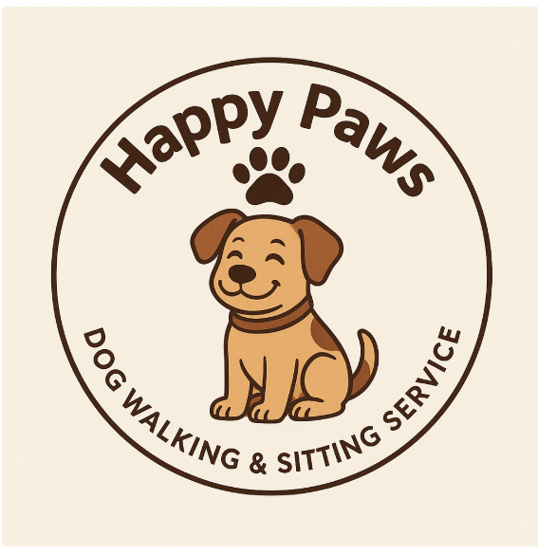

Happy Paws Dog Walking & Sitting Service
Owner – Robert Morgan
Sole Trader
Mobile Number 07445 – 419807
E-mail Address: Happypaws@gmail.com

Section 1. Executive Summary

Happy Paws Dog Walking and Sitting Service is a new sole-trader business that is based in Neath Port Talbot, designed to meet the growing local demand for dependable, affordable, and professional pet care support. The service offers daily dog walking, home visits tailored to the schedules of working professionals, NHS shift staff, and older residents.

The UK pet sector continues to show sustained growth, with approximately 57 percent of households owning pets, including nearly 12 million dogs (Pet Food Manufacturers’ Association [PFMA], 2024). Pet owners increasingly view animal care as an essential service rather than a luxury (Mintel Group Ltd., 2023).

The business is owned and managed by Robert Morgan, who brings over twenty-five years of NHS experience. Skills such as reliability, organisation, and confidentiality are directly transferable to pet-care management, helping to foster client confidence and loyalty. The business will operate as a sole trader, ensuring direct accountability and flexible service delivery.

Start-up funding of approximately £6,000 has been secured through a Business Wales start-up loan will cover insurance, equipment, and marketing costs. Financial forecasts indicate a break-even point at roughly 74 bookings per month, with a projected first-year turnover of £20,000 and a modest profit within six months of trading.

Section 2. Introduction

2.1 Business Background and Idea

The idea for Rob’s Dog Walking and Sitting Service emerged from observing the growing need for dependable pet care among residents in the Neath Port Talbot area. Many pet owners, especially those working full time struggle to provide consistent daily walks for their dogs. According to PFMA (2024), pet ownership in the United Kingdom continues to rise, with dogs remaining the most common companion animals. This social trend, combined with the pressures of modern working life, has expanded opportunities for small pet-care enterprises that offer trustworthy, personal service (Mintel Group Ltd., 2023).

The venture builds on the owner’s twenty-five years of NHS experience, applying established values of reliability, confidentiality, and organisation to pet-care delivery. Small businesses that align their service model with personal credibility and community reputation often achieve sustained competitive advantage (Bridge & O’Neill, 2018). The overall goal is to create a local, community-based dog-walking and sitting service that provides safety, reassurance, and flexibility to clients who treat their pets as family members.

2.2 Business Details

The business will operate as a sole trader and will be both a mobile and home visiting service covering the Neath Port Talbot area. Customers will be able can book appointments by phone, email and social media messaging. Regular feedback mechanisms will be used to maintain transparency and strengthen client relationships an essential element of service quality management (Amoakoh & Naong, 2017).

2.3 Legal Status

Happy Paws Dog Walking and Sitting Service will operate as a sole-trader business. This structure gives the owner full decision-making control, simple tax responsibilities, and minimal administrative burden (GOV.UK, 2024). Registration with HM Revenue & Customs will be completed before launch, and the business will hold appropriate public-liability insurance. The owner will also maintain an up-to-date DBS certificate and a recognised pet first aid qualification to support safe and trustworthy service delivery. The business will comply with all the relevant legislation, including the Animal Welfare Act 2006, local licensing requirements and UK GDPR data-protection rules. Meeting these statutory obligations is essential for safeguarding animals, protecting clients and establishing professional credibility (Neath Port Talbot Council, 2024).

2.4 Ownership and Management

The business is solely owned and managed by Robert Morgan who has worked as a Senior Library Assistant in the NHS for twenty-five years. His experience in handling information, meeting deadlines and providing customer support demonstrates transferable leadership and organisational skills.

Section 3: Market and Competitors

3.1 Market Overview

The UK pet care sector remains one of the most resilient and expanding segments of the domestic service economy. According to the Pet Food Manufacturers’ Association (PFMA, 2024), approximately 57 percent of UK households own a pet, including around 12 million dogs. The sector has continued to grow despite economic fluctuations, supported by strong emotional bonds between owners and animals.

Recent data from Mintel Group Ltd. (2023) shows that spending on pet services has increased by over 25 percent since 2019, with many owners prioritising professional support such as dog walking and home visits. This trend has been reinforced by post-pandemic lifestyle changes and flexible working patterns, where owners often require dependable midday support.

3.2 PESTLE Analysis

The external environment for Happy Paws Dog Walking and Sitting Service has been assessed using the PESTLE framework, which highlights key Political, Economic, Social, Technological, Legal and Environmental influences (Yuksel, 2012).

- Political - Local-authority regulations for animal-service providers and insurance obligations require compliance with licensing and welfare standards.
- Economic – Cost of living pressures may influence client spending, but pet-care demand remains relatively stable due to emotional attachment and
- Social - Growing cultural emphasis on animal welfare and companionship supports market expansion. NHS and professional workers increasingly outsource pet care to manage work life balance
- Technological - Online marketing and social media engagement improve transparency and client confidence
- Legal - Operations must comply with the Animal Welfare Act 2006 and data-protection requirements under the UK GDPR (Neath Port Talbot Council, 2024).
- Environmental - Heightened awareness of sustainability encourages the use of eco-friendly waste bags and local walking routes to reduce carbon impact.

Overall, the PESTLE analysis indicates a supportive environment where social and technological trends work in favour of the business. Legal compliance and cost management remain ongoing priorities.

3.3 SWOT Analysis

A SWOT Analysis has been completed to highlights the business’s internal strengths and weaknesses alongside external opportunities and threats (Namugenyi et al., 2019).

Strengths | Weaknesses
Reliable, trustworthy background from 25 years in the NHS.  Low overheads due to home-based, mobile setup.  Personal, consistent service that builds client trust. | No existing clients at the launch of the business.  Sole Trader and lone worker vulnerable to illness or emergencies.  Limited marketing budget.
Opportunities | Threats
High local demand from Elderly people and shift workers.  Growing pet-care market nationally.  Potential partnerships with vets, groomers, and cafes. | Established local competitors and app-based services.  Rising fuel, insurance, equipment costs  Economic pressures affecting client spending.

The SWOT analysis shows that the business’s competitive positioning as a trust-based, community-led provider, while identifying areas for resilience planning and gradual growth.

3.4 Customers and Target Market

Happy Paws Dog Walking and Sitting Service will target the following customer groups within a ten-mile radius of the Neath Port Talbot area: -

- Working professionals who are away from home for extended periods.
- Shift workers who require flexible booking options.
- Older residents or individuals with limited mobility who need regular walking support.
- Families and holidaymakers who need dependable pet sitting services.

Research indicates that around one third of UK dog owners regularly use external services for exercise or care support (PFMA, 2024). This target market aligns with socio-demographic data showing a high proportion of public-sector and healthcare employees in Neath Port Talbot (Office for National Statistics [ONS], 2022). These groups typically prioritise reliability, safety, and professionalism rather than simply the lowest price, making Happy Paws’ personal and service-focused approach a strong match for local expectations.

3.5 Competitor Analysis

Happy Paws differentiates itself from local competitors such as Happy Days Pet Sitting Service, Paws on the Go and Little Paws Doggy Day Care by offering consistent availability, strong communication and a reliable routine (List of Licensed Animal Boarders - NPT Council, 2025). While many competitors charge £12 to £15 for a 60-minute walk, Happy Paws will enter the market at a competitive £10. This is a deliberate lower introductory rate to attract early clients while maintaining a professional service.

Section 4: Sales and Marketing Strategy

4.1 Marketing Objectives

Marketing objectives provide measurable direction for achieving growth and sustainability. Applying the SMART framework Specific, Measurable, Achievable, Relevant and Time bound helps ensure focus and accountability (MindTools, 2025).
These goals align with small-enterprise best practice, which emphasises incremental, evidence-based growth supported by relationship marketing (Kotler & Armstrong, 2017).

4.2 Marketing Strategy

The marketing strategy integrates digital visibility with community engagement, balancing cost-effective promotion and local reputation building (Bridge & O’Neill, 2018).

Key tactics include: -

- Social Media Engagement - Facebook and Instagram posts showcasing walks, dogs and testimonials to foster trust and visibility.
- Word-of-Mouth Referrals - Encourage clients to recommend the service by offering discounts on their next booking.
- Flyer Distribution - Place printed materials in vet practices, pet shops, and community boards.
- Community Networking - Build partnerships with pet-friendly cafes and local events to strengthen brand awareness.

Using these combined approaches will reinforce Happy Paws’ image as a dependable, locally invested service provider.

4.3 Unique Selling Point (USP)

Happy Paws differentiates itself through its personal, one to one service model and the owner’s NHS background, conveying professionalism and trustworthiness. Larger or app-based competitors can often lack personal accountability, while this business provides continuity clients know exactly who handles their pets. Reliability and transparent communication are the foundation of the brand’s reputation (Amoakoh & Naong, 2017).

4.4 Marketing Mix – The 7 Ps

Using the 7 Ps of Marketing helps business keep marketing consistent and they have been applied to Happy Paws (Erdogan, 2024).

- Product - Professional, reliable dog walking, pet sitting, and home-visit services focused on safety and trust.
- Price - Solo walks £10 per hour for a solo walk, £8 for a thirty-minute solo walk, £5 for an additional dog from the same household. Home visits £15 a one-hour visit or £10 for a thirty-minute visit. Home visits include feeding, toilet breaks, medication if needed and supervision.
- Place - Home-based, mobile service across Neath Port Talbot. Online or phone bookings.
- Promotion - Social media posts, flyers, community partnerships, NHS staff networks, and referral schemes.
- People - Sole trader Robert Morgan experienced, DBS-checked, pet first aid certified and client focused.
- Process - Simple booking confirmation system, owners receive updates and photos after each session if required.
- Physical Evidence - ID badge, business cards, Facebook reviews and a clean professional presentation.

This balanced marketing mix positions the business as a trustworthy, low-cost, high-care service accessible to local pet owners.

4.5 Pricing and Revenue Strategy

Pricing has been set deliberately competitive while still supporting a sustainable income. Local market and price comparisons indicates that most Neath and Port Talbot dog walkers charge between £12 and £15 per hour. Happy Paws will enter the market at £10 for a 1-hour solo walk, £8 for a thirty-minute solo walk, £5 for an additional dog from the same household. Home visits £15 a one-hour visit or £10 for a thirty-minute visit. Home visits include feeding, toilet breaks, medication if needed and supervision. This approach fits with advice that small businesses do better when they focus on value, trust, and building good relationships. Rather than constantly trying to undercut everyone on price (Bridge & O’Neill, 2018). With steady service and regular customers, income should start to settle by around the halfway point of the first year as a solid weekly routine builds up.

Section 5 Operations

5.1 Location and Service Area

Happy Paws will be based from the owner’s home in Neath Town Centre. This base gives easy access to safe and scenic places to walk dogs, including the Gnoll Country Park, Aberavon Beach and the Neath Canal Paths. These locations provide plenty of open, well-maintained space for calm, controlled, and responsible walks. Working from home also keeps running costs low and allows the service to stay flexible and close to the community. These are key strengths for small local businesses (Bridge & O’Neill, 2018).

5.2 Premises and Facilities

As the business does not require commercial premises, a dedicated home office will be used for managing bookings, keeping financial records and storing essential equipment. All items will be kept safely and checked regularly for wear or damage. A small section of the property will be fitted with shelving and secure hooks so that leads, harnesses and other supplies can be stored hygienically and kept organised.

5.3 Equipment, Stock, and Consumables

Dog walking needs simple but reliable equipment. Happy Paws will use strong leads, safe harnesses, waste bags, high vis clothing and a basic pet first aid kit. Good waterproofs and sturdy footwear will also be used, as the work is outdoors in all weather. These items meet the expectations set by Neath Port Talbot Council (2024) and support the standards in the Animal Welfare Act 2006. A few everyday consumables such as treats, wipes and spare clips will also be kept on hand so every walk can run smoothly. Stock will be checked once a month using a simple spreadsheet. This makes it easy to see what needs replacing and stops essential items running out. Keeping things organised in this way helps the service stay reliable and reduces the risk of small problems getting in the way of daily work.

5.4 Systems and Procedures

Using simple and reliable booking systems will help keep Happy Paws running smoothly. All bookings will be managed through Google Calendar and Facebook Messenger using these will make it easy to share updates and send automatic reminders. A basic digital file will be kept for each dog, including medical details and emergency contacts. All information will be stored safely and handled in line with UK GDPR rules (GOV.UK, 2024).

Paper copies of the weekly schedule will be printed out and kept as a backup in case of any technical issues. Finances will be tracked using monthly spreadsheets, following the advice of Atrill and McLaney (2019). This will keep the accounts organised and makes it easier to meet HMRC self-assessment requirements.

5.6 Health, Safety and Legal Compliance

Happy Paws will always follow the Animal Welfare Act 2006 (Animal Welfare Act 2006, 2025). Regular risk checks will be done on the usual walking routes to make sure they stay safe throughout the year. Dogs will always be kept on secure leads and longer walks will include short rest and water breaks, so they do not become tired or overheated. Owners will give their vet details and emergency contacts as part of the consent form so help can be contacted quickly if anything unexpected happens.

5.7 Quality Control

Good customer service really sits at the centre of Happy Paws because people are trusting you with their dog, and most owners see their dog as a member of the family. If something feels off or unclear, they will just book with someone else. Research also suggests that positive service experiences tend to create emotional satisfaction, which often turns into loyalty and repeat bookings (Ladhari, 2009). In a small business, that loyalty makes a big difference. Regular customers will help keep the income steady and reduce the need for lots of advertising because people naturally recommend a service they trust.

6.0 Financial Information

6.1 Cashflow Forecast

Excluding the £6,000 Welsh Government start-up loan, monthly income begins at £616 in Month 1, based on fifteen weekly bookings priced at £10 per walk. Outgoings are estimated at £477 per month, covering insurance, administration costs, basic marketing, fuel, and equipment. This generates a monthly surplus and maintains a positive cashflow every month of the first year. The closing balance rises to £9,042 by Month 12, demonstrating that the business remains financially stable from the outset and can operate and grow without requiring further external borrowing.
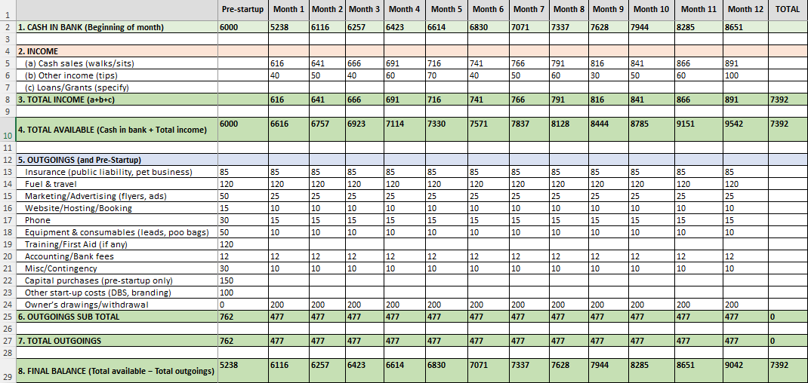

6.2 Start Up and Operational Costs

Start-up costs include equipment, branding, DBS checks, first aid training, and basic marketing resources. These costs are one-off and are funded before trading begins. The ongoing monthly running costs include vehicle travel, marketing, booking software, insurance, administration and consumables such as leads and poo bags. These costs have been kept deliberately low to support sustainability and profit retention in the early stages of trading.

Item | Cost
Business insurance | £85
Equipment and consumables | £50
First Aid Training | £120
DBS check and branding | £100
Capital purchases (set-up only) | £150
Marketing materials | £50
Total Start-Up Costs | £555

Item | Cost
Insurance | £85
Fuel and travel | £120
Marketing | £25
Booking/website | £10
Equipment and consumables | £10
Bank charges and fees | £12
Miscellaneous | £10
Total Monthly Costs | £477

6.3 Sources of Finance and Funding Requirements

Happy Paws received an initial £6,000 start-up loan from the Welsh Government Start-Up Fund (Start Up Loans, 2025). This funding covered the purchase of essential equipment, DBS checks, initial branding and provides working capital during the early months of operation. As a result, the business does not require any further external lending and is financially independent after the first month of business.

References
‌
Atrill, P., & McLaney, E. (2019). Accounting and finance for non-specialists (11th ed.). Pearson Education.

Bridge, S., & O’Neill, K. (2018). Understanding enterprise: Entrepreneurship and small business (5th ed.). Palgrave Macmillan.

Dog and food waste bags - NPT Council. (2025). Npt.gov.uk; NeathPortTalbotCouncil. https://www.npt.gov.uk/bins-and-recycling/equipment-and-collections/dog-and-food-waste-bags/

Erdogan, M. (2024). Applying the marketing mix to service industries: Revisiting the 7Ps framework. International Journal of Business Strategy, 15(1), 78–89.

Gilboa, S., Seger-Guttmann, T., & Mimran, O. (2019). The unique role of relationship marketing in small businesses’ customer experience. Journal of Retailing and Consumer Services, 51, 152–164. https://doi.org/10.1016/j.jretconser.2019.06.004

GOV.UK. (2024). Set up as a sole trader. https://www.gov.uk/set-up-sole-trader

Kotler, P., & Armstrong, G. (2017). Principles of marketing (17th ed.). Pearson Education.

Ladhari, R. (2009). Service quality, emotional satisfaction, and behavioural intentions. Managing Service Quality: An International Journal, 19(3), 308–331. https://doi.org/10.1108/09604520910955320

‌List of licensed animal boarders - NPT Council. (2025). Npt.gov.uk; NeathPortTalbotCouncil. https://www.npt.gov.uk/business/licensing/animal-licensing/list-of-licensed-animal-boarders/

Mintel Group Ltd. (2023). Pet services in the United Kingdom: Market report 2023. Mintel Group Ltd. https://store.mintel.com/report/uk-pet-insurance-market-report-2023

Neath Port Talbot Council. (2024). Animal boarding and dog-walking licensing guidance. https://www.npt.gov.uk/business/licensing/animal-licensing/

Office for National Statistics (ONS). (2022). Labour market and population statistics for Neath Port Talbot. https://www.ons.gov.uk

Pet Food Manufacturers’ Association (PFMA). (2024). Pet population report 2024. PFMA.

Start Up Loans. (2025). Business Wales; Start Up Loans | Business Wales. https://businesswales.gov.wales/businessfinance/types-finance-and-how-apply/start-loans

‌
The Animal Welfare Act 2006, c. 45 (U.K.). https://www.legislation.gov.uk/ukpga/2006/45

Yüksel, I. (2012). Developing a multi-criteria decision-making model for PESTLE analysis. International Journal of Business and Management, 7(24), 52–66. https://doi.org/10.5539/ijbm.v7n24p52

Appendices

Appendix A – Poster

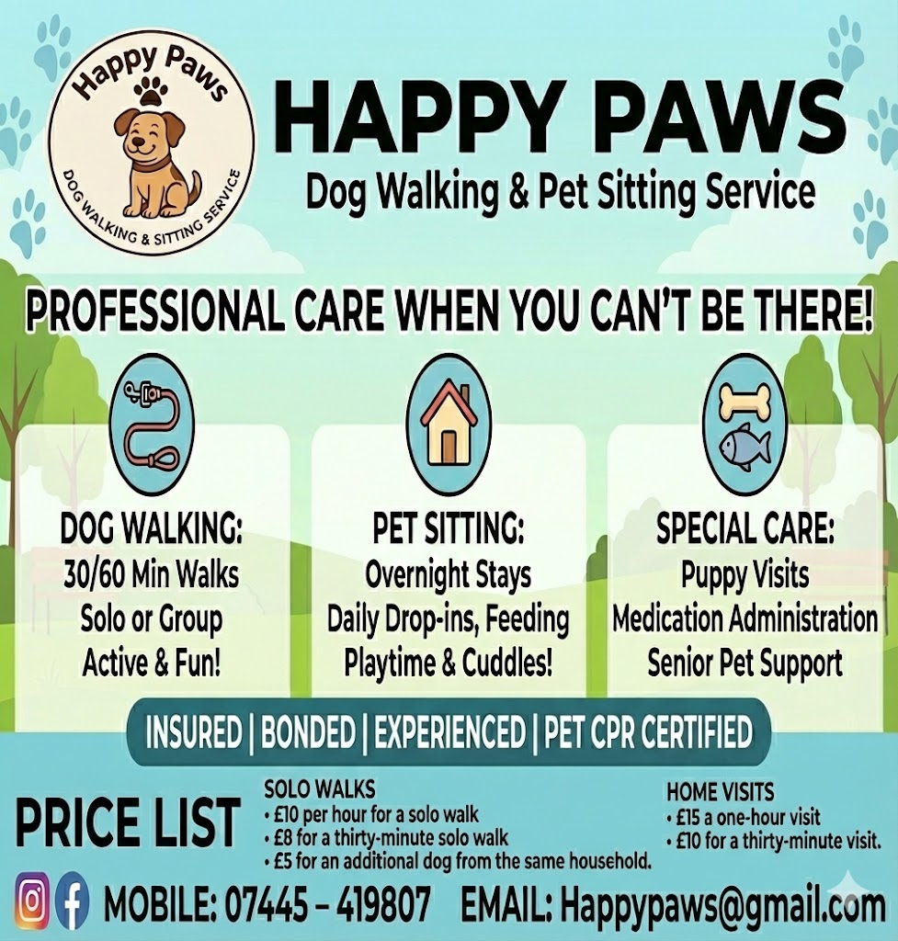

Appendix B – Promotional Flyer

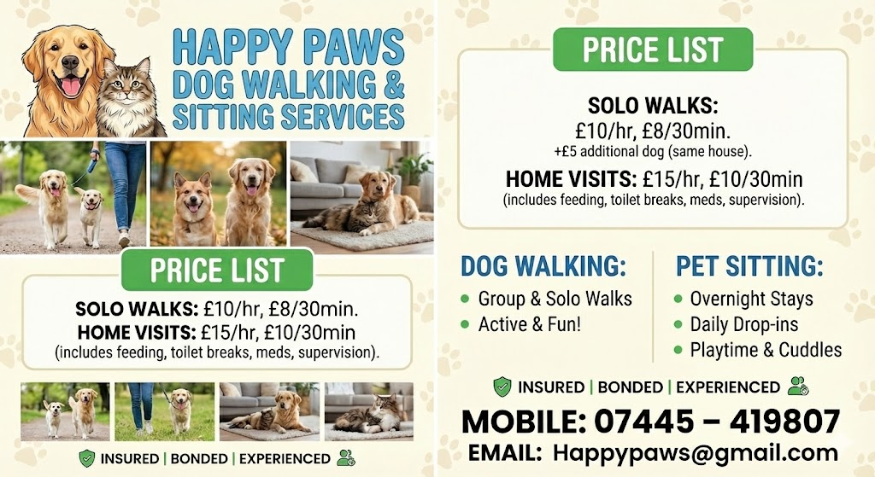

Appendix C - Industry Related CV

Robert Morgan
Dog Walker & Pet Care Professional
Happy Paws Dog Walking & Sitting Service
Email: morgan1545@yahoo.com
Phone: 07445 419807
Location: Neath Port Talbot

Personal Profile
Professional dog walker providing reliable pet care services to customers in Neath Port Talbot. Experienced in handling dogs of all breeds and temperaments, delivering safe, enjoyable walks and trustworthy home visits. Focused on building long-term customer relationships through reliability, clear communication and A genuine care for animal welfare. Committed to providing high safety standards and consistent customer service quality.

Core Skills
- Solo and group dog walking
- Pet sitting and home-check services
- Handling dogs safely and confidently
- Customer communication and updates
- Route planning and familiarisation
- Pet health, behaviour and welfare awareness
- Emergency response and problem solving
- Timekeeping and reliability
- First aid awareness (Animal & Human)
- DBS checked

Professional Experience
Owner & Dog Walker Happy Paws Dog Walking & Sitting Service (2025 to Present)
- Deliver daily walking and pet-sitting services across Neath and surrounding areas.
- Provide solo and group walks tailored to each dog’s temperament and routine.
- Carry out safe handovers, route checks, and weather-adjusted walking plans.
- Send updates and photos to owners after each walk for peace of mind.
- Maintain professional records of bookings, payments, and client details.
- Ensure proper safety practices including lead control, hydration and break points.
- Build long-term trust with clients through reliable and responsive service.

Education & Training
- Applied Leadership and Management in the Workplace (ongoing)
- First-aid trained (Animal & Human)

Additional Information
- DBS Checked
- Insured
- Full driving licence & own transport
- Flexible availability
- Strong knowledge of local routes & parks

References
Are available on request.

