Marking Scheme
SENARIO
In an industrial factory, a conveyor belt transports products through different processing stages.
To maintain safety, prevent collisions, and detect jams, the system must continuously monitor the distance between an object on the conveyor and a fixed reference point.
An ultrasonic HC-SR04 sensor is mounted above the conveyor. When an object approaches, the system evaluates its distance and activates different LED indicators to represent the operational status.

A PIC16F877A microcontroller reads the distance from the ultrasonic sensor, displays the measured value and system status on a 16×2 LCD, and controls three LEDs that represent SAFE, WARNING, and DANGER conditions.
SYSTEM SPECIFACTIONS
- A 12V DC source must be regulated to 5V using a 7805-voltage regulator. This regulated 5V powers the PIC16F877A, HC-SR04 ultrasonic sensor, LEDs, and LCD.
- An Ultrasonic Distance Sensor (HC-SR04) measures the distance to an object on the conveyor and outputs the time-of-flight pulse.
  - Trigger pin connected to RB0.
  - Echo pin connected to RB4.
- Three LEDs connected to PORTC are used to communicate operational states:
Heater (RB0):
  - SAFE (Green LED – RC0)
    - Turns ON when the measured distance is greater than 50 cm.
    - Indicates the conveyor is clear and operating normally.
  - WARNING (Yellow LED – RC1)
    - Turns ON when distance is between 20 cm and 50 cm.
    - Indicates that an object is approaching the inspection zone.
  - DANGER (Red LED – RC2)
    - Turns ON when distance is less than 20 cm.
    - Indicates a jam, collision risk, or object too close to the sensor.

- A 16x2 LCD must display the operational status based on distance:
- “CONVEYOR NORMAL!” when distance > 50 cm
- “MOVEMENT NEARBY!” when 20–50 cm
- “INTRUDER ALERT!” when distance < 20 cm

Answer the Following
- Design the following circuits with proper components and wiring:
- 12V to 5V Power Supply using 7805. [10 Marks]
SOLUTION
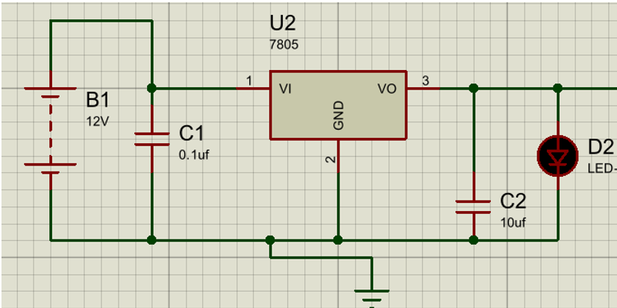
    - Correct use of 7805 voltage regulator (input, output, ground pins properly connected) [2 Marks]
    - Input capacitor (typically 0.1µF or 10µF) connected between input and ground [1 Mark]
    - Output capacitor (typically 0.1µF or 10µF) connected between output and ground [1 Mark]
    - Input voltage source correctly set to 12V DC [1 Mark]
    - Regulated 5V output successfully provided [2 Marks]
    - Correct grounding for all components [1 Mark]
    - Circuit layout clarity and completeness (no floating pins, labelled components)
[2 Marks]
- Ultrasonic distance measurement circuit using HC-SR04 interfaced with PIC16F877A. [10 Marks]
SOLUTION
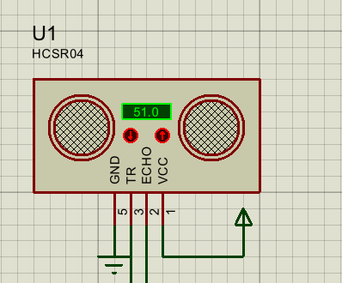
- Correct 4-pin wiring: VCC, GND, TRIG (RB0), ECHO (RB4) [2 Marks]
- TRIG pin connected to PIC output (RB0) for generating 10 µs pulse [2 Marks]
- ECHO pin connected to PIC input (RB4) with proper signal routing [2 Marks]
- Stable 5V supply provided to VCC and proper grounding to GND [2 Marks]
- Clean layout and simulation-ready setup in Proteus. [2 Marks]
- Simulate and validate the above (i) said designed circuits:
- Show regulated 5V output from the power supply. [5 Marks]

SOLUTION
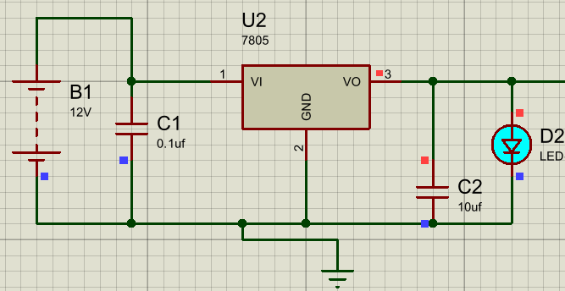
[5 Marks]

(b) HC-SR04 ultrasonic sensor simulation showing varying distance outputs. [5 Marks]
SOLUTION
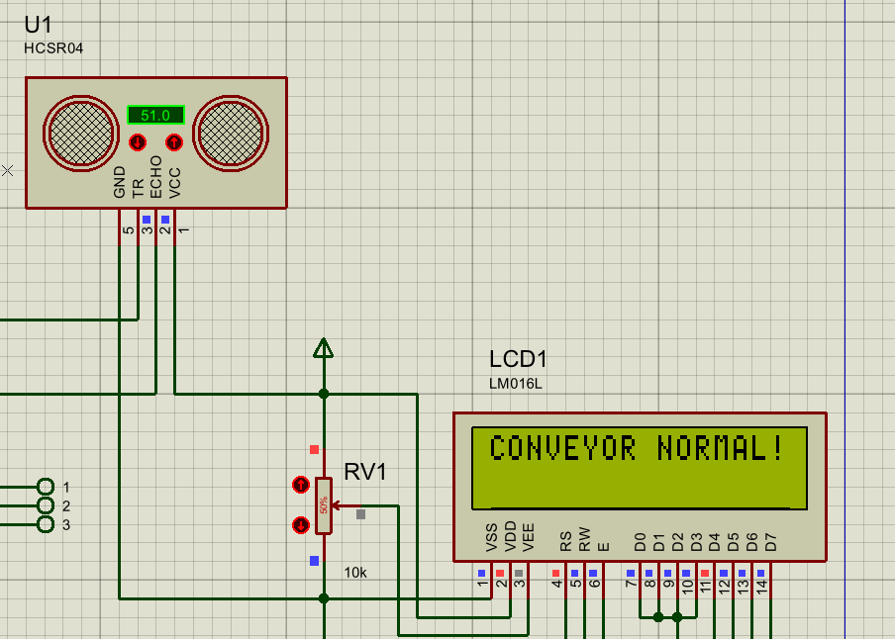
[1.5 Marks]
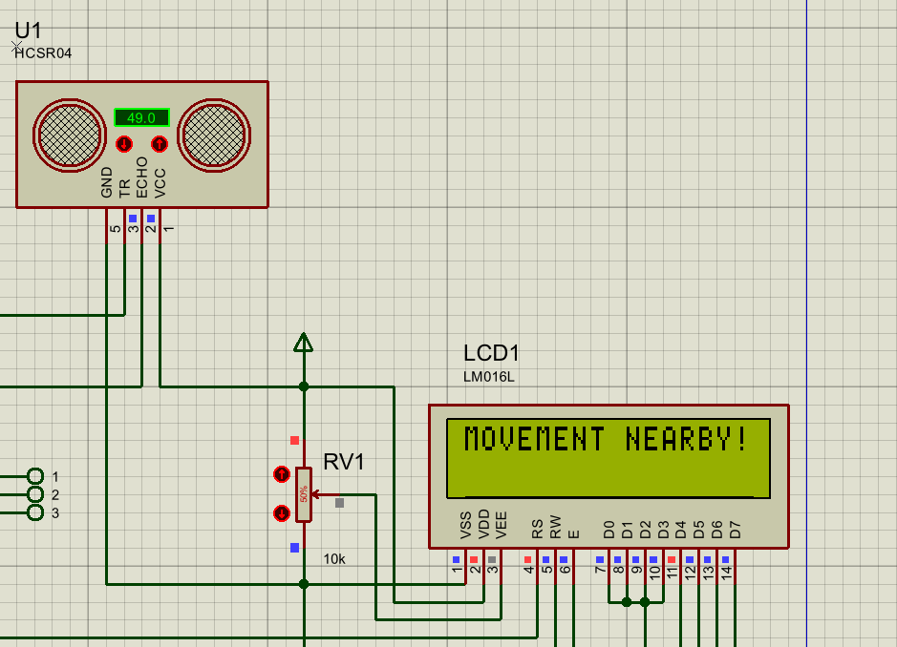
[1.5 Marks]
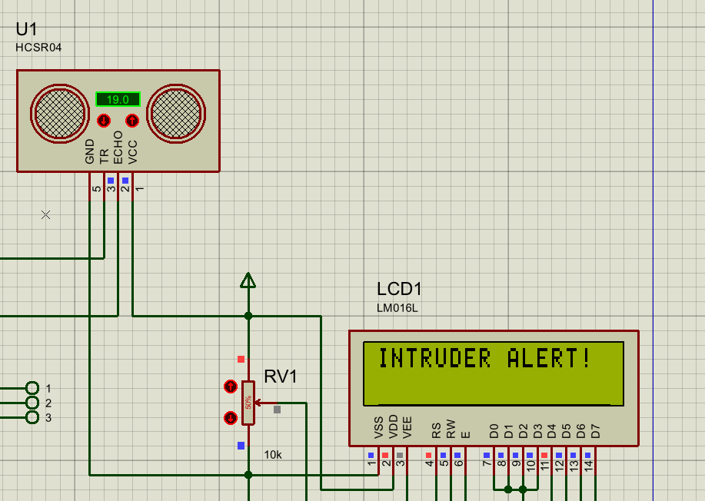
[2 Marks]
- Develop a single CCS C program to:
- Generate trigger pulse on RB0 for the ultrasonic sensor.
- Measure echo pulse on RB4 using Timer1 and calculate distance.
- Control three outputs (RC0 = SAFE, RC1 = WARNING, RC2 = DANGER) based on distance range.
- Display “CONVEYOR NORMAL!”, “MOVEMENT NEARBY!”, or “INTRUDER ALERT!” on LCD.
[30 Marks]
SOLUTIONS
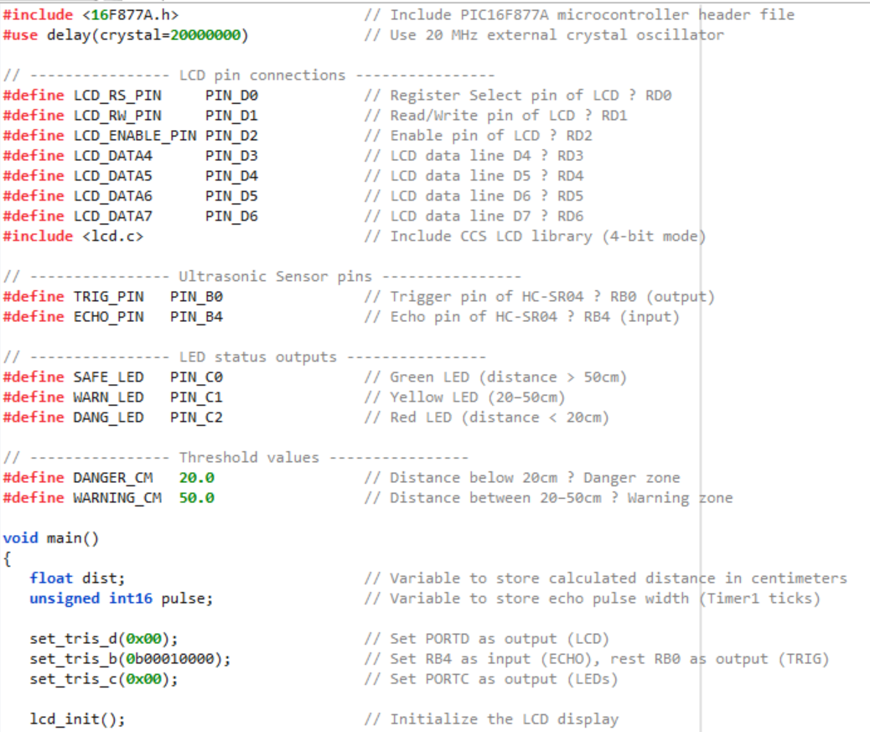
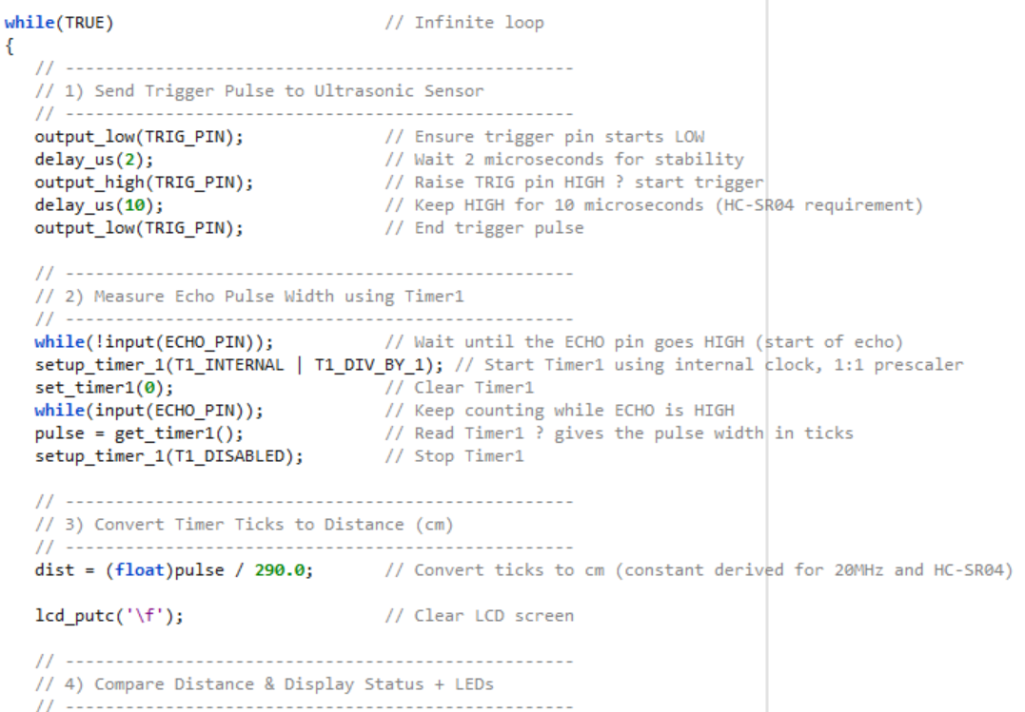
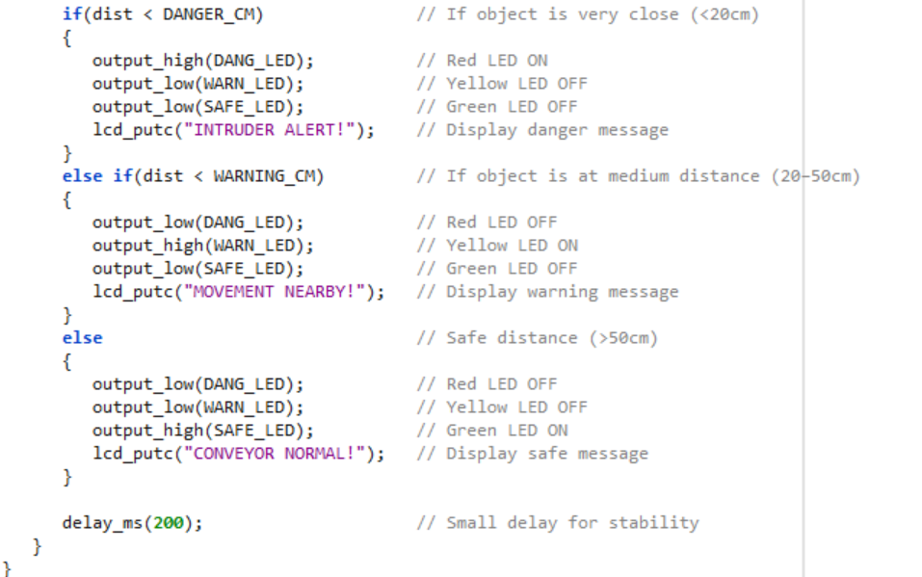
LCD Connections, Ultrasonic pins, LED Status [2 Marks]
Threshold Values [4 Marks]
Sending Triger Pulse [2 Marks]
Measuring Echo pulse [4 Marks]
Time ticks to Distance [4 Marks]
Conditions for Distance and display status [4 Marks]

  - Including Adequate comments [2 Marks]
  - Variable Naming and Declaration: Considering the Ports from the question and declaring them. [ 2 Marks]
  - Code Optimization [2 Marks]
  - Code Structure and Readability: Marks for logical Flow and easy understandability
[2 Marks]
  - Correctness and Functionality. [2 Marks]
- Simulate the complete system and demonstrate functionality by submitting clear screenshots showing the correct outputs for the responses on relays and LCD under cold and hot conditions. [20 Marks]
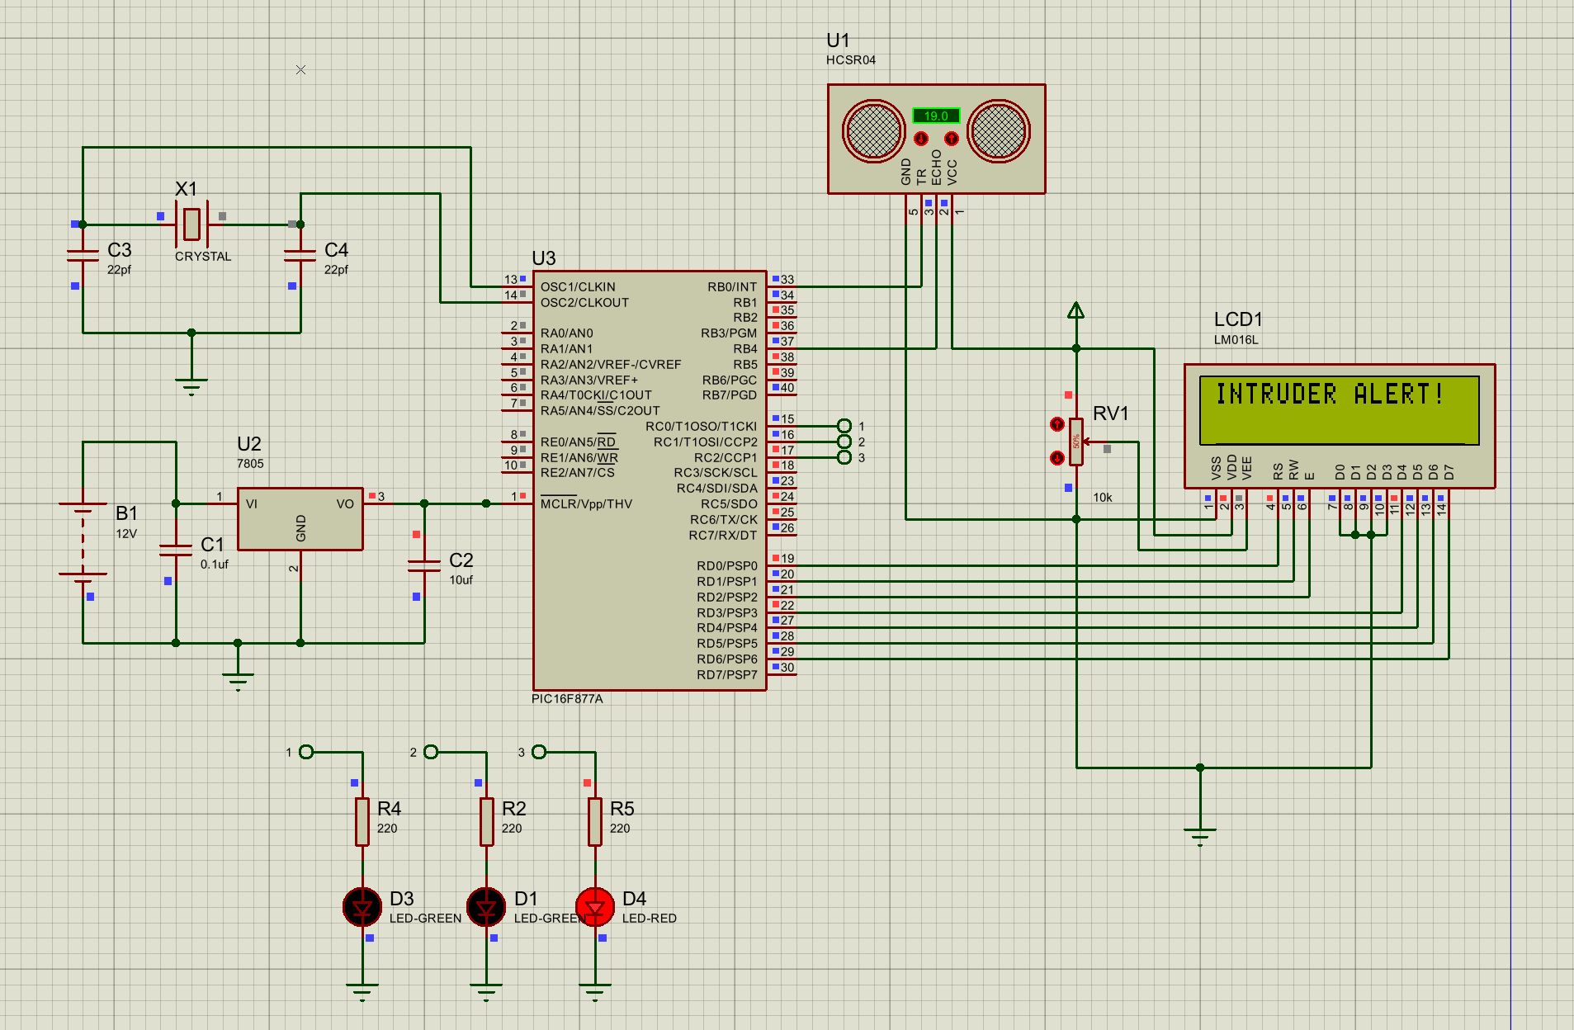
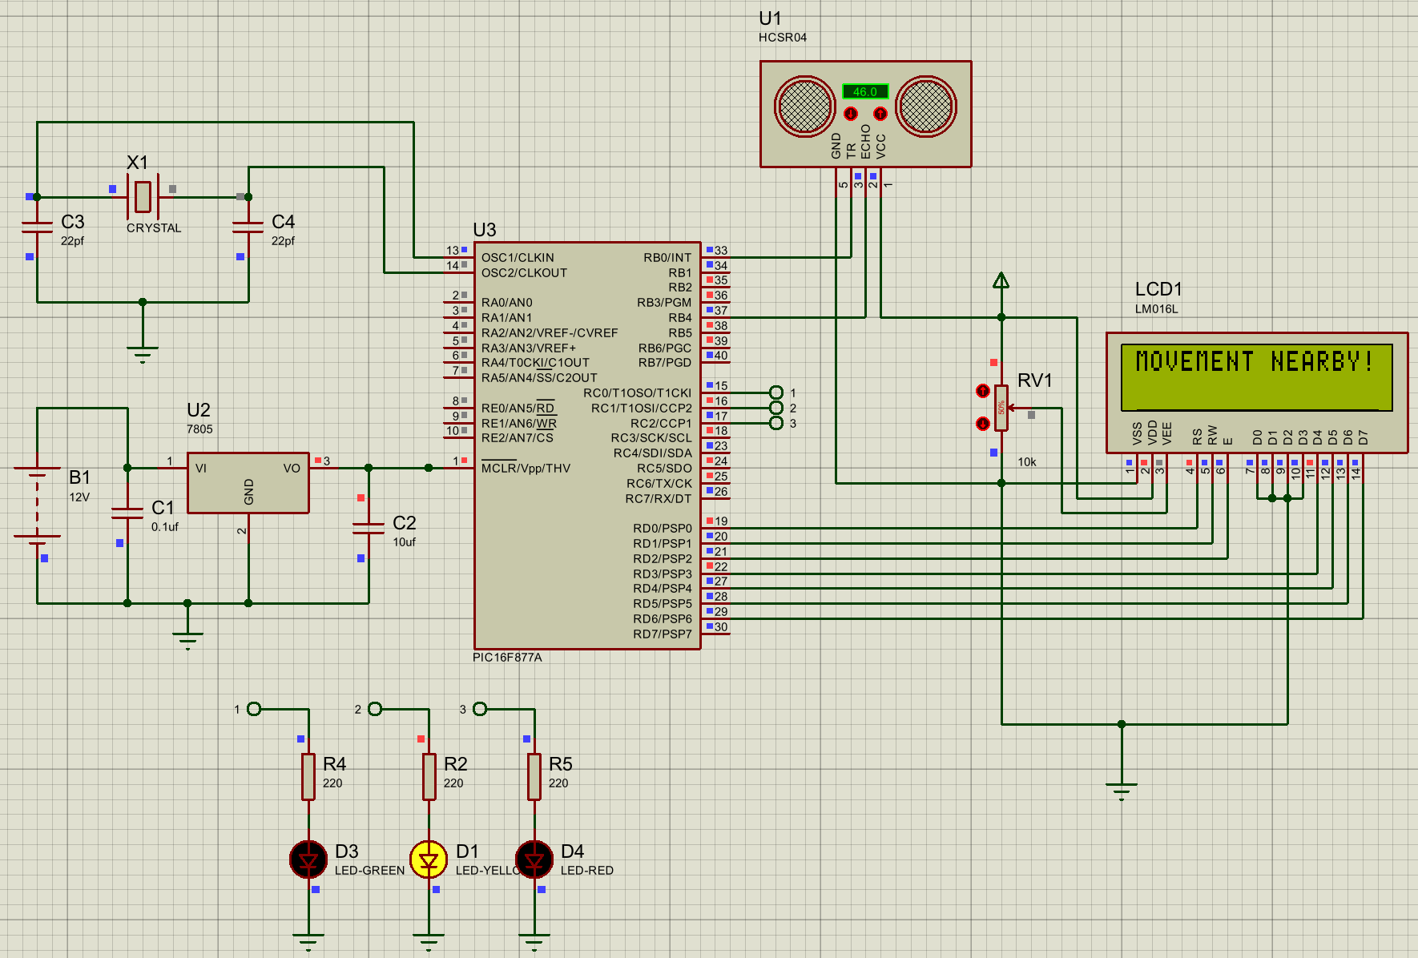
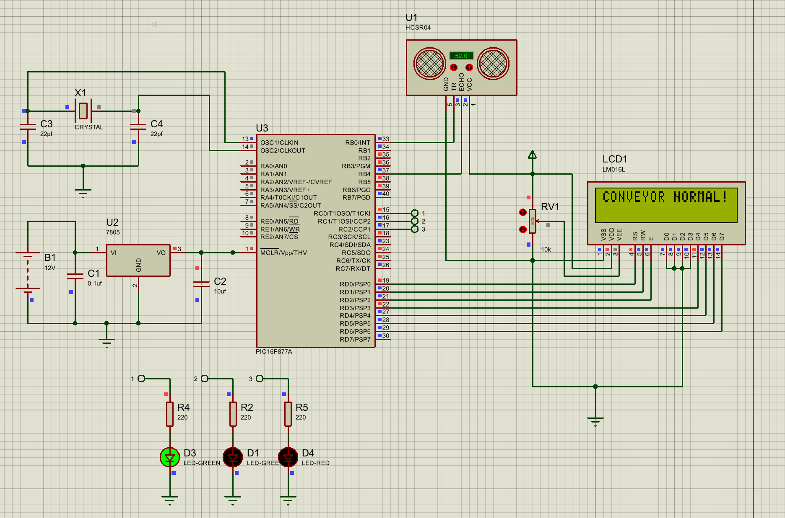
- Functional output for SAFE condition (distance > 50 cm):
- Green LED (SAFE_LED on RC0) ON [2 Marks]
- LCD displays: "CONVEYOR NORMAL!" [2 Marks]
- Functional output for WARNING condition (20 cm ≤ distance ≤ 50 cm):
- Yellow LED (WARN_LED on RC1) ON [2 Marks]
- LCD displays: "MOVEMENT NEARBY!" [2 Marks]
- Functional output for DANGER condition (distance < 20 cm):
- Red LED (DANG_LED on RC2) ON [2 Marks]
- LCD displays: "INTRUDER ALERT!" [2 Marks]
- Clear and labelled screenshots showing all three states [4 Marks]
- Screenshot 1: ≈60 cm with Green LED ON and “CONVEYOR NORMAL!”
- Screenshot 2: ≈35 cm with Yellow LED ON and “MOVEMENT NEARBY!”
- Screenshot 3: ≈15 cm with Red LED ON and “INTRUDER ALERT!”
- Labels for sensor pins (TRIG/ECHO), LEDs, LCD, PIC pins, and supply
- Accuracy and presentation of the overall system (clear layout, correct logic, no floating connections, realistic behaviour) [4 Marks]
- Neat wiring
- No floating pins
- Consistent logic
- Proper component placement (power, crystal, regulators)
- Answer the following theoretically
- Explain the working principle of the HC-SR04 ultrasonic sensor with a neat diagram. [10 Marks]

SOLUTION
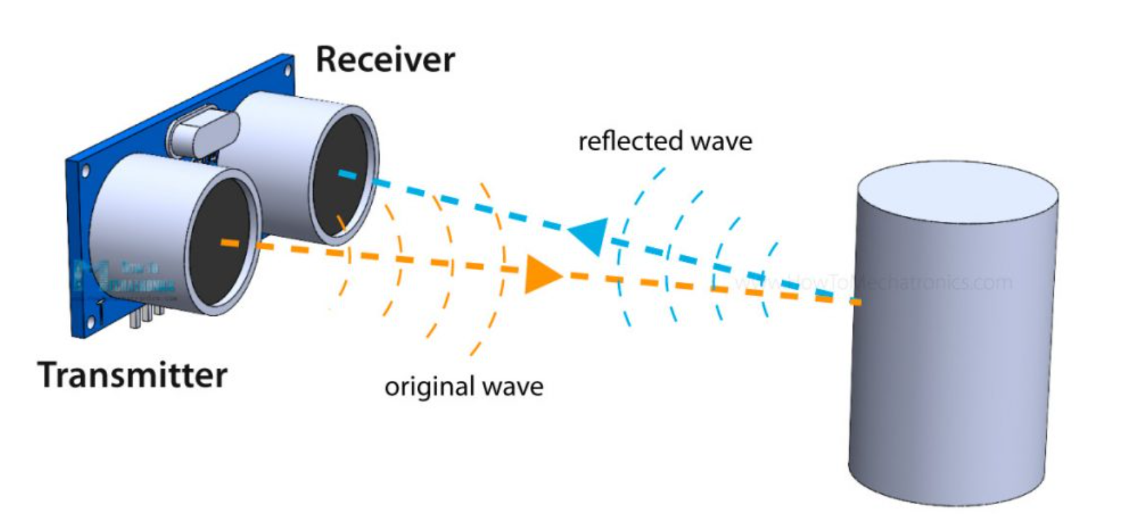
[3 Marks]
- MCU sends a 10 µs HIGH pulse on TRIG [1 Mark]
- sensor emits an 8-cycle burst of ultrasound at ~ 40 kHz. [1 Mark]
- Sound travels through air, hits an object, and reflects. [1 Mark]
- Sensor sets ECHO pin HIGH immediately after the burst; when echo returns, ECHO goes LOW. [1 Mark]
- The duration ECHO stayed HIGH = round-trip time of sound. [1 Mark]
- Because the sound travels to the object and back, the /2 divides the round trip.
[1 Mark]
- Distance is calculated using formula:
Distance = (Time of Flight × Speed of Sound) / 2
[1 Mark]
- Describe the internal operation and need for a 7805-voltage regulator with a neat diagram. [10 Marks]
SOLUITION
- The voltage regulator has an unregulated dc input voltage Vi applied to one input terminal, a regulated output dc voltage Vo from a second terminal, and the third terminal connected to ground. [2 Marks]
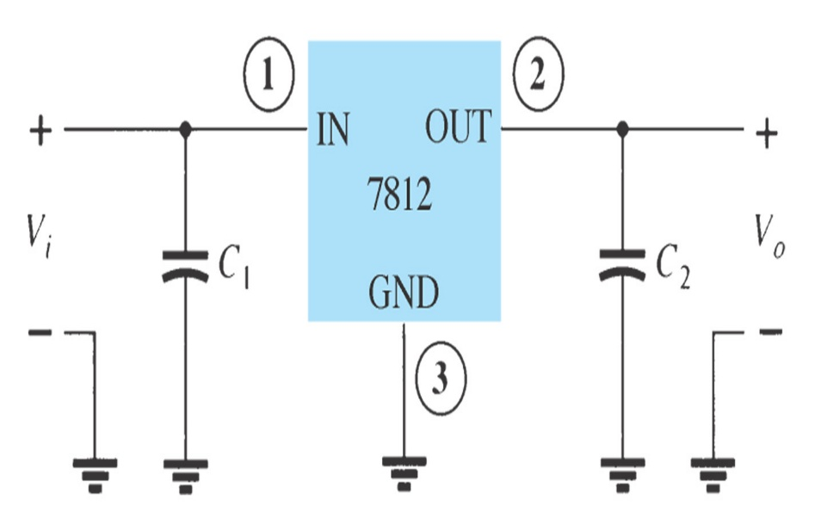 [3 Marks]
- The 7812 is a fixed +12 V linear voltage regulator used to obtain a constant DC output.
An unregulated DC input voltage (Vi) higher than 12 V is applied to Pin 1 (IN).
- Capacitor C1 at the input filters ripples and noise from the incoming supply. Inside the 7812, an internal reference voltage and control circuit compare the output with the reference. [1 Mark]
- Based on this comparison, the internal pass transistor adjusts automatically to maintain a steady 12 V output.
- Pin 3 (GND) provides a reference ground for proper regulation. [1 Mark]
- The regulated +12 V output (Vo) is taken from Pin 2 (OUT). [1 Mark]
- Capacitor C2 at the output improves stability and reduces output voltage fluctuations.
[1 Mark]
- The 7812 includes built-in protection against overcurrent, overheating, and short circuits.
[1 Mark]
- Explain the functions of RS, RW, E, D0–D7, VSS, VDD and VEE in a 16x2 LCD module. [10 Marks]
SOLUTION
- RS (Register Select):
  - Selects between instruction register (RS = 0) and data register (RS = 1).
  - Controls whether the input sent is a command or display data.
[2 Marks]
- RW (Read/Write):
  - Controls the direction of data.
  - RW = 0 for write operations (from MCU to LCD),
  - RW = 1 for read operations (from LCD to MCU).
[2 Marks]
- E (Enable):
  - Acts as a latch.
  - On a high-to-low pulse, the LCD reads data from the data lines.
  - Must be toggled each time data/command is sent.
[2 Marks]
  - D0–D7 data pins – State their role in sending data or instructions; mention 4-bit/8-bit modes. [2 Marks]
- VSS and VDD pins – Identify ground and positive supply terminals.
[1 Mark]
- VEE pin – Mention its use for adjusting display contrast.
[1 Mark]

