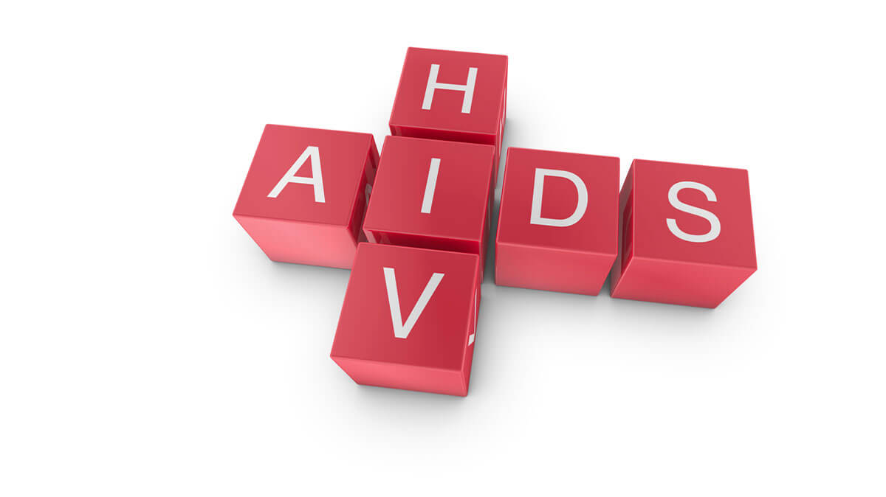
Student Name: Danielli Souza
Student Number: 2211925
Module code and title: LCHS4004 - Introduction to Public Health
Lecturer’s name: Laila Surani

Table of Contents

Introduction 2
A definition of the disease 2
Levels of the incidence that demonstrate the severity of the health issue (Both worldwide and UK statistics) 3
Main Discussion 3
Public health measures available 3
The key determinants/risk factors of the chosen disease 4
Short-term public health consequences of the disease in a health or social care setting 6
Long-term public health consequences of the disease in a health or social care setting 7
Conclusion 8
Reference List 10

Introduction
This specific report is related to the concept of a major health issue within the UK as well as across the whole world. Here, the identified health issue is HIV or AIDS and this crucial health problem will majorly be defined within the different locations of the UK. Gradually, it will also be focused on the deep consequences of the selected disease across the whole world. The purpose of this report is related to the identification of the core causes that can lead a person towards some health issues like HIV and AIDS. This report is about HIV/AIDS. The human immunodeficiency virus (HIV) has two species of lentiviruses that infect humans, and which over time cause the acquired immunodeficiency syndrome, AIDS. This virus leads to a progressive failure of the immune system, thus allowing life-threatening infections and cancers. Without adequate treatment, the lifespan after HIV infection is estimated at 9 to 11 years, depending on the subtype of the virus. In most cases HIV is transmitted sexually by ejaculation of semen and vaginal fluids, it also occurs by blood transfer. Transmission can also occur during pregnancy by an infected mother during childbirth or during breastfeeding. HIV infects helper T cells (CD4 macrophage T cells and dendritic cells) apoptosis of uninfected cells, death of infected CD4 T cells by cytotoxic CB8 lymphocytes that recognize infected cells becoming increasingly susceptible to infections that take advantage leading to the AIDS development.(Wikipedia n.d)

A definition of the disease
In addition to the previous section, it can also be said that the chosen disease for this report is HIV or AIDS. This section will be reflected by the brief overview of HIV or AIDS. Moreover, it can also be said that the acronym of HIV is Human Immunodeficiency Virus. Simultaneously, it is important to say that two terms such as HIV and AIDS are interrelated to each other. HIV or the Human Immunodeficiency Virus is the only cause for chronic immune system disease AIDS. Firstly, it can be defined that HIV is one type of virus that majorly attacks human body cells for fighting a human body against various infections (HIV. Gov, 2023). Furthermore, AIDS or acquired immunodeficiency syndrome is the last stage that can occur due to the HIV infection (HIV. Gov, 2023). Along with this, AIDS is the final consequence of HIV attacks that majorly affects the human body in a bad manner and also damages the human body in a most negative way.

Levels of the incidence that demonstrate the severity of the health issue (Both worldwide and UK statistics)

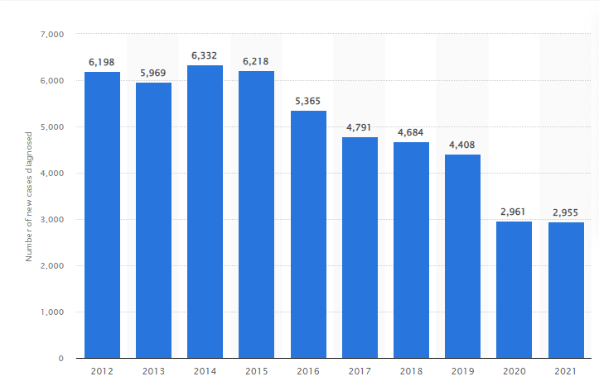
Figure 1: Severity of AIDS or HIV within the UK
(Source: Conor Stewart, 2023)
As per the above-mentioned Figure 1, it has been recognised that the demographic image reflects the severity of AIDS or HIV within the UK, from the FY of 2012 to FY of 2021 (Conor Stewart, 2023). From the figure 1, it has also been recognised that the graphical figure represents a gradual logarithmic growth of graph from the financial year of 2012 to the FY of 2021. The declined nature of the graph represents the gradual decreasing severity of the selected disease within the different locations of the UK.
According to the perspective of an article, published by World Health Organisation (2022), it has also been recognised that there is an estimation of 38.4 million people, who were surviving with the existence of HIV or AIDS at the end of the FY of 2021. Most importantly, it is significant that two thirds of the selected HIV affected people of the world are from the African Region (World Health Organisation, 2022).

Main Discussion

Public health measures available
In addition to the previous section, it can also be said that this paragraph will be focused on the public health measures based on HIV or AIDS related health issues. Moreover, the idea of Public Health Measures or the Social Measures (PHSMs) are related to some measurables or actions that are based on the slow or stop spreading of any infectious disease (such as HIV or AIDS) with the help of some different factors like individuals, institutions, local governments, national governments as well as different communities and international bodies. Some public health strategies are also included within the terms of the public health measures and there are several public health strategies for HIV. Some of the strategies for HIV prevention are related to the implications of pathological tests like HIV, less use of risky and unprotected sexual behaviours, and use of condoms during every single time of sex (Hivinfo.nih.gov, 2021). The purpose of declining the HIV issues majorly focuses on the reduction of the continuous increasing of this disease as an epidemic. This is because a continuous raising of awareness about HIV is highly important by organising some programs like campaigns, Social Media Marketing related to HIV (Fang et al., 2020).
In addition to the previous section, it can also be said that as per the HIV treatment Access during the end of the year 2021, it can be said that 28.7 million people, from the whole world, are able to access the Antiretroviral Therapy, which is majorly recognised as the ART therapy (HIV. Gov, 2023). Furthermore, it can also be said that the 9.7 million are still not able to access the Antiretroviral Therapy (HIV. Gov, 2023).

The key determinants/risk factors of the chosen disease
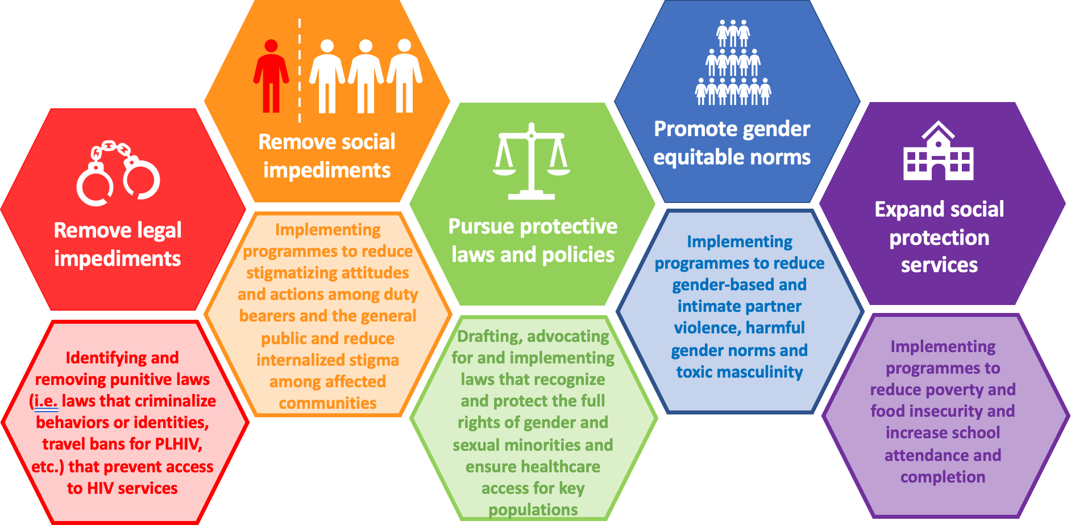
Figure 2: Core risk factors of the selected disease HIV or AIDS
(Source: Althoff et al., 2019)
According to the perspective of Althoff et al., (2019) some core risk factors are related to different risk factors. These are related to the traditional risk factors such as different and core diseases based on sexual transmission. Along with this, it has also been recognised that other risk factors are based on the non-AIDS disease. These all-non-AIDS are included within the terms of the Cancer, end stage liver disease, end stage renal disease as well as the myocardial infarction and many others (Althoff et al., 2019). Thereafter, it can also be said that the aforementioned Figure 2 is majorly focusing on the core risk factors that all are based on the chosen disease, HIV or AIDS. Figure 2 also reflects some other salient risk factors that are based on the removal of legal impediments, social impediments, continuous promotion of gender equitable norms, expansion of social protection services as well as the persuasion of protective laws and policies and many others also (Althoff et al., 2019). These identified core factors are very much crucial for the selected disease.
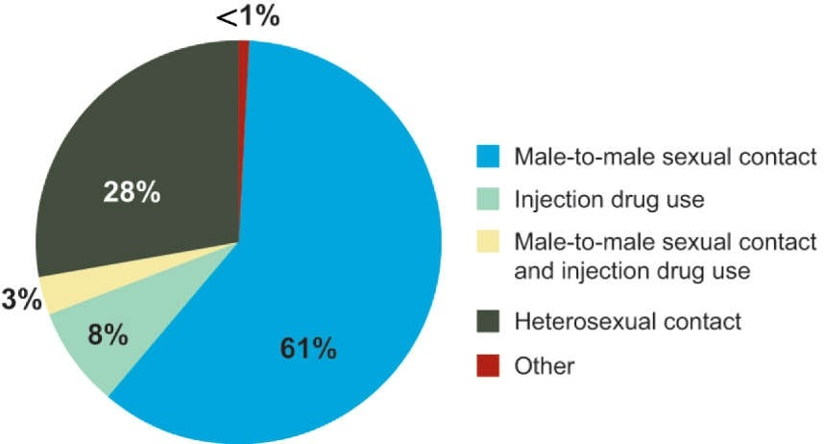
Figure 3: Statistical Figure related to core risk factors of HIV or AIDS
(Source: NIH, 2012)
According to the perspective of aforementioned figure 3, it has also been recognised that the image is related to the terms of the core risk factors of HIV or AIDS. Along with this, some different five factors. These are included within the terms of person-to-person sexual contact, injection drug uses, male to male sexual contact and injection drug use, heterosexual contract and many other different factors. These all factors are related to the terms of different statistical percentages. These are included within the terms of 61%, 28%, 8%, 3% as well as less than 1%, in a respective order (NIH, 2012). These all factors need to be mitigated through some organisation of programmers, social media events and different types of other campaigns for raising awareness against the HIV or AIDS related human disease.

Short-term public health consequences of the disease in a health or social care setting

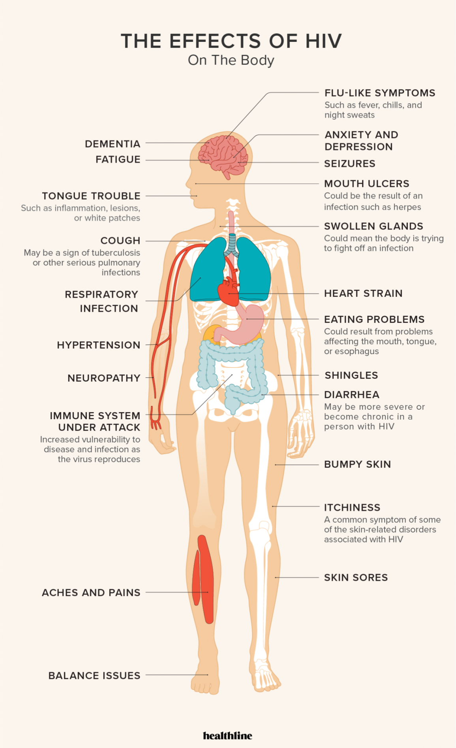
Figure 4: The effect of HIV on human body
(Source: Ann Pietrangelo and Kristeen Cherney, 2022)
As per the perspective of above-mentioned figure 4, it has also been recognised that there are some concerned effects, which all are based on the infectious disease, HIV or AIDS. Some of the effects of HIV are based on the terms of the both short term as well as the long-term consequences. These are included within the terms of Dementia fatigue, tongue trouble, cough, respiratory infections, Hypertension, neuropathy and many others (Ann Pietrangelo and Kristeen Cherney, 2022). Along with this, it has also been recognised by some other types of the Immune system based on attacks, body aches and pains within the whole body, as well as some balance issues. Furthermore, it will also be focused on the different symptoms of flu which are also related to the fever, cold as well as the night sweats and many others (Lorenz et al., 2021). This particular section is based on the many disadvantages, which all will be identified within the following table.

Some names of health diseases related to HIV or AIDS | Disadvantageous aspects of particular disease
Dementia fatigue | - Core symptoms of dementia are the losses of short-term memories.  - It may also lead to paranoia and extreme anxiety.
Respiratory infections | - Focuses on the false ratio of oxygen flows.  - It also increases anxiety
Hypertensions | - Recognises the disturbed arterial pressure due to poor continuity of blood pressure.  - Motion interference
Immune system based on attacks | - It also focuses on the physical as well as the biochemical barriers.  - Focuses on disrupted immune systems.
Table 1: Names of health diseases related to HIV or AIDS related to some advantageous aspects
(Source: Created by Author)

Long-term public health consequences of the disease in a health or social care setting
According to the perspective of an article, published by HIV. Gov (2021), it has also been recognised that there are three different stages that are related to the transmitted disease of HIV or AIDS. These three stages are included within the terms of the Acute HIV Infections, Chronic HIV Infections as well as the Acquired-Immunodeficiency-Syndrome or AIDS. All these three stages have both short-term as well as long-term health consequences, which all are based on the particular transmitted disease like HIV or AIDS. Apart from some short-term public health consequences, there are also some long-term health consequences based on the chosen disease. Some different types of long-term situations as well as the consequences are related to the CVD or the Cardio Vascular disease as well as different other situations such as the non-AIDS based cancer, bone disease, diabetes, frailty, liver disease, lung disease as well as the renal disease and cognitive disorders for the high frequent transmission of the HIV infection (Bernaud et al., 2020). All these identified diseases would be considered within the following table along with some disadvantages.

Some names of health diseases related to HIV or AIDS | Disadvantageous aspects of particular disease
Bone disease | - Bone disease may lead a person towards the low energy activities, sprains as well as the infections.
Liver disease | - Liver disease can lead a human body towards liver failure as well as liver cancer.
Lung Disease | - Disadvantages of lung disease can be recognised as the COPD or it can also be recognised as the Chronic Obstructive Pulmonary Disease.
CVD or the Cardio Vascular disease | - CVD or Cardiovascular-disease can also be recognised as the high blood pressure as well as heart failure, diabetes, obesity, LDL cholesterol and many others.
Table 2: Names of long-term health diseases related to HIV or AIDS along with some advantageous aspects
(Source: Created by Author)

Conclusion
Therefore, it can also be said that the total report is majorly based on the idea of a crucial and sexually transmitted diseases that have majorly been focused on the UK based popularity as well as others from all over the world. Initially the report has defined as well as also evaluated some brief overview of HIV or AIDS. Thereafter, this selected issue has majorly been focused on the major UK based popularities along with all over the world. Thereafter, severity of HIV or AIDS has also been discussed from the perspective of the UK and other places across the world. Some core risk factors along with some short-term and long-term consequences of AIDS have also been recognised here. In addition to the previous section, it can also be said that among all short term and long-term diseases, some of the short-term diseases were included within the terms of the dementia fatigue, respiratory infections, Immune system based on attacks as well as hypertension. All these identified four short term diseases have different types of disadvantageous aspects. Moreover, it can also be said that there is also another term, which is majorly based on long-term disease. These all-long-term diseases are included within the terms of the CVD or the Cardiovascular disease, Bone disease, lung disease as well as the liver disease. All of the short-term as well as the long-term diseases have both advantageous as well as some disadvantages perspectives. Moreover, it can also be said that major disadvantages have been illuminated within this report, which needs to be mitigated by removing most of the issues.

Reference List
Althoff, K.N., Gebo, K.A., Moore, R.D., Boyd, C.M., Justice, A.C., Wong, C., Lucas, G.M., Klein, M.B., Kitahata, M.M., Crane, H. and Silverberg, M.J., 2019. Contributions of traditional and HIV-related risk factors on non-AIDS-defining cancer, myocardial infarction, and end-stage liver and renal diseases in adults with HIV in the USA and Canada: a collaboration of cohort studies. The lancet HIV, 6(2), pp.e93-e104.
Ann Pietrangelo and Kristeen Cherney (2022) The Effects of HIV on the Body: Available at: https://www.healthline.com/health/hiv-aids/effects-on-body [Accessed on 29th March, 2023]
Bernaud, C., Sécher, S., Michau, C., Perre, P., Fialaire, P., Vatan, R., Raffi, F., Allavena, C. and Hitoto, H., 2020. HIV-infected patients aged above 75 years. Medecine et maladies infectieuses, 50(1), pp.43-48.
CDC (2021) HIV Prevention Available at: https://www.cdc.gov/hiv/basics/prevention.html [Accessed on 29th March, 2023]
Conor Stewart (2023) Number of new cases of HIV diagnosed in the United Kingdom (UK) from 2012 to 2021: Available at: https://www.statista.com/statistics/648728/new-hiv-cases-diagnosed-in-the-united-kingdom-uk/ [Accessed on 29th March, 2023]
Fang, E.F., Xie, C., Schenkel, J.A., Wu, C., Long, Q., Cui, H., Aman, Y., Frank, J., Liao, J., Zou, H. and Wang, N.Y., 2020. A research agenda for ageing in China in the 21st century: Focusing on basic and translational research, long-term care, policy and social networks. Ageing research reviews, 64, p.101174.
HIV. Gov (2021) The Stages of HIV Infection : Available at: https://hivinfo.nih.gov/understanding-hiv/fact-sheets/stages-hiv-infection#:~:text=Without%20treatment%20with%20HIV%20medicines,acquired%20immunodeficiency%20syndrome%20(AIDS). [Accessed on 29th March, 2023]
HIV. Gov (2023) Global HIV/AIDS Overview Available at: https://www.hiv.gov/federal-response/pepfar-global-aids/global-hiv-aids-overview#:~:text=HIV%20Treatment%20Access%E2%80%94As%20of,million%20people%20are%20still%20waiting. [Accessed on 29th March, 2023]
HIV. Gov (2023) What Are HIV and AIDS? Available at: https://www.hiv.gov/hiv-basics/overview/about-hiv-and-aids/what-are-hiv-and-aids/ [Accessed on 29th March, 2023]
Hivinfo.nih.gov (2021) The Basics of HIV Prevention: Available at: https://hivinfo.nih.gov/understanding-hiv/fact-sheets/basics-hiv-prevention [Accessed on 29th March, 2023]
Lorenz, D.R., Mukerji, S.S., Misra, V., Uno, H., Gelman, B.B., Moore, D.J., Singer, E.J., Morgello, S. and Gabuzda, D., 2021. Predictors of transition to frailty in middle-aged and older people with HIV: a prospective cohort study. JAIDS Journal of Acquired Immune Deficiency Syndromes, 88(5), pp.518-527.
NIH (2012) HIV/AIDS Research Report Is at Risk for HIV Infection and Which Populations Are Most Affected: Available at: https://nida.nih.gov/publications/research-reports/hivaids/who-risk-hiv-infection-which-populations-are-most-affected [Accessed on 29th March, 2023]
Wikipedia (n.d) Available at: https://en.wikipedia.org/wiki/HIV [Accessed on 14th April, 2023]
World Health Organisation (2022) HIV Available at: https://www.who.int/news-room/fact-sheets/detail/hiv-aids#:~:text=There%20were%20an%20estimated%2038.4,in%20the%20WHO%20African%20Region. [Accessed on 29th March, 2023]
World Health Organisation (2023) Tracking Public Health and Social Measures: Available at: https://www.who.int/emergencies/diseases/novel-coronavirus-2019/phsm [Accessed on 29th March, 2023]

