I confirm that I have not used any AI tools in the research and creation of this assignment. I confirm that I have not presented any AI generated materials as my own work. I confirm I have copies of my drafts, notes, and other resources I used, which I may be asked to provide in evidence.

Section 1 - Develop an infographic to explore Maslow’s model in depth - 1045 words

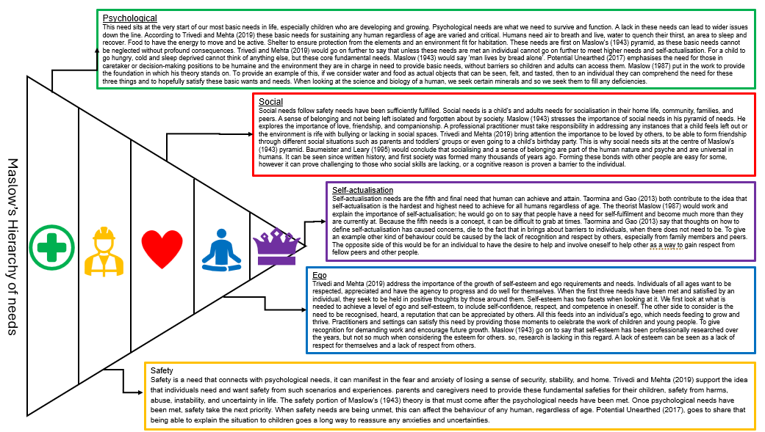

Reference list:
Maslow, A.H. (1943). "A theory of human motivation". Psychological Review.
Potential unearthed, (2017). Hierarchy of Needs – Abraham Maslow; 1943 (content Theory) https://www.potentialunearthed.co.uk/wp-content/uploads/2017/09/Hierarchy-of-Needs.pdf (accessed on 28/11/2025)
Taormina, R.J. and Gao, J.H. (2013) ‘Maslow and the Motivation Hierarchy: Measuring Satisfaction of the Needs’, The American journal of psychology,
Maslow, A. H. (1987). Motivation and personality (3rd ed.). Boston, MA: Addison-Wesley.
Baumeister, R. F., & Leary, M. R. (1995). The need to belong: Desire for interpersonal attachments as a fundamental human motivation. Psychological Bulletin,
Trivedi, A and Mehta, A. (2019). Maslow’s Hierarchey of Needs – Theory of Human Motivation. https://www.raijmr.com/ijrsml/wp-content/uploads/2020/01/IJRSML_2019_vol07_issue_06_Eng_09.pdf (accessed on 28/11/2025)
___________________________________________________________________

Section 2 - Explore in depth the concept of holistic child development with links to Maslow’s model – 1000 words

Maslow’s (1943) Hierarchy of needs has a profound impact when looking at the conceptual and practical impact on children’s development.
Lindon (2012, p. 1) would emphasise the importance of practitioners needing to have a grasp of a wide range of theories that explore the many facets of child development. Theories such as Maslow’s (1962) hierarchy of needs which underpin the holistic processes. It links and shapes the ethos of parenting, professional practices, and the implementation of curriculums in care and educational provisions.
Looking at the psychological portion of Maslow’s (1943) hierarchy of needs, there are two areas of a child’s and young person’s life that have an impact on an individual’s psychological and biological needs. These needs can be impacted by the environment they live in. a child needs air to breath, food to eat, water to drink and to be healthy and free of disease. Lindon (2012, p.8) would further clarify That while young infants such as babies don’t need to be taught on how to use their limbs for walking or crawling. These skills come naturally to most. However, if a child does not have its most basic needs such as food and water, then malnutrition and health ailments will become apparent which will hinder the physical and mental growth of the infant.
A child, infant or young person needs to feel safe and secure. To have a sense of safety, well-being, and stability. The family and environment will play a key factor in this. Maslow (1943) Hierarchy of needs delves into the importance of providing that sense of safety. Sanders and Guerra (2016) stipulate the paramount importance for a child to experience those close relationships with key adult in their lives, such as parents, guardians, teachers, and professional practitioners. A child develops their own identity both in terms of their personality and their cultural enrichment. For that child to develop trust in the system and institutions in place, especially when accessing their local community. Holistic approaches to this vary between different communities locally and globally, each having different emphasis on the importance of child safety, well-being, and stability.
Social needs and access to peer relationships plays a key role in Maslow’s (1943) Hierarchy of needs. Guerra and Sanders (2016) would both go on to say that looking at contrasting environments of the home or childcare environment can be crucial in understanding the social development of a child or young person. If one setting or home is functional, stable, welcoming, and warm an individual will thrive in many ways, they have care givers that can support and comfort them. A contrasting environment will have a negative impact on a child, they may face criticisms, receive no warmth or kind words, an environment where attention needs to be competed. Howes et al (1998) emphasises the importance on the influence of developing healthy attachment relationships, an infant who has a positive relationship with its caregivers, will show this when going into a nursery or playgroup setting where they can develop those key relationships with peers and practitioners.
The development of ego is the next step on Maslow’s (1943) hierarchy of needs and impacts and influences a child at an early age. A child in it is fist three years of development will begin to recognise the world around them and develop a sense understanding of themselves in terms of self-esteem and agency. According to Nas College (2020) people and especially young children, will begin to feel a certain pride in themselves. An infant learning to stack blocks to make a tower, would feel they have achieved something and that they can believe in themselves in some way. A toddle would want to be seen by those around them, such as caregivers and practitioners, a sense of belonging in the world they live in. To be allowed to express and be an individual.
We reach the very top of Maslow’s (1943) hierarchy of needs, which is self-actualisation. Kaufman (2018) underlines acknowledgment that Self-actualisation does not necessarily connect to academic level, culture, race, religion, gender, or level of household income. Kaufman (2018) would go on to give examples and evidence in measuring the characteristics of self-actualisation by looking at the impacts of development and the holistic approaches that can be taken. It takes in account developmental aspects such as social engagement, compassion, acceptance of other people, understanding responsibilities and emotional complexities such as anxiety and depression. A child achieving and having a solid enough foundation enables them to reach the top of Maslow’s (1943) pyramid.

The conclusion of the holistic development has on Maslow’s Hierarchy of needs. Maslow (1962) put significant importance on the work he conducted and the research behind it. For humanity have dual force within them, which are sometimes at war with one another. One side seeks to isolation, safety, introverted, shy from social occasions, restoring to regression and avoidance to change and development. On the other hand, we have another urge within us that seeks to move, advance and improve. To have full autonomy and function of different areas of mind and body. To have the confidence both in the real world and inner self. These two halves are what makes humanity what it is today, tomorrow, and forever more. Maslow’s (1943) work has played a paramount role in providing inspiration to future academics in many fields that have benefited human civilisation. Stoyanov (2017) would go on to say that that while Maslow has played a pivotal role in the field of psychology, his influence expanded to modern management. Though Maslow’s theories have received criticism in the academic field, some of which re debated to this day. But he is still held in high regards, and its impact will be felt for many years to come. Taormina and Gao (2013) concluded that with research forever changing, as more and more institutions and professionals acknowledge the findings and theories of Maslow (1943), improvements and attainment in achieving the five tiers of the pyramid will be more and more possible.

Reference list
A. Wishard Guerra, A. Wishard Guerra, K.E. Sanders, & K.E. Sanders (eds.) (2016) The culture of child care: attachment, peers, and quality in diverse communities. New York, NY :, Oxford University Press.
Howes, C., Hamilton, C., & Phillipsen, L. (1998). Stability and continuity of child-caregiver and child-peer relationships. Child Development.
Journal of Humanistic Psychology. https://scottbarrykaufman.com/wp-content/uploads/2018/11/Kaufman-self-actualization-2018.pdf (accessed on 26/11/25)
Lindon, J. (2012) Understanding child development 0-8 years [electronic resource]. 3rd ed. London:, Hodder Education.
Maslow, A. H. (1943) 'A theory of human motivation', Psychological Review
Maslow, A. H. (1954). Motivation and personality. New York, NY: Harper & Row.
Maslow, A. H. (1998). Toward a psychology of being (3rd ed.) New York, NY: Wiley.
Nas College https://www.nascollege.org/econtent/ecotent-10-4-20/Dr%20R%20R%20B/imgtopdf_generated_20-4.pdf (Accessed 25/11/2025)
Stoyanov, S. (2017) An analysis of Abraham Maslow’s A theory of human motivation. London, [England: Routledge.
Taormina, R.J. and Gao, J.H. (2013) ‘Maslow and the Motivation Hierarchy: Measuring Satisfaction of the Needs’, The American journal of psychology,

___________________________________________________________________

Section 3 - Offer three examples from early years practice to highlight Maslow’s significance in understanding child development. – 1038 words

Maslow (1943) played a very crucial role in developing his theory on human motivation, which then became the concept of Maslow’s Hierarchy of needs. Which he supported and popularised the importance of having diverse levels of needs met, which would grow from simple needs like food and safety to more complex concepts such as ego and self-esteem.
Having worked with young children, especially with early years aged individuals. There have been many experiences where I have experienced and witnessed the effects and impacts of Maslow’s (1943) Hierarchy of needs and the impact of other theorists.
An example of early years practice is for a setting to ensure that the children in their care are having their most basic needs met. Working in an early year’s environment in a ALN school, I work closely with early years children, and one of the most important responsibilities I have I to ensure the well-being and health of the children in my care. While also ensuring there are thriving and developing. Understanding the psychological needs of a child is key, Vygotsky (1981) stresses the importance of being investigative when dealing with the psychological mind and needs. It is important to achieve higher functions when the psychological needs are met. By meeting the baseline of a child’s needs such as toileting, meals, drinks on hand and observing their demeaner and behaviour to ensure they are fit and healthy to starts their school day. During my workday, I would take part in ensuring that the above needs are being met and communicated with fellow practitioners to ensure that there is overlap and consistent communication.
A further example of my own practices in early years is the need and responsibility in providing safety for our most vulnerable in society. TSW (2025) have developed an ethos based on Maslow’s (1943) hierarchy of needs. They go on to say that a person’s sense of safety is there for their own piece of mind and stability.
In a setting such as my own, working with children who neurodivergent, global delay and profound multiple learning difficulties (PMLD). They are so vulnerable and sensitive to changes in their environments. It is important in my role to be consistent, to be a pillar of support and safety, to allow the children in my class to learn in safety and peace. In my own practice, each day I ensure that our object of references and daily visuals correspond to our timetable and day of the week. So, that the children know what to expect and have that consistency and remove or lessen anxiety of what is happening today. The relationship between child and practitioner is important to develop trust and understanding. Having these attachments are key for our children to feel safe. Fleming (2008) goes on to support and write about the works of John Bowlby. He points out that the impact on attachment theory on child development. It explores different models and the complexities of the theories. It helps adults, especially in dealing with stress, anxiety and changes in their lives and the lives of those they support.
Carrying on from this, throughout the day my colleagues and I would always try our best to be observant and safeguard aware to note, communicate and support any concerns we see or notice with the children in our care. In a situation where I noticed a child coming in with unwashed clothing, I made a note of this and immediately informed my line manager of my concerns, and I was safe in the knowledge that this would be taken seriously. Communication is so important in these situations. Keeping up with relevant safeguarding training is of paramount importance for good practice.
Onto the third and final example of early years practice I wish to explore, and share is linking Maslow’s (1943) social portion of his theory. In an early years setting social skills are paramount for our learners to thrive and grow as individuals. Working in a ALN setting has its challenges and barriers that mainstream learners take for granted. Alberg (2018) would go on to say that children who have trouble grasping key social skills such as speech, listening, attention span and absorbing information. A lacking in these skills will cause barriers and issues in a child’s and young person’s development.
Looking in my own setting, we support our children in many ways and in different mediums. It is a way for us to give these wonderful little individuals the means to socialise and communicate. But also, to have a sense of belonging and involvement. I support pupils through a session that uses core boards, which is a symbol-based communication aide. London speech therapy (2025) is one institution that helps and supports this as it has considered one of the first stops in developing communication skills in pre-verbal individuals. I would do a series of activities that have a corresponding core board and model the communication for certain items and actions. One activity involves balloons, with different symbols indicating different actions. One symbol showing blowing, so I would model and blow the balloon. I would then encourage and support a pupil in communicating, such as asking for more, finished or let go. As they grow in confidence new concepts will happen and come along.
In conclusion, Maslow (1943) and other theorists and institutions are there to provide the much-needed scaffolding to meet the fundamental basic needs that then enable more levels of learning and attainment. It provides a solid foundation for practitioners a guide to support their learners. However, it is simplistic and more research would be needed to provide a more comprehensive support for children in early years. I will continue to be objective and open to innovative ideas, so that I can support and nurture the possibilities our children have within them. Buckler (2025) has come to their own conclusion that have merit, when considering the impact of Maslow’s (1943) theory. He emphasises the importance of replacing the last step on the pyramid, he believes that self-actualisation is too confined and lacks growth. Preferring to use self-transcendence as the final need on the pyramid. An emphasis on critical thinking and logic for individuals is key to understanding complex concepts and knowledge.

Reference list

Alberg, J. (2018), Chapter 4, Social development, https://www.infanthearing.org/ebook-educating-children-dhh/chapters/Chapter%204%202018.pdf (accessed on 27/11/2025)
Buckler, S. (2025) ‘Maslow’s greatest critic was… Maslow’, The psychology of education review (Online),
D.E. Cooper, L. Bresler, & J. Palmer (eds.) (2002) Fifty modern thinkers on education [electronic resource]: from Piaget to the present day. New York: London; Routledge.
Fleming, T. (2008), A secure Base for adult learning: Attachment Theory and Adult Education. https://mural.maynoothuniversity.ie/id/eprint/1072/2/TedFleming2008.pdf (accessed on 27/11/2025)
London Speech Therapy (2025), What are core boards? https://www.londonspeechtherapy.co.uk/blog/what-are-core-boards (accessed on 27/11/2025)
Maslow, A.H. (1943) ‘A theory of human motivation’, Psychological Review.
Vygotsky (1981), ‘The Genesis of Higher Mental Functions’, in J.V. Wertsch (ed.), The Concept of Activity in Soviet Psychology, Arnomk, NY: Sharpe.

