
Name: Elizabeth Ademiluyi

ID Number: 1710949

Module Title: Entrepreneurship

Module Code: SBMA 7111

Assignment 1

Assignment Task: Evaluation of Current Entrepreneurial Motivation

Module Lecturer: Richard Small

Word Count: 2,500 - 3,000 Words

Table of Contents

Executive Summary………………………………………………………………………5
Introduction…………………………………………………………………………………5
An entrepreneur……………………………………………………………………………6
Passionate…………………………………………………………………………………..6
Corporate entrepreneurship……………………………………………………………..7
Figure 1. The Well of Talents in Entrepreneurship…………………………………..7
Figure 2. Understanding the Entrepreneurial Process: a Dynamic Approach….8
Figure 3. Model of the Entrepreneurial Process……………………………………..9
Figure 4. Examples of Successful Entrepreneurs………………………………….10
The present perspectives of entrepreneurial motivation………………………….12
Autonomy & enhanced work…………………………………………………………....12
Challenge & opportunity…………………………………………………………………12
Financial motives…………………………………………………………………………13
Family & legacy……………………………………………………………………………13
Recession and Redundancy…………………………………………………………….14
A Gap in the Market………………………………………………………………………14
Entrepreneurial motivation and cultural environmental influences……………15
Figure 5. What is Culture……………………………………………………………….17
Entrepreneurial motivation and economical environmental influences……….18
Current entrepreneurial challenges…………………………………………………..19
Cash Problems…………………………………………………………………………...19
Hiring Employees………………………………………………………………………..19
Managing Time and Schedule………………………………………………………..19
Dividing Tasks……………………………………………………………………………19
Understand the Market………………………………………………………………….19
Marketing Strategy………………………………………………………………………20
Funding……………………………………………………………………………………20
Establish a Strong Brand………………………………………………………………20
Operating in a highly Competitive Environment……………………………………20
Anticipation and Planning for Period of Losses before Profits…………………20
More Current entrepreneurial challenges……………………………………………21
Constant need for innovation within the entrepreneurial arena…………………22
Conclusion………………………………………………………………………………..23

Recommendations……………………………………………………………………….23

Bibliography……………………………………………………………………………….24

Executive Summary
This assignment will expand the understanding of motivations for entrepreneurs, how they help to fill a gap, solve problems and bring solutions where necessary. Recession, job cuts and the unstable economy has increased the number of people starting their own small businesses and growth in entrepreneurial activities. Many necessity-driven and opportunity-driven entrepreneurs sprang up and they all struggle to survive and succeed. Although many of these businesses died, however, a few of them stayed alive and continued successfully.

Introduction
This assignment will critically evaluate the present perspectives of entrepreneurial motivation and also examine the several ways that entrepreneurial motivation could be economically and culturally influenced by their environment. The assignment will define entrepreneurship, discuss some of entrepreneur’s current challenges and the solutions available for them, show different understanding for entrepreneurial processes and the result of such processes, give some examples of successful entrepreneurs, explain the need for constant innovation within the entrepreneurial field, give convincing conclusion and justified recommendations.

An entrepreneur: is a leader, an initiator, a driver, a starter, a challenger, a creator of new things such as a business, a beginner of a project, a risk taker, someone who turns ideas into reality, someone who pushes forward and motivates a group or team to follow, someone who has the ability to change, slow down, accelerates or stop a project, someone who is responsible and accountable for the destiny of a project, someone who identifies a need and goes ahead to fill the void (Burns, 2014; Burns, 2018; Juan, 2015).
“An entrepreneur is someone who knows the right people, can pick a good team, act quickly and make it all happen” (Bolton, & Thompson, 2013).
“A person who habitually creates and innovates to build something of recognised value around perceived opportunities” (Bolton, & Thompson, 2013).
Passionate: Entrepreneurs are passionate people with a driving interior fuel, determination and superior energy that helps to overhaul and exceed their various challenges and injects strength in them to continue chasing goals even when problems arise. They see potential in the market and take calculated risk hoping for profit or personal satisfaction. Entrepreneurs design, introduce and run a new business (Burns, 2014; Burns, 2018; Juan, 2015).
Entrepreneurs are agents of economic change and engine of economic growth, they have a focused and powerful impact in any society or market. They are workaholics who balance solid vision with a readiness to embrace change, they strategies and have a sense of purpose. They add value by bringing innovative solution to key problems, giving employment to the masses, answering problems and much more (Burns, 2014; Burns, 2018; Juan, 2015). Entrepreneur’s looks at the bigger picture, see opportunities everywhere, turn possibilities to reality and are driven by an inborn need to create, build and grow (Burns, 2014; Burns, 2018; Fernandes, 2018).
Corporate entrepreneurship: Some entrepreneurs strongly empower their employees, thereby creates a strong sense of ownership, which usually result in enhanced outcomes for their project (Burns, 2013; Juan, 2015).

Figure 1. The Well of Talents in Entrepreneurship
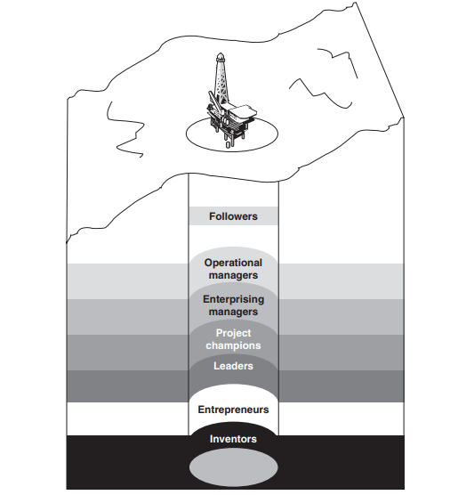
(Bolton, & Thompson, 2013).
Figure 2. Understanding the Entrepreneurial Process: a Dynamic Approach
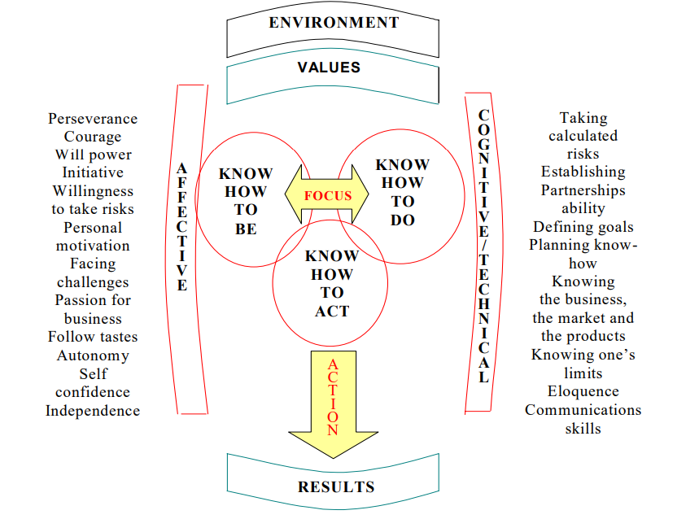
Leadership
Making it happen
Creating alliances
Generating jobs
Contributing to the growth of the country
Generating profit
(ANPAD, 2018).

Figure 3. Model of the Entrepreneurial Process
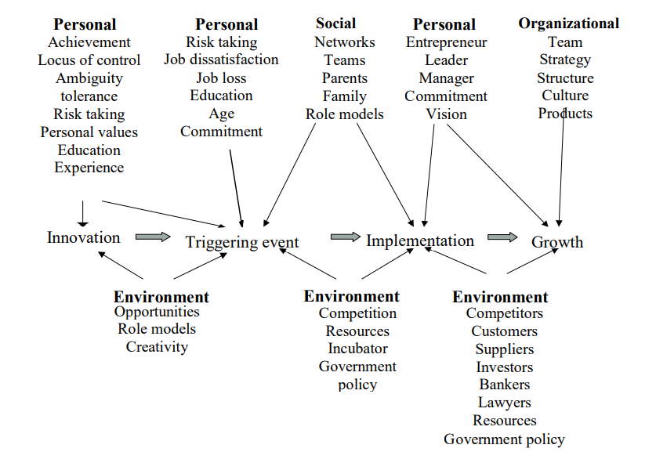
(ANPAD, 2018).

Figure 4. Examples of Successful Entrepreneurs
Pictures | Names | Businesses | Motivation
 | Bill Gates | Co-founder of Microsoft Corp.  Founded: 1975 | Bill Gates loved computers, saw an opportunity, dropped out of Harvard, anticipated the market needs, took a current technology, improved it to a particular market, and controlled that market via innovative advancement and sly professional knowledge. Bill Gates and Paul Allen wrote software for computer start-ups such as Apple.
 | Jeff Bezos | Amazon and Owner of The Washington Post. | Born in 1964, loved computers, graduated in computer science and electrical engineering, worked in Wall Street, quit his lucrative job to target the unexploited prospects of internet market, and opened Amazon.com in 1995.

(GROWTH STRATEGIES, 2018; Business Blog for Successful Entrepreneurs, 2018).

The present perspectives of entrepreneurial motivation
Entrepreneurial motivations can be categorised in terms of the importance attached to autonomy, improved work, challenges, financial issues, and family issues and heritage aspects. Through all trade types, entrepreneurs said that autonomy highest motivator.

Autonomy & enhanced work: The desire for freedom, flexibility, independence, and superior work motivated some entrepreneurs to start their own business (Dannreuther and Perren, 2013; Hisrich, Robert D. 2013).
Although, the characteristics listed above are good, however the entrepreneur need to think of the resources, skills, manpower and costs involves in starting own business.
Challenge & opportunity: The aspiration to personally challenge oneself and achieve a vision, as well as the opportunity to use ones present skills plus the hunt for recognition motivated some entrepreneurs to start a business (Rae, 2014). Such entrepreneurs are determined and energised to attain their vision and as such they try to give all they can to make it a successful reality (Kickul and Lyons, 2012b; Mole and Ram, 2012)
Although it is good for entrepreneurs to challenge themselves, however vision, skills and challenge are not enough to build a successful business. Entrepreneurs need to think outside the box and move forward in other aspects such as resources and finance.
Financial motives: The wish for economic security, greater earnings and prosperity motivated some entrepreneurs to start their business. Burns, (2013) admits that true entrepreneurs (not just managers) are those who established growth firms. Businesses that expand rapidly produce the most riches and jobs and they also account for 50% of a countries GDP for example United States of America. Even though, only a few companies are in this league (Burns, 2013).
However, the wish for financial security, bigger earnings and fortune can only be achieved if the foundation is solid and well planned. An entrepreneur is expected to think past the traditional income creating business activities.
Family & legacy: The desire to continue the family business or build a new family business motivated some entrepreneurs to start or continue a business. Family business play a great part in global economy, Boston Consulting Group's analysis admits that they are over 30% of all businesses with sales of above $1 billion (KACHANER, et al., 2012). Examples of family businesses are; Porsche, Walmart, Tata Group, Samsung and others. Family businesses are different in their distinctiveness, and their unique possession structure offers them a long-term orientation lacked by public companies (KACHANER, et al., 2012). Family businesses have a lasting financial performance higher than non-family businesses and they focus more on resilience than performance (KACHANER, et al., (2012).
Although, family business is good and easy for family members to start or continue a good reputable business with a good brand name and strong brand image, but not all the family members are entrepreneurs, business minded or ready to put in the hard work required. Family members that are lavish money spenders can easily bring the business down. On the other hand, great entrepreneurs in the family can grow and develop the family business.
Recession and Redundancy: Redundancy motivated some entrepreneurs to start their own business while in pursuit of a stable employment. A lot of recession-era ambitious employee’s saw their redundancy as an opportunity to start their own business. Recession presents sincere opportunities for beginning entrepreneurs as many closing businesses leave behind unfulfilled market demands (Rae, 2014). Similarly, request for more efficient and inexpensive products and services rise during recessions prompting innovations in many areas.
Although recessions and redundancies lead many entrepreneurs into starting their own business, however, starting a business is not as good as making the business a huge success. Thus new entrepreneurs need to think about business survival and success.
A Gap in the Market: Superior hostel entrepreneur (Elizabeth Ademiluyi) saw a gap in the students hostel market and she was motivated to fix it and bring a lasting solution to the student accommodation problems and also prevent students from falling into the hands of shark landlords who provides substandard accommodations and rip students off their finances (Please see presentation slides and business plan). Elizabeth has also had the experience of a shark landlord with one of her sons who went to Luton University. The shark landlord charged over £1,000 a month for a damped loft room and the case ended up in court.
Although Universities are trying their best to provide student accommodations, but their provisions are inadequate and this made students vulnerable leading them to any available accommodation around, however, a standardised student hostel like Superior Hostel will solve student’s accommodation problems.

Entrepreneurial motivation and cultural environmental influences.
Culture is an essential part of humanities daily lives, the social behaviour, characteristics, customs, ideas, knowledge and the general way of life of a particular people or society (Al-Sherrawi, 2017). It is an economic driver and it shows in our daily lives. Wealth is produced by cultural workers, and the economy depend on skilled cultural workers to generate new ideas, initiatives and businesses. It also helps to attract new settlers and supports in retaining present citizens (Al-Sherrawi, 2017).

The development of new business has direct impact on society’s culture and their economic growth and prosperity. Socio-cultural factors such as: Family, different social classes, Ethnicity, Religion, Physical qualities and Education have impact on entrepreneurial activities in any country. This is because, socio-cultural issues effect decisions to make new businesses (Journal of Business and Management, 2014).
Cultural matters in business communications across cultures is a big subject. The idea of negotiating culture is thus employed, explained and applied to information at organizational and individual levels in multicultural meetings. Communication is viewed as a difficult, concern and vibrant procedure where global bosses exchange meaning (Clausen, 2007).
In relation to entrepreneurship, cultural environment, is stated as the components of social structure and culture of people which certainly or adversely affect and effect entrepreneurial development, conduct and presentation. These rudiments conditions the standards, rational and actions of the people in esteem to entrepreneurship comprise the social-cultural environment of entrepreneurship (Journal of Business and Management, 2014).

Entrepreneurs thus need to study the culture of the people in order to produce or develop an acceptable business for the people. For example an entrepreneur who goes to set up a meat business in a vegetarianism and veganism society or country such as India, has failed before the start of the business. So it is very important to study the culture and know what you are going in to.

Figure 5. What is Culture?

(Al-Sherrawi, 2017).

Entrepreneurial motivation and economical environmental influences.
Social and political instability if not controlled can affect the economy and hinder entrepreneurial motivation and development in any country. Crisis such as: corruptions, high interest rate, labour unrest etcetera can intensely influence businesses and make them sterile, make the banking and financial institutions to come under threat as a result of the motionless situation in business, deter development and make an economy to crack down (Journal of Business and Management, 2014).
On the other hand, healthy political culture and pleasant law and order brings healthy economy and also birth new entrepreneurs. It is therefore advisable for leaders and politicians to be alert and responsible to remove all impediments and create a welcoming business environment so that new entrepreneurs will spring up and start durable businesses and the business environment will function accurately (Journal of Business and Management, 2014).
An example of New Zealand Maori People where economic reforms positively impacted their competitiveness, development and entrepreneurial business growth. When any economy develop their institutional agenda in several methods that can develop the positive environment required for growth and creation of entrepreneurship, the development that will be bath will contribute massively to employment and increase the growth of the nation (ZAPALSKA et al., 2003).

Current entrepreneurial challenges
Cash Problems: Good cash flow pays the bills even though cheques are just arriving. There is a need for many young entrepreneurs to pay their bills before customers cheques comes in. Sometimes failure to budget or delayed invoices causes commotion. Sending invoices promptly or outsourcing to collection agencies will help, so that they can collect money from customers who are unwilling to pay (Helen, 2018).
Hiring Employees: Staffs are vital for the smooth running of a business. Employing skilled, talented and competent workers who will help to achieve the business goals is a big challenge for entrepreneurs. Advertising online, job centres, local newspapers will help to get the right talents (Helen, 2018).
Managing Time and Schedule: Most young entrepreneurs over work themselves for long hours and are usually exhausted. Proper time management and an assistant who can manage efficiently in your absence will be appropriate (Helen, 2018).
Dividing Tasks: It is advisable for entrepreneurs not to overburden themselves with too much work, dividing the tasks, giving everyone their bits as well as setting targets to accomplish will ease the work and get things done much quicker (Helen, 2018).
Understand the Market: Entrepreneurs need to conduct proper research, visibility studies, understand the market and look at the trends before investing in a project. It is important that the business catches the interest of the market, attract the national and the local community (Helen, 2018).
Marketing Strategy: Local, National and International marketing and advertisements on social media, newspapers, flyers, business cards, bill boards, brochures, Television, Radio, and online will speedily increase the awareness of your brand and of cause increase your business (Helen, 2018).
Funding: Either getting a loan or a sponsor is a challenge for current entrepreneurs. Banks are very careful to loan money to new businesses because of the failure rate. Therefore many entrepreneurs will have to look for families, friends or use their saving to fund their business (Helen, 2018).
Establish a Strong Brand: It is vital for entrepreneurs to develop a strong brand to be able to successfully compete in the present market, without a strong brand, the business may be shaky. Quality products and innovation will help entrepreneurs to establish a strong brand (Alton, 2016).
Operating in a highly Competitive Environment: Entrepreneurs should endeavour to be better than their competitors if they plan to succeed in their chosen industry and have a good market share. Intensive advertisements and marketing promotions will help entrepreneurs to advance their business (Alton, 2016).
Anticipation and Planning for Period of Losses before Profits: Many if not all entrepreneurs experience losses at the beginning of their business before the business later starts to make profit. Having some savings aside will help entrepreneurs to survive the period of losses (Alton, 2016).

More Current entrepreneurial challenges are:
- Keeping the Business Profitable
- Flexibility and freedom accessible through the internet
- Uncertainty of the job market
- Providing Outstanding Customer Services
- Employee engagement
- Growth and Business Potential
- Budgeting
- Competition and Self-Doubt
(Alton, 2016).

Constant need for innovation within the entrepreneurial arena.

Innovation is one if not the most significant element of a successful business. Innovators generate new ideas, approaches, products and bring solutions to problems resulting in value creation for both the customers and the business (Tredgold, 2018).
- Innovators easily grow their businesses and have a big market share.
- Innovation makes a company exceptional and better than competitors.
- Innovation helps businesses to offer unique products and services in order to meet the regularly changing customer’s needs.
- Innovation helps businesses to continuously improve.
- Innovative companies attract innovative talents who will grow the business even further.
(Tredgold, 2018).

Conclusion

The analyses of the present viewpoints of entrepreneurial motivation exposes their zeal, passion and strength to follow their dream to a successful achievement. A summary of some current entrepreneurial challenges and the solutions available for them has been discussed. The analyses revealed that cultural and economic issues can effect both positively and negatively entrepreneurial development in a society. The various ways in which entrepreneurial motivation can be culturally and economically influenced by the environment was uncovered and the measures to prevent bad cultural and economic environmental influences on entrepreneurial motivation explained.
The assignment has fully analyse several ways that a society can help in supporting developments and growth by paving ways and opening doors for fresh entrepreneurs to come in with great talents, new knowledge, innovations and developments. This will result in massive growth for the society or country.

Recommendations

- Employ the right talents who will support to accomplish your goals.
- Recognise and target the right market.
- Enhance value to your customers.
- Have a differentiation strategy that is unique from the competitors.
- Continuous innovation through research and development.
Bibliography

Alton Larry, (2016) The 8 Biggest Challenges for New Entrepreneurs (Online) Available at: https://www.entrepreneur.com/article/254721 (Accessed: 15/09/18).

Al-Sherrawi Mohannad Husain, (2017) WHAT IS CULTURE? (Online) Available at: https://www.researchgate.net/post/What_is_Culture/1 (Accessed: 18/09/18).

ANPAD, (2018) Understanding the Entrepreneurial Process: a Dynamic Approach (Online) Available at: http://www.scielo.br/pdf/bar/v7n2/v7n2a07.pdf (Accessed: 18/09/18).

Bolton, B. & Thompson, J. (2013) Entrepreneurs: Talent, Temperament, Technique (3rd Ed) Oxford: Elsevier Butterworth-Heinemann.

Burns Paul, (2014) New venture creation: a framework for entrepreneurial start-ups. Houndmills, Basingstoke: Palgrave Macmillan. Available at: https://oxfordbrookes.idm.oclc.org/login?url=http://lib.myilibrary.com?id=977428.

Burns Paul, (2018) New venture creation: a framework for entrepreneurial start-ups. Second edition. London: Palgrave.

Burns Paul, (2013) Corporate entrepreneurship: innovation and strategy in large organizations. 3rd ed. Basingstoke: Palgrave Macmillan.

Business Blog For Successful Entrepreneurs, (2018) (Online) Available at: https://in-business.org.uk/jeff-bezos-leadership-style-an-inspirational-entrepreneur/ (Accessed: 18/09/18).

Clausen Lisbeth, (2007) Corporate Communication Challenges A 'Negotiated' Culture Perspective. International Journal of Cross Cultural Management, Vol 7, Issue 3, pp. 317 – 332 https://doi.org/10.1177/1470595807083376

Dannreuther, C. and Perren, L. (2013) The political economy of the small firm. London: 1/5 09/17/18 Enterprise and Entrepreneurship U58022 | Oxford Brookes Reading Lists Routledge. Available at: https://oxfordbrookes.idm.oclc.org/login?url=http://lib.myilibrary.com?id=459093.

Fernandes Paula, (2018) Entrepreneurship Defined: What It Means to Be an Entrepreneur (Online) Available at: https://www.businessnewsdaily.com/7275-entrepreneurship-defined.html (Accessed: 15/09/18).
GROWTH STRATEGIES, (2018) Bill Gates (Online) Available at:
https://www.entrepreneur.com/article/197526 (Accessed: 18/09/18).

Helen, (2018) Top Business Challenges for Young Entrepreneurs (Online) Available at: https://www.netcashcows.co.uk/701/business/top-business-challenges-for-young-entrepreneurs.html (Accessed: 18/09/18).

Hisrich, Robert D. (2013) International entrepreneurship: starting, developing, and managing a global venture. 2nd ed. Los Angeles: SAGE.

Journal of Business and Management (IOSR-JBM), (2014) e-ISSN: 2278-487X, p-ISSN: 2319-7668. Volume 16, Issue 9.Ver. II, PP 01-10 www.iosrjournals.org www.iosrjournals.org

Juan Jose de la Torre, (2015) Digital Transformation Leader for Middle East and Africa, IBM (Online) Available at: https://www.entrepreneur.com/article/245628 (Accessed: 15/09/18).

Journal of small business and enterprise development’ (no date). London: Henry Stewart Publications. Available at: http://capitadiscovery.co.uk/brookes/items/756901.

KACHANER, N., STALK, G. and BLOCH, A., (2012). What You Can Learn from Family Business. Harvard business review, 90(11), pp. 102-106.

Kickul, J. R. and Lyons, T. S. (2012b) Understanding social entrepreneurship: the relentless pursuit of mission in an ever changing world. New York: Routledge. Available at: https://oxfordbrookes.idm.oclc.org/login?url=http://lib.myilibrary.com?id=344337.

Mole, K. and Ram, M. (2012) Perspectives in entrepreneurship: a critical approach. Houndmills, Basingstoke: Palgrave Macmillan. Available at: https://oxfordbrookes.idm.oclc.org/login?url=http://lib.myilibrary.com?id=976436.

Rae, D. (2014) Opportunity-centred entrepreneurship. Second edition. Basingstoke: Palgrave Macmillan.

Tredgold Gordon, (2018) Do’s and Don’ts of Marketing Analytics Dashboards (Online) Available at: https://www.inc.com/gordon-tredgold/4-reasons-why-you-need-to-focus-on-innovation.html (Assessed: 19/09/18).

ZAPALSKA ALINA M., DABB HELEN & PERRY GEOFF (2003) Environmental Factors Affecting Entrepreneurial Activities: Indigenous Maori Entrepreneurs of New Zealand, Asia Pacific Business Review, 10: 2, 160-177, DOI: 10.1080/13602380410001677191

