University of Wales Trinity Saint David

School of Engineering

Designing a Kiteboard Hydrofoil Wing – Structural Design

Joshua Axon

2218372


Contents
1 Table of Figures iii
1.1 Appendix A Table of Figures iv
1.2 Table of Equations v
1.3 Table of Tables v
2 Introduction 1
3 Literature Review – Development of FEA and Optimisation Techniques 2
3.1 Origins and Evolution 2
3.1.1 Analytical and hand-calculation methods 2
3.2 Analytical Foundations 3
3.3 Expansion, Integration and Future Use 3
4 FE Model Development – Baseline Wing Analysis 5
4.1 FE Model, Geometry, Element selection & Mesh Strategy 5
4.2 Steel Baseline Analysis 6
4.3 Definition of Anisotropic Material 7
5 Optimisation of Ply Lay-Up 9
5.1 Optimisation objectives, step and initial convergence problem 9
5.2 Design Iteration and Convergence Behaviour 10
5.3 Ply Orientation Evolution & Uneven distribution 11
5.4 Stress and Failure Analysis 13
5.4.1 Statistical Check 14
5.4.2 Mitigation Proposal 14
5.5 Manufacturability and Discretisation 15
5.6 Critical Reflection and Pre-vailing concerns 16
6 Experimental Validation and Data Correlation 17
6.1 Prototype step up 17
6.2 Data Acquisition and Correlation 17
7 Discussion and Relation to Technical Literature 18
8 Conclusions and Recommendations 18
9 Bibliography 19
10 Appendix A 21

Table of Figures
Figure 1 Representation of the stress tensor and its components on an infinitesimal cube (Carleton College, 2024). 2
Figure 2 - Comparison of warpage predictions obtained from Altair Inspire Mold (traditional solver-based FEA) and Altair physicsAI (AI-driven prediction). While both methods show qualitatively similar deformation trends, the AI model delivers results in a fraction of the time and with slightly different quantitative outputs, illustrating both the potential and the current limitations of AI-augmented simulation workflows taken from https://altair.com/blog/articles/artificial-intelligence-in-manufacturing 4
Figure 3 - Finite Element (FE) model of the hydrofoil wing showing the applied load and boundary condition. The upper half of the hydrofoil is modelled using 2D quadrilateral shell elements. A 500 N downward load is applied near the outer mid-span, while the root section is fully constrained in all six degrees of freedom to simulate a fixed support. 5
Figure 4 - Finite Element simulation of the 2 mm thick steel reference wing showing the total displacement distribution (XYZ magnitude). The colour scale represents the overall deflection of the structure under a 500 N vertical load, with a maximum displacement 6
Figure 5 - Finite Element Model of the Hydrofoil Wing with Unidirectional Laminate Definition. The FE mesh illustrates the alignment of two-dimensional shell elements along the longitudinal axis of the hydrofoil to represent the directional stiffness of the unidirectional carbon-fibre laminate. Element orientation has been adjusted to ensure fibre alignment follows the principal load path, improving the accuracy of anisotropic material behaviour in the simulation. 7
Figure 6 - Laminate ply direction and layer thickness / group properties for the CRFP. 7
Figure 7 – Finite Element simulation of the initial CRFP unoptimized wing showing the total displacement distribution (XYZ magnitude). The colour scale represents the overall deflection of the structure under a 500 N vertical load, with a maximum displacement 8
Figure 8 - Design Studio Output showing initial pitfall in the optimisation around issue with an over constrained problem, causing only 1 design cycle 9
Figure 9 – Design History Plot showing constraint violation taken from the design studio output showing the compliance with the main design criteria of deflection over design iteration process 10
Figure 10 - Design History Plot showing objective compliance taken from design studio output showing the design cycle iteration and it's effect on overall weight. 10
Figure 11 - Design Variable thickness plot showcasing the change in thickness of each of the direction plys over the design cycle, L1THK = -90deg, L2THK = -45deg, L3THK= 0.0deg, L4THK = 45deg, L5THK = 90deg. 11
Figure 12 - Finite Element simulation of the optimised CRFP wing showing the total displacement distribution (XYZ magnitude) after the 13th load cycle. The colour scale represents the overall deflection of the structure under a 500 N vertical load, with a maximum displacement and has been changed to filled rather than element contours. 11
Figure 13- Finite Element simulation of the optimised CRFP wing showing the total displacement distribution (XYZ magnitude) after the 7th load cycle. The colour scale represents the overall deflection of the structure under a 500 N vertical load, with a maximum displacement and has been changed to filled rather than element contours. 12
Figure 14 – FE simulation map of displacement of original 0 cycle unoptimized laminate layering now with filled contours rather than element contours. 12
Figure 15 – FE simulation map of von Misus principal stresses for cycle 0 of the unoptimized laminate layering with filled contours. 13
Figure 16 – FE simulation map of von Misus principal stresses for cycle 13 of the optimized laminate layering with filled contours. 13
Figure 17 - Typical Fibre Orientation Configurations in Composite Laminates Adapted from (Satam, et al., 2022) The figure illustrates common ply orientations used in composite laminate design. The lower diagrams show unidirectional reinforcement, providing strength mainly along the fibre axis, and bidirectional reinforcement, providing load-carrying capability in both principal in-plane directions. 14
Figure 18 - Design Studio history file showcasing the unrealistic layering design variable thickness. 15
Figure 19 - Design History Plot showing the now discretised design variable optimisation constraint violation taken from the design studio output showing the compliance with the main design criteria of deflection over design iteration process 15
Figure 20 – Design History Plot showing the now discretised design variable optimisation constraint violation taken from the design studio output showing the compliance with the main design criteria of deflection over design iteration process. 16
Figure 21 - Design Studio history file showcasing the with now discretised variables with cycle 12 showing a clear achievable ply thickness. 16
Figure 22 - Experimental Setup for Beam Deflection Test, the frame provides a rigid support system ensuring that measured deflections correspond primarily to bending deformation within the beam. 17

Appendix A Table of Figures
Appendix A 1 - Mechanical and Thermal Properties of Cytec APC-2/AS4 Carbon Fibre Reinforced PEEK (UD Prepreg) Extracted from Cytec Engineered Materials, “APC-2 PEEK Thermoplastic Polymer Technical Data Sheet,” pp. 2. The table presents typical polymer and laminate properties for unidirectional carbon/PEEK tape at 60 % fibre volume fraction, including longitudinal and transverse tensile, compressive, flexural, and in-plane shear strengths over a range of service temperatures. At 75 °F (24 °C) the 90° tensile strength is 13 ksi (≈ 86 MPa), confirming high transverse performance suitable for comparison with epoxy-based CFRPs. 21

Table of Equations
Equation 1 - Matrix formulation expressing the fundamental relationship between the nodal force vector, the global stiffness matrix, and the nodal displacement vector (Turner, et al., 1956). 3
Equation 2 - Algebraic representation illustrating the assembly of the global stiffness matrix as the summation of individual element stiffness matrices (Caprani, 2011). 3
Equation 3 - calculates the global stiffness of the 2 mm thick steel wing, defined as the ratio of applied load to maximum deflection. 6
Equation 4 - expresses the stiffness-to-weight ratio, providing a normalised measure of structural efficiency that serves as the benchmark for subsequent composite lay-up designs 6
Equation 5 – calculates the global stiffness of the CRFP unoptimized wing, defined as the ratio of applied load to maximum deflection. 8
Equation 6 – expresses the stiffness-to-weight ratio of the CRFP unoptimized wing. 8
Equation 7 – Maximum Principal Stress Theory equation relating von Misus principal stress in red area of FE simulation to CRFP transverse stress in tension resistance. 14

Table of Tables
Table 1 - Material properties and stiffness comparison table 8

Introduction
This design report aims to optimise a composite hydrofoil wing through structural analysis, predominantly using Finite Element Analysis, and demonstrate AHEP3 learning outcomes. The hydrofoil wing, made from unidirectional CFRP, aims to reduce weight while maintaining structural integrity. A key acceptance criterion is that deflection does not exceed that of the 2 mm steel baseline.
For this report, the board is interpreted as the entire hydrofoil component; thus, the criteria for success are to ensure that the maximum displacement from the component’s root to wing tip (longitudinal direction) under a 500 N vertical load at mid-span is comparable or better than the 2 mm steel baseline model, ensuring consistent stiffness evaluation.
As the material is anisotropic, the longitudinal and lateral stiffness differ significantly, with a much lower Young’s modulus laterally. Therefore, adequate ply layering and orientation are required to provide axial bending stiffness, in-plane shear capacity, and global laminate stability. These parameters will be refined through FEA to identify load paths and stress concentrations for optimal ply distribution.
The report will be structured in 7 sections. Sections 2 to 6 outline the methodology to complete the required tasks outlined in the brief. The work is structured around five sequential tasks that reflect a complete engineering design process. Task 1 (Section 2) examines the development of FEA and optimisation techniques for the study's theoretical basis. Task 2 (Section 3) involves constructing an FE model of the hydrofoil wing using the specified boundary conditions and material properties. Task 3 (Section 4) focuses on optimisation to reduce mass while satisfying deflection constraints. Task 4 (Section 5) proposes a validation experiment to correlate simulated and physical deformation, while Task 5 (Section 6) relates the design and findings to existing technical literature and industry standards. Together, these tasks move from theory to modelling, optimisation, testing, and reflection, demonstrating a professional engineering design process.

Literature Review – Development of FEA and Optimisation Techniques

Origins and Evolution
Understanding the development of FEA provides essential context for its role in optimisation and composite design. Originating from mathematical principles in structural mechanics and evolving through integration with computer-aided design to AI-based optimisation, FEA has become fundamental to modern engineering practice. To appreciate its impact, it is first necessary to examine how design and analysis were conducted before FEA and the limitations of those traditional methods.

Analytical and hand-calculation methods
Prior to computer-based FEA, engineers relied on analytical hand calculations, empirical data, and physical testing. Structural members were idealised as beams, plates, or shells, and stresses determined using classical elasticity, moment-distribution methods, and manually derived stiffness relationships. These approaches could only accommodate simple geometries and boundary conditions, necessitating large safety factors to account for uncertainty in materials and loading often resulting in heavy, over-engineered components (Cook, et al., 2001).
Achieving both lightness and stiffness was particularly challenging, as it required resolving three-dimensional stress states within complex geometries. While engineers understood tensor-based stress analysis conceptually, such calculations were prohibitively time-consuming to perform manually. As illustrated in Figure 1, the stress tensor contains nine components six independent that define normal and shear stresses acting on an infinitesimal element (Carleton College, 2024). Evaluating these relationships across a structure with thousands of points highlights why digital computation became essential to modern analysis and design optimisation (Zienkiewicz & Taylor, 2000).

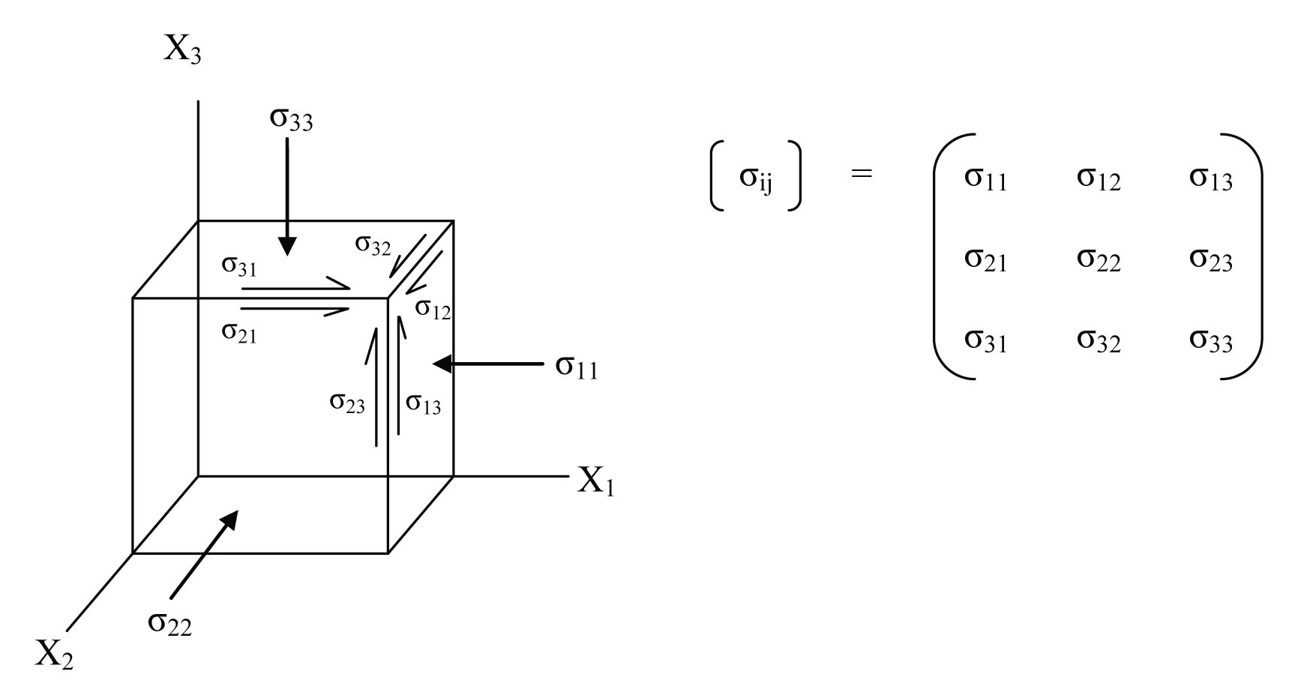
Figure 1 Representation of the stress tensor and its components on an infinitesimal cube (Carleton College, 2024).

Analytical Foundations
With the advent of computing and the availability of processing power, the relevance of discretisation in terms of structural analysis gained traction as discretised structures & methods, where stress tensors are evaluated, gained prominence. Early pioneers Richard Courant first introduced the concept of dividing structures into small subregions, i.e. discretised subregions. Turner, Clough, Martin, and Topp, who formalised the stiffness matrix method (Zienkiewicz & Taylor, 2000).
The stiffness matrix method forms the basis of most modern stress analysis today, as it provides a structured mathematical framework for relating nodal forces to nodal displacements through a series of linear equations. Each evaluated structural member was then expressed through a matrix, using array end element matrices that provided a global stiffness matrix. As alluded to in section 2.1, the manipulation and solving of these large arrays are a perfect application for computer analysis. The rise of digital computing in the 1960s–70s shifted structural analysis from empirical to computational methods. This is the basis on which modern FEA is built (Turner, et al., 1956).
Equation 1 - Matrix formulation expressing the fundamental relationship between the nodal force vector, the global stiffness matrix, and the nodal displacement vector (Turner, et al., 1956).
$$\left\{F^{e}\right\}=\left[K\right]\{u^{e}\}$$
Equation 1 outlines this relationship, where F is a vector of nodal forces, K is a stiffness matrix based on the structure's resistance to deformation, and u is the vector for nodal displacements. Key to note is that each beam, truss, and plate has its own stiffness matrix, which is derived from its basic elasticity and geometry which is outlined in equation 2 (Caprani, 2011).
Equation 2 - Algebraic representation illustrating the assembly of the global stiffness matrix as the summation of individual element stiffness matrices (Caprani, 2011).
$${\sum{{[K]}_{Global}=}[K]}_{Plate}+{[K]}_{Truss}+{[K]}_{Beam}…. etc$$

Expansion, Integration and Future Use
The combination of matrix-based structural theory and digital computation transformed finite element methods from academic research tools into an industrial design standard. Between the 1970s and 1990s, the growing maturity of digital systems enabled the development of commercial software capable of integrating finite element analysis with emerging CAD and CAE platforms. This integration allowed engineers to model and evaluate structural performance directly within three-dimensional design environments, making it possible to analyse complex interactions and loading conditions that had previously been unfeasible using purely analytical methods. Notable software developments during this period included NASTRAN (NASA Structural Analysis), originally developed by NASA in the late 1960s and later commercialised by MSC Software (MacNeal–Schwendler Corporation), and ANSYS, founded by John Swanson in 1970 (ANalysis SYStems; Swanson Analysis Systems, Inc. SASI) (Principal, 2018).
Advancements in computational capability allowed for more accurate non-linear analysis simulating more complex structural loading conditions. Composite-material modelling allowed engineering to represent layered anisotropic materials (e.g. CFRP). FEA also began to move into Multiphysics environments thermal and fluid mechanics began to be replicated in simulated conditions. These brought FEA from fringe specialist application to widespread comprehensive and core to mechanical design (Bathe, 1996) (Zienkiewicz & Taylor, 2000).
Finite element analysis continues to evolve, improving the fidelity and efficiency of simulations as computational power increases. The discipline now stands at the threshold of a paradigm shift, with emerging methods that combine artificial intelligence (AI) and finite element modelling (FEM) frameworks. These approaches train deep neural networks using traditional FEA data to predict structural responses within milliseconds representing performance gains of up to 200–500 times over conventional solvers such as ANSYS or ABAQUS. Such techniques have the potential to dramatically reduce the computational cost of fine-mesh and nonlinear analyses. However, they also introduce new challenges regarding reliability, accountability, and data integrity: if an AI-based model produces an incorrect result, where does responsibility lie with the designer, the algorithm, or the training dataset? Furthermore, as predictive systems become self-referential, relying primarily on their own generated data, questions arise about how these models will continue to learn and remain verifiable over time (Sahani, 2024).

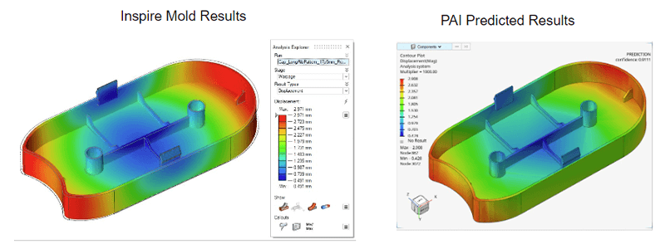
Figure 2 - Comparison of warpage predictions obtained from Altair Inspire Mold (traditional solver-based FEA) and Altair physicsAI (AI-driven prediction). While both methods show qualitatively similar deformation trends, the AI model delivers results in a fraction of the time and with slightly different quantitative outputs, illustrating both the potential and the current limitations of AI-augmented simulation workflows taken from https://altair.com/blog/articles/artificial-intelligence-in-manufacturing

FE Model Development – Baseline Wing Analysis

FE Model, Geometry, Element selection & Mesh Strategy
To optimise ply placement and evaluate the performance of the composite hydrofoil wing, a finite element (FE) model was first developed.
The hydrofoil geometry was simplified to include only the upper half of the wing section, as the lower surface contributes symmetrically to global stiffness but does not significantly influence the out-of-plane deflection of interest. This assumption reduces the model’s surface area and hence the total number of elements, improving computational efficiency without compromising result accuracy. The model setup is shown in Figure 3.

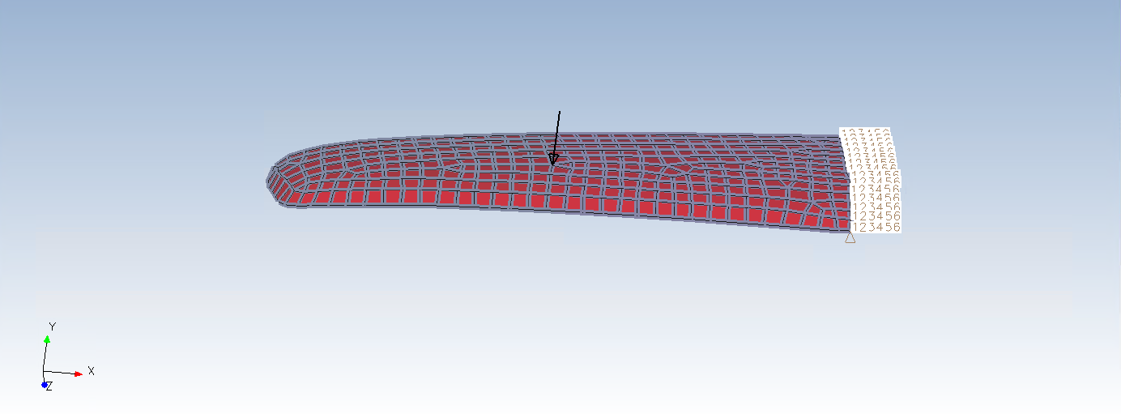
Figure 3 - Finite Element (FE) model of the hydrofoil wing showing the applied load and boundary condition. The upper half of the hydrofoil is modelled using 2D quadrilateral shell elements. A 500 N downward load is applied near the outer mid-span, while the root section is fully constrained in all six degrees of freedom to simulate a fixed support.
A uniformly distributed downward load of 500 N was applied near the outer mid-span of the wing to represent the vertical hydrodynamic force described in the design brief. The geometry was idealised as a thin-walled structure; therefore, 2D shell elements were adopted, consistent with best practice for plate- or shell-like components where one dimension (thickness) is much smaller than the others (Hearn, 1997).
The hydrofoil root was modelled as a fully fixed boundary condition, with all six degrees of freedom constrained. This represents a rigid attachment preventing translation or rotation at the root and allows deflection to occur primarily near the free end, where the design criterion is evaluated. Idealising the root as fully fixed eliminates unnecessary computation associated with root deformation and focuses the analysis on global bending behaviour along the span. The model's mesh is made primarily of quadrilateral (QUAD) elements, and where these converge, triangular (TRI) elements are used to ensure no overlapping of QUAD elements (Efficient Engineer, 2021).
Overall, the model setup balances fidelity and efficiency, capturing realistic structural response while maintaining an acceptable runtime and mesh density for subsequent optimisation and comparative analysis.

Steel Baseline Analysis
The steel reference model with 2 mm thick shell serves as the baseline reference for evaluating the stiffness and deflection performance of the composite hydrofoil. The finite element analysis was conducted under a vertical load of 500 N applied at mid-span, with the root face fully fixed to replicate a cantilever condition.
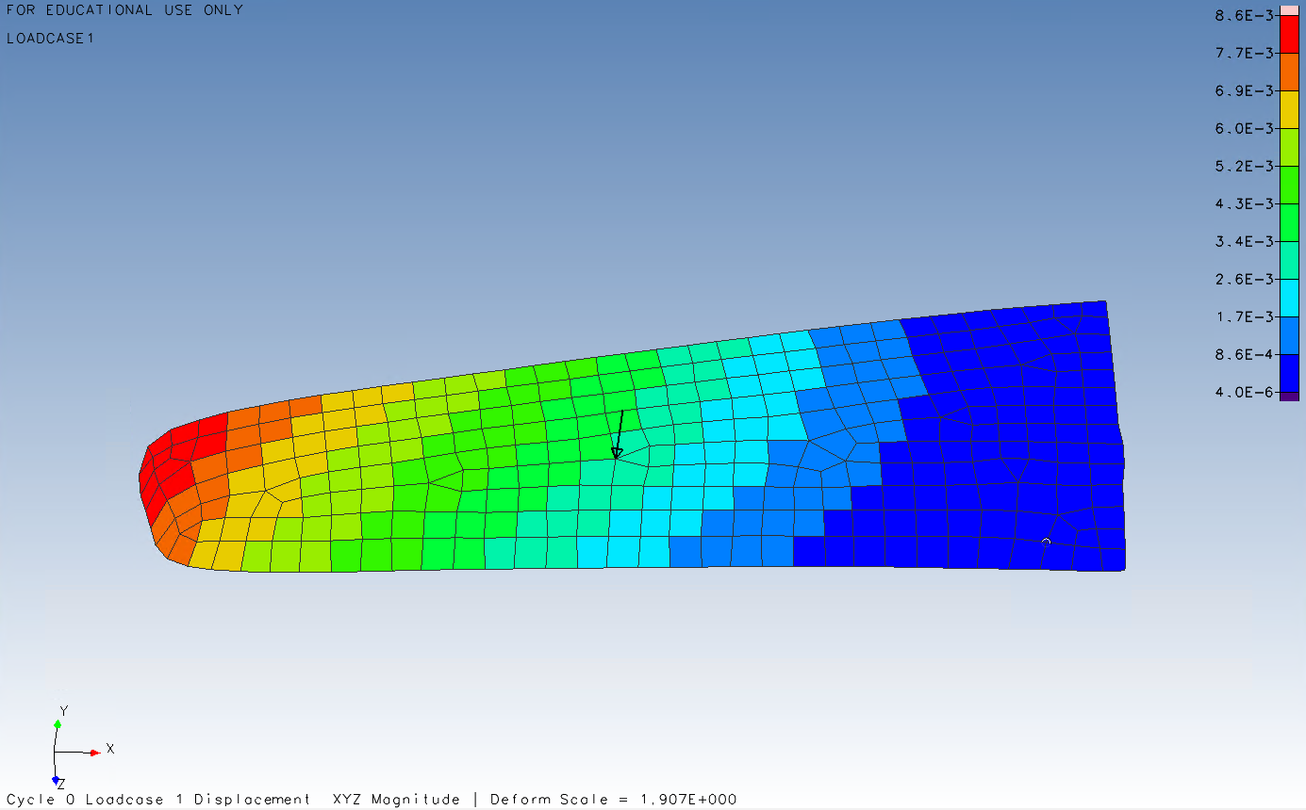
Figure 4 - Finite Element simulation of the 2 mm thick steel reference wing showing the total displacement distribution (XYZ magnitude). The colour scale represents the overall deflection of the structure under a 500 N vertical load, with a maximum displacement
The overall stiffness of the wing can be determined from the applied load and corresponding maximum deflection, as shown in Equation 3.
Equation 3 - calculates the global stiffness of the 2 mm thick steel wing, defined as the ratio of applied load to maximum deflection.
$$k=\frac{f}{δ}=\frac{500}{8.6}=58.12 N/mm$$
To assess structural efficiency, the stiffness-to-weight ratio was calculated (Equation 4) using the measured model mass of 0.465 kg.
Equation 4 - expresses the stiffness-to-weight ratio, providing a normalised measure of structural efficiency that serves as the benchmark for subsequent composite lay-up designs
$$\frac{Stiffness}{weight}=\frac{k}{mg}=\frac{56.18}{(0.465×9.81)}=12.992 N^{2}/mm$$
This value serves as the benchmark for evaluating subsequent composite lay-up designs, which must demonstrate comparable stiffness and lower mass while maintaining a maximum deflection not exceeding 8.6 mm. Functionally, the steel baseline defines the minimum acceptable stiffness and performance target for optimisation.

Definition of Anisotropic Material
A unidirectional carbon-fibre reinforced plastic (CFRP) laminate was then defined. To define anisotropic stiffness, the Element orientation was adjusted to align with the principal load path as seen in Figure 5.
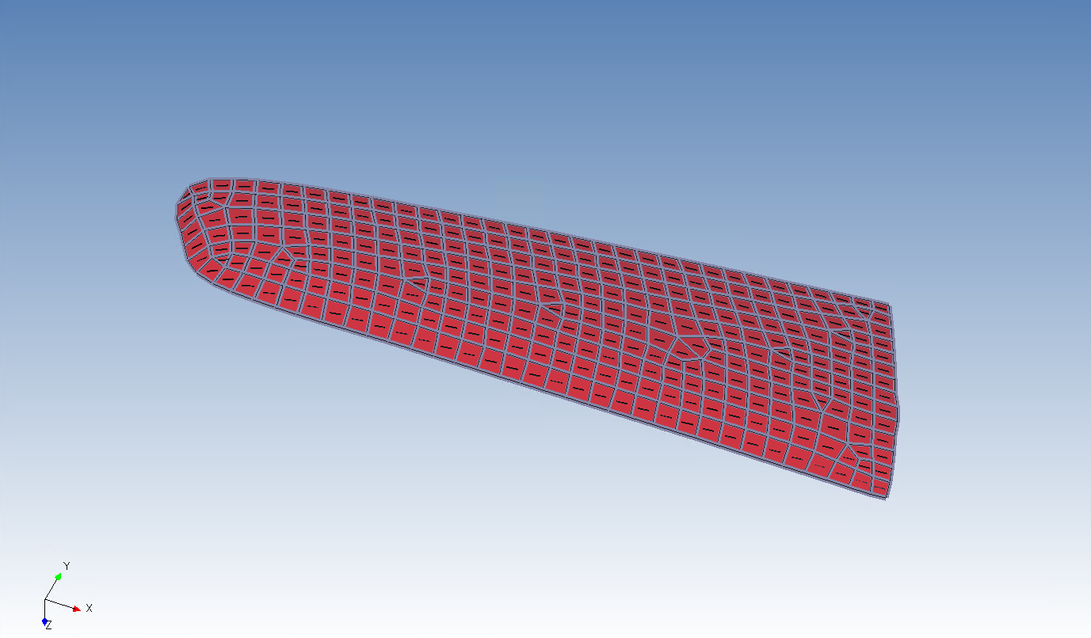
Figure 5 - Finite Element Model of the Hydrofoil Wing with Unidirectional Laminate Definition.
The FE mesh illustrates the alignment of two-dimensional shell elements along the longitudinal axis of the hydrofoil to represent the directional stiffness of the unidirectional carbon-fibre laminate. Element orientation has been adjusted to ensure fibre alignment follows the principal load path, improving the accuracy of anisotropic material behaviour in the simulation.
The laminate was modelled as 25 unidirectional CFRP plies, each 0.1 mm thick, with orientations of five plies at each of −90°, −45°, 0°, 45°, and 90°. The 0° direction was defined along the wing’s longitudinal axis (root–tip) this was done by defining a property value for the laminate which can be seen in figure 6.
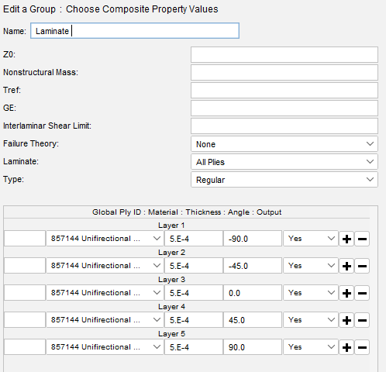
Figure 6 - Laminate ply direction and layer thickness / group properties for the CRFP.
A simulation was then run with the same load case as the steel wing, below in figure 7 showing maximum deflection at the tip of four times that of baseline steel.
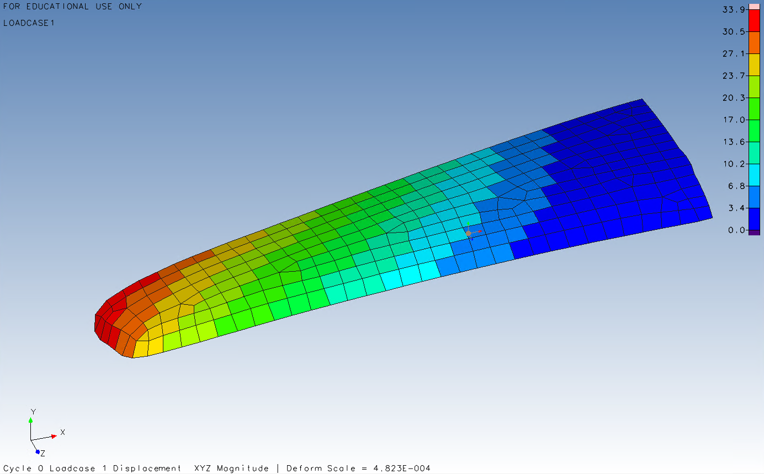
Figure 7 – Finite Element simulation of the initial CRFP unoptimized wing showing the total displacement distribution (XYZ magnitude). The colour scale represents the overall deflection of the structure under a 500 N vertical load, with a maximum displacement
Using the same equations use for the steel baseline the global stiffness and stiffness to weight ratio can be calculated seen below in equation 5 & 6 a comparison between the can be seen in table 1.
Equation 5 – calculates the global stiffness of the CRFP unoptimized wing, defined as the ratio of applied load to maximum deflection.
$$k=\frac{f}{δ_{Max}}=\frac{500}{33.9}=14.749 N/mm$$

Equation 6 – expresses the stiffness-to-weight ratio of the CRFP unoptimized wing.
$$\frac{Stiffness}{weight}=\frac{k}{mg}=\frac{14.749}{(0.231×9.81)}=6.509 N^{2}/mm$$
Table 1 - Material properties and stiffness comparison table
Material | Thickness | Deflection | Mass | Load | Stiffness | Stiffness/Weight
Steel | 2mm | 8.9mm | 465g | 500N | 58.12N/mm | $12.992$N²/mm
CRFP | 2.5mm | 33.9mm | 231g | 500N | 14.749N/mm | 6.509 N²/mm

Although the CFRP model is about half the mass of the steel, it performs four times less effectively in resistance to deflection. Additionally, while the CRFP offers significant weight savings, the global stiffness and stiffness-to-weight are notably lower.

Optimisation of Ply Lay-Up

Optimisation objectives, step and initial convergence problem
The objective, as shown at the end of section 3, is to see a 4x improvement in deflection resistance while minimising the mass of the laminate. To achieve this, design variables were set for ply orientation and thickness. Constraints were placed on weight, and the target of 8.6mm deflection was set.
Once an initial run was started, however, it stalled after a single iteration. This can be seen by the soft convergence after one cycle in Figure 8. This was due to an overly constrained design variable limit for ply thickness of 0.5e-4. Adjusting the minimum thickness to 0.1e-3 restored solve stability and allowed normal design progression. This issue underpins the potential pitfalls in iterative-based optimisation.

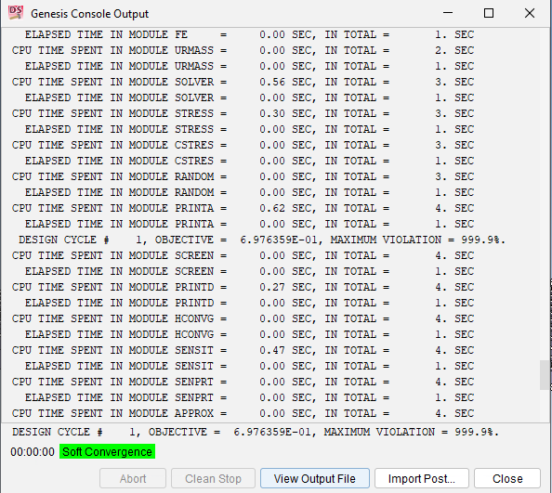
Figure 8 - Design Studio Output showing initial pitfall in the optimisation around issue with an over constrained problem, causing only 1 design cycle.

Design Iteration and Convergence Behaviour
With corrected bounds, the optimisation proceeded and reached a hard convergence after 13 design cycles. Figures 9–10 show that displacement constraints were initially violated but recovered by iteration 2. From cycles 3 to 13, weight was steadily shaved off the structure, and in fact, by the last design cycle, mass was reduced by 25% all while deflection reduced and stayed compliant with the target of 8.4mm. It is important to note, however, that cycle 7 updates produced negligible improvements, implying the optimisation had already begun to converge on a solution.
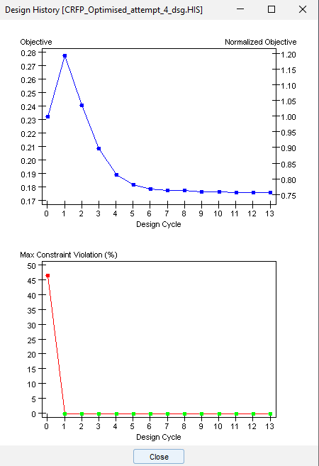
Figure 9 – Design History Plot showing constraint violation taken from the design studio output showing the compliance with the main design criteria of deflection over design iteration process
Figure 10 - Design History Plot showing objective compliance taken from design studio output showing the design cycle iteration and it's effect on overall weight.

Ply Orientation Evolution & Uneven distribution
The design variable thickness history (Figure 11) showcases a rapid promotion of 0° piles by the optimiser. By cycles 6-7, they dominate, and that remains unchanged through to cycle 13. This reflects the objective of the optimisation to increase longitudinal stiffness and indicates that the optimiser prioritised axial stiffness over transverse strength.
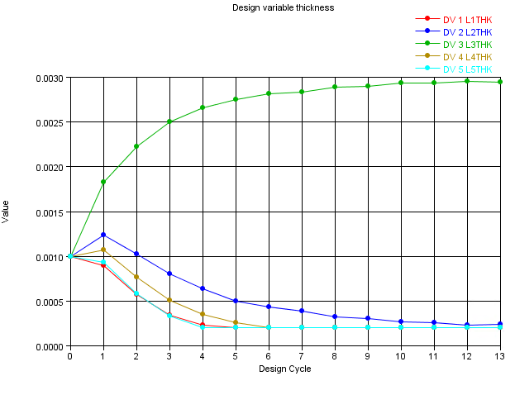
Figure 11 - Design Variable thickness plot showcasing the change in thickness of each of the direction plys over the design cycle, L1THK = -90deg, L2THK = -45deg, L3THK= 0.0deg, L4THK = 45deg, L5THK = 90deg.
Additionally, comparison of displacement contours between cycles 7 and 13, shown in figures 12 and 13, shows minimal changes, confirming again that the optimiser had reached convergence on its constraints long before cycle 13.
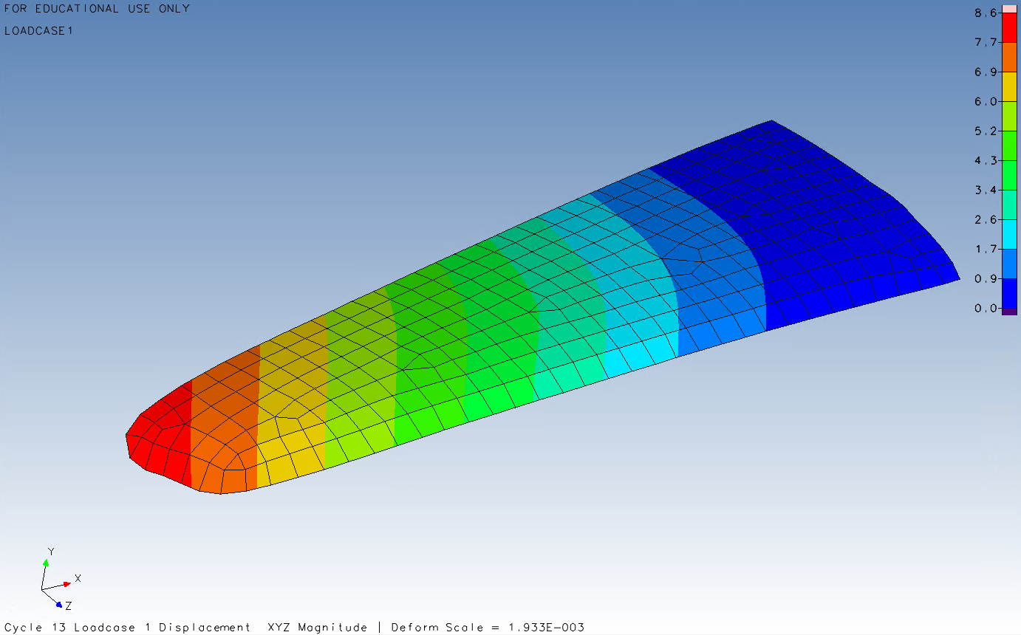
Figure 12 - Finite Element simulation of the optimised CRFP wing showing the total displacement distribution (XYZ magnitude) after the 13th load cycle. The colour scale represents the overall deflection of the structure under a 500 N vertical load, with a maximum displacement and has been changed to filled rather than element contours.
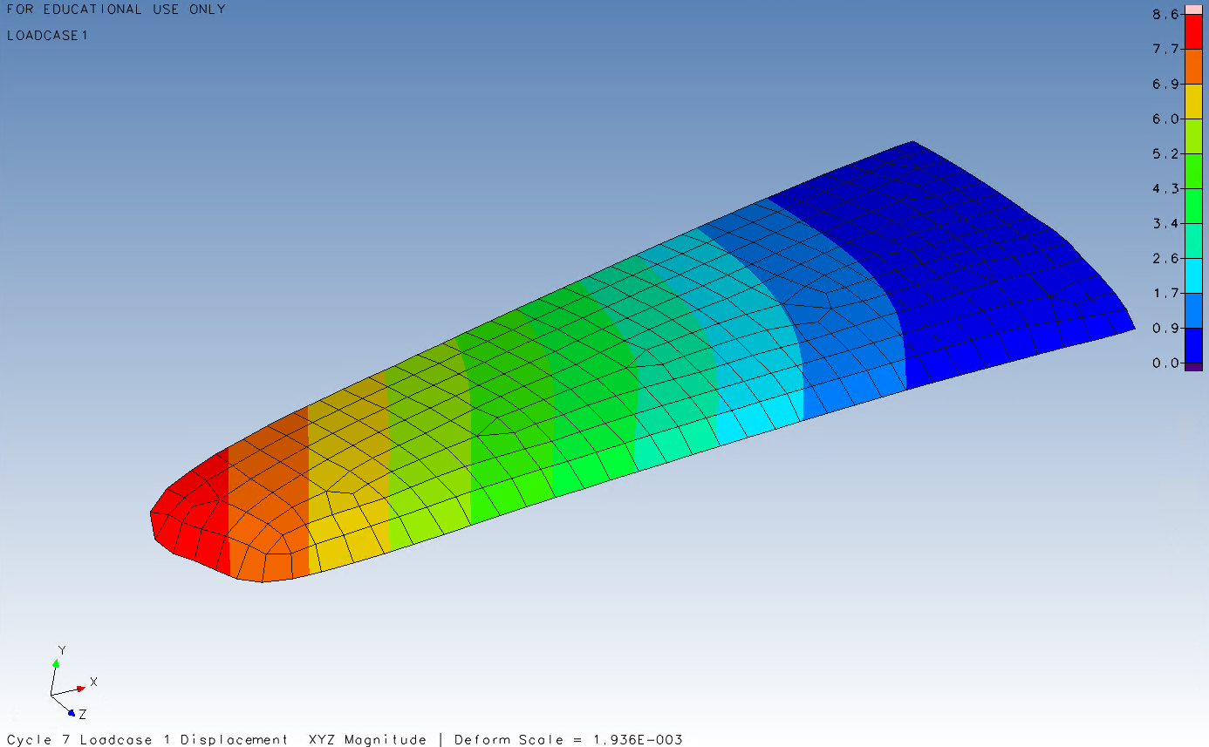
Figure 13- Finite Element simulation of the optimised CRFP wing showing the total displacement distribution (XYZ magnitude) after the 7th load cycle. The colour scale represents the overall deflection of the structure under a 500 N vertical load, with a maximum displacement and has been changed to filled rather than element contours.

However, the curvature of the iso-lines relative to the unoptimized map in figure 14, implies that stiffness has been redistributed poorly and unevenly, suggesting potential stress concentrations in areas which have been stripped of ±45° plies (Belkadi, et al., 2015). The design had been optimised for displacement but looks to have a lack of balance in-place or transverse strength.

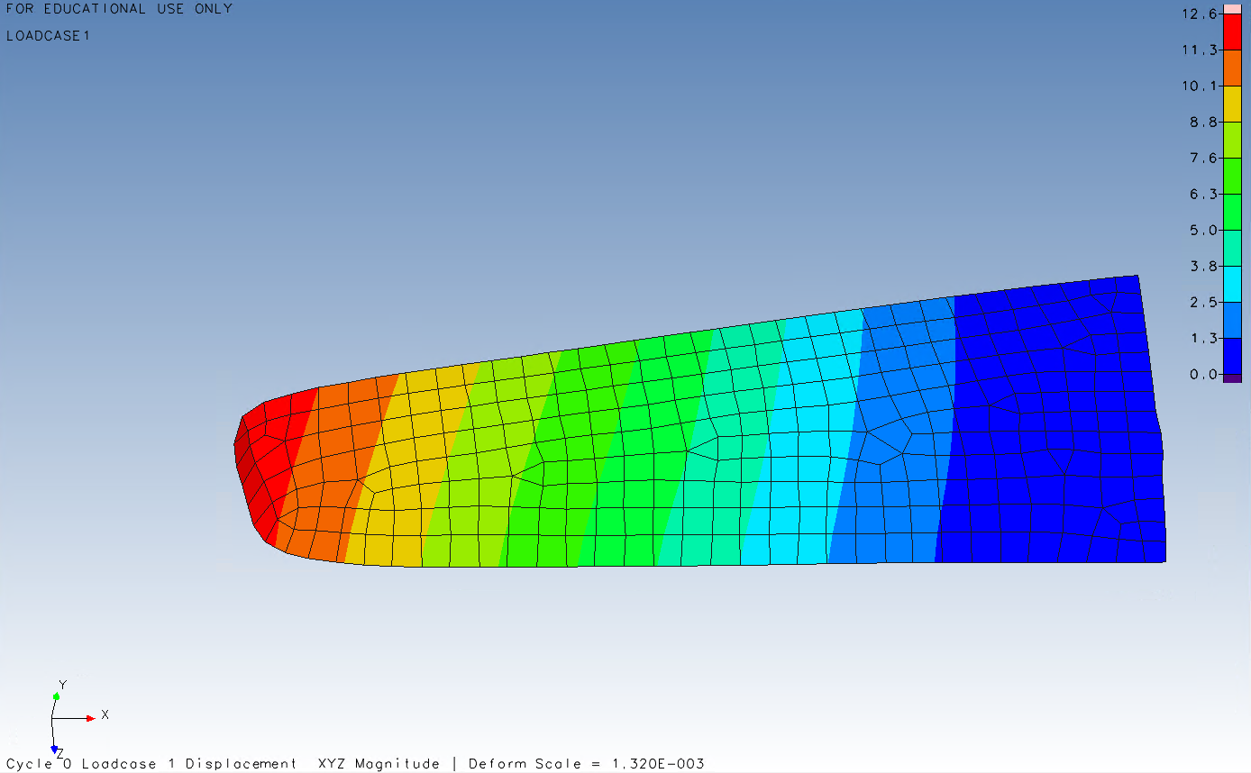
Figure 14 – FE simulation map of displacement of original 0 cycle unoptimized laminate layering now with filled contours rather than element contours.

Stress and Failure Analysis
The von Mises plots in figures 15 and 16 verify that stresses have been redistributed unevenly with the removal of ±45° plies (Rajadurai, et al., 2017), they concentrate around the root of the hydrofoil, consistent with second-order effects due to the stress stiffening of the structure (Dobson, 2003).

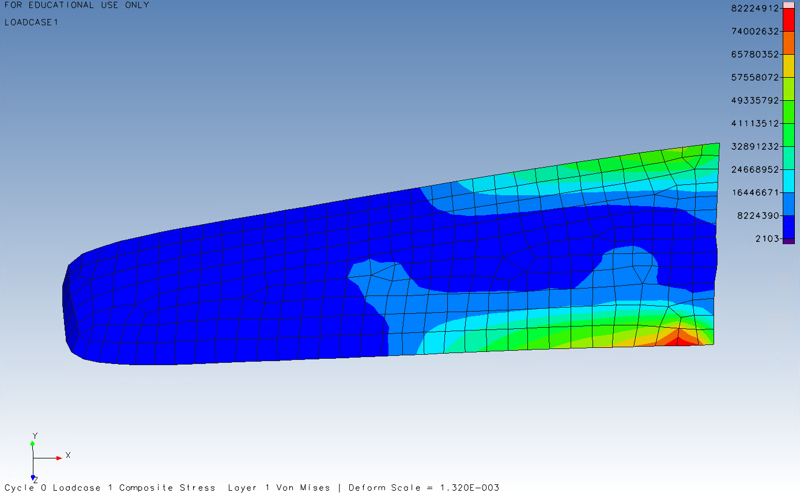
Figure 15 – FE simulation map of von Mises principal stresses for cycle 0 of the unoptimized laminate layering with filled contours.

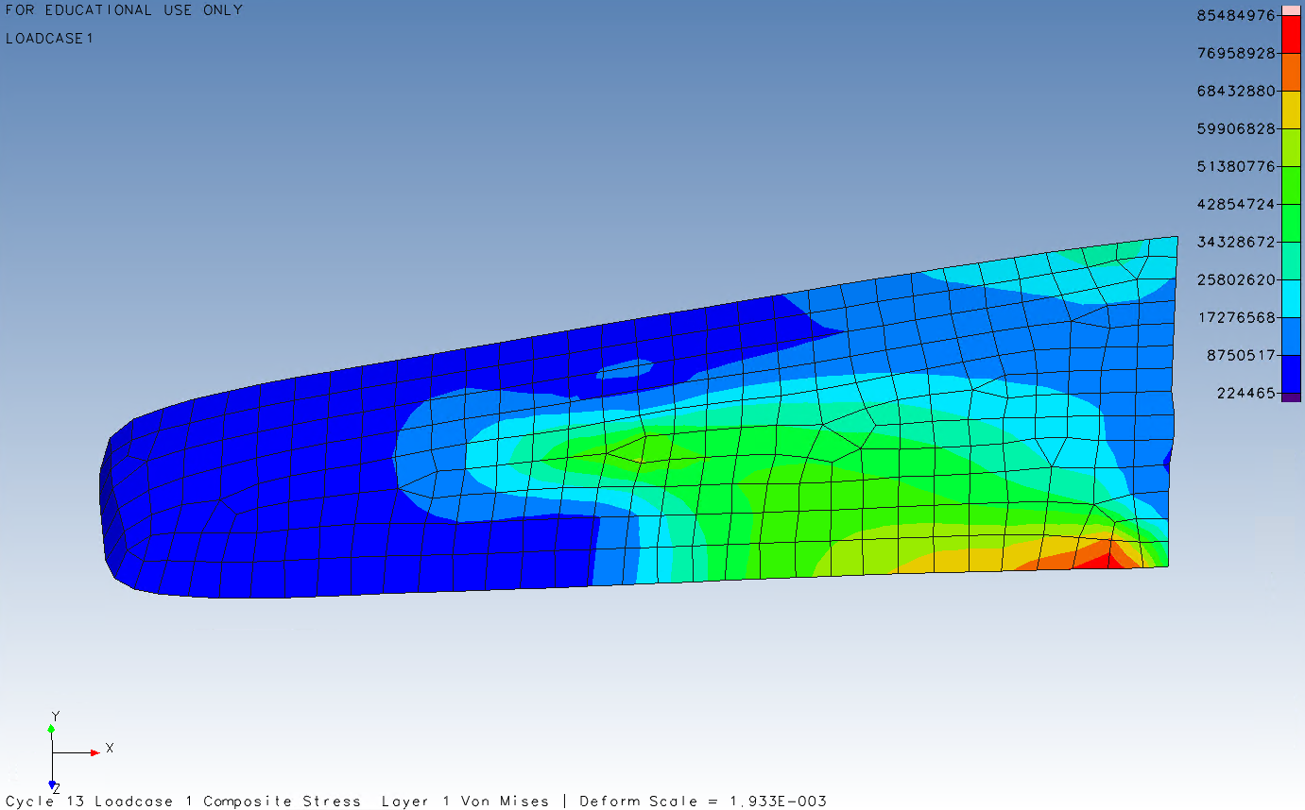
Figure 16 – FE simulation map of von Mises principal stresses for cycle 13 of the optimized laminate layering with filled contours.

Statistical Check
Applying Rankine’s maximum-principal-stress theory as CRFP is brittle material showcases that transverse tensile limit of the material has been exceed. CRFP is also anisotropic and weak in one direction the loading seen in figure 15 & 16 is in the materials minor axis so the lower value of allowable transverse stress in tension (Yt) is used.

Equation 7 – Maximum Principal Stress Theory equation relating von Mises principal stress in red area of FE simulation to CRFP transverse stress in tension resistance.
$$σ_{1}=σ_{yt}=\left(43.4×{10}^{6}\right)-\left(86×{10}^{6}\right)=-40×{10}^{6}pa=material failure$$

Mitigation Proposal
Two mitigation options are proposed: (1) a bidirectional lay-up is used to restore transverse strength in the material, like that seen in Figure 17 (Satam, et al., 2022), (2) a tougher matrix is used, such as APC-2 PEEK with Yt​≈86MPa, the datasheet for which can be seen in Appendix A. It should be noted that there is uncertainty around the secondary load effects, and it's not clear from the analysis what acts as transverse or longitudinal stress; therefore, a design factor of 1.5 or 2 and a combination of options 1 and 2 is recommended to ensure a robust design.
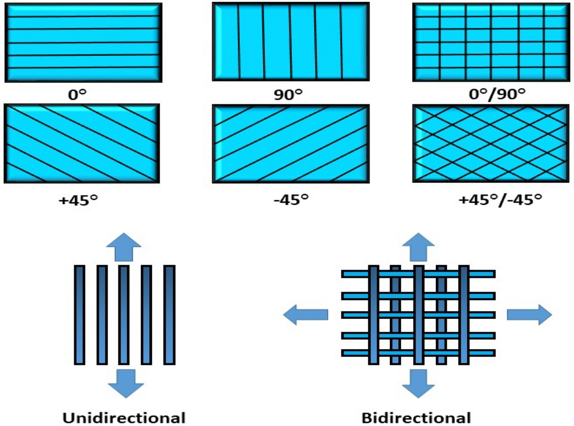
Figure 17 - Typical Fibre Orientation Configurations in Composite Laminates Adapted from (Satam, et al., 2022)
The figure illustrates common ply orientations used in composite laminate design. The lower diagrams show unidirectional reinforcement, providing strength mainly along the fibre axis, and bidirectional reinforcement, providing load-carrying capability in both principal in-plane directions.

Manufacturability and Discretisation
As shown, the numerical optimum was reached and all constraints were satisfied; however, the resulting thicknesses were sub-micron, way beyond practical manufacturing capability (Air, et al., 2023), as shown in Figure 18. To reconcile this infeasibility, design variables were discretised to 0.1 increments representing realistic ply layers.
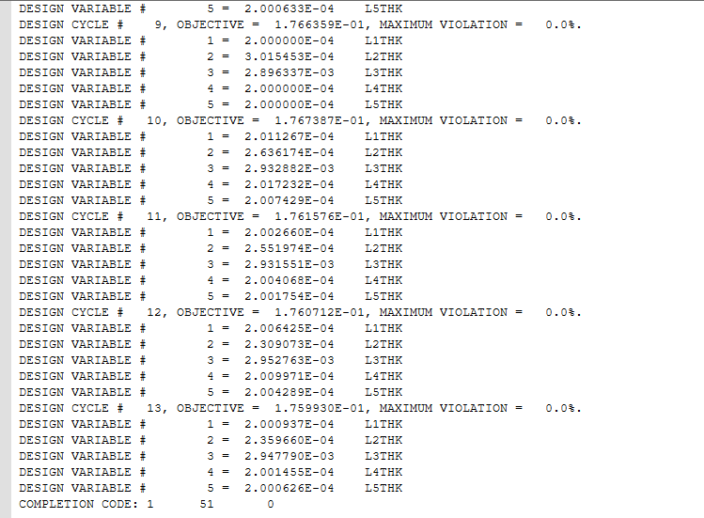
Figure 18 - Design Studio history file showcasing the unrealistic layering design variable thickness.
A rerun of the optimisation shown in figures 19 to 21 showed a similar convergence to the same solution however at cycle 12 a jump in mass as layer thicknesses were made realistic. In all cycles compliance with displacement was preserved. These adjustments demonstrate reconcilement with manufacturing reality.
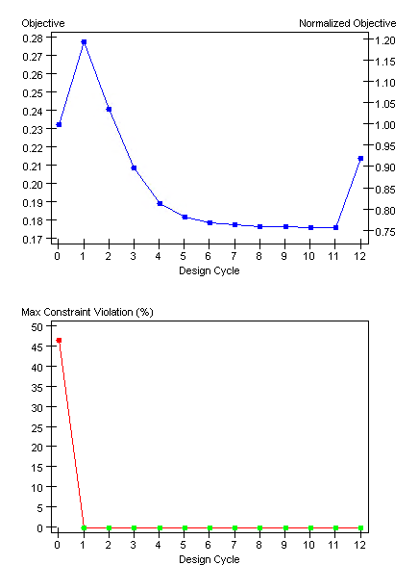
Figure 19 - Design History Plot showing the now discretised design variable optimisation constraint violation taken from the design studio output showing the compliance with the main design criteria of deflection over design iteration process
Figure 20 – Design History Plot showing the now discretised design variable optimisation constraint violation taken from the design studio output showing the compliance with the main design criteria of deflection over design iteration process.

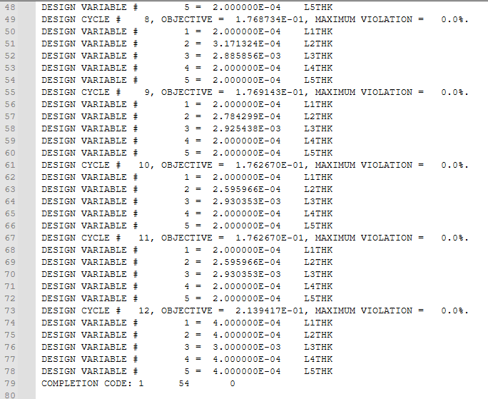
Figure 21 - Design Studio history file showcasing the with now discretised variables with cycle 12 showing a clear achievable ply thickness.

Critical Reflection and Pre-vailing concerns
The optimised laminate achieves the displacement target yet is tuned for a single load case. The analysis highlights sensitivity in ply lay-up with a bias now shown to longitudinal stiffness at the sacrifice of transverse and global stability. Concerns around buckling, pre-mature material failure due to localised yielding and a general lack of stability in the design mean that further analysis into these would be recommended. Nevertheless, the study achieves it desired outcome with a significantly reduced part weight while improving displacement stiffness in the longitudinal direction.

Experimental Validation and Data Correlation

Prototype step up
With the discretised ply layers now integrated into the design a prototype can be made to bridge the gap between numerical and physical analysis. The specimen would use a similar idealised load case; the wing would be treated as a cantilever, the wing would be fully fixed at the root, a vertical load of 500N would the be applied at the mid span via a hydraulic cylinder. It’s then proposed that a vertical displacement gauge or laser distance sensor would be affixed at the tip to measure $∆δ$. Supplementary digital strain & strain gauges would be used to correlate the von Mises / principal stress seen in FE model (Maywalt, 2010), it’s also proposed that gauge is affixed to a dummy piece of steel to account for any changes in resistance through the strain gauge or Wheatstone bridge circuits to account for variance due to environmental conditions such as temperature (Hearn, 1997). The test rig would look similar to that seen in figure 22, with obvious changes for a cantilever beam simply supported on one side, hydraulic cylinders and digital strain setups.
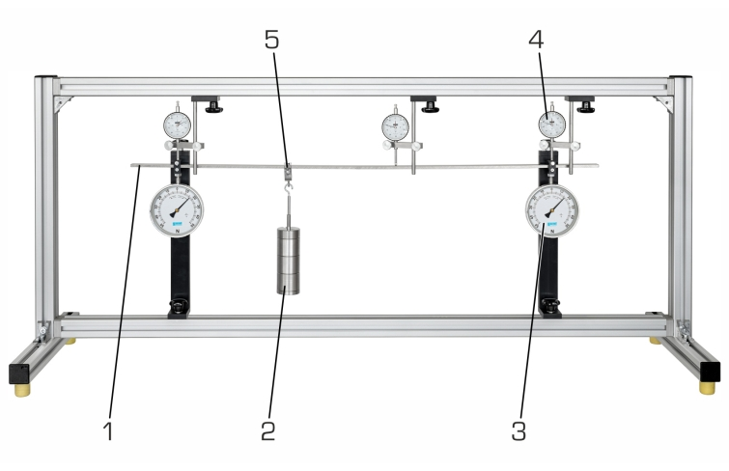
Figure 22 - Experimental Setup for Beam Deflection Test, the frame provides a rigid support system ensuring that measured deflections correspond primarily to bending deformation within the beam.
It's also proposed that the wing would be coated in brittle lacquers. These would offer a qualitative judgment showcase for load paths and stress concentrations in the prototype. These could then be compared to the figures shown in this report to see if there is any perceived variance in the FE-predicted load case (Salmon, 1950).

Data Acquisition and Correlation
The use of digital gauges and or laser sensors ensures all experimental data can be logged. This would allow deflection and stress reading to be averaged and compared to FE-predicted values at the relevant FE nodes. A correlation factor can then be calculated between the FE and test values. It then suggested that an acceptable variance on the correlation factor be defined by the end user / manufacturer of the part (ASME, 2020) as this would have to incorporate potential variance due to actual ply-thickness, defects in the part etc.
A regression plot of both sets of data could then be made to ascertain if displacement curvature aligned between both data sets, as well as von Mises comparison plots. This, combined with the brittle lacquers, offers a qualitative and quantitative analysis of the model’s accuracy. The proposed test follows accepted composite-testing standards such as ASTM D3039 (ASTM, 2014) , ensuring traceability and comparability of results. Specimen preparation should adhere to these standards.

Discussion and Relation to Technical Literature
The FE model results and proposed experimental analysis can be linked to a wide context of structural, composite, design theory and best practice. For example, the metallic baseline follows principles from Eurocode 3 for elastic design of steel components, which prioritise global stiffness, stiffness to weight efficiency and minimising deflection (British Standard Institute, 2022). That standard in turn draws on theories of elastic failure, such as the Rankie theory used in this report.
However, composite structural design lacks a unified code; instead, industrial standards follow material-specific standards such as ASTM D3039 and D3518. The recommendation of application of a global safety factor to anisotropic materials to account for uncertainty around second-order effects aligns with industry standards such as NASA-STD-7009 & NBS 563, and its recommendations around setting and approving acceptance criteria as part of a sustainable practice (NASA, 2019) & (National Bureau of Standards, 1979).

Conclusions and Recommendations
This study has demonstrated a complete structural design workflow for a composite hydrofoil wing, progressing from FE modelling and baseline benchmarking through to optimisation and additional validation testing. The analysis has confirmed that a unidirectional CFRP alternative could meet the displacement performance of a steel shell; however, critically, only after it had been optimised. In its unoptimized form, it offered insufficient rigidity.
The optimisation process revealed the influence of ply orientation and achieved a rigid and stiff laminate design. The convergence toward predominantly 0° piles and submicron thickness of the ply demonstrates the requirement for understanding design parameters and how they might introduce additional risk and uncertainty into a design by focusing too heavily on design constraints and objects. The initial convergence problem demonstrates just how important design variance variables are to the success of FE models and optimisation.
Analytical checks validated qualitative judgement that the convergence toward 0° piles had a negative impact on global stability and confirmed that transverse material strength limits had been exceeded. The report further defined potential mitigation strategies through the use of bi-directional fibre or improved / strengthened composite matrices such as APC-2 PEEK to ensure a robust design and ensure protection against any second-order effect in minor axes. The adoption of discretised variables ensures that the solution is numerically correct and also feasible from a manufacturing point of view.
It's the recommendations of this report that future work should extend to the continued analysis of the part, but expanded to include buckling, second-order effect, stress and material failure checks. To ensure robustness of design under assumed realistic loading conditions. Overall, the project demonstrates how the integration of engineering understanding with computational optimisation can deliver lightweight, high-performance designs aligned with modern composite engineering practice.

Bibliography
Air, A., Shamsuddoha, M. & Gangadhara, B., 2023. A review of Type V composite pressure vessels and automated fibre placement based manufacturing. Composites Part B: Engineering, Volume 253, p. 110573.
ASME, 2020. V V 10 - Standard for Verification and Validation in Computational Solid Mechanics, s.l.: American Society of Mechanical Engineers .
ASTM , 2018. Standard Test Method for In-Plane Shear Response of Polymer Matrix Composite Materials by Tensile Test of a ±45° Laminate, Pennsylvania: American Standards for Testing & Materials.
ASTM, 2014. Standard Test Method for Tensile Properties of Polymer Matrix Composite Materials, Pennsylvania: American Standards for Testing & Materials.
Bathe, K., 1996. Finite Element Procedures. New Jersey: Prentice Hall.
Belkadi, A., Benyahia, A. & Ouali, N., 2015. Influence of the Plies Orientation on the Rigidity of the Laminated Composites. Alger, Conference on Multiphysics Modelling and Simulation for Systems Design, pp. 1-7.
British Standard Institute, 2022. Eurocode 3 - Design of Steel Structures, London: BSI.
Caprani, C., 2011. Structural Analysis IV - Matrix Stiffness Method, s.l.: s.n.
Carleton College, 2024. Tensors and the Stress Tensor. [Online]
Available at: https://serc.carleton.edu/NAGTWorkshops/mineralogy/mineral_physics/tensors.html
[Accessed 18 October 2025].
Clough, R., 1960. The finite element method in place stress analysis.. Pittsburgh, Second ASCE Conference on Electronic Computation.
Cook, R., Malkus, D. & Pleasha, M., 2001. Concepts and Applications of Finite Element Analysis. 4th ed. s.l.:Wiley.
Dobson, R., 2003. A brief overview of 2nd order (or P-Delta) Analysis, Finland: tekla.
Efficient Engineer, 2021. Understanding the Finite Element Method. [Online]
Available at: https://efficientengineer.com/finite-element-method/
[Accessed 20 October 2025].
Hearn, E., 1997. Mechanics of Materials 1. third ed. Butterworth Heinemann: Reed Educational.
Maywalt, S., 2010. Wing Displacement Measurement Tests. [Online]
Available at: https://www.acuitylaser.com/laser-sensors/case-studies/ar1000-laser-distance-sensor/wing-displacement-measurement-tests/
[Accessed 20 October 2025].
NASA, 2019. APPLYING NASA-STD-7009 STANDARD FOR MODELS AND SIMULATIONS TO SURROGATE AND OTHER STATISTICAL MODELS , Alabama: NASA.
National Bureau of Standards, 1979. Advanced Composites: Design and Applications, Washington: U.S. Department of Commerce.
Principal, N., 2018. Analysis Origins - MSC and NASTRAN. [Online]
Available at: https://www.nafems.org/blog/posts/analysis-origins-msc-and-nastran/?srsltid=AfmBOoq_MxuhfVn5W_C-qvfKbkpWUEKPHqXNZqnCHpNjZSVKT_aBCzTD
[Accessed 18 October 2025].
Rajadurai, M., Vinayagam, P., Priya, G. & Balakrishnan, K., 2017. Optimization of Ply Orientation of Different Composite Materials for Aircraft Wing. International Journal of Advanced Engineering Research and Science, 4(6), pp. 111-117.
Sahani, S. K., 2024. AI-Enhanced Finite Element Method (FEM) for Structural Analysis. Journal of Electrical Systems, 20(1), pp. 661 - 676.
Salmon, B., 1950. Stress Analysis with Brittle Lacquer: A Method for the Experimental Evaluation of Loads Developed in Components of Complex Shape. Aircraft Engineering and Aerospace Technology: An International Journal, 22(9), pp. 256 - 263.
Satam, A. et al., 2022. A review on carbon fiber-reinforced hierarchical composites: mechanical performance, manufacturing process, structural applications and allied challenges. Carbon Letters, 32(5), pp. 1173-1205.
Turner, M., Martin, R. & Topp, L., 1956. Stiffness and Deflection of Complex Structures.. Journal of the Aeronautical Sciences , 23(9), pp. 805 - 823.
Zienkiewicz, O. & Taylor, R., 2000. The Finite Element Method Vol. 1: The basis. 5th ed. Berkeley, California: Butterworth-Heinemann.

Appendix A
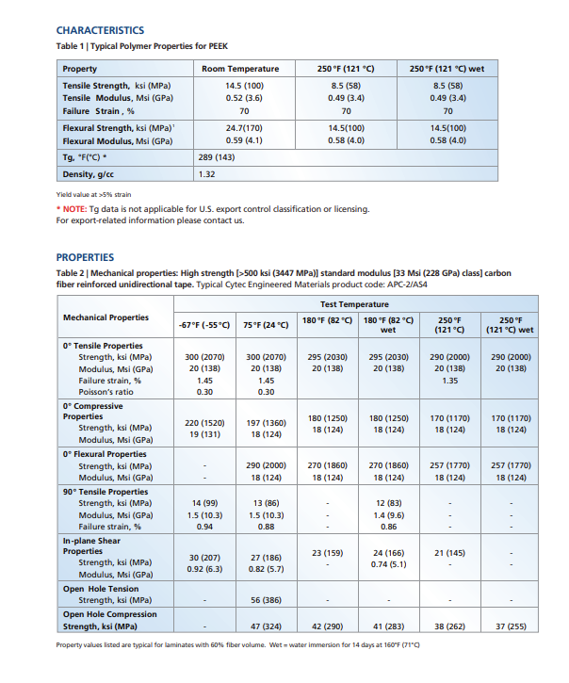
Appendix A 1 - Mechanical and Thermal Properties of Cytec APC-2/AS4 Carbon Fibre Reinforced PEEK (UD Prepreg)
Extracted from Cytec Engineered Materials, “APC-2 PEEK Thermoplastic Polymer Technical Data Sheet,” pp. 2.
The table presents typical polymer and laminate properties for unidirectional carbon/PEEK tape at 60 % fibre volume fraction, including longitudinal and transverse tensile, compressive, flexural, and in-plane shear strengths over a range of service temperatures. At 75 °F (24 °C) the 90° tensile strength is 13 ksi (≈ 86 MPa), confirming high transverse performance suitable for comparison with epoxy-based CFRPs.

