Case Study 1:
The organisers of the TechCon international conference want to keep track of their large collection of workshops associated with their event. Their initial requirements are listed as:
- Each workshop which will be held as part of the conference will have a name.
- Each workshop will be conducted on a particular date/dates (as some of the workshops might last more than a day).
- Several participants may sign up to one or more workshops.
- For each participant, they need to record their name, email address, and the workshops which they wish to attend.
- The conference venue has a number of meeting rooms, each of a fixed capacity.
- Each meetings room is identified by a floor and room number.
- Every workshop needs an allocated meeting room; If a workshop lasts for more than a day, then it will use the same room on all the days.
a) Draw an entity-relationship diagram suitable for representing this information, in particular the connections between participants, workshops, rooms, and dates.

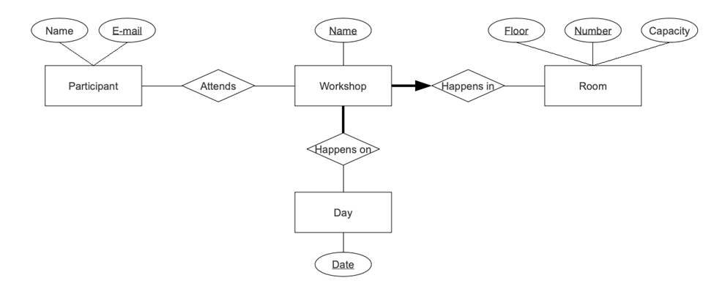

2. Create an ER model for each of the following descriptions:
(a) A large organization has several parking lots, which are used by staff.
(b) Each parking lot has a unique name, location, capacity, and number of floors (where appropriate).
(c) Each parking lot has parking spaces, which are uniquely identified using a space number.
(d) Members of staff can request the sole use of a single parking space. Each member of staff has a unique number,
name, telephone extension number, and vehicle license number.
(e) Represent all the ER models described in parts (a), (b), (c), and (d) as a single ER model. Provide any assumptions
necessary to support your model.

3. Create an ER model to represent the data used by the library.
The library provides books to borrowers. Each book is described by title, edition, and year of publication, and is uniquely identified using the ISBN. Each borrower is described by his or her name and address and is uniquely identified using a borrower number. The library provides one or more copies of each book and each copy is uniquely identified using a copy number, status indicating if the book is available for loan, and the allowable loan period for a given copy. A borrower may loan one or many books, and the date each book is loaned out and is returned is recorded. Loan number uniquely identifies each book loan.

