DIGITAL SKILLS AND RESEARCH METHODS



Student name: Sara Garcia
Student number: 1907378
Module name: Digital Skills and Research Methods
Module number: BMSW4003
Group 9 Term 2
Lecturer name: Balendran Kandasamy
CONTENTS

- Abstract

- Introduction

- Literature Review

- Primary reseach

4.1 Methodology

4.2 Ethical considerations

- Results

- Limitations of the study

- Conclusion

- References

- Appendix A

- Appendix B

- Abstract
This research report is based on the Moodle platform in order with the purpose to know if the students who use it are satisfied with the facilities it offers, with satisfactory final results because the students clarify that it is an easy platform to use and that in turn it is facilitating the course to them.
I used the technique of sampling methods to carry out the survey and its respective report. As a final result, after I analyzing each result, I concluded that it is a very useful and effective platform, but that in turn they could add some details that could help to improve it.

- Introduction
In this research report on the Moodle platform you can find results from the secondary data collection of a Portuguese university and also results from the primary data collection of a survey I sent by email to eleven participants from an English university, in both results the students They claim that it is a very useful platform.
Later I explain the methodology that I have used to carry out my survey clarifying that I use the technique of sampling methods. In addition, I explain how the data of the participants is privatized and protected.
Later, I interpret the results of the survey in different types of graphs, analyzing each of them and giving a final report on the results of the survey in general.
I also include my weaknesses when studying, later you will find the conclusion on all the research report I have done.
Finally I have added different tasks done in class in addition to the survey with your questions and eleven answers.

- Literature Review
I am going to talk about a survey carried out by a Portuguese university that analyzes the use and tools offered by the Moodle platform.
This survey was carried out to 278 participants with results that demonstrate the great potential of this platform, but also that the students consider that it could offer them more tools to increase their improvement and thus offer more learning.
The average age of the participants was 21.8, most of them women, 150 to be exact and 128 men. It can be seen with a clear difference that most of the participants were students, most of them were studying masters.
Most of the participants carried out the survey from a computer with 71%, the rest from their mobile phone with a great difference also in the use of a private network since it was voted by 93% of the participants.
The average use of the internet was an hour and a half a day, giving more use to email and searches.
Students use Moodle about 49 times a month for the purpose of downloading materials or watching news, and the Moodle tools that students use the most are news and assignments.

Costa et al. (2012)
4. Primary research

4.1 Methodology
To carry out this investigation I have used the technique the sampling methods.
First of all, I carried out an example of a handmade survey to be clear about how I wanted to carry out my research work, so I decided that the objective would be to know how satisfied the students are with the Moodle platform, how much time they spend on it and how They could improve this platform.
Secondly, I described the details and characteristics of the participants since I knew that I was addressing the students of my same course to whom I myself sent my survey by email. I observed in the results that everyone is satisfied with what this platform offers them, with a high average use of Moodle from the mobile phone between 3-5 days a week. Finally, I observed that the majority are women between 18 and 25 years old.
Third, I chose the exact number of questions I wanted to ask participants based on what information I wanted to collect and the purpose of the research. Next, I designed the type of questionnaire, how I wanted to expose each question and the colors and structure that I would use. I chose the exact questions that I wanted to capture and ask in my survey, starting with knowing if Moodle would be a platform that they would recommend to their classmates, how much time do they spend on it, how easy do they find this platform, if they would like to improve something and if it was so, what would they improve, from which device they use Moodle, which tool is the most used and how much the course is facilitating the use of this platform. Finally, I focused on two specific questions where I wanted to know what genger and what age range each of the participants are.
Later, I wanted to test the survey before sending it to the participants so I conducted a pilot survey choosing a small part of the official survey to make sure it would be successful.
Finally, once the survey was sent to the student's emails, I obtained the final results, a summary, analysis and an interpretation of these, I reflected these data in writing in this research report.

Dr Nic's Maths and Stats (2020) What is Sampling Methods

4.2 Ethical considerations
All research must apply a strategy to protect and privatize those who are involved, so due to data protection, the participants in this survey have been ensured that all people participate anonymously. All participants have given their consent knowing the objectives before the research. At all times, communication has been transparent and honest.
Due to personal protection, no private information has been required and no confidential data has been collected, all participant data has been respected.

IT Pro team (2019) What is Data Protection

- Results
After conducting a survey of eleven participants about the Moodle platform, here are the questions, answers and results that I have analyzed.

In questions 1, 2 and 8 we can clearly see that all the participants recommend the use of Moodle to the rest of their classmates since the average of this question is 4.91 out of 6, in addition to the fact that everyone agrees that it offers a easy operation with an average of 4 out of 5 and also they think that the use of Moodle is facilitating the course with a 3.73 based on 5.
In the survey they are qualitative, discrete and ordinals. Answers just with valuations or with numbers, with particular order from the number with the least value to the highest value.
This bar chart has the labels on the graph and the vertical axis is labelled with non-technical manner.

In question two we can see how 7 of the 11 participants use the Moodle platform 3-5 days a week, another 3 of our participants use this platform 1-2 days a week and finally the remaining participant uses it between 5-7 days a week.
In the survey is quantitative, discrete and ratio. Answers with numbers and words with numerical order from the minimum to the maximum days a week.
This pie chart has the labels on the horizontal axis below the circle in a non-particular manner.

In question 4 they show us how 6 of the 11 participants are satisfied with the platform and would not add anything else, but instead 2 of them agree that they could improve it by adding something and in turn the other 3 remaining participants think that perhaps if that they would add something else.
In the survey is qualitative, discrete and ordinal. Answers with words and with no particular order.
This side-by-side bar chart has the labels on the horizontal axis below the numbers which are ordered.

Question 5 gives us examples of things that would add to the Moodle platform. One of them gives us the advice to change the design, another of our participants advises us to put more details of the timetable and finally they offer us another idea such as a bar of statistics of how much we use each module.
In the survey is qualitative and nominal. Answers with phrases (or words) with no particular order.
This pie chart has the labels on the vertical axis to the right side of the circle in a non-particular manner.

In question 6 they clarify which is the most used device when using Moodle as well. With a clear majority, the most used device is the mobile phone, 7 of our participants being the voters of this option, so the rest of our 4 participants clarified that they use it from the laptop.
In the survey is quantitative, discrete and ratio. Answers just with words with no particular order.
This pie chart has the labels to the right side of the circle with non-particular order and also inside the circle indicating the device that they are using it.

In question 7 we observe that the most used tool on this platform are the different Moodles, with 9 of the participants voting for this. 1 of them voted the Mail option, so the remaining participant voted 0365 Apps, thus leaving the library with zero votes.
In the survey is quantitative, discrete and nominal. Answers with words with no particular order.
This pie chart has the labels on the horizontal axis below the circle in a non-particular manner.

In question 9 we have a clear majority, being 8 women the participants and the remaining 3 men.
In the survey is qualitative and nominal. Answers just with words with no particular order.
This stacked bar chart has the labels on the graph and the vertical axis is labelled in a non-particular order.

Finally, in question 10 we can see how 4 of our participants are between 18 and 25 years old, another 3 are between 25 and 35 years old, and among the remaining 4, 2 of them are between 36 and 45 and the last 2 between 46 and 50.
In the survey is quantitative, continuous and ratio. Answers just with numbers with a particular order starting with a number of younger age until older number of age.
This pie chart has de labels into circle indicating the different range of ages with non-particular order.

- Report
Most of the participants are women between 18-25 years old. Each and every one of the participants are happy with the Moodle and its operation as they think it is useful and it is facilitating the course to them. Most of the participants think that the Moodle is very complete, others students think that they could add something else to improve it. The most used application with a big difference are Moodles. Participants usually use Moodle between 3-5 days a week from their mobile phone.

- Limitations of the study

We all have weaknesses when it comes to studying. My main weakness is the language since English is not my official language but I am working on it to improve it. Lack of consistency is also one of my weaknesses because I had not studied for three years and I had never done this kind of investigation report. The lack of adequate study techniques is another of my weaknesses, but for this I am at university trying to learn and improve them step by step. This quarantine has also been an impediment for me since it has limited my ability to conduct interviews with more participants and it has limited me when it comes to doing searches off the internet.

- Conclusion

After I analyzed the results on the Moodle platform of secondary research on the students of a Portuguese university and the results of primary research of the survey carried out by myself on eleven students of an English university, I have obtained on average that both students would recommend the use from this platform to the rest of their classmates, since they both agree that Moodle is easy to use and that it is facilitating the course to them. Most of the participants are agree that it is a fairly complete platform but that in turn some others students think that they could add details that would make it better.
The most used device when putting the Moodle platform into use among English university students is the mobile phone, they giving it an average use of between three and five days a week, in contrast, at the Portuguese university, most of its students use the Moodle platform for an hour and a half a day by entering it about forty-nine times a month from their computer.
Something that I have also drawn as a conclusion after obtaining the results is that the majority of the students and participants are women in both universities and within a wide variety of ages, at the English university most of them are between eighteen and twenty-five years of age and that the average age at the Portuguese university is twenty-one and a half years.

- References

Costa, et al. (2012) The use of Moodle e-learning platform: a study in a Portuguese University [Online] Available at: https://www.sciencedirect.com/science/article/pii/S2212017312004689 (Accessed: 13 April 2020)

Dr Nic's Maths and Stats (2020) Sampling: Simple Random, Convenience, systematic, cluster, stratified – Statistics Help [Video] Available at: https://www.youtube.com/watch?v=be9e-Q-jC-0 (Accessed: 12 April 2020)

IT Pro team (2019) What is the Data Protection Act 1998? Available at: https://www.itpro.co.uk/data-protection/28085/what-is-the-data-protection-act-1998 (Accessed: 12 April 2020)

Streofkerk,R. (2020) Qualitative vs quantitative research. Available at: https://www.scribbr.com/methodology/qualitative-quantitative-research/
(Accessed: 13 April 2020)

- Appendix A
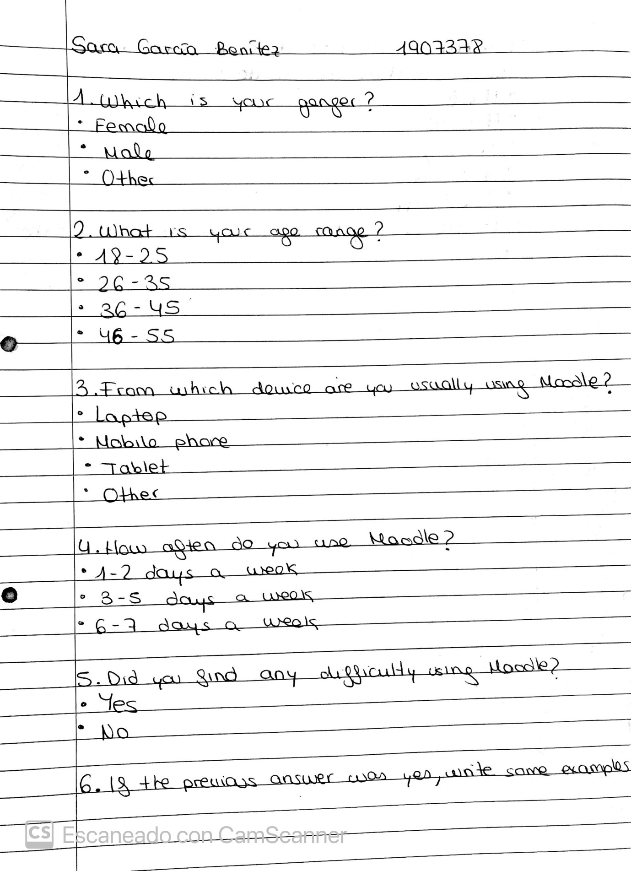

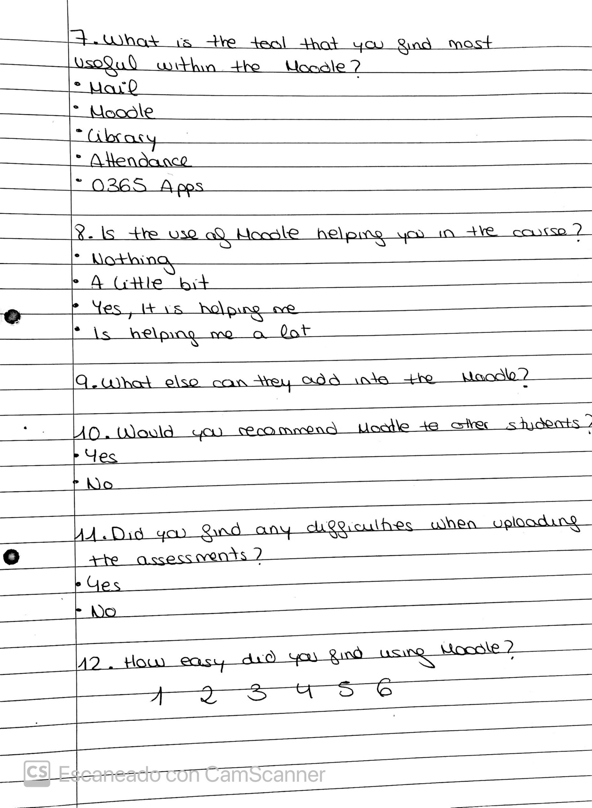

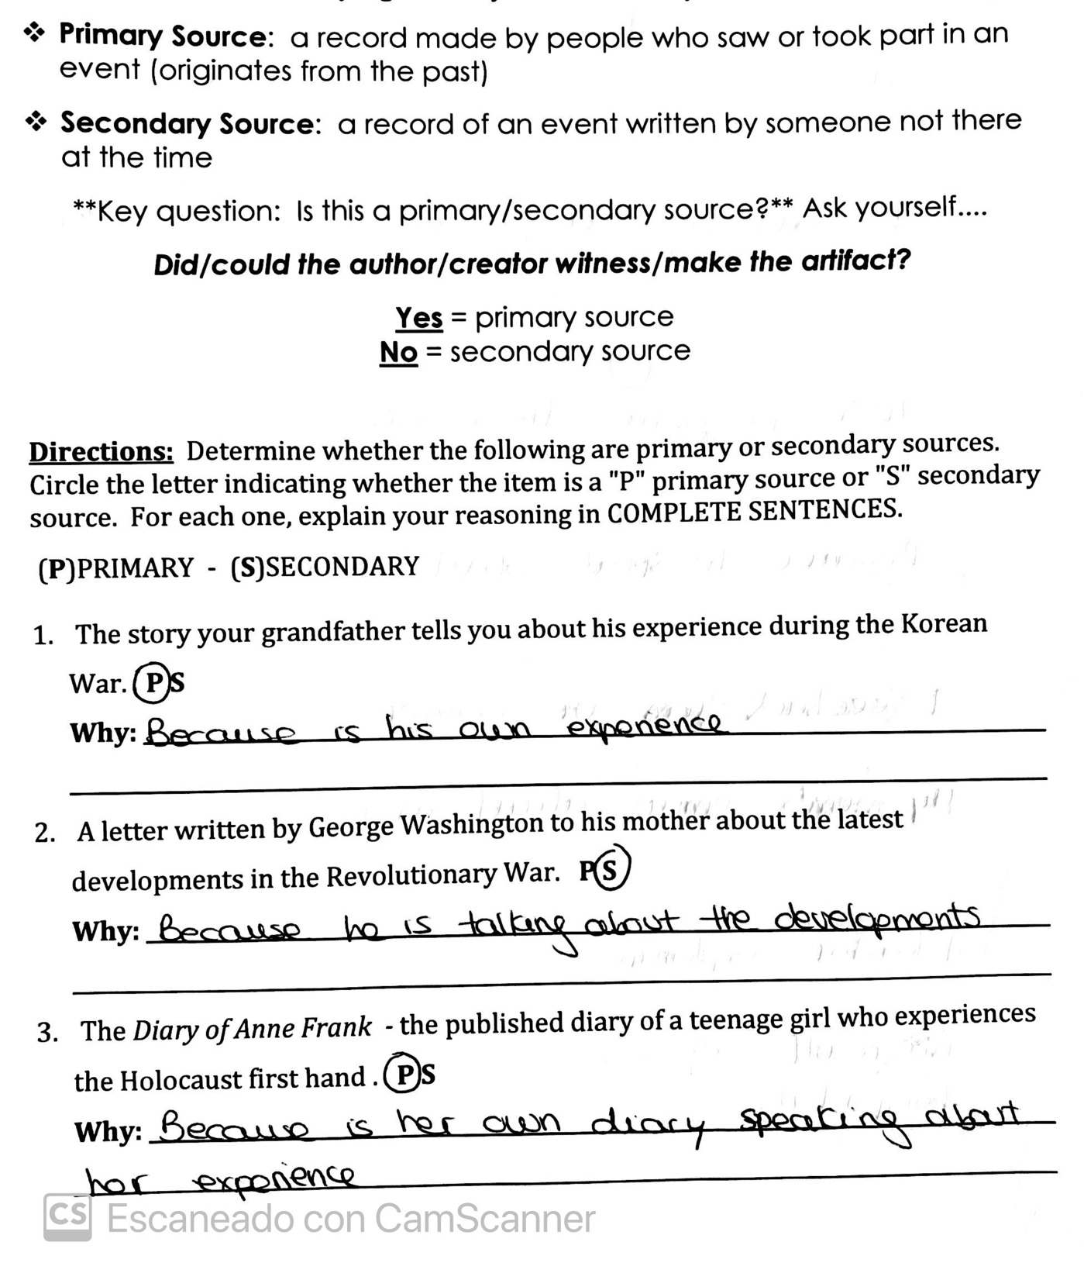

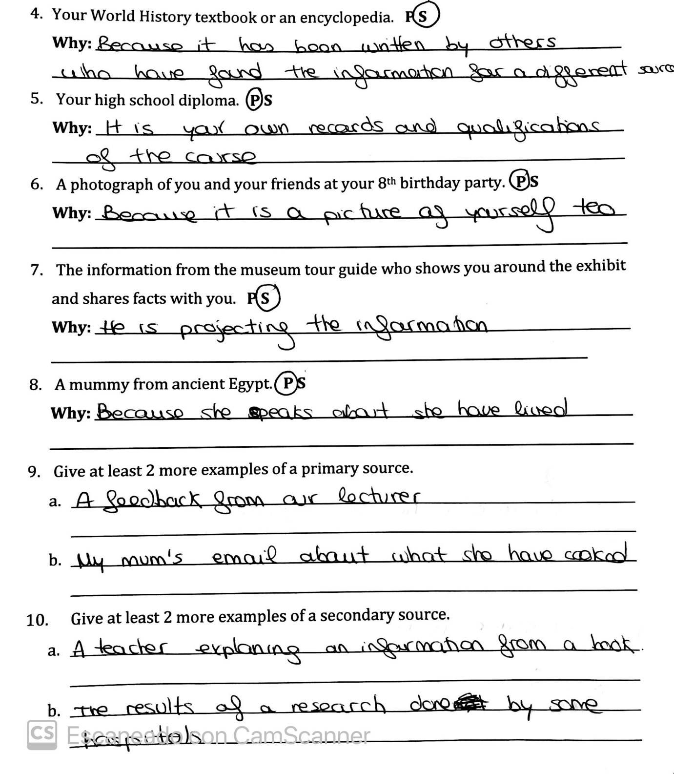

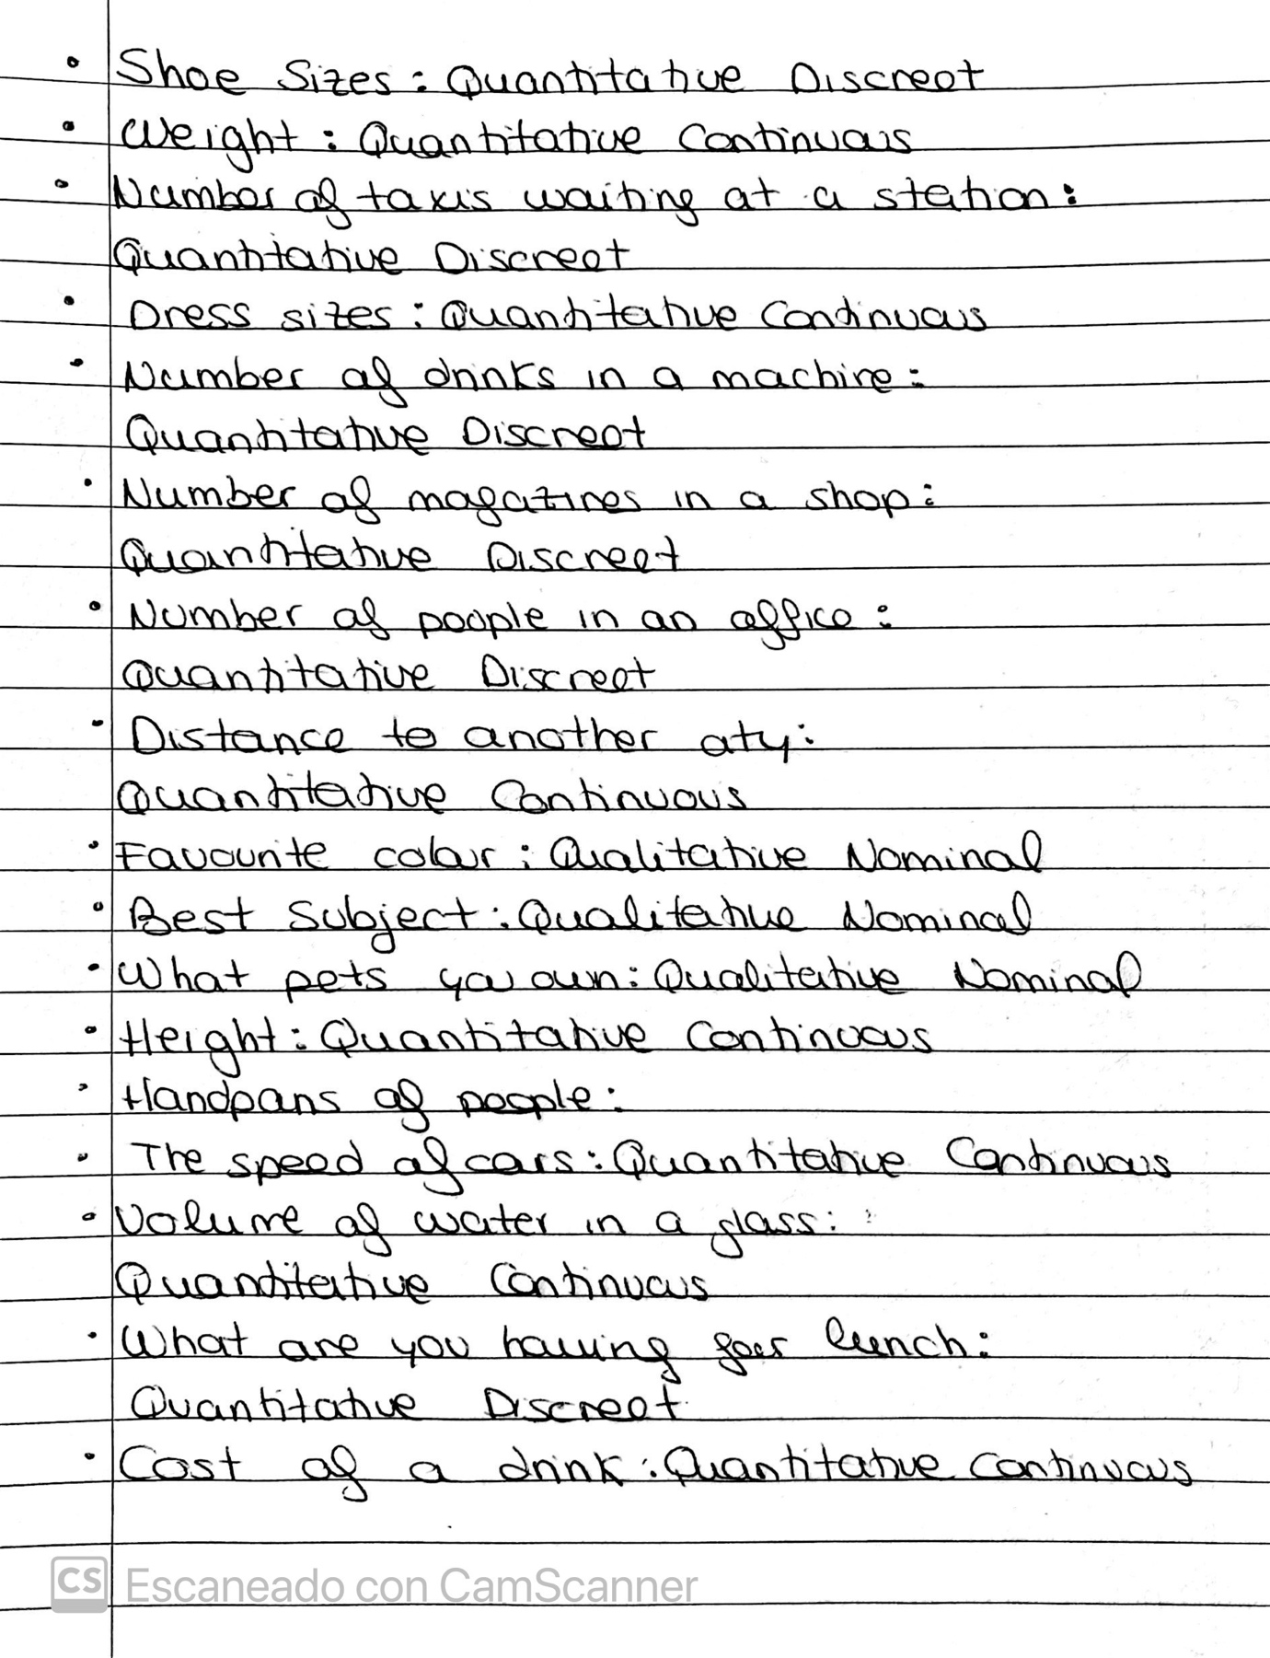

10.Appendix B

 | Q1 | Q2 | Q3 | Q4 | Q5 | Q6 | Q7 | Q8 | Q9 | Q10
1 | 5 | 3-5 days | 4 | Maybe | Not sure | Mobile  phone | Moodles | 4 | Male | 18-25
2 | 6 | 3-5  days | 5 | Yes | Change in the layout | Laptop | Moodles | 5 | Female | 18-25
3 | 6 | 3-5  days | 5 | Yes | A bar of statistics to find which module they have to pay more attention | Laptop | Moodles | 5 | Male | 25-35
4 | 4 | 1-2 days | 3 | No | All is right | Mobile  phone | 0365 Apps | 3 | Female | 25-35
5 | 5 | 3-5  days | 4 | No | Nothing | Laptop | Moodles | 4 | Female | 36-45
6 | 3 | 1-2 days | 3 | No | Nothing | Mobile  phone | Mail | 2 | Female | 25-35
7 | 6 | 1-2 days | 5 | Maybe | Details of timetable and announcements | Mobile  phone | Moodles | 3 | Female | 46-50
8 | 5 | 3-5  days | 4 | No | Nothing | Mobile  phone | Moodles | 4 | Female | 46-50
9 | 3 | 3-5  days | 3 | No | Nothing | Mobile  phone | Moodles | 3 | Female | 18-25
10 | 5 | 5-7  days | 4 | No | Nothing | Mobile  phone | Moodles | 4 | Female | 18-25
11 | 6 | 3-5  days | 4 | Maybe | Nothing | Laptop | Moodles | 4 | Male | 36-45

