Jacob Davies
2416227
Networks and Cyber Security Essentials
Assignment 1
Synthesize a solution to a potential real-life scenario

Table of Contents
Introduction 2
Identification of Modern Threats 3
Modern Security Policies (Zero Trust Aligned) 4
Technical Mitigation Measures 6
Proactive Monitoring and Incident Response 7
Continuous Training and Awareness 8
Conclusion 9
References 10

Introduction

Cybersecurity has become one of the biggest concerns for organisations, especially in the financial services industry where companies store sensitive customer and financial data. Cybercriminals are constantly developing more advanced methods of attack, making it difficult for businesses to rely on traditional security systems alone. The growth of cloud computing, remote working, and mobile device usage has increased the number of possible entry points for attackers. As a result, organisations must adopt stronger and more proactive security measures.[3][5]

Vigilant Trust & Asset Management (VTAM) has recently experienced several security incidents, including phishing attacks that bypassed email filters and an attempted ransomware infection. These incidents show that the company’s current security approach is no longer enough to protect against modern threats. A successful cyberattack could lead to financial losses, operational disruption, reputational damage, and legal consequences.

This report will examine the current cyber threats facing VTAM and propose a modern security framework based on the Zero Trust model. It will also outline security policies, technical controls, monitoring solutions, and staff training programmes that can help improve the organisation’s overall cybersecurity posture. Recommendations will be linked to recognised standards such as the NIST Cybersecurity Framework (CSF) and ISO 27001.

Identification of Modern Threats

VTAM faces a variety of both internal and external cybersecurity threats that could affect its systems, employees, and customers. Modern cyberattacks are becoming more sophisticated, making it essential for organisations to understand the risks they face.

One of the biggest external threats is Ransomware-as-a-Service (RaaS). This is where cybercriminal groups develop ransomware tools and sell or rent them to other attackers. This has made ransomware attacks more common because attackers no longer need advanced technical skills to carry out attacks. If VTAM were infected with ransomware, important systems and files could become encrypted, preventing employees from accessing critical business data until a ransom is paid. [3][5]

Another major threat is AI-powered phishing and vishing attacks. Attackers now use artificial intelligence to create highly convincing emails, fake voices, and messages that appear legitimate. Employees may be tricked into clicking malicious links or revealing passwords and financial information. Since financial companies regularly communicate with customers and suppliers, these attacks can be difficult to detect.
Supply chain attacks are also increasing. In these attacks, cybercriminals target trusted third-party software providers or suppliers in order to gain access to larger organisations. The MOVEit breach is an example of this type of attack, where vulnerabilities in file transfer software allowed attackers to steal sensitive information from multiple companies worldwide.[4]

Cloud-related risks are another concern for VTAM due to its use of cloud services and hybrid working.[3] Misconfigured cloud storage, weak passwords, or poor access controls can expose sensitive customer information to unauthorised users. Employees accessing systems remotely from personal devices or unsecured networks also increase security risks.

Internal threats should not be ignored either. Employees may accidentally cause security incidents by using weak passwords, downloading unsafe software, or falling victim to phishing scams. There is also the possibility of malicious insiders intentionally abusing their access privileges. These threats highlight the need for stronger controls and continuous monitoring.

Modern Security Policies (Zero Trust Aligned)

To improve security, VTAM should implement modern security policies based on the Zero Trust model. Zero Trust is based on the principle of “never trust, always verify.” The diagram below shows a simplified Zero Trust architecture for VTAM. This means that every user, device, and application must be verified before being granted access to company resources, regardless of whether they are inside or outside the network.

The Zero Trust Architecture diagram below shows a simplified Zero Trust Architecture for VTAM

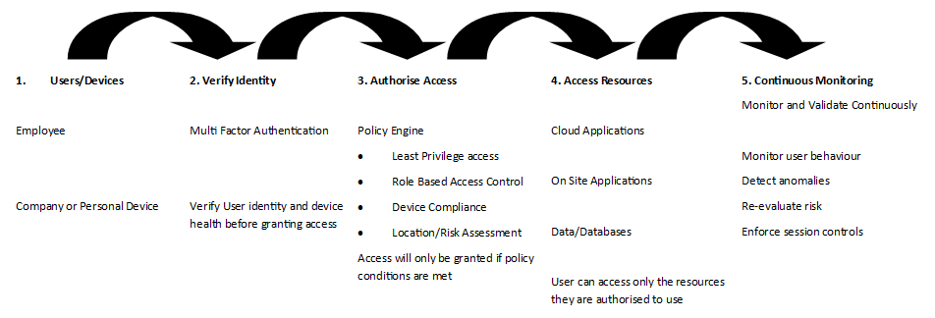

One important policy is the mandatory use of Multi-Factor Authentication (MFA). Employees should be required to verify their identity using an additional method such as a mobile app or security code. This reduces the chances of attackers gaining access through stolen passwords.

VTAM should also apply the principle of least privilege. Employees should only have access to the systems and information necessary for their job role. For example, finance staff may require access to payment systems, while other departments may not. Restricting access helps reduce the impact of insider threats and compromised accounts.

Another important policy is device compliance. Any device connecting to the company network should meet minimum security requirements such as updated antivirus software, encryption, and operating system updates. This is especially important in hybrid working environments where employees may use laptops and mobile devices outside the office.

Data protection policies should require encryption of sensitive information both at rest and during transmission. This helps prevent attackers from reading stolen data. VTAM should also introduce an acceptable use policy that explains how employees are expected to use company systems and internet services safely.
These policies support the NIST Cybersecurity Framework core functions[1]:

- Identify
- Protect
- Detect
- Respond
- Recover

They also align with ISO 27001 standards, which focus on maintaining confidentiality, integrity, and availability of information.

Technical Mitigation Measures

In addition to security policies, VTAM should implement several technical measures to reduce cyber risks and improve resilience against attacks.
One of the most effective controls is Multi-Factor Authentication (MFA). Even if attackers steal a password, they would still need the second verification method to gain access. MFA should be applied to all user accounts, especially email systems, remote access services, and cloud applications.

VTAM should also implement a Security Information and Event Management (SIEM) system. SIEM tools collect logs and security information from different systems and analyse them in real time.[1] This allows suspicious activity to be identified quickly. For example, repeated failed login attempts or unusual network activity could trigger an alert for investigation.

Endpoint Detection and Response (EDR) tools should also be installed on company devices. EDR solutions monitor laptops, desktops, and servers for malicious behaviour such as ransomware activity or unauthorised software execution. If suspicious behaviour is detected, infected systems can be isolated before the attack spreads across the network.
Patch management is another essential security measure. Many cyberattacks target systems with outdated software vulnerabilities. VTAM should regularly install security updates and prioritise vulnerabilities listed in the CISA Known Exploited Vulnerabilities (KEV) catalogue.[2]

To reduce the impact of ransomware attacks, VTAM should maintain immutable backups. These backups cannot easily be changed or deleted by attackers, ensuring that data can be restored after an incident. Backups should be tested regularly to ensure recovery processes work correctly.
Cloud Security Posture Management (CSPM) tools should also be used to monitor cloud environments for misconfigurations and security weaknesses. This will help protect sensitive financial data stored in cloud systems.

Proactive Monitoring and Incident Response

VTAM should implement a 24/7 monitoring strategy to detect and respond to threats in real time. This can be achieved using a SIEM system combined with Security Orchestration, Automation, and Response (SOAR) tools.
The incident response process can be summarised as follows:

Threat detected → Alert generated → Security analyst reviews → Threat contained → Systems recovered → Incident reported

SIEM tools collect data from various sources and generate alerts when suspicious activity is detected. SOAR tools can automate responses, such as isolating infected devices or blocking malicious IP addresses.

The SIEM Process Flow diagram below shows the SIEM monitoring and incident response process used to detect and respond to cyber threats

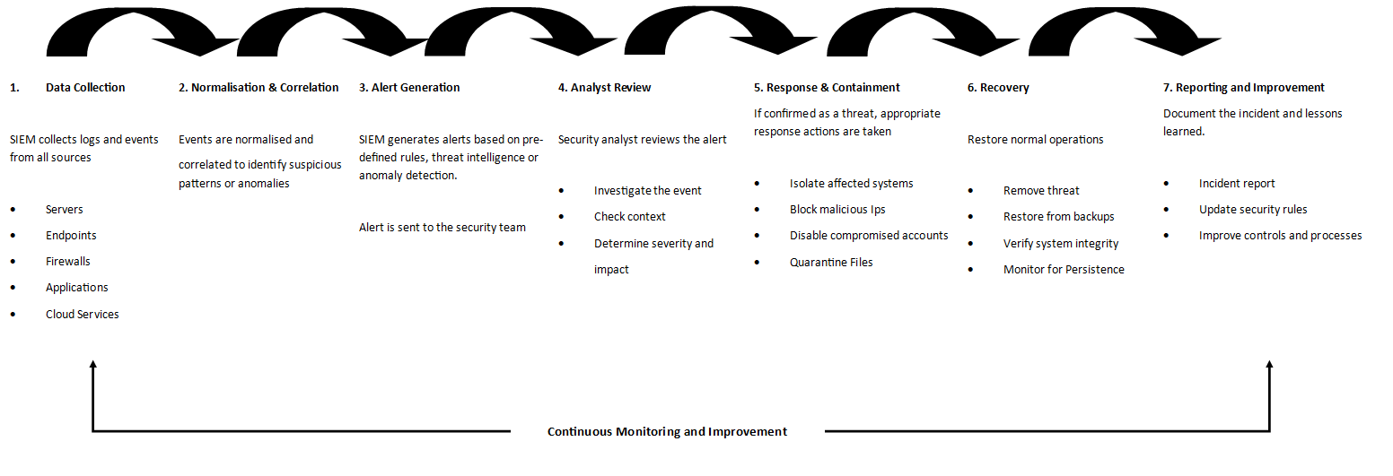

For ransomware incidents, the response should include isolating affected systems, restoring data from backups, and conducting a full investigation to prevent future attacks. A clear incident response plan ensures that VTAM can respond quickly and minimise damage.

Continuous Training and Awareness

Employee awareness is a critical component of cybersecurity. VTAM should implement a continuous training programme rather than relying on one-time sessions.

This programme should include regular phishing and vishing simulations to help employees recognise and respond to social engineering attacks. Training should be role-specific, with higher-risk departments such as finance receiving additional guidance. Cyber Security experts could be hired to do penetration testing to test users to see if they pick up on phishing attempts and follow the correct protocols to report the issue and put a stop to it before any serious damage could occur.

Interactive and engaging training methods, such as short workshops and real-life scenarios, should be used instead of traditional videos. Employees should also be encouraged to report suspicious activity, and positive behaviour can be reinforced through rewards or recognition.

Creating a strong security culture ensures that employees become an active line of defence against cyber threats.

Conclusion

In conclusion, VTAM faces a range of modern cybersecurity threats that require a proactive and comprehensive approach. By adopting a Zero Trust model and aligning with frameworks such as NIST CSF and ISO 27001, the organisation can significantly improve its security posture.[1]

The implementation of technical controls such as MFA, SIEM, EDR, and secure backups, combined with continuous monitoring and employee training, will reduce the risk of cyber incidents. These measures not only protect sensitive data but also minimise financial, operational, and reputational damage.

Investing in cybersecurity is essential for ensuring long-term resilience and maintaining trust in an increasingly complex threat landscape.

References

[1] NIST Cybersecurity Framework, “Cybersecurity Framework (CSF) 2.0,” National Institute of Standards and Technology, 2024. [Online]. Available: https://www.nist.gov/cyberframework.
[2] CISA Known Exploited Vulnerabilities Catalog, “Known Exploited Vulnerabilities Catalog,” Cybersecurity and Infrastructure Security Agency, 2026. [Online]. Available: https://www.cisa.gov/known-exploited-vulnerabilities-catalog.
[3] ENISA Threat Landscape Report, “ENISA Threat Landscape 2024,” European Union Agency for Cybersecurity, 2024. [Online]. Available: https://www.enisa.europa.eu/publications/enisa-threat-landscape-2024.
[4] MOVEit Breach Overview, “What Happened in the MOVEit Transfer Cyberattacks,” Progress Software, 2024. [Online]. Available: https://www.progress.com/blogs/what-happened-moveit-transfer-cyberattacks.
[5] Microsoft Digital Defense Report, “Microsoft Digital Defense Report 2024,” Microsoft, 2024. [Online]. Available: https://www.microsoft.com/en-us/security/security-insider/microsoft-digital-defense-report-2024

