EFFECTIVE TEAM WORKING AND COMMUNICATION
BMSW4002_ETW_T2_SFTW_Assignment 1 (Written Assignment) _OCT. 2022 LON GROUP 3 WEEKEND TERM 2 PART 1
LECTURER : SOBAN SADIQ

2134113 JOANNA KOWALIK

- Introduction
Communication is a two-way process of exchanging ideas and information between people. Communication can be expressed by body language and gestures or sign languages, with hands for example.
- Models of Communication:

SHANON AND WEAVER (1948)
The fundamental communication model Shannon and Weaver's developed by Warren Weaver and Claude Shannon in 1948. Model is found in almost every introductory communication textbook in college or university. My main point here is to demonstrate that people are more complicated than a simple model because improves so many aspects of everyday life. helps to improve communication by removing background noise. This model considers communication to be a two-way process, making the model applicable in communication.
The following are the main components of this model:
- Sender – who posses informations in the first place
- Message – convert message into a signal
- Channel – carries informations from the source
- Receiver – destination (end-point)

Transmition of Information after Shanon and Weaver:
Information Source
Observer
Success
Corection Device
Received Signal
Signal
Messageee
Transmitter
Receiver
Noise Source

MARIA AND PEDRO
Following all information’s collect from this story Pedro is a key worker on building construction area and Maria is his wife. One day they have conversation on the phone where Maria asking her husband to see if is any chance to get her chicken on its way home. Pedro answer that “okay” –it was quick confirmation answer but without question for example like – which chicken exactly, organic or normal chicken breast fillets, in portion etc. He’s arrived home, taking off his shoes and straight walking to the kitchen looking his wife asked “Maria, where are you ?”. She said she is sitting on the sofa in living room, after exchange another quick reply’s Pedro find her on living room and straight away Maria looks at him and switch the question: “Where is the chicken?” – funny thing when Pedro responds which chicken, she talks about because she’s mentioned that question when the conversation was begin. He replied: “ “ Oh, no! I thought you said when I come home, I will see you in the kitchen “.
This confusions explains Shannon and Weaver Model of Communications because there is Sender – person who ask someone to buy a “chicken” , Signal – Message been send , between of that was Noise – work noise difficulties to hear another person properly, Receiver – person who was join the conversation and received a message .
This could be prevented when Pedro will give to Maria proper feedback , I mean – He will take a break from work shift and stay in silent place when they have conversation or will ask Maria question back which exactly “chicken” she want .
This can be avoided using with Shramm Model of Communication where for noise can help feedback as like “Sure, no problem but tell me which chicken You want exactly” or “I will do it but tell me more and if you need anything else, I will get that for You”
Shramm (1954)
After having already put in life the Shannon and Weaver model, I will write about Shramm’s model of communication which has roots from the Shannon and Weaver model itself. Wilber Shramm proposed the model of communication in 1954. He emphasises that communication is not complete until the sender receives feedback from the recipient.
I’ve been also learnt on lessons in University there is as well
- Decoder – person who received message to ears or eyes like a receiver
- Encoder – person who speak, give it message to another person like a speaker
Difference between The Shannon-Weaver model of communication to Schramm’s Model is noise which expressed in one direction, namely encoding, interpreting, and decoding. The Schramm model lacks direction as he sees both participants sender and receiver when Shannon and Weaver see only one-way system role of either sender or receiver.

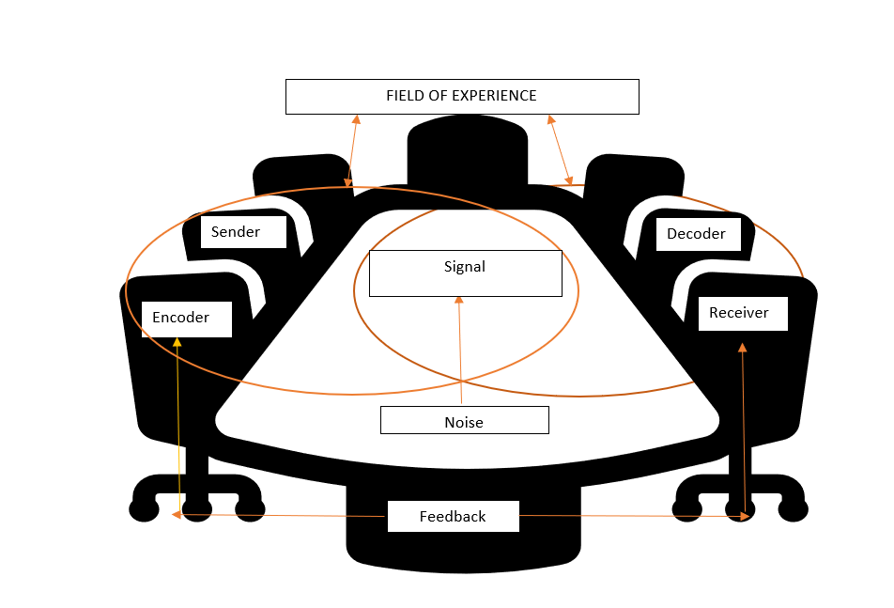

As I mentioned in first case study “maria and pedro” , misunderstanding could be avoided with proper feedback . I mean he can phone her back on break time or somewhere quiet place for example like “Maria sorry for ask again but can You repeat the question because I can not hear You properly before” or ask what she mean with word “kitchen” “what I have to do about this” .
I had similar experience at my workplace with my Manager mostly when I am asking anything for example “ What I have to do with this rubbish area “ or “ I should waiting for engineer or skip that place and do next?” .

Berlo’s Model (1960)

In 1960 Dawid Berlo developed Berlo’s SMCR model of Communication from Shannon and Weaver (1949) described factors for individual components making the communication more efficient and effective, includes three social functions: surveillance, correlation, and transmission. This model is not limited to direct interpersonal communication.


Decodes
Encodes
Culture
Social System
Attitudes
Knowledge
Communication Skills
Culture
Social System
Structure
Tasting
Smelling
Touching
Seeing
Hearing
Code
Treatment
Elements
Content
Knowledge
Attitudes
Communication skills
Source
Message
Channel
Receiver
A Source encodes a message for a channel to a receiver who decodes the message S-M-C-R model

- Sender - where the message originates and is responsible for encoding.
- Communication Skills – Sender needs to have excellent experiences on communication so then will communicate better
- Attitude – touch the audience and will be sure ti have on hand proper subject or environment so both receiver and sender will be matter in that position
- Knowledge – a sender needs to be sure for effectiveness in communication, knowledge from message that begins communication
- Social System – another part where sender belongs to society and them values, believe of cultures. Mostly will bother communication.
- Culture – those differences between methods of communications can make communication very difficult. That is happening when one culture is only accepted not others.
- Message – to not allowed different forms of communication, sender needs send a message that needs like to: transform their wishes into voice, video or text etc.
Factors affecting message:
- Content – all message comes covered in content from beginning to end.
- Elements – gestures, sign languages or called elements of a message.
- Treatment – exposes a way of which and how the message gets to the receiver.
- Structure – Message is not your assurance of effective communication. Effective message depends on how the message is being delivered.
- Code – Peoples can use any structures of communication they choose. Like text, video, written, or any other form. Code is to convey the message.

- Channel

The medium that allows the message to be received by the receiver is called channel. When communicating someone might require the aid of various channels. People depend on their intuition when conveying F

Factors Affecting Channel

- Hearing – receiving orally transmitted messages
- Seeing – learning body language to written messages by seeing
- Touching – non-verbal messages are transmitted through touch
- Smelling – ability to gather loads of information by smelling
- Tasting – Food information can be gathered with the help of the tongue through tasting
- Receiver
Communication is a two-way process, and a sender undergoes all the components mentioned above to communicate messages to the receiving body. The receiving body is the decoder of the message.

Factors Affecting Receiver

Factors affecting receiver are very similar to the factors affecting the sender.

- Communication skills – Excellent communication skills is essential for receiver. Decoding and Understanding messages require receivers to put their communication skills in work mode.
- Attitude – Outlook of receiver towards the sender
- Knowledge – A receiver should possess knowledge of the subject of communication to translate the message clearly
- Social System – Receiver’s interpretation skills can be influenced by religion, values and beliefs
- Culture – Cultural values influence the understanding and interpreting abilities of the receiver
Drawbacks of Berlo’s model of communication

- The model is not complete as it fails to acknowledge the communication barriers
- There is no room for receiving feedbacks from recipients as it is linear model
- Senders and Receivers must be balanced to ensure effectiveness of the model
Conclusion

David Berlo outlined the foundation of achieving effective communication with this Sender-Message-Channel-Receiver model.

Communication skills: reading, listening, speaking. Language differences.

Attitude: Bored, not listening, assuming things.

Knowledge: differences between sender and receiver which might result in language which the receiver does not understand.

A professor of English language at Welsh University that lived in the big house near the little village. One night the was an accident because professor fell asleep with a cigarette in his hand and when he woken up, he saw his house being in fire because of it. He opened the pipe which he shouldn’t, and that pipe exploded. Next episode shows: When the professor awakes and saw the house in the fire, he rushed outside into the village screaming “The edifice is being consumed by a great conflagration!”. He’s repeat that twice, but no one understand him and of course people ignore him because of that at all. He was trying to explain situation in different way but still no one was acted. Professor was giving up and try to come back home to rescue anything left from a fire. But when he arrived that he saw that his house had been destroyed. He said down on thew ground and went the next day he went to village and start crying out loud to people. He said “My home has been destroyed by the fire.

1)The village people didn’t help to the professor because there was Welsh village, and some people don’t understand at all English language. It means there was language barrier.
2)I’m sure when he will come closer to people and not shout from long distance, they will respond something like “we don’t understand what you say it” and then he will try to say that on different language way or try to translate to them.
3)This story represents Berlo’s Model of Communication because there is lack of knowledge because professor didn’t visit village often so he don’t know people who lived there exactly social system means place of situation of a sender to disrupt communication between of the people, lack of elements I’m mean proper explain what happened in simple words who actually can understand if professor working on University.
Experience at my workplace I don’t have it because I am a cleaner and I always follow Health and Safety rules like avoid smoking cigarettes inside of the cleaning area – building or lift – or smoking next to the pipes or meters. But from Family members in Poland experience there is situation: When my auntie arrived in workplace – small shop in the village with groceries – she left cooking pan in kitchen stove and left to work. At home was her 15-year-old daughter and after one minute when she come to kitchen from room, she wanted pick it up juice for herself from fridge. Then she saw smog from the stove and heard alarm from cooker very loudly. She straight away run outside look someone to help her and when she found a neighbour, she starts shout “fire, fire in my house please help” by English language but Lady never understand what she said. Wiktoria was trying to repeat that or try to say that in polish language but was hard for her to do that. Scared and panic feelings picked lady hand and both run to my auntie shop to say that there in the house is a fire caused by burnt meal in the kitchen stove. She picked a fire extinguisher and calm the fire out.

COMMUNICATION SKILLS

Verbal – spoken and written, shown.
Non-Verbal – Body language, facial expressions, gestures.

A Day with the Chief
1. Given the professional context, would you have done the same or differently if you were in
Mark’s position? I would do the same as Mark.
2. Do you think Mark correctly evaluated the context? Very correctly!
3. What communication factors led to the change in the CEO’s attitude? All communication factors are essential in the business world.

Active Listening - paying attention and not doing other things like reading your phone, filing your nails, assuming what the other person is going to say or completing their sentences.
Empathetic listening – listening and trying to put yourself in the speaker’s shoes.

Max the Multi Tasker
1) What element of communication do you think was responsible for what happened? Interference
2) How could it have been prevented? By using better and more understanding communicational words
3) Was Tamara right to behave in the way she did? No, there are other ways to deal with things.

THE ADVANTAGES and DISADVANTAGES of TECHNOLOGY in communication
ADVANTAGES:
- It is a fast mode of communication.
- Accessible for people all over the world.
- It is universal.

DISADVANTAGES:

- Raised dependency on technology.
- Closures of stores because of online business.
- Security risks.

CONCLUSION
I got to know various ways and structures of communication in this study. Also, advantages and disadvantages of communication globally.

REFERENCES
(Maund A., 2023)

References
Bhasin, P., July 2022. Berlos Model of Communication. [Online]
Available at: http://marketingeggspert.com/communication/berlos-model-of-communication/
[Accessed 1 January 2022].
Duck, S. a. M. D., 2016. Technology and Media. In: Certyfikate in Higher Education: Skills for the Workplace Student Yearbook. London: SAGE, pp. 248-273.

Genosko., G., Accessed 01/01/2022. Chapter : Regaining Weaver and Shannon , From WWII to the WW. In: JSTOR, ed. Remodelling Communication . s.l.:University of Toronto Press, pp. 29-47.
Maund A., S. M. T. P. K., 2023. In: Certificate in Higher Education: Skills for the Workplace Student Yearbook. Wales: sagepublishing.com, p. 546.
Management Study Guide
https://www.managmentstudyquide.com/schramm-model-of-communication.htm
Training, M., 2010. In: Effective Communication Skills. s.l.:Training & Ventus Publishing ApS.
University Library Books https://uwtsd.ac.uk/library
Quintanilla, K.M and Wahl, S.T , 2017. Verbal and Non-Verbal Communication. In: Certyfikate in Higher Education: Skills for the Worplace Student Yearbook. London: Sage, pp. 68-85.

