LV6 Contemporary Themes

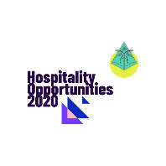
Conference planning
Job Fair Event

Conference Planning Team : Andreea Popa, Erol Asan, Mihaela Costea, Narcisa Ieremie

Executive Summary
In this paper a conference in the field of Hotel Industry will be planned, more precisely it will be a Job Event in which we hope that many people will find a job and many companies will find the right employees.
We will establish the team that will take care of the planning and we will draw up logs for each week until the event. In these logs, we will show what actions each team member will perform as well as the progress of our activity.
Our Event:
This Event is about the Job Fair.
The name of the Event: Hospitality Opportunities 2020
Our team member, Mihaela, will create a logo for this event.
Erol will receive the staff list from the venue.
Andreea has received the signed contracts from the venue through the legal team.
Narcisa will sign the collaboration contracts with sponsors
The purpose of the Event
This Event is to help unemployed people in the hospitality industry to find a suitable job and to have as well an option to choose as many companies will attend.
The End result that we want:
We are willing to end it with 50% of the attendees to become employers. We also want the vast majority of participants to submit their CVs
How do we want to achieve it?
We will achieve this goal by inviting important personalities and names from the hospitality industry who will speak at the event.
We will also invite important companies in the field who want to hire staff. (Conferize - Create better events, 2020)
We will advertise in the most important social media sites as well as on television.
Our team is determined and will work hard to make this possible

The goal is realistic
The proposed objective is realistic and quite easy to achieve. We believe that we will exceed even the percentage of 50% employed people because there is a high demand for staff in the hotel industry. Our team is passionate and will work hard to achieve this goal. (How To Organise A Conference: 14 Key Steps To Success, 2020)

Details of our Event:
Venue: The job fair is going to take place at the Leonardo Royal Hotel London in Tower Bridge. Trinity & Goodmans Suit
Date: 05 /09/2020
Hour: 12:00 -20:00
The cost will be 25 per person including food and beverage. Equipment is provided by the venue
Sponsorship: Leonardo Royal Hotel London, Marriott Windsor, Sheraton Heathrow, Skyline Heathrow, Marriott Heathrow, Hilton Paddington, Park Plaza Westminster, Novotel Southwark, Intercontinental O2, Inn Park Hotel Westminster, Shangri-La Hotel London Bridge, Athenaeum Hotel Green Park, Ritz Hotel Piccadilly and the University of Wales.
The capacity of Venue: 850 people
Will be 16 HR manager + 32 managers +32 assistant manager +5 organiser and 3 guest speakers
Participation fee: £5
Promotion: Indeed, Facebook, Reed.com, Twitter, Jobcentre, LinkedIn
Team distribution:
Erol: Production and Stage, Technical Supervisor and on-site Director of the event
Narcisa: Sponsorships and Advertising, Marketing Team leader
Mihaela: Attendee and Venue Management Supervisor, F&B Coordinator
Andreea: Project Team Leader, Main Event Organiser and Guest Speaker liaison
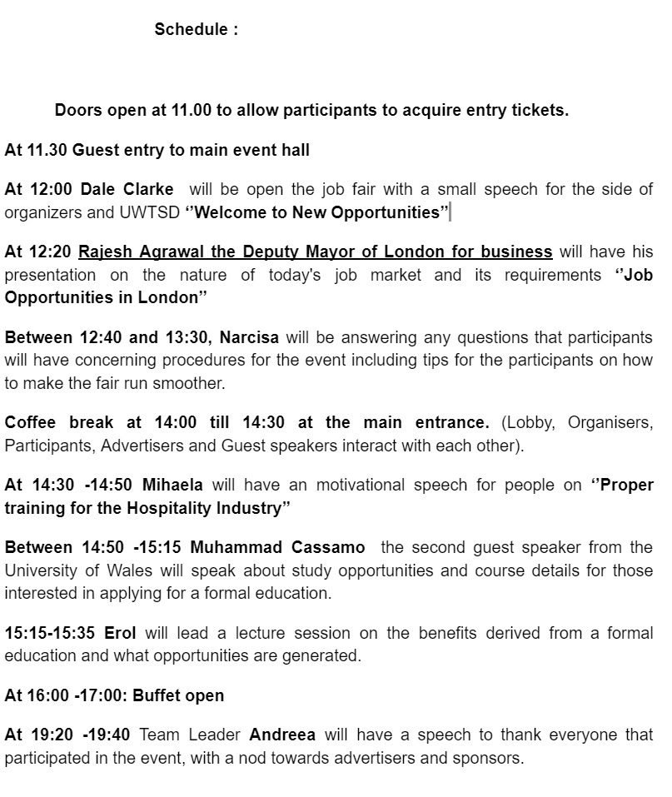

– Learning Logs for Conference –

Student Name:
MIHAELA COSTEA

Week 1 | Monday, July 6th, 2020
Planning:
- We set the name of our event to be: Hospitality Opportunities
- We have established the role of each member of the team
- We agreed to meet once a week in a meeting, to discuss
- We set the date for the event
Organising:
- We established the responsibilities and roles:
- This is our team selection:
  - Marketing and Advertising: Narcisa
  - Event manager and guest speaker: Andreea
  - The venue, Food and Beverages and guest services: Mihaela
  - Technical and event responsable: Erol
- I will be responsible for the venue and attendees.

Managing:
- We set the schedule for our meetings
- I created a group chat on WhatsApp
- I will contact the venue staff to discuss about our requirements.
Marketing:
- We have to make our strategic plan
- We will continue to communicate with the rest of the team
- Creating the design for the conference materials
- I will contact Narcisa to update me with new information
Technical:
- We need to assist in improving standards for the venue
- We received the list of assets and created the list of requirements for the conference
- I bring the list with jobs descriptions
- We received the Venue space specifications
- Fire codes and legal requirements to be discussed on-site on a later date.
- I will contact the venue staff to see what I have at my disposal (staff, catering-buffet, location, menu, decoration)

Problems/Resolution Action Plan:
- I pointed out the problems that arose
- The space has certain limitations and we need to talk to the competent people about it
- It has been decided that whenever an issue presents itself, to bring it to the group discussion
Focus for the Week:
- We need to focus on how to make the conference more efficient
- Andreea to prepare the contracts to be approved and signed
- I need more information and I will get in touch with the venue managers.

Student Signature:

Mihaela Costea
Date:
6/07/20

Week 2 | Monday, July 13th, 2020
Planning:

- We set the conference budget
- We established the topics for discussion and distributed the topic to each speaker
- I received the job description list from the companies
    - Conference management.

Organising:
- We choose our theme: Hotel Industry Job Market in 2020
- Mihaela will have a motivational speech about finding a job nowadays
- Erol will answer questions from the public
- Andreea will have the closing speech
- We have decided which guests will speak at the conference. These are:
- Rajesh Agrawal, deputy mayor of London
- Muhammad Cassamo, Placement Coordinator UWTSD
- Dale Clarke, Lecturer UWTSD
Managing:
- Narcisa, the marketing manager, asked us for additional data
- The project manager, Andreea, handled the problems that appeared this week
- No other problems for this week
Marketing:

- Narcisa created an additional team to help her with the marketing campaign
- The platforms on which the event will be advertised have been established. These are: FB, Instagram,LinkedIn, Twitter
- The design for the flyers has been established.
- A website will be created

Technical:
- This week, the design for the website, flyers and other promotional materials was approved
- Progress has been made in recent weeks
- Erol asked to meet again this week to discuss technical issues

Problems/Resolution Action Plan :
- Meetings must be held according to plan
- A system for debating ideas has been set up if any member of the team has ideas to propose
- Everything goes according to plan
- There were small problems related to the misunderstanding of some roles in the marketing team chosen by Narcisa but Andreea solved them successfully
Focus for the Week:
- We started advertising in the media to promote our sponsors and event
- An e-mail group has been set up to communicate with potential contractors
- Narcisa agreed to have the marketing plan completed next week

Student Signature:
Mihaela Costea
__________________________________
Date:
13/07/20
_________________________________

Week 3 | Monday, July 20th, 2020
Planning:

- We recorded promotional movies to be shot during the speeches.
- The final contracts were approved by Andreea and signed
- We need to send the documents to Erol who will upload them to the conference website
- Mihaela will meet this week with the managers from Food and Beverages to establish the menu and other details and requirements. The final menu must be approved this week
- The final photos must be sent to the technical team to upload
- Narcissus to complete the flyers, this week is the final for them
- No issues for this week

Organising:

- Subgroups have been created to help
- Narcisa has completed the promotional materials
- Andreea will check, with each group, to see the progress and what activities need to be done
- The problems will be brought to the attention of the team

Managing:

- We set the slogan: “New opportunities, from here”
- The management team approved the slogan
- The deadline has been set for all promotional materials to be August 1. After this date, nothing can be changed and they will start printing
- Narcisa will set up a meeting with each of the sponsors to present the materials and be approved by them

Marketing:
- Narcisa will work with Erol for ideas on the marketing campaign
- A campaign will be launched at universities to bring the event to the attention of students looking for jobs. The help of the guests from the university is needed
Technical:

- Erol uploaded promotional material to the website. Also, the movie and the profile of the event was uploaded
- The first paid advertising campaign has started. Sponsors have free advertising but other companies must pay for advertising on the website
- All other external social media have been connected to our website

Problems/Resolution Action Plan:

- We need more communication between team members to make sure everything goes according to plan
- Mihaela will meet with Andreea this week to determine what the priorities are for next week
- Erol will visit the venue to see if there are any technical issues
Focus for the Week:
- Sponsors received access to the site to upload their profiles and any movies or other promotional materials
- As of today, a final list has been prepared with what remains to be done to be verified
- The site will be active next week so everything must be completed by then

Student Signature:
Mihaela Costea__________________________
Date:
20/07/20
_________________________________

Week 4 | Monday, July 27th, 2020
Planning:
- All deadlines were set for the remaining activities and all team members wrote them down
- All team members will access the site to correct any errors
- The general recapitulation was made for the event

Organising:

- Future meetings have been set up for members of the various departments to discuss further problems
- All team members are now working against the clock
- Members of the Marketing and Technical departments will meet this week to discuss
Managing:

- The management team will meet again this week to discuss the sponsors
- All departments are aware of their tasks and there are no problems

Marketing:

- Narcisa is waiting for the approval of the marketing plan. He is studying with Andreea, helped by Mihaela
- The design of the website was presented to the team who were delighted

Technical:
- Erol should meet with a copyright specialist to review the website and logo
- The site is ready to launch, it must be approved by Andreea
- No other technical problems this week

Problems/Resolution Action Plan:

- If there are copyright issues, they should be resolved this week

Focus for the Week:

- Final approval for posters, flyers
- Additional upload of information on the website

Student Signature:

Mihaela Costea
__________________________________

Date:

27/07/20
_________________________________

Week 5 | Monday, August 3rd, 2020
Planning:

- The website has been successfully launched
- The sponsors have agreed that they can make some small changes only until next week
- The four members of the team will visit the space this week and will make sure that everything goes according to plan.
- Maintain contact with team members, sponsors and partners to prevent possible issues
- Mihaela will make public the final menu
- Narcisa will have another meeting, online, with the sponsors

Organising:

- An online meeting will be held this week to determine the latest changes
- All team members were advised to respond promptly to emails and keep in touch. Answer the phone
- The team will enter the WhatsApp group online, every day at 3 pm to discuss
- The other subgroups are well organized and know what to do

Managing:

- All objectives are set and carried out in accordance with the established program.
- There are no management problems
- Andreea has no other instructions to give for this week
Marketing:
- The ads run according to plan
- It answers questions from the public as well as from some sponsors or people involved
- The guests who will speak at the event have prepared their speech

Technical:

- Sponsor’s profiles are completed and running.
- All sections are completed with the necessary information
- Mihaela made a suggestion to introduce a new section on the website for assignments
- No technical issues this week

Problems/Resolution Action Plan:
- Everything goes normally, without any problems

Focus for the Week:

- If necessary, guest speakers should be assisted
- The final space arrangements have been made. The sets, the lights were set.
- The social media promotional campaign achieves its goal, more and more people become aware of the event and register their participation

Student Signature:

Mihaela Costea
__________________________________

Date:

25/05/20
_________________________________

Week 6 – Final Week | Monday, August 10th, 2020
- Team members reported completion of tasks
- Narcisa and the Marketing team will continue to run the advertising campaign
- Mihaela has everything set at Food and Beverages
- all team members will be on standby for any updates
- The event is set to take place exactly as we set it

Student Signature:

_________Mihaela Costea_________________________

Date:

01/06/20
_________________________________

Review of the Conference | How was the Conference in general? How the Planning, Organization, Marketing and Management and Event Delivery took place?

This Conference was a great success, all participants were satisfied, both people who came to look for a job and companies that wanted to hire staff. More than 50% of job seekers have already concluded employment contracts and 10% have been called for a subsequent interview. The rest of the people have submitted their CVs and will be contacted, due to the short time and a large number of participants.
The sponsors were satisfied with the result because the conference was publicized, images from its time being transmitted by televisions.
Our team is proud of the result obtained because we have achieved and even exceeded the goal.
Special thanks to our speakers, Mr Dale Clarke, Mr Rajesh Agrawal and Mr Muhammad Cassamo who made the conference very interesting and attractive for the participants.

References

Billetto UK. 2020. How To Organise A Conference: 14 Key Steps To Success. [online] Available at: <https://billetto.co.uk/l/how-to-organise-a-conference> [Accessed 27 August 2020].

Discover.conferize.com. 2020. Conferize - Create Better Events. [online] Available at: <https://discover.conferize.com/event-platform/signup/?01aor-02ldg-03sea-04aw-05dm-06src-07v2o-08uk-09en-10nno-11noc-12nokw&gclid=Cj0KCQjws536BRDTARIsANeUZ5_sgY5h3rHcrmjz7kM3k4EogiVCb3E2FfCEMZOxgTFf8Xw2up70xR4aAuEDEALw_wcB> [Accessed 27 August 2020].
Olympia.london. 2020. Plan Succesfull Conference. [online] Available at: <https://olympia.london/blog/article/how-plan-successful-conference-10-tips-conference-planning> [Accessed 27 August 2020].

Appendixes:


