

Certificate of Higher Education in Business Skills for the Workplace

LCLM4004 Problem Solving and Decision Making

Individual Report
On
A proposes and evaluates solutions to improve sales performance.

Table of Contents

1. Introduction / Case Overview 3
2. Proposed Solutions 4
3A. Evaluation of Solutions using PMI Technique 5
3B. Preferred Solution Justification 5
4A. Risk Analysis 6
4B. Risk Explanation 6
5A. Implementation Plan 7
5B. Justification of Implementation Plan 7
6A. KPI and SMART Objectives 8
6B. Evaluation of KPI 8
7. Key Findings 9
8. Appendix 11

Introduction / Case Overview

Green Haven Florists is a small independent flower shop with its customized arrangements and environmentally friendly mission. Nonetheless, the company is already experiencing considerable difficulties, such as the alleged 30 per cent reduction in store sales, the growth of operating expenses, and the emergence of online flower retailers. The trends in the industry indicate that the behaviours of the customers is moving towards online shopping, and online floral companies are expanding very fast, and the competition is increasing (IBISWorld, 2015). Also, the costs of the products have been raised due to inflation and a supply chain problem, which further deals with profitability. This report suggests and discusses the viable recommendations in order to enhance the sales performance and sustainability of Green Haven Florists in the long term.

Proposed Solutions
Two viable options can be suggested to solve declining sales and competitiveness of Green Haven Florists.
The first is a digital transformation in terms of upgrading websites and integrating e-commerce. By making the web site design and usability more customer-friendly, it will be improved and make the process of browsing products and making orders easier. The e-commerce feature enables the customers to place an order online, extending the business beyond its physical premises and augmenting the market coverage. Studies indicate that digitalization helps small enterprises to reach broader markets and enhance performance by utilizing online platforms (Small Business Charter, 2025). Moreover, a subscription system of regular deliveries of flowers can also help maintain stable income and customer loyalty.
The second one is the social media marketing campaign and local branding strategy. Being more proactive in pursuing the use of such platforms like Instagram and Tik Tok the business in question will be able to promote brand awareness and demonstrate its distinctive floral designs. Social media marketing is especially efficient to reach younger, digitally engaged customers and enhance engagement. It is also capable of creating a push of traffic online as well as the physical store due to targeted promotions and content. Moreover, online advertising assists companies in accessing a wider range of customers and enhances customer loyalty, making it more competitive in the retailing conditions of today (Lawler, 2023).

3A. Evaluation of Solutions using PMI Technique
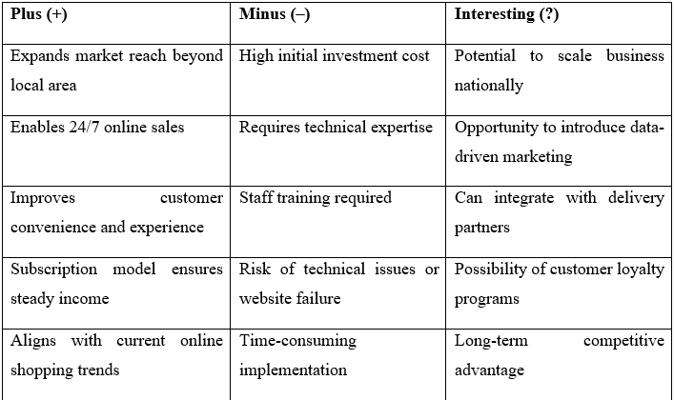

The PMI (Plus, Minus, Interesting) method is used to test the two solutions proposed. This helps achieve a structured comparison, determining the benefits, drawbacks, and possible consequences of each alternative, contributing to effective decision-making in the face of uncertainty (IvyPanda, 2024). The table of the complete PMI analysis is presented in the Appendix.
As the analysis reveals, Solution 1 (Digital Transformation) has substantial opportunities, among which are the increased market coverage, scalability, and the possibility to receive stable income via online sales and subscriptions. Nevertheless, it is more expensive to implement in the first place, more technological, and demands employee training.
Solution 2 (Social Media Marketing), on the contrary, is comparatively inexpensive and can be used to achieve rapid outcomes by raising the awareness of the brand and customer involvement. However, its results are less predictive, and it might not directly lead to the growth in revenues without the powerful conversion strategies.

3B. Preferred Solution Justification
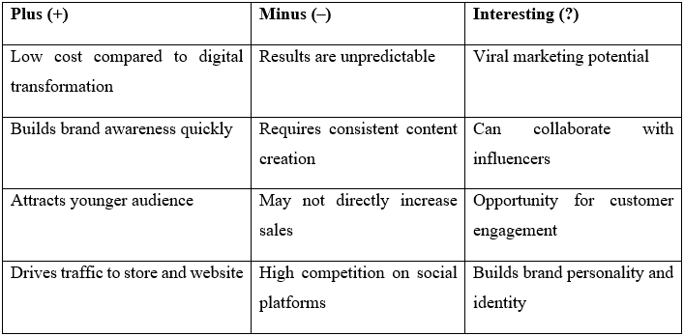

According to the analysis, the best solution to Green Haven Florists is digital transformation. This will provide long-term sustainability as the business can adjust to the shifting consumer behaviour where online shopping is becoming more and more dominant. It enables the company to access more customers beyond the physical location which enhances the potential of revenue. Moreover, the concept of e-commerce and subscription services is a direct response to the issue of diminished sales as it enables the generation of predictable and scalable streams of income. Digital transformation is the best and the most viable solution although it has to be initially invested in since the long-term gains and alignment to current trends in the retail industry make it a better strategy.

4A. Risk Analysis
There are a number of major risks associated with the chosen solution of digital transformation that have to be analyses to make sure that the implementation is successful. To begin with, the initial expenses involved in building and supporting an e-commerce platform can be a strain, especially in the face of small and strained businesses. Studies have shown that digital transformation can necessitate ongoing technology, training, and system upgrades, which can put financial risks on the organization (Daniel, 2025). Second, the technical risks like system failures, site downtime, or integration can interfere with the operations and have an adverse impact on the customer experience. Such operational risks are typical when implementing new technologies and can affect business continuity and reputation (Slassi-sennou and Elmouhib, 2025).
The other urgent problem is that employees lack digital skills, which may decrease the efficiency and slow down the process of adopting digital. Lack of the right expertise can make businesses unable to effectively use online platforms or make full use of digital tools. Moreover, employee and customer resistance to change can be a barrier to the transition since people tend to stick to traditional approaches (Enterspeed, 2020).

4B. Risk Explanation
These challenges notwithstanding, the risks identified can be addressed and alleviated using the right strategies. As an example, it could be to invest in staff training programs, which would enhance digital skills and provide flawless working of the system. Also, hiring specialists to develop and maintain websites will help mitigate technical risks and enhance reliability. The studies indicate that the effectiveness of a project is enhanced as structured decision-making and risk assessment help to minimize uncertainty and facilitate readiness (www.pmi.org, n.d.). Moreover, a step-by-step process will help reduce financial strain. Altogether, the potential risks are less than the long-term advantages of expansion of the market reach, better sales, and sustainability of the business, and thus, the digital transformation can be seen as a feasible and viable strategic solution.

5A. Implementation Plan

Digital transformation implementation will be a systematic and a step-by-step process that will be carried out within a period of 2-3 months. To begin with, Green Haven Florists will outsource the services of a professional web developer to design and create a user-friendly web site. The second phase is to design and develop the website, which is mobile-friendly and attractive. This will be followed by the addition of an online ordering and payment system to allow e-commerce. After the development of the system, the staff will be trained on how to handle the platform. Lastly, an online advertising campaign will be initiated to advertise the new site and get customers. The implementation must be done in a step-by-step strategy because a digital transformation needs careful planning, education, and constant enhancement to make it a success (Kennedy, 2025).

5B. Justification of Implementation Plan

The implementation plan is in logical and sequential order, whereby the development of the web site comes first, then system integration, testing and subsequent launch. This sequence will provide the order with one stage depending on the other, which will minimize errors and enhance efficiency. The roles are well defined, whereby the web developer is to undertake technical duties, whereby the business owners and staff are to undertake operations and customer care. The given 2-3 months period is realistic because a digital transformation initiative regarding small business is usually carried out in steps with attainable milestones to prevent failure and opposition (Vofox, 2025). This systematic method will raise the chances of successful adoption and sustainability.

6A. KPI and SMART Objectives

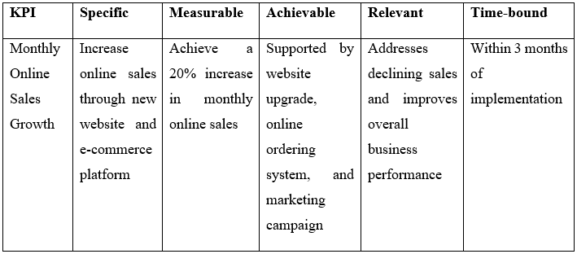

An appropriate Key Performance Indicator (KPI) at Green Haven Florists is the number of sales made online monthly since this directly corresponds to the success of the digital transformation strategy. KPIs are quantifiable metrics based on which the effectiveness of a business in attaining its goals is evaluated (Yasar, 2023).
The SMART goal associated with this KPI is:
- Specific: Increase online sales
- Measurable: By 20%
- Attainable: With the help of improvement of websites and marketing.
- Relevant: Discusses declining sales.
- Time-bound: Within 3 months

6B. Evaluation of KPI
The chosen KPI is important in tracking the performance of the implemented solution. The business can easily determine the success of the digital transformation strategy in relation to the targeted goals by monitoring the growth of sales online every month. KPIs are quantifiable tools that assist organisations to assess performance and make decisions (AtScale, 2025). In case the target is not achieved, the management can use the data to give the target an analysis and therefore change strategies like improving the usability of the websites or the marketing. Moreover, constant observation will enable the company to see trends, act in advance to overcome difficulties, and guarantee future enhancement of sales results.

7. Key Findings
- To be competitive in the retail sector nowadays, digital presence is necessary.
- Declining in-store sales highlight the need for strategic change
- There is a lot of growth through online sales.
- The long-term solution is the most sustainable one suggested by digital transformation.
- Core strategy is supported by social media marketing but not substituted.
- The risks that are identified can be addressed through planning and training.
- It has to be implemented in a methodical and gradual way.
- KPI monitoring makes performance monitoring and improvement possible.
- SMART goals are highly specific and quantifiable.
- In general, business resilience and competitiveness through digital strategies are stronger.

Conclusion:
To a 30% decline in in-store sales and rising competition from online retailers. The analysis confirms that a digital transformation integrating e-commerce and subscription services is the most sustainable solution to ensure long-term business resilience.
Key takeaways from the report include:
• Strategic Shift: Transitioning to an online model allows the business to reach wider markets and align with modern consumer shopping behaviours.
• Managed Implementation: Risks such as high initial costs and technical challenges will be mitigated through a phased 2-3-month rollout and specialized staff training.
• Performance Tracking: Success will be measured by a SMART objective to increase online sales by 20% within three months, providing a clear metric for future growth.
By methodically adopting these digital strategies, Green Haven Florists can overcome current financial pressures and secure a competitive advantage in the evolving retail landscape.

Reference
‌AtScale. (2025). Key Performance Indicators (KPIs). [online] Available at: https://www.atscale.com/glossary/key-performance-indicators-kpis/.
‌Enterspeed.com. (2020). Successful digital transformation – modernise and scale with ease. [online] Available at: https://www.enterspeed.com/insights/successful-digital-transformation [Accessed 19 Apr. 2026].
IBISWorld (2015). Online Flower Retailers in the UK - Market Research Report (2015-2030). [online] Ibisworld.com. Available at: https://www.ibisworld.com/united-kingdom/industry/online-flower-retailers/5149/.
‌IvyPanda. (2024). The PMI Decision-Making Technique. [online] Available at: https://ivypanda.com/essays/the-pmi-decision-making-technique/.
‌Pym, D.V. (1987). Risk Management | PMI. [online] www.pmi.org. Available at: https://www.pmi.org/learning/library/risk-management-9096.
‌Qmarkets. (2025). Digital Transformation Strategy: Your 7-Step Guide. [online] Available at: https://www.qmarkets.net/resources/article/digital-transformation-strategy/.
‌Qobra.co. (2026). Available at: https://www.qobra.co/glossary/key-performance-indicator-kpi.

