Leading and implementing workplace change
BMSW6103

Rasheda Begum
(1814351)
Dennis Pepple



Contents

Title | Page
Introduction | 3
Power and Politics | 4-8
Stakeholder Management models | 9-18
Thomas Kilman resolution model | 19-22
Conclusion | 23
Recommendations | 24
References | 25-26

Introduction

This report will be used, given the case study of the 114 Post Office branches going on strike for 24 hours over the dispute on pay rise, to highlight the importance of power and politics in an organisation, how this affects the employees and employers and what strategies are put into place to overcome the disturbance’s and negotiate on a resolution.
The report will illustrate the differences between power and politics, how they are used to gain effective productivity. The two models that will be addressed in this report will be the Salience and Power Interest Matrix model, it will also discuss any stakeholders an explanation of their relationship and their limitations. The report will also touch on the Thomas-Kilmann conflict mode instrumental model. The report will describe and critically evaluate the different resolutions approach the model has to offer and suggest a suitable approach for the case study.

Power and Politics

Power and politics in an organisation are equally important. Power is the influence and politics is the resource. Organisational politics is the ability of an individual or any department to attract resources needed towards achieving their goals or objectives.
Power is defined to individuals who have the capability or the ability to act and impose on others to achieve a result. In organisations power is interpreted in different ways depending on the context. The source of power can be external as well as internal like the position or expertise of an individual.
Every organisation is governed by politics. Fighting it or making an effort to win is pointless. In fact, it may serve as "a tool for executing strategy" and "a natural, beneficial instrument required to alter activities." * "Politics has a lot of bad connotations, but it's not only a tool for the egotistical," says Insead. Leaders must, at the very least, be aware of the situation so they can defend themselves from any pushback they may encounter when implementing a strategy (M.T. Wroblewski, 2018).
There are two sources of power: formal and informal. The formal power is based on the individual’s position within the organisation like managers, CEO’S team leaders whereas the informal power comes from the individual’s own characteristics or knowledge like experts and specialists.
There are 3 types of formal power:
- Legitimate power
- Reward power
- Expert power
Types of informal power
- Referent power
- Coercive power
Politics within the organisation is the resource available, without the power the resources cannot be utilised, on the contrary if the resources weigh up more than the power then the organisation can be in trouble. Typical example is an employee with specialist training and now wants to work from home and is adamant in doing this, in the result of not agreeing could cause the company to lose the employee and lose time in finding a replacement resulting in productivity loss. The resource here (specialist/private branches) has the upper hand, and the power (management/union ) is not effective in this scenario.
In the case given 114 branches have decided to go on strike whereas the 11,000 have not, giving customers the satisfaction that they can still use the services available with limited disturbance. The organisational power here has not exceeded the politics and management conflict. The fact that only 114 branches have gone on strike explains that the power from higher sources e.g. managers and team leaders in the organisation were not persuasive enough to make all employees from the private branches to follow them to lead the same way, conflict between the thoughts of branch managers and superior seniors clashed and therefore did not follow the lead.
The fact that only 114 branches are government owned and the 11,000 that are privately owned, summarises that the government is losing its power to some extent over these branches. Privatised companies would have their own rules and regulations.
The members of the organisation leading the strike have used legitimate and reward power to influence the employers to behave in this manner. Legitimate power used by the individuals in the higher authority in the organisation have utilised specialist knowledge and training to conduct and maintain the strike making sure all measures have been followed. This power is received to individuals who occupy a specialist position within the company. This role is indefinite and has no timescale it gives the individual authority. The role suits better in organisations that follow a hierarchical system. This power is not used solely, and leaders combine this with other powers within the organisation. In the case study given, the individuals that are in a higher position have jointly decided to take this decision, the organisation has a hierarchy system and therefore legitimate power exists.
They organisation used reward power in portraying the message to the employers of the 114 branches that there will be a pay rise increase and that the government will adhere to their demands. However, the strike itself is not self-sufficient. However, this power gives the individual the capacity to offer rewards and benefits, leaders like to use this power as a positive outcome when they have achieved the desired result or outcome. The results are usually in the form of benefits, promotions, public praise or a pay rise, however some leaders would argue that this power is not as effective as we think. The value of the reward increases on the level of work achieved however this can also cause a hindrance due to the demand of the workload and cause negativity within the individual such as increased workload, longer hours in result causing less productivity in the long run (French, J.P. and Raven, B. (1959). In the case study, the reward power to some extent is not sufficient or adequate to bring the other 11,000 branches to follow.
Union members do not trust management of the organisation, the 114 post offices are the representative of the government. The Union here has used referent power, Lipkin 2013, suggests that this is the power that gives the individual the greatest influence. This power is illustrated through qualities that inspire and bring trust to their colleagues this also includes honesty and integrity.
A person that demonstrates this power is a natural leader that imposes interpersonal skills is a good listener and is always there to support their colleagues. This power is internal as this cannot be passed on from others but a skill that grows within you making you a better person. The union reps use this power to build a trusting relationship with the employees and therefore can in a way manipulate senior members who then approach the other employees of the organisation to follow and lead.
The government is not easily going to accept the demands of the strike as this will impose other factors such as future strikes and disturbances throughout the organisation. It will mirror the union the misunderstanding that their demands are easily accepted. Certain individuals in the various government sectors will try and use their expert power to divert the situation with many reasons to why the pay increase should not be addresses and not easily give in to the situation.
This power comes from both knowledge and experience within the field of your expertise. Due to the individual’s expert knowledge, it gives them the credibility and colleagues trust and respect your opinions. This is a natural gesture and people are pulled towards you. This power gives the individual the ability to be able to raise concerns and advice their colleagues across the organisation to enhance the development of individuals and the company. There are no limitations to this power, experts must continue to maintain their knowledge and credibility (Eatough, 2021).
Lipkin, 2013 advises that leaders should avoid using coercive power. This power out of all the powers involves behaviour that will threaten or force people to agree or to do your will. These agreements will either be agreed in fear or repercussions of losing their position or job. Many companies demand leaders and expertise specialists to continually produce new innovations and ideas and those who do not measure up face the threat of losing their position or job and get replaced. This power is suitable for short term processes because coercive power creates unhappy, disengaged employees that lose motivation that results in poor productivity, it is in the company’s best interest to avoid such situation so that employee retention is not affected.
The representatives of the organisation and union cannot use this sort of power, the usage of this power will only bring negativity in the workplace and low morale. This could also cause poor productivity and less engagement amongst employees and departments.
Conflict is another way how power and politics are expressed in an organisation. Conflict comes in many forms and can be dealt with in many ways, there are different levels of conflict. Conflict can benefit the organisation as well as cause damage too. To be able to resolve conflict in the organisation one can use its power by the position held to rectify the issue and resolve with measures involved.
Conflict is Hostility, negative attitudes, antagonism, violence, competition, and misunderstanding are all forms of conflict. It is also linked to circumstances in which two opposed organisations have conflicting interests. It can be characterised as a conflict between two or more persons or groups, with each individual or group attempting to persuade others to embrace their point of view (D, Putri).
Organizational conflict is described as behaviour that is meant to obstruct the accomplishment of another person's objectives. As a result of the incompatibility of goals, conflict occurs from competing behaviours. Internal conflict is unavoidable, according to Lewis, French, and Steane (1997). This is the result of boundaries forming inside any organisational structure, resulting in distinct groups competing for limited resources.
Organizational conflict, sometimes referred to as workplace conflict, is the condition in which individuals or groups within the organisation disagree or misunderstand one another as a result of divergent needs, wants, opinions, views, values, or goals. The case study reflects the conflict in the situation between the union and the government. The union represents the employees of the 114 branches, conflict can be negative and positive within any organisation.
It clearly demonstrates that due to conflict the difference in thought processes all employees although 11,000 branches being private have not been influenced by the union reps to follow this through, leaving the strike not as effective as it could have been. There are no limitations to this case if all branches, private and government owned carried out the strike then the situation would have been different to handle and maybe the decisions made would be different at a higher scale.
Zaleznik,1970 stated that conflicts of interest in the fight for resources are simple to spot, for instance when allocating funds for R&D or capital planning. But these disputes can be resolved through negotiation processes, which all competitors validate by taking part.
The damage caused by the strike has not only demoralised employees but also the running of the post office with no cash deliveries and collection (Aromaa, Eriksson, and Montonen, 2019).
The strike had a negative impact on the service provided for the customers and gave the company a bad image. The fear of dismissal due to participation of strike can cause them distress of livelihoods, having no job security means compromising with living standards and costs.
To summarise, organisation's politics and power allow it to maintain itself and control certain members. Managing organisational politics aids in demotivating workers, raising stress levels, and maybe altering their attitudes. It is Power's responsibility to secure employee commitment and maintain compliance inside the organisation. Understanding organisational behaviour, power dynamics, and politics can lead to an important discussion.

Stakeholders management and Models

Stakeholders make up an organisation, they are the people who:
- Invest
- Hold shares
- Have interest
- Involved
- Users
- Having affect

The word stake means to have interest anyone with interest in an organisation is a stakeholder.
There are two types of stakeholders primary and secondary stakeholders who have power and those that do not.
Management is the act of a process of organising, directing, co-ordinating and controlling resources to achieve the organisational objectives and goals. There are two types of stakeholders internal and external.
Stakeholder theory is an ethical concept that considers the impact of corporate decisions, trends, profitability, and other factors on all stakeholders, including shareholders, employees, financiers, the government, customers, and suppliers.
In an essay published in 1983, Freeman invented the term "stakeholder theory."In 1995, Thomas Donaldson collaborated with Lee Preston on an essay titled "The Stakeholder Theory of Corporations: Concepts, Evidence, and Implications in the Academy of Management Review." In addition, Thomas advanced the concept in a journal article titled "Response: Making Stakeholder Theory Whole" in 1999.
The journal "The Stakeholder Revolution and the Clarkson Principles" was released in 2002.When the concept grew, more individuals comprehended people's relationships beyond, within, and outside the thing.
Management is the act of a process of ongoing, directing, co-ordinating and controlling resources to achieve organisational objectives and goals.
To critics who claimed that assumptions in economic models were often unrealistic, Milton Friedman, one of the most prominent and influential neoclassical economists of the twentieth century, responded by saying that theories should be judged on their ability to predict events rather than the supposed realism of their assumptions.
Milton suggests that by maximising profits for shareholders will increase their interest will make them work better for themselves and the company and have promote overall welfare.
Milton believes that an organisation must make money and that should be its only purpose, their only accountable to themselves and their shareholders. He believes that the only social responsibility of an organisation is to use the resources available and to engage in activities designed that will increase profits engage in a open free competition without deception or fraud.
Stakeholders of the Post Office:
- Customers
- Employees
- Union
- Local community
- Royal Mail PLC
- Local Politician
- Secretary of State for Business
- Management
- Travel Money Bureau de Exchange
- Cashiers
- Security company
- Banks
- DPS
- Hermes
- Yodel
- Cleaning company
- Stationary company
- Sanitiser Company

Salience Model

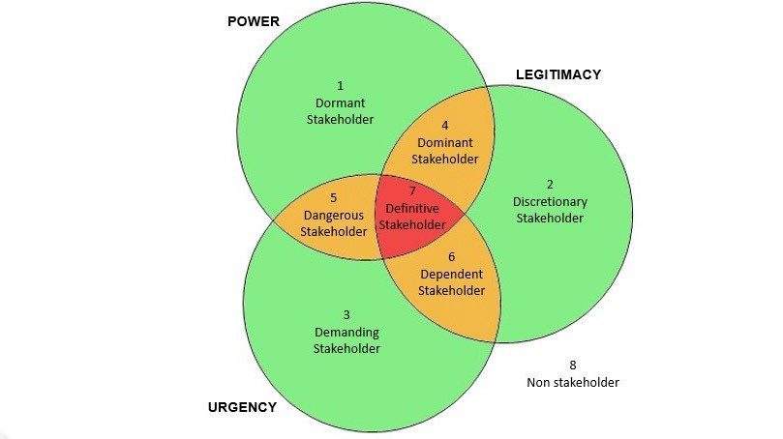
Government
Royal Mail PLC
Banks
Union

Media
Staff – Managers and employees
Local
community
Customers
Union
Bureau de Exchange

Royal Mail PLC
Banks
Local community
Local Politician
Ministry of Finance

Along with the dependent stakeholder, the dormant stakeholder is depicted in the model. The government is a powerful stakeholder, they don't have a lot of influence,but when they decide to make changes within the financial institutions then the Post Office will be affected.

Changes to interests rates for travel money for instance will go pass by the goverments bill before it is authorised to go live. This goes saying for Royal Mail and Banks are also classed as the powerful stakeholder, changes in these departments can affect the post office and the people using the service.
The Union is a very powerful stakeholder as it can cause disruptions to the whole organisation by performing strikes and this will have a severe affect on the employees involved creating job losses, low morale, disengagement and not to mention all the inconvenience it will cause to the community and customers using the service
The local political and Ministry of Finance are the dormant stakeholders, their presence and input has no such influence on the organisation.

The staff are definate stakeholders along with local community and customers. These are the people that use the services and allow the company to fuction.

The postmaster is the key stakeholder because they will be impacted by any events that take place.

The post office managers fall under the category of dormant individuals and have the most influence. The spokeswoman stated that the post office had insultingly only promised a 2 percent pay increase for the years 2022–2023.
The situation is growing challenging as living expenses increase by 7% annually (Figueroa et al. 2019). Postal management is disrespecting the public sector pay policy decline by closing all branches and adhering to stronger government regulations, increasing the wage by 250 pounds. On the other hand, the post office is demonstrating a significant power play by important personnel and asserting that the issue is not affordability but rather authority limits. It goes without saying that there they will demonstrate more strike and disruptions in the future.

Power Interest Grid Model
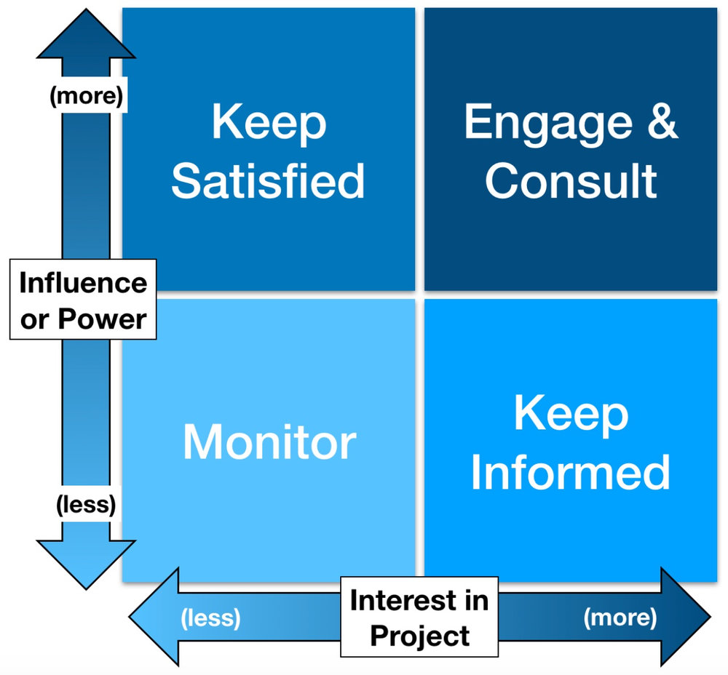
Media

Union
Staff
Customers
Employees
Local community
Customers
Government
Post office manager
Stakeholder analysis is the systematic collection and analysis of qualitative data to ascertain which interests should be taken into consideration when formulating and/or putting into practise a policy or programme. Participants in a process are called stakeholders. Actors might be an individual, a group of individuals, or an organisation with a vested interest in the enterprise or policy. The interested parties who indicated a vested interest in the policies or developments are known as stakeholders. Stakeholders might range from global to national to regional. They may represent businesses or nonprofits, governmental or non-governmental organisations, civil society, and end users or consumers. The study's objectives and purpose have an impact on the many stakeholder groups, which are all unique.
The examination of stakeholders is based on a variety of factors. Power-interest, power-influence, influence-impact, priority-impact, and powerlegitimacy-urgency are the traits employed in the stakeholder analysis models.

The prominent models used in the stakeholder analysis are:
- Power-Interest grid (level of authority and level of concern)
- Power-Influence grid (level of authority and active involvement)
- Influence-Impact grid (active involvement and ability to effect changes)
- Priority-impact grid (Level of importance and ability to effect changes)
- Salience model (Power-Legitimacy-Urgency)

Power – Interest grid:
The two attributes, power and interest, are used in this approach to analyse the stakeholders. The major players are the stakeholders with the greatest influence and power. The least significant person is the one who has low authority and interest.
Power -Influence grid:
The power-interest grid and this approach both classify stakeholders using the same attribute. The stakeholders are divided into key actors, active participants, observers, and spectators depending on their level of involvement, influence, and power.
Influence impact grid :
The relationship between the stakeholders' influence and impact is explained by this paradigm. Depending on how important they are, the stakeholders are divided into high and low categories.
The matrix interest grids are based on Mendelow framework.

- A) Low power, low Interest - Minimal effort
These can be largely disregarded, although this does not respond to any moral or ethical reflections.
It's simply the attitude to embrace when strategic positioning is the most important objective.
- B) Low power, high interest - Keep informed
Can increase their overall influence by forming coalitions with other stakeholders to exert greater pressure and consequently grow more influential.
The management strategy for dealing with these stakeholders is to “stay informed”.
- C) High power, low interest - Keep satisfied
All these stakeholders need to do to become influential is revitalize their interest.
This will move them instantly into the high influence sector, and therefore the management strategy for these stakeholders is to "stay satisfied".

- D) High power, high interest - Key players
Those that have the most impact.
The question here is how many competing stakeholders are in this quadrant of the map.
If there is only one (for example, management), conflicts are unlikely to arise in a specific decision-making circumstance.
If there are several and they disagree on how to proceed, there are likely to be difficulties in decision-making and strategic arrangement.
The Power Interest Grid is identified as a tool to ‘identify catergorise and administer stakeholders’ (Gavieiro Besteiro, 2022).
Project managers create a grid at the beginning of the project and use the project phases. The Power Interest Grid model shows a grouping of stakeholders based on their level of concern about project outcomes. Stakeholders are plotted on the grid in terms of the power and interest they have in connection to the project. The existing network of interest can be submitted for the Crown Post Office postmaster case.
From the matrix above, it can be seen that the government has high influence and low interest, as do the post managers. The local community must be informed as they have little power and interests. The Deputy Postmaster and Communications Syndicate are in a position of high power and influence, while the media are of high interest and low influence. Members of communications unions can be identified as key players and these people will cause problems by not working The scenario includes approximately 3,500 employees involved in the conflict. However, employees show great interest, they have less power to effect change, and they find that stopping work can handle the wage freeze. Each identified stakeholder has a duty that must be fulfilled.
The interrelation of the models chosen for the stakeholder analysis and evaluation is that the most important reason for the identification and the understanding of the stakeholders involved. The employees and customers along with community members all participate in the model. The stakeholders invest hoping for positive outcomes so that the post office continues to work.
The model clearly demonstrates that although some stakeholders are dormant or have no high influence wherever they are on the model the end result should be that the all employees go back to work. The pay rise dispute caused 114 branches to go on strike can only cause damage to the existing service provided and raise concerns for disengagement of employees, whilst customers face the inconvenience of having no cash deliveries or collections.

Limitations of models
Both Salience and Power Interest Grid models have their own limitations, the Salience model requires a more subjective procedure which can become time consuming.
The question is that how effective is this model? The three major attributes power, legitimacy and urgency all must undergo a timely analysis.
It is in the best interest of organisations that projects are dealt with minimal disruption to avoid further costs as delays can become a hinder. The limitation of the Salience model is that it provides depth of analysis but the results are not evident.
“Any time one might have an interest in something that someone else also has an interest in, then there are n numbers of limitations faced” (Kalhan et al. 2021).

These are part of stakeholder identification, categorisation and management. Representing one's own interests is increasingly becoming an obstacle in the stakeholder analysis programme.
The Power Interest Grid model demonstrates the categories stakeholders are put in to help decision making effective. The model mirrors the effectiveness of each stakeholder due do its power and importance in the organisation. “Stakeholders analysis uncovers and removes multiple barriers in understanding the project’s progression” (Kochhar, 2020).

This model is used for categorising the stakeholders during a change project in terms of allowing them to be effectively managed. Different decision-makers are there as a part of understanding how the model works. The making strategy as the name suggests takes account of the power and interest profile. “Stakeholders analysis uncovers and removes multiple barriers in understanding the project’s progression” (Kochhar, 2020). While the power interest model is in action, stakeholder power means the ability to use the resources and get some desired outcome. While the voting, legal and political power is limited within a specific people there is lower turnover rates observed in organisations.
The Mendelow’s matrix is used to identify the priority stakeholders and how they manage to communicate throughout the organisation. Each stakeholder is interrelated to each other and this model has no limitation. - The Government cannot ignore the demands of the strike but use power to resolve the issue, undermining the strike will leave an impact on the work that is performed by the experts.

3. Thomas Kilman’s Conflict resolution model

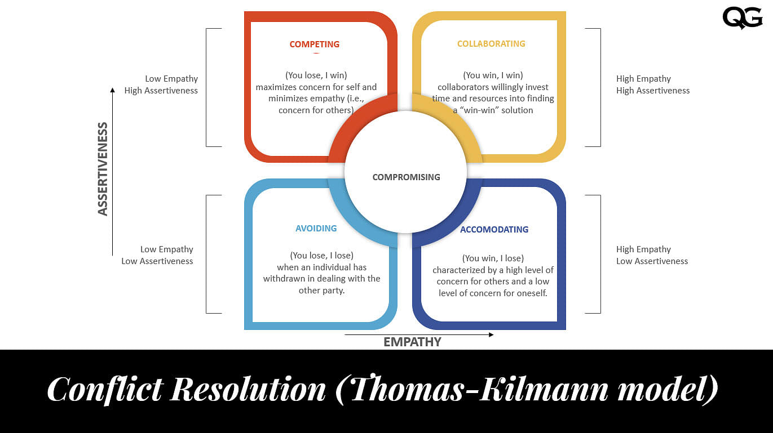

Researchers Kenneth Thomas and Ralph Kilmann developed a conflict resolution model. This model is known as the Thomas-Kilmann model.
Conflicts arise when people disagree. Disagreement can relate to their perceptions, ideas, values, motivations or desires.
This model is based on two dimensions of conflict management: assertiveness and empathy. Based on these two dimensions, there are five conflict resolution strategies: compete, avoid, welcome, cooperate and compromise.
The first dimension of conflict management is assertiveness. Assertiveness refers to the ability to speak out and defend one's opinion. It can be used both positively and negatively, depending on the application. While assertive manner may seem aggressive, it's actually a way to convey yourself efficiently.
Empathy is the second dimension of conflict management. Empathy means understanding another person's point of view and feelings. If you empathize with someone else, you can put yourself in that other person's situation. As a result, you will find ways to resolve the conflict more easily.
Five Conflict Resolution Strategies: Competing, Avoiding, Accommodating, Collaborating and Compromising:
These five strategies all represent different approaches to conflict management. They all have different strengths and weaknesses. The best approach depends on the specific circumstances.
- Competing - At the top left of the graph we have high assertiveness and low empathy. We use competition as a conflict resolution strategy whenever we resort to aggression. Moreover, we also become uncooperative with the adversary.
The first conflict resolution strategy is competition. This strategy works well when you are in a leadership position and have limited time and resources to resolve the conflict.
Competition is not always bad. If you think about it, competition helps us achieve our goals.
However, this strategy has some drawbacks. First, the competition usually leads to negative emotions such as anger, frustration, aggression, and hostility. Second, it doesn't help you build good relationships because you don't listen to what others are saying. Finally, it can cause you to miss opportunities because the other party doesn't want to work with you anymore.
- Avoiding - At the bottom left of the graph, we see low assurance and low empathy. That is, you are not representing considering or emphasizing the other party's point of view. The second conflict resolution strategy is to avoid them.
People use this conflict management strategy when they know they have no authority over the other person. Instead, they avoid confrontation by ignoring or avoiding conflict altogether. They also choose to ignore the problem altogether.
Avoidance is often seen as passive and weak. However, if you really need to avoid conflict, do so by all means. This way you don't have to deal with the problem, giving you peace of mind.
- Accommodation - This is the third conflict resolution strategy. The idea behind this approach is to make concessions. For example, if one person makes a request, you agree to do what the first person asked instead of arguing about it. It's an effective way to deal with conflict when you lack power. But be careful, if you make concessions, you risk losing control of the goal or agenda.
It is always best to analyse the positive and negative outcomes before your final decision is made.
- Collaboration - On the top right, we see strong assertiveness and empathy.
When working together, be moderate in problem solving. You are trying to balance power between you and another person. They also try to find common ground and work together towards a common goal. It is an ideal choice when both parties are committed to reaching a mutual agreement. The goal here is to reach an agreement.
Working together has never been easy, it requires the sharing of personal opinions and feelings. It also needs two people who trust each other and appreciate collaboration.
- Compromising - In the middle of the model is the fifth strategy, which is compromising. This is the middle of the assertiveness and empathy scales.
When you compromise, you take the middle ground between opposing opinions. This means accepting specific terms and conditions and specifying some other elements. And since you are trying to resolve a disagreement, it is important to show flexibility. This strategy usually gives the feeling of a win-win scenario, in which both sides feel they have gotten something out of the conflict.
The case study demonstrates that collaboration is in need for any situation and is the best resolution out the five discussed. The level of accommodating and displaying assertiveness is at a high level. In an organisation the persons position reflects on the decisions made right or wrong.
When both parties agree mutually to have a win- win approach even though it means to clearly put behind any conflicts they have no matter how big to agree and get the task done without any further disturbance. In the case study, it exhibits 114 branches have gone on strike whereas the 11,000 branches are still in full working order. The only way to resolve this situation without any further outbreaks is that the Government adheres to an increase that allows the employers to be able to extend the cost of living and supporting their demands without compromising the financial side of the organisation, both parties can discuss this to be able to come up with a feasible resolution.
There are many factors that support conflict resolution, such as team building, leadership development and training, improving performance whilst still addressing and boosting employee morale for better engagement to avoid retention. Specialist tools are used to monitor stress reduction. If the organisation can fulfil the requirements of these factors and takes into consideration the damage it will do if not followed, then can the organisation be more successful.
Which culture you come from—individualist or collectivistic—has the biggest impact on how you approach conflicts (Ting-Toomey, 1997). People who were reared in collectivistic cultures frequently perceive direct conflict communication as personal attacks (Nishiyama, 1971), and as a result, they are more prone to handle conflict by avoiding it or making accommodations. From a collectivistic viewpoint, the main objective of a disagreement is the preservation of relationships rather than the preservation and manifestation of individual individualism is primarily defined as having one's own opinions and acting courageously in accordance with those opinions. Any perceived restriction on personal freedom is likely to cause issues right away and demand a solution. commonly the missights and traits. Individual rights are subordinated to group interests under this strategy.
According to Gudykunst & Kim (2003), if you're an individualist in a disagreement with a collectivist, you should take the following into account:
Recognize that collectivists may favour having a neutral third party arbitrate the conflict so that people involved can resolve their differences amicably to maintain relational harmony. Use verbal cues that are more ambiguous. If the other person doesn't acknowledge the dispute or doesn't want to resolve it, let it go. Gudykunst & Kim (2003).
Dispute resolution is identified as a process aimed at satisfying the minimum of needs of both parties and directing their interests to the center. In view of direct and indirect confrontation and mediation, arbitration is important. Dispute resolution takes place with a recovery from strikes and putting individuals to work to resolve conflicts. Active listening and consideration of options involves defining the problem and drawing up an action plan. At stake is resolving a dispute through conflict resolution and discussing how goals were achieved (Tjandra et al. 2019). It is also an important factor in determining the roles of the solution following disagreements, discussions and disputes.

Conclusion

The case study has highlighted many factors on stakeholders using the Salience and Power Matrix model. The potential stakeholders some who are dormant do not need to get involved and do not have a say whereas dominant stakeholders such as the employees, customers and the local community who use the service and deliver the service are far more involved within the organisation. The strike has caused a bad image for the organisation along with disruption to service. The strike has caused many employees to demoralise and disengage the whole process has made many to lose motivation.
Increases living costs is a contributing fact towards the strike, employees need a secure financial background and motivation to work, the conflicts caused by the strike will only dishearten them.
Anaylsing the report and the models the best process which would work for this case study is the collaboration resolution from the Thomas Kilmans model.

Recommendation

The entire reason for the strike was the inadequate pay rise of 2% equivalent to £250. The company needs to understand the demands and needs of the employees to prevent further disruption to the services provided. The cost of living has risen and due to these unforeseen circumstances, to avoid any more issues, Royal Mail should come up with a plan to execute that will benefit both parties. A collaboration of face-to-face meetings can bring positivity and build trust within both groups so that this will discourage further disruptions in the form of strikes. The union then can help guide the employees to get back into work rather than encouraging them to participate in the strike.

References

https://www.acowtancy.com/textbook/acca-bt/a2-stakeholders-in-business-organisations/the-mendelow-framework/notes
Aromaa, E., Eriksson, P. and Montonen, T., 2019. Getting Everybody on Board: The Mundane and Relational Views on Leadership and Management. Responsible Humane Strategies for Gender Equality, Empowerment and Leadership.
https://www.betterup.com/blog/types-of-power
Conflict and conflict management (Dian Artamevia Eka Putri)

Currie,R.R., Seaton,S. and Wesley, F. (2009) Determining stakeholders for feasibility analysis, Annals of Tourism Research, 36(1): 41–63.
Figueroa, C.A., Harrison, R., Chauhan, A. and Meyer, L., 2019. Priorities and challenges for health leadership and workforce management globally: a rapid review. BMC health services research, 19(1), pp.1-11.
French, J.P. and Raven, B. (1959) ‘The bases of social power’ in Cartwright, D. and Zander, A.F. (Eds) Group Dynamics: Research and Theory. London: Tavistock.
- Freeman, R. E. (1984) Strategic Management: A Stakeholder Approach, p46, Boston, MA: Pitman. Latest edition
Bryson, J. (1995) Strategic
Stakeholder Analysis | BEST way to analyse, Stakeholders https://www.stakeholdermap.com/stakeholder-analysis.html(Accessed on 14 January, 2020).
Gavieiro Besteiro, A., 2022. Leadership and Management Excellence. In Strategy in Action (pp. 143-173). Springer, Cham.
Kalhan, S., Redish, A.D., Hester, R. and Garrido, M.I., 2021. A salience misattribution model for addictive-like behaviors. Neuroscience & Biobehavioral Reviews, 125, pp.466-477.
Kochhar, R., 2020. Leadership-Fall 2020.
Tjandra, N.C., Ensor, J. and Thomson, J.R., 2019. Co-creating with intermediaries: understanding their power and interest. Journal of Business-to-Business Marketing, 26(3-4), pp.319-339.

https://www.wallstreetmojo.com/stakeholder-theory/ (Ratan Sharma)
What Keeps Leaders Up at NightRecognizing and Resolving Your Most Troubling Management Issues By Nicole Lipkin · 2013

https://hbr.org/1970/05/power-and-politics-in-organizational-life by Abraham Zaleznik , 1970
https://smallbusiness.chron.com/impact-power-politics-organizational-productivity-35942.html
https://socialsci.libretexts.org/Courses/Butte_College/Exploring_Intercultural_Communication_(Grothe)/08%3A_Intercultural_Conflict/8.02%3A_Intercultural_Conflict_Management

