Student: Diana Leontina Macaran

Ration analysis of Hitlon

Student name: 2016802
Module name: Financial Management for the Hotel Industry BMIH5007
Lecturer name: Dale Clarke

Executive summary

Table of Contents
Executive summary 1
Introduction 3
Financial Analysis 4
Profitability Ratios 4
Asset Turnover ratios 6
Liquidity ratios 8
Gearing 9
Limitations of ratio analysis 12
Conclusion 13
Reference 14

Table 1 - Profitability ratios for 2019 and 2020 4
table 2 – Asset turnover ratios for 2019 and 2020 6
table 3- Liquidity ratios for 2019 and 2020 7

Introduction
Hilton is a hotel chain company that manages a global network of around 600 premium hotels in 78 states (Maffei, 2018). The report will be addressed to the CEO and will include information on the company's profit, cash flow, and gear ratio for the fiscal years 2019 and 2020.
A financial ratio, also known as an accounting ratio, is the size of two quantitative data obtained from a company's financial statements. Many conventional ratios have been used in accountancy to try to determine a corporation's or other company's comprehensive financial status. Financial ratios can be employed by company executives, present and future investors, and a company's creditors. Financial ratios can be used by industry professionals to analyze the capabilities and drawbacks of different businesses (Groppelli and Ehsan Nikbakht, 2000). Whenever a company's stock is listed on a stock exchange, the current value of the stock is utilized in some financial ratios.
Financial analysis involves the procedure of assessing the effectiveness and appropriateness of firms, enterprises, expenditures, and other financial operations. Financial analysis is often done to determine if or not a company has been sustainable, liquid, solvent, or lucrative enough just to deserve a monetary investment (J Fred Weston and Brigham, 1990). This is accomplished by combining fiscal statistics and figures. The financial analyst should go at a business's financial accounts, including the financial report, financial statements, as well as cash flow statement, in detail. Both business management and investment management can benefit from financial analysis (Williams, 2008). Calculating ratios from information in the accounting records to evaluate those of other firms or the company's previous past achievements is among the most prevalent techniques to examine financial data.

Financial Analysis

Profitability Ratios

Ratio | Formula | 2019 | 2020
Gross Profit Margin | (Gross profit/sales)*100 | 25.76% | 13.53%
Net Profit Margin | (Net profit/sales)*100 | 9.32% | -16.60%
ROCE | (Profit Before Interest /Total assets less current liability )*100 | 13.03% | -0.83%
Table 1 - Profitability Ratios for 2019 and 2020
Profitability ratios represent a group of financial indicators that are used to evaluate a company's capacity to create profits through a period of its sales, operational costs, balance sheet holdings, or shareholders' investment, utilizing data from a certain moment in time. Most profitability ratios imply that the firm is doing well if the score is greater than a rival's ratio or even the same proportion from a prior quarter. Whenever contrasted to analogous firms, the business's record, or industry average measures, profitability ratios are also most informative (Husain et al., 2020).
EBIT stands as income preceding interest and taxes and will be a measure of a company's financial performance. Income fewer costs, without taxes and interest, is EBIT. Operational income, operating income, as well as profit without interest, and taxes are all terms used to describe EBIT (Murphy, 2020).
Following accounting for the direct costs of conducting business, such as labor, supplies, and another direct manufacturing cost direct manufacturing cost, the gross profit margin informs you how much money your company generated. The operational profit margin plus net profit margin are the other two primary profitability measures. It is perhaps the most significant of the 3 profitability indicators since, without a sufficient gross profit margin, your firm will not be viable, at least not for long. On the surface, a gross profit margin ratio of 50 to 70% should appear to be appropriate for many sorts of enterprises, including shops, hotels, factories, and other product makers (BDC, 2021).
Figure 1 shows that the gross profit margin (estimated using Hilton reports) fell considerably in 2020 compared to 2019. The fact that this rate does not even approach 40% suggests poor financial performance.
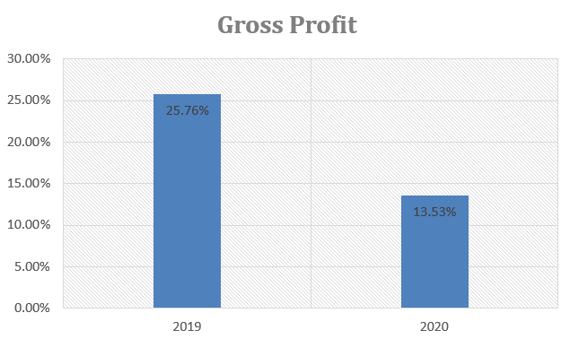Figure 1 – Gros Profit Margin in 2019 and 2020

Figure 2 shows that the net profit in 2020 will be a loss. As a result, the company's financial performance deteriorated dramatically from 2019 to 2020. This poor result could be attributed to a drop in the company's operating income, as well as the detrimental impact of COVI-19's restrictions.
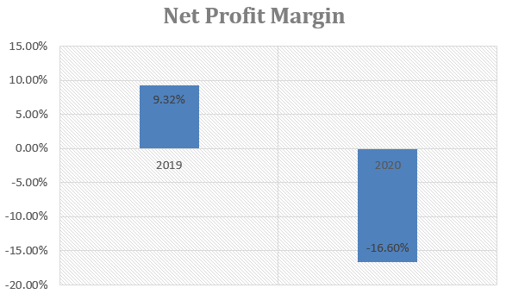
Figure 2
Figure 3 depicts the financial indicator ROCE (Return On Capital Employed), which was generated using the Hilton Hotel's financial statements. In 2019, this measure falls short of the 20% criteria (which indicates satisfactory performance), coming in at only 13.03 percent, indicating that revenues were lower than the value of the assets owned. This rate will fall below zero in the coming year (2020), signaling an alarm for the financial management team. However, this bad financial performance is partially justified due to the pandemic situation and the investments taken to adjust to the new normal.
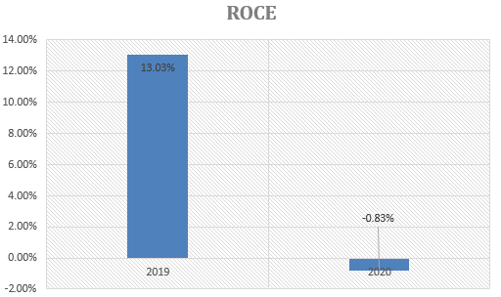Figure 3

Asset Turnover ratios

Ratio | Formula | 2019 | 2020
Total assets turnover | (Sales Turnover/ Total assets less current liabilities)*100 | 78.20% | 16.99%
Working Capital Turnover | (Sales Turnover / Net current assets)*100 | 451% | 57.94%
Table 2 – Asset Turnover ratios for 2019 and 2020
Table 2 displays the asset turnover ratio indicator values for 2020 and 2019, and I can see that it has a value of 17 percent for total assets turnover in 2020, but it is significantly higher in 2019 with 78.20. Working capital turnover has a much larger value in 2019, whereas it has a significantly lower value in 2020, by 57.94 percent.
An asset turnover ratio compares the worth of an organization's assets to the quantity of its income of a company. This is a metric that measures how well a corporation uses its assets to produce income. A business's ability to generate income out of its properties is measured by its asset turnover ratio. The greater the asset turnover ratio, greater productive this is. A poor asset turnover ratio, on the other hand, suggests that a corporation is not effectively leveraging its resources to produce revenue. (Fairfield and Yohn, 2001)
As a result, the value of 78.20 percent in the first indication suggests that the firm is more efficient in producing money from its assets than it is in generating sales in 2020. It has the financial resources to pay all of its short-term financial obligations, according to the working capital turnover indication for 2019. In general, the bigger a company's working capital, the more efficient it is.
The values of the working capital turnover and total assets turnover indices were represented in Figure 4. As a result, the indexes' values for 2020 are lower than the prior year. This shows that the corporation is more effective at earning revenue from its assets. In 2020, the corporation does not effectively leverage its assets to produce revenue.
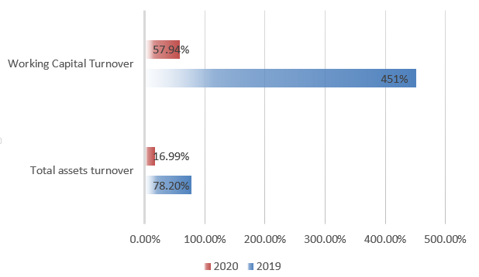Figure 4 - Asset Turnover ratios for 2019 and 2020

Liquidity ratios
Table 3, shows the values of the current ratio and fast ratio indicators so that we can see that the current ratio indicator has the lowest value is 2019, while the quick ratio indicator has the highest value in 2020. The value of 2019 indicates that the corporation is having difficulty meeting its short-term obligations.
Ratio | Formula | 2019 | 2020
Current Ratio | Current Assets/Current Liabilities | 0.729 | 1.728
Quick Ratio | (Current Assets-Stocks)/ Current Liabilities | 0.727 | 1.727
Table 3- Liquidity ratios for 2019 and 2020
The current ratio indication is shown in Figure 5, and it can be seen that the year 2020 is much greater than the year 2019, which has a value of 0.729. As a result, this metric reflects a company's capacity to repay short-term debts due the next year. The value of 2019 indicates that the corporation is having difficulty meeting its short-term obligations.
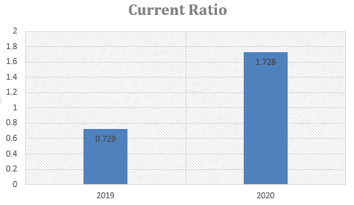Figure 5
The Quick Ratio is shown in Figure 6, and it can be seen that it has a minimal value in 2019 and a much greater value in 2020. The value of 2020 is that the firm's assets match its current assets, implying that the corporation can pay off its present debts without selling long-term assets. In the prior year, this meant that the corporation could not completely pay its existing short-term loans, hence actions to enhance liquidity were suggested.
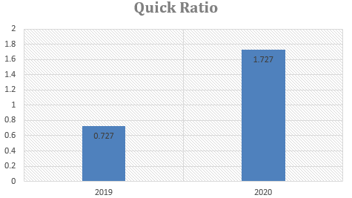Figure 6

Gearing
Ratio | Formula | 2019 | 2020
Debt Ratio | Total debt/total assets | 1.031 | 1.088
Interest Cover | Profit before Interest and tax/Periodic Interest Charges | 3.806 | -0.277
Figure 7 – Gearing indicators
Figure 7 shows that the debt ratio is lower than in 202 when 1,088 is present and that the interest cover has a negative value in 2020. So, the negative number for 2020 suggests that there are fewer operating profits to satisfy interest payments and that the firm is more exposed to volatile interest rates, while the positive value for 2019 shows that the company is more vulnerable to unpredictable interest rates. It can be seen in this indication that it desired a lower value in 2019 than in 2020, where it desired a greater value. At the same time, the company's assets will be larger in 2020.
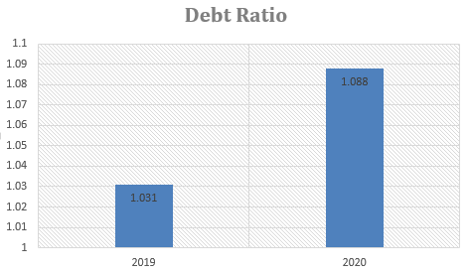Figure 8
Figure 9 shows that it will hit a negative threshold of -0.277 in 2020, after reaching a considerable value of 3,806 the previous year. The smaller the ratio, the more debt expenses burden the corporation and the fewer resources it has to invest elsewhere. A company's capacity to fulfill interest expenditures may be questioned if its interest coverage ratio is below 1.5 or lower.
The negative number for 2020 suggests that the firm will have fewer operational earnings to satisfy interest payments, making it more exposed to interest rate volatility, while the positive value for 2019 shows that the company will be capable of meeting its interest commitments.

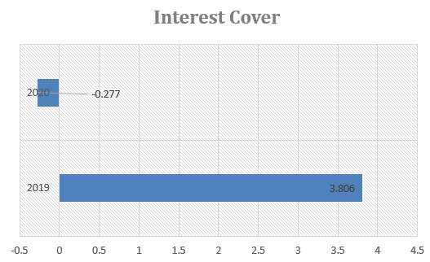Figure 9

Importance of ratio analysis
Efficient budgeting and financial management are required for a long-term organization and goal. Ratio analysis provides a valuable systematic method that may help the managers better understand financial outcomes and patterns over time, as well as give crucial indications of organizational effectiveness (Horrigan, 1968). Administrators should utilize ratio analysis to identify advantages and vulnerabilities in order to develop plans and projects. Ratio analysis may be used by investors to compare your outcomes to those of other companies or to make decisions about strategy implementation and purpose relevance (J Fred Weston and Brigham, 1990).

Limitations of ratio analysis
The information in the ratio analysis is from the past; it is not current (BBC, 2022). As a result, ratio analysis indicators are not always indicative of upcoming firm development. A company's performance might exceed expectations depending on its innovations and management team. On the other hand, a situation in which a firm appears to be promising in the analysis might quickly deteriorate for a variety of reasons.
External variables such as a global recession are not taken into consideration in ratio analysis, and for the period 2019-2020, the pandemic scenario was a major external issue that impacted all businesses in any industry (BBC, 2022).
And, the last thing on the list, it might be tough to evaluate a company with others since they may not have been inclined to share material (Lesáková, 2007), or the data disclosed by the corporation inside the financial account of a company is the basis for ratio analysis. This data might be modified by the company's board of directors to show a greater accomplishment than what it actually has. As a result, ratio analysis may not adequately reflect the underlying situational factors, because material deception is not detectable by basic analysis. It is critical for an analyst to be aware of these potential distortions and to do thorough thorough verification prior to drawing any conclusions (CFI, 2021).

Conclusion
According to the Hilton corporation's 2019-2020 financial statements, which were used to create financial ratios, the firm had a period of decreased overall performance during this time. In addition, in 2020, there will be a loss or extremely substantial variations in the indicators.
The fact that the company's status deteriorated during this time is unsurprising, given that the whole hotel sector saw bad performance as a result of the Covid-19 issue. These indicators should also be examined during periods when external forces had a significant impact in order to provide a more comprehensive view of how this organization handles crisis circumstances (for example the crisis of 2008). Another option is to delay imposing a penalty on the corporation until the hospitality sector as a whole has returned to normal.

Reference

BBC (2022). Purpose and limitations of Ratio Analysis - Ratios - Higher Business management Revision. [online] BBC Bitesize. Available at: https://www.bbc.co.uk/bitesize/guides/zrxn47h/revision/5.
BDC (2021). What is the gross profit margin ratio. [online] BDC.ca. Available at: https://www.bdc.ca/en/articles-tools/entrepreneur-toolkit/templates-business-guides/glossary/gross-profit-margin-ratio.
CFI (2021). Limitations of Ratio Analysis - Ratios are Popular, Learn About the Problems. [online] Corporate Finance Institute. Available at: https://corporatefinanceinstitute.com/resources/knowledge/finance/limitations-ratio-analysis/.
Fairfield, P.M. and Yohn, T.L. (2001). Using Asset Turnover and Profit Margin to Forecast Changes in Profitability. Review of Accounting Studies, 6(4), pp.371–385. doi:10.1023/a:1012430513430.
Groppelli, A.A. and Ehsan Nikbakht (2000). Finance. Hauppauge, N.Y.: Barron’s.
Horrigan, J.O. (1968). A Short History of Financial Ratio Analysis. The Accounting Review, [online] 43(2), pp.284–294. Available at: https://www.jstor.org/stable/243765.
Husain, T., Sarwani, Sunardi, N. and Lisdawati (2020). Firm’s Value Prediction Based on Profitability Ratios and Dividend Policy. Finance & Economics Review, 2(2), pp.13–26. doi:10.38157/finance-economics-review.v2i2.102.
J Fred Weston and Brigham, E.F. (1990). Essentials of managerial finance. Chicaco Ill.: Dryden.
Lesáková, Ľ. (2007). Uses and Limitations of Profitability Ratio Analysis in Managerial Practice. [online] Available at: https://kgk.uni-obuda.hu/sites/default/files/24_Lesakova.pdf.
Maffei, A. (2018). A Brief History of Hilton Hotels. [online] https://www.torontosom.ca. Available at: https://www.torontosom.ca/blog/a-brief-history-of-hilton-hotels.
Murphy, C.B. (2020). Earnings Before Interest and Taxes – EBIT Definition. [online] Investopedia. Available at: https://www.investopedia.com/terms/e/ebit.asp.
Williams, J.R. (2008). Financial & managerial accounting: the basis for business decisions. Boston: Mcgraw-Hill/Irwin.

