ASSIGNMENT: 1

ASSIGNMENT TITLE: Hotel Report /handbook for INTERCULTURAL COMPETENCE

MODULE: Cultural Awareness

STUDENT NAME: Ruksana Begum

STUDENT NUMBER; 2118820

TUTOR: Rodrigo Fernandes Aguilera

DUE DATE: 10th March 2023

CONTENTS PAGE

A. | EXECUTIVE SUMMARY | PAGE 3
B. | EXECUTIVE SUMMARY CONTINUED | PAGE 4
C. | INTRODUCTION | PAGES 5-6
D. | Research Theory Models | PAGE 7-8
E. | Hofstede Cultural Dimension | PAGE 9
F. | Trompenaars and hampden- turner dimensions | PAGE 10
G. | Globe's-research-programme | PAGES 11-13
H. | SIMILARITIES/DIFFERENCES FROM-HOST-COUNTRY/TOURIST COUNTRY:  Using Hofstede cultural survey tool | PAGES 14-17
I. | Hotel Handbook Recommendations  Do's & DONT’S | PAGES 18-19
J. | SUMMARY | PAGES 20
K. | REFERENCES | PAGES 21-25

Executive Summary-This Report will analyse the cultural differences between both tourist and Host country which has been selected as Bangladesh as guest country, and London UK as the host country.

London is-boosting, colourful, mixed inclusive society. The city is famous with great landmarks, the most popular sights to see are Buckingham Palace, Madame Tussauds, Westminster Abbey, tower bridge, and the Big Ben, There are also a number of modern attractions in London, such as the London Eye, The Tate Modern, and the ulti-purpose London Stadium. According to A Goel (2023) his recent survey by real estate and tourism consultancy Resonance London, states that this capital has been titled the best city in the world for 2023, going ahead of New York, Paris, Japan, Bangkok, Singapore, and Hong Kong and other popular influential cities around the world.The UK has lots of good moral, diversity, ethics, for respect to religion. About five percent of the nationals are Muslim, whilst another large proportion of the population are Hindus and Jews also within the country, but the largest religion within the UK is Christianity. Study.com(2023)
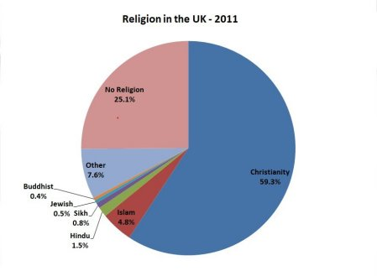
The hospitality industry has grown impressively larger over the past few decades with a notable delivery of quality services and exclusive culture exchange opportunities for travellers around the globe. Rosewood Hotel Group is a highly spread hospitality company in the UK including one located in the capital city, London. With the overwhelming growth of tourists in the UK has made the cross-culture and international guest experiences more sensitive. The understanding of cross-culture elements and their implementation strategies are key policies of Rosewood. In addition, cross-cultural leadership, analysis of organisational culture issues, and identification of human obstacles plays a crucial role in determining the importance of cross-culture intelligence/sensitivity. Hossein Khan, (2019) By adopting these cross-culture theories Rosewood can mark its reputation as the best guest service in hospitality internationally.

Executive Summary Continued…..Looking into the tourist country Bangladesh shares it’s border with Myanmar(Burma) and India along the beautiful Bengal bay. Bangladesh is best known for it’s beautiful culture, ancient archaeology and exciting history. Religion has a crucial part of the population. Bangladesh is religiously habituated, the societies religious beliefs, heritage makes them who they are, for many Bangladeshi’s there religion comes first as part of their identity followed by their ethnicity. There are 3 main religions in Bangladeshi which is Hinduism, Buddhism, and Islam. Most of Bangladesh society identifies themselves are Muslim(89.1%) followed by Hinduism (10%) of the population. Then the remainder of the population (0.9%) identifies themselves as being Buddhist and a small minority as Christians. Islam has an essential part in the political and personal lives of the majority of the population making it the official religion of Bangladesh 1988. This is a significant impact on the country’s influences of culture and history. Most of the society (70%) means of living is through farming, it’s the greatest field for employment in Bangladesh. However (30%) of the society are in poverty, with that being said the economical standards are improving especially over the last few years. Bangladesh has a hierarchy system were people are situated as a higher or lower individual according to their age and position in-life. S. Chara(2017).

This report will also provide information for hotel staff with recommendation and critically evaluate the cultural intelligence to the staff members, so that there approach is correct, according to the tourist countries conduct of behaviour and practise. It is important for staff to have cultural sensitivity and awareness. It is essential to focus on Bangladesh guest service implications, and meet their needs according to the Bangladeshi cultural values.
This report will look into relevant research and cross cultural theories-models-frameworks, showing the advantages and disadvantages of each one, but will be mainly focusing on the Hofstede cultural dimension theory- a framework for cross cultural dimension. The report will be using the country comparison tool to look at the similarities and differences between host and tourist country. There will be a Guideline table of Do’s and Don't s for staff to adhere to. This report will support staff to understand and manage the Bangladeshi guest service experience to the best level. It will enable the staff to comprehend and gain additional understanding of Bangladeshi customs, contemporary issues and influences upon tourism, In order to enhance their service experienced and meet guest needs making amendments if needed and deal with the customer request
INTRODUCTION




Cvent, (2023)

HOST COUNTRY Rosewood London:The-destination that has been chosen is-London UK, the reason is-this country has lots to attract the chosen-tourist, there’s a long-history, i.e. a great-monarchy/must see attractions/museums/great building/figures and-it ‘s multi-cultural-society of people from different-backgrounds. Mojo Travels, (2020)

The UK is-one of the tourist hubs around the globe. From research,-between the month of January-September, the-UK-welcomed 21.2 million-tourists in-2022. London being the capital that is a comparative significance-flow of international-travellers than the other-cities. Visit-Britain, (2018)-Rosewood is the five-star hotel-known for its quality services/its better understanding of cross-culture evaluation. Rosewood-is not just a renowned name in the hospitality industry-but is a landmark of customer-centric strategies that create a long-lasting connection/interaction between international-guests/the cultures they engage with.
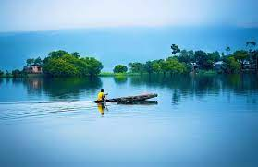
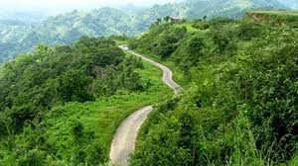

Tripsell, (2022)
Bangladesh–(Guest Country)-Is a-South-Asian-country with -beautiful-landscapes/tourist attractions. Despite being a tourist attraction, many Bangladeshi’s-travels across the borders to new dimensions/unseen cultures around the-globe. According to report by UK-visa, (2023)in 2022 successful UK-visitor’s visa was calculated as 74.20% and refusal rate-of-25.03%. The dominant belief of Bangladeshi nationality is-Islam with a fascinating diversified-culture. When people from-Bangladesh visit the-Rosewood Hotel-the-cross-cultural leadership-theory is emphasised on the available-strategies as it’s the culture/beliefs that makes-Bangladesh a sensitive country to deal with.

Judgmental attitudes-Managers-are more likely to-interact with guests which means that any kind of judgmental-attitude shall be prohibited for the managers to promote Bangladeshi customers in the UK. Timm, A. (2011)

Generalised Analysis-According to Moran, Harris and Moran, (2007)-the source of conflicts has been ideology/economics which will be-different in the new era of transformational-challenges. The cross-cultural leadership approach-helps the identification of problems within the-organisation that can be sorted out. Samovar, Porter and McDaniel, (2010)

Research and Theory models:
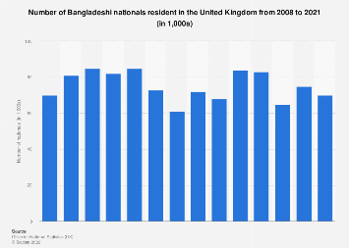
(Ukvisa, 2023)

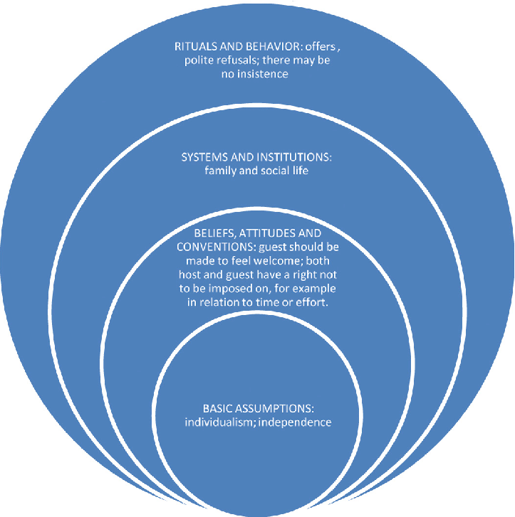
(Martin and Nakayama, 2022)
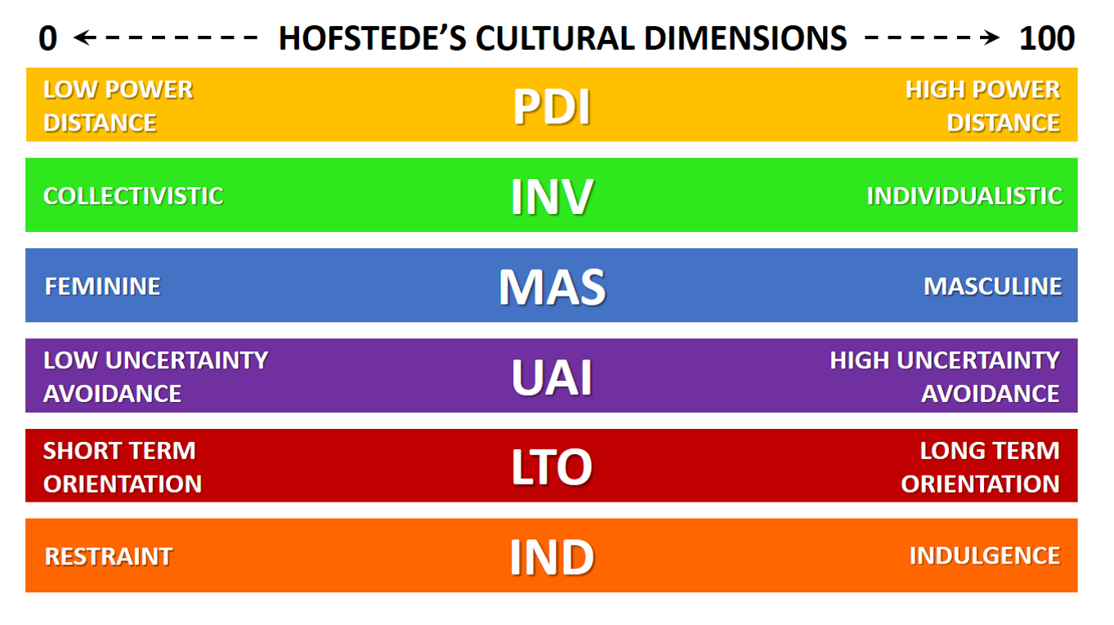
L Bruin, (2012) Figure 2: Hofstede Cultural Dimensions[Framework]

HOFSTEDE (THE THEORIST):
Samovar L et al (2016) expresses that “Hofstede work measured cultural dimensions at a national rather than an individual level,51 which means that his value dimensions, characterise the dominant culture in that society.”page 222
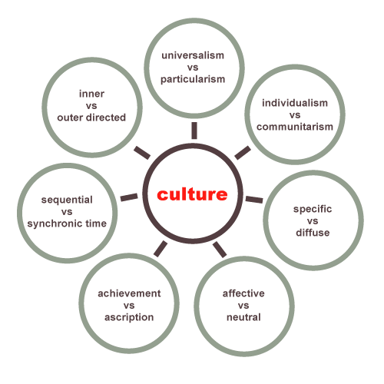
Trompenaars and hampden- turner dimensions:Fons-trompenaars worked with shell in 9different-countries. Research carried out showed-people in different cultures are diverse from each other within 7-dimensions, most of them are-matching to Hofstede dimensions/although other-dimensions present various awareness/understanding.
Dudovskiy, (2013) Figure 2 trompenaars and hampden-[cultural Dimension]
Globe's-research-programme-This model checks practises/values at industrial/organisational/societal level. The-dimensions are created by the societal cultural variation an incorporation to Hofstede. Globe operates nine dimensions to create-culture-clusters. These are formed from other research projects, alongside-religion-languages-geography/ethnicity. Authentic-developments-economical-stats are also a crucial part of clustering. The clusters are arranged-according to calculations-concerning the average distance in societal cultural-dimension.
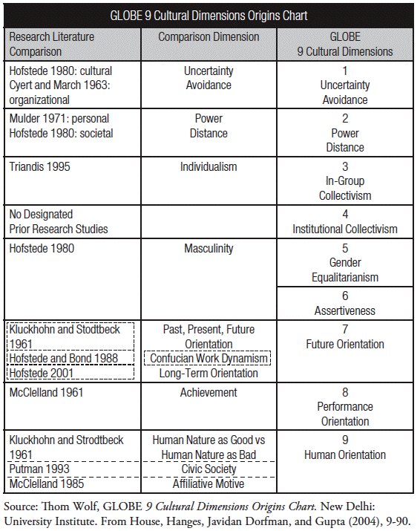

Table 6.6shows these various clusters and the countries in each-cluster

Country Clusters
Anglo | Confucian Asia | Germanic Europe | Latin America | Nordic Europe | Middle East | Sub-Saharan Africa
Australia  Canada  Ireland  New Zealand  South Africa (White)  United Kingdom  United States | China  Hong Kong  Japan  Singapore  South Korea  Taiwan | Austria  Switzerland  Netherlands  Germany (former East)  Germany (former West) | Argentina  Bolivia  Brazil  Colombia  Costa Rica  El Salvador  Guatemala  Mexico  Venezuela | Denmark  Finland  Sweden | Qatar  Morocco  Turkey  Egypt  Kuwait | Namibia  Nigeria  South Africa (Black)  Zambia  Zimbabwe
Rice University, (2023) The Globe Framework

Table 6.7 shows how the various clusters rank these leadership types:

Country Clusters and Preferred Leadership Styles
Leadership Style | Anglo | Confucian Asia | Germanic Europe | Latin America | Middle East | Nordic Europe | Sub-Saharan Africa
Charismatic | High | Medium | High | High | Low | High | Medium
Team-oriented | Medium | Medium/High | Medium/Low | High | Low | Medium | Medium
Participative | High | Low | High | Medium | Low | High | High
Humane-oriented | High | Medium/High | Medium | Medium | Medium | Low | Medium
Autonomous | Medium | Medium | High | Low | Medium | Medium | Low
Self-protective | Low | High | Low | Medium/High | High | Low | Medium
Rice University, (2023) The Globe Framework

Understand cultural differences in ethnicity and social culture UK-VS-Bangladesh

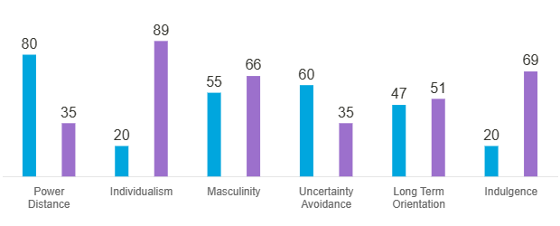
Angela, B, (2018) “Hofstede insights”,A cultural survey tool, to check cross cultural management for comparison of different countries [Online graph]

SIMILARITIES/DIFFERENCES FROM-HOST-COUNTRY/TOURIST COUNTRY: | UK: | BANGLADESH:
POWER DISTANCE:  Definition of power distance stated on Wikipedia is “a dimension theorized/proven by Geert Hofstede, who outlined multiple cultural dimensions throughout his work.” Wikipedia 2023, (https://en.m.wikipedia.org/wiki/Power_distance) | Britain has a-score of 35 for power-distance. In Britain today it is believed-where you are born should not-affect how far you can reach in the future. British-culture-believe that-everything should be impartial/everyone should be treated equally. | Bangladesh-score is-80, this shows that people-in this culture agree with people placed into ranking system according to their background. The community-have a place in the Hierarchy system. Depending which family you are born into, if born into the top end of the hierarchy you are treated as higher class.
INDIVIDUALISM-Vs COLLECTIVISM-BBC Ideas 2020 describes individualism as a category were self independence-is the main force within a particular society within its community/family. There is a lot of influence on a persons own outcome of life, in individualism society an-individual take cares of themselves. Where as collectivist group of individuals are in a team. | - The UK score is 89-British are-highly Individualist-they like to keep themselves to themselves.  - The youngsters are-told to learn how to stand on their own two-feet to make their own-successful life.  - The-pathway-to success-is-by accomplishments/achievements from your own-actions. | In comparison to the UK-Bangladesh has a lower-score of 20, because Bangladesh is regarded as a collective society one reason being that long traditions-that have been passed down from generation to generation.  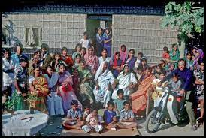  R, Hayden, (No date)
MASCULINITY-vs-Femininity:A-high-(Masculine) rate shows that the people have the-drive/determination/achievement/to compete to success.“Femininity expresses the extent to which the dominant values in society are assertiveness, money/material things/not caring for others/quality of life and people”. Moran. R (2018) Page 24   | - The UK-score is-66 of a Masculine society:This is because the British-public are regarded-as-successful individuals. The-British-society-thrive on-success/they are continuously motivated to discover more throughout life.  Woodburnpress, (2023) | - Bangladesh also has a high score of 66. So far throughout this research this is the first similarity amongst the UK and Bangladesh.  - Although both-country scores are high reasons behind the scores may-differ as Bangladesh is-a high Muslim-majority country. The men are regarded with most of the responsibilities for providing-leaving the females to-stay at home-females sometimes-they are not permitted to be working in any business field amongst other men. Religion is an integral part of Bangladeshi society-Islamic religious leaders such the scholars/priest have the highest-authority.
Uncertainty-Avoidance-Hofstede concept of uncertainty avoidance is- on how society manages control of-the unknown-to the length in which the people of different cultures try to reduce this uncertainty. Snitker, T (2010) | - UK has low score of 35, this reflects UK as a nation has a changeable-structure to their day/making adjustments to their-days/going along/amending as new advise is given. British society-are at ease with changeable circumstances. | - Bangladesh score is-60. it’s mainly-a-Muslim country:they-have-a timetable of-5 different prayers called out throughout the day-practised whether the individual is-at home/work. This rule applies to-everyone. People’s days are-structured around the prayer.
LONG-TERM ORIENTATION-VS-Short term ORIENTATION  M Castano (2022) explains that-long-term-orientation/  Short term orientation is-a-cultural-measurement, which shows how other cultures assess-their way of being within long/short timescale. To distinguish-the-difference-between both long term orientation is concentrating on the future. Short term orientation focuses-on-the-present. | UK score is-51. This reflects that the British-are not able to be set on-or-fix on something in the long run-they are more likely to-make switch-movements/decisions-for example moving home or getting new job etc.      Forbes, 2023 | - Bangladesh has an intermediate score at-47-this does not indicate a strong preference in either direction.
INDULGENCE-VS-SELF RESTRAIN-According to Jandt F(2020) The Hofstede cultural dimension- indulgence Vs Restraint-Indulgence-is-when individuals are-free to do what they like. Where as Restraint-is to hold back/manage their desires.    T Allingham, (2023) | Britain has an-increased score of 69-this-shows British society are-known to be easy going and-have more indulgence in-life. The high-score-in-indulgence reflects on how-British culture like to splash out. They’re confident/hopeful to make the most out of-life.  S Totade, (2022)  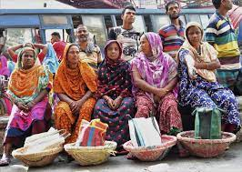   | Bangladesh-is-a-moderate nation/people do not believe spending out of control/anyone who does-is regarded-as-behaving inappropriately/wasting money is also considered to be sinful.  T Reuters Foundation, (2022

Hotel Handbook Recommendations
DO’S | DON’T
- In Bangladesh the right hand-is used for eating/passing food/same for business cards/receipts/menus & for giving-receiving cash. | - Guest treatment should not be-judgmental based on the socioeconomic background.
- Prayer area for collective prayer rituals | - Serving Haram food intentionally or accidentally.
- Hotel instructions/guidelines shall be provided in Bengali as many of them might not understand-English. | - Forbidden religious-activities
- It-has-traditionally been considered respectful for men-women to maintain distance-be prepared replace front of desk staff with Female representative.  - You May offer chicken/beef/lamb-as-a-meal-option, but only if halal.  - It’s-compulsory to remove one’s shoes when entering another’s personal space-if for any reason -you need to enter guest room do so by removing first as a sign of respect. | Using a monolingual approach in every communication stage.  Don’t serve-alcohol to the Muslim customers Scroope,(2017)    Aboutislam, (2023)
- Bangladeshi’s are not big on waiting in lines-on arrival of guests if a que is building-get extra staff to reduce waiting time.  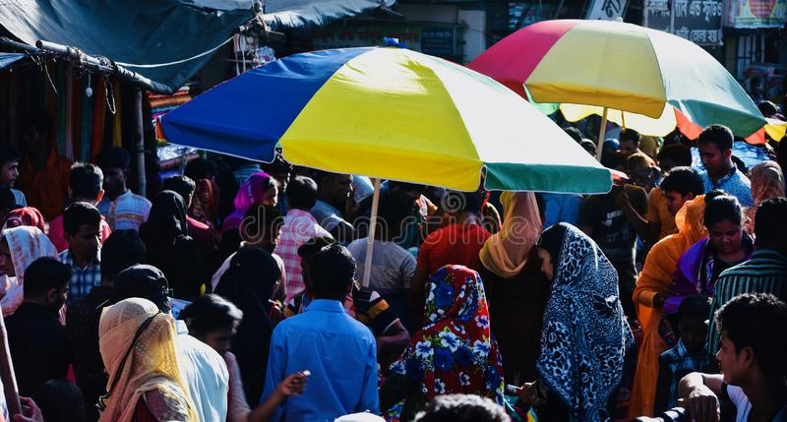  N, Hossain (2023) | - In Bangladesh, the head is-the highest/most sacred part of the human body. The feet is the lowest sacred-dirtiest part of the human-body.  - It’s-considered rude to point your foot at a person-even showing someone the sole of your feet/shoe is very rude. Do not raise feet-if sitting/never put your feet on a table/couch.
- Greetings must be-on the guest’s practices-which will create a more welcoming environment. | - Show extra respect towards the elderly, do not-address them by their name but rather sir/ madam.  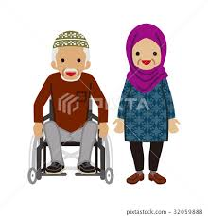



Summary:

Dreamstime Photos, (2023)





In a nutshell Rosewood London-has proved to be the best hotel in customer service in the UK hospitality industry. For the organic growth of the hotel business it’s essential to understand and value cross-culture ethics-staff members shall be trained accordingly. Cross-cultural leadership plays-a key role in analysing cultural differences, conflicts and solutions to enhance tourism. Bangladesh is a sensitive nation in terms of culture/social norms/religion/economy-for which understanding cultural diversification is very important

References:
Jandt F, (2020) Introduction to intercultural Communications, 10th Edition, Sage: 2445 Teller Road, Thousand Oaks, Carlofornia USA

Lacalle E, (2021) Six most important challenges in the hotel industry.[online] Available at: https://www.news.com/en/blog/hotel-challenges (Accessed: 1 March 2023).

Moran. R, (2018) Managing cultural differences 10th Edition, pg24 Routledge Abington

Moran, R.T., Harris, P.R. and Moran, S.V. (2007) Managing cultural differences: global leadership strategies for the 21st century. 7th ed. Amsterdam ; Boston: Elsevier/Butterworth-Heinemann (Managing cultural differences series).

Samovar, L.A., Porter, R.E. and McDaniel, E.R. (2010) Communication between cultures. 7th ed. Belmont, CA: Wadsworth/Cengage Learning (Wadsworth series in speech communication).

Samovar L, (2016) Communication Between Cultures, 9th Edition, pg222, Cengage Learning, Boston, USA

Scroope, C. (2017) Bangladeshi Culture - Etiquette, Cultural Atlas. [online] Available at:
http://culturalatlas.sbs.com.au/bangladeshi-culture/bangladeshi-culture-etiquette (Accessed: 2 March 2023).

S. Chara, (2017) Cultural Atlas- Bangladeshi Culture[online] Available at: https://culturalatlas.sbs.com.au/bangladeshi-culture/bangladeshi-culture-rreli
(Accessed:13th February 2023).

Snitker. T, (2010) Uncertainty Avoidance [online] Available at; https://www.sciencedirect.com/topics/computer-science/uncertainty-avoidance#:~:text
/(Accessed 10th February 2023).

Semantic-scholar.org,(no date) Interpreting-Hofstede-Model-and-GLOBE-Model [online] Available at: https://www.semanticscholar.org/paper/Interpreting-Hofstede-Model-and-GLOBE-Model%3A-Which-Shi-Wang/9b0ae3bbf5153dd8675d959d9041ea1a4ddb76a6/figure/0 /(Accessed 10th February 2023).

Study.com(2023) UK Religion, [online] Available at:https://study.com/academy/lesson/how-religion-in-the-uk-influences-public-life.html#:(Accessed:13th February 2023)

Timm, A. (2011) Intercultural problems in the tourism industry. [online] Available at: https://www.grin.com/document/178258 (Accessed: 1 March 2023).

Ukvisa, (2023) UK Visas for Bangladeshi 2023: Fees and Entry Requirements. [online] Available at: https://ukvisa.blog/2022/02/28/uk-visa-for-bangladeshi-citizens/ (Accessed: 1 March 2023).

VisitBritain, (2018) Monthly Data, VisitBritain. [online] Available at: https://www.visitbritain.org/2022-monthly-data (Accessed: 1 March 2023).

Wikipedia, (2023) Power Distance [online] Available https://en.m.wikipedia.org/wiki/Power_distance (Accessed 10th February 2023)

Other
Journals/surveys

Hossein Khan, M.Y.,2019) ‘Cross cultural leadership and the hospitality industry: a leadership style towards success in organisational goals in Arts & Humanities -[Online Journal]Available at: https://doi.org/10.15406/ahoaj.2019.03.00100. (Accessed: 1 March 2023).

A Goel (2023) What you need to know London the best city in the world 2023,[online survey] Available at:https://www.travelandleisureasia.com/in/insight/what-you-need-to-know/london-best-city-in-the-world-2023/#:
(Accessed: 1 March 2023).

YouTube videos
BBC Ideas, (2020)Individualism is it good or bad [video] Available at: https://youtube.be/LZVRIOD2DPU ( Accessed 10th February 2023)

Mojo Travels, (2020) Top 10 Must see attractions in London, [video] Available at: https://youtube.be/CTrHNiDFdqs( Accessed 13^{h} February 2023)

M Castano(2022) Long Term VS Short Term Orientation- Hofstede Dimensions [video] Available at:https://youtube.com/watch?v=osIZsgVc6I0&feature=share
(Acssessed 11th February 2023)

Graphs/ Charts/Frameworks/Images

Angela B, (2018) Hofstede insights, Country-Comparison/ United Kingdom/Bangladesh [online graph] Available at; https://www.hofstede-insights.com/country-comparison/united kingdom/( Accessed 30th January 2023)

Britanncia, (no date) Bangladesh - Languages | Britannica.[online graph] Available at: https://www.britannica.com/place/Bangladesh/Languages
(Accessed: 1 March 2023).

J Dorfman & Gupta, (2004) Cultural dimensions origins chart [online chart] Available at: https://www.staff.ncl.ac.uk/david.harvey/MKT3008/culture.html
(Accessed: 5thMarch 2023).

J Dudovskiy, (2013)Trompenaars and Hampden-Turner Cultural Dimensions[online graph] Available at: https://www.Trompenaars/Research-Methodology.net
(Accessed: 5thMarch 2023).

L Bruin, (2012) Business-to-you Hofstede’s Cultural Dimensions[Framework] Available at: www.B2U(business-to-you.com)
(Accessed 12th February 2023)

About Islam, (2023)The connection between Islam and alchohol [online images]Available at:Come back ⚡ (halalwinecellar.com) (Accessed: 5thMarch 2023).
Cvent, (2023) Rosewood a sense of place [online images]Available at: https:www.cvent.com/venues/london/luxury-hotel/rosewood-london/venue-3ba13203-d761-47e5-8156-c286c34f2055(Accessed 7th March 2023)
Dreamtimes, (2023) Staff greeting guests in Asian hotel[online images]Available at:Staff Greeting Guests in Asian Hotel Stock Image - Image of indonesia, typical: 65793631 (dreamstime.com) (Accessed 7th March 2023)
Forbes, (2023), Focus on what you can control [online images] Available at:When Hunting For A New Job, Focus On What You Can Control (forbes.com) Accessed 7th March 2023)
N, Hossain (2023) A crowded marketplace in Bangladesh unique photo [online image]Available at:A Crowded Marketplace in Bangladesh Unique Photo Editorial Image - Image of creativity, shop: 126951615 (dreamstime.com) Accessed 7th March 2023)
R, Hayden, (No date)Rural Bangladeshi family, [online images]Available at: https://www.flickr.com/photos/rosmee/4868069604 Accessed 7th March 2023)
S Totade, (2022) Indulge In These 5 Best Luxury Destinations For A Family Holiday[online images]Available at:Indulge In These 5 Best Luxury Destinations For A Family Holiday (ndtv.com) Accessed 7th March 2023)
T Allingham,(2023) Save Money, [online image]Available at: https://www.savethestudent.org/save-money (Accessed 7th March 2023)
T Reuters Foundation, (2022)As fuel prices and the cost of living soar, Bangladesh's poorest warn "I can't survive[online images] Available at:Rising inflation traps Bangladesh climate migrants (trust.org) Accessed 7th March 2023)
Tripsell, (2022)15 top cities of Bangladesh [online images]Available at: https://www.tripsell.com/best(Accessed 7th March 2023)
Woodburnpress, (2023), 4 Reasons to Graduate [online Poster] Available at: https://www.woodburnpress.com/4reasons-tograduate-poster.htmlAccessed 7th March 2023)

